Additional file 8:

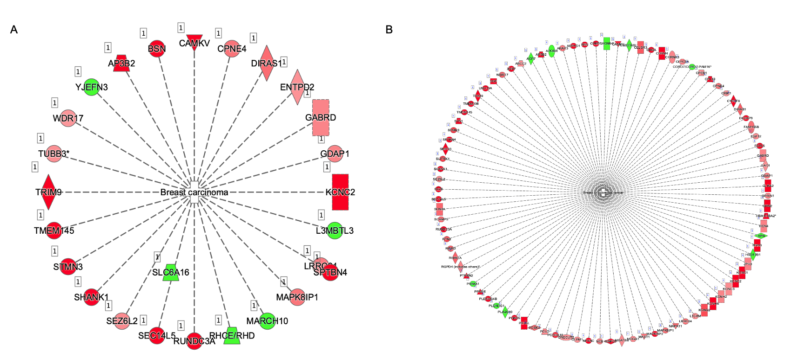

Analysis of breast cancer associated genes in MCF-7 REST knockdown cells. . A, Gene network analysis of breast carcinoma associated genes using Ingenuity Pathway Analysis software in MCF-7 cells transfected with siRNA for REST and treated with vehicle (PBS) compared to MCF-7 cells transfected with control siRNA and treated with vehicle (PBS). B, Gene network analysis of breast carcinoma associated genes using Ingenuity Pathway Analysis software in MCF-7 cells transfected with siRNA for REST and treated with estradiol (10nM) compared to MCF-7 cells transfected with control siRNA and treated with estradiol (10nM). Genes which were significantly (p<0.05) up-regulated (red) or down-regulated (green) in RNA-sequencing results.

