Additional file 5

GEO dataset analysis. Hierarchical clustering of REST target downstream breast cancer gene expression data form A, GSE2034 and B, GSE19615.
A.
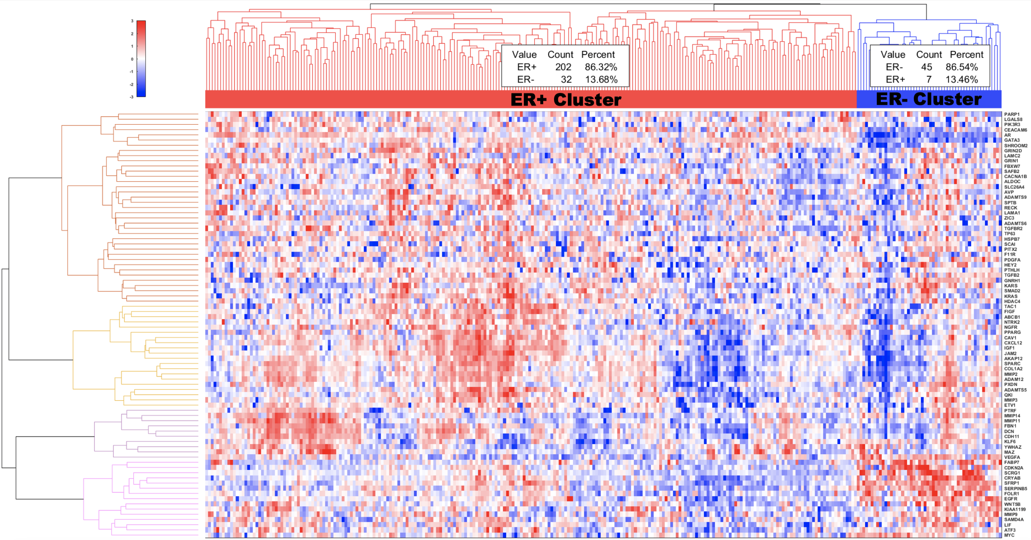
B.
