SUPPLEMENTARY INFORMATION

A nature-inspired nanodelivery platform for gene silencing in hematopoietic stem and progenitor cells

Stijn R.J. Hofstraat¹*, Tom Anbergen²*, Robby Zwolsman¹*, Jeroen Deckers², Yuri van Elsas², Mirre M. Trines¹, Iris Versteeg², Bram Priem², Youssef B. Darwish¹, Teun Kleuskens¹, Francisca Borges², Rianne J.F. Maas², Lars M. Verhalle¹, Willem Tielemans², Pieter Vader³, Olivier G. de Jong⁴, Abraham J.P. Teunissen^{5,6,7,8}, Eliane Brechbühl⁵, Henk M. Janssen⁹, P. Michel Fransen⁹, Anne de Dreu¹, David P. Schrijver¹, Yohana C. Toner², Thijs J. Beldman², Mihai G. Netea^{2,10}, Willem J.M. Mulder^{1,2#}, Ewelina Kluza¹, Roy van der Meel^{1#}

- Laboratory of Chemical Biology, Department of Biomedical Engineering, Eindhoven University of Technology, Eindhoven, The Netherlands.
- Department of Internal Medicine and Radboud Center for Infectious Diseases (RCI), Radboud University Medical Center, Nijmegen, The Netherlands.
- CDL Research & Department of Experimental Cardiology, University Medical Center Utrecht, Utrecht, The Netherlands
- Department of Pharmaceutics, Utrecht Institute of Pharmaceutical Sciences (UIPS), Utrecht University, Utrecht, The Netherlands.
- BioMedical Engineering and Imaging Institute, Icahn School of Medicine at Mount Sinai, New York, New York, USA.
- Department of Diagnostic, Molecular, and Interventional Radiology, Icahn School of Medicine at Mount Sinai, New York, New York, USA.
- Cardiovascular Research Institute, Icahn School of Medicine at Mount Sinai, New York, New York, USA.
- Icahn Genomics Institute, Icahn School of Medicine at Mount Sinai, New York, New York, US.
- SyMO-Chem B.V., Eindhoven, The Netherlands.
- Department of Immunology and Metabolism, Life and Medical Sciences Institute, University of Bonn, Bonn, Germany

* These authors contributed equally to this work.
# Corresponding authors: r.v.d.meel@tue.nl and willem.mulder@radboudumc.nl

Supplementary Figure 1. siRNA-aNP formulation procedure. The lipid molecules dissolved in ethanol are rapidly mixed via a T-junction with siRNA dissolved in sodium acetate buffer (25 mM, pH 4). The resulting intermediate product is then dialyzed against PBS buffer (pH 7.4). Next, the intermediate product is again rapidly mixed with apoA1 dissolved in PBS. The final product is filtered, concentrated, and analyzed.

Supplementary Figure 2. Radio-thin layer chromatography (radio-TLC) shows complexation of ⁸⁹Zr with DFO-siRNA and integration into ⁸⁹Zr-siRNA-aNP. a. MALDI spectra indicating conjugation of DFO to the siRNA sense strand b. Radio-TLC analysis of free ⁸⁹Zr (top left) showing a peak at 15 mm. The peak clearly shifts when ⁸⁹Zr is chelated to DFO-siRNA, yielding ⁸⁹Zr-siRNA (top right). We used ⁸⁹Zr-siRNA for hot formulation of the prototype aNP (bottom right) and a control LNP (bottom left).

Supplementary Figure 3. Ex vivo LAMP1 silencing using various siRNA constructs. Screening of siLAMP1 constructs using bone marrow-derived macrophages (Supplementary Table 4). The transfection was performed with Lipofectamine RNAiMAX at a concentration of 10 & 100 nM respectively. The LAMP1 mean fluorescence intensity was measured by flow cytometry. For further experiments, siLAMP1e was selected (dark orange). Data represents mean ± SD of one experiment (minimal of n=2 biological replicates).

Supplementary Figure 4. Reporter gene silencing in vitro for aNP formulations with diverse compositions. Firefly luciferase knockdown in a dual-reporter assay of aNP formulations with a cholesterol (C) to phospholipid (PL) ratio ranging from 0.1 to 2.5 and containing phospholipid types POPC, DMPC & DPPC as indicated above the bars.

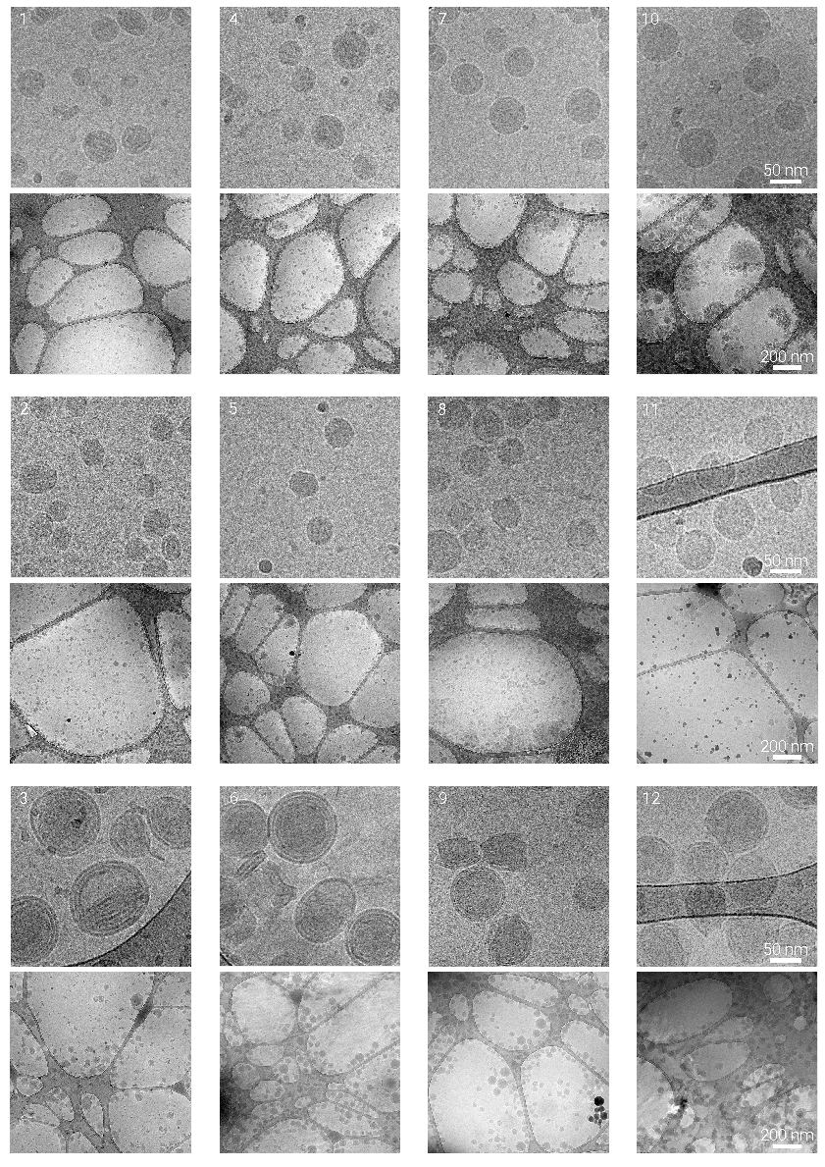
Supplementary Figure 5 continues on the next page.
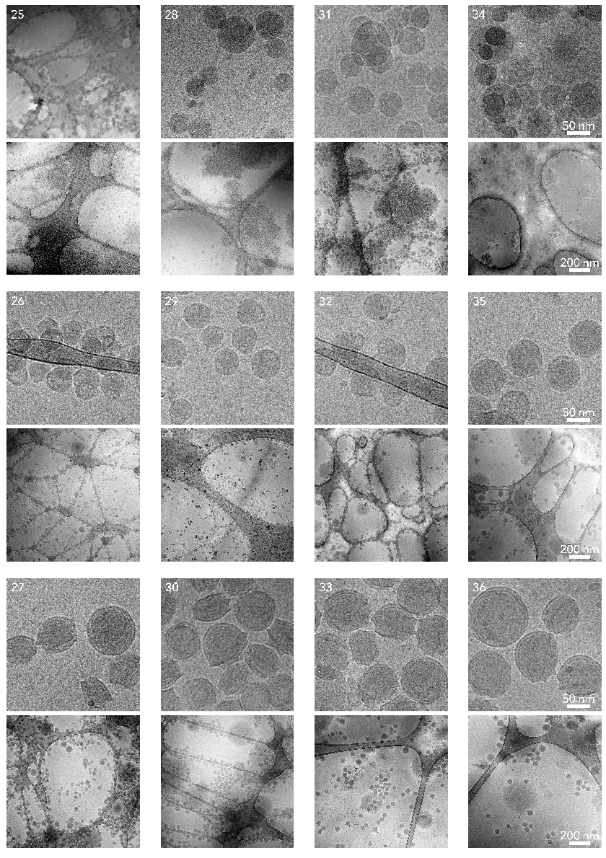
Supplementary Figure 5 continues on the next page.

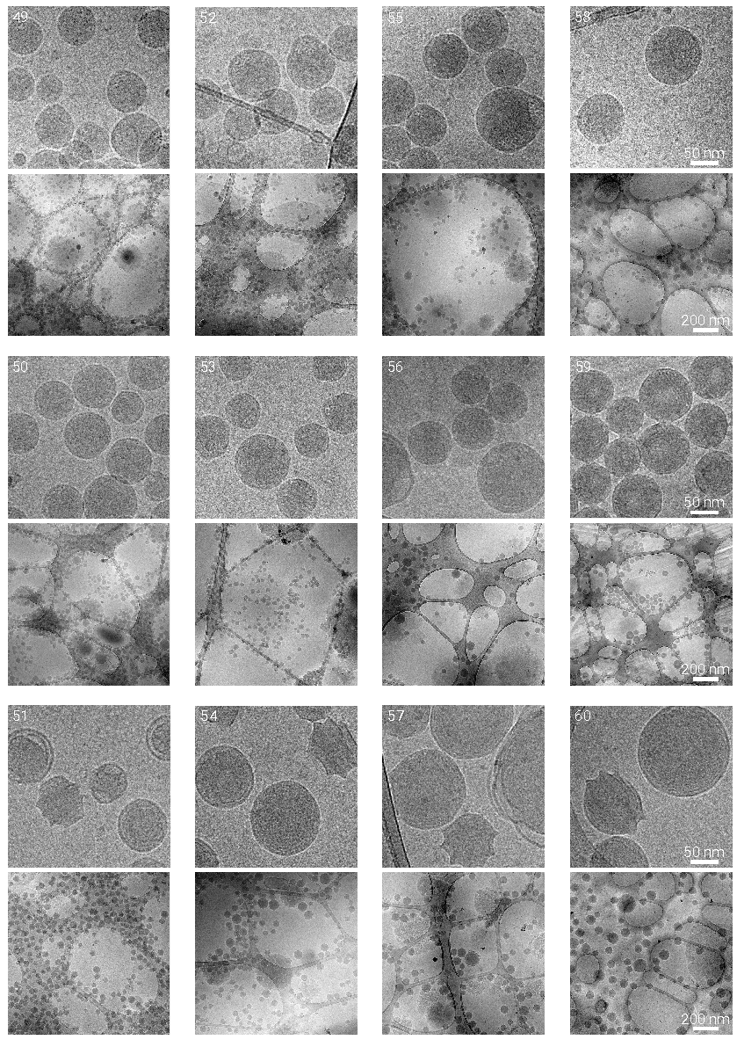
Supplementary Figure 5 continues on the next page.

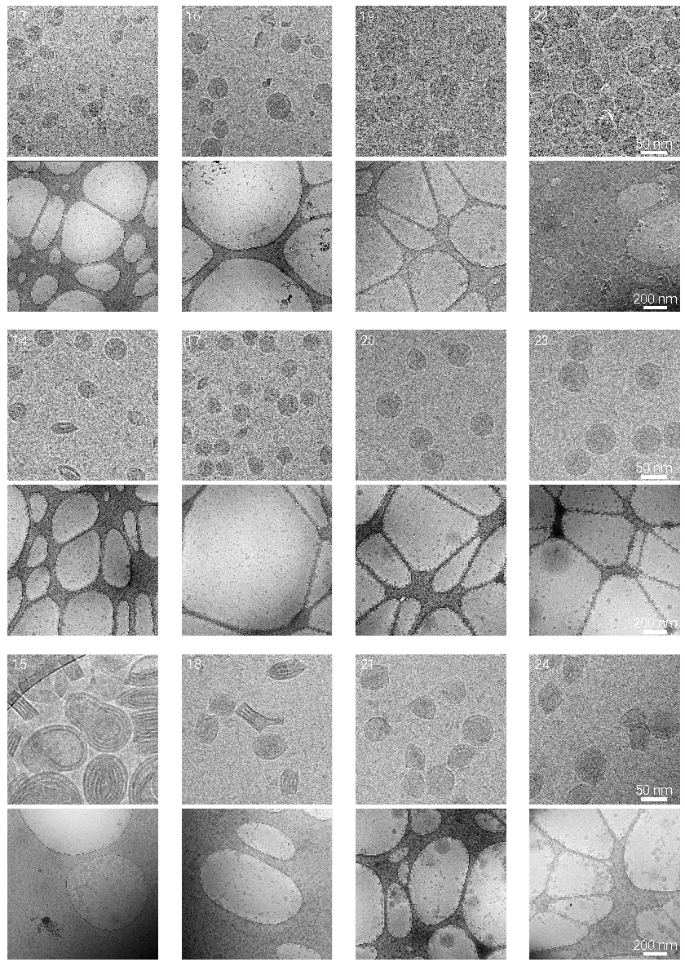
Supplementary Figure 5 continues on the next page.

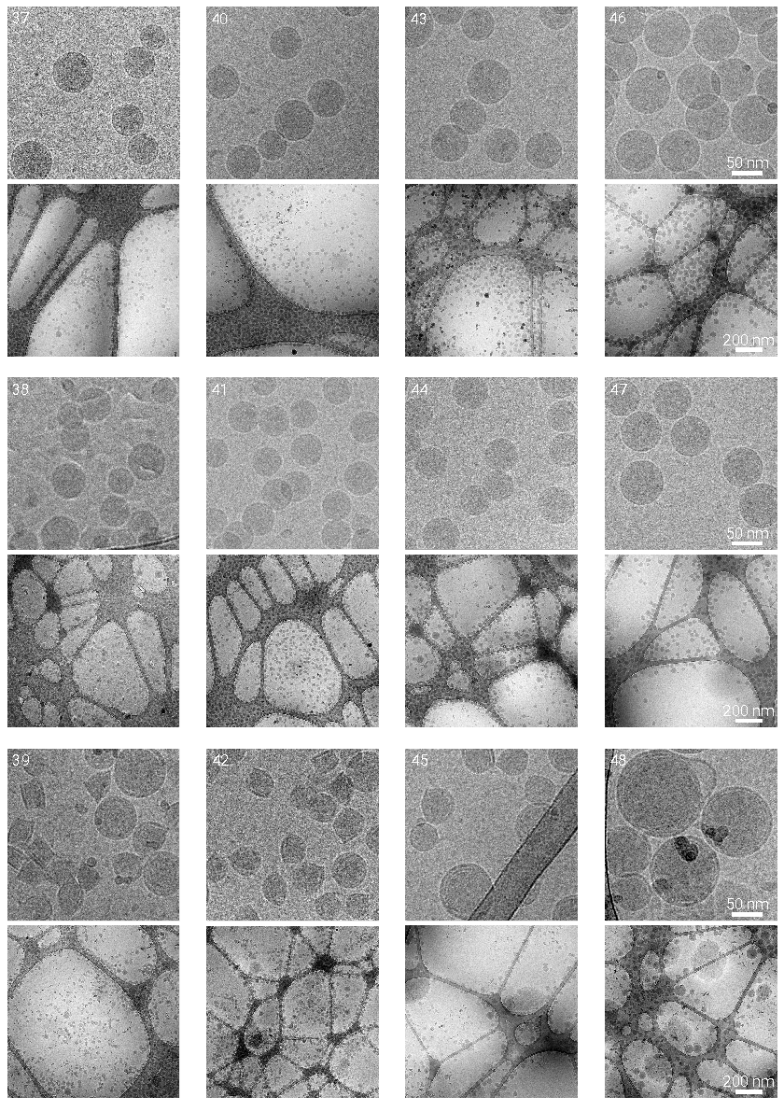
Supplementary Figure 5 continues on the next page.

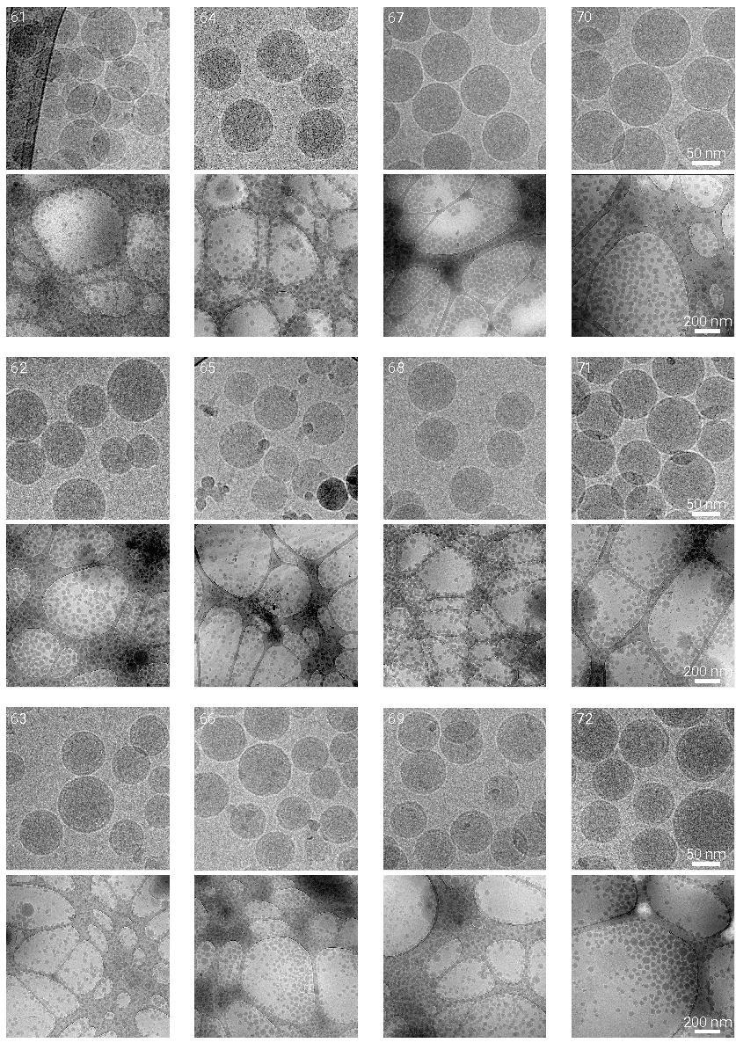
Supplementary Figure 5. Comprehensive siRNA-aNP library overview. Detailed cryo-EM images of 72 siRNA-aNP formulations. Top panels. Cryo-TEM image at a 24000-fold magnification. The scalebar represents a size of 50 nm. Bottom panels. Higher level overview of the formulation at a 6500-fold magnification. Scale bar represents a size of 200 nm.

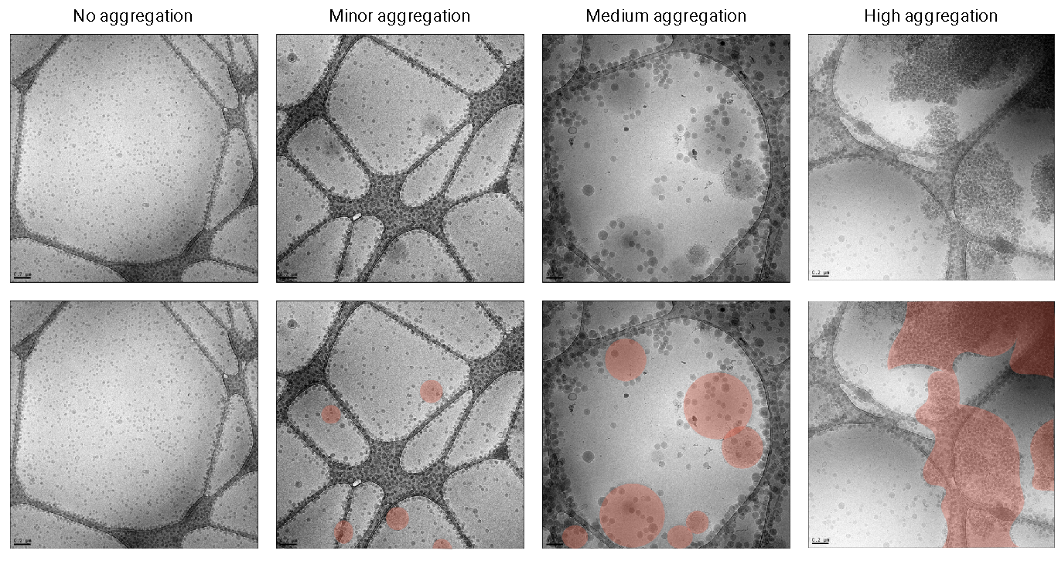
Supplementary Figure 6. Representative cryo-EM images displaying no aggregation to high aggregation. The degree of aggregation was assessed by determining the area of lipid aggregates (masked in red) divided by the total area of the image (n=10).

Supplementary Figure 7. Gating strategy for flow cytometry analysis. a. Progenitor cells. b. Myeloid cells. Antibody panels are listed in the Materials and Methods section.
Supplementary Figure 8. In vivo aNP induced LAMP1 knockdown effect of progenitor cells in the bone marrow. LAMP1 MFI measured by flow cytometry in various cell populations in the bone marrow including, HSCs, LT, HSCs, MPPs, MyPs, CMPs & GMPs. The gating strategy utilized in this experiment is displayed in Supplementary Figure 7a. The knockdown effect compared to a negative control formulation is displayed. Data represent mean ± SD of one experiment (n=6 animals) and analyzed by one-way ANOVA with Bonferroni post hoc test. Statistically significant differences between aNP Target versus aNP Control formulations are indicated by: * indicates statistical significance (p ≤ 0.05), ** indicates statistical significance (p ≤ 0.01), *** indicates statistical significance (p ≤ 0.001), **** indicates statistical significance (p ≤ 0.0001).

Supplementary Figure 9. In vivo aNP induced LAMP1 knockdown effect of myeloid cells in the bone marrow. LAMP1 MFI measured by flow cytometry in various cell populations in the bone marrow among which leukocytes, myeloid cells, dendritic cells, macrophages, monocytes, monocytes Ly6C high, neutrophils & monocytes Ly6C low. The gating strategy is displayed in Supplementary Figure 7b. Data represent mean ± SD of one experiment (n=6 animals) and analyzed by one-way ANOVA with Bonferroni post hoc test. Statistically significant differences between aNP Target versus aNP Control formulations are indicated by: * indicates statistical significance (p ≤ 0.05), ** indicates statistical significance (p ≤ 0.01), *** indicates statistical significance (p ≤ 0.001), **** indicates statistical significance (p ≤ 0.0001).

Supplementary Figure 10. In vivo aNP induced LAMP1 knockdown effect of myeloid cells in the spleen. LAMP1 MFI measured by flow cytometry in various cell populations in the bone marrow among which leukocytes, myeloid cells, dendritic cells, macrophages, monocytes, monocytes Ly6C high, neutrophils & monocytes Ly6C low. The gating strategy is displayed in Supplementary 7b. Data represent mean ± SD of one experiment (n=6 animals) and analyzed by one-way ANOVA with Bonferroni post hoc test. Statistically significant differences between aNP Target versus aNP Control formulations are indicated by: * indicates statistical significance (p ≤ 0.05), ** indicates statistical significance (p ≤ 0.01), *** indicates statistical significance (p ≤ 0.001), **** indicates statistical significance (p ≤ 0.0001).

SUPPLEMENTARY TABLES

Supplementary Table 1. Compositions of siRNA-aNP library formulations.

Supplementary Table 2. Cryo-EM recorded sizes of siRNA-aNPs in the tested series of formulations.

Supplementary Table 3. Primer sets for target and housekeeping genes used in RT-qPCR

Supplementary Table 4. siRNA sequences

