Appendix 1:
An example to demonstrate model M.4 for plot phenotypes:
$y_{3}=1μ+Z_{u_{1}}u_{1}+\left(Z_{u_{2,a}}+Z_{u_{2,b}}\right)u_{2}+Z_{v_{3}}v_{3}+Z_{{(uu)}_{3}}{(uu)}_{3}+e_{3}$
Three-way hybrid | Parent 1 | Grandparent 2a | Grandparent 2b | Plot phenotype
31 | 11 | 21 | 25 | 101
32 | 11 | 22 | 25 | 102
33 | 11 | 22 | 21 | 103
34 | 12 | 23 | 25 | 104
35 | 13 | 24 | 21 | 105
36 | 13 | 25 | 24 | 106

$$\left[\begin{matrix}101 \\ 102 \\ 103 \\ 104 \\ 105 \\ 106\end{matrix}\right]=\left[\begin{matrix}1 \\ 1 \\ 1 \\ 1 \\ 1 \\ 1\end{matrix}\right]μ+\left[\begin{matrix}1 & 0 & 0 \\ 1 & 0 & 0 \\ 1 & 0 & 0 \\ 0 & 1 & 0 \\ 0 & 0 & 1 \\ 0 & 0 & 1\end{matrix}\right]\left[\begin{matrix}u_{11} \\ u_{12} \\ u_{13}\end{matrix}\right]+\left[\begin{matrix}1 & 0 & 0 & 0 & 1 \\ 0 & 1 & 0 & 0 & 1 \\ 1 & 1 & 0 & 0 & 0 \\ 0 & 0 & 1 & 0 & 1 \\ 1 & 0 & 0 & 1 & 0 \\ 0 & 0 & 0 & 1 & 1\end{matrix}\right]\left[\begin{matrix}u_{21} \\ u_{22} \\ u_{23} \\ u_{24} \\ u_{25}\end{matrix}\right]+\left[\begin{matrix}1 & ⋯ & 0 \\ ⋮ & ⋱ & ⋮ \\ 0 & ⋯ & 1\end{matrix}\right]\left[\begin{matrix}v_{31} \\ v_{32} \\ v_{33} \\ v_{34} \\ v_{35} \\ v_{36}\end{matrix}\right]+\left[\begin{matrix}1 & ⋯ & 0 \\ ⋮ & ⋱ & ⋮ \\ 0 & ⋯ & 1\end{matrix}\right]\left[\begin{matrix}{uu}_{31} \\ {uu}_{32} \\ {uu}_{33} \\ {uu}_{34} \\ {uu}_{35} \\ {uu}_{36}\end{matrix}\right]+\left[\begin{matrix}e_{101} \\ e_{102} \\ e_{103} \\ e_{104} \\ e_{105} \\ e_{106}\end{matrix}\right]$$
Variance:
$$V(y_{3})=Z_{u_{1}}G_{A_{1}}Z_{u_{1}}^{'}σ_{A,1}^{2}+\left(Z_{u_{2,a}}+Z_{u_{2,b}}\right)G_{A_{2}}{\left(Z_{u_{2,a}}+Z_{u_{2,b}}\right)}^{'}σ_{A,2}^{2}+Z_{v_{3}}G_{D_{3}}Z_{v_{3}}^{'}σ_{D,3}^{2}+Z_{{(uu)}_{3}}G_{{AA}_{3}}Z_{{(uu)}_{3}}^{'}σ_{AA,3}^{2}+σ_{e_{3}}^{2}$$
Variances $σ_{A,1}^{2}$, $σ_{A,2}^{2}$, $σ_{D,3}^{2}$ and $σ_{AA,3}^{2}$ are the components of plot variances that are explained based on the parental genotypes of inbred lines in populations 1 and 2.
To investigate the sources of variances explained by individuals’ genotypes, plot phenotypes and model, we assume populations 1 and 2 have the same allele frequencies, that inbred lines in populations 1 and 2 are completely inbred and non-related, and that the three-way population has additive, dominance and epistatic variances of $σ_{A}^{2}$, $σ_{D}^{2}$ and $σ_{AA}^{2}$ based on genotypes of three-way hybrid individual plants. The variance components that were explained by genotypes of inbred lines in model M.4 would be:
$$V(y_{3})=Z_{u_{1}}G_{A_{1}}Z_{u_{1}}^{'}\frac{σ_{A}^{2}}{2}+\left(Z_{u_{2,a}}+Z_{u_{2,b}}\right)G_{A_{2}}{\left(Z_{u_{2,a}}+Z_{u_{2,b}}\right)}^{'}\frac{σ_{A}^{2}}{8}+Z_{v_{3}}G_{D_{3}}Z_{v_{3}}^{'}\frac{σ_{D}^{2}}{2}+Z_{{(uu)}_{3}}G_{{AA}_{3}}Z_{{(uu)}_{3}}^{'}\frac{5σ_{AA}^{2}}{8}+σ_{e_{3}}^{2}$$
The covariance coefficient of additive genetics between plots from the same parent would be $\frac{1}{2}$ for inbred parents. The coefficient would be $\frac{1}{4}$ for non-inbred parents assuming non-related parents in populations. Therefore, the additive genetic variances of plot that are explained by the genotypes of inbred population 1 and 2 are $\frac{1}{2}*σ_{A}^{2}$ and $\frac{1}{2}*\frac{1}{4}*σ_{A}^{2}$, respectively. Hence, M.4 could explore a total additive genetic variance of $\frac{σ_{A}^{2}}{2}+\left(\frac{σ_{A}^{2}}{8}+\frac{σ_{A}^{2}}{8}\right)=\frac{3σ_{A}^{2}}{4}$. As compared to $σ_{A}^{2}$ of three-way population, additive genetic variance of $\frac{σ_{A}^{2}}{4}$ is missing. This missing variance might not be explored when individual genotypes and phenotypes of three-way hybrids were unknown.
The covariance coefficient of a plot and itself for dominance effect would be 1.0 if the genotypes of individuals within the plot were known. We could only know exactly the genotype of the gamete that was inherited from inbred lines of population 1 to the three-way offspring. The covariance coefficient of dominance for this gamete is 1.0. However, the genotype of the other gamete that was inherited from inbred lines of population 2 to the three-way offspring was unknown. In addition, the effect of dominance is not additive. Therefore, the contribution of the (other) gamete to the plot variance is zero. Hence, the dominance variance of plot that is explained by the genotypes of the two gametes is $\frac{1}{2}*σ_{D}^{2}+\frac{0}{2}*σ_{D}^{2}=\frac{σ_{D}^{2}}{2}$. As compared to $σ_{D}^{2}$ of three-way population, dominance variance of $\frac{σ_{D}^{2}}{2}$ is missing. This missing variance might not be explored when individual genotypes and phenotypes of three-way hybrids were unknown.
Similarly, we could only know exactly the genotype of the gamete that was inherited from inbred lines of population 1 to the three-way offspring. The covariance coefficient of epistasis for this gamete is 1.0. The genotype of the other gamete that was inherited from inbred lines of population 2 to the three-way offspring was unknown. However, the epistatic effect is additive, thus the covariance coefficient of epistasis for this other gamete is $\frac{1}{4}$. Therefore, the epistatic variance of plot that is explained by the genotypes of the two gametes is $\frac{1}{2}*σ_{AA}^{2}+\frac{1}{2}*\frac{1}{4}*σ_{AA}^{2}=\frac{5}{8}σ_{AA}^{2}$. As compared to $σ_{AA}^{2}$ of three-way population, epistatic variance of $\frac{3σ_{AA}^{2}}{8}$ is missing.
With M.4, the missing variances of additive genetics $\frac{σ_{A}^{2}}{4}$, dominance $\frac{σ_{D}^{2}}{2}$ and epistasis $\frac{3σ_{AA}^{2}}{8}$ would go to the permanent environmental effect or the residual if each plot consists of finite number of loci. However, here in this study, these missing variances do not existed in the plot variance. This is because we assumed that each plot consists of infinite number of individuals, that the plot phenotype is the mean of all individuals within the plot, and that parents within inbred populations contribute equally genes to the three-way hybrids (random selection and random mating).

Appendix 2:
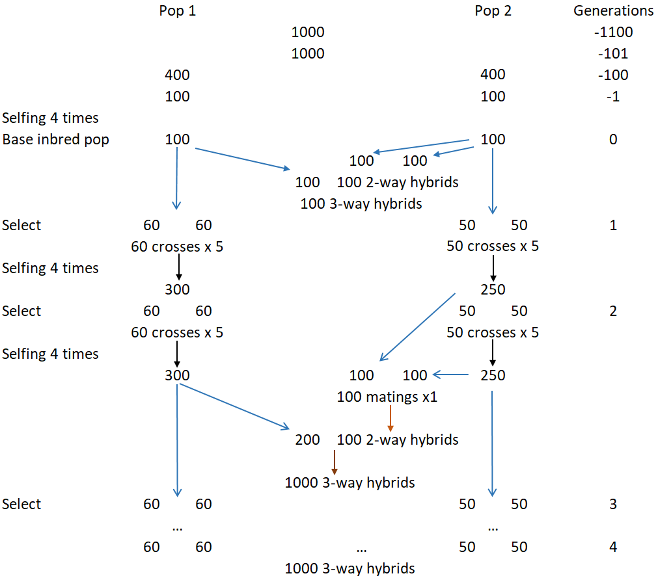
Figure 1: Historical populations and breeding scheme for three-way hybrids

