SUPPORTING INFORMATION FOR
Accelerating antibiotic discovery by leveraging machine learning models: application to identify novel inorganic complexes
Miroslava Nedyalkova,¹ Gözde Demirci,¹ Youri Cortat,¹ Kevin Schindler,¹ Fatlinda Rhamani,¹ Justine Horner,^{1,2} Aurelien Crochet,¹ Aleksandar Pavic,³ Olimpia Mamula Steiner,² Fabio Zobi,¹* and Marco Lattuada¹*
¹ Department of Chemistry, Fribourg University, Chemin Du Musée 9, 1700 Fribourg, Switzerland
² Haute école d’ingénierie et d’architecture, University of Applied Sciences Western Switzerland HES-SO, Pérolles 80, 1700 Fribourg, Switzerland;
³ Institute of Molecular Genetics and Genetic Engineering, University of Belgrade, Vojvode Stepe 444a, 11042 Belgrade, Serbia
Table of contents
Analytic details of 3a, 3c, 4a, 4c, 8a and 9a – page S1-S2
IR spectra (solid-state) of 3a, 3c, 4a, 4c, 8a and 9a – Figure S1 – page S2
UV-Vis spectra of 3a, 3c, 4a, 4c, 8a and 9a – Figure S2 – page S3
¹H-NMR spectra of 3a, 3c, 4a, 4c, 8a and 9a – Figures S3-S8 – page S4-S7
Antibacterial activity of different Re complexes against S. aureus wild-type strain (MSSA, left) and S. aureus methicillin-resistant (MRSA) strain – Figure S9 – page S7
Crystallographic details of 4c – Figures S10 – page S8
Table with crystal data and structure refinement for 4c – Table S1-Page S8
Table with selected bond lengths for 4c – Table S2-Page S9
Table with Selected Bond Angles for C5-Py – Table S3-Page S9
Table of the statistical metrics for assessment of the model – Table S4-page S10
fac-[Re(CO)₃(dinonyl)Br] (3a). 4,4′-Dinonyl-2,2′-bipyridine-Re(CO)₃Br complexes. Heptane was used as a reaction solvent. Yellow powder, yield 85.8%. IR (solid, ν_{CO}, cm⁻¹): 2015.63, 1909.15, 1888.87. UV-Vis (MeOH, λ_{max} [nm]): 358, 290, 244. ¹H NMR (400 MHz, CDCl₃): δ = 8.92 (d, J=5.7 Hz, 2 H), 7.96 (d, J=1.1 Hz, 2 H), 7.32 (dd, J=5.6, 1.6 Hz, 2 H), 2.78 - 2.85 (m, 4 H), 1.72 (d, J=7.7 Hz, 4 H), 1.23 - 1.46 (m, 24 H), 0.86 - 0.93 ppm (m, 6 H).
fac-[Re(CO)₃(dinonyl)Py]⁺ SO₃CF₃⁻ (3c). 4,4′-Dinonyl-2,2′-bipyridine-Re(CO)₃Py complexes. Yellow powder, yield 75.3%. IR (solid, ν_{CO}, cm⁻¹): 2028.21, 1905.26. UV-Vis (MeOH, λ_{max} [nm]): 317, 304, 251. ¹H NMR (400 MHz, CD₂Cl₂): δ = 8.97 (d, J=5.7 Hz, 2 H), 8.31 (s, 2 H), 8.17 (d, J=5.0 Hz, 2 H), 7.85 (t, J=7.8 Hz, 1 H), 7.55 (d, J=5.7 Hz, 2 H), 7.31 - 7.37 (m, 2 H), 2.88 (dd, J=8.7, 6.2 Hz, 4 H), 1.69 - 1.78 (m, 4 H), 1.24 - 1.43 (m, 24 H), 0.85 - 0.91 ppm (m, 6 H). ESI-MS (ACN): m/z, 758.0 [M]⁺, measured; calculated for [C₃₆H₄₉N₃O₃Re]⁺: 758.01.
fac-[Re(CO)₃(PBzIm)Br] (4a). 2-(2′-Pyridyl)benzimidazole-Re(CO)₃Br complexes. Yellow powder, yield 89.5%. IR (solid, ν_{CO}, cm⁻¹): 2020.94, 1889.09. UV-Vis (MeOH, λ_{max} [nm]): 340, 238. ¹H NMR (400 MHz, d-DMSO): δ = 14.79 (br. s., 1 H), 9.10 (d, J=5.5 Hz, 1 H), 8.54 (d, J=7.7 Hz, 1 H), 8.37 - 8.45 (m, 1 H), 7.83 - 7.88 (m, 1 H), 7.76 - 7.82 (m, 2 H), 7.54 - 7.61 ppm (m, 2 H).
fac-[Re(CO)₃(PBzIm)Py]⁺ SO₃CF₃⁻ (4c). 2-(2′-Pyridyl)benzimidazole-Re(CO)₃Py complexes. Yellow powder, yield 55%. IR (solid, ν_{CO}, cm⁻¹): 2027.15, 1901.19. UV-Vis (MeOH, λ_{max} [nm]): 342, 230. ¹H NMR (400 MHz, CDCl₃): δ = 14.48 (br. s., 1 H), 9.14 (d, J=6.1 Hz, 1 H), 9.00 (d, J=7.9 Hz, 1 H), 8.28 (t, J=7.9 Hz, 1 H), 8.16 (s, 2 H), 8.02 (d, J=6.7 Hz, 2 H), 7.80 (t, J=7.8 Hz, 1 H), 7.67 - 7.72 (m, 1 H), 7.59 - 7.64 (m, 2 H), 7.25 ppm (m, 2 H). ESI-MS (ACN): m/z, 544.7 [M]⁺, measured; calculated for [C₂₀H₁₄N₄O₃Re]⁺: 544.56.
fac-[Re(CO)₃(5,6pin)Br] (8a). 5,6 pinene bipyridine-Re(CO)₃Br complexes. Yellow powder, yield 87.4%. IR (solid, ν_{CO}, cm⁻¹): 2012.01, 1876.28. UV-Vis (MeOH, λ_{max} [nm]): 333, 319, 251. ¹H NMR (400 MHz, CD₃CN): δ = 9.05 (d, J=5.6 Hz, 1 H), 8.33 (d, J=8.2 Hz, 1 H), 8.11 - 8.19 (m, 2 H), 7.70 (t, J=7.5 Hz, 1 H), 7.54 - 7.60 (m, 1 H), 3.39 - 3.58 (m, 2 H), 2.97 - 3.04 (m, 1 H), 2.72 - 2.82 (m, 1 H), 2.53 (d, J=2.9 Hz, 1 H), 1.45 (d, J=2.9 Hz, 3 H), 1.23 - 1.35 (m, 1 H), 0.64 - 0.70 ppm (m, 3 H).
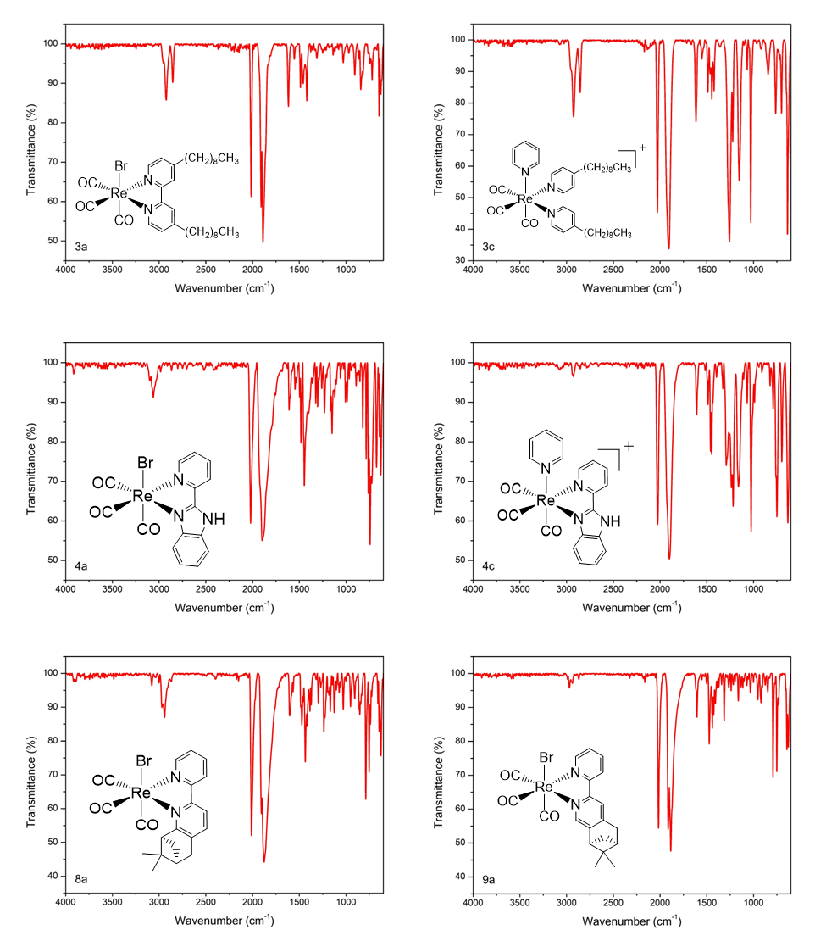
fac-[Re(CO)₃(4,5pin)Br] (9a). 4,5 pinene bipyridine-Re(CO)₃Br complexes. Yellow powder, yield 86.9%. IR (solid, ν_{CO}, cm⁻¹): 2016.69, 1913.78, 1885.45. UV-Vis (MeOH, λ_{max} [nm]): 325, 310, 292, 248. ¹H NMR (400 MHz, CD₃CN): δ = 9.00 (d, J=4.0 Hz, 1 H), 8.55 (s, 1 H), 8.35 (d, J=7.9 Hz, 1 H), 8.23 (s, 1 H), 8.15 (t, J=7.9 Hz, 1 H), 7.55 - 7.60 (m, 1 H), 3.19 (d, J=2.4 Hz, 2 H), 3.05 (s, 1 H), 2.80 (s, 1 H), 2.38 (s, 1 H), 1.45 (s, 3 H), 1.25 (d, J=10.0 Hz, 1 H), 0.68 ppm (d, J=5.1 Hz, 3 H).
Figure S1. IR spectra (solid state) of 3a, 3c, 4a, 4c, 8a and 9a complexes
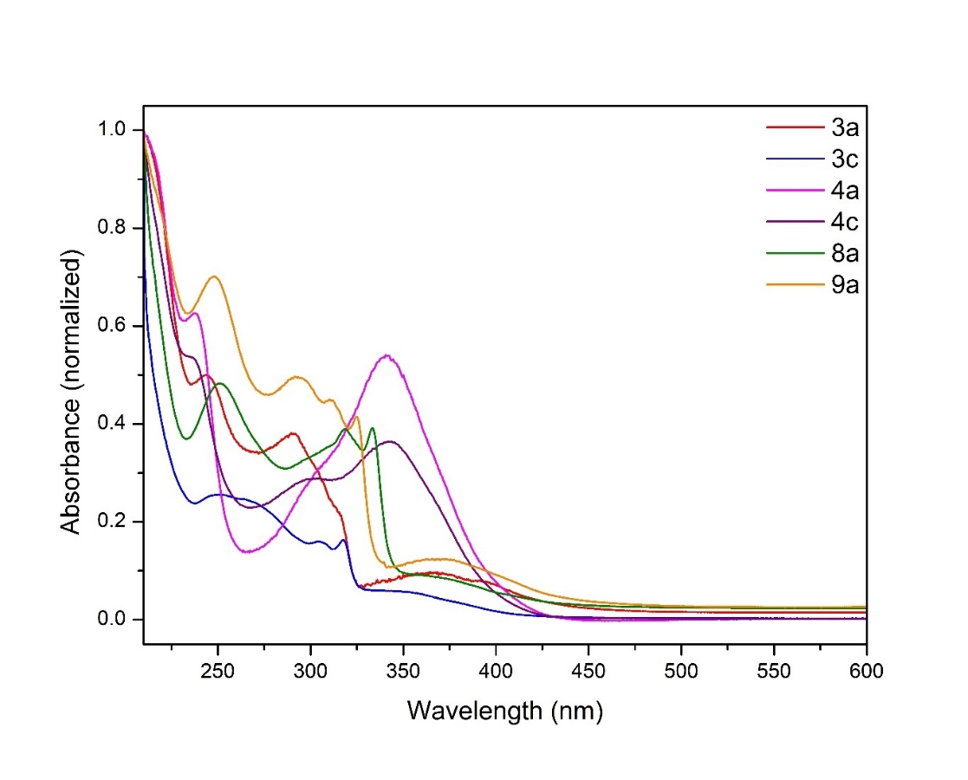
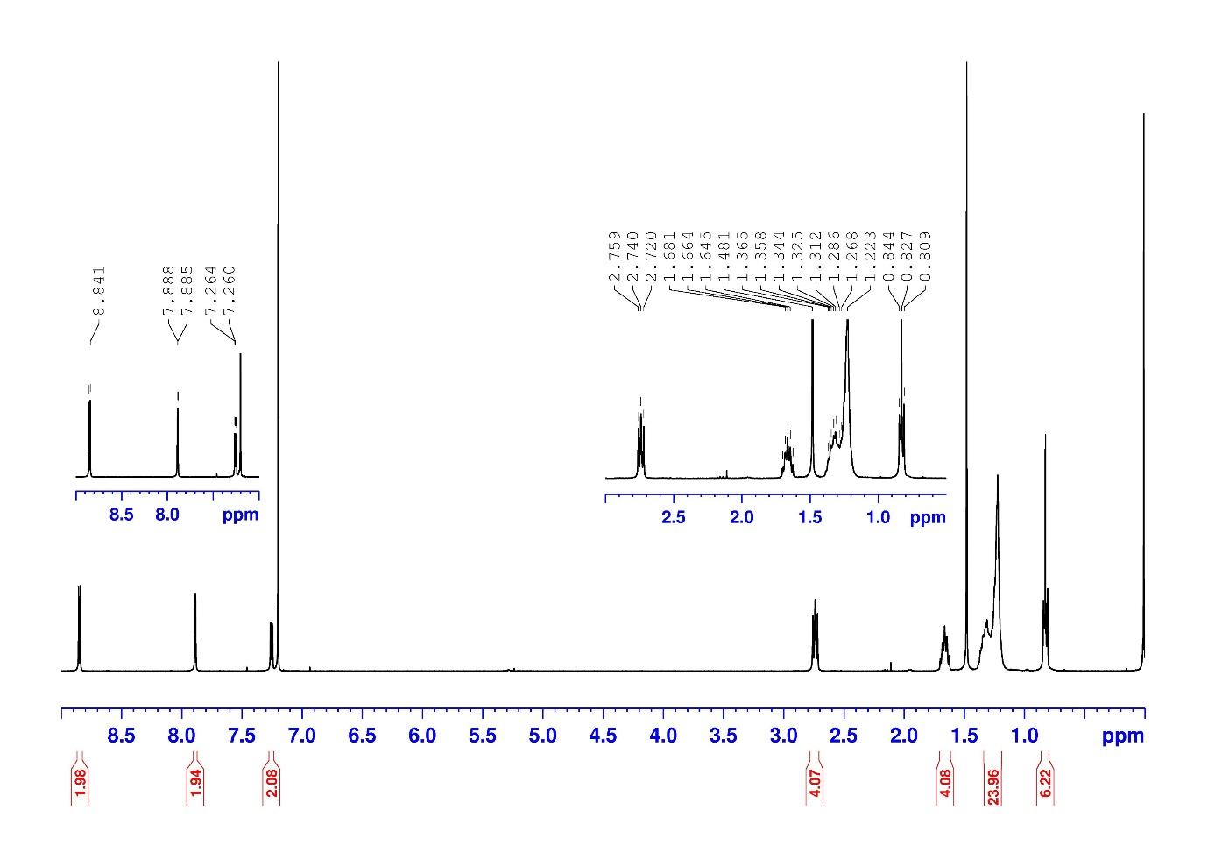
Figure S2. UV-Vis spectra of 3a, 3c, 4a, 4c, 8a and 9a complexes in MeOH
Figure S3. ¹H NMR spectrum of 3a (in CDCl₃).
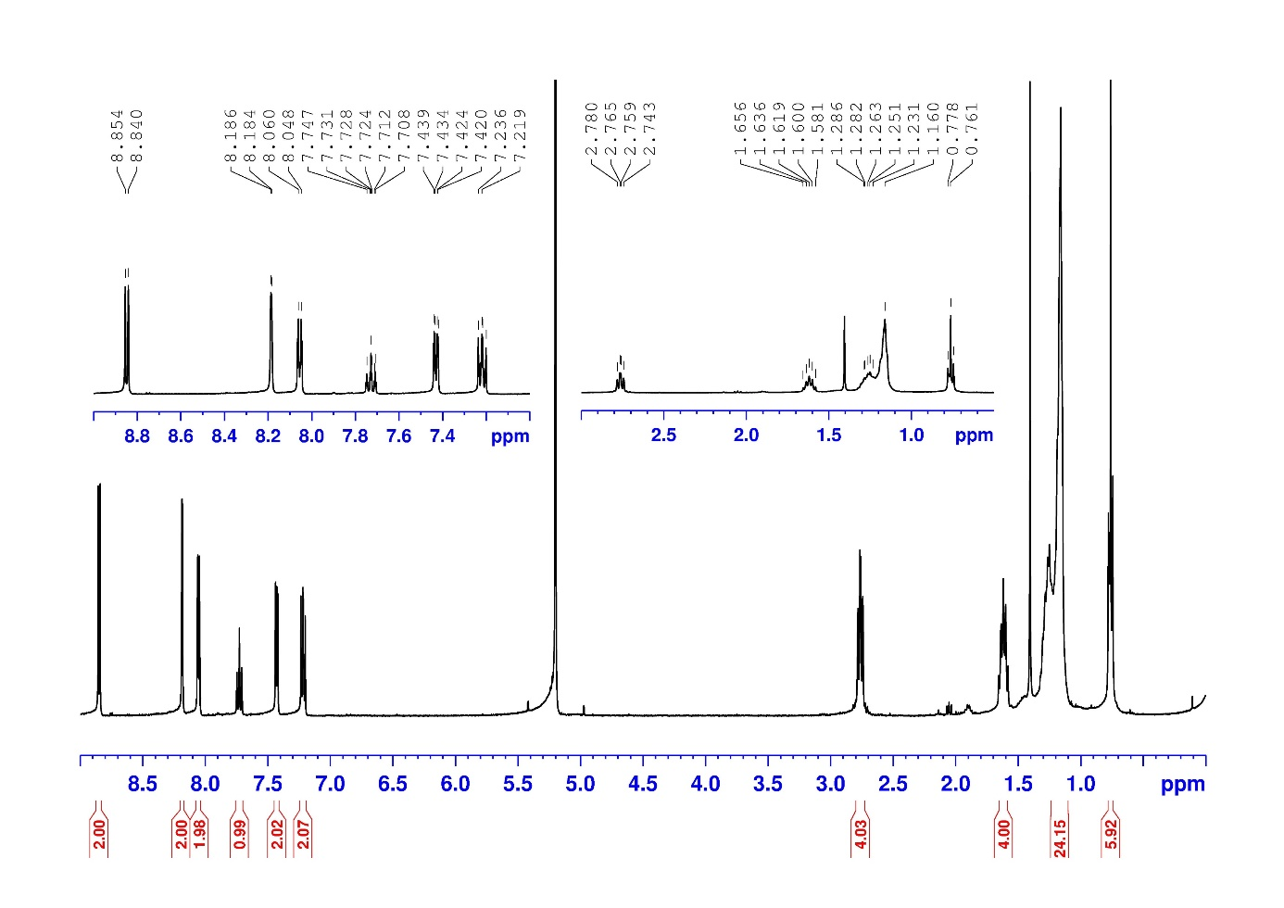
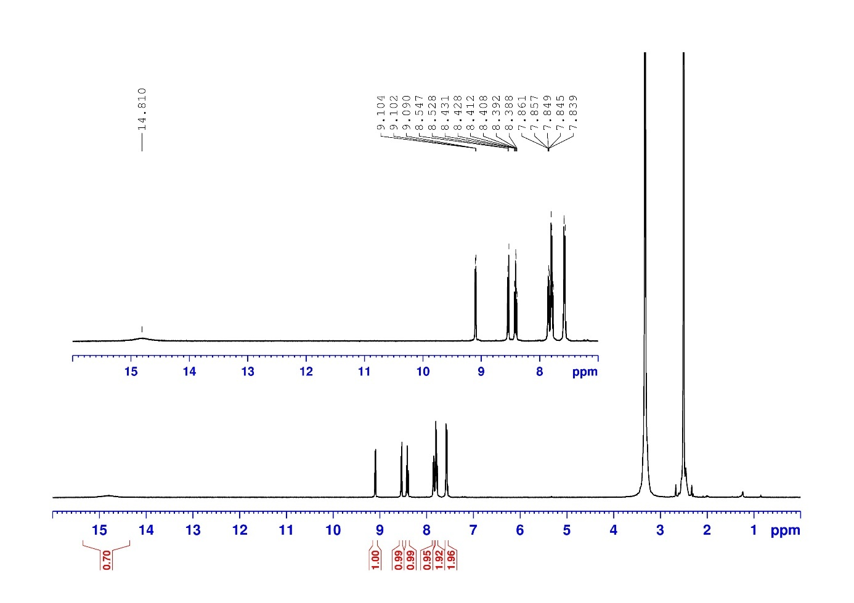
Figure S4. ¹H NMR spectrum of 3c (in CD₂Cl₂).
Figure S5. ¹H NMR spectrum of 4a (in d-DMSO).
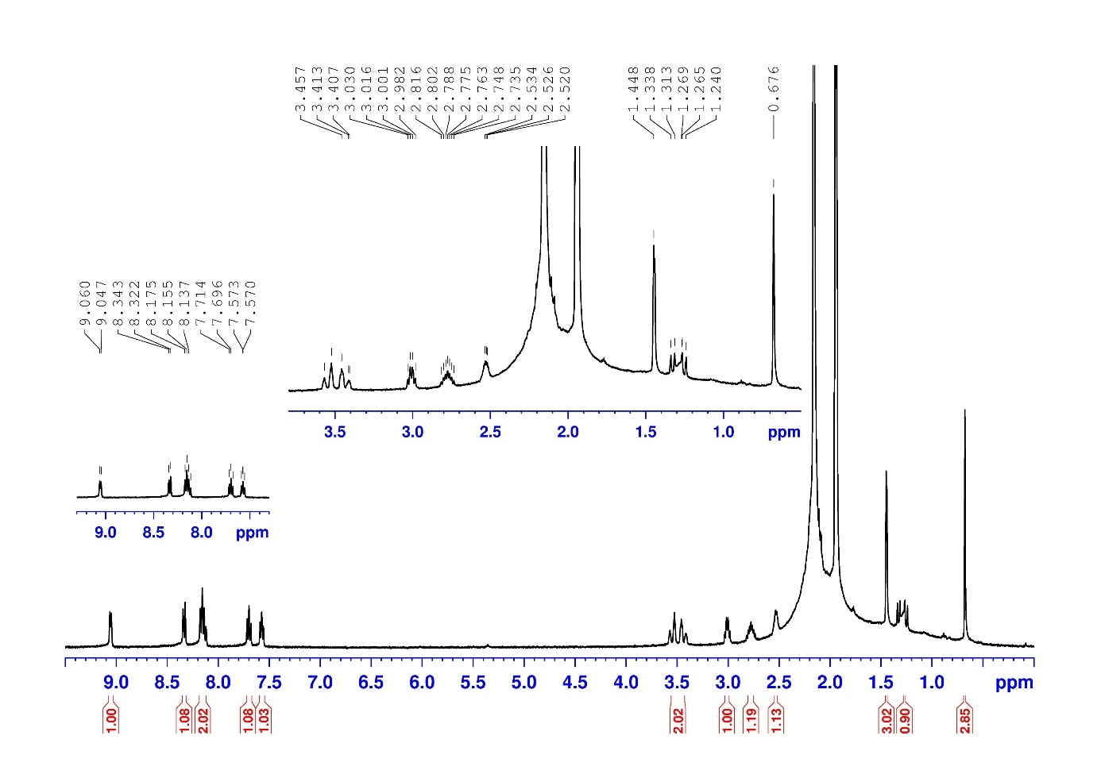
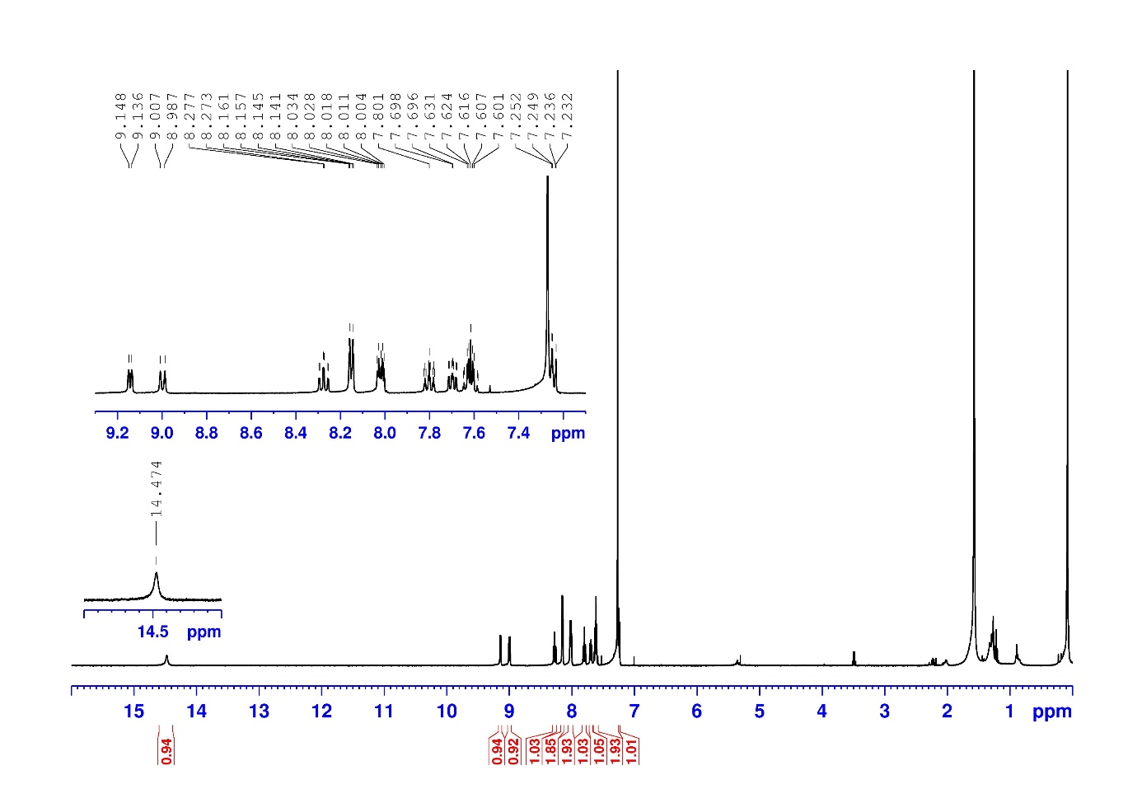
Figure S7. ¹H NMR spectrum of 8a (in CD₃CN).
Figure S6. ¹H NMR spectrum of 4c (in CDCl₃).

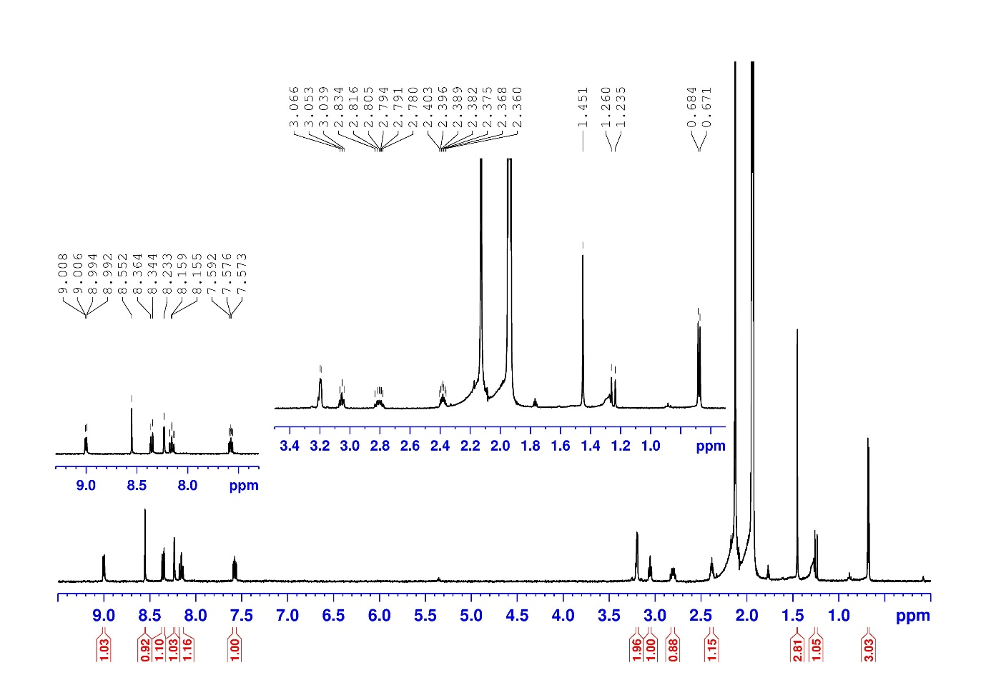
Figure S8. ¹H NMR spectrum of 9a (in CD₃CN).

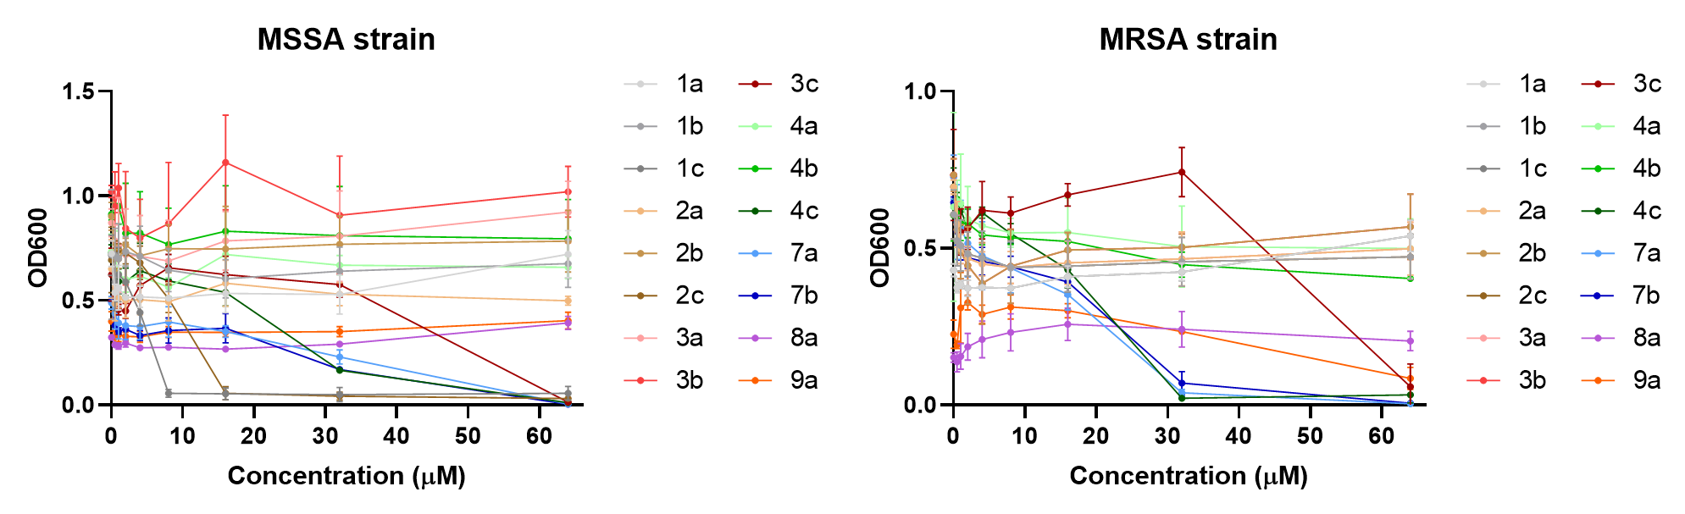
Figure S9. Antibacterial activity of different Re complexes against S. aureus wild-type strain (MSSA, left), and S. aureus methicillin-resistant (MRSA) strain.

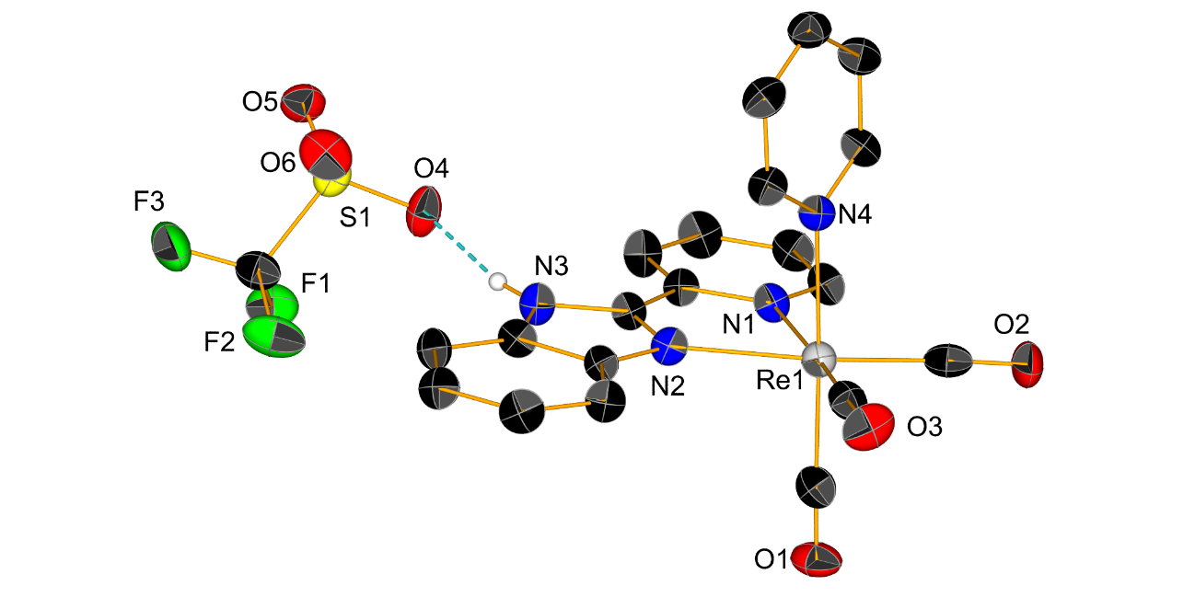
Figure S10. Crystal structures of 4c. Thermal ellipsoids are at 50% probability. Hydrogen atoms are omitted for clarity.

Table S1 Crystal data and structure refinement for 4c.
Identification code | 4c
Empirical formula | C₂₁H₁₄F₃N₄O₆ReS
Formula weight | 693.637
Temperature/K | 250(2)
Crystal system | triclinic
Space group | P-1
a/Å | 9.5117(4)
b/Å | 11.1656(4)
c/Å | 11.7463(4)
α/° | 91.327(3)
β/° | 90.437(3)
γ/° | 109.873(3)
Volume/Å³ | 1172.74(8)
Z | 2
ρ_{calc}g/cm³ | 1.964
μ/mm⁻¹ | 11.610
F(000) | 661.9
Crystal size/mm³ | 0.16 × 0.123 × 0.07
Radiation | Cu Kα (λ = 1.54186)
2Θ range for data collection/° | 8.42 to 139.02
Index ranges | -11 ≤ h ≤ 8, -13 ≤ k ≤ 11, -13 ≤ l ≤ 14
Reflections collected | 32432
Independent reflections | 4284 [R_{int} = 0.1205, R_{sigma} = 0.0554]
Data/restraints/parameters | 4284/0/325
Goodness-of-fit on F² | 1.054
Final R indexes [I>=2σ (I)] | R₁ = 0.0647, wR₂ = 0.1677
Final R indexes [all data] | R₁ = 0.0664, wR₂ = 0.1705
Largest diff. peak/hole / e Å⁻³ | 2.93/-2.66

Table S2 Selected Bond Lengths for 4c.
Atom | Atom | Length/Å
Re1 | N1 | 2.207(7)
Re1 | N2 | 2.184(8)
Re1 | N4 | 2.216(8)
Re1 | C18 | 1.946(13)
Re1 | C19 | 1.907(14)
Re1 | C20 | 1.918(12)
O1 | C18 | 1.120(15)
O2 | C19 | 1.173(16)
O3 | C20 | 1.150(14)

Table S3 Selected Bond Angles for C5-Py.
Atom | Atom | Atom | Angle/˚
N2 | Re1 | N1 | 74.4(3)
N4 | Re1 | N1 | 83.5(3)
N4 | Re1 | N2 | 83.1(3)
C18 | Re1 | N1 | 94.7(4)
C18 | Re1 | N2 | 94.9(4)
C18 | Re1 | N4 | 177.6(4)
C19 | Re1 | N1 | 98.4(4)
C19 | Re1 | N2 | 172.6(4)
C19 | Re1 | N4 | 94.3(4)
C19 | Re1 | C18 | 87.5(5)
C20 | Re1 | N1 | 173.1(4)
C20 | Re1 | N2 | 99.7(4)
C20 | Re1 | N4 | 92.3(4)
C20 | Re1 | C18 | 89.4(5)
C20 | Re1 | C19 | 87.3(5)

Table S4. Statistical metrics for the model assessment

TARGET | TP | FP | TN | FN | Specificity | Accuracy | PPV | Recall | MCC | F Score | Total number | Sensitivity
MRSA43300 (target) MIC 4 | 6 | 7 | 9 | 0 | 0.563 | 0.682 | 0.462 | 1.00 | 0.510 | 0.632 | 22 | 1
MRSA43300 (target) MIC 8 | 7 | 8 | 7 | 0 | 0.467 | 0.636 | 0.467 | 1.00 | 0.467 | 0.636 | 22 | 1
MRSA43300 (target) MIC 16 | 9 | 7 | 5 | 1 | 0.417 | 0.636 | 0.563 | 0.90 | 0.354 | 0.692 | 22 | 0.9
MRSA43300 (target) MIC 32 | 10 | 5 | 7 | 0 | 0.583 | 0.773 | 0.667 | 1.00 | 0.624 | 0.800 | 22 | 1
ATCC25923 (target) MIC 4 | 7 | 6 | 9 | 0 | 0.600 | 0.727 | 0.538 | 1.00 | 0.568 | 0.700 | 22 | 1
ATCC25923 (target) MIC 8 | 9 | 8 | 5 | 0 | 0.385 | 0.636 | 0.529 | 1.00 | 0.451 | 0.692 | 22 | 1
ATCC25923 (target) MIC 16 | 9 | 7 | 5 | 1 | 0.417 | 0.636 | 0.563 | 0.90 | 0.354 | 0.692 | 22 | 0.9
ATCC25923 (target) MIC 32 | 13 | 9 | 0 | 0 | 0.000 | 0.591 | 0.591 | 1.00 | 0 | 0.743 | 22 | 1

Accuracy: (TP + TN) / (TP + FP + TN + FN)
Specificity: TN/(TN+FP)
Precision: TP/(TP + FP)
Recall: TP/(TP + FN)
MCC: (TP × TN – FP × FN)/sqrt((TP + FN)(TP + FP)(TN + FP)(TN + FN))
F1: 2 × ((precision × recall)/(precision + recall))
Sensitivity: TP/(TP+FN)

