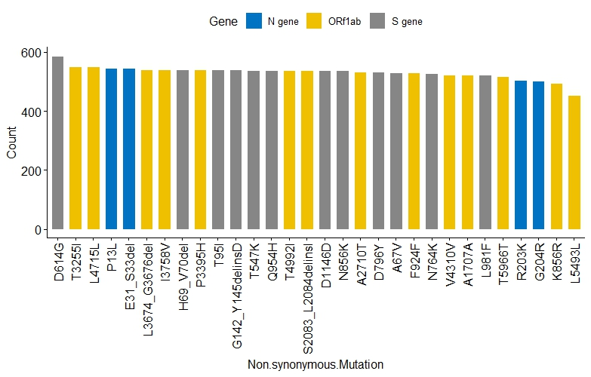
Supplementary Fig. 1: Top 30 mutations in non-vaccinated and vaccinated patients in Kenya.
Mutations
Counts

Supplementary Fig. 1: Shows the top 30 mutations in non-vaccinated and vaccinated patients in Kenya. Mutations were mostly found on the ORF1a/b, S, and N gene. Mutations in blue are found in the N genes, those in yellow are found in the ORF 1a/b, and those in grey are found in the S gene.

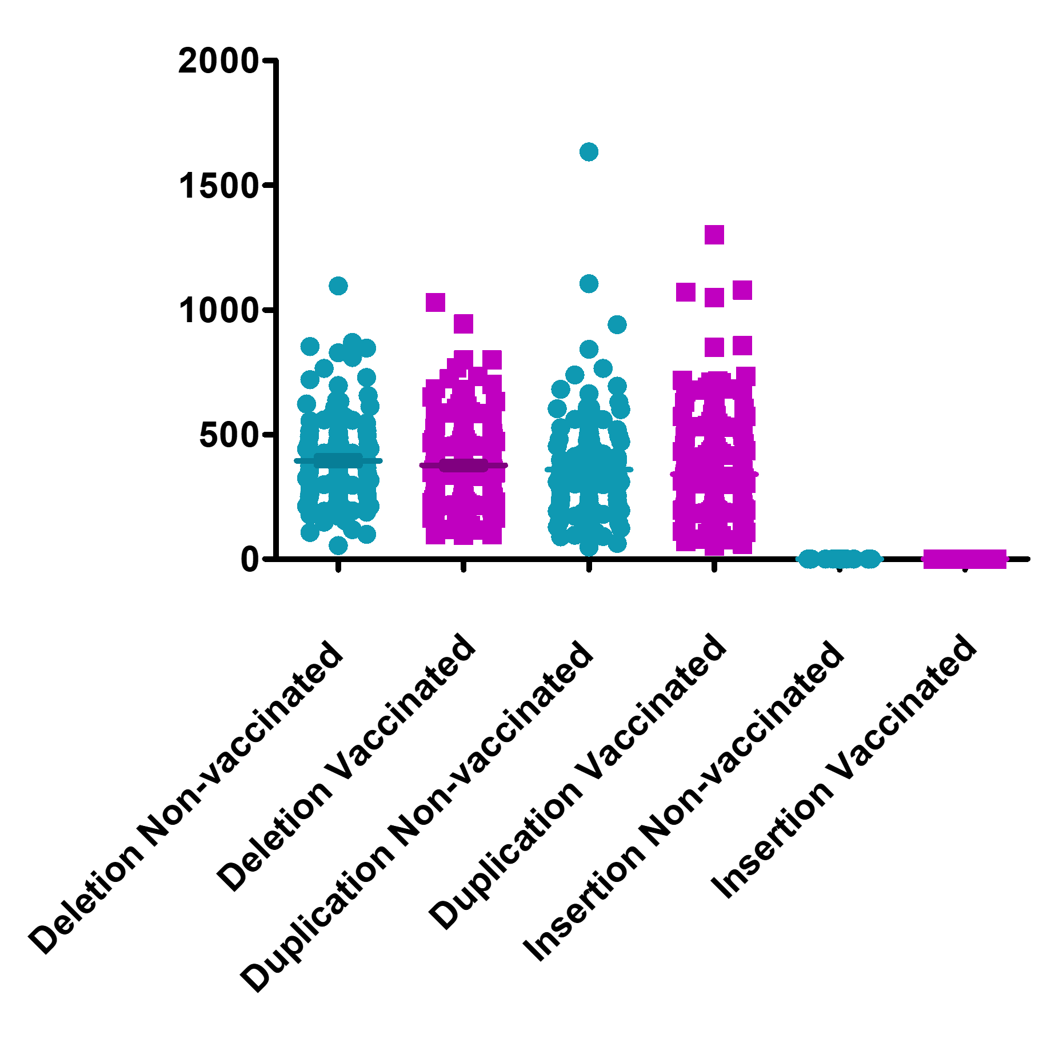
Supplementary Fig. 2: Recombination events per patient in non-vaccinated and vaccinated patients in Kenya.
Deletion
Duplication
Insertions
Non-vaccinated
Vaccinated
Patient samples
Recombination events

Supplementary Fig. 2: Shows the number of deletion, duplications, and insertion events per patient in non-vaccinated and vaccinated patients in Kenya. Green circles represent recombination events found in non-vaccinated patients and purple boxes represent those found in vaccinated patients.

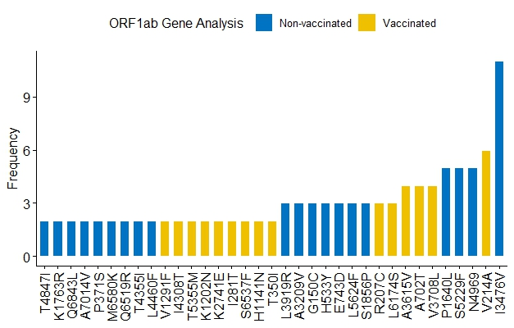
A.
Supplementary Fig. 3: Unique mutations in the ORF 1a/b, N, and S gene of non-vaccinated and vaccinated patients in Kenya.

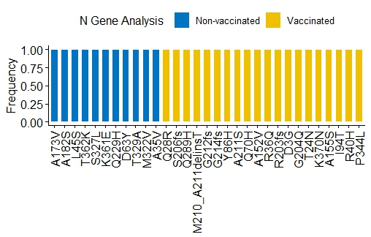
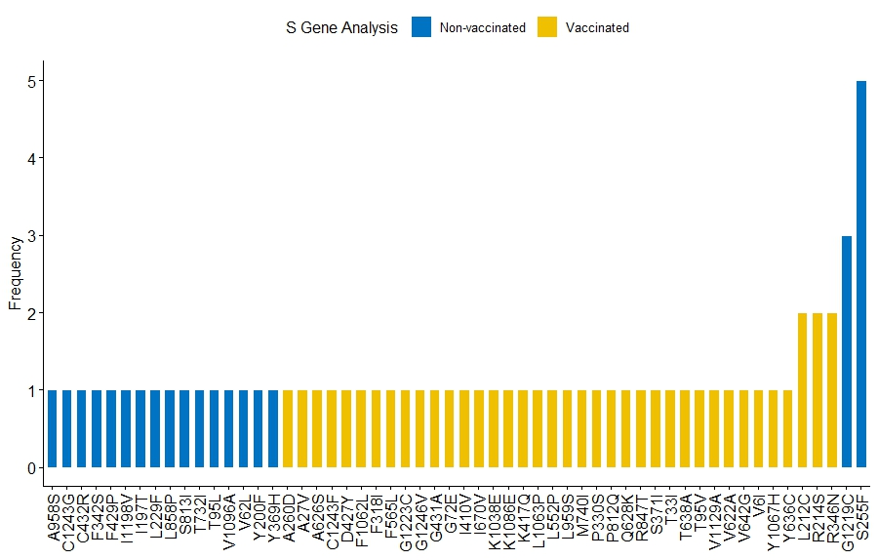
B.
C.
Supplementary Fig. 3: Unique mutations in non-vaccinated and vaccinated patients in Kenya. Mutations in blue represent those found in non-vaccinated patients and those in yellow represent those in vaccinated patients. A. Shows unique mutations in the ORF1 a/b. B. Shows unique mutations in the S genes C. Shows unique mutations in the N gene.

