Design and Synthesis of N-terminal segment Peptides: A New Innovative Finding for Antimicrobial Activity

Rajavenkatesh Krishnamoorthy^{1*}, Priyanka Adhikari², Parthiban Anaikutti², Saravanakumar Rajagopal³, Rajendran Babhu Vignesh⁴
^{1*}Organic and Bioorganic Chemistry Laboratory CSIR-CLRI, Adyar, Chennai-600020, Tamil Nadu, India
²Centre for GMP extraction facility (Dept. of Biotechnology), National Institute of Pharmaceutical Education and Research, Guwahati-781101, Assam, India
³Department of Chemistry, Sethu Institute of Technology, Kariapatti, Virudunagar-626115, Tamil Nadu, India
⁴Department of Chemistry, Velammal college of Engineering and Technology, Viraganoor,
Madurai-625009, Tamil Nadu, India

Corresponding author

Dr. K. RAJAVENKATESH,
Organic and Bioorganic Chemistry Laboratory,
CSIR-Central Leather Research Institute (CSIR-CLRI),
Adyar, Chennai-600020, Tamilnadu, India.
Email: krajavenkateshkcmp5@gmail.com / rajavenkateshk2@gmail.com

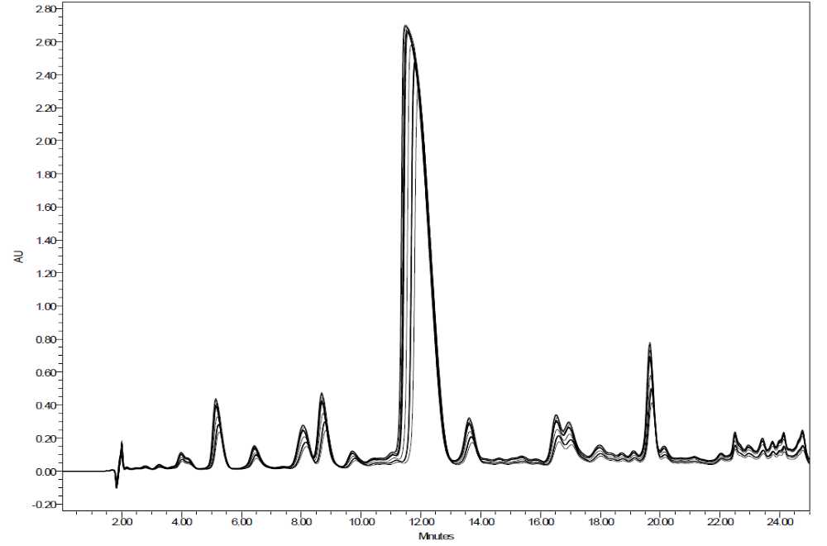
P1 (crude)
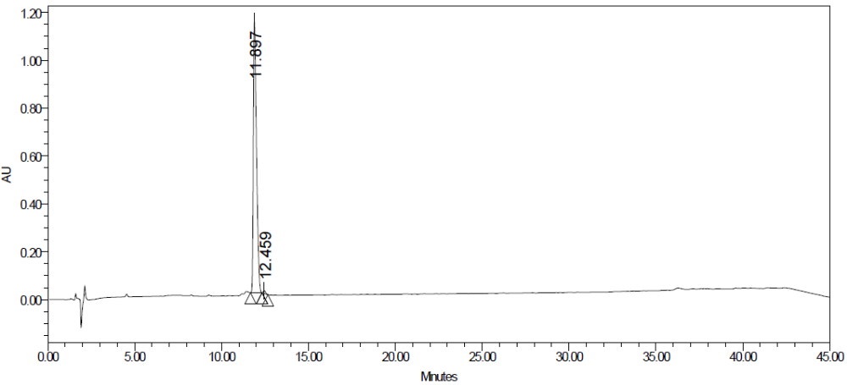
P1 (purified)
Figure S1: An overlay of semi preparative HPLC chromatograms of crude and purified P1

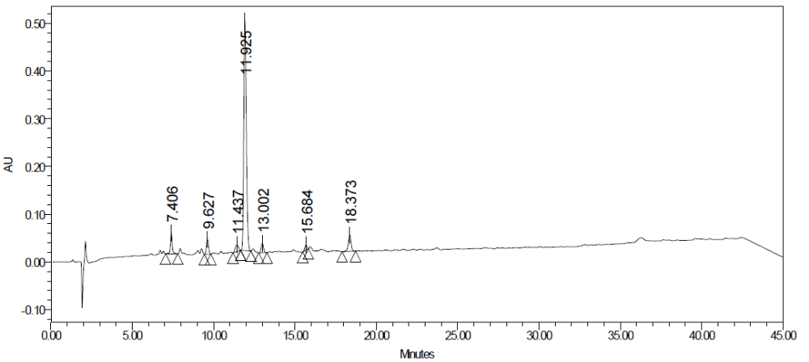
P1 (crude)
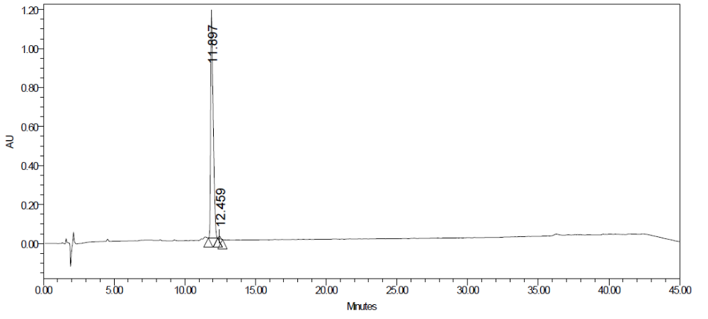
P1 (purified)
Figure S2: HPLC Chromatograms of crude and purified P1

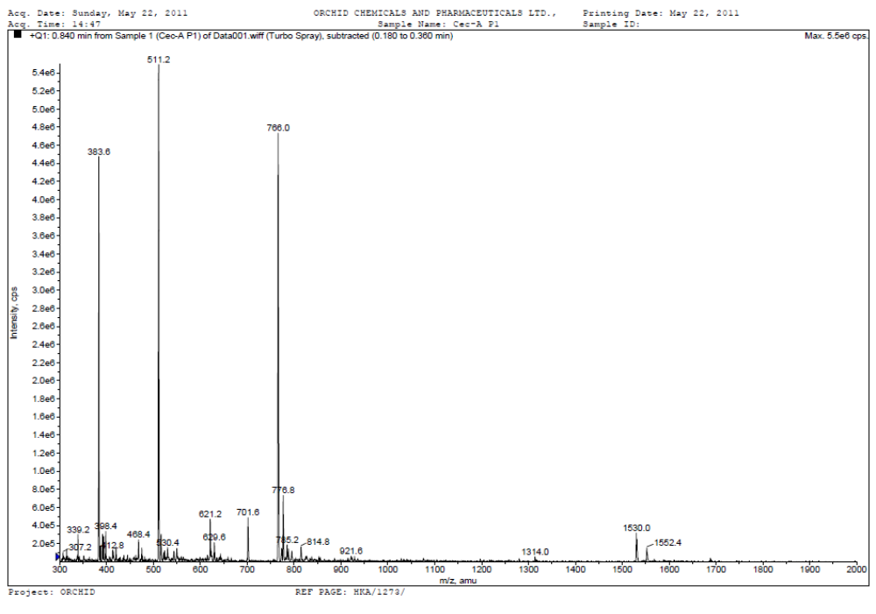
Figure S3: ESI mass spectrum of P1

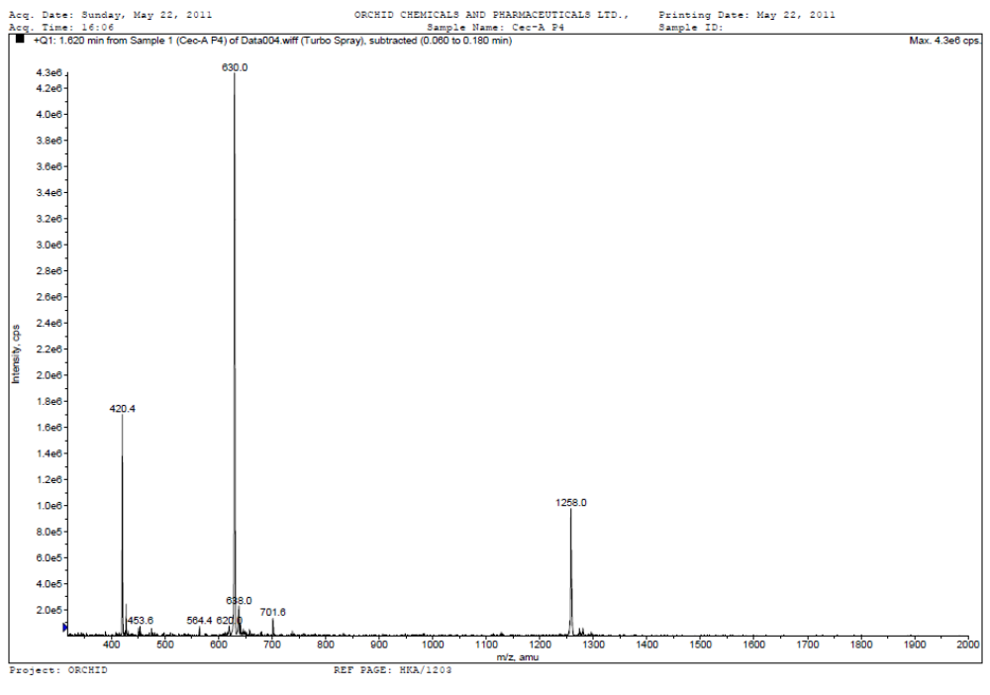

Figure S4: ESI mass spectrum of P2

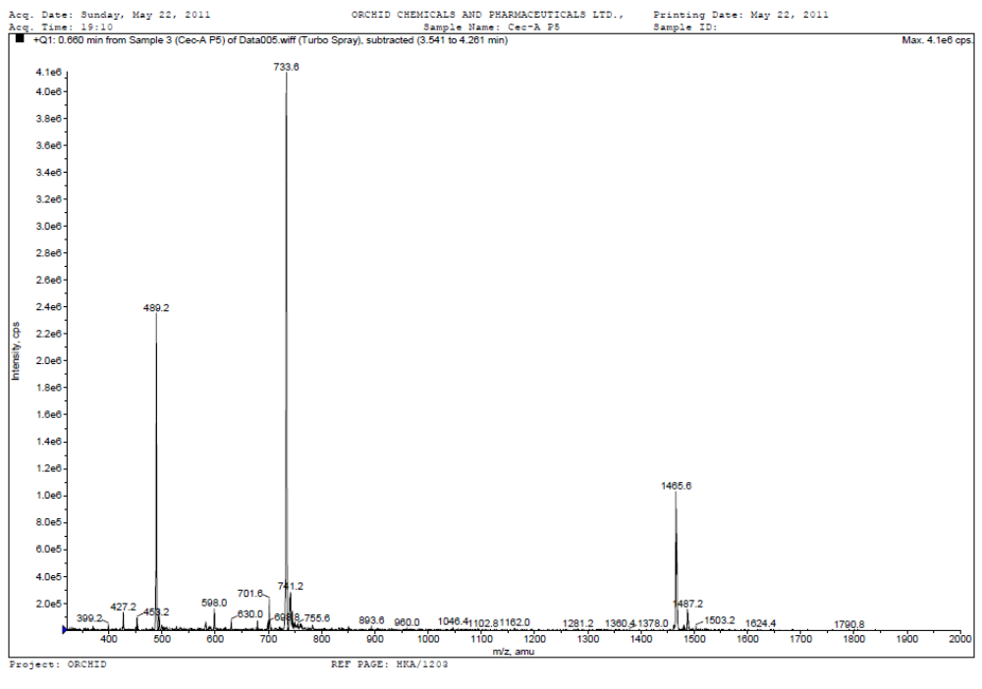
Figure S5: ESI mass spectrum of P3

