Supplementary Information
Article title: Soil metabolic factors, not pathogens, drive replant disease: insights from a 20-year soil legacy experiment
Authors: Chongwei Li, Guozhong Chen, Nan Zou, Hongxia Zhang, Haokun Li, Ping Zhu, Xinfu Bai, Ying Zhao, Yuping Hou, Xingxiao Zhang

Supplementary Materials and Methods
Soil metabolomic analysis
Extraction and determination of metabolites
One gram of soil was collected and 20 µL of internal standard (L-2-chloro-phenylalanine, 0.3 mg mL⁻¹, methanol configuration) was added in 1 mL of methanol-water mixture (methanol: water [v:v], 1:1). Two small steel balls were added in turn and placed at −20 °C for 2 min for precooling. Next, they were ground using a grinder (60 Hz, 2 min). The homogenized sample was transferred to a 15-mL centrifuge tube, the residue on the tube wall was transferred to 1 mL of mixed solution (methanol: water [v:v] = 1:1), and the process was repeated thrice (3 mL in total). Centrifugation was performed for 10 min (7,700 r min⁻¹ and 4 ℃). The supernatant (2.5 mL) was added into a 5-mL centrifuge tube and lyophilized. A 400 µL volume of mixed solution (methanol: water [v:v] = 1:1) was re-dissolved and subjected to vortex oscillation for 60 s and ultrasonication for 30 s. Next, the solution was transferred to a 1.5-mL centrifuge tube and centrifuged for 10 min (12,000 r min⁻¹ and 4 °C). The supernatant (300 µL) was transferred into a glass derivatization bottle. Quality control (QC) samples were prepared by mixing the extract of all the samples with the same volume, such that the volume of each QC sample was the same as that of each sample. Samples were lyophilized using a centrifugal dryer. Next, 80 µL of methoxyamine hydrochloride pyridine solution (15 mg mL⁻¹) was added to the glass derivatization vial, followed by vortex oscillation for 2 min. The oxidation reaction was performed at 37 °C in an oscillation incubator for 90 min. Subsequently, 80 µL of bis (trimethylsilyl) trifluoroacetamide (BSTFA) (containing 1% trimethylchlorosilane [TMCs]) derivative reagent and 20 µL of n-hexane were added to the vial, along with 10 µL of 11 types of internal standard fatty acid methyl esters (C8/C9/C10/C12/C14/C16, 0.8 mg mL⁻¹; C18/C20/C22/C24/C26, 0.4 mg mL⁻¹, all in chloroform configuration), followed by vortex oscillation for 2 min. The reaction was performed at 70 °C for 60 min. Samples were taken out and placed at room temperature (20–30 °C) for 30 min for gas chromatography–mass spectrometry (GC−MS) analysis. The 11 fatty acid methyl esters used were (methyl octanoate, C8:0), (methyl nonoate, C9:0), (methyl caprate, C10:0), (methyl dodecanoate, C12:0), (methyl myristate, C14:0), (methyl hexadecanoate, C16:0), (methyl stearate, C18:0), (methyl eicosanoate, C20:0), (methyl behenate, C22:0), (methyl tetracosanoate, C24:0), and (methyl eicosanoate, C26:0).

GC−MS analysis
GC conditions: a DB-5MS capillary column (30 m × 0.25 mm × 0.25 µm. Agilent J&W scientific, Folsom, CA, USA) was used. The carrier gas was high-purity helium (purity ≥ 99.999%), the flow rate was 1.0 mL min⁻¹, and the temperature of the injection port was 260 °C. An injection volume of 1 µL without partial flow injection was applied, and the solvent was delayed for 5 min.
Programmed temperature rise: the initial temperature of the column temperature box was 60 °C, and the temperature was increased to 125 °C at 8 °C min⁻¹ then, increased to 210 °C at 5 °C min⁻¹, followed by an increase to 270 °C at 10 °C min⁻¹ and to 305 °C at 20 °C min⁻¹ for 5 min.
MS conditions: The electron bombardment ion source temperature was 230 °C, the four-stage rod temperature was 150 °C, and electron energy was 70 eV. The full scan mode was applied, and the quality scanning range was 50–500 m/z.

Soil metabolic pathways analysis
The Kyoto Encyclopedia of Genes and Genomes IDs of differentially expressed metabolites in P. quinquefolius-cultivated soil samples were used for pathway enrichment analysis when compared with those in CK to obtain enrichment results for different metabolic pathways. The hypergeometric test was used to determine the pathway entries that were significantly enriched in significantly differentially expressed metabolites as follows:
$$p=1-\sum_{i=0}^{m-1}{\frac{\left({M \atop i}\right)\left({N-M \atop n-i}\right)}{\left({N \atop n}\right)}},$$
where N is the total number of metabolites, n is the number of differentially expressed metabolites in N, M is the number of metabolites annotated as a specific pathway, and m is the number of differential metabolites annotated as a specific pathway. Pathways associated with a p-value < 0.05 were considered significantly enriched in metabolites.

Soil microbiome analysis
Extraction of total soil DNA, PCR amplification, and high-throughput amplicon sequencing
The MP Biomedicals DNA Isolation Kit (Santa Ana, CA, USA) was used to extract DNA according to the manufacturer’s instructions. The concentration and purity of DNA samples were determined using a UV-1200 ultraviolet spectrophotometer (Shanghai Mapada, China) and agarose gel electrophoresis. Samples were stored at −20 °C until further treatment. Primers 338F (5′-ACTCCTACGGGAGGCAGCA-3′) and 806R (5′-GGACTACHVGGTWTCTAAT-3′) (with a high coverage rate for bacterial groups[1, 2]) were used to amplify the V3–V4 region of 16S rRNA gene for bacterial community analysis. The universal internal transcribed spacer 1 (ITS1) region[3, 4] of fungi in soil samples was amplified using primers ITS1F (5′-CTTGGTCATTTAGAGGAAGTAA-3′) and ITS2R (5′-TGCGTTCTTCATCGATGC-3′). The primers TAReuk454FWD1F (5'-CCAGCASCYGCGGTAATTCC-3′) and TAReukREV3R (5′-ACTTTCGTTCTTGATYRA-3′) were used to amplify the V4 region of eukaryotes in soil samples[5]. The reaction volume for PCR amplification was 25 µL; the reaction mixture contained 5 µL of 5× reaction buffer, 5 µL of 5× GC buffer, 2 µL of dNTPs (2.5 mmol), 1 µL of 338F primer (10 µmol), 1 µL of 806R primer (10 µmol), 2 µL of DNA template, 8.75 µL of ddH₂O, and 0.25 µL of Q5 (High-Fidelity DNA Polymerase, NEB, Ipswich, MA, USA). The PCR protocol consisted of initial denaturation at 98 °C for 2 min; 28 cycles of denaturation at 98 °C for 15 s, annealing at 55 °C for 30 s, and extension at 72 °C for 30 s; and a final extension was performed at 72 °C for 5 min. Reaction mixtures were held at 10 °C until further analysis. Three replicates were used per sample, which were pooled to minimize PCR bias. PCR products were detected via electrophoresis on 2.0% agarose gels, and fragments of approximately 450 bp were purified using the AxyPrep DNA Gel Extraction Kit (Axygen, Union City, CA, USA). PCR amplicons were quantified using the PicoGreen dsDNA Assay Kit (Invitrogen, Waltham, MA, USA). Finally, paired-end 2× 300-bp sequencing of bacterial amplicons was performed on the MiSeq platform (Illumina, San Diego, CA, USA) at Major Biotechnology Co., Ltd (Shanghai, China). The detailed experimental procedure is shown in Supplementary Fig. 2.

Sequence analyses
Raw sequences were assembled for each sample using the unique barcodes obtained from the quantitative insights into microbial ecology (QIIME, v1.8.0, qiime.org) pipeline[6] after removing the primer sequences and adaptors. Low-quality sequences were filtered out using the criteria proposed by Gill et al.[7] and Chen and Jiang[8]. Paired-end reads were assembled using FLASH v1.2.7[9]. After chimera detection, the remaining high-quality sequences were clustered into operational taxonomic units (OTUs) at 97% sequence identity using UCLUST (http:// drive 5.com/usearch/manual/uclust_algo.html)[10]. A representative sequence was selected from each OTU using default parameters. The OTU taxonomic classification was conducted using the Basic Local Alignment Search Tool (BLAST, https://blast.ncbi.nlm.nih.gov/Blast.cgi) by comparing the representative sequences set against the Greengenes[11] and Unite Database[12] to ultimately retrieve the best hit[13]. An OTU table was generated to record the abundance of each OTU in each sample and its taxonomy. OTUs containing under 0.001% of total sequences across all samples were discarded. The QIIME software was used to analyze β-diversity and compare the similarity in species diversity among different samples. The overall analysis process is shown in Supplementary Fig. 3. Raw sequencing data were deposited in the Sequence Read Archive at the National Center for Biotechnology Information under the Bioproject ID PRJNA 922374. The major online cloud platform (https://cloud.majorbio.com/), R v3.6.0, GraphPad Prism 8 (https://www.graphpad.com/), and Adobe Illustrator CS6 (64-bit, https://www.adobe.com/) were used to generate the analysis charts and results.

Petri dish validation experiment
Pyruvic acid and four fatty acids (myristic, dodecanoic, capric acids, and octanoate radical; purity = 99.97%) were purchased from Shanghai Aladdin Biochemical Technology Co., Ltd. (Shanghai, China) to complete the physiological ripening of AG seeds purchased from Weihai Dongxu American Ginseng Co., Ltd. (Weihai, China). Seed germination tests were performed as follows: two layers of filter paper were placed in Petri dishes, followed by the placement of 10 healthy AG seeds and the addition of 0, 0.1, 0.5, 1, 2, or 5 mmol L⁻¹ pyruvic acid solution (3 mL) [14]. Each treatment had four replicates. The Petri dishes were placed in a constant-temperature incubator at 25 °C in the dark. Seed development was monitored and recorded daily. Six treatment groups were prepared for fatty acids, including one distilled water treatment, four single fatty acid treatments, and one treatment that mixed the four fatty acids. The concentration gradient was set to 0, 0.44, 0.88, 1.75, 3.50, and 7.00 mmol L⁻¹ based on the absolute content of phenolic acids measured using high-performance liquid chromatography (HPLC). The substances were dissolved in methanol, and the methanol solutions were added to the Petri dishes. After the methanol had dried, distilled water was added. Octanoate radical ions were measured in the metabolites; therefore, sodium octanoate was selected as a substitute. The calculated sodium ion concentration was approximately 0.0011 g mL⁻¹, and its impact on seed germination was considered negligible.

Pot validation experiments
Two-year-old AG seedlings of similar sizes and without spreading leaves were transplanted into flower pots for the vermiculite pot experiments, (depth = 17 cm, top diameter = 8 cm, and bottom diameter = 4.5 cm) containing an adequate quantity of vermiculite (particle diameter 1–3 mm). One plant was added to each pot, and an appropriate quantity of distilled water was added. Subsequently, 30 mL of Hoagland nutrient solution was added to supplement the inorganic nutrients necessary for the growth of AG. The water content of the vermiculite was maintained at 16–20%[15] by daily watering. The seedlings were grown under natural light conditions. The AG seedlings were randomly divided into groups after one week of stabilization, each with 12 pots containing no abnormal seedlings. The different groups were treated by adding 10 mL of pyruvic acid solution at concentrations of 0, 0.5, or 2.5 mmol L⁻¹ along with 0, 0.44, or 1.75 mmol L⁻¹ of mixed fatty acid solution. Concentrations were selected according to the results of the Petri dish bioassay. Subsequently, 10 mL of Hoagland nutrient solution was added every 2 days, and the seedling pots were randomly moved every 3 days to avoid edge effects. Growth, leaf expansion rate, plant height, and crown width (1/2 × [length and width]) were observed and measured regularly.
The soil pot experiments were performed at an artificially shaded facility in Zhenshan, Yantai (37°30′–37°32′ N, 121°19′–121°21′ E). Healthy and uniform AG seedlings were transplanted into pots containing local Wendeng farmland soil (depth = 27.3 cm, top diameter = 22.4 cm, and bottom diameter = 15.4 cm) that were placed in the field ridges to ensure consistent soil moisture and temperature. The pots were also watered. After planting, the pots were stabilized for 15 days, followed by the addition of 0, 0.5, or 2.5 mmol L⁻¹ of pyruvic acid solution and 0, 0.44, or 1.75 mmol L⁻¹ of the mixed fatty acid solution. Each treatment had 8 replicates, and the other treatments and measured indicators were the same as previously described.
Two organic forms of nitrogen (glycine and tyrosine) were selected for bioassays of AG seedlings to assess the promoting effect of organic nitrogen on AG growth. We explored the preference of AG for inorganic N under different ratios of ammonia nitrogen (AN) and nitrate nitrogen (NN). Therefore, we set up the following treatments: CK, normal N addition (AN/NN = 1/1); INA, inorganic nitrogen, with AN dominant (AN/NN = 3/1); INN, inorganic nitrogen, with NN dominant (AN/NN = 1/3); ON, only organic N (0.1 mmol L⁻¹ glycine and 0.5 mmol L⁻¹ tyrosine); MNA, mixed nitrogen, with AN dominant: ON and INA are diluted and mixed (the concentration of total nitrogen was consistent with the other treatments); and MNN, mixed nitrogen, with NN dominant: ON and INN are diluted and mixed (the concentration of the total nitrogen component was consistent with the other treatments). Other nutrients (excluding nitrogen) were provided in Hoagland’s solution. Seed germination does not depend on external nutrients; therefore, we did not conduct the Petri dish experiment. We built a soil condition with few nutrients by mixing river sand and vermiculite (3:1 v/v) to avoid interference with original soil nutrients. Each treatment had 20–40 replicates (CK, MNA, and MNN had 20 replicates; AN, NN, and ON had 40 replicates). Other processes were consistent with those described above.

Supplementary Results
Microbial α- and β-diversity and significantly different taxa in P. quinquefolius-cultivated soil
Microbial diversity and community composition were analyzed by sequencing the V3–V4 region of bacterial 16S rDNA, the ITS1 region of fungal rDNA, and the V3–V4 region of eukaryotic 18S rDNA (non-fungal eukaryotic sequences were obtained after fungal sequences were removed). A total of 2,418,732, 2,708,928, and 2,729,081 valid sequences were obtained from 40 samples, and the average lengths of the sequences were 413.57, 237.00, and 237.00 bp, respectively (Supplementary Table 10).
Several differential classification groups were identified using variance analysis. For bacteria, the abundance of members from six phyla [Chloroflexi, Gemmatimonadetes, Chlamydiae, Dependentiae, FCPU426 (elevated in A1), and Patescibacteria (depleted in A1 and A10)], and 21 genera, including Sphingomonas (decreased in all P. quinquefolius-cultivated soil samples), Blastococcus (decreased in all P. quinquefolius-cultivated soil samples), Jatrophihabitans, Gemmatimonas, Burkholderia-Caballeronia-Paraburkholderia, Sphingobacterium, Actinospica, Catenulispora, Terrabacter, Mesorhizobium, Edaphobacter, Novosphingobium, Methylobacterium (decreased in A1), Rhodanobacter, FCPS47, Acidicaldus, 1921-2 (increased in A1 and A20), and Acidothermus, Roseiarcus, Hyphomicrobium, together with Nitrosospira (increased in A1), significantly differed between CK and P. quinquefolius-cultivated soil (Supplementary Fig. 6).
For fungi, the abundance of three phyla, Basidiomycota (decreased in A1), Rozellomycota (increased in A1), and Ascomycota (increased in A1 and A20), and eight genera, Fusarium, Naganishia, Cercophora (decreased in A1), Acremonium (decreased in A1, A20), Penicillium (decreased in A1, A10), Leuconeurospora, Acephala, and Oidiodendron (increased in A1), significantly differed between CK and P. quinquefolius-cultivated soil (Supplementary Fig. 7A and B). For non-fungal eukaryotes, the abundance of Nematoda was significantly reduced in A1 compared with that in CK, and that of eight genera significantly varied between the CK and P. quinquefolius-cultivated soil groups: Birojimia (increased in A1), Vermamoeba, Auxenochlorella, Pseudoplatyophrya (decreased in A1), Vorticellides, Adriamonas, Gymnophrys (decreased in A1 and A20), and Fisculla (decreased in A1 and A20) (Supplementary Fig. 8).

The following Supplementary Information is available for this article:
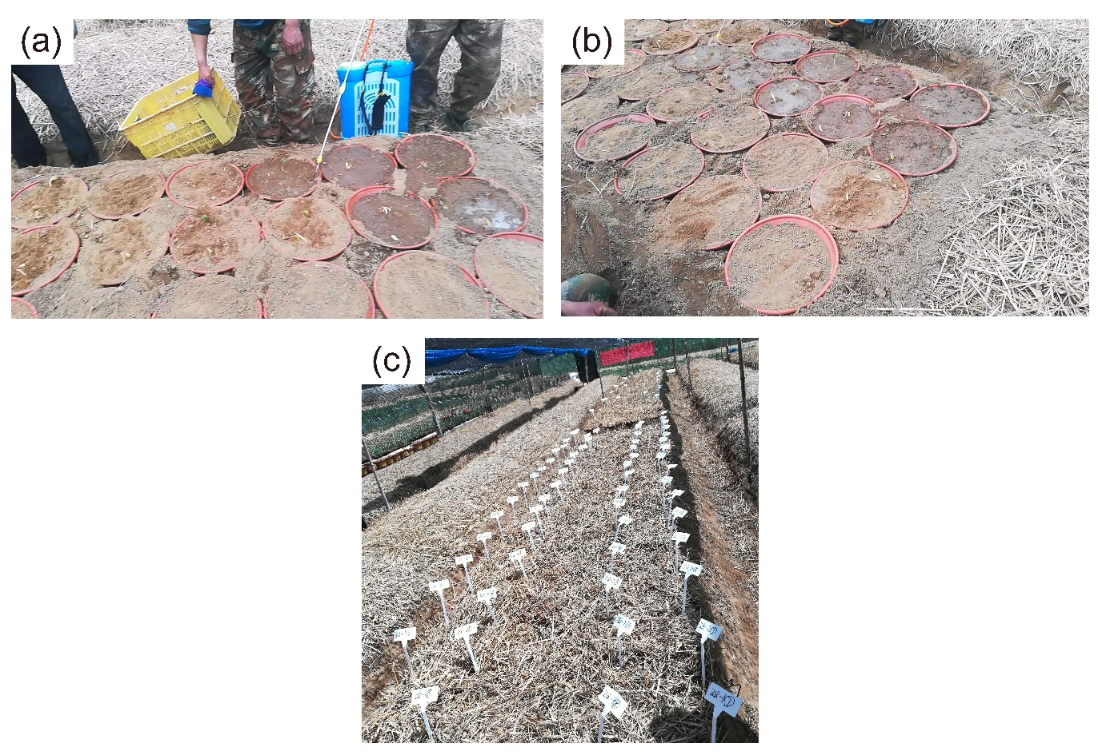
Supplementary Fig. 1 First planting, watering, and covering with wheat (Triticum aestivum) straw in a shaded shed.
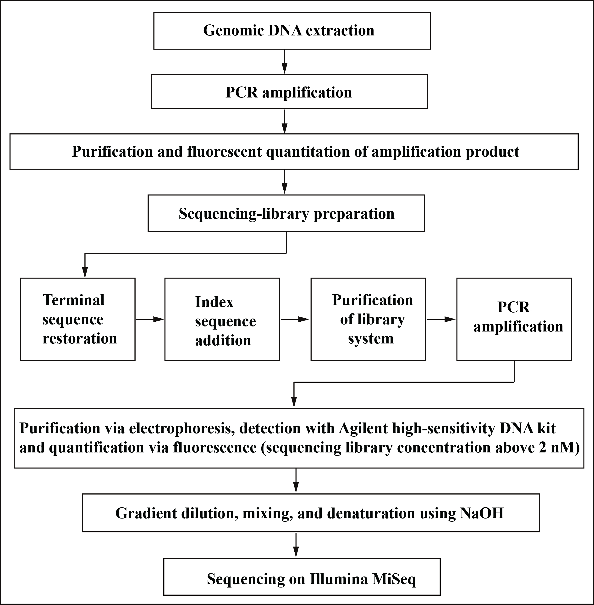
Supplementary Fig. 2 Flowchart of the sequencing experimental procedure.
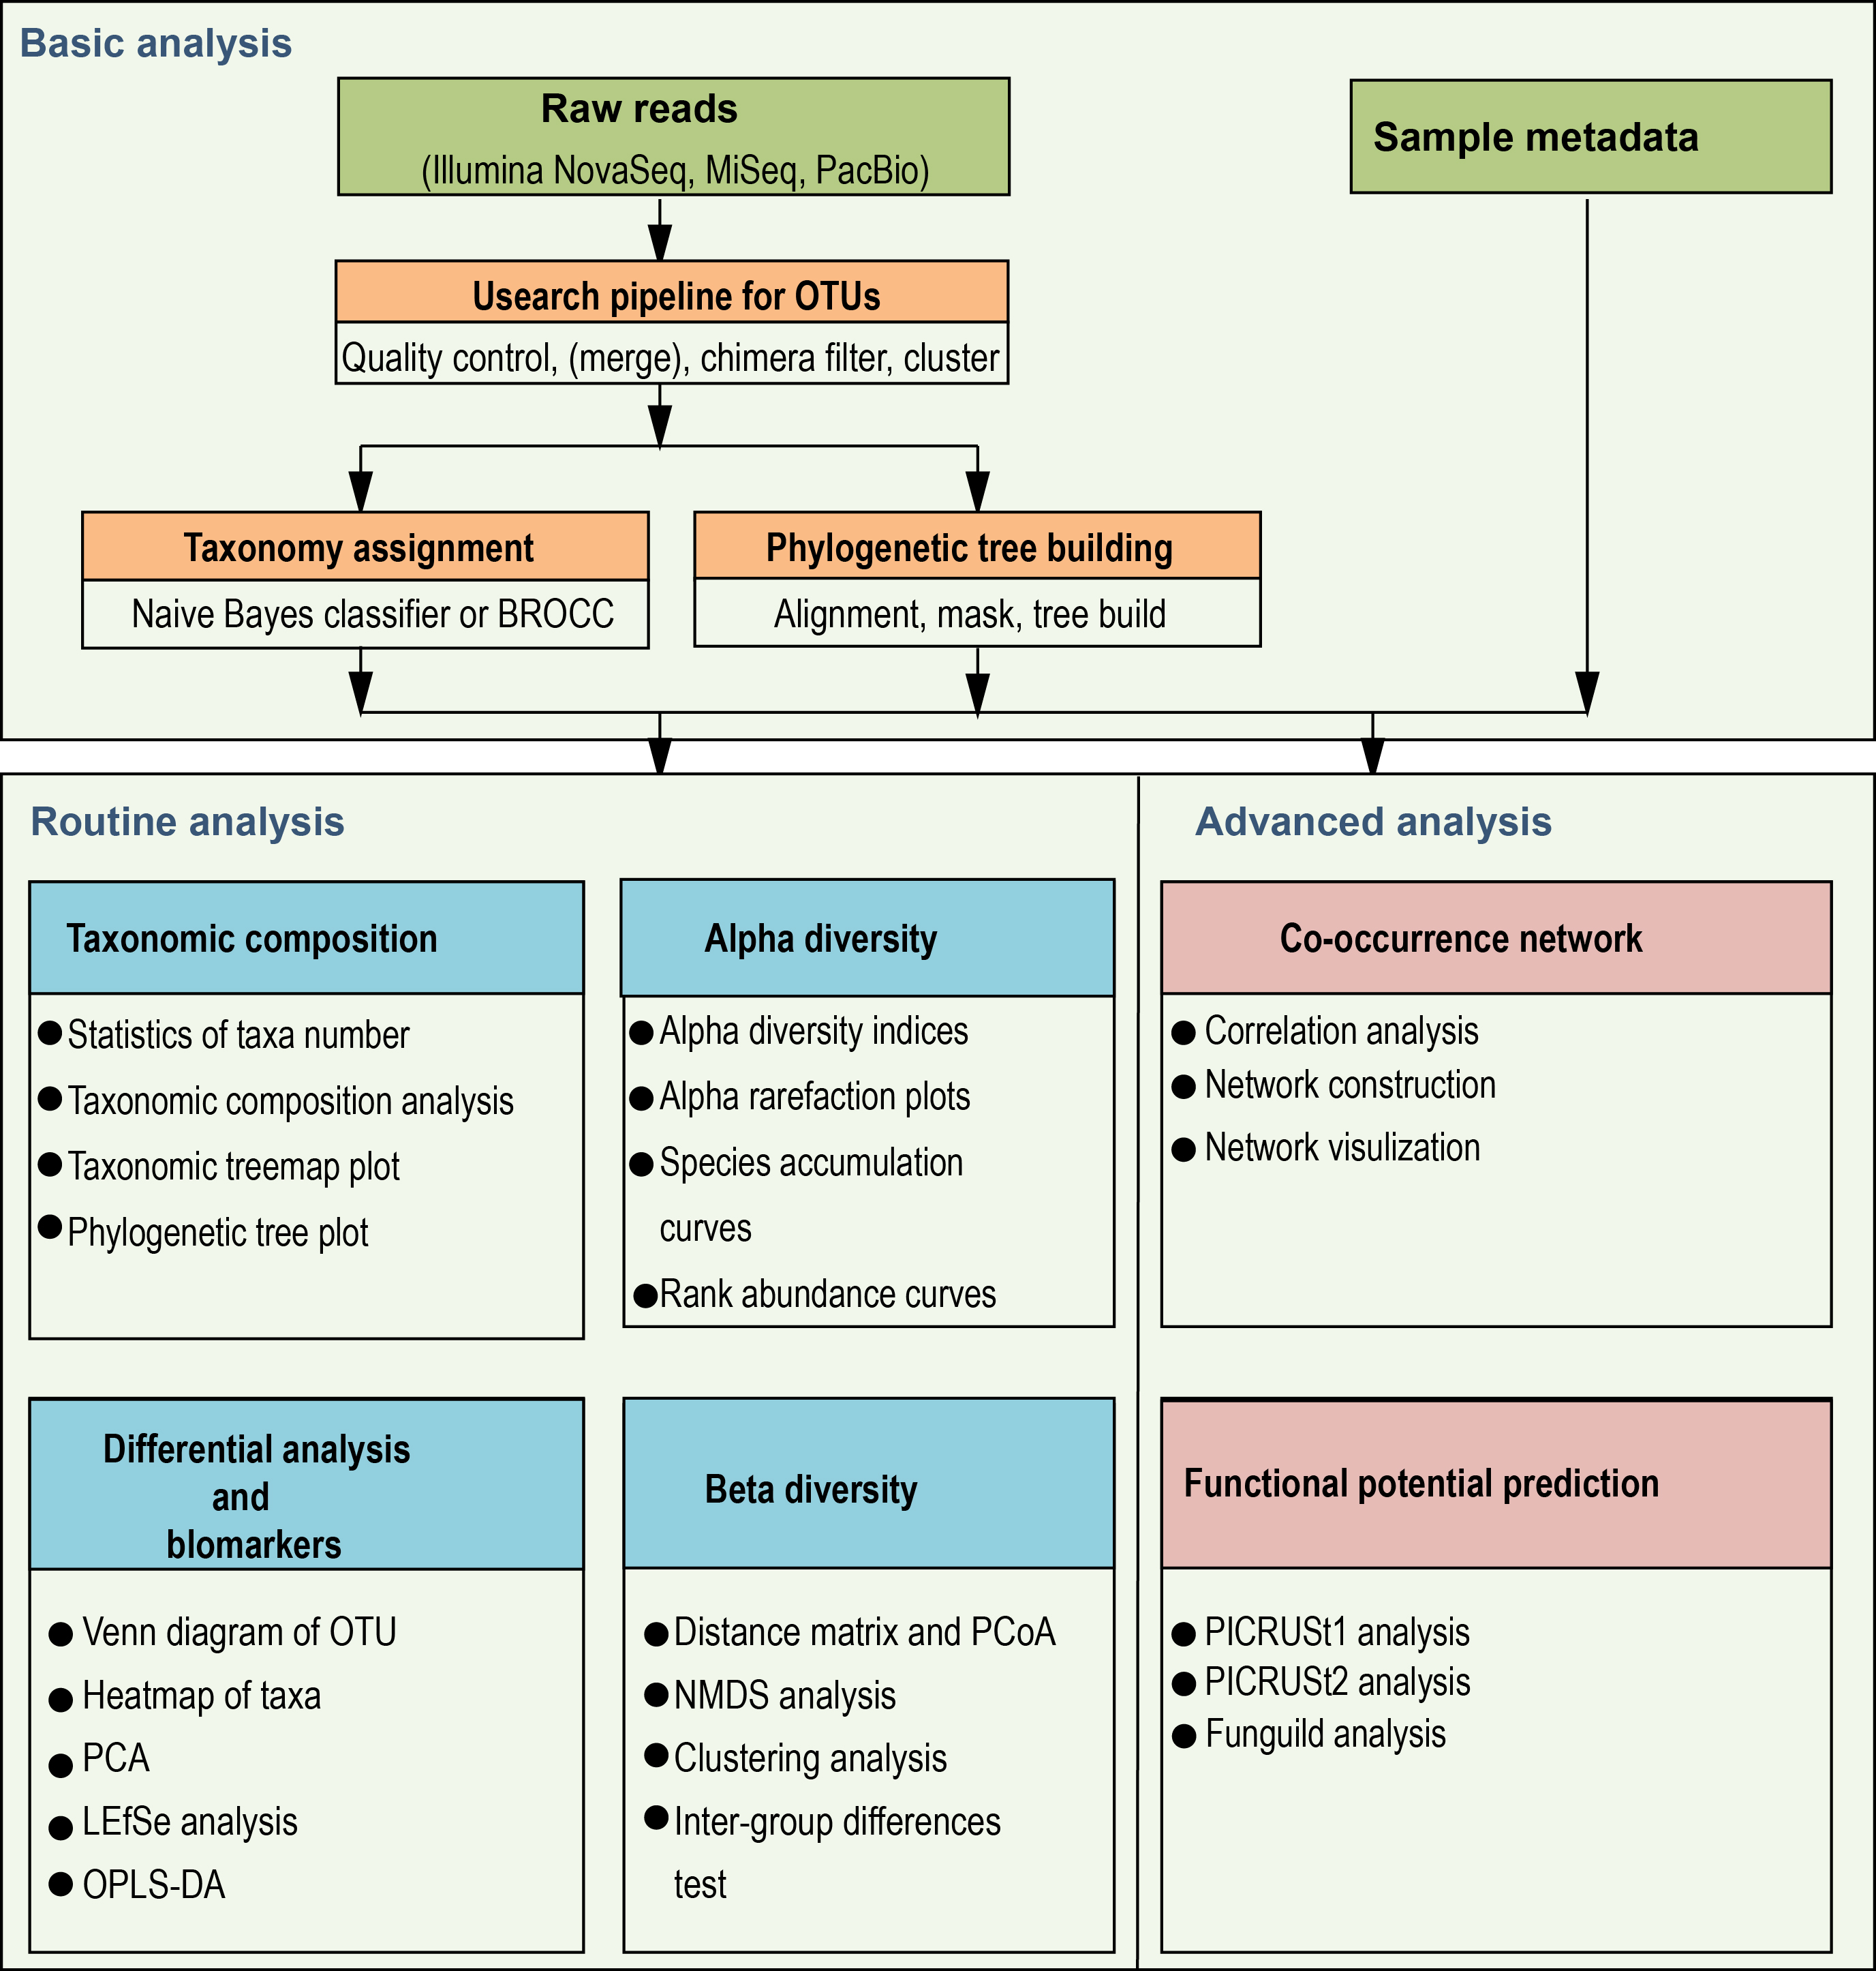
Supplementary Fig. 3 Pipeline chart of the sequence analyses.
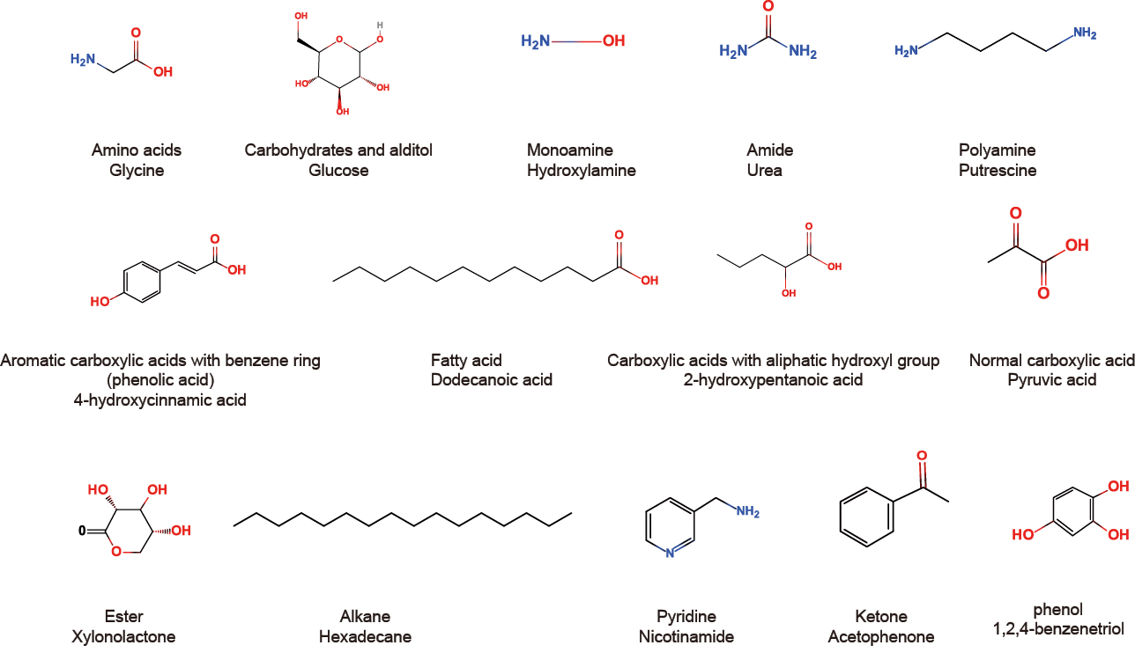
Supplementary Fig. 4 Classification of metabolites based on functional groups. The representative chemical formulas of the classified substances are listed in the figure.

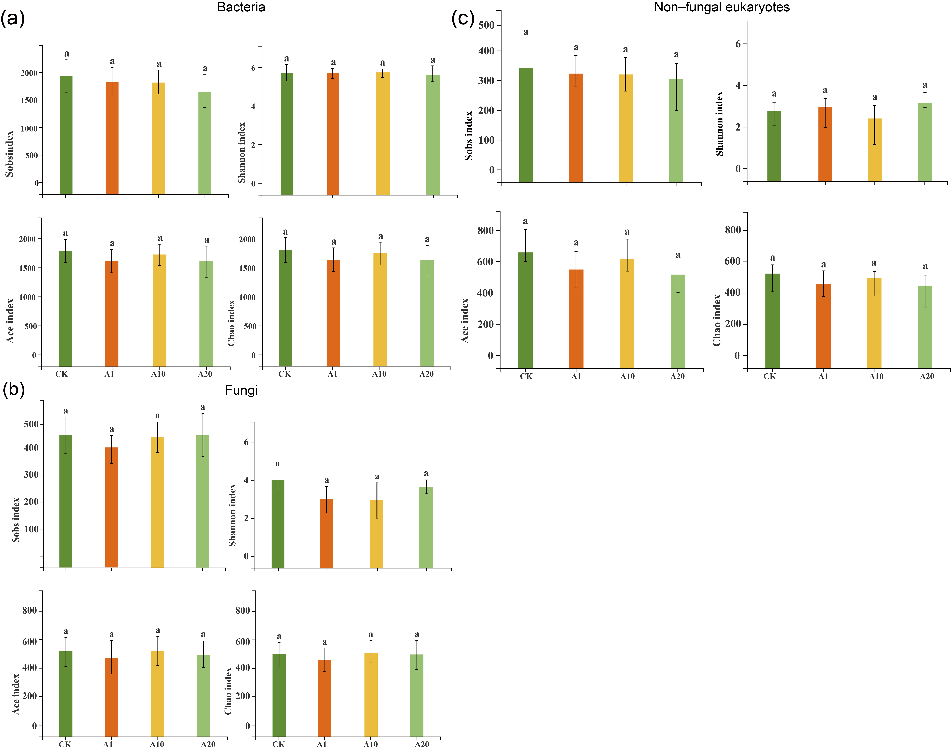
Supplementary Fig. 5 Analysis of α-diversity indices (Sobs, Shannon, ACE, and Chao1) of soil bacteria. (a) Fungal, (b) non-fungal, and (c) eukaryotic communities (mean ± SD, n = 10). The same lowercase letters in the same plot indicate no significant differences between samples (p > 0.05). CK, control soil with no ginseng cultivation history; A1, soil with 1-year post-ginseng rotation; A10, soil with 10-year post-ginseng rotation; A20, soil with 20-year post-ginseng rotation.
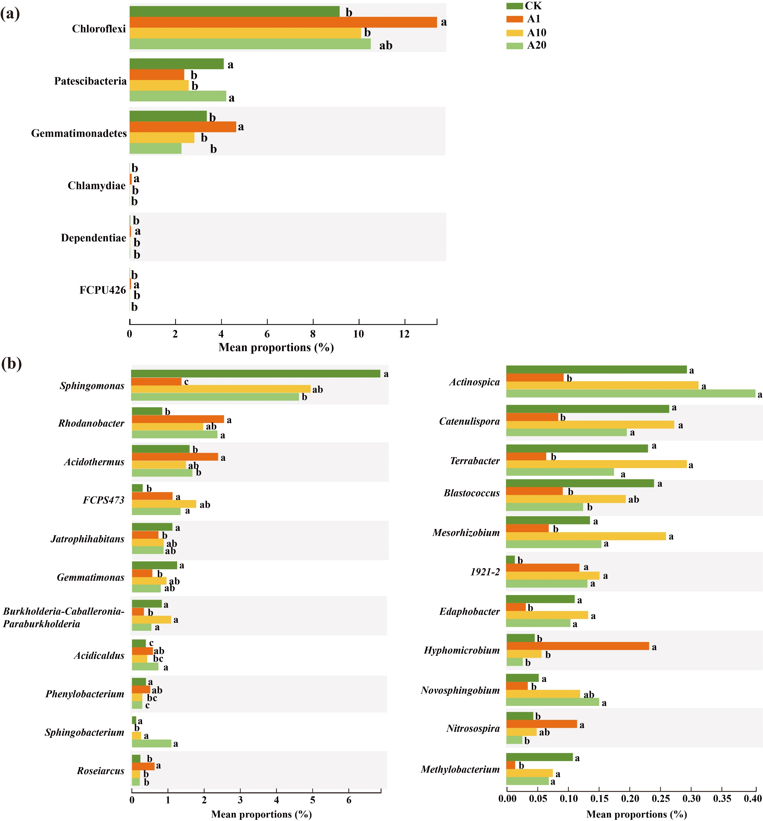
Supplementary Fig. 6 Significantly different bacterial phyla (a) and genera (b) in American ginseng–cultivated soil (P. quinquefolius-cultivated soil) samples with different restoration years. Data are presented as the mean (n = 10). Different lowercase letters among groups of different bacteria indicate significant differences between groups (p < 0.05). CK, control soil with no ginseng cultivation history; A1, soil with 1-year post-ginseng rotation; A10, soil with 10-year post-ginseng rotation; A20, soil with 20-year post-ginseng rotation.
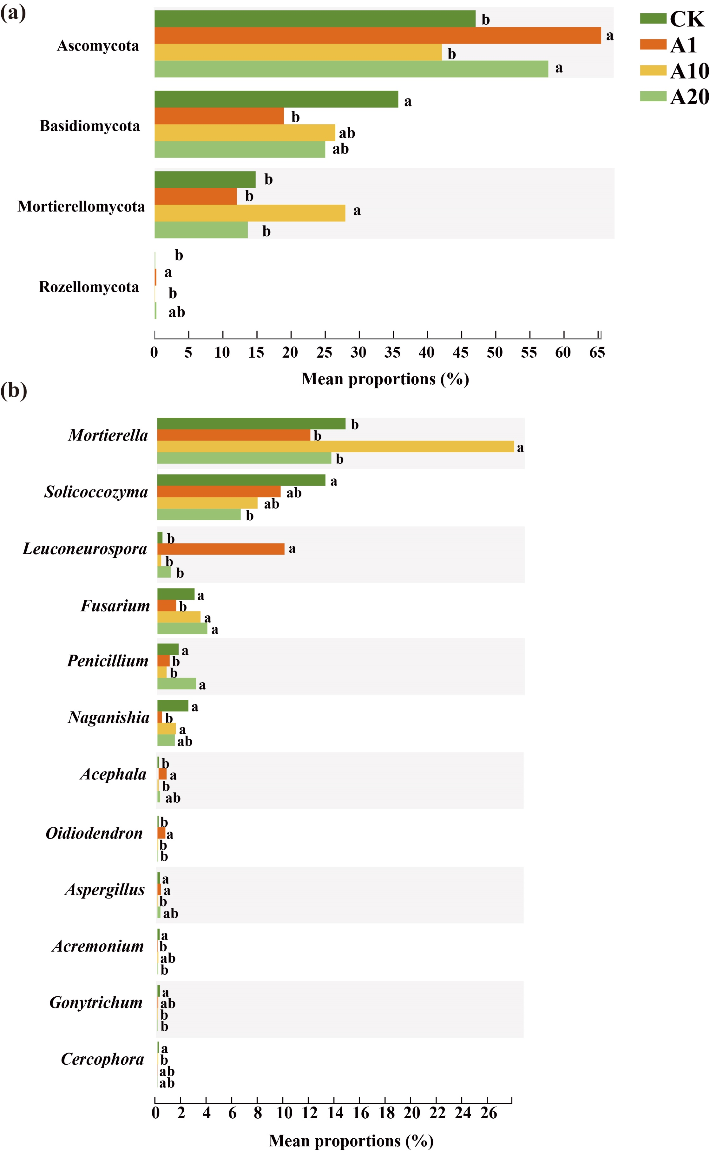
Supplementary Fig. 7 Significantly different fungal phyla (a) and genera (b) in P. quinquefolius-cultivated soil samples with different restoration years. Data are presented as the mean (n = 10). Different lowercase letters among groups of different fungi indicate significant differences between groups (p < 0.05). CK, control soil with no ginseng cultivation history; A1, soil with 1-year post-ginseng rotation; A10, soil with 10-year post-ginseng rotation; A20, soil with 20-year post-ginseng rotation.
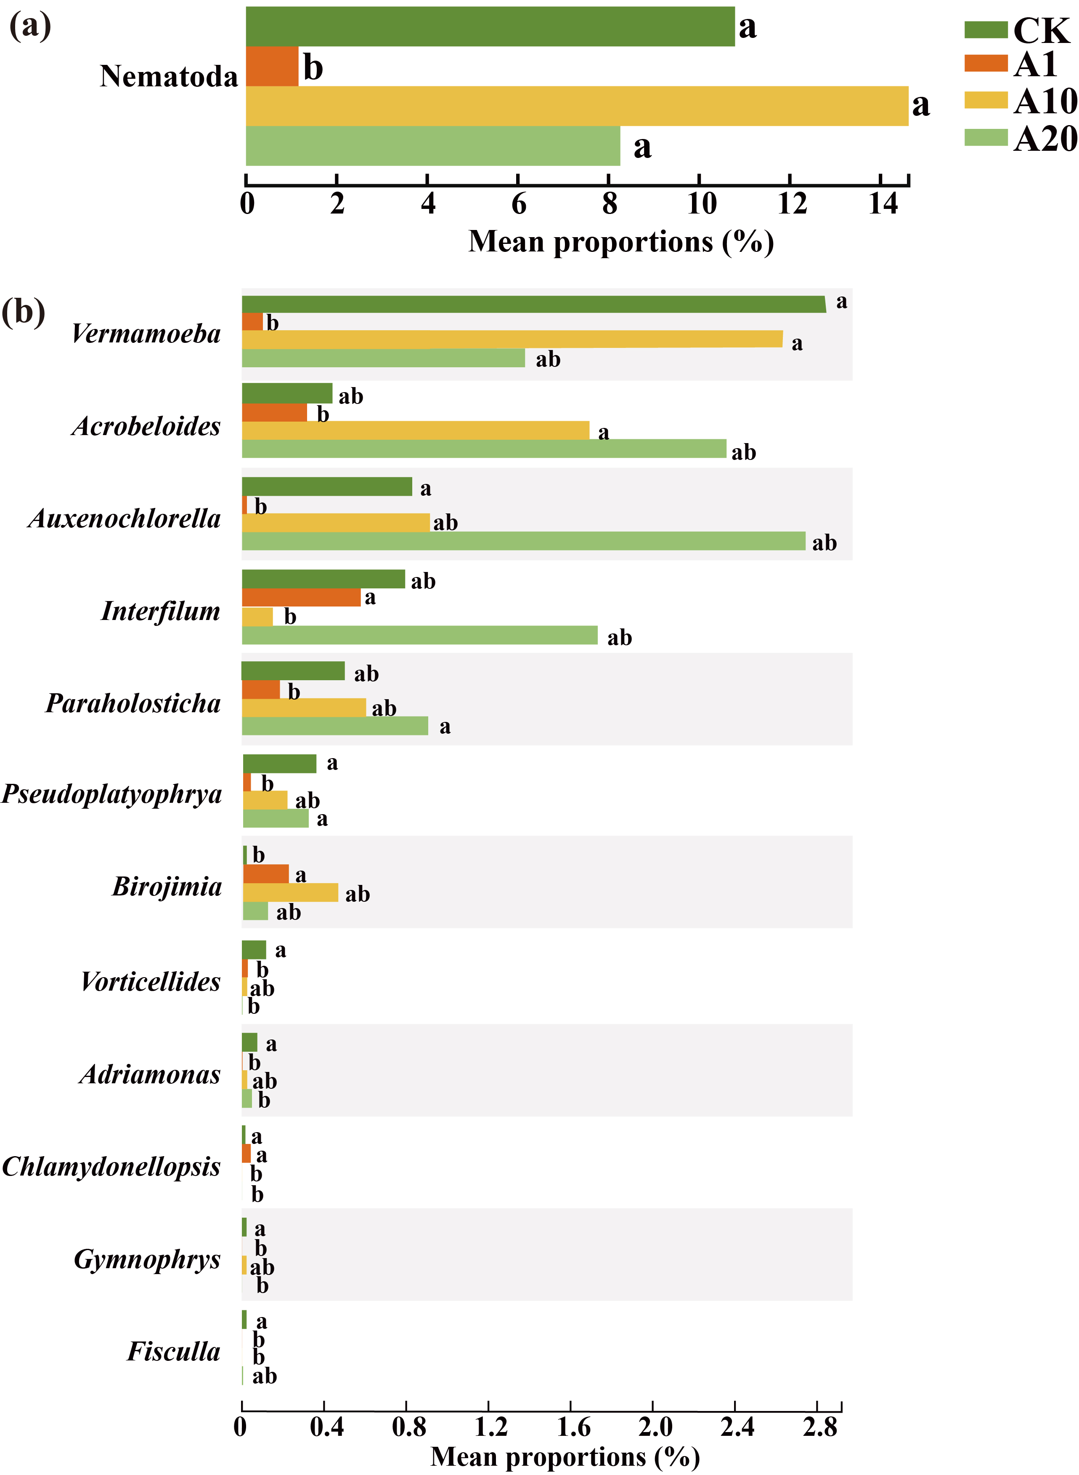
Supplementary Fig. 8 Significantly different non–fungal eukaryotic phyla (a) and genera (b) in P. quinquefolius-cultivated soil samples with different restoration years. Data are presented as the mean (n = 10). Different lowercase letters among groups of different groups indicate significant differences between groups (p < 0.05). CK, control soil with no ginseng cultivation history; A1, soil with 1-year post-ginseng rotation; A10, soil with 10-year post-ginseng rotation; A20, soil with 20-year post-ginseng rotation.
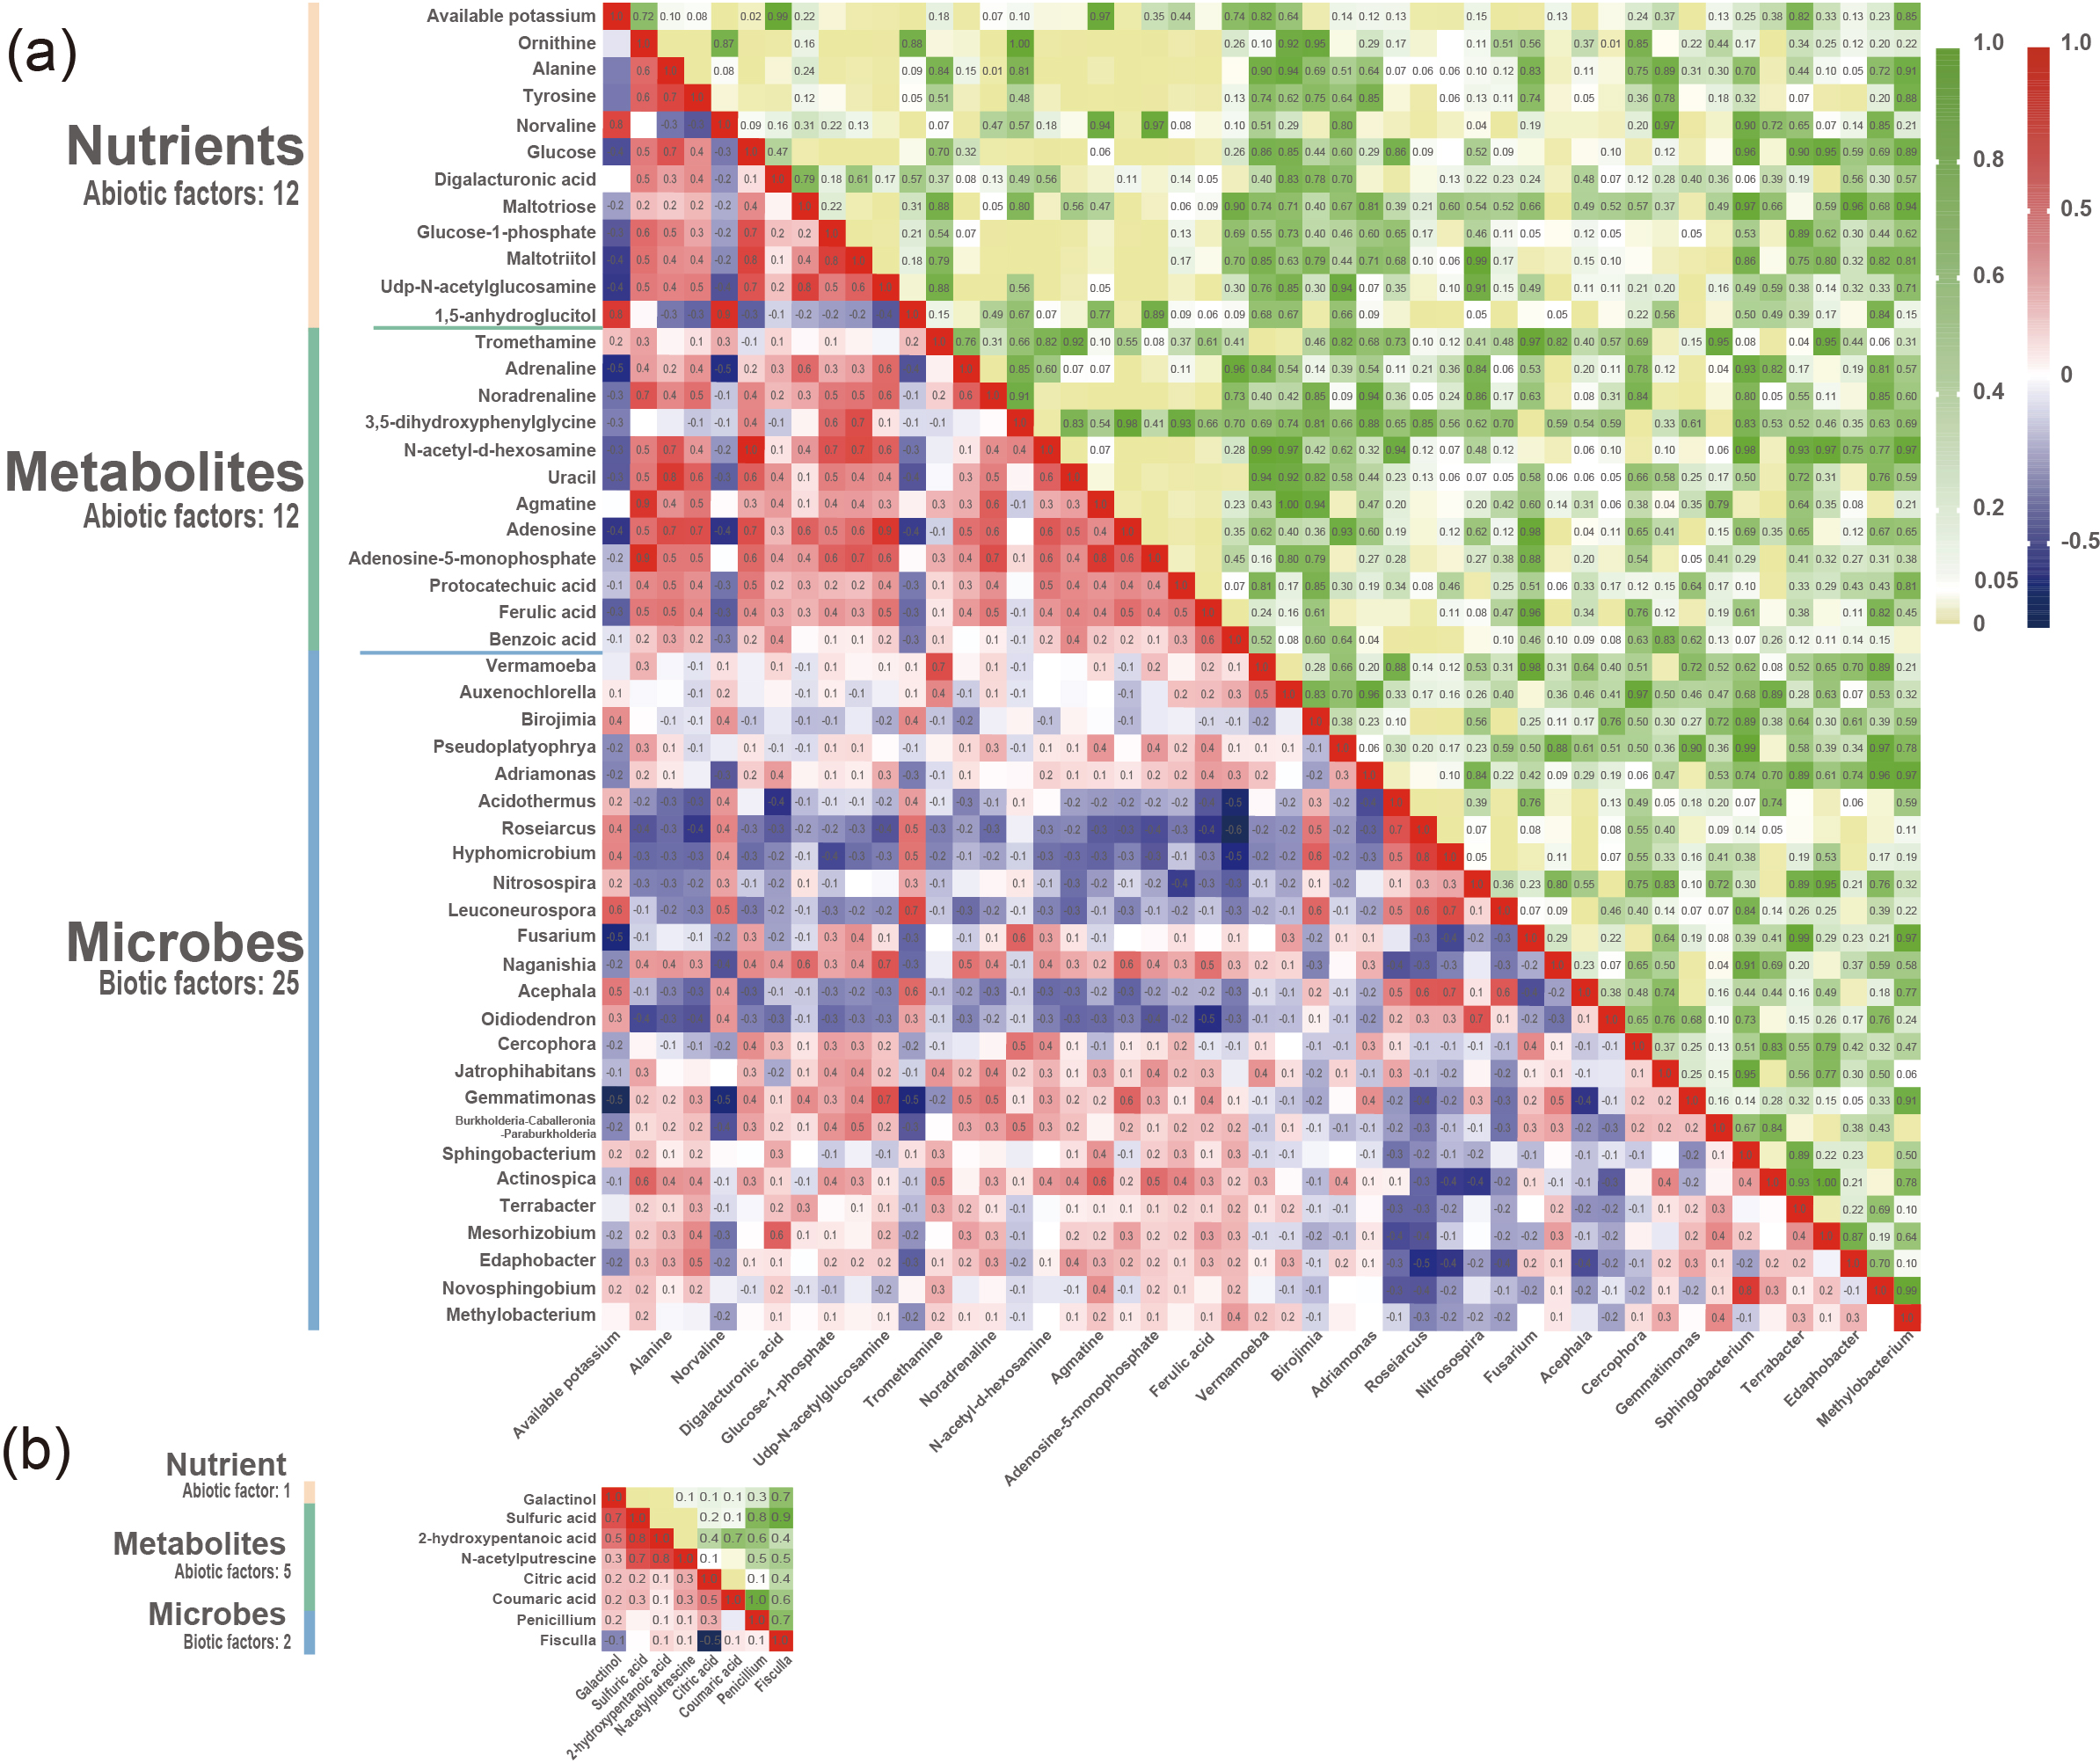
Supplementary Fig. 9 Pearson’s correlation analysis heatmaps of soil short-term (a) and medium-term (b) significant potential factors (SPFs) in P. quinquefolius-cultivated soil. The Pearson’s correlation heatmap is shown on the lower left, where numbers in the grid represent the correlation R-value. The correlation significance heatmap is shown on the upper right, where p-values are shown in the grid (n = 10).
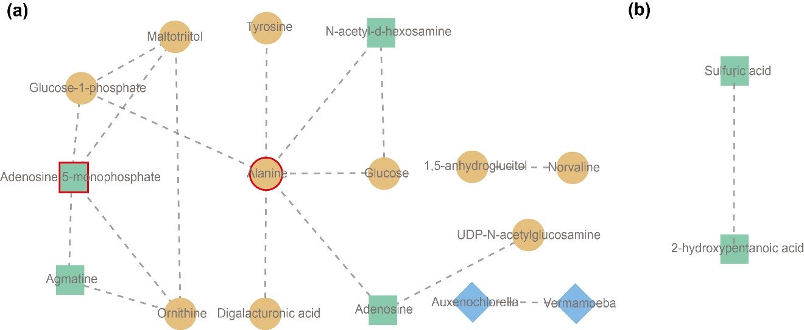
Supplementary Fig. 10 Network analysis of SPFs in P. quinquefolius-cultivated soil after different periods of rotation. (a) and (b) Correlation network of short-term and medium-term factors, respectively. The correlation coefficients were calculated, whereby |R| > 0.7 and p < 0.01 constitute an association network node, and the different colors and shapes identify the different types of factors (yellow circles = nutrient factors; green squares = metabolite factors; blue diamonds = microbial factors). A connection between nodes indicates a correlation between the two factors, and a dotted line indicates a positive correlation. The more connections pass through a node, the stronger the degree of correlation. The red lines indicate the factors with a correlation degree (number of correlated nodes) ≥ 4.

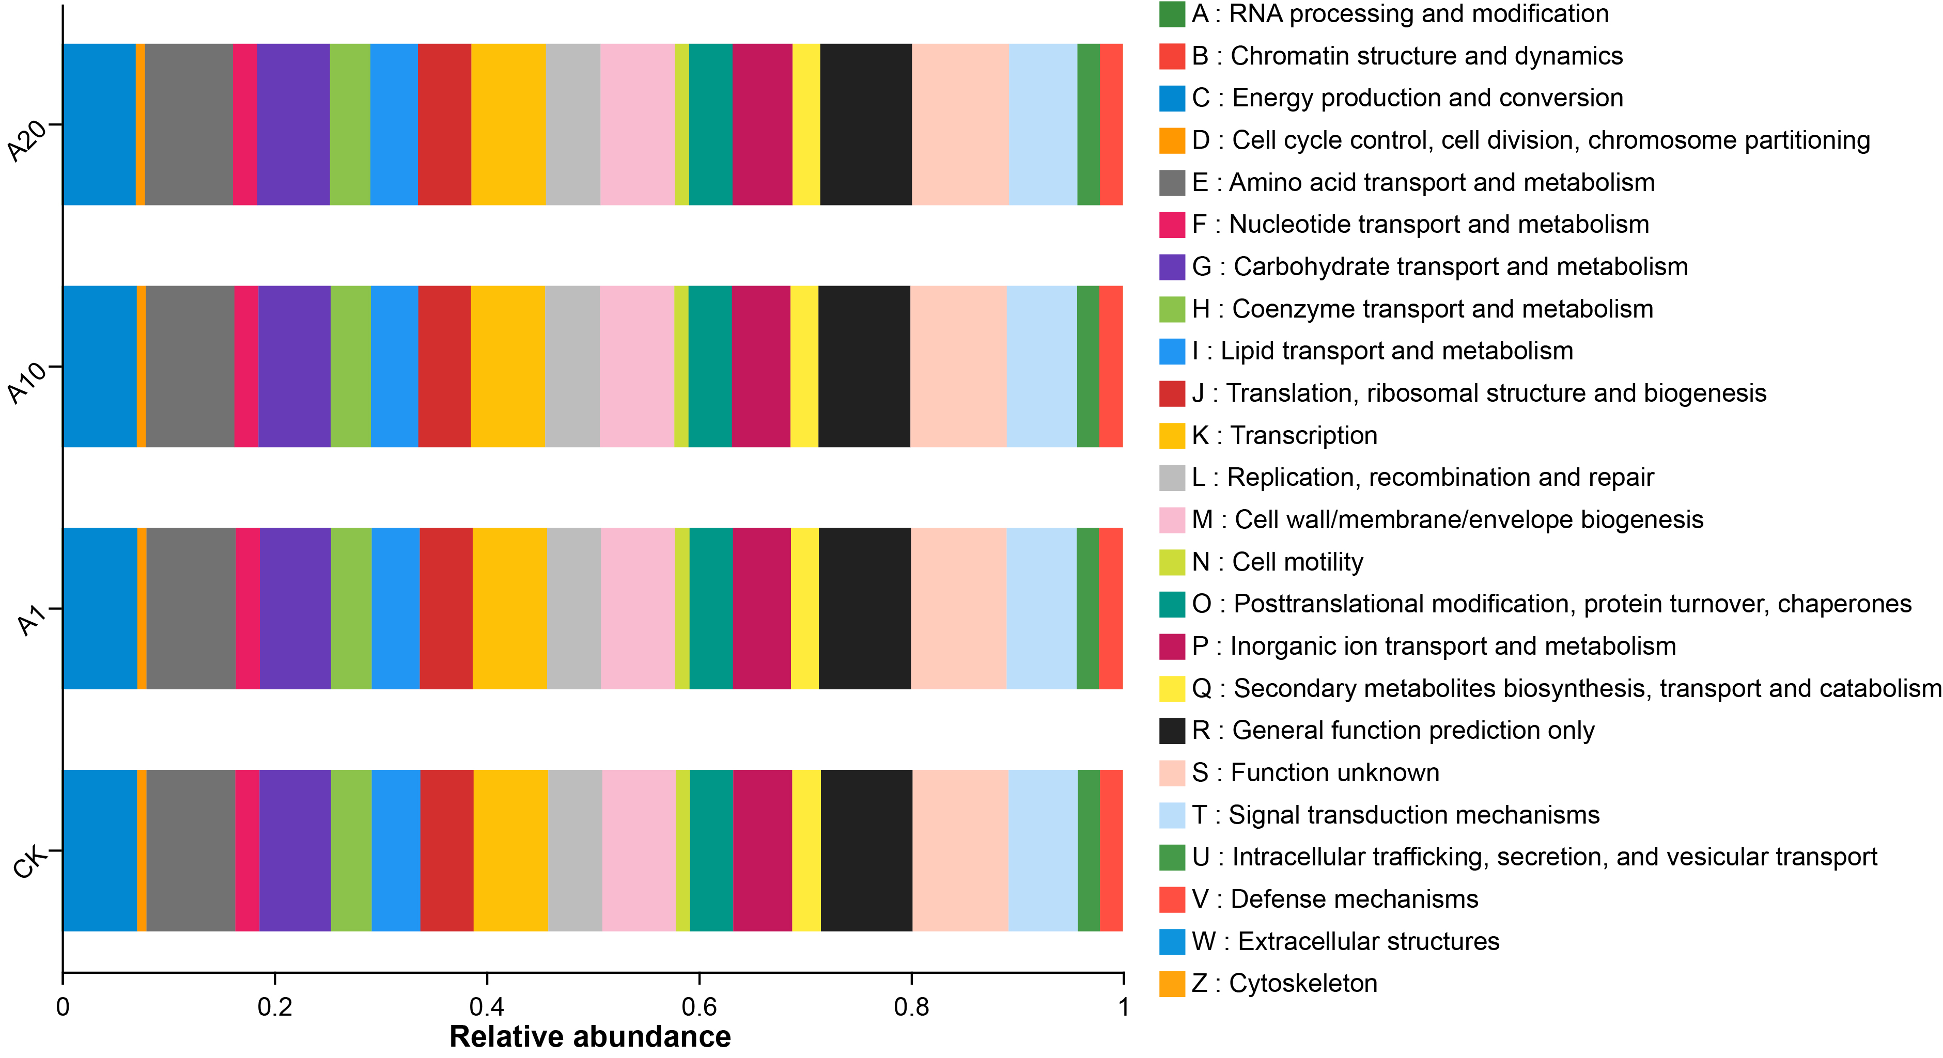
Supplementary Fig. 11 COG function classification of bacteria.
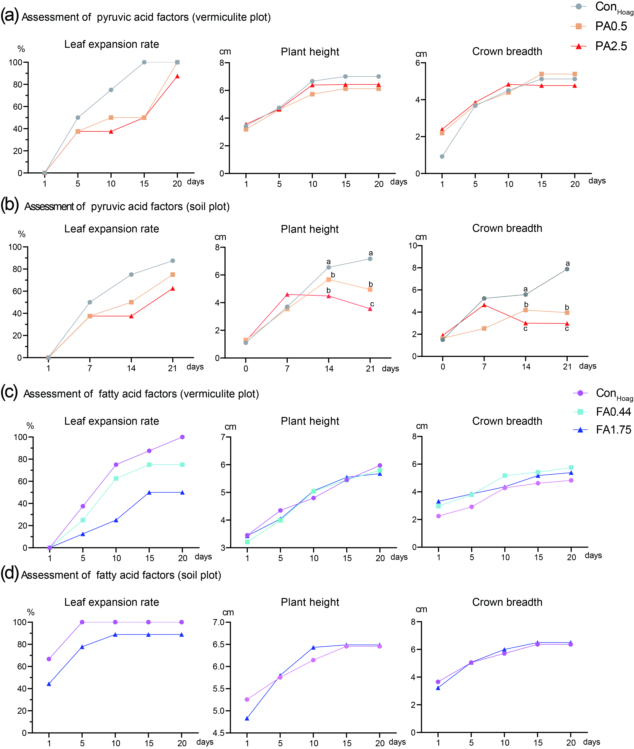
Supplementary Fig. 12 Allelopathic effects of pyruvic acid and fatty acids on the growth of AG seedlings. Con_{Hoag} represents the Hoagland nutrient solution treatment group, whereas PA0.5 and PA2.5 represent the 0.5 and 2.5 mmol L^{–1} pyruvic acid treatment groups, respectively. FA0.44 and FA1.75 represent the 0.5 and 2.5 mmol L^{–1} fatty acids treatment groups, respectively. Different lowercase letters in the figure indicate a significant difference (covariance analysis, n = 10, p < 0.05).

Supplementary Table 1 Geographical location (longitude, latitude, and altitude) of each plot and current aboveground and fore-rotating crops
 | CK | A1 | A10 | A20
1 | 37.07° N, 122.12° E, 70 m,  Triticum aestivum, Blank | 37.07° N, 122.11° E, 70 m  T. aestivum, P. quinquefolius | 37.07° N, 122.12° E, 50 m  T. aestivum, Arachis hypogaea | 37.07° N, 122.12° E, 40 m  Blank, A. hypogaea
2 | 37.18° N, 122.24° E, 70 m,  Blank, Blank | 37.07° N, 122.12° E, 70 m,  T. aestivum, P. quinquefolius | 37.07° N, 122.12° E, 50 m  Blank, Zea mays | 37.07° N, 122.12° E, 50 m  Blank, Ipomoea batatas
3 | 37.18° N, 122.23° E, 40 m  Blank, Z. mays | 37.07° N, 122.12° E, 70 m  T. aestivum, P. quinquefolius | 37.07° N, 122.12° E, 50 m  T. aestivum, A. hypogaea | 37.07° N, 122.12° E, 40 m  Blank, A. hypogaea
4 | 37.18° N, 122.23° E, 40 m  Blank, A. hypogaea | 37.07° N, 122.12° E, 70 m  T. aestivum, P. quinquefolius | 37.07° N, 122.12° E, 60 m  Blank, Z. mays | 37.07° N, 122.12° E, 50 m  Blank, A. hypogaea
5 | 37.18° N, 122.23° E, 40 m  Z. mays, T. aestivum | 37.18° N, 122.23° E, 40 m  T. aestivum, P. quinquefolius | 37.07° N, 122.12° E, 60 m  Blank, Z. mays | 37.07° N, 122.12° E, 50 m  Blank, A. hypogaea
6 | 37.18° N, 122.23° E, 40 m  Blank, Blank | 37.18° N, 122.23° E, 40 m  T. aestivum, P. quinquefolius | 37.07° N, 122.11° E, 70 m  Blank, Z. mays | 37.11° N, 122.07° E, 70 m  Blank, Blank
7 | 37.19° N, 122.25° E, 40 m  T. aestivum A. hypogaea | 37.18° N, 122.23° E, 40 m  T. aestivum, P. quinquefolius | 37.07° N, 122.11° E, 70 m  Blank, Z. mays | 37.11° N, 122.07° E, 70 m  Blank, Z mays
8 | 37.19° N, 122.25° E, 40 m  Blank, Zea mays | 37.18° N, 122.23° E, 40 m  T. aestivum, P. quinquefolius | 37.07° N, 122.12° E, 70 m  Blank, Z. mays | 37.11° N, 122.07° E, 0 m  Blank, A. hypogaea
9 | 37.19° N, 122.25° E, 35 m  Weeds, Z. mays | 37.18° N, 122.23° E, 40 m  T. aestivum, P. quinquefolius | 37.07° N, 122.12° E, 70 m  Blank, Z. mays | 37.13° N, 122.06° E, 60 m  Blank, Z. mays
10 | 37.19° N, 122.25° E, 35 m  Weeds, A. hypogaea | 37.18° N, 122.23° E, 40 m  T. aestivum, P. quinquefolius | 37.07° N, 122.12° E, 70 m  T. aestivum, A. hypogaea | 37.13° N, 122.06° E, 60 m  Blank, Blank
CK, control soil with no ginseng cultivation history; A1, soil with 1-year post-ginseng rotation; A10, soil with 10-year post-ginseng rotation; A20, soil with 20-year post-ginseng rotation. Data are in the order of latitude, longitude, and altitude, aboveground crops at sampling time, and fore-rotating crop. Blank indicates that there is no crop on the plot.

Supplementary Table 2 Chemical properties in P. quinquefolius-cultivated soil samples with different restoration years
Chemical property | CK | A1 | A10 | A20
pH | 4.69 ± 0.07ª | 4.19 ± 0.04^{c} | 4.49 ± 0.08^{b} | 4.34 ± 0.04^{bc}
Organic matter content (g kg^{–1}) | 16.38 ± 0.91ª | 14.43 ± 0.83ª | 13.63 ± 0.80ª | 15.15 ± 1.02ª
Total nitrogen content (g kg^{–1}) | 0.97 ± 0.07ª | 0.99 ± 0.07ª | 0.89 ± 0.05ª | 1.03 ± 0.09ª
Total phosphorus content (g kg^{–1}) | 0.84 ± 0.08ª | 0.70 ± 0.07ª | 0.71 ± 0.05ª | 0.92 ± 0.07ª
Alkaline hydrolysis nitrogen content (mg kg^{–1}) | 103.17 ± 13.79ª | 147.84 ± 21.33ª | 131.01 ± 11.50ª | 117.03 ± 12.67ª
Available phosphorus content (mg kg^{–1}) | 84.82 ± 14.10ª | 88.72 ± 24.19ª | 94.72 ± 14.80ª | 131.70 ± 17.49ª
Available potassium content (mg kg^{–1}) | 123.97 ± 13.76^{b} | 208.98 ± 7.65ª | 132.97 ± 13.26^{b} | 142.87 ± 13.74^{b}
Data are presented as the mean ± SE (n = 10). CK, control soil with no ginseng cultivation history; A1, soil with 1-year post-ginseng rotation; A10, soil with 10-year post-ginseng rotation; A20, soil with 20-year post-ginseng rotation. Different lowercase letters in the same row indicate significant differences among samples (p < 0.05); bold values represent a significant difference vs. CK group[16].

Supplementary Table 3 Relative content of small molecular organic nutrients in P. quinquefolius-cultivated soil samples
Amino acids and amino acid analogs | CK | A1 | A10 | A20
N–acetylornithine | 0.242 89ª | 0.213 73^{b} | 0.212 66^{b} | 0.213 41^{b}
5–aminovaleric acid | 0.012 67ª | 0.011 24^{b} | 0.010 63^{b} | 0.011 16^{b}
Serine | 0.000 73ª | 0.000 51^{b} | 0.000 55^{b} | 0.000 56^{b}
Leucine | 0.000 07ª | 0.000 04^{b} | 0.000 04^{b} | 0.000 04^{b}
Glycine | 0.005 02ª | 0.002 84^{c} | 0.005 35ª | 0.003 93^{b}
Histidine | 0.024 44ª | 0.008 39^{b} | 0.016 55^{ab} | 0.011 67^{b}
Pyroglutamic acid | 0.001 77ª | 0.000 46^{b} | 0.001 77ª | 0.000 89^{b}
Threonine | 0.000 38ª | 0.000 26^{c} | 0.000 36^{ab} | 0.000 29^{bc}
Ornithine | 0.006 34ª | 0.004 55^{b} | 0.005 97ª | 0.005 58ª
Alanine | 0.011 65ª | 0.004 62^{b} | 0.014 57ª | 0.010 09^{ab}
Tyrosine | 0.000 16ª | 0.000 07^{b} | 0.000 23ª | 0.000 16ª
Glutamate | 0.001 30ª | 0.001 24ª | 0.001 06^{b} | 0.001 06^{b}
N–carbamoylaspartate | 0.000 24ª | 0.000 22^{ab} | 0.000 19^{b} | 0.000 20^{b}
Beta–alanine | 0.007 24ª | 0.006 87ª | 0.005 83^{b} | 0.005 75^{b}
N–methylalanine | 0.019 22ª | 0.017 51^{ab} | 0.016 96^{b} | 0.018 00^{ab}
Tranexamic acid | 0.000 83ª | 0.000 73^{ab} | 0.000 74^{ab} | 0.000 73^{b}
Isoleucine | 0.008 87^{ab} | 0.005 10^{b} | 0.013 20ª | 0.008 99^{ab}
L–serine | 0.002 20^{ab} | 0.000 95^{b} | 0.003 39ª | 0.002 00^{ab}
L–threonine | 0.001 81^{ab} | 0.000 74^{b} | 0.002 80ª | 0.001 68^{ab}
4–aminobutyric acid | 0.002 22^{ab} | 0.001 01^{b} | 0.003 36ª | 0.002 72^{ab}
Proline | 0.002 20^{ab} | 0.000 92^{b} | 0.003 63ª | 0.002 50^{ab}
Asparagine | 0.002 46ª | 0.002 55ª | 0.002 21^{b} | 0.002 45^{ab}
Aspartate | 0.011 07^{b} | 0.013 10ª | 0.012 79ª | 0.013 75ª
Norvaline | 0.002 01^{b} | 0.005 72ª | 0.002 30^{b} | 0.003 02^{b}
Carbohydrates and alditol | CK | A1 | A10 | A20
Glycerol | 0.177 17ª | 0.097 79^{b} | 0.117 46^{b} | 0.125 96^{b}
Sophorose | 0.218 81ª | 0.112 03^{b} | 0.133 39^{b} | 0.102 29^{b}
1–butanol | 0.003 66ª | 0.003 14^{b} | 0.003 70ª | 0.003 33^{b}
Palatinitol | 0.009 99ª | 0.007 41^{b} | 0.009 59^{ab} | 0.008 42^{bc}
Melezitose | 0.036 72ª | 0.013 83^{b} | 0.028 28^{ab} | 0.019 30^{bc}
Galactinol | 0.005 07ª | 0.000 73^{b} | 0.000 97^{b} | 0.001 65^{ab}
Glucose | 0.008 27ª | 0.003 69^{b} | 0.007 58ª | 0.006 65^{ab}
Digalacturonic acid | 0.006 84ª | 0.002 20^{b} | 0.007 78ª | 0.005 30^{ab}
Maltotriose | 0.032 44ª | 0.003 75^{b} | 0.007 49^{ab} | 0.008 01^{ab}
Glucose–1–phosphate | 0.006 10ª | 0.002 89^{b} | 0.005 98ª | 0.004 97^{ab}
Maltotriitol | 0.007 87ª | 0.003 62^{b} | 0.009 20ª | 0.005 87^{ab}
UDP–N–acetylglucosamine | 0.006 06ª | 0.001 73^{b} | 0.003 87^{ab} | 0.003 78^{ab}
D7–glucose | 0.002 09ª | 0.002 01ª | 0.001 55^{b} | 0.001 58^{b}
Hexitol | 0.002 40ª | 0.002 13^{ab} | 0.001 95^{b} | 0.002 03^{b}
D–xylitol | 0.004 85^{ab} | 0.003 63^{b} | 0.012 68ª | 0.008 61^{ab}
3–Deoxyhexitol | 0.000 74^{ab} | 0.000 08^{b} | 0.000 98ª | 0.000 46^{ab}
Sorbitol | 0.834 54^{ab} | 0.363 63^{b} | 1.198 04ª | 1.234 67ª
Ethylene glycol | 0.025 64ª | 0.021 76^{ab} | 0.015 39^{b} | 0.021 35^{ab}
Methyl β–D–glucopyranoside | 0.042 22^{ab} | 0.011 58^{b} | 0.062 45ª | 0.027 06^{b}
1,5–anhydroglucitol | 0.000 23^{b} | 0.000 43ª | 0.000 25^{b} | 0.000 27^{b}
Data are presented as the mean ± SE (n = 10). CK, control soil with no ginseng cultivation history; A1, soil with 1-year post-ginseng rotation; A10, soil with 10-year post-ginseng rotation; A20, soil with 20-year post-ginseng rotation. Data are presented as the relative average expression of each metabolite, and different lowercase letters in the same row indicate significant differences among samples (p < 0.05); bold values represent a significant difference vs. CK group¹⁶.

Supplementary Table 4 Phenolic acid metabolite content (mg kg^{–1}) in P. quinquefolius-cultivated soil samples with different restoration years
Phenolic acid metabolites | CK | A1 | A10 | A20
Coumaric acid | 0.97 ± 0.07ª | 0.31 ± 0.04^{c} | 0.59 ± 0.15^{bc} | 0.78 ± 0.12^{ab}
Protocatechuic acid | 0.99 ± 0.06ª | 0.58 ± 0.08^{b} | 0.72 ± 0.09^{ab} | 0.82 ± 0.11^{ab}
p–Hydroxybenzoic acid | 2.59 ± 0.07ª | 2.17 ± 0.14ª | 2.31 ± 0.13ª | 2.24 ± 0.18ª
Vanillic acid | 1.61 ± 0.09ª | 1.46 ± 0.08ª | 1.47 ± 0.04ª | 1.49 ± 0.10ª
Caffeic acid | 0.02 ± 0.01^{b} | 0.23 ± 0.15^{b} | 0.01 ± 0.01^{b} | 0.74 ± 0.22ª
Syringic acid | 2.33 ± 0.14ª | 1.55 ± 0.13^{b} | 1.66 ± 0.14^{b} | 1.48 ± 0.17^{b}
Vanillin | 0.87 ± 0.06ª | 1.00 ± 0.12ª | 0.89 ± 0.06ª | 0.87 ± 0.07ª
p–Coumaric acid | 3.52 ± 0.22ª | 2.06 ± 0.35^{b} | 2.43 ± 0.15^{b} | 2.71 ± 0.21^{b}
Ferulic acid | 1.51 ± 0.12ª | 0.85 ± 0.16^{b} | 1.19 ± 0.08^{ab} | 1.34 ± 0.09^{ab}
Benzoic acid | 2.35 ± 0.37ª | 1.29 ± 0.37^{b} | 2.28 ± 0.27ª | 2.91 ± 0.34ª
Data are presented as the mean ± SE (n = 10). CK, control soil with no ginseng cultivation history; A1, soil with 1-year post-ginseng rotation; A10, soil with 10-year post-ginseng rotation; A20, soil with 20-year post-ginseng rotation. Different lowercase letters in the same row indicate significant differences among samples (p < 0.05); bold values represent a significant difference vs. the CK group.

Supplementary Table 5 Changes in metabolites in P. quinquefolius-cultivated soil samples
Amines (23) | CK | A1 | A10 | A20
Derivatives of monoamine (7)
Tromethamine | 0.00017ª | 0.00008^{b} | 0.00021ª | 0.00014ª
Ethanolamine | 0.00392ª | 0.00256^{b} | 0.00531ª | 0.00336^{b}
Adrenaline | 0.00074ª | 0.00064^{b} | 0.00068^{ab} | 0.00068^{ab}
Noradrenaline | 0.00074ª | 0.00064^{b} | 0.00068^{ab} | 0.00068^{ab}
Hydroxylamine | 0.01379ª | 0.01253^{b} | 0.01197^{b} | 0.01224^{b}
N–methylalanine | 0.01922ª | 0.01751ª | 0.01696^{b} | 0.018ª
Amides (10)
Urea | 0.00413ª | 0.00399ª | 0.00399ª | 0.00217^{b}
N–acetylputrescine | 0.2796ª | 0.25559^{ab} | 0.25161^{b} | 0.25473^{b}
3,5–Dihydroxyphenylglycine | 0.00351ª | 0.00243^{b} | 0.00235^{ab} | 0.00232ª
N–acetyl–d–hexosamine | 0.01195ª | 0.00545^{b} | 0.01098^{ab} | 0.01002^{ab}
Hippuric acid | 0.00046ª | 0.00045ª | 0.00042^{b} | 0.00045ª
Uracil | 0.00059ª | 0.00036^{b} | 0.00058ª | 0.00055ª
Alanine–alanine | 0.00152ª | 0.00146^{ab} | 0.00129^{b} | 0.00139^{ab}
Cyanuric acid | 0.00057ª | 0.00019^{c} | 0.00041^{b} | 0.00028^{bc}
Oleamide | 0.00773^{b} | 0.00682^{d} | 0.00825ª | 0.0073^{c}
Asparagine | 0.00256ª | 0.00255ª | 0.00221^{b} | 0.00245^{ab}
Polyamines and derivatives (6)
Agmatine | 0.20344ª | 0.17744^{b} | 0.20023ª | 0.21032ª
Adenosine | 0.00366ª | 0.00137^{b} | 0.00338ª | 0.0024^{ab}
Inosine | 0.00026ª | 0.00024^{ab} | 0.00021^{ab} | 0.0002^{b}
Phosphenodiimidic amide | 0.00300ª | 0.00181^{b} | 0.00265^{ab} | 0.00207^{b}
Adenosine–5–monophosphate | 0.00270ª | 0.00194^{b} | 0.00253ª | 0.00241ª
Putrescine | 0.00750ª | 0.00649^{b} | 0.00666^{b} | 0.00652^{b}
Carboxylic acids (19)
Aromatic carboxylic acids with benzene rings (3)
Terephthalic acid | 0.00385ª | 0.00203^{b} | 0.00186^{b} | 0.0015^{b}
Hydrocinnamic acid | 0.00071ª | 0.00049^{b} | 0.00048^{b} | 0.00045^{b}
3,5–dimethyl–benzoic acid | 0.00067ª | 0.00047^{b} | 0.00047^{b} | 0.00047^{b}
Fatty acids (9) | CK | A1 | A10 | A20
Palmitic acid | 0.0599ª | 0.04551^{b} | 0.05569ª | 0.04281^{b}
Stearic acid | 0.0153ª | 0.00946^{b} | 0.01212^{ab} | 0.00866^{b}
Lignoceric acid | 0.00089^{b} | 0.00132^{ab} | 0.00172ª | 0.00133^{ab}
Myristic acid | 0.00405^{b} | 0.00539ª | 0.00552ª | 0.00539ª
Decanoic acid | 0.00551^{b} | 0.00567^{b} | 0.00612ª | 0.00574^{b}
Octanoate radical | 0.00283^{b} | 0.00304ª | 0.00311ª | 0.00308ª
Behenic acid | 0.00104^{b} | 0.00145^{ab} | 0.00182ª | 0.00139^{ab}
Dodecanoic acid | 0.00166^{c} | 0.00189^{b} | 0.00203ª | 0.00195^{ab}
Montanic acid | 0.00081^{b} | 0.00133ª | 0.0015ª | 0.00129ª
Carboxylic acids with aliphatic hydroxyl groups (6)
2–Hydroxypentanoic acid | 0.00249ª | 0.00222^{ab} | 0.00202^{b} | 0.0021^{b}
Citric acid | 0.00139ª | 0.00089^{b} | 0.00134^{b} | 0.0015ª
Isocitric acid | 0.00367^{b} | 0.00867ª | 0.00401^{b} | 0.00459^{b}
Digalacturonic acid | 0.00684^{b} | 0.0022^{ab} | 0.00778ª | 0.0053^{ab}
Erythronic acid | 0.00024ª | 0.00017^{b} | 0.00020^{ab} | 0.00015^{b}
Lactic acid | 0.02204ª | 0.01354^{b} | 0.01955ª | 0.01385^{b}
Normal carboxylic acids (2)
Pyruvic acid | 0.01844^{c} | 0.10335ª | 0.04351^{b} | 0.06773^{ab}
Malonic acid | 0.00124ª | 0.00107^{ab} | 0.00102^{ab} | 0.00102^{b}
Esters (2)
Xylonolactone | 0.00033ª | 0.00012^{c} | 0.00024^{b} | 0.00015^{c}
Monomyristin | 0.00916^{ab} | 0.00804^{ab} | 0.00984ª | 0.00764^{b}
Alkanes (3)
Alkane | 0.00265ª | 0.00256^{b} | 0.00261^{b} | 0.00254^{b}
Hexadecane | 0.00052^{ab} | 0.00047^{b} | 0.0006ª | 0.00051^{ab}
Tetracosane | 0.00204ª | 0.00196^{b} | 0.00203ª | 0.00201^{bc}
Pyridine and its derivatives (3)
1,3–dihydroxypyridine | 0.00129ª | 0.00086^{b} | 0.00086^{b} | 0.0008^{b}
Nicotinic acid | 0.00028ª | 0.00025^{ab} | 0.00024^{ab} | 0.00024^{b}
Nicotinamide | 0.00261ª | 0.00226^{b} | 0.00217^{b} | 0.00225^{b}
Ketones (3)
Acetophenone | 0.00044ª | 0.00027^{b} | 0.00033^{b} | 0.00028^{b}
Phenols (3) | CK | A1 | A10 | A20
1,2,4–benzenetriol | 0.00754ª | 0.00573b | 0.00651^{b} | 0.00625^{b}
2,6–Bis(tert–butyl)phenol | 0.00235ª | 0.00205^{b} | 0.00206^{b} | 0.0019^{b}
Chlorine compounds (3) | CK | A1 | A10 | A20
Chlorphentermine | 0.00254^{b} | 0.00416ª | 0.00348ª | 0.00348ª
CK, control soil with no ginseng cultivation history; A1, soil with 1-year post-ginseng rotation; A10, soil with 10-year post-ginseng rotation; A20, soil with 20-year post-ginseng rotation. Data are presented as average expression of each metabolite, and different lowercase letters in the same row indicate significant differences between samples (n = 10, p < 0.05); bold values represent a significant difference compared with the CK group. Classification basis: substances were classified mainly according to functional groups that are divided into 8 categories, including amines (– NH₂), carboxylic acids (– COOH), esters (– COOC–), alkanes (C_{n}H_{2n + 2}), pyridines (C₅H₅N), inorganic acids, ketones (– CO –), phenols (benzene ring – OH), and chlorinated organics (– Cl). The amines and carboxylic acids categories were subdivided into other subclasses according to different functional groups. For example, amines are divided into monoamines and polyamines according to the number of amino groups, and amides according to the presence or absence of acyl groups; carboxylic acids are divided into carboxylic acids with benzene ring (aromatic carboxylic acids), fatty acids, carboxylic acids with alcohol hydroxyl groups, and general carboxylic acids according to the presence or absence of benzene ring, long-chain alkanes, and alcohol hydroxyl groups.

Supplementary Table 6 Changes in the abundance of beneficial and harmful microbes in American ginseng-cultivated soils
Microbe | Results | Functional description
Reduction in the abundance of beneficial bacteria in P. quinquefolius-cultivated soil
Sphingomonas | Decreased in the A1, A10, and A20 soils compared with that in the CK | Sphingomonas can improve plant stress resistance[17] and degrade monocyclic and polycyclic aromatic hydrocarbons, including phenolic acids[18] that are considered plant probiotics[19].
Burkholderia-Caballeronia-Paraburkholderia | Decreased in A1 | Burkholderia-Caballeronia-Paraburkholderia is a beneficial bacterium recruited by ginsenosides in P. notoginseng and enhances pathogenic fungal resistance[20].
Gemmatimonas | Decreased in A1 | The relative abundance of Gemmatimonas positively correlates with organic nutrient content[21, 22]. This indicates that the loss of organic nutrients affects soil microbes in the P. quinquefolius-cultivated soil; this has been verified by the PLS-SEM results that revealed a positive effect of soil microorganisms on organic nutrient content.
Terrabacter | Decreased in A1 | The relative abundance of Terrabacter positively correlates with organic nutrient content[21, 22]. In addition, Terrabacter could improve soil pH[23]. It has been isolated from ginseng soil and can convert ginsenoside Rb1 into the more active ginsenoside XVII[24].
Catenulispora | Decreased in A1 | Catenulispora can inhibit the reproduction of some Fusarium species[25]. Catenulispora acidiphila is ubiquitous in forest soil[26] and can help maintain the healthy development of forest ecosystems[27].
Mesorhizobium | Decreased in A1 | The abundances of several strains of Mesorhizobium that improve salt and heavy metal stress resistance and promote seed germination[28] [29] are reduced in A1 soil.
Methylobacterium | Decreased in A1 | Methylobacterium could produce bioactive plant cytokinins[30], provide nutrients for plants, and enhance pathogen resistance [31].
Reduction in the abundance of beneficial fungi in P. quinquefolius-cultivated soil
Acremonium | Decreased in A1, A20 | Acremonium is negatively correlated with the presence of viruses or pathogenic fungi[32, 33], acts as a disease suppressor and probiotic, and controls root-knot nematodes[34].
Penicillium | Decreased in A1 | Penicillium can degrade hydrocarbons[35, 36] and promote plant growth under stress conditions[37, 38].
Naganishia | Decreased in A1 | Naganishia secretes substances that promote plant growth[39] and exists in the rhizosphere soil of medicinal plants, including P. ginseng[40].
Increase in the abundance of potentially beneficial bacterium
Rhodanobacter | Elevated in A1, A10, and A20 | Rhodanobacter is common in P. ginseng-cultivated soils[41] and confers resistance against Fusarium solani[42].
Increase in the abundance of potentially beneficial fungus
Acephala | Increased in A1 | Fungi from the Acephala group dissolve inorganic phosphorus and co-colonize plants with mutualist arbuscular mycorrhizal fungi[43].
Reduction in the abundance of harmful fungi
Fusarium | Decreased in A1, A10 | Fusarium is pathogenic in numerous crops[44].
Cercophora | Decreased in A1 | Cercophora is pathogenic in numerous crops[44–46].
Reduction in the abundance of harmful nematodes
Nematodes | Decreased in A1 | Nematodes are an important factor in AG root-rot[47].
Meloidogyne | Decreased in A1 | Meloidogyne can facilitate plant infection by Fusarium and other pathogens, thereby aggravating disease[48].

Supplementary Table 7 Important metabolic pathways and upregulated and metabolites in P. quinquefolius-cultivated soil samples with different restoration years
Pathway ID | Metabolic pathway | Downregulated differential metabolites | Upregulated differential metabolites
ko04721 | Synaptic vesicle cycle | Glycine
ko05034 | Alcoholism | Tyrosine; adenosine
ko04068 | FoxO signaling pathway | Glucose
ko04540 | Gap junction | 5-Hydrotryptamine; Norepinephrine
ko05030 | Cocaine addiction | Tyrosine
ko05031 | Amphetamine addiction | Tyrosine
ko04723 | Retrograde endocannabinoid signaling | Ethanolamine; glycerol
ko04742 | Taste transduction | 5–Hydroxytryptamine; Sucrose; norepinephrine
ko05230 | Central carbon metabolism in cancer | Glucose; glycine; L–leucine
ko00642 | Ethylbenzene degradation | Acetophenone
ko00052 | Galactose metabolism | Glucose; D–glucose; D–sorbitol; glycerol
ko04974 | Protein digestion and absorption | Glycine; tyramine; L–proline; L–aspartic acid
ko00333 | Prodigiosin biosynthesis |  | Dodecanoic acid
ko00480 | Glutathione metabolism | Putrescine; glycine; Nanomine
ko02010 | ABC transporters | Putrescine; D7–glucose; Nanomine; D–sorbitol; Glycerol; L–alanine
ko00970 | Aminoacyl–tRNA biosynthesis | Glycine, L–tyrosine, glycine–tRNA, L–tyrosine –tRNA
ko02020 | Two–component system | D–glucose; glucose; Norepinephrine
ko04080 | Neuroactive ligand–receptor interaction | Epinephrine; noreoinephtine; 5-hydroxytryptamine; adenosine; glycine
ko00330 | Arginine and proline metabolism | Agmatine; putrescine
ko00230 | Purine metabolism | Glycine; adenosine
ko00630 | Glyoxylate and dicarboxylate metabolism | Glycine
ko01230 | Biosynthesis of amino acids | Tyrosine; glycine
ko00960 | Tropane, piperidine and pyridine alkaloid biosynthesis | Putrescine
ko00524 | Neomycin, kanamycin and gentamicin biosynthesis | Glucose; 6–phosphate glucose
ko01200 | Carbon metabolism | Glycine
ko01210 | 2–Oxocarboxylic acid metabolism | Tyrosine
ko00860 | Porphyrin and chlorophyll metabolism | Glycine
ko01220 | Degradation of aromatic compounds | Acetophenone
ko02026 | Biofilm formation – Escherichia coli | Glycine
ko04024 | cAMP signaling pathway | 5-Hydrotryptamine
ko04978 | Mineral absorption | Glycine
ko00460 | Cyanoamino acid metabolism | Tyrosine; alanine; glycine
ko00730 | Thiamine metabolism | Tyrosine; glycine
ko01502 | Vancomycin resistance | Glycine
ko02060 | Phosphotransferase system PTS | Glucose
ko04750 | Inflammatory mediator regulation of TRP channels | 5-hydrotryptamine
ko00680 | Methane metabolism | Tyrosine; glycine
ko04726 | Serotonergic synapse | 5-hydrotryptamine
ko00120 | Primary bile acid biosynthesis | Glycine
ko04976 | Bile secretion | Glucose
ko00260 | Glycine, serine and threonine metabolism | Glycine
ko00310 | Lysine degradation | Glycine
ko00440 | Phosphonate and phosphinate metabolism | Glycine
ko00240 | Pyrimidine metabolism | Uracil
ko00380 | Tryptophan metabolism | 5-hydrotryptamine
ko04923 | Regulation of lipolysis in adipocytes | Norepinephrine
ko04212 | Longevity regulating pathway⎯worm | Resveratrol
ko04714 | Thermogenesis | Norepinephrine
ko00040 | Pentose and glucuronate interconversions | D-xylonolactone; glycerol
ko00561 | Glycerolipid metabolism | Glycerol
ko00100 | Steroid biosynthesis | Ergosterol
ko00061 | Fatty acid biosynthesis |  | Dodecanoic acid
ko04211 | Longevity regulating pathway | Resveratrol
ko00791 | Atrazine degradation | Cyanuric acid
ko00945 | Stilbenoid, diarylheptanoid and gingerol biosynthesis | Resveratrol

Supplementary Table 8 Effect of pyruvic acid on American ginseng seed germination
Concentration  (mmol L^{–1}) | Germination rate on the fifth day (%) | Germination rate on the seventh day (%) | Comprehensive allelopathic effect index
0 | 3.40 ± 0.40^{b} | 5.50 ± 0.40^{b} | 0.00
0.1 | 6.00 ± 0.71ª | 6.75 ± 0.63ª | 0.25
0.5 | 5.50 ± 0.65^{ab} | 5.75 ± 0.63^{ab} | −0.23
1 | 4.25 ± 0.86^{abc} | 5.50 ± 0.29^{ab} | −0.02
2 | 3.25 ± 0.38^{bc} | 4.25 ± 0.86^{bc} | −0.35
5 | 2.50 ± 0.50^{c} | 3.50 ± 0.29^{c} | −3.19
Data are presented as the mean ± SE (n = 40). Statistically significant differences within each column (p < 0. 05) are denoted by different letters.

Supplementary Table 9 Effect of different fatty acid solutions on American ginseng seed germination
Treatment |  | Concentration (mmol L^{–1}) | Germination potential (%) | Germination rate (%) | Comprehensive allelopathic effect index
Myristic acid | 7.00 |  | 20.00 ± 0.00ª | 25.00 ± 5.00^{b} | −0.31 ± 0.06^{b}
Myristic acid | 3.50 |  | 25.00 ± 9.57ª | 37.50 ± 4.78^{ab} | −0.23 ± 0.08^{ab}
Myristic acid | 1.75 |  | 20.00 ± 5.77ª | 32.50 ± 4.78^{ab} | −0.36 ± 0.06^{b}
Myristic acid | 0.88 |  | 20.00 ± 0.00ª | 30.00 ± 7.07^{ab} | −0.33 ± 0.06^{b}
Myristic acid | 0.44 |  | 30.00 ± 9.13ª | 52.50 ± 10.30ª | −0.09 ± 0.09ª
Dodecanoic acid | 7.00 |  | 25.00 ± 5.00ª | 27.50 ± 7.50ª | −0.20 ± 0.09^{ab}
Dodecanoic acid | 3.50 |  | 30.00 ± 4.08ª | 40.00 ± 8.16ª | −0.01 ± 0.07ª
Dodecanoic acid | 1.75 |  | 22.50 ± 7.50ª | 32.50 ± 10.30ª | −0.20 ± 0.09^{ab}
Dodecanoic acid | 0.88 |  | 25.00 ± 5.00ª | 30.00 ± 7.07ª | −0.22 ± 0.08^{ab}
Dodecanoic acid | 0.44 |  | 20.00 ± 4.08ª | 30.00 ± 4.08ª | −0.34 ± 0.05^{b}
Capric acid | 7.00 |  | 15.00 ± 5.00^{b} | 32.50 ± 6.29ª | −0.47 ± 0.06^{b}
Capric acid | 3.50 |  | 7.50 ± 7.50^{b} | 30.00 ± 4.08ª | −0.57 ± 0.08^{b}
Capric acid | 1.75 |  | 17.50 ± 4.78^{b} | 35.00 ± 5.00ª | −0.41 ± 0.05^{b}
Capric acid | 0.88 |  | 15.00 ± 2.88^{b} | 37.50 ± 4.78ª | −0.41 ± 0.05^{b}
Capric acid | 0.44 |  | 20.00 ± 4.08^{ab} | 37.50 ± 12.5ª | −0.20 ± 0.08ª
Octanoate radical | 7.00 |  | 17.50 ± 4.79^{ab} | 20.00 ± 4.08^{b} | −0.44 ± 0.08ª
Octanoate radical | 3.50 |  | 10.00 ± 5.77^{b} | 35.00 ± 12.58^{ab} | −0.51 ± 0.08ª
Octanoate radical | 1.75 |  | 22.50 ± 2.50^{ab} | 35.00 ± 6.45^{ab} | −0.36 ± 0.04ª
Octanoate radical | 0.88 |  | 12.50 ± 7.50^{b} | 25.00 ± 13.22^{ab} | −0.51 ± 0.10ª
Octanoate radical | 0.44 |  | 17.50 ± 4.79^{ab} | 37.50 ± 6.29^{ab} | −0.43 ± 0.05ª
Mixed | 7.00 |  | 15.00 ± 2.89^{b} | 0.00 ± 0.00^{c} | −0.82 ± 0.05^{b}
Mixed | 3.50 |  | 12.50 ± 2.50^{b} | 2.50 ± 2.50^{c} | −0.78 ± 0.06^{b}
Mixed | 1.75 |  | 10.00 ± 0.00^{b} | 5.00 ± 2.89^{c} | −0.76 ± 0.05^{b}
Mixed | 0.88 |  | 12.50 ± 4.79^{b} | 15.00 ± 2.89^{b} | −0.50 ± 0.09ª
Mixed | 0.44 |  | 12.50 ± 4.79^{b} | 22.50 ± 2.50^{b} | −0.57 ± 0.05ª
CK | 0 |  | 35.00 ± 6.45ª | 52.50 ± 11.09ª | 0
Data are presented as the mean ± SE (n = 10). Statistically significant differences within each column (p < 0. 05) are denoted by different letters.

Supplementary Table 10 Optimized data after quality control
 | Amplified Region | Samples | Sequences | Bases (bp) | Average length
Bacteria | 338F_806R | 40 | 2418732 | 1000314917 | 413.57
Fungi | ITS1F_ITS2R | 40 | 2708928 | 643363775 | 237.00
Non-fungal eukaryotes | TAReuk454FWD1F_TAReukREV3R | 40 | 2729081 | 1035684665 | 379.50

Supplementary References
1. Balcázar JL, De Blas I, Ruiz-Zarzuela I, Vendrell D, Gironés O, Muzquiz JL. Sequencing of variable regions of the 16S rRNA gene for identification of lactic acid bacteria isolated from the intestinal microbiota of healthy salmonids. Comp Immunol Microbiol Infect Dis. 2007;30:111–8.
2. Kuczynski J, Lauber CL, Walters WA, Parfrey LW, Clemente JC, Gevers D, et al. Experimental and analytical tools for studying the human microbiome. Nat Rev Genet. 2011;13:47–58.
3. Landlinger C, Bašková L, Preuner S, Willinger B, Buchta V, Lion T. Identification of fungal species by fragment length analysis of the internally transcribed spacer 2 region. Eur J Clin Microbiol Infect Dis. 2009;28:613–22.
4. Borman AM, Linton CJ, Miles SJ, Johnson EM. Molecular identification of pathogenic fungi. J Antimicrob Chemother. 2008;61 Suppl 1:i7-12.
5. Maritz JM, Rogers KH, Rock TM, Liu N, Joseph S, Land KM, et al. An 18S rRNA workflow for characterizing protists in sewage, with a focus on zoonotic trichomonads. Microb Ecol. 2017;74:923–36.
6. Caporaso JG, Kuczynski J, Stombaugh J, Bittinger K, Bushman FD, Costello EK, et al. QIIME allows analysis of high-throughput community sequencing data. Nat Methods. 2010;7:335–6.
7. Gill SR, Pop M, DeBoy RT, Eckburg PB, Turnbaugh PJ, Samuel BS, et al. Metagenomic analysis of the human distal gut microbiome. Science. 2006;312:1355–9.
8. Chen H, Jiang W. Application of high-throughput sequencing in understanding human oral microbiome related with health and disease. Front Microbiol. 2014;5:508.
9. Magoč T, Salzberg SL. FLASH: fast length adjustment of short reads to improve genome assemblies. Bioinformatics. 2011;27:2957–63.
10. Edgar RC. Search and clustering orders of magnitude faster than BLAST. Bioinformatics. 2010;26:2460–1.
11. DeSantis TZ, Hugenholtz P, Larsen N, Rojas M, Brodie EL, Keller K, et al. Greengenes, a chimera-checked 16S rRNA gene database and workbench compatible with ARB. Appl Environ Microbiol. 2006;72:5069–72.
12. Nilsson RH, Larsson K-H, Taylor AFS, Bengtsson-Palme J, Jeppesen TS, Schigel D, et al. The UNITE database for molecular identification of fungi: Handling dark taxa and parallel taxonomic classifications. Nucleic Acids Res. 2019;47:D259–64.
13. Altschul SF, Madden TL, Schäffer AA, Zhang J, Zhang Z, Miller W, et al. Gapped BLAST and PSI-BLAST: a new generation of protein database search programs. Nucleic Acids Res. 1997;25:3389–402.
14. Wang Y. Researching on the effect of precursors on growth and metabolism in callus of Pananx quinquefilium L. MASc. Jilin Agricultural University; 2007.
15. Li C, Chen G, Zhang J, Zhu P, Bai X, Hou Y, et al. The comprehensive changes in soil properties are continuous cropping obstacles associated with American ginseng (Panax quinquefolius) cultivation. Sci Rep. 2021;11:5068.
16. Li C, Bai X, Chen G, Zhu P, Zhang S, Hou Y, et al. Differences in soil nutrients and phenolic acid metabolites contents in American ginseng cultivated soils with different restoration years. Chin J Plant Ecol. 2021;45:1263–74.
17. Chen ZJ, Tian W, Li YJ, Sun LN, Chen Y, Zhang H, et al. Responses of rhizosphere bacterial communities, their functions and their network interactions to Cd stress under phytostabilization by Miscanthus spp. Environ Pollut. 2021;287:117663.
18. Kertesz MA, Kawasaki A, Stolz A. Aerobic hydrocarbon-degrading Alphaproteobacteria: Sphingomonadales. In: McGenity, T. (eds) Taxonomy, Genomics and Ecophysiology of Hydrocarbon-Degrading Microbes. In: McGenity TJ, editor. Taxonomy, Genomics and Ecophysiology of Hydrocarbon-Degrading Microbes. Cham: Springer International Publishing; 2017. p. 1–21.
19. Adhikari TB, Joseph CM, Yang GP, Phillips DA, Nelson LM. Evaluation of bacteria isolated from rice for plant growth promotion and biological control of seedling disease of rice. Can J Microbiol. 2001;47:916–24.
20. Luo L, Wang L, Deng L, Mei X, Liu Y, Huang H, et al. Enrichment of Burkholderia in the rhizosphere by autotoxic ginsenosides to alleviate negative plant-soil feedback. Microbiol Spectr. 2021;9:e0140021.
21. Zheng X, Zhu Y, Wang Z, Zhang H, Liu B. Effects of a novel bio-organic fertilizer on the composition of rhizobacterial communities and bacterial wilt outbreak in a continuously mono-cropped tomato field. Appl Soil Ecol. 2020;156:103717.
22. Li F, Chen L, Zhang J, Yin J, Huang S. Bacterial community structure after long-term organic and inorganic fertilization reveals important associations between soil nutrients and specific taxa involved in nutrient transformations. Front Microbiol. 2017;8:187.
23. Liang J, Yu X, Cao Y, Zhang J, Yan N, Xue L, et al. Effect of quicklime on microbial community in strong acidic soil. J Soil Sci Plant Nutr. 2021;21:1771–81.
24. An D-S, Cui C-H, Lee H-G, Wang L, Kim SC, Lee S-T, et al. Identification and characterization of a novel Terrabacter ginsenosidimutans sp. nov. beta-glucosidase that transforms ginsenoside Rb1 into the rare gypenosides XVII and LXXV. Appl Environ Microbiol. 2010;76:5827–36.
25. Świecimska M, Golińska P, Wypij M, Goodfellow M. Genomic-based classification of Catenulispora pinisilvae sp. nov., novel Actinobacteria isolated from a pine forest soil in Poland and emended description of Catenulispora rubra. Syst Appl Microbiol. 2021;44:126164.
26. Copeland A, Lapidus A, Glavina Del Rio T, Nolan M, Lucas S, Chen F, et al. Complete genome sequence of Catenulispora acidiphila type strain (ID 139908). Stand Genomic Sci. 2009;1:119–25.
27. Fonseca JP, Hoffmann L, Cabral BCA, Dias VHG, Miranda MR, de Azevedo Martins AC, et al. Contrasting the microbiomes from forest rhizosphere and deeper bulk soil from an Amazon rainforest reserve. Gene. 2018;642:389–97.
28. Madline A, Benidire L, Boularbah A. Alleviation of salinity and metal stress using plant growth-promoting rhizobacteria isolated from semiarid Moroccan copper-mine soils. Environ Sci Pollut Res Int. 2021;28:67185–202.
29. Liu M, Huang H, Bao S, Tong Y. Microbial community structure of soils in Bamenwan mangrove wetland. Sci Rep. 2019;9:8406.
30. Kosmiatin M, Husni A, Salma S. In vitro growth response of patchouli (Pogostemon cablin) cultured in medium containing Methylobacterium spp. filtrate. IOP Conf Ser: Earth Environ Sci. 2021;762:012076.
31. Zhang C, Wang MY, Khan N, Tan LL, Yang S. Potentials, utilization, and bioengineering of plant growth-promoting Methylobacterium for sustainable agriculture. Sustainability. 2021;13:1–12.
32. Bonanomi G, Alioto D, Minutolo M, Marra R, Cesarano G, Vinale F. Organic amendments modulate soil microbiota and reduce virus disease incidence in the TSWV-tomato pathosystem. Pathogens. 2020;9:379.
33. Liu L, Yan Y, Ding H, Zhao J, Cai Z, Dai C, et al. The fungal community outperforms the bacterial community in predicting plant health status. Appl Microbiol Biotechnol. 2021;105:6499–513.
34. Peiris PUS, Li Y, Brown P, Xu C. Fungal biocontrol against Meloidogyne spp. in agricultural crops: A systematic review and meta-analysis. Biol Control. 2020;144.
35. Myazin VA, Korneykova MV, Chaporgina AA, Fokina NV, Vasilyeva GK. The effectiveness of biostimulation, bioaugmentation and sorption-biological treatment of soil contaminated with petroleum products in the Russian subarctic. Microorganisms. 2021;9:1722.
36. Gleeson DB, Martin BC, Lardner T, Ball AS, Grice K, Holman AI, et al. Natural attenuation of legacy hydrocarbon spills in pristine soils is feasible despite difficult environmental conditions in the monsoon tropics. Sci Total Environ. 2021;799:149335.
37. Patel S, Parekh V, Patel K, Jha S. Plant growth-promoting activities of Penicillium sp. NAUSF2 ameliorate Vigna radiata salinity stress in phosphate-deficient saline soil. Appl Biochem Microbiol. 2021;57:500–7.
38. Xie Y, Bu H, Feng Q, Wassie M, Amee M, Jiang Y, et al. Identification of Cd-resistant microorganisms from heavy metal-contaminated soil and its potential in promoting the growth and Cd accumulation of bermudagrass. Environ Res. 2021;200:111730.
39. Oliveira LSS, Pinto LM, de Medeiros MAP, Toffaletti DL, Tenor JL, Barros TF, et al. Comparison of Cryptococcus gattii/neoformans species complex to related genera (Papiliotrema and Naganishia) reveal variances in virulence associated factors and antifungal susceptibility. Front Cell Infect Microbiol. 2021;11:642658.
40. Kim JY, Han SM, Lee JS. Isolation and tyrosinase inhibitory activity of wild yeasts obtained from soil in the fields of medicinal plants, ginseng and Korean angelica. Kor J Mycol. 2018;46:315–23.
41. Weon HY, Kim BY, Hong SB, Jeon YA, Kwon SW, Go SJ, et al. Rhodanobacter ginsengisoli sp. nov. and Rhodanobacter terrae sp. nov., isolated from soil cultivated with Korean ginseng. Int J Syst Evol Microbiol. 2007;57 Pt 12:2810–3.
42. Huo Y, Kang J-P, Park J-K, Li J, Chen L, Yang D-C. Rhodanobacter ginsengiterrae sp. nov., an antagonistic bacterium against root rot fungal pathogen Fusarium solani, isolated from ginseng rhizospheric soil. Arch Microbiol. 2018;200:1457–63.
43. Della Monica IF, Saparrat MCN, Godeas AM, Scervino JMS. The co-existence between DSE and AMF symbionts affects plant P pools through P mineralization and solubilization processes. Fungal Ecol. 2015;17:10–7.
44. Bhar A, Jain A, Das S. Soil pathogen, Fusarium oxysporum induced wilt disease in chickpea: A review on its dynamicity and possible control strategies. Proc Indian Natl Sci Acad. 2021;87:260–74.
45. Penton CR, Gupta VVSR, Yu J, Tiedje JM. Size matters: Assessing optimum soil sample size for fungal and bacterial community structure analyses using high throughput sequencing of rRNA gene amplicons. Front Microbiol. 2016;7:824.
46. Yuan Q-S, Xu J, Jiang W, Ou X, Wang H, Guo L, et al. Insight to shape of soil microbiome during the ternary cropping system of Gastradia elata. BMC Microbiol. 2020;20:108.
47. Zhang GZ, Zhang HW. First report of root rot of American ginseng (Panax quinquefolium) caused by Ditylenchus destructor in China. Plant Dis. 2007;91:459.
48. Guimarães Pacifico M, Eckstein B, Bettiol W. Screening of Bacillus for the development of bioprotectants for the control of Fusarium oxysporum f. sp. vasinfectum and meloidogye incognita. Biol Control. 2021;164:104764.

