Supplementary Materials 1
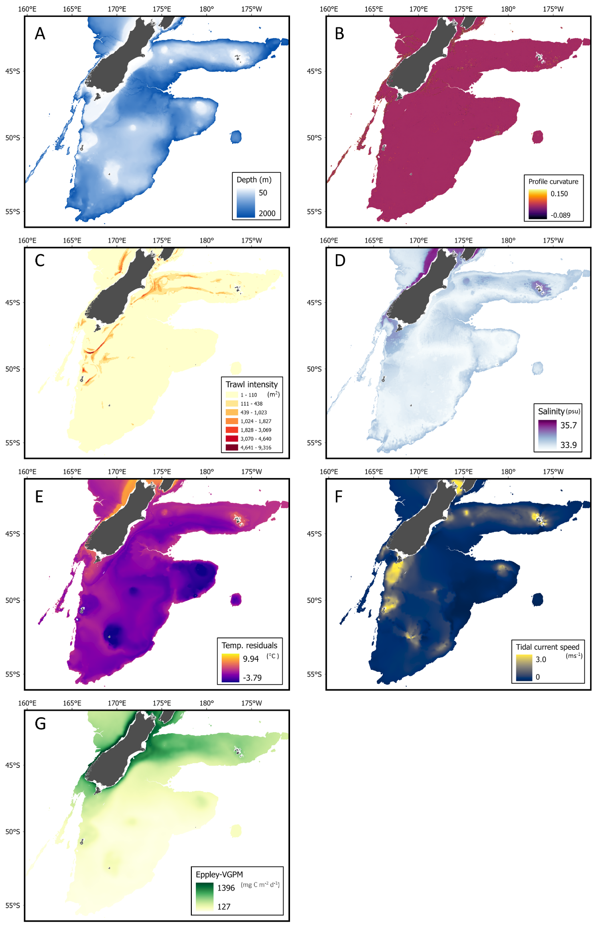
Figure S1. Spatial distribution of explanatory variables used in joint species distribution modelling: A) Depth; B) Profile curvature; C) Trawl history; D) Salinity; E) Temperature residuals; F) Tidal current speed; G) Mean Eppley-VGPM.

Table S1. Vulnerability score of VME indicator morphotypes to bottom trawling
Taxon | SPRFMO VME indicator taxa | Vulnerability score | Morphotype | Notes
Alcyonacea | Alcyonacea | 2.05906846 | octocorals_fleshy_arborescent-alcyonacea; octocorals_fleshy_mushroom-alcyonacea | average these two classes
Anemones | Actinaria | 1.957890021 | anemones_solitary-actiniaria
Anthomastus sp. | Alcyonacea | 1.957890021 | octocorals_fleshy_mushroom-alcyonacea
Antipatharia | Antipatharia | 2.273030283 | octocorals_seafan_fern_simple-antipatharia
Ascidiacea
Asteroidea
Barnacles
Bivalvia
Brachiopoda
Brachyura
Brisingidae | Brisingidae | 2.097617696 | Echinoderms_Feather stars_Unstalked-crinoids | No appropriate label in standard CATAMI list. Use same vulnerability as for unstalked crinoids
Bryozoa | Bryozoa | 2.177326603 | bryozoans_hard_branching-bryozoans; bryozoans_hard_encrusting-bryozoans; bryozoans_hard_fenestrate-bryozoans; bryozoans_soft_dendroid-bryozoans; bryozoans_soft_foliaceous-bryozoans | average all CATAMI codes except 'massive'
Buccinidae
Caridea
Caryophylliidae | Scleractinia | 2.776388541 | stony_corals_solitary-scleractinia
Ceriantharia | Actinaria | 1.695582496 | anemones_solitary-corallimorpharia | Burrowing taxon, so choose lowest anmeone value
Cidaroidea
Cladorhizidae | Porifera | 2.457980201 | sponges_erect_1d-porifera | selected lowest sponge value
Corallimorpharia
Crinoidea (motile) | Crinoidea | 2.097617696 | Echinoderms_Feather stars_Unstalked-crinoids | Added relevant CATAMI label then scored as for stalked but reducing 'rareness' and 'sessility' from 3 to 2
Crinoidea (stalked) | Crinoidea | 2.720294102 | crinoid_stalked-crinoid_stalked
Crustacean lobster
Demospongiae | Porifera | 2.776388541 | sponges_erect_2d-porifera | selected mid-vulnerability category from CATAMI sponges
Dermechinus horridus
Echinothurioida
Echiura
Enypniastes.eximia
Epizoanthidae | Zoantharia | 2.549509757 | anemones_colonial-zoantharia | review: commensal so consider adjusting vulnerability downwards
Euechinoidea
Flabellum | Scleractinia | 2.62202212 | stony_corals_solitary_free-scleractinia
Galatheidae Chirostylidae
Gastropoda
Goniocorella dumosa | Scleractinia | 2.776388541 | stony_corals_colonial-scleractinia
Gorgonacea | Gorgonacea | 2.624256248 | octocorals_bottle_brush_complex-gorgonacea; octocorals_bottle_brush_simple-gorgonacea; octocorals_branching_arborescent-gorgonacea; octocorals_branching_bushy-gorgonacea; octocorals_seafan_flexible-gorgonacea; octocorals_whip-gorgonacea | average all Gorgonacea
Gorgonocephalidae
Hexactinellida | Porifera | 2.776388541 | sponges_erect_2d-porifera | selected mid-vulnerability category
Holothuroidea
Hyalascus sp. | Porifera | 2.776388541 | sponges_cup_tube_chimney-porifera
Hyalinoecia sp.
Hydrozoa | Hydrozoa | 2.549509757 | hydroids_colonial_feather-hydroidolina | All in jSDM are bushy colonial
Isididae | Gorgonacea | 2.62202212 | octocorals_branching_arborescent-gorgonacea
Kophobelemnon sp. | Pennatulacea | 2.389211864 | octocorals_quill-pennatulacea
Metanephrops challengeri
Nudibranchia
Octopoda
Ophiuroidea
Paguridae
Pennatulacea | Pennatulacea | 2.389211864 | octocorals_quill-pennatulacea | In jSDM data most are 'quill' form
Polychaeta
Primnoidae | Gorgonacea | 2.62202212 | octocorals_branching_arborescent-gorgonacea
Psolidae
Pycnogonida
Radicipes sp | Gorgonacea | 2.423839929 | octocorals_whip-gorgonacea
Ranellidae
Scaphopoda
Scleractinia | Scleractinia | 2.776388541 | stony_corals_colonial-scleractinia | in jSDM data all are 'colonial'
Serolidae
Siphonophore
Spatangoida
Stephanocyathus sp | Scleractinia | 2.776388541 | stony_corals_solitary-scleractinia
Stylasteridae | Stylasteridae | 2.614064524 | hydrocorals_branching-stylasterids
Taiaroa tauhou | Gorgonacea | 1.695582496 | anemones_solitary-corallimorpharia | review: burrowing, small, solitary - use burrowing anemone value from CATAMI
Telesto sp. | Gorgonacea | 2.776388541 | octocorals_branching_bushy-gorgonacea | review: very small - adjust vulnerability
Volutidae
Worm indet
Xenophyophoroidea
Zoanthidea | Zoantharia | 2.549509757 | anemones_colonial-zoantharia

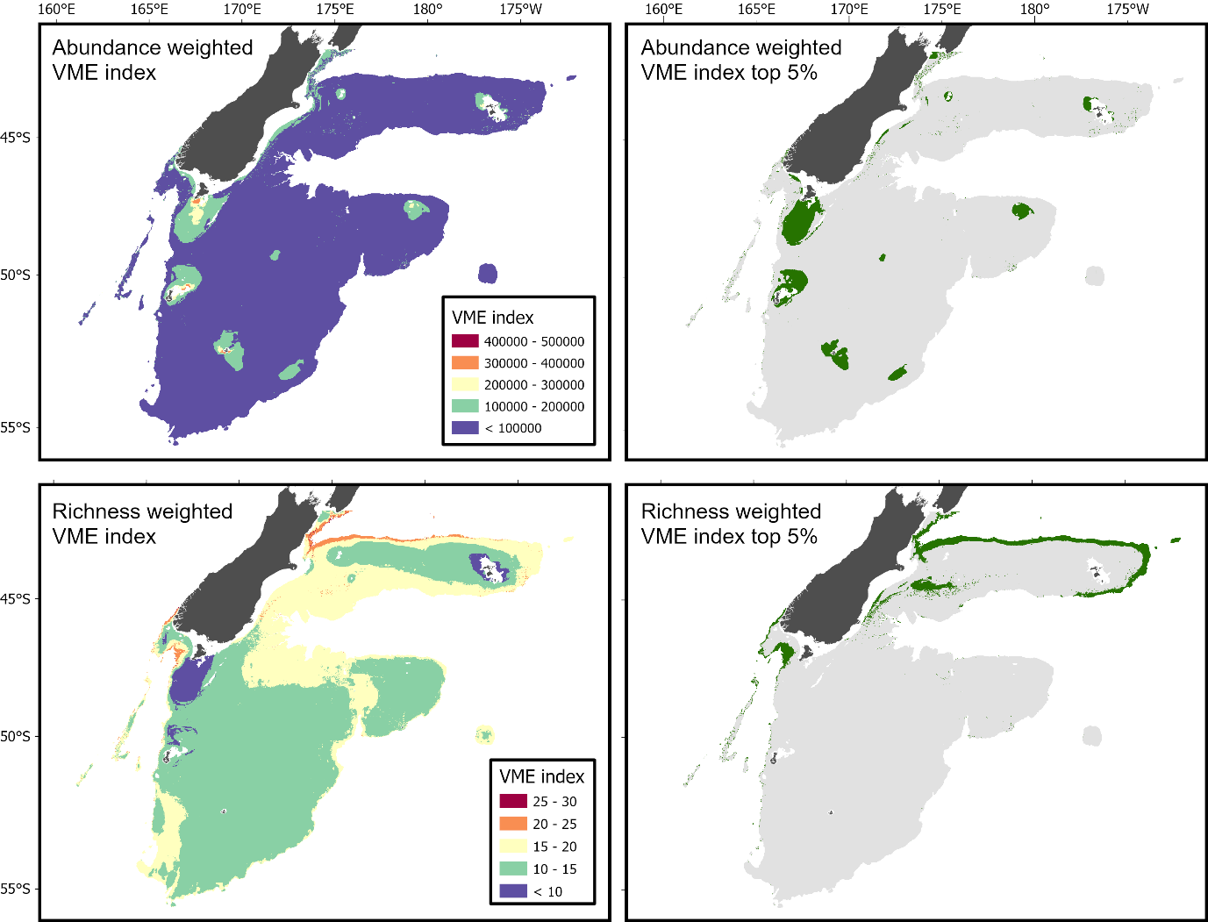
Figure S2. Predicted abundance-based VME index (top left) and top 5% of abundance-based VME index values (95th percentile threshold; top right). Predicted richness-based VME index (bottom left) and top 5% of richness-based VME index values (95th percentile threshold; bottom right).

