Fabrication of Ammonia Gas Sensor Using In Situ Synthesis of Polypyrrole-Zinc Oxide Nanorod Nanocomposites on Textiles

Debasis Maity^{1,2}, D. Ranjith Kumar³, Ramasamy Thangavelu Rajendra Kumar ^{1,3*}

¹DRDO BU Center for Life Sciences, Bharathiar University, Coimbatore – 64146, India.
²Department of Biosystems Science and Engineering, ETH Zurich, Mattenstrasse 26, CH-4058 Basel, Switzerland.
³Department of NanoScience and Technology, Bharathiar University, Coimbatore - 641046, Tamil Nadu, India.

* Corresponding Author: rtrkumar@buc.edu.in

The schematic diagram of gas sensing measurement:

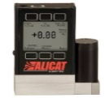

MFC₃

Input
Sensor
Humidity probe
Water
Output
MFC₂
Chamber
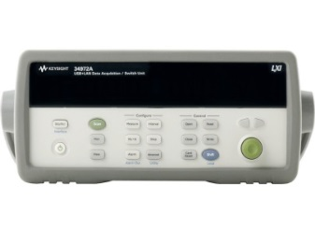
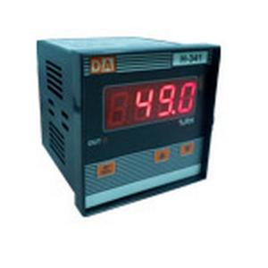
Ammonia solution

MFC₁
Bubbler
N₂ cylinder
H-341
Keysight 34972A
Open Valve

Figure S1: Supplementary Figure 1 illustrates the schematic diagram of the gas sensing measurement setup.

SEM image:

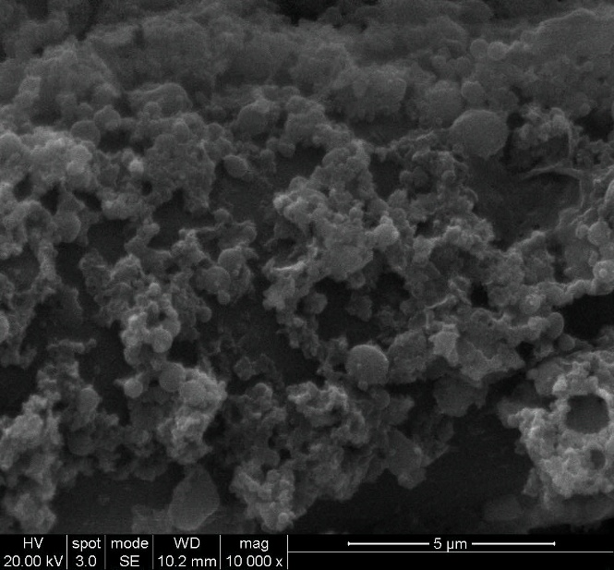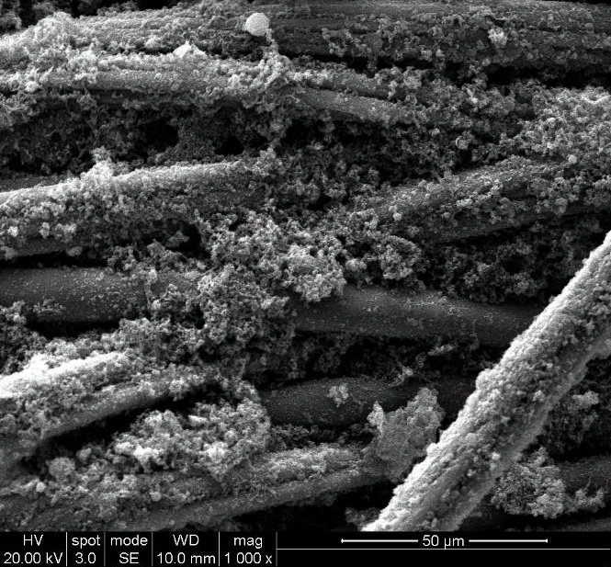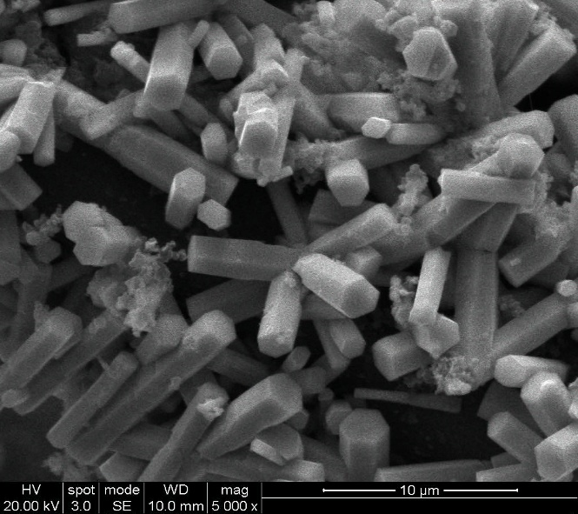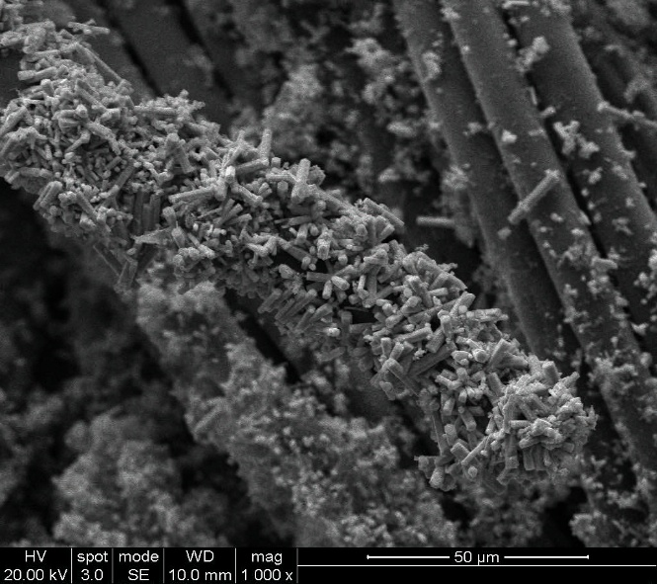
(a)
(c)
(b)
(d)
Figure S2: The scanning electron microscopic (SEM) images of (a-b) PPy and (c-d) ZnO/PPy coated fabric at different magnifications.

EDX analysis:
Figure 1(c) and (d) present a comparison of the EDX analysis for polypyrrole and polypyrrole/ZnO coated fabric, respectively. For the polypyrrole coated fabric, the relative weight percentage of elements recorded were 59.91% for C, 19.99% for O, and 20.10% for N.
In contrast, the polypyrrole/ZnO coated fabric exhibited weight percentages of 58.66% for C, 11.92% for N, 23.30% for O, and 6.11% for Zn. These results indicate the elemental composition of the respective coated fabrics.
(a)
(b)

Figure S3: Energy-dispersive analysis X-ray (EDAX) images of the (a) polypyrrole coated fabric and (b) ZnO/PPy coated fabric.

