Supplement: Impact of gene-by-trauma interaction in MDD-related multimorbidity clusters

Sarah Bonk^{1*}, Nora Eszlari^{2,3*}, Kevin Kirchner¹, Andras Gezsi⁴, Linda Garvert¹, Mikko Koukkanen^{5,6,7}, Isaac Cano⁸, Hans J. Grabe^{1,9}, Peter Antal^{4*}, Gabriella Juhasz^{2,3*}, Sandra Van der Auwera^{1,9*}

¹Department of Psychiatry and Psychotherapy, University Medicine Greifswald, 17475 Greifswald, Germany.
²Department of Pharmacodynamics, Faculty of Pharmacy, Semmelweis University, Nagyvárad tér 4., H-1089 Budapest, Hungary.
³NAP3.0-SE Neuropsychopharmacology Research Group, Hungarian Brain Research Program, Semmelweis University, Üllői út 26., H-1085 Budapest, Hungary.
⁴Department of Measurement and Information Systems, Budapest University of Technology and Economics, Műegyetem rkp. 3., H-1111 Budapest, Hungary.
⁵Department of Public Health and Welfare, Finnish Health and Welfare Institute. Biomedicum 1, Haartmaninkatu 8, 00290 Helsinki, Finland.
⁶Department of Human Genetics and South Texas Diabetes and Obesity Institute, School of Medicine at University of Texas Rio Grande Valley, Brownsville, TX, United States.
⁷Research Program for Clinical and Molecular Metabolism, Faculty of Medicine, University of Helsinki, Finland.
⁸Hospital Clínic de Barcelona. Institut d’Investigacions Biomèdiques August Pi i Sunyer (IDIBAPS). Universitat de Barcelona. Villarroel 170. Barcelona, 08036. Spain.
⁹German Centre for Neurodegenerative Diseases (DZNE), Site Rostock/Greifswald, 17475 Greifswald, Germany.
*contributed equally

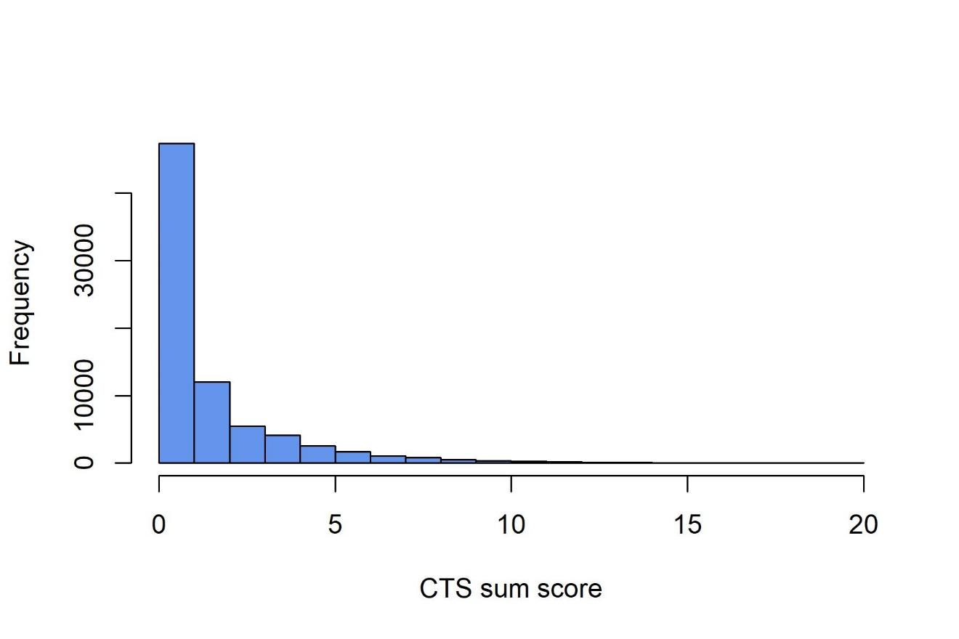
Fig. S1. Histogram of CTS sum score in UKB sample.

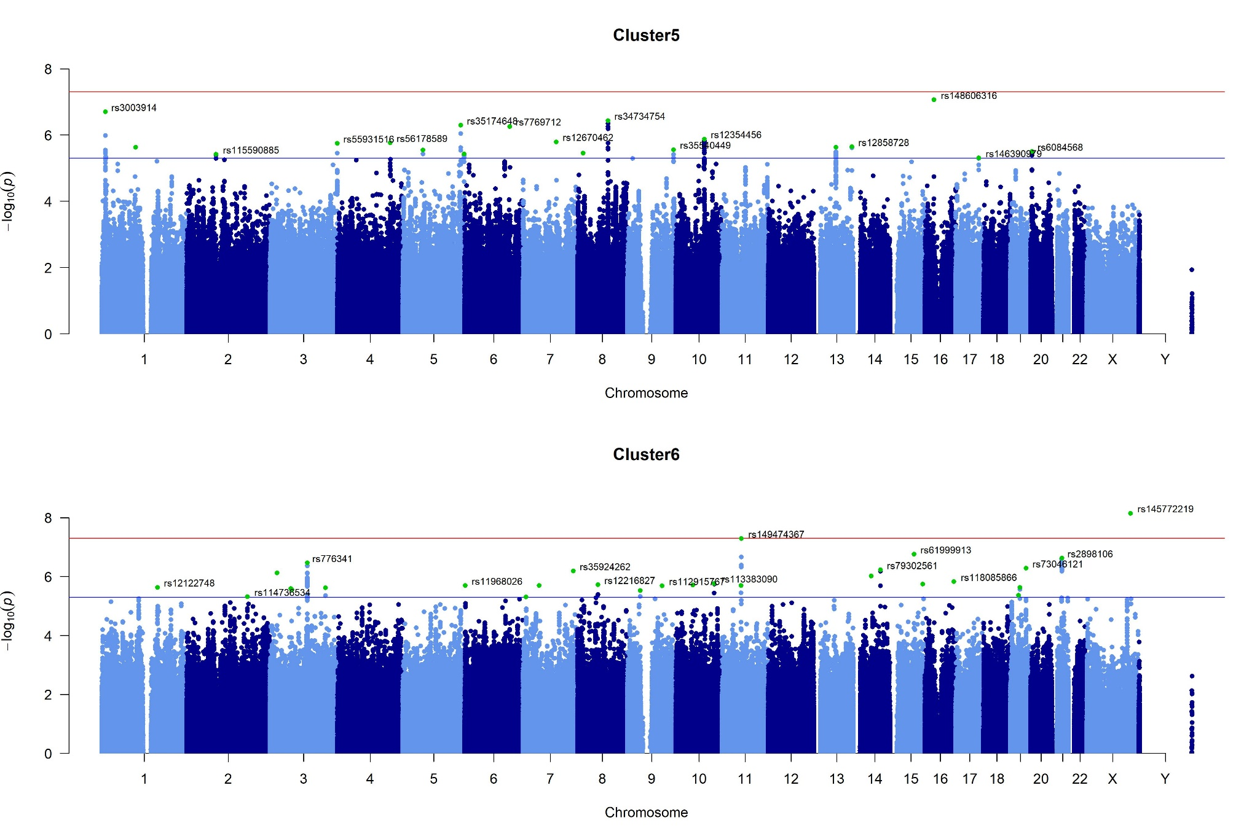
Fig. S2. SNP based Manhattan Plot of G×E GWAS

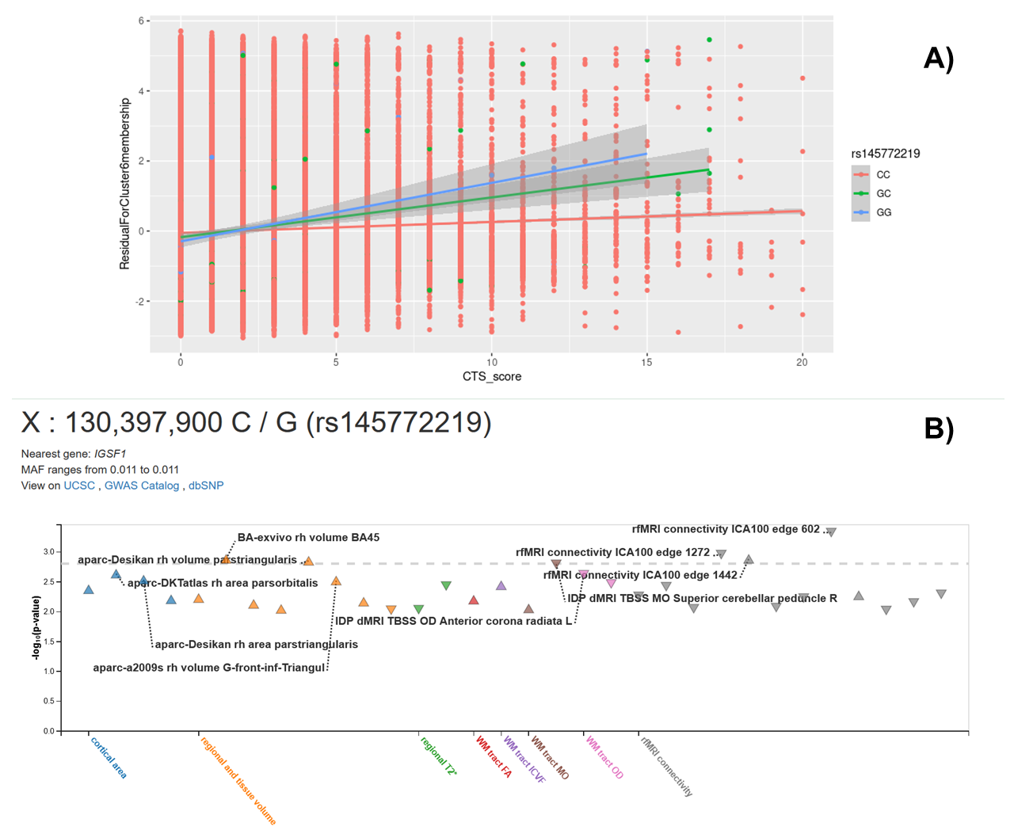
Fig. S3. Association of childhood trauma score with membership to Cluster 6 depends on rs145772219 genotype, as our only genome-wide significant interaction result demonstrates (panel A), and the associations of rs145772219 genotype with brain imaging phenotypes in UK Biobank are shown (panel B). In our results, G allele of rs145772219, in contrast to CC genotype and in an additive manner, seems to protect against Cluster 6 membership in the absence of childhood trauma but confers a risk for cluster 6 membership in case of higher levels of childhood trauma. G allele, at the same time, is significantly associated with a higher volume of two parts of the right inferior frontal gyrus (https://open.win.ox.ac.uk/ukbiobank/big40/ , https://open.win.ox.ac.uk/ukbiobank/big40/pheweb33k/ , Elliott et al., 2018; Smith et al., 2021). Nearest gene to rs145772219 is IGSF1 (Immunglobulin Superfamily Member 1). In our results (panel A), males’ haploid genotypes are coded as if homozygous; and membership to Cluster 6 is a residual of the linear regression model applied in the GWAS analysis for the membership as outcome but without main effect terms of CTS score and the SNP, and their interaction term. CTS: Childhood Trauma Screener; SNP: single-nucleotide polymorphism.
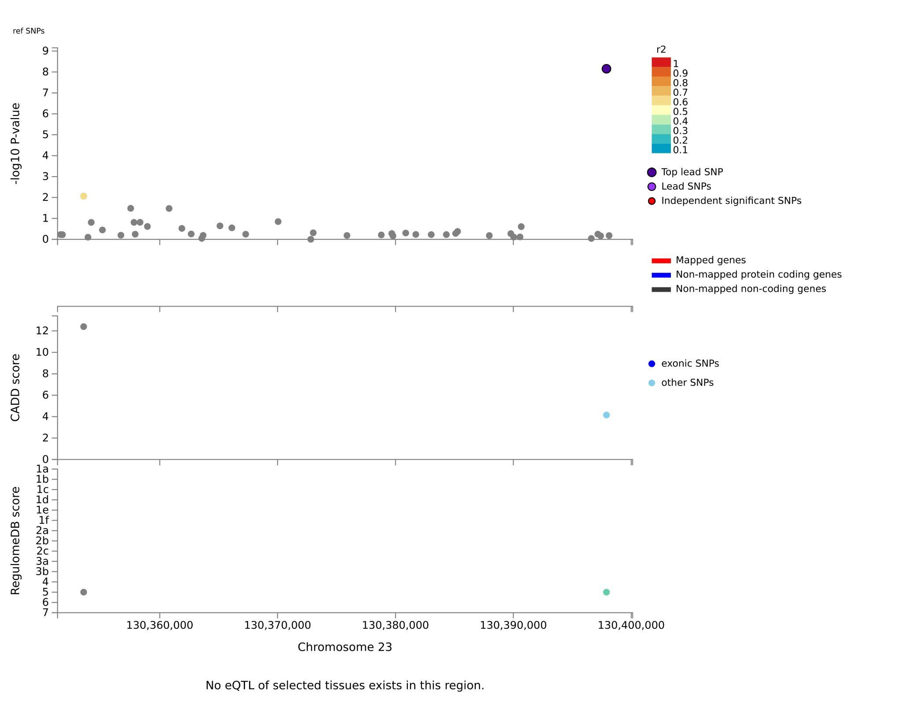
Fig. S4. FUMA regional plot for chromosome 23 (X chromosome) Cluster 6 genome-wide significant locus.

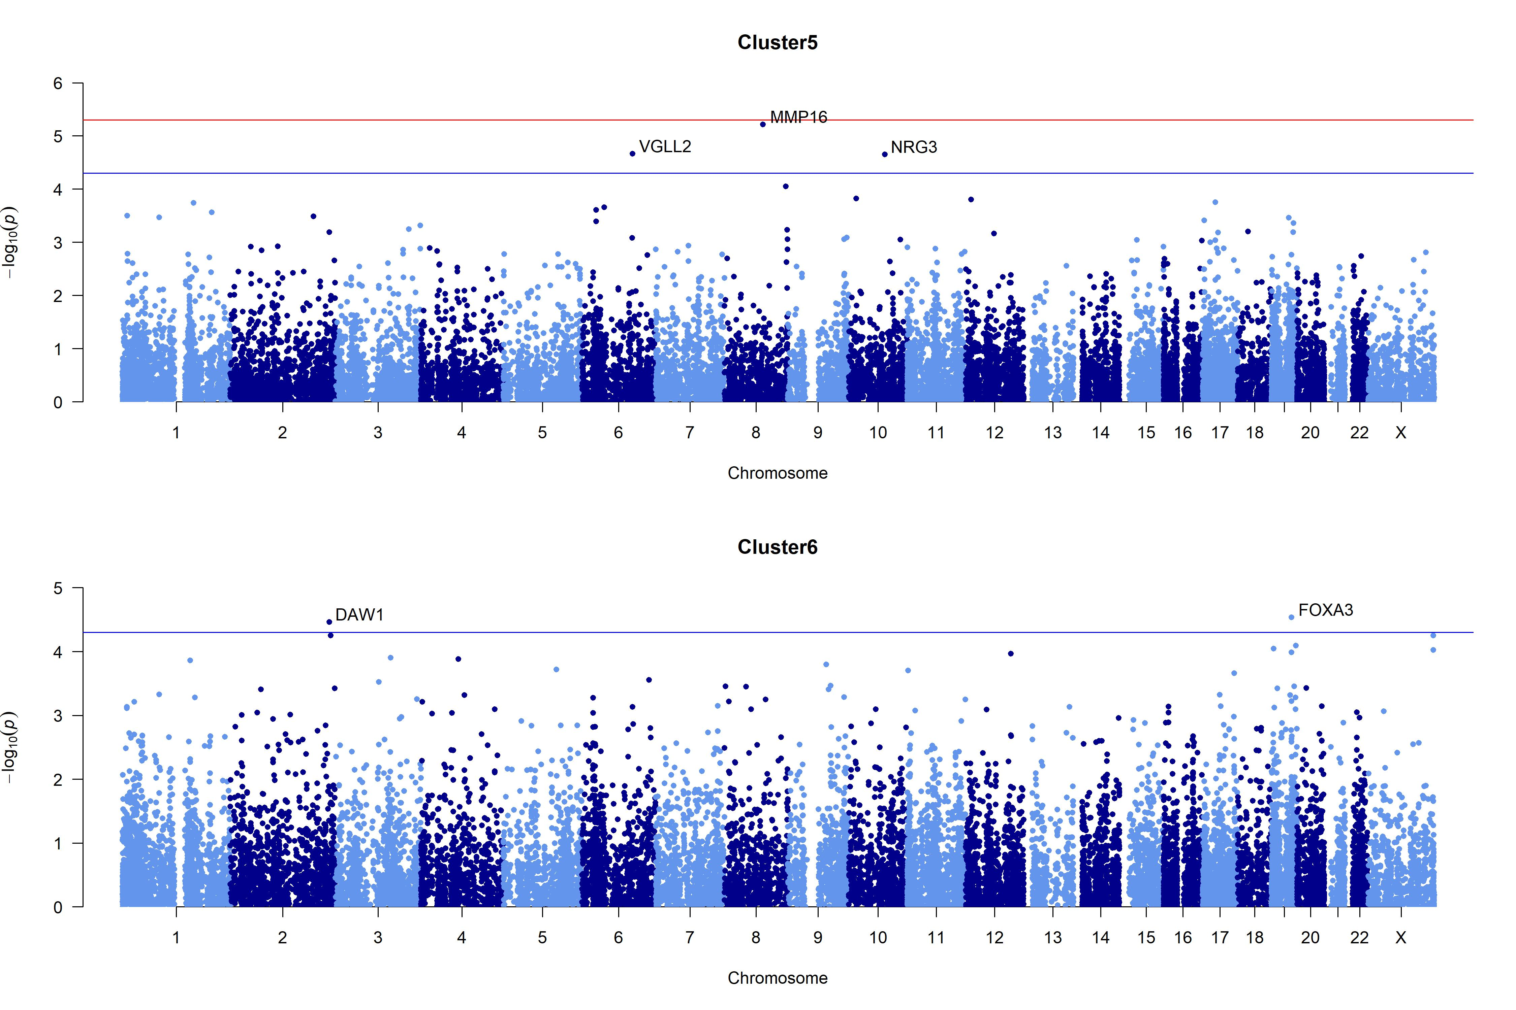
Fig. S5. Gene based Manhattan Plot from G×E GWAS
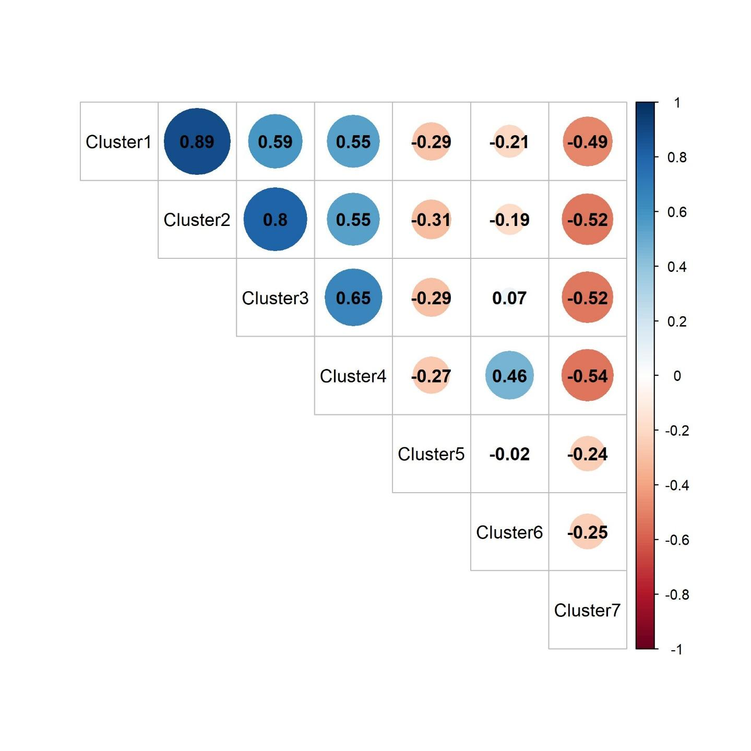
Fig. S6. Correlation of Beta values from MDD-related clusters G×E GWAS in UKB (N = 76,856).
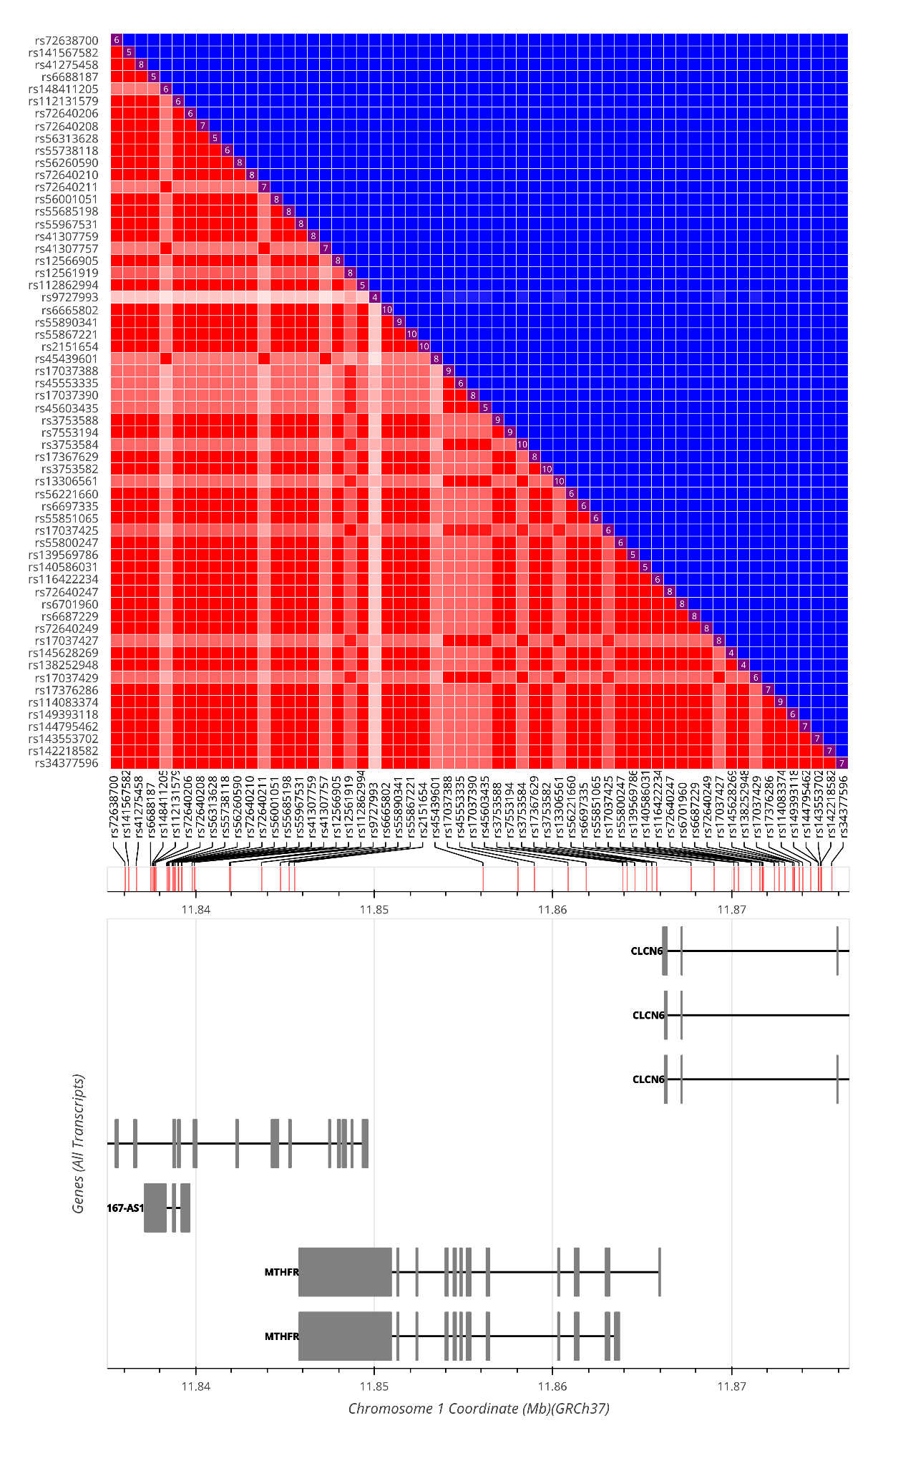
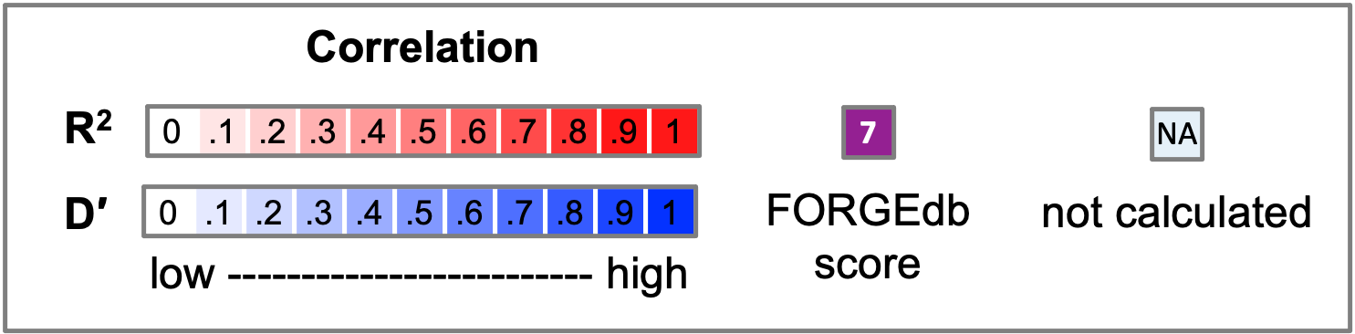
Fig. S7. Heatmap matrix of pairwise linkage disequilibrium statistics of the 60 significant SNPs from MTHFR gene (created with LD matrix tool https://ldlink.nih.gov/?tab=ldmatrix). The 60 SNPs were chosen due to them being significant in five clusters.

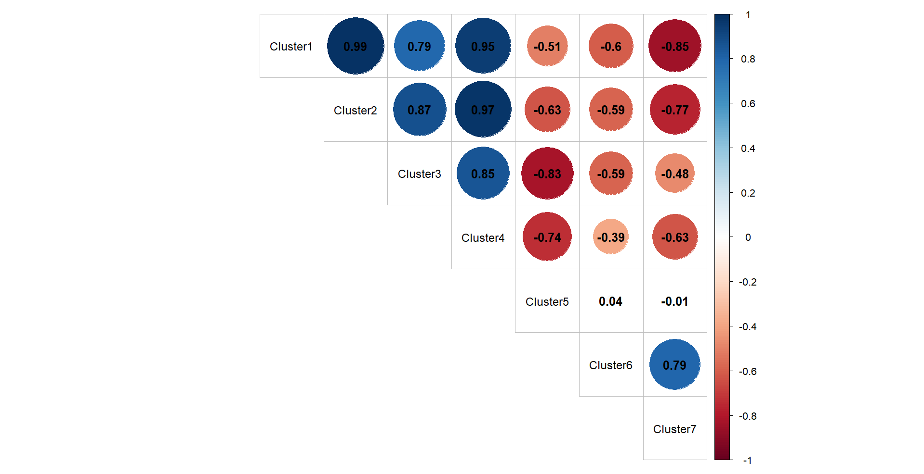Fig. S8. Correlation of beta values from four independent MTHFR SNPs (rs9727993, rs148411205, rs12561919, rs112131579) for all seven clusters. The four SNPs were chosen due to them being significant in five clusters.

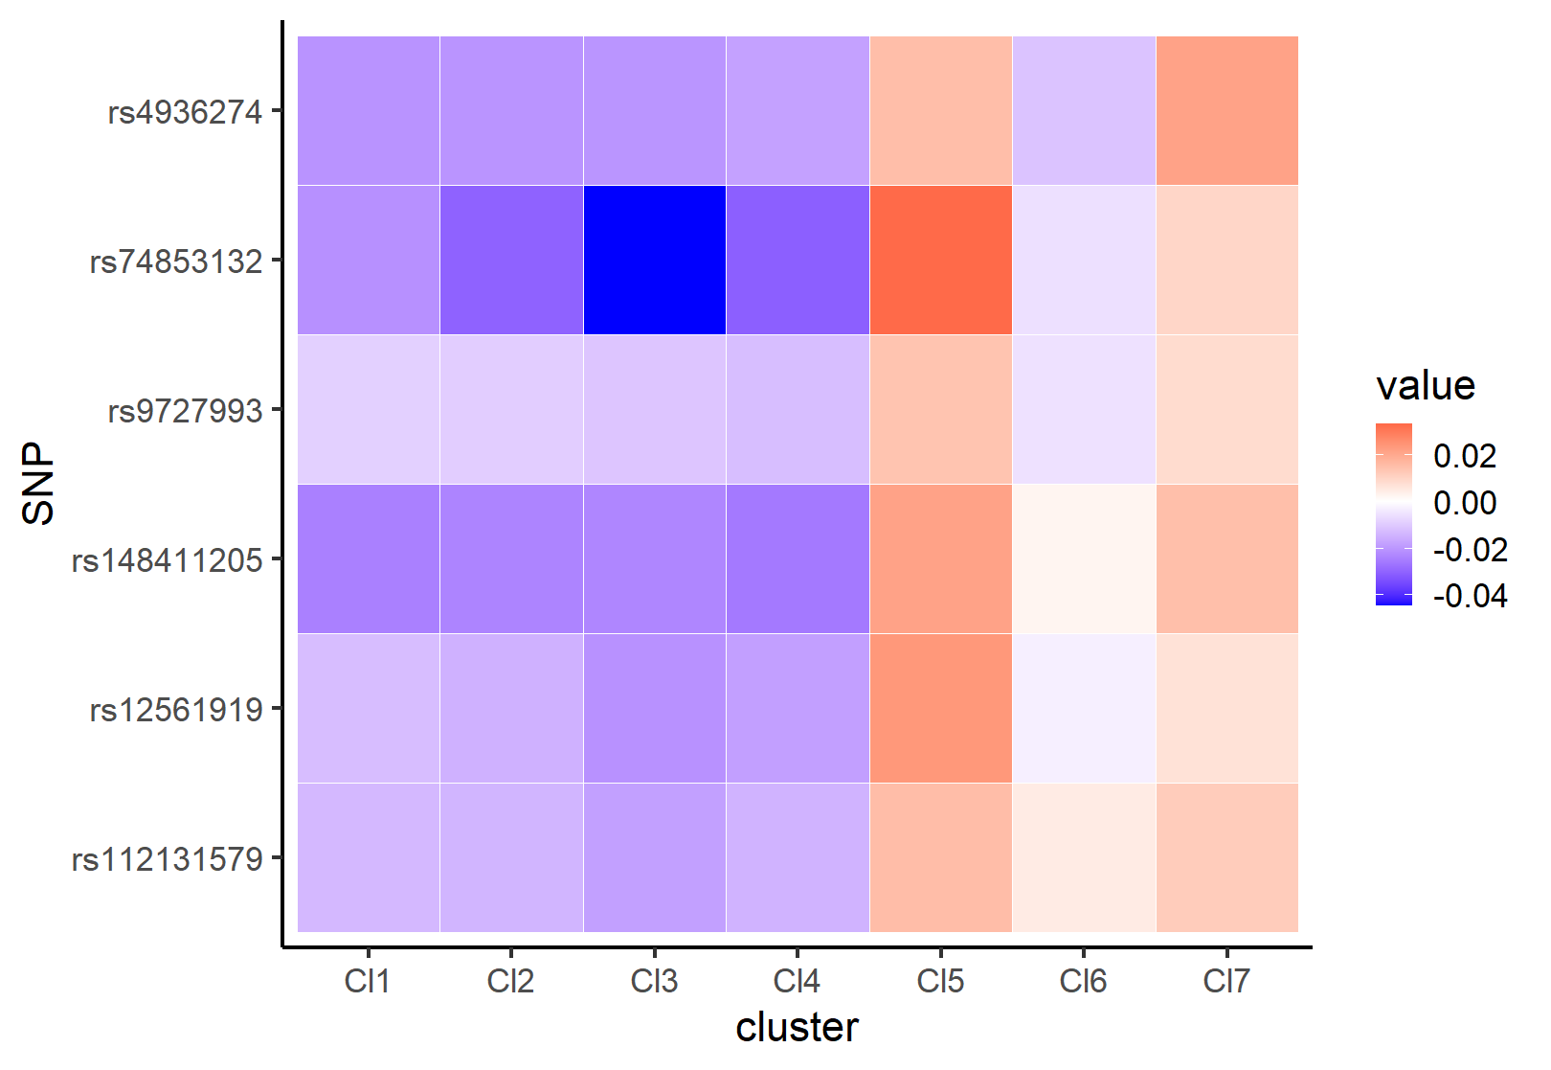
Fig. S9. Heatmap matrix of beta values in all seven clusters. rs4936274 DRD2; rs74853132 FKBP5; rs9727993, rs148411205, rs12561919, rs112131579 MTHFR

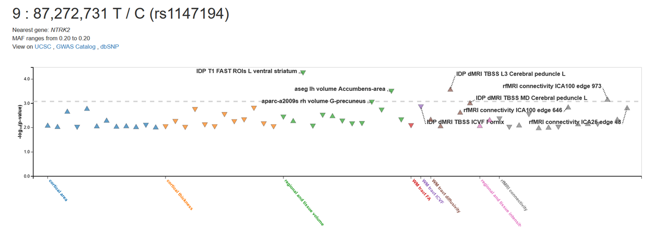
Fig. S10. Associations of NTRK2 rs1147194 C allele with brain imaging phenotypes in UK Biobank. C allele is associated with reduced volumes of left nucleus accumbens and ventral striatum (https://open.win.ox.ac.uk/ukbiobank/big40/ , https://open.win.ox.ac.uk/ukbiobank/big40/pheweb33k/ , Elliott et al., 2018; Smith et al., 2021).

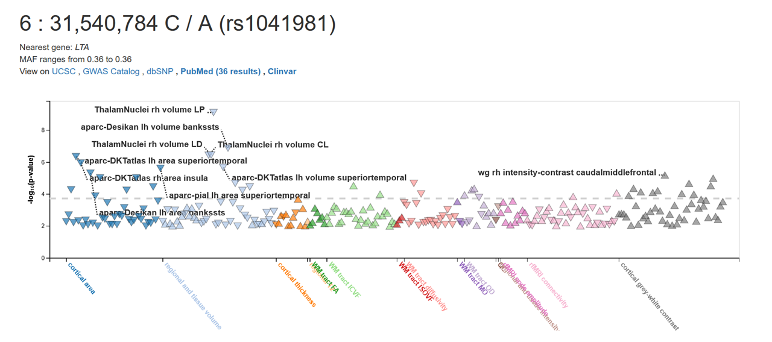
Fig. S11. Associations of TNF (LTA) rs1041981 A allele with brain imaging phenotypes in UK Biobank. A allele is associated with reduced volumes of right thalamic nuclei, and reduced area parameters of the left superior temporal cortex (https://open.win.ox.ac.uk/ukbiobank/big40/ , https://open.win.ox.ac.uk/ukbiobank/big40/pheweb33k/ , Elliott et al., 2018; Smith et al., 2021).

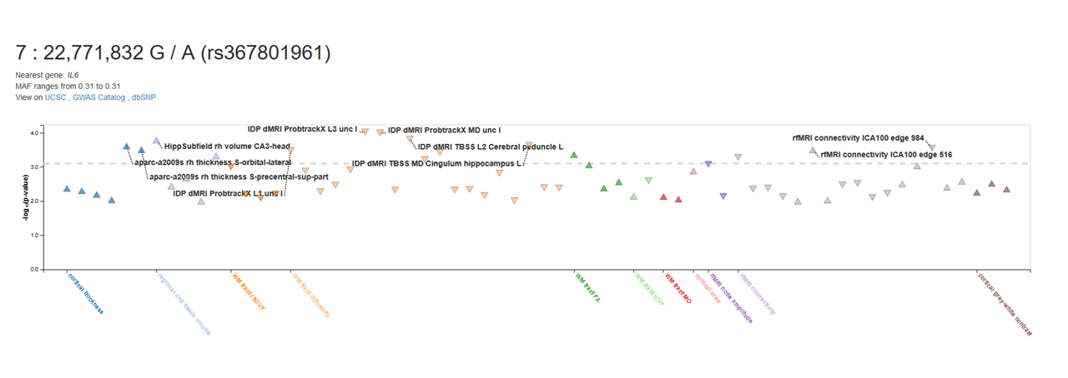
Fig. S12. Associations of IL6 rs367801961 A allele with brain imaging phenotypes in UK Biobank. A allele is associated with increased cortical volume parameters of bilateral precentral sulci, as well as an increased volume of right hippocampal CA3 head and higher fractional anisotropy (reflecting a higher tract integrity) in left cerebral peduncle (https://open.win.ox.ac.uk/ukbiobank/big40/ , https://open.win.ox.ac.uk/ukbiobank/big40/pheweb33k/ , Elliott et al., 2018; Smith et al., 2021).

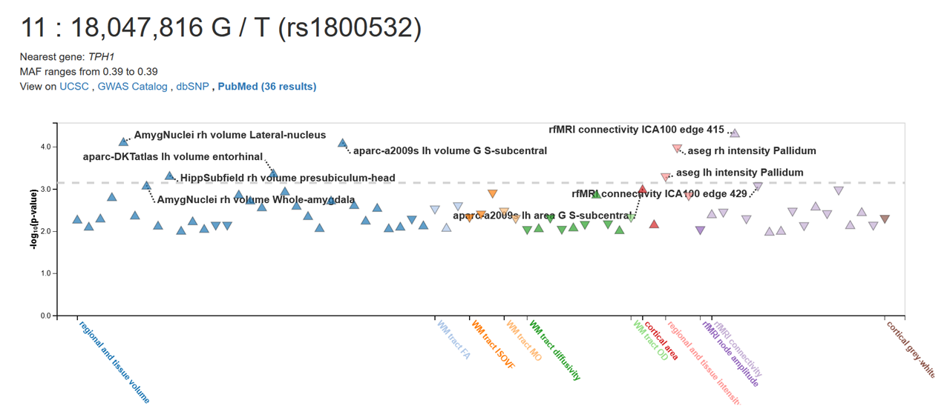
Fig. S13. Associations of TPH1 rs1800532 T allele with brain imaging phenotypes in UK Biobank. T allele is associated with a bilateral decreased intensity of pallidum, and with increased volumes of left entorhinal cortex, right hippocampal presubiculum-head, and right lateral nucleus of amygdala (https://open.win.ox.ac.uk/ukbiobank/big40/ , https://open.win.ox.ac.uk/ukbiobank/big40/pheweb33k/ , Elliott et al., 2018; Smith et al., 2021).

References
Elliott, L.T., Sharp, K., Alfaro-Almagro, F., Shi, S., Miller, K.L., Douaud, G., Marchini, J., Smith, S.M., 2018. Genome-wide association studies of brain imaging phenotypes in UK Biobank. Nature 562, 210–216.
Smith, S.M., Douaud, G., Chen, W., Hanayik, T., Alfaro-Almagro, F., Sharp, K., Elliott, L.T., 2021. An expanded set of genome-wide association studies of brain imaging phenotypes in UK Biobank. Nature neuroscience 24, 737–745.

