Supplementary data:
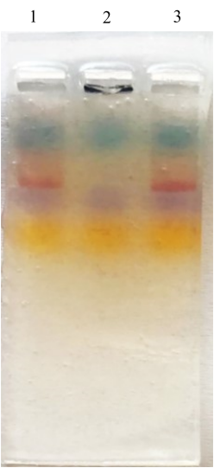

Supplementary. 1 gel electrophoresis of DC specific Apt-modified GNPs. Well 1 and 3 were loaded with Apt-modified GNPs and well 2 with naked GNPs

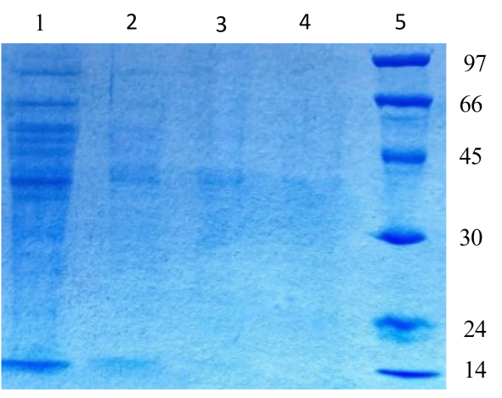

Supplementary. 2 SDS-PAGE analysis to evaluate the loaded protein of Pla.orintalis pollen extract on GNPs, well 1: total extract (1000 μg/ml), well 2: 100 μg total extract as control, well 3: non-binding protein of Pla.orintalis pollen extract on GNPs; well 4: detached protein of "Pla. ext-Apts-GNPs" complex, well 5: LMW protein marker

