Supporting information for “Food-web complexity, consumer behavior and diet specialism: impacts on ecosystem stability”
Tommi Perälä^{1*}, Mikael Kuisma², Silva Uusi-Heikkilä¹ and Anna Kuparinen¹
in ”Theoretical Ecology”
¹ Department of Biological and Environmental Science, University of Jyväskylä, Finland
² Department of Physics, Technical University of Denmark, Denmark
*Corresponding author: Tommi Perälä, tommi.a.perala@jyu.fi, +358 40 805 3692‬

Additional Figures

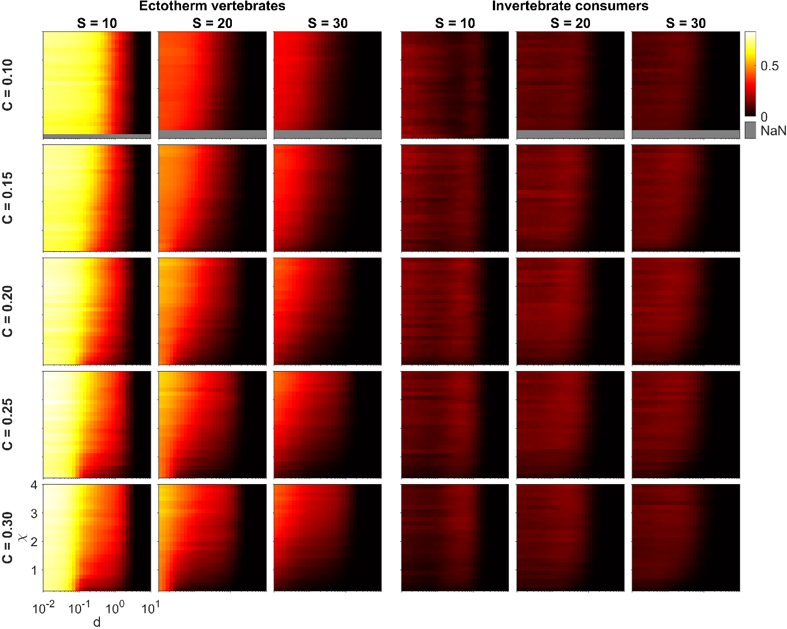
Fig S1 Food-web oscillation measure $O_{tot}$ as a function of the second Extended Niche model parameter $χ$ and intraspecific consumer interference parameter $d$ for small, intermediate and large network sizes $S$, five values of network connectance $C∈\{0.10, 0.15,0.20,0.25,0.30\}$, and two metabolic types of consumers (ectotherm vertebrates, invertebrate consumers). The lighter the color the higher the average $O_{tot}$ for the food webs generated with the corresponding parameter value 5-tuple $(MType, S,C,χ, d)$. For the figure, we filtered out those parameter combinations that had less than 200 replicate food webs
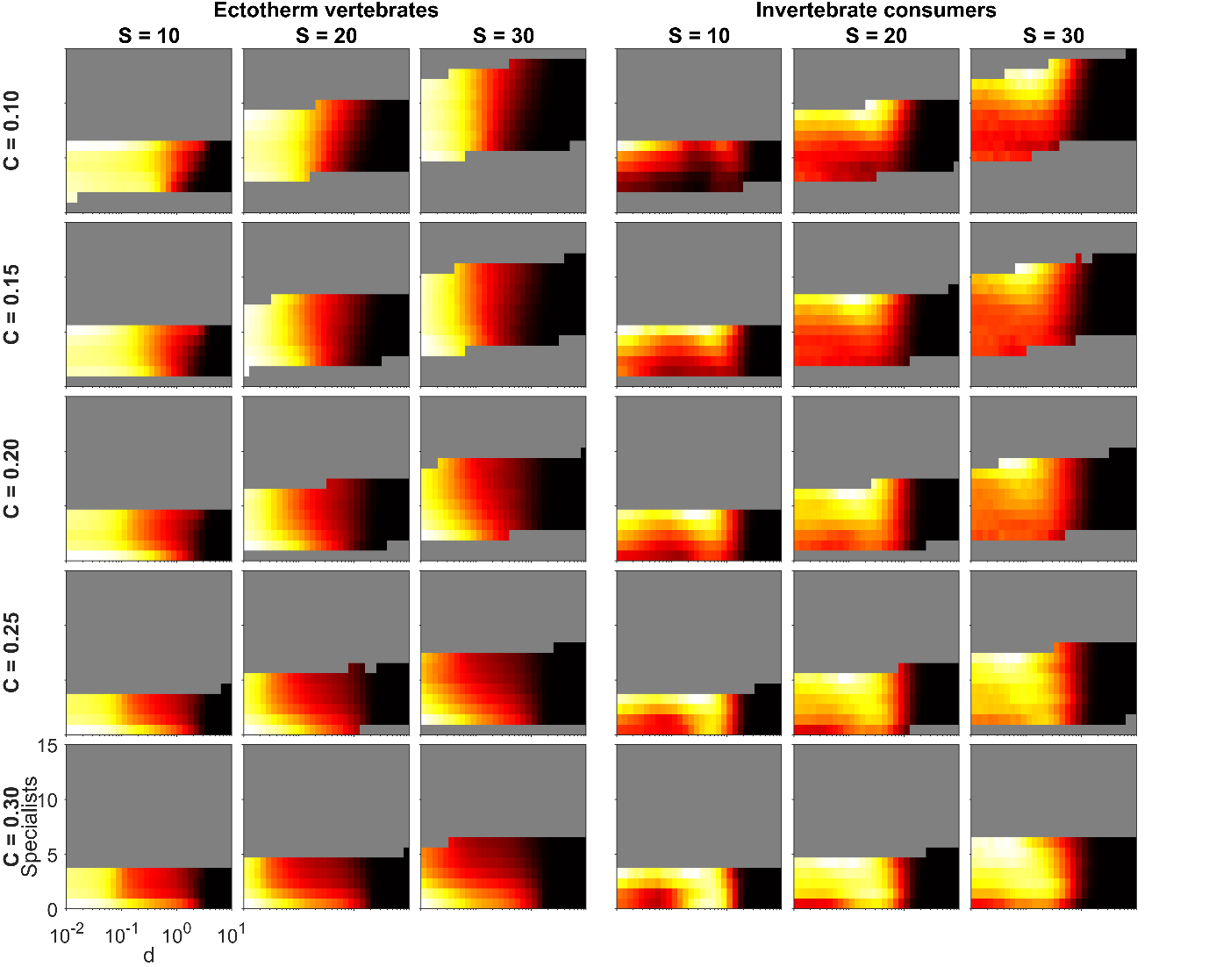
Fig S2 Food-web oscillation measure $O_{tot}$ as a function of the number of specialists and intraspecific consumer interference parameter $d$ for small, intermediate and large network sizes, five values of network connectance $C∈\{0.10, 0.15,0.20,0.25,0.30\}$, and two types of consumers (ectotherm vertebrates, invertebrate consumers). The lighter the color the higher average $O_{tot}$ for the corresponding food-web property – food-web dynamics parameter value pair $(Specialists, d)$. A species was considered a specialist when it had at most 10% of the species in the original food web on its diet. Each panel has its own scale, and as the figure attempts to highlight the relative effect of specialism within each panel, the color bars are not shown. Moreover, only those $(Specialists, d)$ pairs are shown that had data from at least 400 simulations. Furthermore, for aesthetic reasons, a robust mean estimator was used, which ignored outliers whose distance to the mean was more than 4 standard deviations

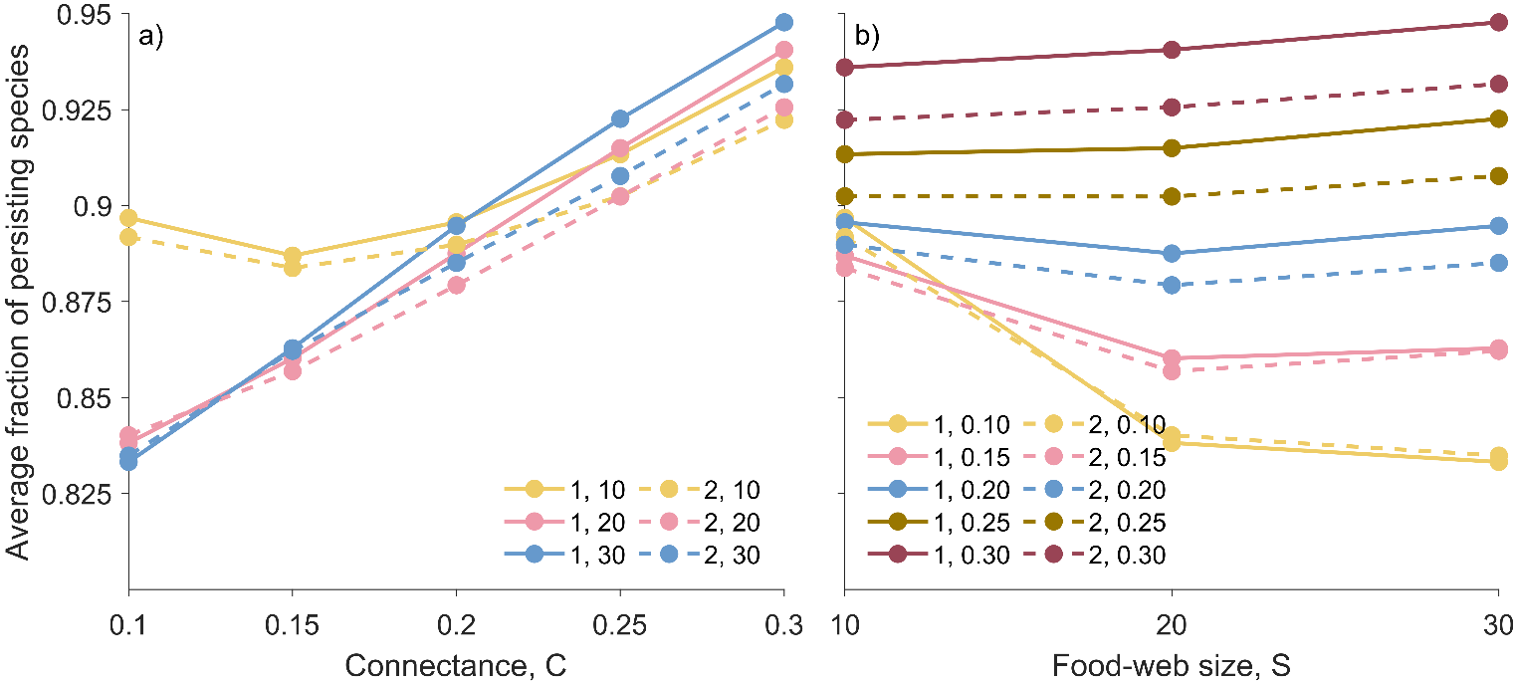Fig S3 Average fraction of persisting species in the food webs generated randomly using the Extended Niche model, ${NICHE}_{3}(S,C,χ)$ plotted against connectance (panel a) and food-web size (panel b). The line style and color denote different pairs of metabolic type (1 = ectotherm vertebrates, 2 = invertebrate consumers) and $S$ (panel a), and metabolic type and $C$ (panel b)

