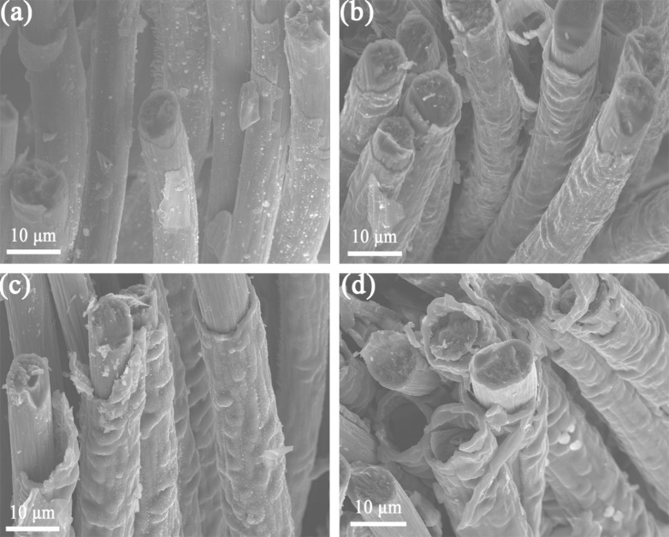
Fig. S1 The cross-sectional SEM images for different number of cycles (a) CF@PPy-30 ,(b) CF@PPy-60, (c)CF@PPy-90, (d) CF@PPy-120.

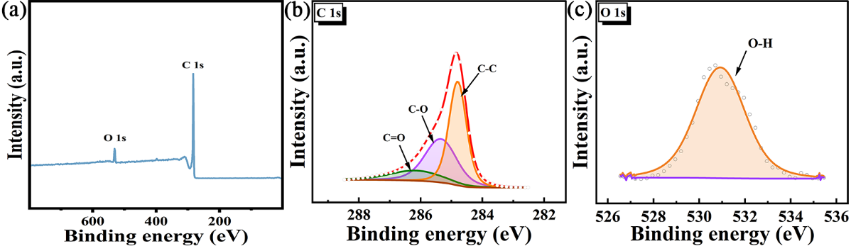
Fig. S2 XPS of CF (a) full scan, (b) C 1s ,(c)O 1s;

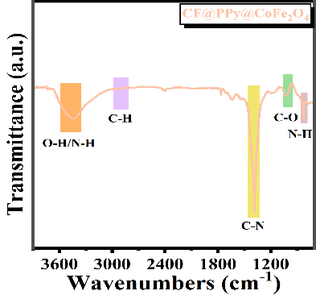
Fig.S3 FT-IR spectra of CF@PPy@CoFe2O4;

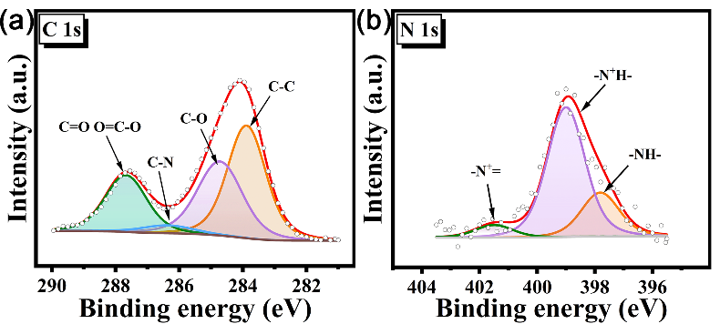
Fig. S4 XPS of CF@PPy@CoFe2O4. (a)C 1s and (b)N 1s

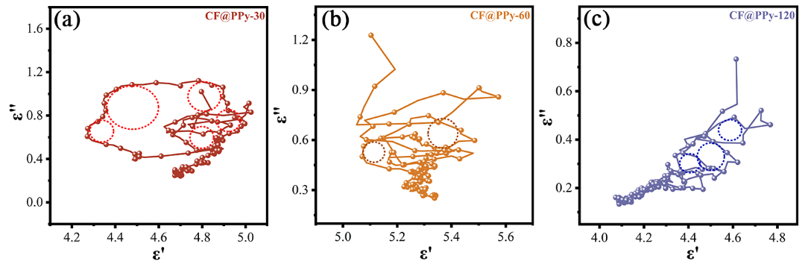
Fig. S5 Cole–Cole curves of (a) CF@PPy-30;(b) CF@PPy-60;(c) CF@PPy-120.

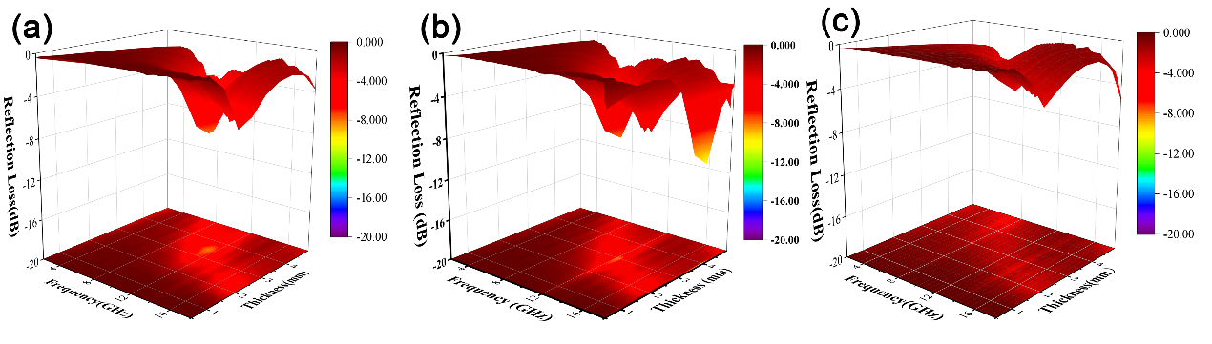
Fig. S6 RL values versus frequency of (a) CF@PPy-30;(b) CF@PPy-60;(c) CF@PPy-120.

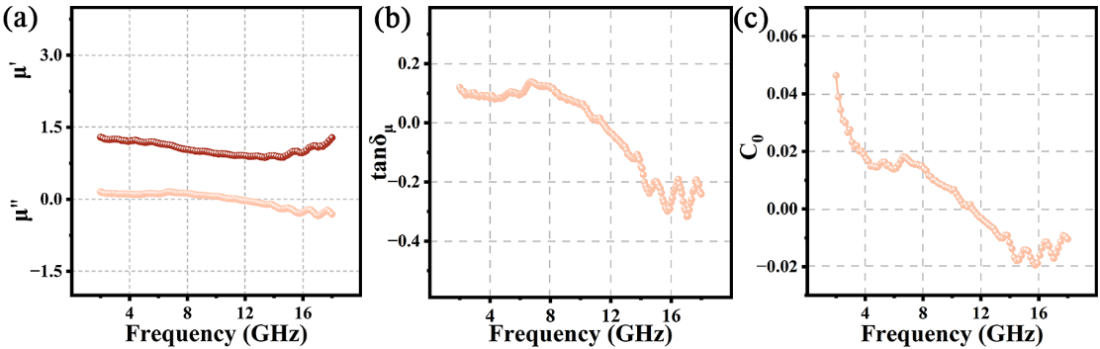
Fig.S7 (a) Real part curve and imaginary part curve of complex permeability， (b) The magnetic loss tangent, (c) C0 of CF@PPy@CoFe2O4.

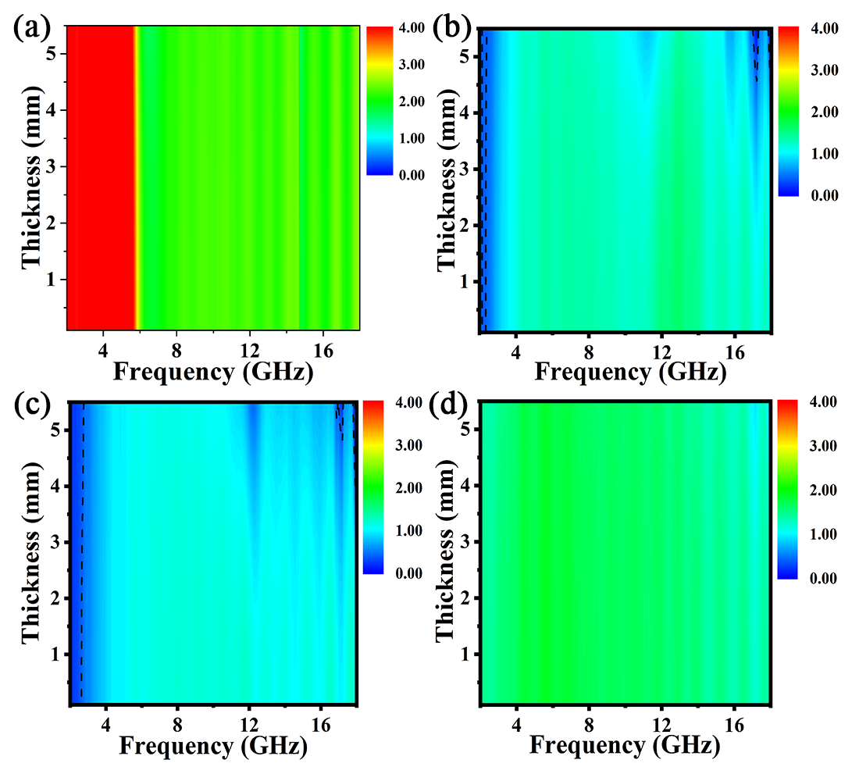
Fig. S8 Impedance matching of (a) CF@PPy-30;(b) CF@PPy-60;(c) CF@PPy-120.

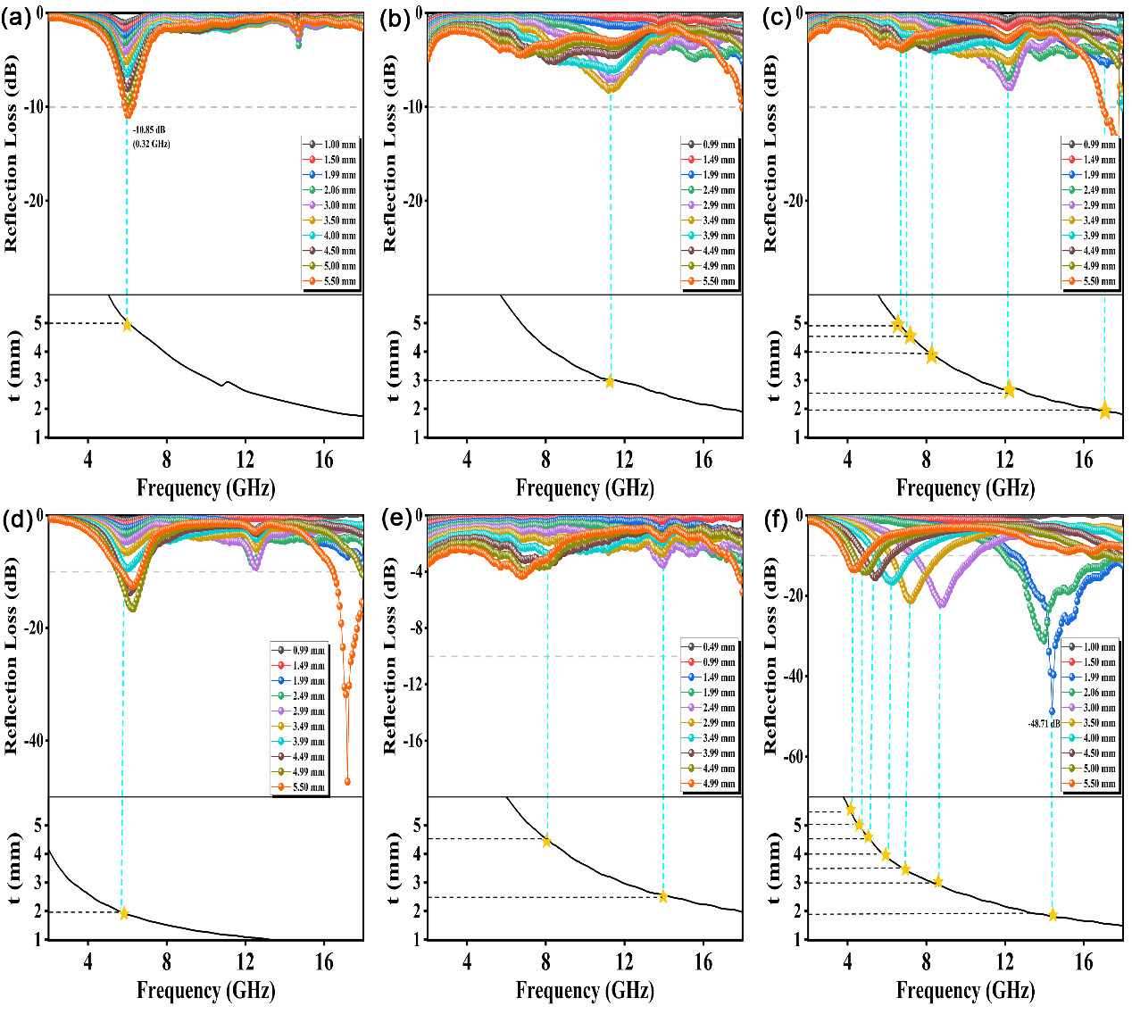
Fig.S9 Quarter-wavelength curves of (a) CF;(b) CF@PPy-30;(c) CF@PPy-90; (d)CF@PPy-120; (e)CF@PPy@CoFe2O4.

