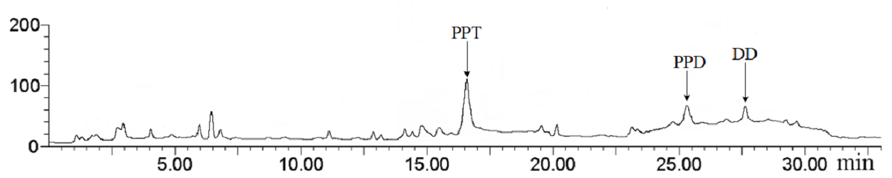
FIGURE S6. LC-MS analyses of dammarenediol-II, protopanaxadiol and protopanaxatriol in the transgenic tobacco co-expressing PnDDS, CYP12H and CYP6H. DD, dammarenediol-II; PPD, protopanaxadiol; PPT, protopanaxatriol.

