Fig. S1. Detection and expression analysis of introduced genes in transgenic tobacco expressing PnDDS. (A) Genomic DNA PCR for screening of transgenic tobacco lines via detection of introduced genes. (B) RT-PCR analysis of the introduced PnDDS genes in transgenic lines (T1, T2, T3, T4 and T5). WT tobacco was used as the negative. WT, wild-type. +, positive control.

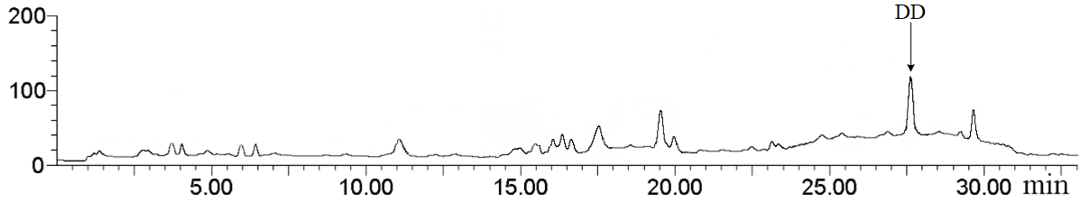
Fig. S2. LC-MS analyses of dammarenediol-II in the transgenic tobacco expressing PnDDS. DD, dammarenediol-II.

Fig. S3. Detection and expression analysis of introduced genes in transgenic tobacco co-expressing PnDDS and CYP12H. (A) Genomic DNA PCR for screening of transgenic tobacco lines via detection of introduced genes. (B) RT-PCR analysis of the introduced PnDDS and CYP12H genes in transgenic lines (T1, T2, T3, T4 and T5). WT tobacco was used as the negative. WT, wild-type. +, positive control.

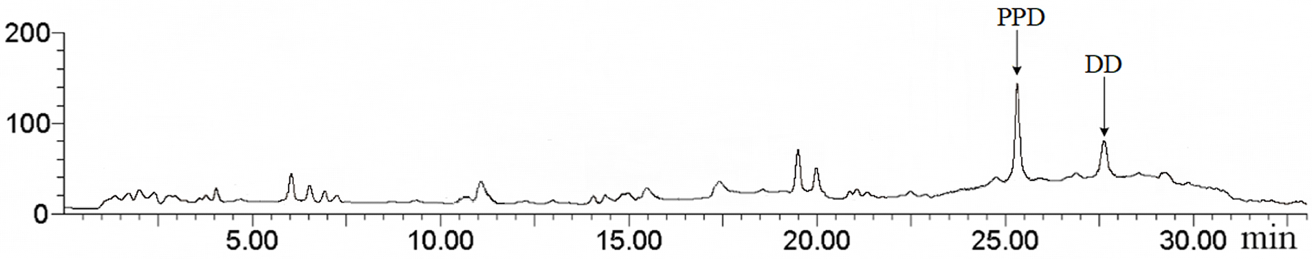 Fig. S4. LC-MS analyses of dammarenediol-II and protopanaxadiol in the transgenic tobacco co-expressing PnDDS and CYP12H. DD, dammarenediol-II; PPD, protopanaxadiol.

Fig. S5. Detection and expression analysis of introduced genes in transgenic tobacco co-expressing PnDDS, CYP12H and CYP6H. (A) Genomic DNA PCR for screening of transgenic tobacco lines via detection of introduced genes. (B) RT-PCR analysis of the introduced PnDDS, CYP12H and CYP6H genes in transgenic lines (T1, T2, T3, T4 and T5). WT tobacco was used as the negative. WT, wild-type. +, positive control.

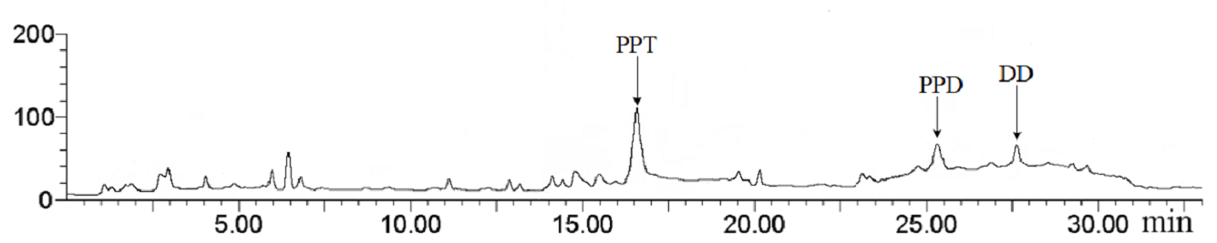
Fig. S6. LC-MS analyses of dammarenediol-II, protopanaxadiol and protopanaxatriol in the transgenic tobacco co-expressing PnDDS, CYP12H and CYP6H. DD, dammarenediol-II; PPD, protopanaxadiol; PPT, protopanaxatriol.

Fig. S7. SDS-PAGE protein electrophoresis of the tobacco
（Note, A, Transgenic tobacco during the seedling stage; B, Transgenic tobacco during the mature stage；M, protein maker; 1-2, wild type tobacco; 3-7, the transgenic tobacco of producing ginsenoside F1）

Fig. S8. APCI-MS₁ ionization spectra of dammarenediol-II, protopanaxadiol, protopanaxatriol and ginsenoside F1 peaks in the transgenic tobacco co-expressing PnDDS, CYP12H, CYP6H and UGT20. DD, dammarenediol-II; PPD, protopanaxadiol; PPT, protopanaxatriol; F1, ginsenoside F1.

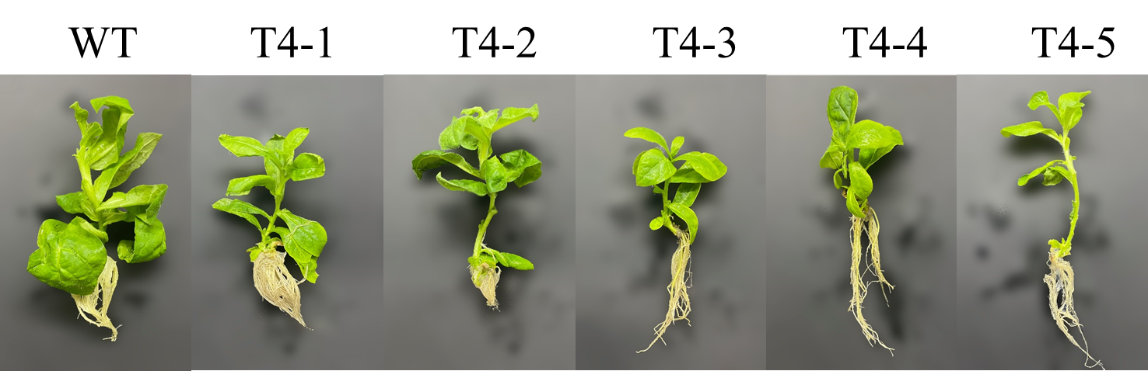
Fig. S9. The wild type and transgenic tobacco plants. WT, wild type tobacco; T4, PnDDS/CYP12H/CYP6H/UGT20-transgenic tobaccos.

