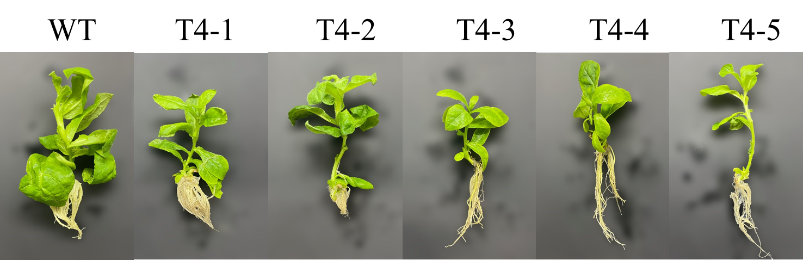
Fig. S8. The wild type and transgenic tobacco plants. WT, wild type tobacco; T4, PnDDS/CYP12H/CYP6H/UGT20-transgenic tobaccos.

