Strategies towards submicron size and high performance magnetic PGMA@Fe₃O₄@SiO₂-COOH microspheres with biological application
Tianhao Xiaª, Yunpeng Wangª, Pragati Awasthiª, Wenkun Dong^{b}, Mengting Li^{b}, Xvsheng Qiao^{a*}, Dong Chen^{b}, Shisheng Ling^{b} and Xianping Fanª
ª State Key Laboratory of Silicon Materials & School of Materials Science and Engineering, Zhejiang University, Hangzhou 310058, China
^{b} Assure Tech. (Hangzhou) Co., Ltd, Hangzhou 310015, China
* Corresponding Author, E-mail: qiaoxus@zju.edu.cn
Table S1 Experiment design for the preparation of PGMA@Fe₃O₄ microspheres
Batch | GMA (mL) | NH₃·H₂O (mL) | Na₃Cit (g) | Fe³⁺ (mol/L) | Fe²⁺ (mol/L)
A-1 | 2.25 | 1.0 | 0.050 | 0.1200 | 0.0750
A-2 | 2.25 | 2.0 | 0.050 | 0.1200 | 0.0750
A-3 | 2.25 | 3.0 | 0.050 | 0.1200 | 0.0750
A-4 | 2.25 | 4.0 | 0.050 | 0.1200 | 0.0750
A-5 | 2.25 | 5.0 | 0.050 | 0.1200 | 0.0750
A-6 | 2.25 | 6.0 | 0.050 | 0.1200 | 0.0750
B-1 | 2.25 | 3.0 | 0.025 | 0.1200 | 0.0750
B-2 | 2.25 | 3.0 | 0.050 | 0.1200 | 0.0750
B-3 | 2.25 | 3.0 | 0.075 | 0.1200 | 0.0750
B-4 | 2.25 | 3.0 | 0.100 | 0.1200 | 0.0750
B-5 | 2.25 | 3.0 | 0.125 | 0.1200 | 0.0750
B-6 | 2.25 | 3.0 | 0.150 | 0.1200 | 0.0750
C-1 | 2.25 | 3.0 | 0.050 | 0.0800 | 0.0500
C-2 | 2.25 | 3.0 | 0.050 | 0.1000 | 0.0625
C-3 | 2.25 | 3.0 | 0.050 | 0.1200 | 0.0750
C-4 | 2.25 | 3.0 | 0.050 | 0.1400 | 0.0875
C-5 | 2.25 | 3.0 | 0.050 | 0.1600 | 0.1000
C-6 | 2.25 | 3.0 | 0.050 | 0.1800 | 0.1125
D-1 | 2.25 | 3.0 | 0.050 | 0.1200 | 0.0750
D-2 | 4.50 | 3.0 | 0.050 | 0.1200 | 0.0750
D-3 | 6.75 | 3.0 | 0.050 | 0.1200 | 0.0750
D-4 | 9.00 | 3.0 | 0.050 | 0.1200 | 0.0750
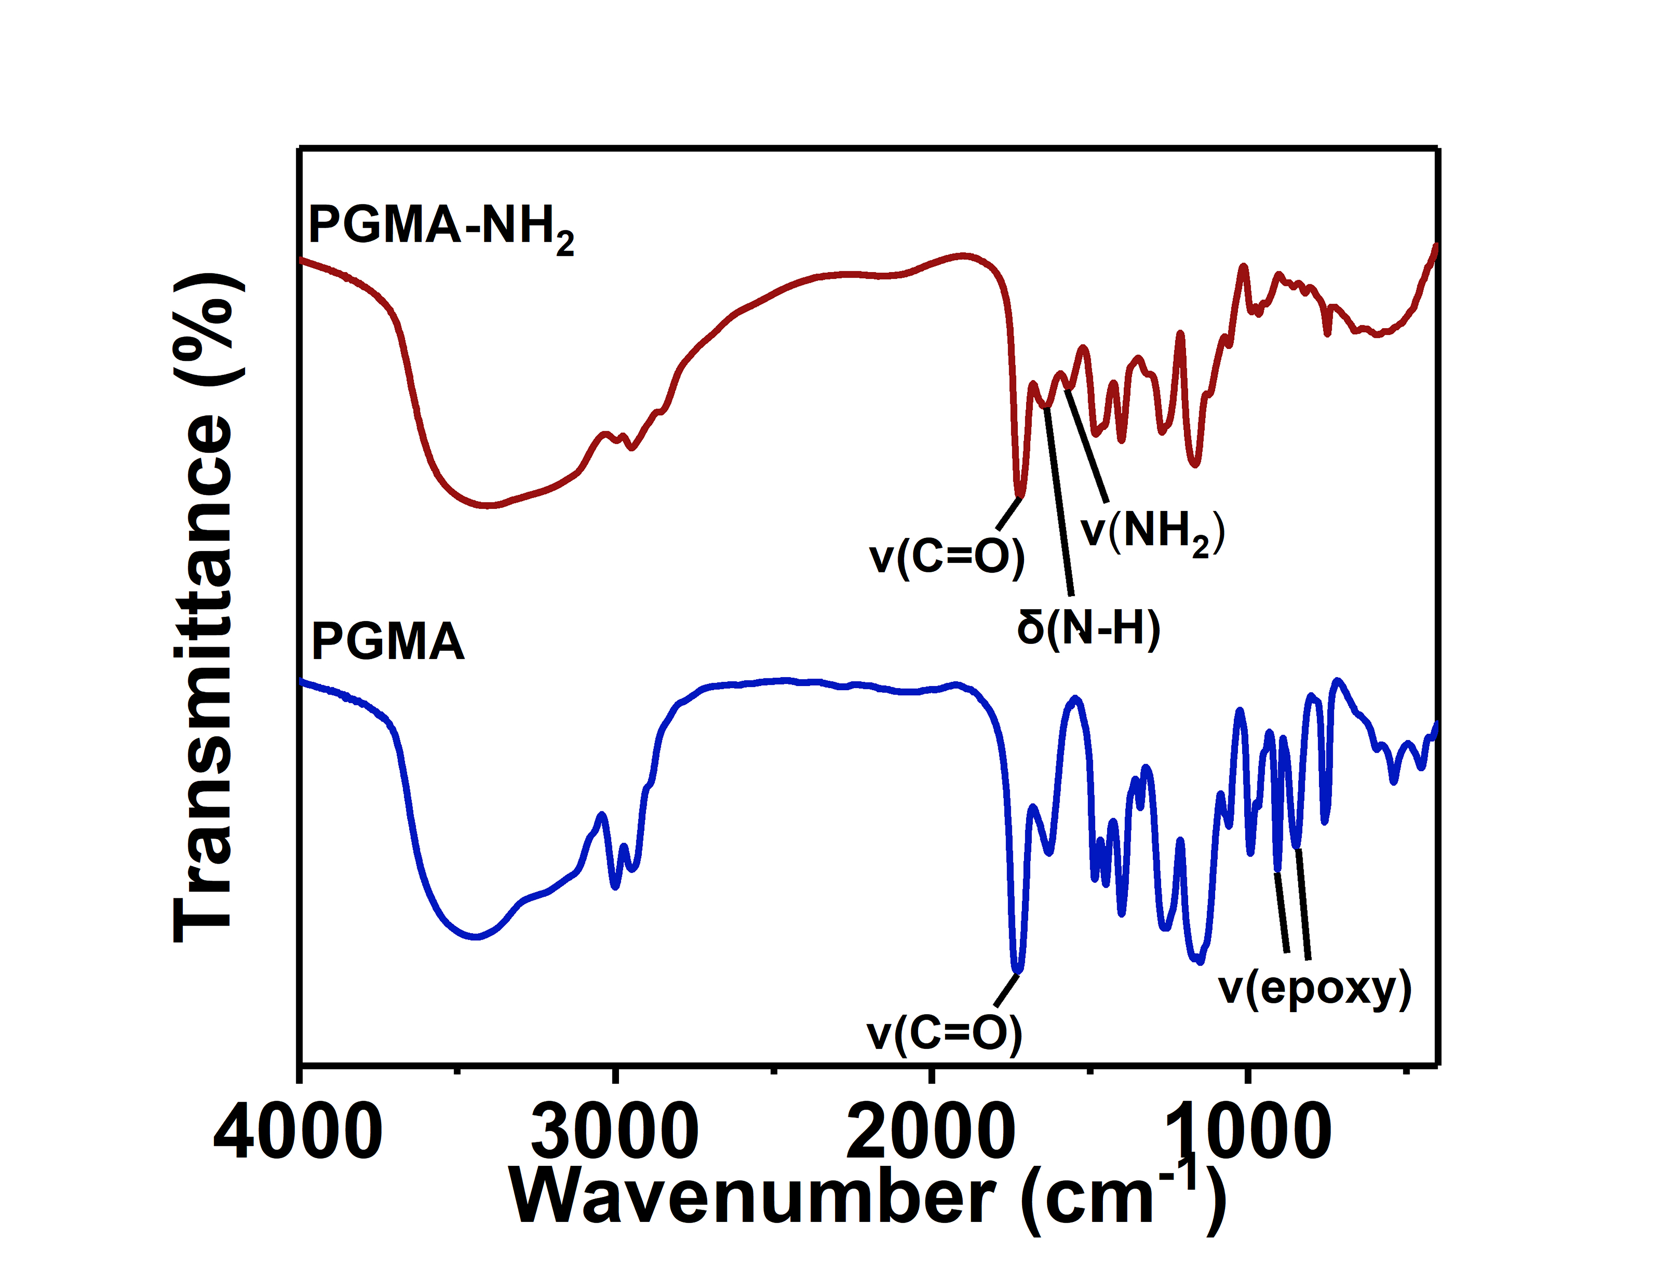
Fig. S1 FTIR spectra of PGMA and PGMA-NH₂ microspheres
Fig. S2 Effects of ammonia volume (a, b), Na₃cit amount (c, d), Fe³⁺ and Fe²⁺ concentration (e, f) on the saturation magnetization, magnetic content, grain size, residual magnetization, and coercive force of PGMA@Fe₃O₄ microspheres

