Static and dynamic adsorption of arsenate from water by iron ion complexed with 3-aminopropyltriethoxysilane-modified carboxymethyl chitosan

Changjin Jiangª, Shuang Zhangª, Ting Zhang^{a,b,}*

ª College of Chemistry and Chemical Engineering, Central South University, Changsha 410083, Hunan, People’s Republic of China
^{b} Key Laboratory of Hunan Province for Water Environment and Agriculture Product Safety, Central South University, Changsha 410083, Hunan, People’s Republic of China

* Corresponding author.
Corresponding author at: College of Chemistry and Chemical Engineering, Central South University, Changsha 410083, Hunan, People’s Republic of China.
E-mail address: zhangting@csu.edu.cn (T. Zhang).

Table S1
Operating parameters for ICP-MS.
Parameters | Setting
Plasma RF power | 1550 W
Plasma gas flow rate | 15.0 L min^{–1}
Carrier gas flow rate | 0.9 L min^{–1}
Auxiliary gas flow rate | 0.9 L min^{–1}
Collision cell gas and flow rate | He, 4.3 L min^{–1}
Monitored ion (m/z) | ⁷⁵As
Dwell time | 1.0 s (As)

Table S2
Removal efficiency of As(V) from real water samples using Fe-ACMC.
Sample | pH | Initial As(V) concentration (mg L^{–1}) | Residual As(V) concentration (μg L^{–1}) | Removal efficiency (%)
Tap water | 7.91 | 9.94 | 29.83 | 99.7
Lake water | 7.95 | 10.69 | 42.75 | 99.6
River water | 8.01 | 10.87 | 43.47 | 99.6

Table S3
BET surface area, average pore diameter and pore volume of Fe-ACMC
Material | S_{BET} (m² g⁻¹) | D_{p} (nm) | V_{p} (cm³ g⁻¹)
Fe‒ACMC | 1.012 | 5.670 | 0.004

Table S4
Comparison of the proposed adsorbent with other reported modified chitosan-composite adsorbents for As(V) removal.
Adsorbent | pH | Adsorption capacity (mg g⁻¹) | Reference
Chitosan-magnetic graphene oxide grafted polyaniline doped with cobalt oxide | 7.0 | 90.91 | [1]
Iron-chitosan-coated sand | 7.0 | 56.00 | [2]
Magnetic nanoparticles impregnated chitosan beads | 6.8 | 35.70 | [3]
Granular adsorbents made from water treatment residuals materials and chitosan | 6.5 | 21.71 | [4]
CMC@Fe₃O₄ | 3.0 | 20.1 | [5]
Chitosan with magnetic nanoparticles | 5.0 | 10.4 | [6]
Chitosan/clay/magnetite composite | 5.0 | 6.50 | [7]
TiO₂-impregnated chitosan bead | 7.7 | 3.66 | [8]
Molybdate-impregnated chitosan beads | 5.0 | 1.99 | [9]
Chitosan | 5.0 | 1.90 | [10]
Fe(III)-chitosan | 3.0 | 33.85 | [11]
Fe(III)-chitosan-CTAB | 4.0 | 31.69 | [12]
Fe-ACMC | 7.0 | 84.18 | In this study
References:
[1] Gabris M.A., S. Rezania, M. Rafieizonooz, E. Khankhaje, S. Devanesan, M.S. AlSalhi, M.J. Aljaafreh, A. Shadravan. Chitosan magnetic graphene grafted polyaniline doped with cobalt oxide for removal of Arsenic(V) from water. Environmental Research, 2022, 207: 112209.
[2] Gupta A., M. Yunus, N. Sankararamakrishnan. Chitosan- and iron-chitosan-coated sand filters: a cost-effective approach for enhanced arsenic removal. Industrial & Engineering Chemistry Research, 2013, 52: 2066-2072.
[3] Wang J., W. Xu, L. Chen, X. Huang, J. Liu. Preparation and evaluation of magnetic nanoparticles impregnated chitosan beads for arsenic removal from water. Chemical Engineering Journal, 2014, 251: 25-34.
[4] Zeng H., Y. Yu, F. Wang, J. Zhang, D. Li. Arsenic(V) removal by granular adsorbents made from water treatment residuals materials and chitosan. Colloid Surface A, 2020, 585: 124036.
[5] Jiang Z., N. Li, P. Li, B. Liu, H. Lai, T. Jin. One-step preparation of chitosan-based magnetic adsorbent and its application to the adsorption of inorganic arsenic in water. Molecules, 2021, 26: 1785.
[6] Kloster G.A., M. Valiente, N.E. Marcovich, M.A. Mosiewicki. Adsorption of arsenic onto films based on chitosan and chitosan/nano-iron oxide, International Journal of Biological Macromolecular, 2020, 165: 1286-1295.
[7] Cho D.W., B.H. Jeon, C.M. Chon, Y. Kim, F.W. Schwartz, E.S. Lee, H. Song. A novel chitosan/clay/magnetite composite for adsorption of Cu(II) and As(V). Chemical Engineering Journal, 2012, 200: 654-662.
[8] Miller S.M., J.B. Zimmerman. Novel, bio-based, photoactive arsenic sorbent: TiO₂-impregnated chitosan bead. Water Research, 2010, 44: 5722-5729.
[9] Chen C., T. Chang, J. Kuo, Y. Chen, Y. Chung. Characteristics of molybdate-impregnated chitosan beads (MICB) in terms of arsenic removal from water and the application of a MICB-packed column to remove arsenic from wastewater. Bioresource Technology, 2008, 99: 7487-7494.
[10] Chen C., Y. Chung. Arsenic removal using a biopolymer chitosan sorbent. Journal of Environmental Science and Health Part a-Toxic/Hazardous Substances & Environmental Engineering, 2006, 41: 645-658.
[11] Jiang C., T. Zhang, S. Li, Z. Yang. A comparative study on Fe(III)-chitosan and Fe(III)-chitosan-CTAB composites for As(V) removal from water: preparation, characterization and reaction mechanism. Environmental Science and Pollution Research, 2022, 29, 77851–77863.

Table S5
Dynamic adsorption parameters of As(V) on the fixed-bed column of Fe-ACMC.
Q  (mL min⁻¹) | C₀  (mg L⁻¹) | Z  (cm) | m  (g) | t_{total}  (min) | q_{total}  (mg) | q_{eq}  (mg g⁻¹) | m_{total}  (mg) | Removal  (%)
2.00 | 60 | 0.6 | 0.4994 | 300 | 25.80 | 51.66 | 36.00 | 71.7
3.00 | 60 | 0.6 | 0.5000 | 140 | 23.31 | 46.62 | 25.20 | 92.5
4.00 | 60 | 0.6 | 0.5006 | 115 | 22.50 | 44.95 | 27.60 | 81.5
3.00 | 30 | 0.6 | 0.5004 | 285 | 20.31 | 40.59 | 25.65 | 79.2
3.00 | 45 | 0.6 | 0.4996 | 180 | 21.06 | 42.15 | 24.30 | 86.7
3.00 | 60 | 0.6 | 0.5000 | 140 | 23.71 | 47.42 | 25.20 | 94.1
3.00 | 60 | 0.6 | 0.5003 | 140 | 23.56 | 47.09 | 25.20 | 93.5
3.00 | 60 | 1.2 | 1.0300 | 270 | 41.16 | 39.77 | 48.60 | 81.7
3.00 | 60 | 1.8 | 1.5020 | 480 | 54.36 | 36.19 | 86.40 | 62.9

Table S6
Comparison of dynamic adsorption capacity for As(V) on Fe-ACMC with the reported adsorbents.
As(V) adsorption material | pH | Adsorption capacity  (mg g⁻¹) | Reference
Chitosan-g-(HEMA-Co-SSS) | 3.5 | 10.80 | [12]
The beaded coal mine drainage Sludge-Youngdong (BCMDS-YD) adsorbent | 7.6 | 4.56 | [13]
3-aminopropyltriethoxysilane grafted chitosan | 5.0 | 2.58 | [14]
Granular adsorbent (GA) | 6.5 | 0.76 | [15]
Fe-ACMC | 7.0 | 47.04 | In this study
References:
[12] Vijayasri K., A. Tiwari, C.V. Chaudhari. Mitigation of toxic arsenic(V) from aqueous solution in fixed-bed column using functionally modified bio-polymer. Inorganic and Nano-Metal Chemistry, 2021, 51: 780-791.
[13] Lee Y., Y. Ren, M. Cui, Y. Zhou, O. Kwon, J. Ko, J. Khim. Arsenic adsorption study in acid mine drainage using fixed bed column by novel beaded adsorbent. Chemosphere, 2022, 291: 132894.
[14] Lalhmunsiama L., S.M. Lee, Lalchhingpuii, D. Tiwari. Functionalized hybrid material precursor to chitosan in the efficient remediation of aqueous solutions contaminated with As(V). Journal of Environmental Chemical Engineering, 2016, 4: 1537-1544.
[15] Zeng H., S. Sun, Y. Yu, J. Zhang, D. Li. Column studies on the adsorption of As(V) by granular chitosan adsorbent prepared with backwashing iron-containing sludge. Colloids and Surfaces A: Physicochemical and Engineering Aspects, 2021, 627: 127247.

Fit of the Adams-Bohart and Thomas models
(1) Adams-Bohart model
The Adams-Bohart model is used to describe the initial adsorption phase of the breakthrough curve in the process of adsorbing As(V) in a fixed bed, and its expression is as Equation (1) [16]:
$ln\left(\frac{C_{t}}{C_{0}}\right)=k_{AB}C_{0}t-k_{AB}N_{0}\frac{z}{U_{0}}$ (1)
where k_{AB} (L (mg min⁻¹)) represents rate constant of Adams-Bohart model, N₀ (mg L⁻¹) is the saturation concentration, Z (cm) is is the bed height, U₀ (cm min⁻¹) is the linear velocity of influent solution.
(2) Thomas model
The Thomas model is a commonly used mathematical model to describe the behavior of the penetration curve in a fixed-bed column. Its derivation assumes Langmuir kinetics of adsorption-desorption and no axial dispersion. The linear form of Thomas model is expressed as Equation (2) [11]:
$ln\left(\frac{C_{0}}{C_{t}}-1\right)=\frac{{k_{Th}q}_{e}m}{Q}-k_{Th}C_{0}t$ (2)
where k_{Th} (mL (mg min⁻¹)) represents rate constant of Thomas model, q_{e} (mg g⁻¹) is the maximum adsorption capacity, m (g) is the dry weight of the adsorbent in the adsorption column.
Reference:
[16] Saadi R., Z. Saadi, R. Fazaeli. Continuous flow separation of Ni(II) from aqueous solution by nanostructured γ-alumina. Particulate Science and Technology, 2014, 32: 341–347.

Table S7
Adams-Bohart and Thomas models fitting parameters under different conditions using linear regression analysis.
Q  (mL min⁻¹) | C₀  (mg L⁻¹) | Z  (cm) | m  (g) | Adams-Bohart model |  |  | Thomas model
 |  |  |  | K_{ab}×10⁻³  L (min·mg)⁻¹ | N₀×10³  (mg L⁻¹) | R² | K_{th}  mL (min·mg)⁻¹ | q₀  (mg g⁻¹) | R²
2.00 | 60 | 0.6 | 0.4994 | 0.15 | 43.20 | 0.8325 | 0.42 | 41.16 | 0.9692
3.00 | 60 | 0.6 | 0.5000 | 0.90 | 30.17 | 0.7019 | 1.83 | 43.05 | 0.9593
4.00 | 60 | 0.6 | 0.5006 | 0.50 | 39.18 | 0.8816 | 1.20 | 44.87 | 0.9788
3.00 | 30 | 0.6 | 0.5004 | 0.77 | 28.97 | 0.9101 | 1.43 | 38.44 | 0.9802
3.00 | 45 | 0.6 | 0.4996 | 1.11 | 28.73 | 0.8045 | 2.35 | 40.50 | 0.9825
3.00 | 60 | 0.6 | 0.5000 | 1.03 | 31.08 | 0.7205 | 1.86 | 42.26 | 0.9632
3.00 | 60 | 0.6 | 0.5003 | 1.18 | 29.18 | 0.7378 | 2.11 | 39.91 | 0.9682
3.00 | 60 | 1.2 | 1.0300 | 0.52 | 28.05 | 0.7377 | 1.11 | 37.38 | 0.9639
3.00 | 60 | 1.8 | 1.5020 | 0.07 | 33.41 | 0.6178 | 0.24 | 32.38 | 0.9382

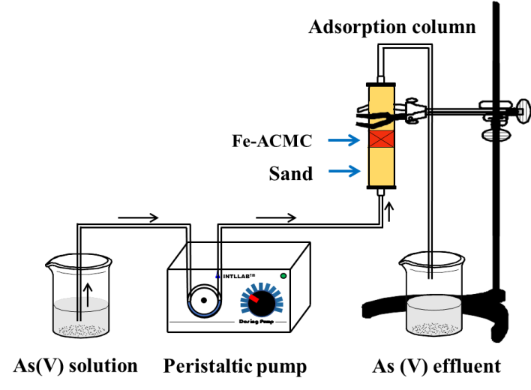
Figure S1. Schematic diagram of the experimental setup for the dynamic adsorption of As(V) in water by Fe-ACMC.

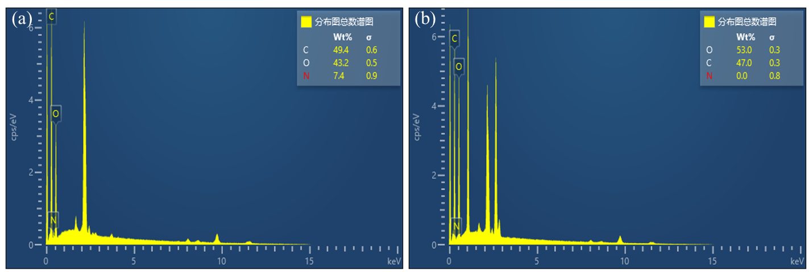
Figure S2. EDS spectrum of chitosan (a) and carboxymethyl chitosan (b)

Figure S3. XRD patterns of ACMC and Fe-ACMC.

Figure S4. N₂ adsorption-desorption isotherms of Fe-ACMC.

Figure S5. Effects of solution flow rate (a), inlet As(V) concentration (b), and bed height (c) on breakthrough curves.

Figure S6. Removal efficiency of As(V) by Fe-ACMC after eight cycles.

