Supplementary Data
Figures
Figure S1. CONSORT diagram. The trial, NCT0451005, “CAR T Cells After Lymphodepletion for the Treatment of IL13Rα2 Positive Recurrent or Refractory Brain Tumors in Children”, treated 11 patients as of May 15, 2023. 5 patients were evaluable for response, 1 patient was inevaluable for response, and 1 patient was pending. All patients were evaluable for safety.
11 patients leukapheresed &
product manufactured
Excluded (n = 4 )
Not meeting inclusion criteria (n = 3)
Chose not to participate (n = 1)
7 patients received
CAR T cells
3 patients on Treatment Plan 1
3 evaluable
4 patients on Treatment Plan 2:
2 evaluable
1 inevaluable
1 pending

Figure S2. Dot plot heatmap of curated set of marker genes used in cell type annotations for CSF.
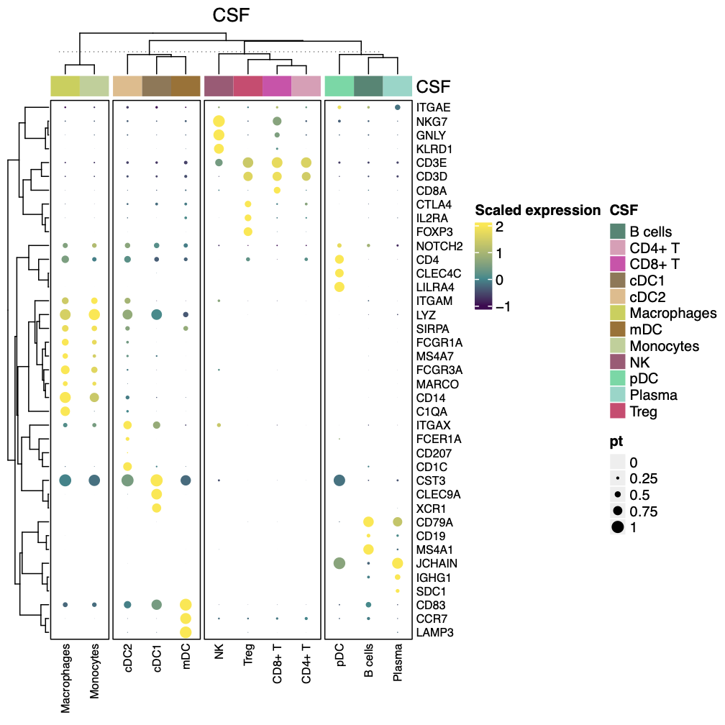

Figure S3. Dot plot heatmap of curated set of marker genes used in cell type annotations for PBMCs.
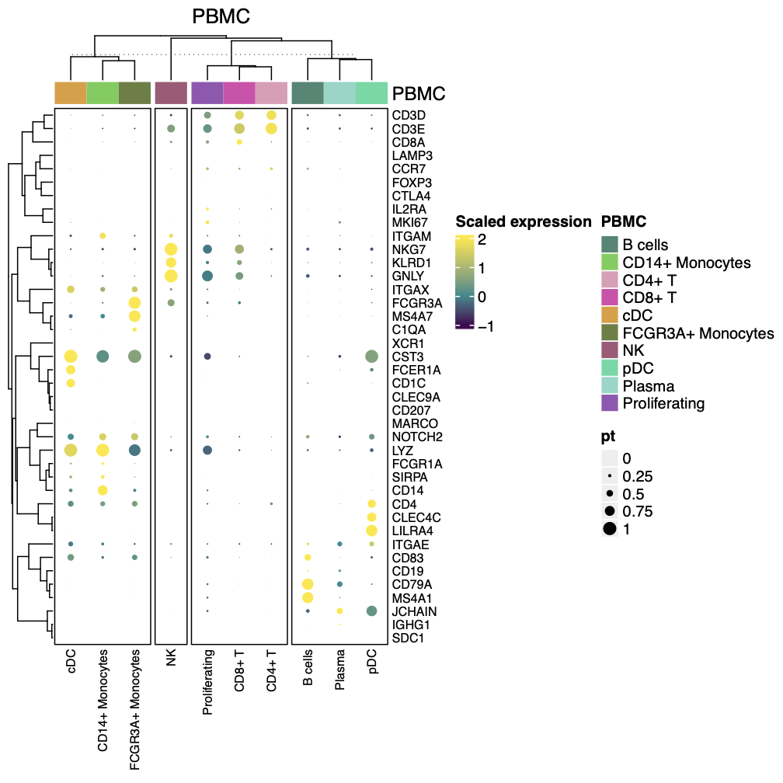

Figure S4. Flow cytometry. Flow cytometry comparing immune cell populations, including A) CAR⁻ and B) CAR⁺ T cells, across cycles in PBMC and CSF. C) CD8+ and CD8- distribution of CAR+ and CAR- T within CSF samples. D) Percent CAR⁺ T and CAR⁻ T of CD3⁺ T cells in CSF.

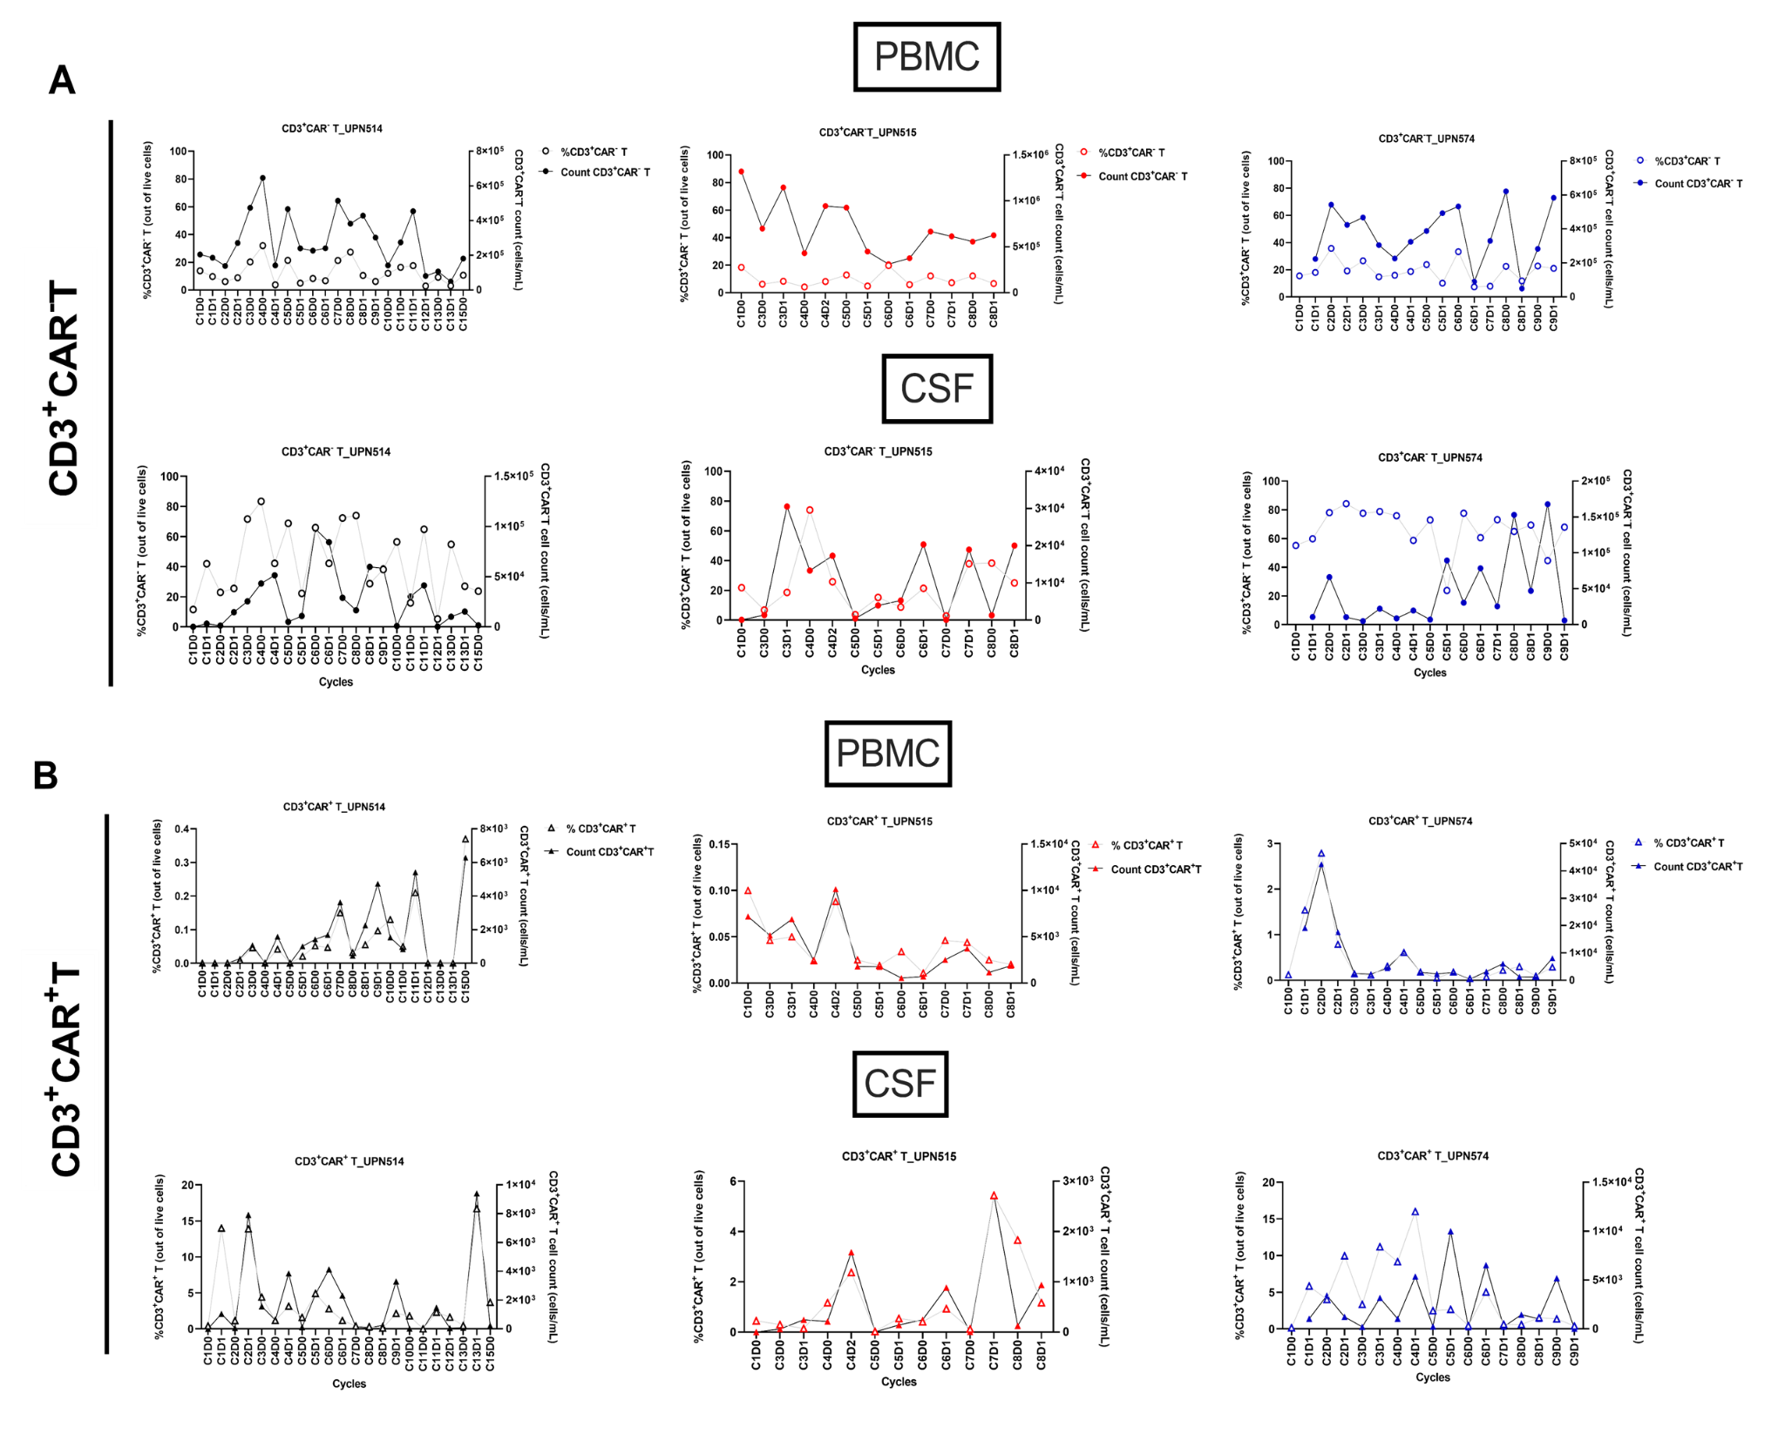

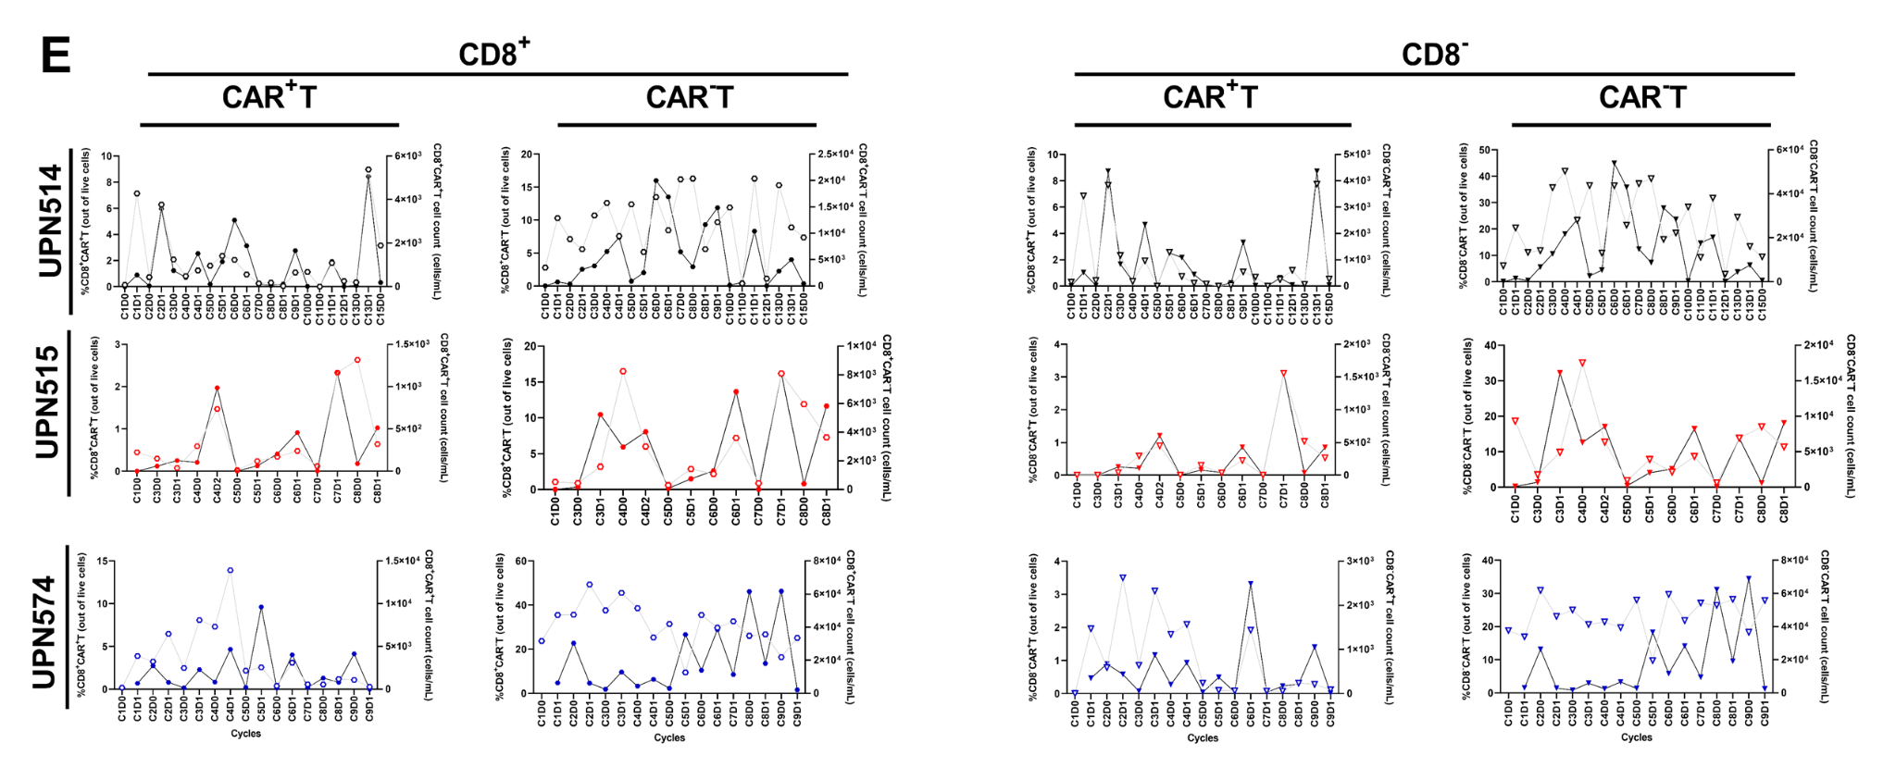
C
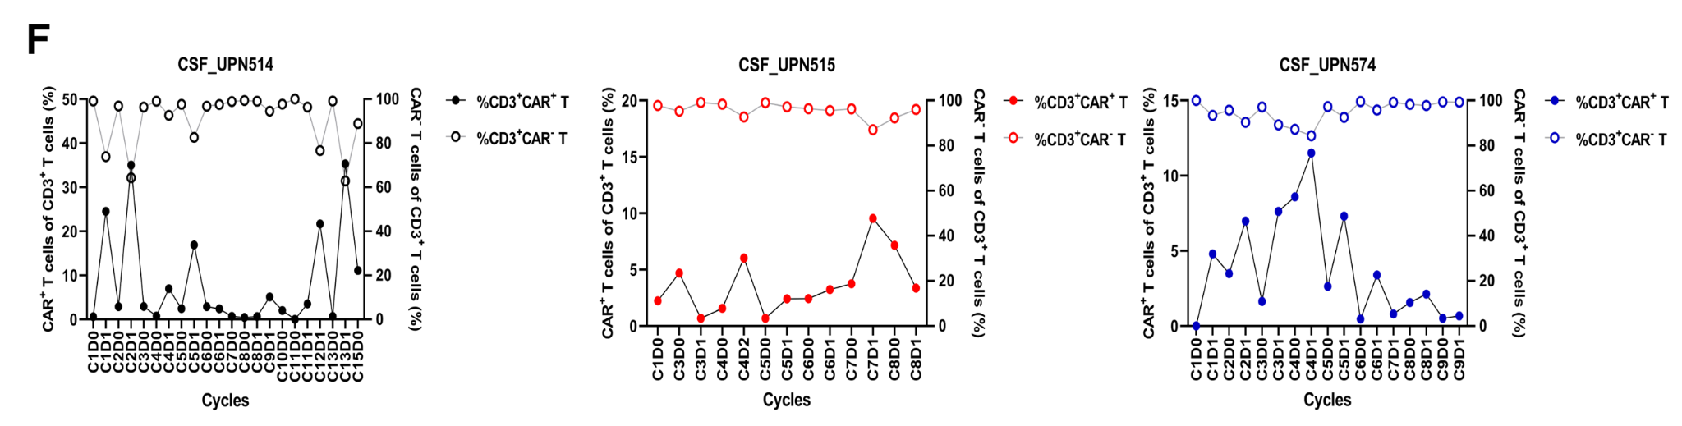
D

Figure S5. Comparison of cell type proportions between matched CSF and PBMC samples. A) UMAP of CSF + PBMC integrated object split by sample type. Cell type annotations were unified between the two sample types. B) Stacked bar plot of cell type proportions for CSF and PBMC. C) Point range plot comparing the proportion of cell types between CSF and PBMC. Red points in C represent cell types with a significant proportional difference between categories. abs(Log2FD) greater than 0 represents cell types at a higher proportion in PBMC compared to CSF.
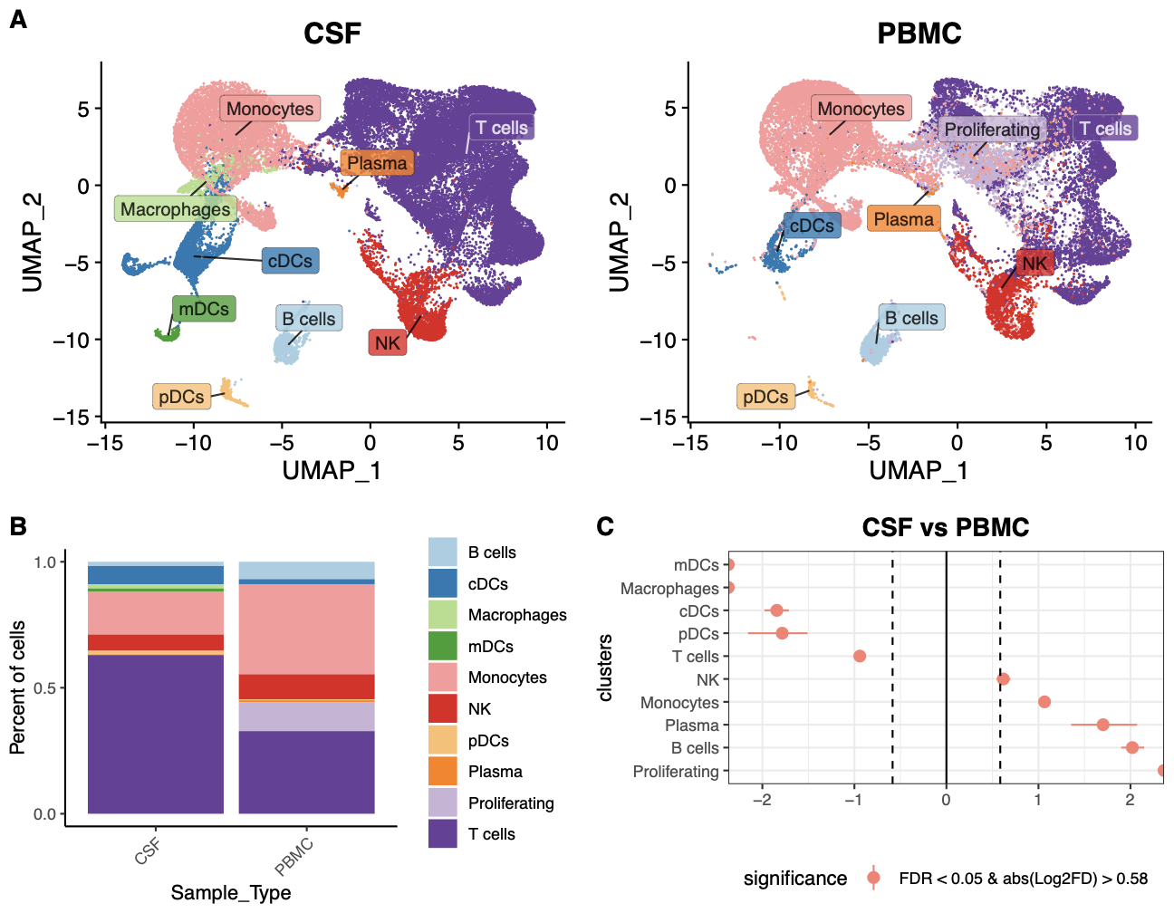

Figure S6. Dot plot heatmap of curated marker genes for T cell state annotations in CSF.
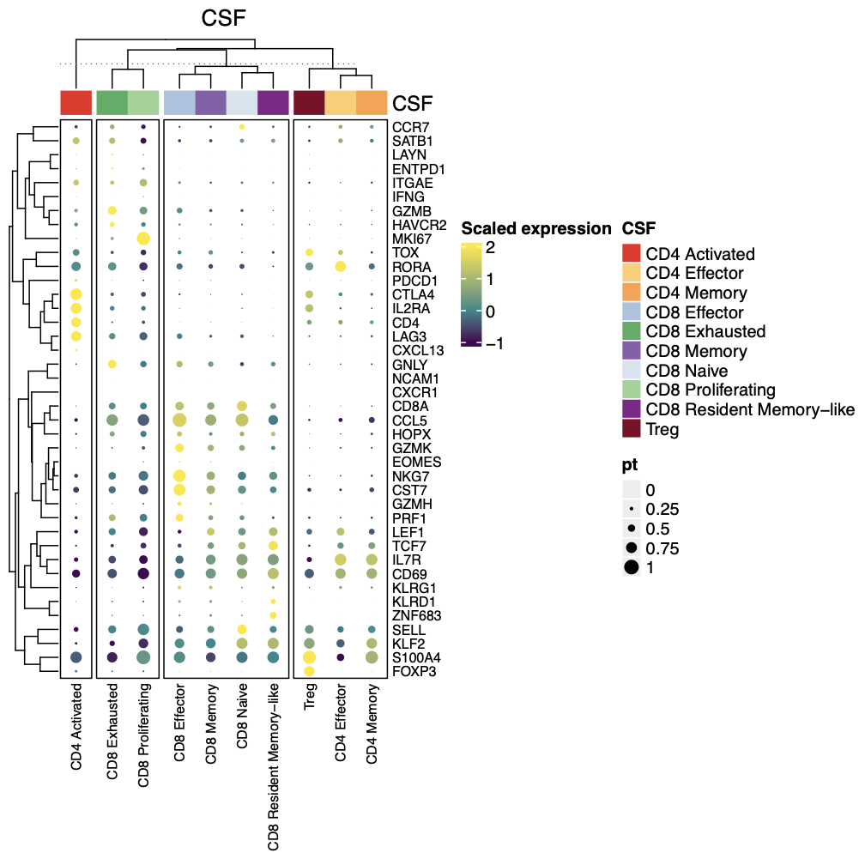

Figure S7. Dot plot heatmap of curated marker genes for T cell state annotations in PBMCs.
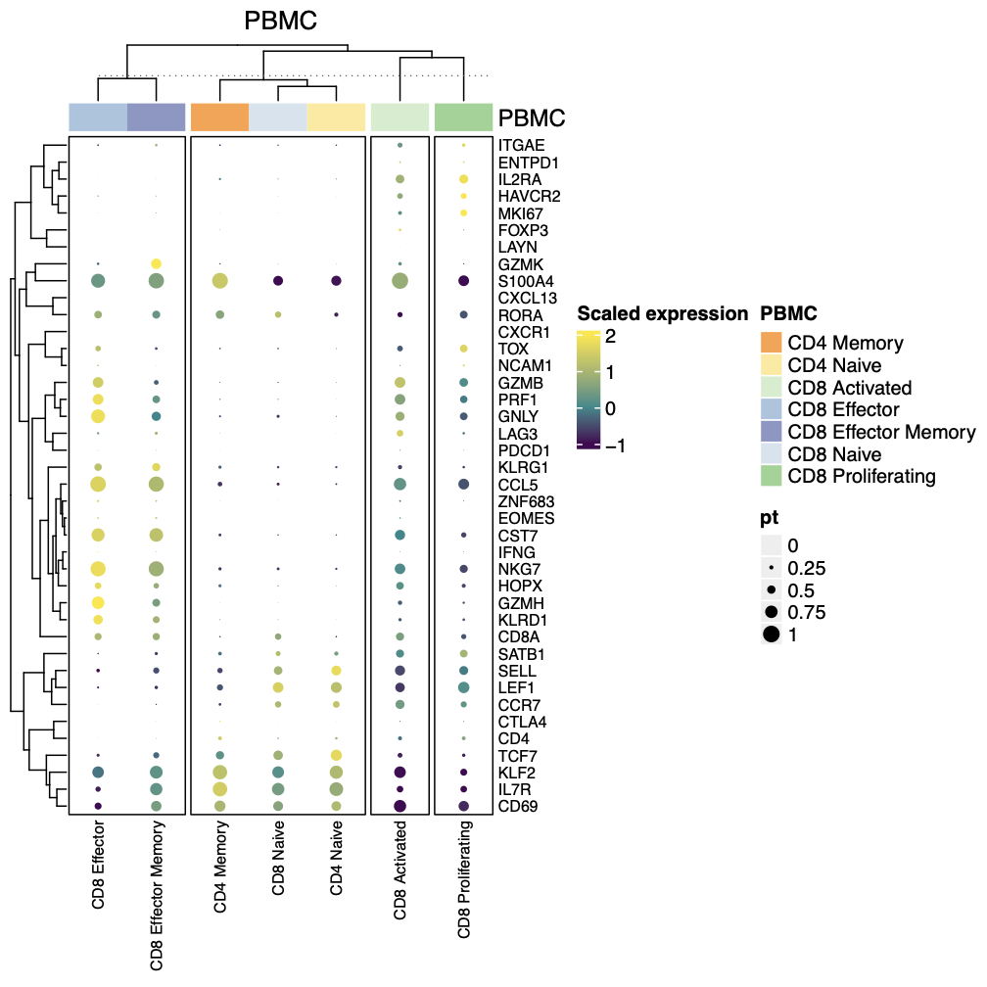

Figure S8. Dot plot heatmap of curated marker genes for T cell state annotations in product.
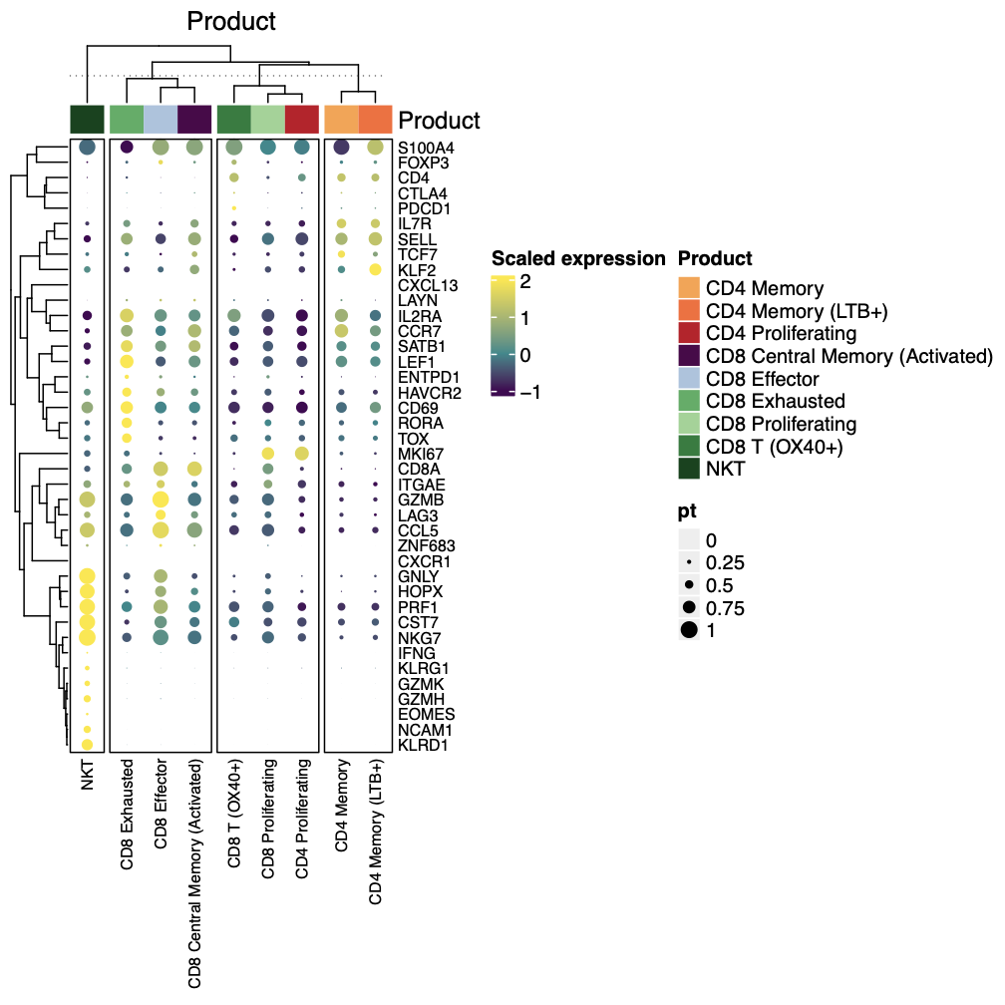

Figure S9. Product UMAPs and cell type/state proportions for responding and non-responding patients. A) UMAP of 12,391 T cells in the engineered products colored by cell type/state. B) Stacked bar plot for each patient organized by patients that did not have any radiographic response during therapy (non-responding patients) and by patients that did have a radiographic response at any point during therapy (responding patients).
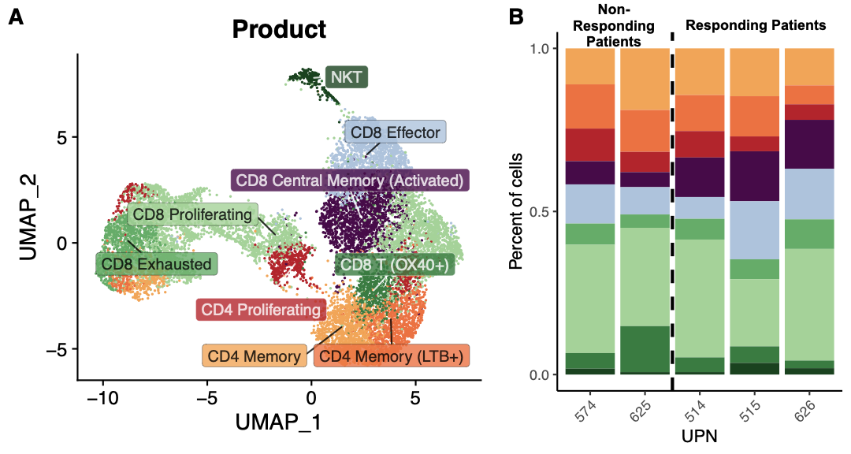

Figure S10. Cell type proportion differences between CAR⁻ and CAR⁺ T cells in CSF. A) Stacked bar plot of T cell type/state proportions among CAR⁻ and CAR⁺ cells in CSF. B) Point range plot comparing the proportion of T cell states in CSF between CAR⁻ and CAR⁺ cells.
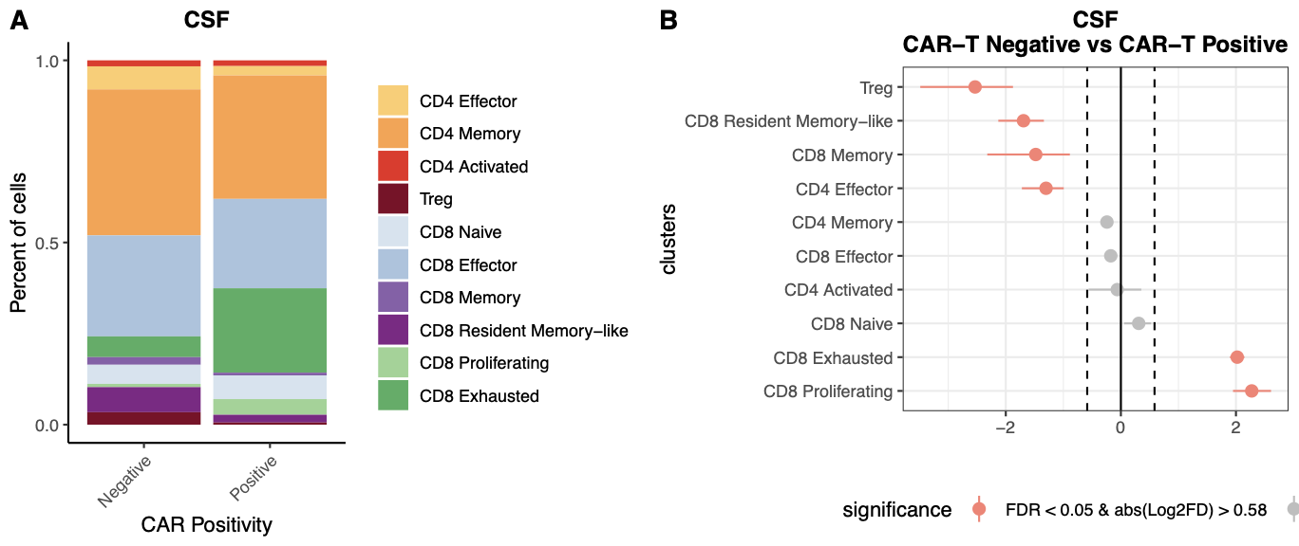

Figure S11. Proportion of CAR⁺ and CAR⁻ T cells in cells with expanded and unexpanded TCRs. Stacked bar plot of proportion of CAR⁺ positive (red) and CAR⁻ (gray) T cells in CSF between cells with expanded and unexpanded TCRs.
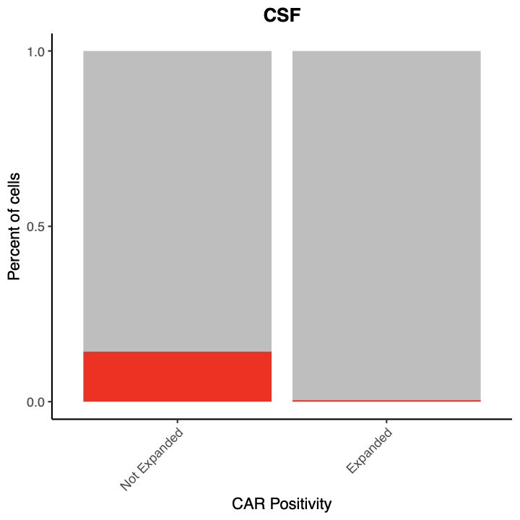

Figure S12. Cytokine data. A) Cytokine fold changes in CSF from each patient’s C1D0. B) Cytokine fold changes in serum from each patient’s C1D0.
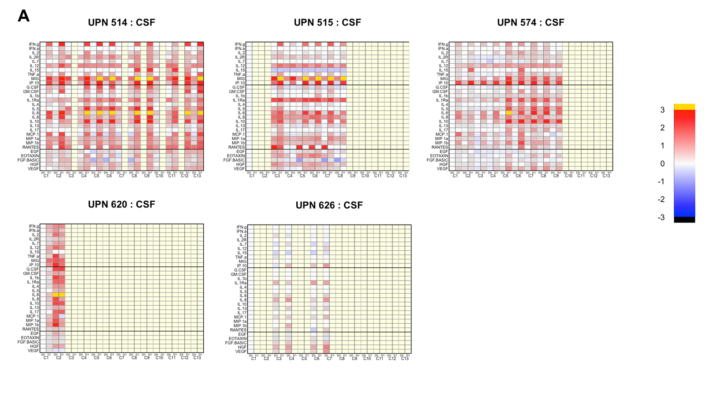
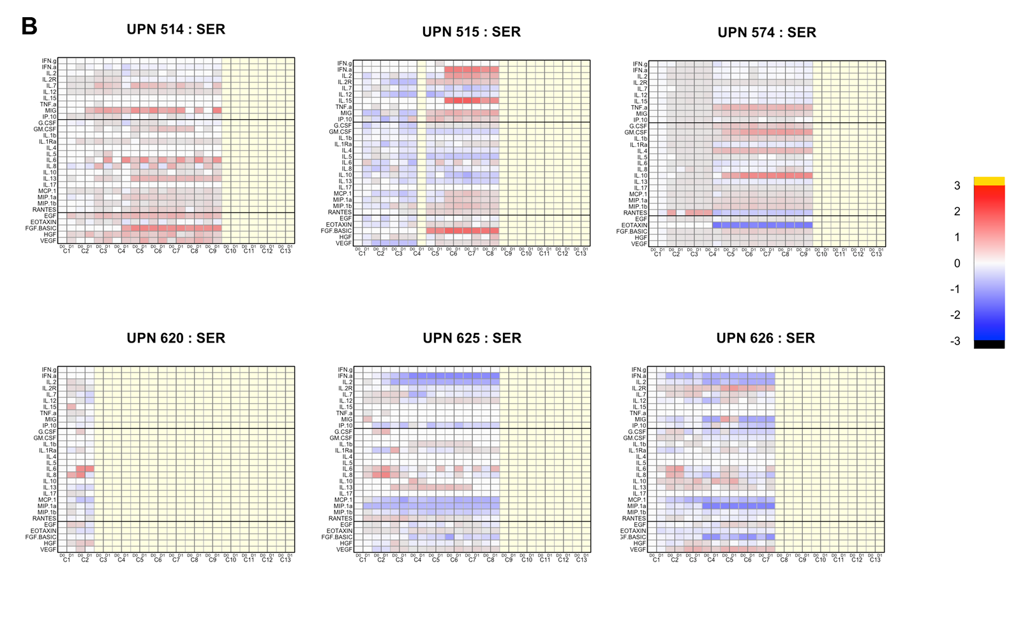

Figure S13. scRNA data from tumors. A) UMAP all tumor cells colored by clusters at 0.2 resolution; B) FeaturePlot of SCT expression of immune marker gene, PTPRC; C) UMAP immune cells re-integrated colored by cell type; D) Dotplot heatmap of immune cells for cell type annotations. Curated set of genes from Table S17 are shown in the dotplot heatmap.

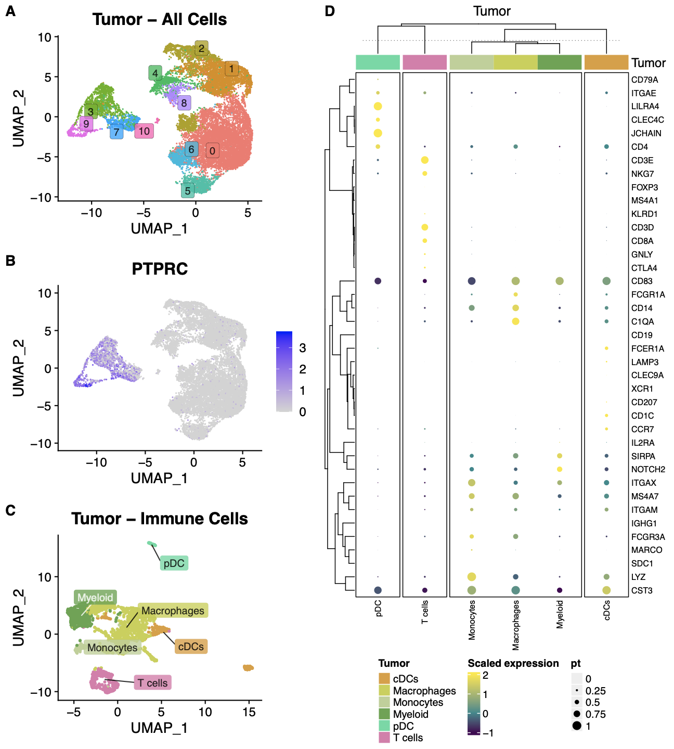

Figure S14. Filtering thresholds. Smoothscatter plots for each sample type showing the distribution of %mt and log(nFeature) (top) and %mt and log(nCount) (bottom). Vertical and horizontal lines represent filtering thresholds implemented on each sample type.
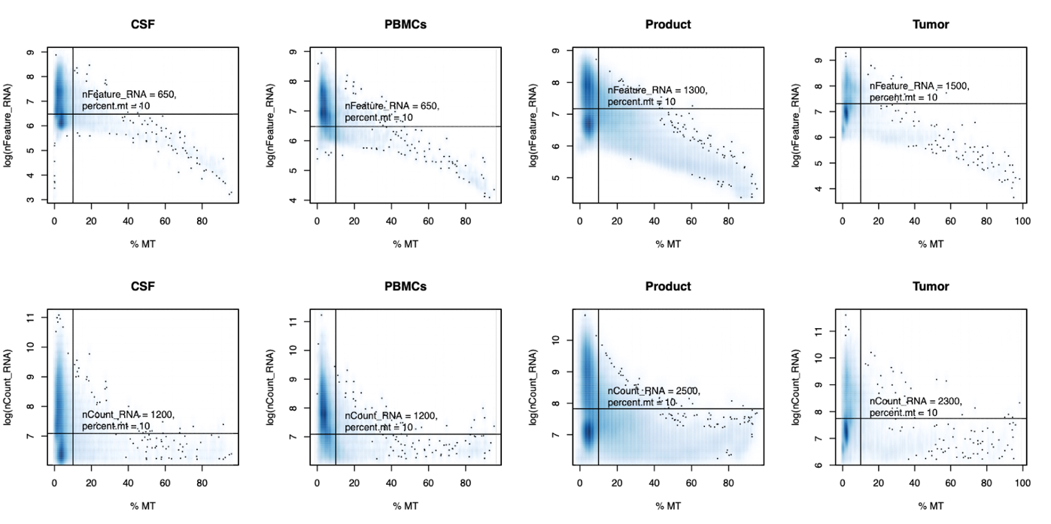

Table S1. IHC screening results. As of May 2023, 37 people were IHC screened for IL13Rα2.
Disease Type | H Score (≥50) | Screening Result
DIPG/DMG | 90+ | Treated
DIPG/DMG | 60+ | Patient not treated
DIPG/DMG | 150+ | Patient not treated
DIPG/DMG | 130+ | Patient not treated
DIPG/DMG | 150+ | Treated
DIPG/DMG | 110+ | Patient not treated
DIPG/DMG | 140+ | Screening
DIPG/DMG | 50 | Screening
DIPG/DMG | 5+ | Failed IHC
DIPG/DMG | 0 | Failed IHC
HGG | 230+ | Patient not treated
HGG | 160+ | Patient not treated
HGG | 200+ | Treated
HGG | 110+ | Screening
HGG | 190+ | Patient not treated
HGG | 145+ | Patient not treated
HGG | 60+ | Patient not treated
HGG | 10 | Failed IHC
HGG | 35+ | Failed IHC
HGG | 15+ | Failed IHC
HGG | 35+ | Failed IHC
HGG | 0 | Failed IHC
HGG | 10 | Failed IHC
HGG | 10 | Failed IHC
Ependymoma | 120+ | Treated
Ependymoma | 210+ | Treated
Ependymoma | 110+ | Treated
Ependymoma | 10 | Failed IHC
Ependymoma | 15 | Failed IHC
Ependymoma | 20 | Failed IHC
Ependymoma | 40 | Failed IHC
Ependymoma | 0 | Failed IHC
Medulloblastoma |  | Failed IHC
Medulloblastoma | 20 | Failed IHC
Medulloblastoma | 0 | Failed IHC
Medulloblastoma | 10 | Failed IHC
Medulloblastoma | 0 | Failed IHC

Table S2. CAR T cell manufacturing.
UPN | Freeze Day | Cells  Manuf  (×10⁶) | Viability¹ |  | Potency (CAR+)² | Identity (CD3+)³ | WPRE⁴ | VSV-G⁵ | Bead⁶ | Sterility⁷ | Endotoxin | Product  QC Release
514 | 12 | 3120 | 96.1% |  | 73.0% | 88.6% | 4.0 | 0.2 | 3.3 | Neg | <2.0 EU/mL | PASS
515 | 13 | 6240 | 89.3% |  | 58.0% | 99.6% | 1.4 | 0.0 | 4.3 | Neg | <0.5 EU/mL | PASS
554 | 15 | 489 | NA |  | NA | NA | NA | NA | NA | NA | NA | NA
574 | 12 | 2130 | 82.0% |  | 49.4% | 99.5% | 1.2 | 1.1 | 0.0 | Neg | 0.105 EU/mL | PASS
574B | 12 | 2200 | 87.9% |  | 75.8 | 99.2% | 3.2 | 0.1 | 0.3 | Neg | 0.051 EU/mL | PASS
585 | 13 | 2270 | 76.7% |  | 80.3% | 98.8% | 2.7 | 0.4 | 1.0 | Neg | 0.035 EU/mL | PASS
625 | 13 | 2930 | 83.8% |  | 83.5% | 97.4% | 5.0 | 1.2 | 3.0 | Neg | <0.025 EU/mL | PASS
626 | 12 | 2470 | 85.2% |  | 69.9% | 99.4% | 2.4 | 2.0 | 0.7 | Neg | <0.025 EU/mL | PASS
618 | 12 | 1690 | 72.4% |  | 54.3% | 99.2% | 1.5 | 0.6 | 2.7 | Neg | <0.025 EU/mL | PASS
620 | 13 | 4460 | 89.5% |  | 31.0% | 98.1% | 1.1 | 0.6 | 2.3 | Neg | <0.025 EU/mL | PASS
644 | 13 | 3380 | 78.2% |  | 69.4% | 99.6% | 2.0 | 2.0 | 0.7 | Neg | <0.025 EU/mL | PASS
Release criteria include: ¹Cell viability ≥70%; ²Expression of CD19t ≥10%; ³CD3 ≥80%; ⁴WPRE (woodchuck hepatitis virus posttranscriptional regulatory element; functions to boost transgene expression) ≤5 average copies/cell; VSV-G (vesicular stomatitis virus (VSV) G-protein; functions in efficient transduction of non-dividing cells) average copy # <2.5 copies/50 ng DNA; ⁶Residual Dynal Beads < 100 beads per 3x10⁶ cells (T_{CM} cells are activated with anti-CD3/CD28 Dynal beads, which must be removed); ⁷Negative for bacterial and fungal elements.

Table S3. Serum testosterone levels
Date | Serum T total (ng/dL)* | Peripheral Blood  CAR+T | Cycle/Day
UPN620
2022.09.02 | 263 | na | C1D-5
2022.09.06 | 298 | na | C1D-1
2022.09.09 | 432 | na | C1D2
2022.09.15 | 137 | 0 | C2D1
UPN625
2022.10.05 | 155 | 6 × 10³ (0.1%) | C3D7
2022.11.03 | 503 | 0 | C5D1
2022.11.10 | 129 | <0.1% | C6D1
2022.11.17 | 140 | na | C7D1
2022.11.30 | 327 | na | C8D7
UPN626
2022.10.04 | <2.5 | 0 | C3D0
2022.11.02 | 68 | na | C6D1
2022.11.09 | 237 | na | C7D1
*Normal 264-916 ng/dL

Table S4. Treatment outcomes.
Research Subject | Age/  Sex | Diagnosis  @ Tx | KPS  @ Tx | Cycles ICV  1-4 | Optional  Cycles | Therapy-related  SAEs | Procedure-related SAEs | DLTs | Best Response# | Vital Status
CAR T cells without lymphodepletion
UPN 514 | 20/M | Posterior fossa ependymoma grade 3 | 90 | 4 | 11 ICV | Gr 1 CRS | None | None | PD | Deceased
UPN 515 | 15/F | Diffuse midline glioma H3K27M grade 4 | 70 | 4 | 4 ICV | No TR-SAE  No DLT | Gr 3 wound dehiscence  Gr 3 CSF leakage | None | SD | Deceased
UPN 574 | 24/F | Posterior fossa group A (PFA) ependymoma grade 3 | 100 | 4 | 5 ICV | No TR-SAE  No DLT | None | None | PD | Alive
CAR T cells with lymphodepletion
UPN 620 | 22/M | Hemispheric glioma, H3G34  grade 4 | 50 | 2 | None | None | Catheter-related infection | None | inevaluable | Deceased
UPN 625 | 16/M | Posterior fossa group A (PFA) ependymoma grade 3 | 60 | 4 | 4 ICV | None | None | None | PD | Deceased
UPN 626 | 15/M | Diffuse midline glioma  H3K27M grade 4 | 60 | 4 | 3 ICV | None | None | None | SD | Deceased

Table S5. Sample information for scRNAseq data.
UPN | Cycle | Day | Sample Type | Multiplexed | Batch
514 | 5 | 1 | CSF | No | 42
514 | 5 | 1 | PBMC | Yes | 37
514 | 8 | 1 | CSF | No | 38
514 | 8 | 1 | PBMC | Yes | 37
514 | 11 | 1 | CSF | No | 37
514 | 11 | 1 | CSF | No | 42
514 | 11 | 1 | PBMC | Yes | 38
514 | NA | NA | Product | Yes | 38
515 | 4 | 2 | CSF | No | 37
515 | 4 | 2 | CSF | No | 42
515 | 4 | 2 | PBMC | Yes | 38
515 | 8 | 1 | CSF | No | 38
515 | 8 | 1 | PBMC | Yes | 37
515 | NA | NA | Product | Yes | 37
574 | 3 | 1 | CSF | No | 38
574 | 3 | 1 | PBMC | Yes | 37
574 | 8 | 1 | CSF | No | 37
574 | 8 | 1 | CSF | No | 42
574 | 8 | 1 | PBMC | Yes | 38
574 | NA | NA | Product | Yes | 38
574 | NA | NA | Tumor (CD45-) | No | 39
574 | NA | NA | Tumor (CD45+) | No | 39
625 | 1 | 0 | PBMC | Yes | 40
625 | 3 | 1 | PBMC | Yes | 39
625 | 4 | 1 | PBMC | Yes | 40
625 | NA | NA | Product | Yes | 39
625 | NA | NA | Tumor (CD45-), post-tx | No | 41
625 | NA | NA | Tumor (CD45+), post-tx | No | 41
625 | NA | NA | Tumor (Myelin depleted), pre-tx | No | 40
626 | 1 | 0 | PBMC | Yes | 39
626 | 4 | 1 | PBMC | Yes | 39
626 | 7 | 1 | PBMC | Yes | 40
626 | NA | NA | Product | No | 40

Table S6. Radiographic categories during each cycle for scRNAseq samples.
Patient | Cycle, Day (scRNA) | Radiographic Change | Broad Category
514 | 5, 1 | Progression | Non-Response
514 | 8, 1 | Response | Response
514 | 11, 1 | Progression | Non-Response
515 | 4, 2 | Response | Response
515 | 8, 1 | Progression | Non-Response
574 | 3, 1 | Progression | Non-Response
574 | 8, 1 | Progression | Non-Response
625 | 1, 0 | Baseline | Non-Response
625 | 3,1 | Progression | Non-Response
625 | 4, 1 | Progression | Non-Response
626 | 1,0 | Baseline | Non-Response
626 | 4, 1 | Response | Response
626 | 7, 1 | Progression | Non-Response

Table S7. Marker genes for T cell type and state annotations.
T Cell Type | State | Marker Genes
CD4+ T | Naive | LEF1, CCR7, SATB1, KLF2, SELL, IL7R
CD4+ T | Effector | RORA, CXCR1, GZMB, GZMH, PRF1, KLRG1, GNLY, NKG7
CD4+ T | Memory | S100A4, IL7R, EOMES, TCF7, SELL, CCR7, LEF1, PDCD1
CD4+ T | Activated | CD69, IFNG
CD4+ T | Proliferating | MKI67
CD8+ T | Naive | LEF1, CCR7, SATB1, KLF2, SELL, IL7R
CD8+ T | Effector | CXCR1, GZMB, GZMH, PRF1, KLRG1, GNLY, NKG7
CD8+ T | Effector Memory | GZMK, KLRD1
CD8+ T | Memory | CCL5, S100A4, IL7R, EOMES, TCF7, SELL, CCR7, LEF1, PDCD1
CD8+ T | Central Memory | CCR7
CD8+ T | Resident Memory | ITGAE, ZNF683
CD8+ T | Activated | CD69, IFNG
CD8+ T | Proliferating | MKI67
CD8+ T | Exhausted | HAVCR2, TOX, ENTPD1, LAG3, PDCD1, CXCL13, LAYN

Table S8. Cell types in CSF and PBMC. Single cell proportion test results comparing cell types between CSF and PBMC.
clusters | CSF | PBMC | Obs_log2FD | Pval | FDR | Boot_mean_log2FD | Boot_CI_2.5 | Boot_CI_97.5
B cells | 0.0170 | 0.0914 | 2.4302 | 0.0010 | 0.0010 | 2.4315 | 2.3061 | 2.5623
Macrophages | 0.0168 | 0.0000 | -Inf | 0.0010 | 0.0010 | NA | NA | NA
Monocytes | 0.1707 | 0.2435 | 0.5124 | 0.0010 | 0.0010 | 0.5132 | 0.4606 | 0.5670
NK | 0.0646 | 0.1270 | 0.9759 | 0.0010 | 0.0010 | 0.9743 | 0.8935 | 1.0497
Plasma | 0.0026 | 0.0056 | 1.1037 | 0.0010 | 0.0010 | 1.1184 | 0.7094 | 1.5369
Proliferating | 0.0000 | 0.1238 | Inf | 0.0010 | 0.0010 | NA | NA | NA
T cells | 0.6299 | 0.3849 | -0.7108 | 0.0010 | 0.0010 | -0.7108 | -0.7395 | -0.6806
cDCs | 0.0723 | 0.0188 | -1.9431 | 0.0010 | 0.0010 | -1.9455 | -2.1076 | -1.7939
mDCs | 0.0120 | 0.0000 | -Inf | 0.0010 | 0.0010 | NA | NA | NA
pDCs | 0.0141 | 0.0050 | -1.5092 | 0.0010 | 0.0010 | -1.5145 | -1.8650 | -1.1889

Table S9. Cell types during response and nonresponse windows. Single cell proportion test results comparing cell types between non-response and response windows in CSF.
Clusters | Non-Response | Response | Obs_log2FD | Pval | FDR | Boot_mean log2FD | Boot_CI_2.5 | Boot_CI_97.5
B cells | 0.0137 | 0.0273 | 0.9971 | 0.0010 | 0.0012 | 1.0011 | 0.7712 | 1.2160
CD4+ T | 0.3342 | 0.1773 | -0.9141 | 0.0010 | 0.0012 | -0.9147 | -0.9829 | -0.8477
CD8+ T | 0.3472 | 0.2117 | -0.7139 | 0.0010 | 0.0012 | -0.7150 | -0.7773 | -0.6528
Macrophages | 0.0093 | 0.0400 | 2.0999 | 0.0010 | 0.0012 | 2.0984 | 1.8744 | 2.3254
Monocytes | 0.0950 | 0.4058 | 2.0943 | 0.0010 | 0.0012 | 2.0943 | 2.0324 | 2.1555
NK | 0.0688 | 0.0514 | -0.4217 | 0.0010 | 0.0012 | -0.4220 | -0.5777 | -0.2815
Plasma | 0.0024 | 0.0033 | 0.5028 | 0.0689 | 0.0689 | 0.4893 | -0.1886 | 1.1216
Treg | 0.0220 | 0.0124 | -0.8313 | 0.0010 | 0.0012 | -0.8229 | -1.0980 | -0.5373
cDC1 | 0.0088 | 0.0109 | 0.3113 | 0.0300 | 0.0327 | 0.3076 | -0.0297 | 0.6233
cDC2 | 0.0675 | 0.0490 | -0.4619 | 0.0010 | 0.0012 | -0.4620 | -0.6064 | -0.3204
mDC | 0.0133 | 0.0080 | -0.7394 | 0.0010 | 0.0012 | -0.7445 | -1.1345 | -0.4020
pDC | 0.0177 | 0.0029 | -2.6090 | 0.0010 | 0.0012 | -2.6352 | -3.2961 | -2.0874

Table S10. T cell states in nonresponse and response windows. Single cell proportion test results comparing T cell types/states between non-response and response windows in CSF.
Clusters | Non-response | Response | Obs_log2FD | Pval | FDR | Boot_mean log2FD | Boot_CI_2.5 | Boot_CI_97.5
CD4 Activated | 0.0174 | 0.0110 | -0.6605 | 0.0030 | 0.0043 | -0.6652 | -1.1741 | -0.2249
CD4 Effector | 0.0508 | 0.1052 | 1.0517 | 0.0010 | 0.0020 | 1.0460 | 0.8849 | 1.1991
CD4 Memory | 0.4069 | 0.3256 | -0.3218 | 0.0010 | 0.0020 | -0.3225 | -0.3961 | -0.2511
CD8 Effector | 0.2703 | 0.2931 | 0.1169 | 0.0040 | 0.0050 | 0.1179 | 0.0335 | 0.1986
CD8 Exhausted | 0.0758 | 0.0735 | -0.0434 | 0.3277 | 0.3641 | -0.0414 | -0.2318 | 0.1386
CD8 Memory | 0.0174 | 0.0309 | 0.8274 | 0.0010 | 0.0020 | 0.8243 | 0.5439 | 1.0964
CD8 Naive | 0.0579 | 0.0317 | -0.8704 | 0.0010 | 0.0020 | -0.8856 | -1.1616 | -0.6463
CD8 Proliferating | 0.0135 | 0.0070 | -0.9522 | 0.0030 | 0.0043 | -0.9829 | -1.6171 | -0.4152
CD8 Resident Memory-like | 0.0588 | 0.0913 | 0.6344 | 0.0010 | 0.0020 | 0.6381 | 0.4795 | 0.8033
Treg | 0.0313 | 0.0309 | -0.0220 | 0.4695 | 0.4695 | -0.0357 | -0.3418 | 0.2329

Table S11. Cell types in lymphodepleted and nonlymphodepleted PBMC. Single cell proportion test results comparing cell types between patients who received lymphodepletion and those who did not in PBMC.
Clusters | Lympho-depleted | Non-lympho-depleted | Obs_  log2FD | Pval | FDR | Boot_mean_  log2FD | Boot_CI_2.5 | Boot_CI_97.5
B cells | 0.0082 | 0.0914 | -3.4757 | 0.0010 | 0.0014 | -3.4929 | -3.9090 | -3.1054
CD14+ Monocytes | 0.5419 | 0.1813 | 1.5795 | 0.0010 | 0.0014 | 1.5796 | 1.5286 | 1.6350
CD4+ T | 0.0541 | 0.1192 | -1.1400 | 0.0010 | 0.0014 | -1.1440 | -1.3008 | -1.0032
CD8+ T | 0.1217 | 0.2656 | -1.1266 | 0.0010 | 0.0014 | -1.1252 | -1.2296 | -1.0234
DC | 0.0238 | 0.0188 | 0.3378 | 0.0070 | 0.0077 | 0.3310 | 0.0566 | 0.5867
FCGR3A+ Monocytes | 0.0326 | 0.0374 | -0.2005 | 0.0420 | 0.0420 | -0.2014 | -0.4349 | 0.0020
Monocytes | 0.0882 | 0.0247 | 1.8349 | 0.0010 | 0.0014 | 1.8296 | 1.6560 | 1.9917
NK | 0.0244 | 0.1270 | -2.3827 | 0.0010 | 0.0014 | -2.3887 | -2.6033 | -2.1760
Plasma | 0.0161 | 0.0056 | 1.5325 | 0.0010 | 0.0014 | 1.5351 | 1.1265 | 1.9146
Proliferating | 0.0873 | 0.1238 | -0.5044 | 0.0010 | 0.0014 | -0.5035 | -0.6261 | -0.3870
pDC | 0.0018 | 0.0050 | -1.4693 | 0.0020 | 0.0024 | -1.5152 | -2.5019 | -0.7003

Table S12. T cell states in lymphodepleted and nonlymphodepleted patients. Single cell proportion test results comparing T cell types/states between patients that received lymphodepletion and those who did not in PBMC.
clusters | Lympho-depleted | Non-Lympho-depleted | Obs log2FD | pval | FDR | Boot_mean log2FD | Boot_CI_2.5 | Boot CI_97.5
CD4 Memory | 0.2771 | 0.2142 | 0.3716 | 0.0010 | 0.0014 | 0.3674 | 0.2225 | 0.5120
CD4 Naive | 0.0182 | 0.0955 | -2.3937 | 0.0010 | 0.0014 | -2.4217 | -3.1011 | -1.8637
CD8 Activated | 0.0667 | 0.0233 | 1.5139 | 0.0010 | 0.0014 | 1.5051 | 1.0943 | 1.8926
CD8 Effector | 0.3541 | 0.3090 | 0.1967 | 0.0020 | 0.0023 | 0.1949 | 0.0735 | 0.3109
CD8 Effector Memory | 0.1351 | 0.1422 | -0.0746 | 0.2637 | 0.2637 | -0.0766 | -0.3051 | 0.1375
CD8 Naive | 0.0970 | 0.1960 | -1.0154 | 0.0010 | 0.0014 | -1.0173 | -1.2847 | -0.7671
CD8 Proliferating | 0.0519 | 0.0197 | 1.3975 | 0.0010 | 0.0014 | 1.4010 | 0.9356 | 1.8226

Table S13. Number of CAR T cells detected in CSF by scRNAseq.
UPN | Cycle | # T cells | # CAR⁺ | # CAR⁻ | Proportion CAR⁺
514 | 5 | 1913 | 360 | 1553 | 0.188
514 | 8 | 427 | 5 | 422 | 0.012
514 | 11 | 6967 | 46 | 6921 | 0.007
515 | 4 | 3299 | 333 | 2966 | 0.101
515 | 8 | 2947 | 148 | 2799 | 0.050
574 | 3 | 5803 | 1640 | 4163 | 0.283
574 | 8 | 2665 | 3 | 2662 | 0.001

Table S14. Number of CAR T cells detected in PBMC by scRNAseq.
UPN | Cycle | # T cells | # CAR⁺ | # CAR⁻ | Proportion CAR⁺
514 | 5 | 1028 | 24 | 1004 | 0.023
514 | 8 | 690 | 18 | 672 | 0.026
514 | 11 | 883 | 28 | 855 | 0.032
515 | 4 | 327 | 18 | 309 | 0.055
515 | 8 | 1296 | 25 | 1271 | 0.019
574 | 3 | 1765 | 32 | 1733 | 0.018
574 | 8 | 908 | 37 | 871 | 0.041
625 | 1 | 60 | 3 | 57 | 0.050
625 | 3 | 42 | 18 | 24 | 0.429
625 | 4 | 386 | 27 | 359 | 0.070
626 | 1 | 488 | 8 | 480 | 0.016
626 | 4 | 59 | 15 | 44 | 0.254
626 | 7 | 120 | 8 | 112 | 0.067

Table S15. CAR T cell phenotypes in CSF. Single cell proportion test results comparing T cell types/states between CAR⁺ and CAR⁻ T cells in CSF.
clusters | Negative | Positive | Obs_log2FD | Pval | FDR | Boot_mean log2FD | Boot_CI_2.5 | Boot_CI_97.5
CD4 Activated | 0.0165 | 0.0158 | -0.0623 | 0.4356 | 0.4356 | -0.0757 | -0.5757 | 0.3808
CD4 Effector | 0.0632 | 0.0256 | -1.3005 | 0.0010 | 0.0012 | -1.3078 | -1.6784 | -0.9822
CD4 Memory | 0.4008 | 0.3389 | -0.2423 | 0.0010 | 0.0012 | -0.2420 | -0.3213 | -0.1640
CD8 Effector | 0.2772 | 0.2454 | -0.1758 | 0.0010 | 0.0012 | -0.1792 | -0.2863 | -0.0793
CD8 Exhausted | 0.0570 | 0.2316 | 2.0220 | 0.0010 | 0.0012 | 2.0252 | 1.8870 | 2.1522
CD8 Memory | 0.0209 | 0.0075 | -1.4793 | 0.0010 | 0.0012 | -1.5336 | -2.2572 | -0.9166
CD8 Naive | 0.0525 | 0.0651 | 0.3101 | 0.0060 | 0.0067 | 0.3019 | 0.0654 | 0.5140
CD8 Proliferating | 0.0089 | 0.0430 | 2.2741 | 0.0010 | 0.0012 | 2.2786 | 1.9444 | 2.6044
CD8 Resident Memory-like | 0.0688 | 0.0213 | -1.6922 | 0.0010 | 0.0012 | -1.7069 | -2.1415 | -1.3524
Treg | 0.0343 | 0.0059 | -2.5333 | 0.0010 | 0.0012 | -2.5796 | -3.5203 | -1.9129

Table S16. Expanded T cell clones in CSF. Single cell proportion test results comparing T cell types/states between cells with an expanded TCR and ones without in CSF.
Clusters | Expanded  (Top 20%) | Not Expanded (Bottom 20%) | Obs log2FD | Pval | FDR | Boot_mean log2FD | Boot_CI_2.5 | Boot_CI_97.5
CD4 Activated | 0.0414 | 0.0134 | 1.6262 | 0.0010 | 0.0017 | 1.6295 | 1.3366 | 1.9192
CD4 Effector | 0.0414 | 0.0453 | -0.1299 | 0.1558 | 0.1948 | -0.1318 | -0.3694 | 0.1030
CD4 Memory | 0.3871 | 0.4661 | -0.2680 | 0.0010 | 0.0017 | -0.2674 | -0.3321 | -0.2054
CD8 Effector | 0.3656 | 0.2235 | 0.7098 | 0.0010 | 0.0017 | 0.7091 | 0.6336 | 0.7816
CD8 Exhausted | 0.0424 | 0.0731 | -0.7854 | 0.0010 | 0.0017 | -0.7903 | -1.0267 | -0.5531
CD8 Memory | 0.0147 | 0.0165 | -0.1577 | 0.2647 | 0.2647 | -0.1640 | -0.5613 | 0.2365
CD8 Naive | 0.0365 | 0.0691 | -0.9211 | 0.0010 | 0.0017 | -0.9286 | -1.1787 | -0.6850
CD8 Proliferating | 0.0173 | 0.0157 | 0.1384 | 0.2627 | 0.2647 | 0.1300 | -0.2696 | 0.5032
CD8 Resident Memory-like | 0.0103 | 0.0430 | -2.0534 | 0.0010 | 0.0017 | -2.0696 | -2.5714 | -1.6456
Treg | 0.0432 | 0.0343 | 0.3329 | 0.0040 | 0.0057 | 0.3318 | 0.0807 | 0.5781

Table S17. Marker genes for cell-type annotations.
Cell Type | Marker Genes
CD4+ T | CD3D, CD3E, CD8A
CD8+ T | CD3D, CD3E, CD4
Treg | CD3E, CD3D, FOXP3, IL2RA, CTLA4
NKT | CD3E, CD3D, NKG7, HOPX, NCAM1, CST7
NK cells | GNLY, NKG7, KLRD1
Macrophages | LYZ, MARCO, FCGR1A, C1QA
CD14+ Monocytes | CD14, LYZ
FCGR3A+ Monocytes | FCGR3A, MS4A7
DCs | FCER1A, CST3
cDC1 | CD8A, CLEC9A, ITGAE, ITGAX, THBD (CD141), XCR1
cDC2 | CD1C, CD207, ITGAM, NOTCH2, SIRPA
mDCs (mature DCs) | LAMP3, CD83, CCR7
pDCs | LILRA4, CLEC4C, JCHAIN
Plasma | JCHAIN, IGHG1, SDC1
B cells | MS4A1, CD79A, CD19

