Supplementary Figure S1. Relative abundance of the top 10 bacterial classes in AM-EM mixed and EM dominant tree stands. In label names, * indicates a group more abundant in AM-EM mixed plots while + indicates a group more abundant in EM dominant plots.
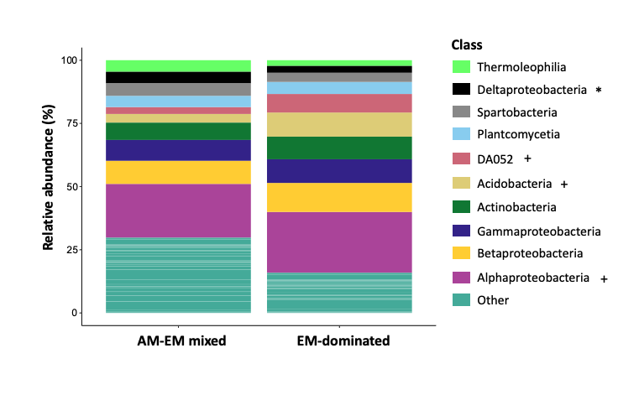

Supplementary Figure S2. Relative abundance of the top 10 bacterial orders in AM-EM mixed and EM dominant tree stands. In label names, * indicates a group more abundant in AM-EM mixed plots while + indicates a group more abundant in EM dominant plots.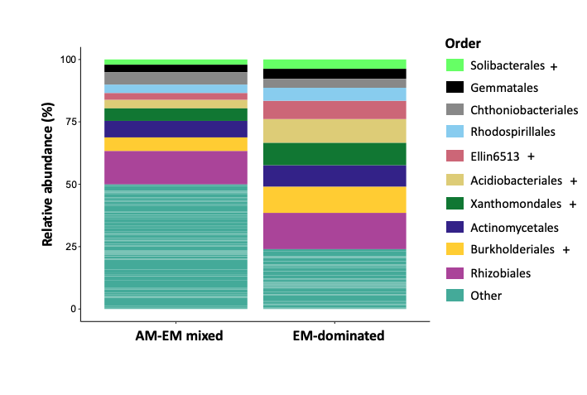

Supplementary Figure S3. Relative abundance of the top 10 bacterial families in AM-EM mixed and EM dominant tree stands. In label names, * indicates a group more abundant in AM-EM mixed plots while + indicates a group more abundant in EM dominant plots.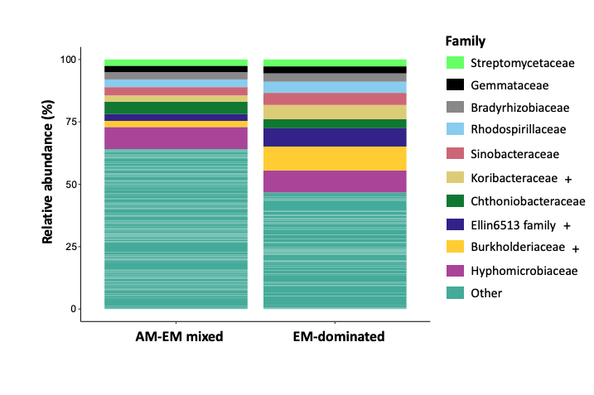

Supplementary Figure S4. Relative abundance of the top 10 bacterial genera in AM-EM mixed and EM dominant tree stands. In label names, * indicates a group more abundant in AM-EM mixed plots while + indicates a group more abundant in EM dominant plots.

