Supplementary Materials
Supplementary Materials 1. Heart Rate Evoked Potentials without Baseline Correction
S1.1 TANOVA
TANOVA using the recommended L2 normalisation was performed on HEP data without baseline correction. Similar to the primary analysis, a significant main effect of group that survived duration control (33ms) for multiple comparisons was found from 234 to 294ms (global count statistics across the whole epoch p = .02). This result was significant when activity was averaged across the significant window from 234 to 294ms (p= .005, partial η²= .04). Consistent with the primary analysis, meditators showed HEPs with a more central posterior distribution of positive voltages. No interaction was again found between group and conditions (EC and EO; p > .05 for the entire time period, global count statistics across the whole epoch p = .1). Figure S1 depicts topographical differences between groups for the significant window from 234 to 294ms.

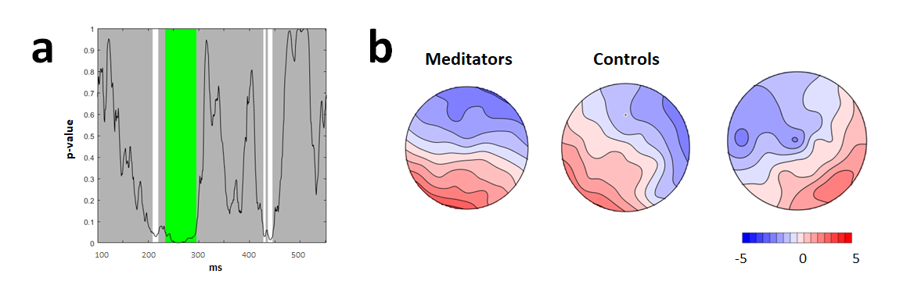
Fig. S1 a–p-graph of TANOVA of HEP without baseline correction showing the significant main effect of group and p-values across the duration of the epoch (global count statistics across the whole epoch p = .02, FDR p < .05). Green bars reflect periods that exceeded the duration control for multiple comparisons across time (33ms). This period was a longer duration of significance than 95% of the 5000 randomizations. b - TANOVA topographic maps for each group and a t- map for meditators topography minus control topography during the 234 to 294ms time window (averaged across the significant period p = .005, partial η²= .04)

S1.2 GFP
A GFP randomisation test was also performed on HEP data without baseline correction. Again, there was no significant main effect of Group, no periods of significance lasted longer than the duration control of 45ms (global count statistics across the whole epoch p = .22), nor interaction for Group x Condition (EC and EO; global count statistics across the whole epoch p = 1). See figure S2.

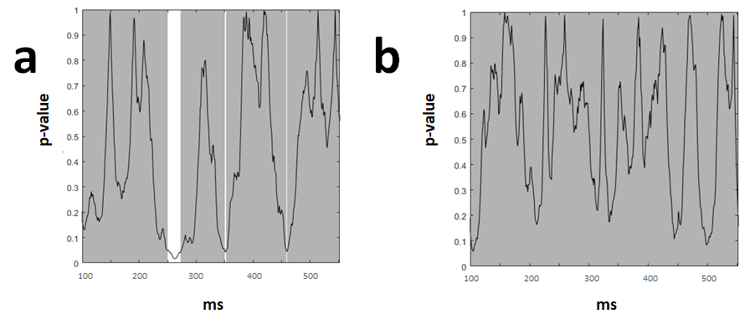
Fig. S2 a- Main effect of group in GFP test across the duration of the epoch. b- Group effects by conditions (EC and EO) interaction in GFP test across the duration of the epoch. No significant main effect of Group, nor interaction for Group x Condition in GFP were present (no significant periods lasted longer than the duration control of 45ms)

Table S1
Descriptive of HRV metrics for all groups and conditions
 | Meditators |  |  |  |  |  | Controls
 | EC |  |  | EO |  |  | EC |  |  | EO
 | M | SD | SE | M | SD | SE | M | SD | SE | M | SD | SE
HR | 69.12 | 1.71 | 10.43 | 68.96 | 1.67 | 10.14 | 71.86 | 1.58 | 9.34 | 72.8 | 1.49 | 8.83
RR | 892.61 | 23.7 | 144.17 | 892.90 | 22.24 | 135.29 | 851.79 | 18.09 | 107.03 | 839.28 | 16.74 | 99.02
RMSSD | 43.59 | 3.95 | 24.04 | 47.51 | 4.38 | 26.65 | 42.04 | 3.99 | 23.61 | 42.38 | 3.99 | 23.62
HF | 620.68 | 107.93 | 656.53 | 765.66 | 114.75 | 698 | 687.81 | 127.79 | 756.04 | 662.73 | 126.64 | 749.2
LF | 1739.7 | 390.5 | 2375.31 | 1819.08 | 376.68 | 2291.23 | 675.68 | 110.55 | 654.02 | 849.36 | 137.9 | 815.82
nuHF | 32.77 | 3.79 | 23.06 | 59.24 | 3.92 | 23.87 | 49.69 | 4.13 | 24.43 | 54.41 | 3.71 | 21.95
LFnu | 60.51 | 4.35 | 26.44 | 34.03 | 3.37 | 20.5 | 39.43 | 3.40 | 20.09 | 35.1 | 3.27 | 19.34
LF/HF | 4.75 | 1.04 | 6.312 | 4.64 | 1.20 | 7.32 | 2.16 | 0.36 | 2.10 | 2.94 | .65 | 3.83
Note. M = Mean; SD = Standard Deviation; SE = Standard Error; EC = Eyes Closed; EO = Eyes Opened; HR = Heart Rate; RR = Time between two adjacent R-waves of the QRS complex; RMSSD = Root mean square of successive differences between successive RR intervals; HF = High Frequency; LF = Low Frequency; nuHF = Normalised High Frequency Units; LFnu = Normalised Low Frequency Units; LF/HF = ratio of LF and HF.
Supplementary Materials 2. Descriptive of HRV metrics
Supplementary Materials 3. Topographical Consistency Test
The TCT was conducted to assess consistency of neural activity within each group and condition separately (Koenig et al., 2011). Although results showed topographical consistency within all groups and conditions during the majority of the entire epoch indicating that TANOVA comparisons between conditions and groups are valid during the majority of time periods. There were some variabilities in both groups and conditions after 600ms (see figure S3)
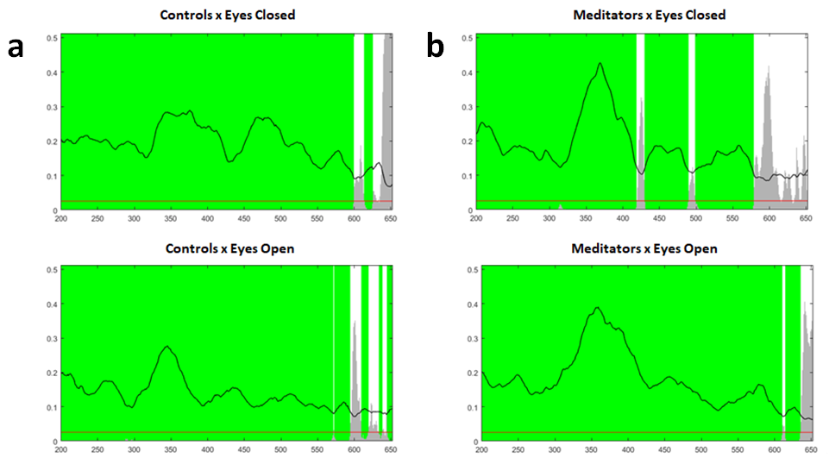

Fig. S3 a - Controls. b- Meditators. The GFP values are represented by the line and p- values are indicated by grey bars. Results showed topographical consistency within all groups and conditions during the majority of the entire epoch (marked in green). There were some variability in both groups and conditions after 600ms (marked white).

Supplementary Materials 4. Average RRI Entropy by Group

Table S2
Means and Standard Error of EEG and ECG Entropy
 | Meditators |  | Controls
 |  | M (SE) |  | M (SE)
EEG |  | .64 (.01) |  | .64 (.02)
ECG |  | .47 (.03) |  | .59 (.02)

