Supplementary data

1. Examples of quinoline-based medicines

Sup. 1 Fig. 1 | Structural representations of quinoline scaffold and derivatives. Quinoline is a foundational scaffold in medicinal chemistry, underlying its potential in anticancer, anti-inflammatory, antibacterial, and antiviral activities.

2. Dataset characterization

Sup. 2 Fig. 1 | PubChem and ZINC15 datasets. Characterization for quinoline-scaffold molecules
ZINC15 data was obtained from the website https://zinc15.docking.org/tranches/home/ with a filter for Drug-Like properties (981 million substances). The filter for quinoline molecules and conversion to SMILES is available in a CSV file and the conversion to Graphs is available in numpy compressed files for adjacency and node features, all in the github repository (https://github.com/bmacedo111/MedGAN/tree/main/data).
3. Model architecture

Input
Latent Vector (z)
A random vector of shape according to the latent dimension, sampled from a Gaussian distribution.
$$z\sim Ν\left(0,Ι\right)$$
Architecture
Dense Layers
The latent vector (z) is passed through multiple dense layers and each layer applies an hyperbolic tangent (tanh) function:
$$y=\frac{e^{Wx+b}-e^{-\left(Wx+b\right)}}{e^{Wx+b}+e^{-\left(Wx+b\right)}}$$
$$\text{where} W and b are the weight and bias of the layer, respectively$$
Adjacency Matrix Generation (A):
The final dense layer is reshaped and symmetrized to an adjacency tensor. Softmax is applied to the tensor along axis=1.
$$A_{ij}=\frac{e^{x_{adjacency,ij}}}{\sum_{j=1}^{N}{e^{x_{j}}}}$$
Feature Matrix Generation (F):
The final dense layer is reshaped to a feature tensor. Softmax is applied to the tensor along axis=2.
$$F_{ij}=\frac{e^{x_{features,ij}}}{\sum_{j=1}^{N}{e^{x_{j}}}}$$
Discriminator
Graph Convolution Layers:
These layers perform Relational Graph Convolutions (ReLU in model 3 and LeakyReLU in model 2).

$$Xout​=ReLU\left(Aggregate\left(A,F\right)W\right)=max⁡(0,Aggregate\left(A,F\right)W)$$
$$Xout​=LeakyReLU\left(Aggregate\left(A,F\right)W\right), where LeakyReLU\left(x\right)= \left\{\begin{aligned}x if x> 0 \\ αx if x ≤0\end{aligned}\right.$$

where Aggregate(A,F) is a function that takes the adjacency matrix A and the feature matrix F as input and aggregates information from neighboring nodes. This aggregated information is then passed through a weighted linear transform W and activated by the ReLU function. The constant α determines the "leakiness" of the function in LeakyReLU.

Dense Layers:
The output of the Graph Conv layers is passed through Dense layers with activation as ReLU.
$$y=ReLU\left(Wx+b\right)=max⁡(0,Wx+b)$$
A dropout layer is applied with dropout rate.
Final Dense Layer:
Outputting a single scalar value representing the "realness" of the input graph.

Loss Functions
Discriminator Loss
$$D_{Loss}=D_{Generated}-D_{Real}+ λ×GP$$
Generator Loss
$$G_{Loss}={- D}_{Generated}$$
Gradient Penalty
$$GP={\left(1-|\left|∇Α\right||\right)}^{2}+ {\left(1-|\left|∇F\right||\right)}^{2}$$
||∇Α|| and ||∇F|| are the norms of the gradients of the discriminator’s output with respect to Adjacency and Feature matrix, respectively.

Optimizer: RMSProp
The RMSProp algorithm is used to update the weights W and biases b for both the Discriminator (D) and the Generator (G), aiming to minimize their respective loss functions with a gradient:
$$g_{D}=∇_{W,b}​DLoss$$
$$g_{G}=∇_{W,b}​GLoss$$
Update the moving average of past squared gradients for both the Discriminator and the Generator:
$$v_{D,G}=βv_{D,G}+\left(1-β\right)g_{D,G}2$$
Update the weights W and biases b for both the Discriminator and the Generator:
$$W_{D,G}=W_{D,G}-α \frac{g_{D,G}}{\sqrt{v+ϵ}}$$
$$b_{D,G}=b_{D,G}-α \frac{g_{D,G}}{\sqrt{v+ϵ}}$$
where,
α is the learning rate.
β is the decay rate.
ϵ is a small constant to prevent division by zero.
4. Hyperparameter search

Sup. 4 Table 1 | Hyperparameter search. The configurations that offered the most promising results when compared to the baseline model were identified by their validity performance.
 | Base model | Improvement | No improvement
Neuron units | 128 | - | 64 | 256 | 512
Latent dimension | 64 | 256 | 128 | 512 | 2048
Activation function | Tanh/ReLU | Leaky ReLu | Tanh | ReLU | SELU
Optimizer and  learning rate | Adam  (1e-5) | RMSprop  (1e-4,  1e-5) | Adam (1e-3, 1e-4, 1e-6) | RMSprop (1e-3,  1e-6) | SDG (1e-4, 1e-5, 1e-6) | Adagard  (1e-4,  1e-5,  1e-6) | Adadelta (1e-4, 1e-5, 1e-6)
Regularizer | Dropout  (0.2) | Dropout  (0.01, 0.5) | Dropout (0.8) | L1/L2 | L1/l2 + Dropout (0.2)
Generator units | 512 | 4092 | 1024 | 2046 | 8184
Discriminator units | 512 | 4092 | 1024 | 2046 | 8184
Batch size | 32 | 128 | 8 | 512

Sup 4 Fig. 1 | Validity performance using various optimized parameters. The percentage of valid generated molecules was assessed, and better results were observed for LeakyReLU activation function, RMSProp optimizer with a lower learning rate, and increased Latent dimension and neuron units for the generator and discriminator.

5. Tox21 Model training and results

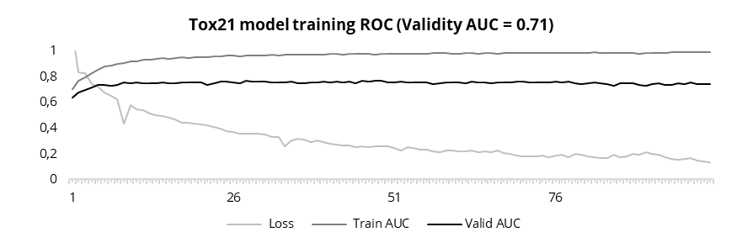
Sup. 5 Fig. 1 | Training Progression of the Tox21 Model. Convolutional Graph constraints were applied to ensure the same molecule size and atom types.

Sup. 5 Table 1 | Toxicity. Models 2 and 3 generated molecules were evaluated with the pre-trained tox21 model for 12 targets and the results show the percentage of non-toxic compounds with mean and median values.

* random sample of 10,000 molecules

6. Molecules generated samples

Sup. 6 Fig. 1 | Samples of molecules generated with model 3 trained with subset ZINC15 III

