Supplementary Information
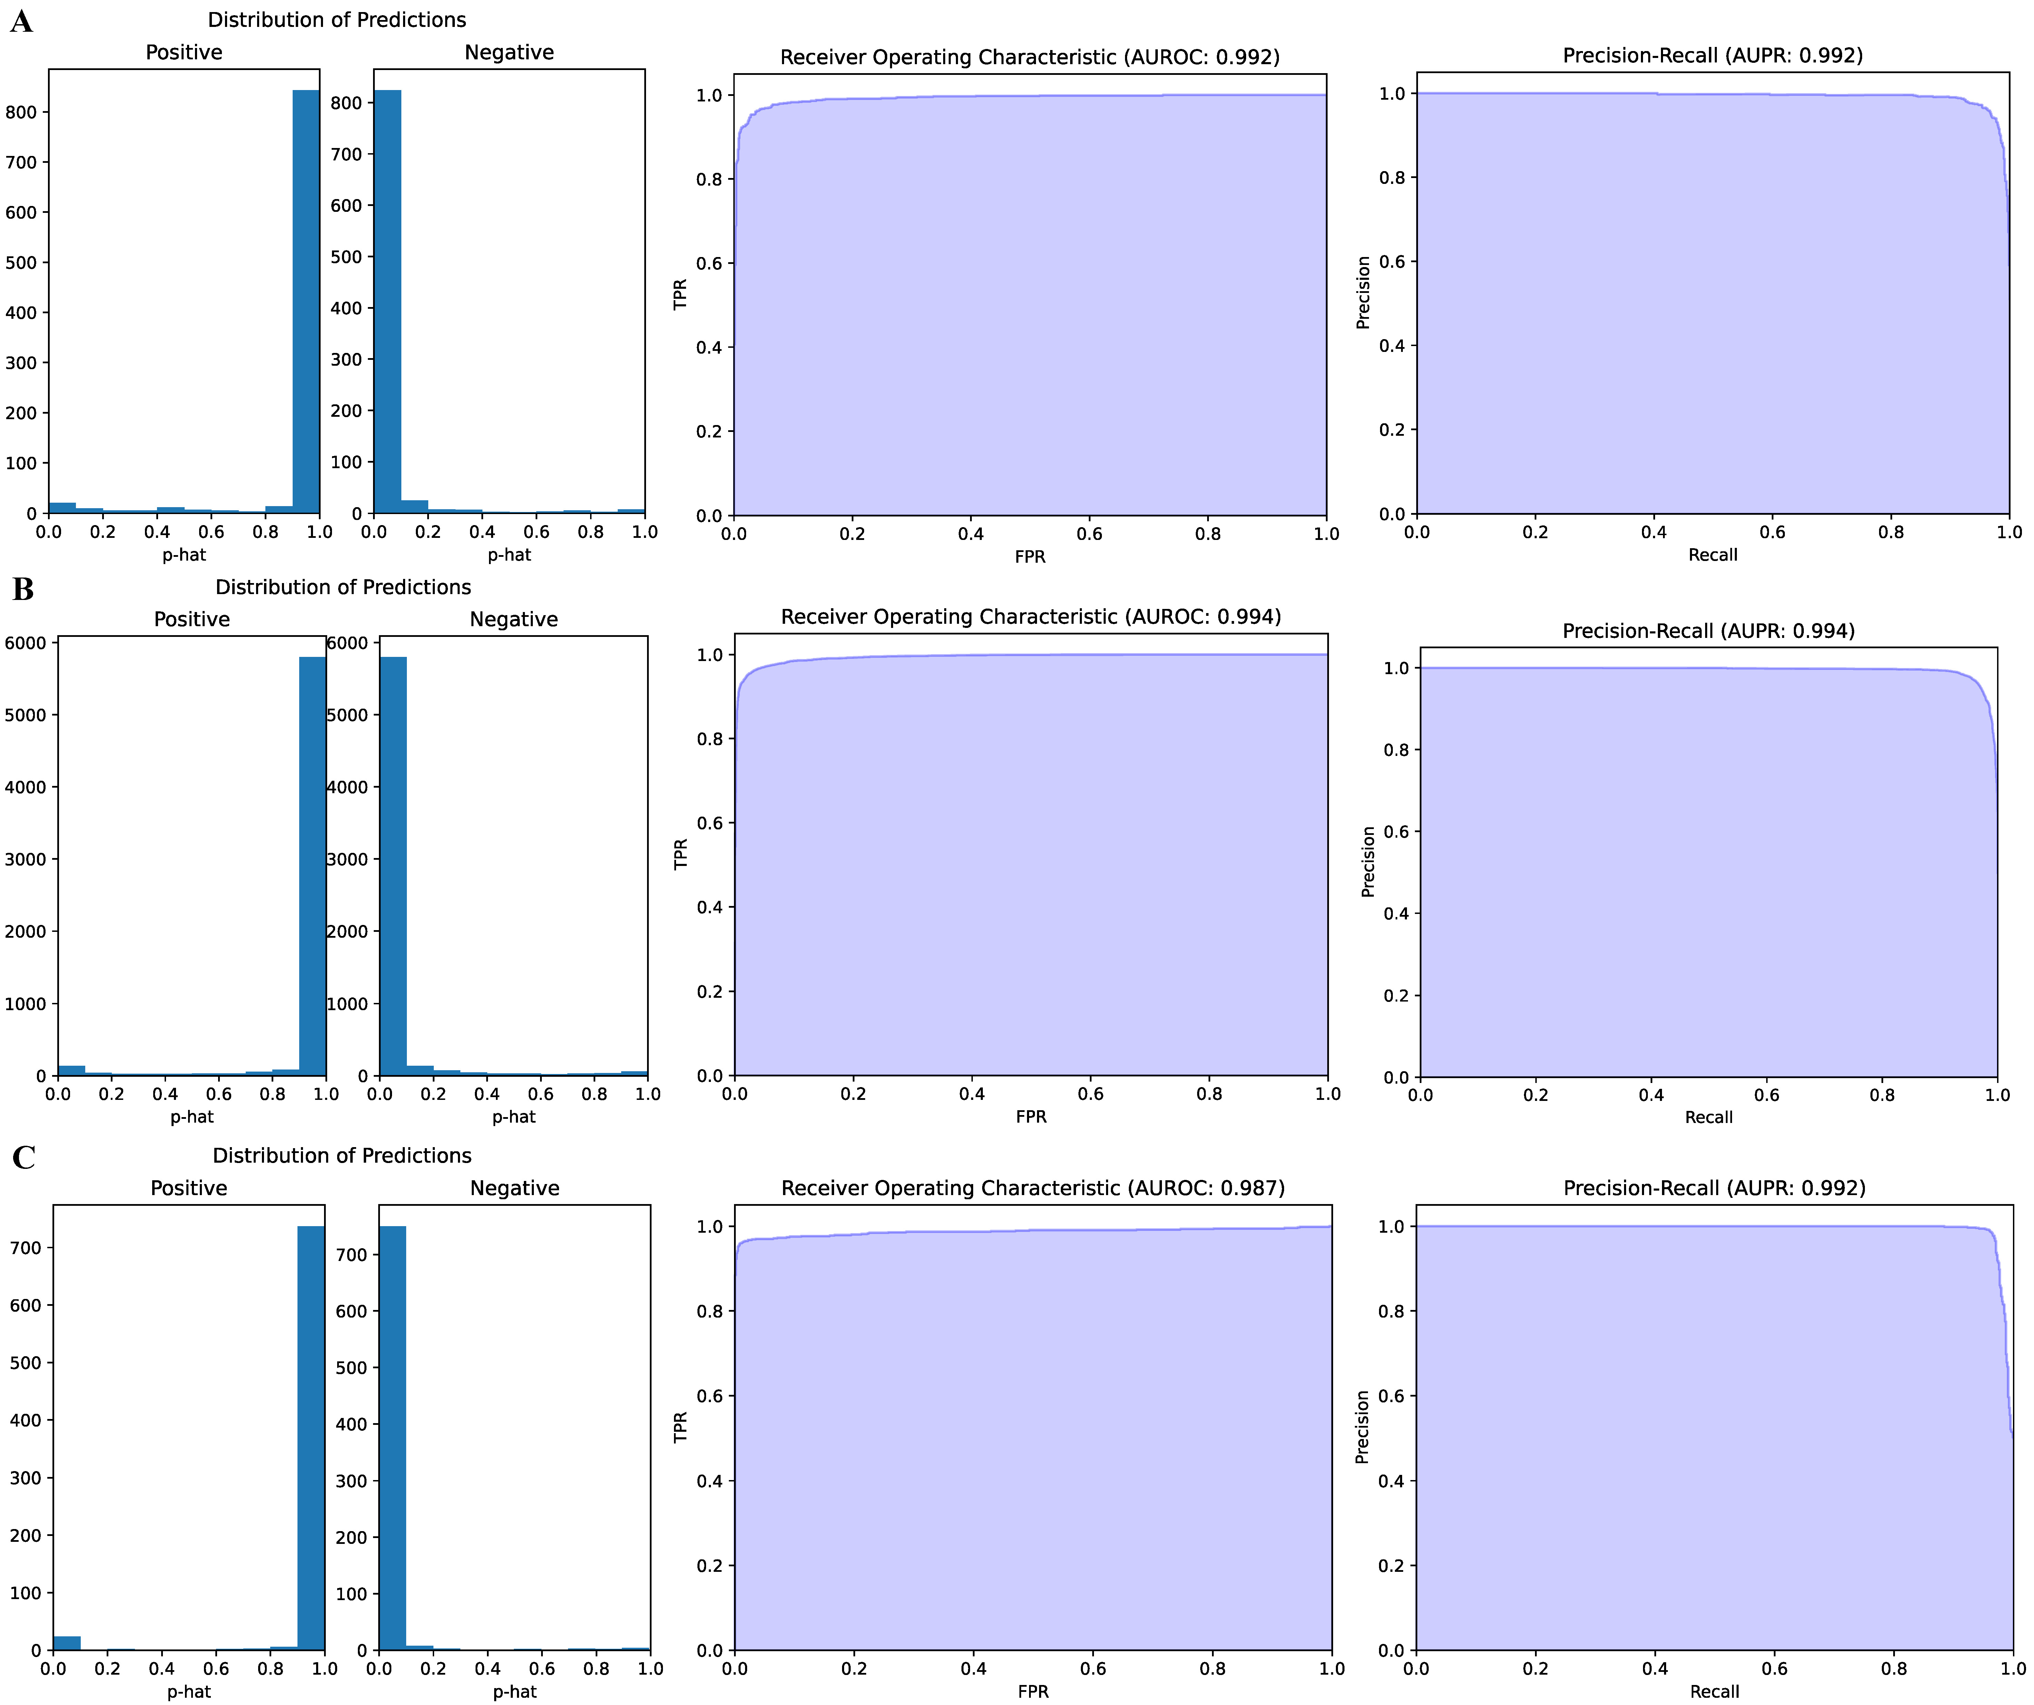
Figure S1. The distribution of predictions, the receiver operating characteristic, and precision-recall curves at sequence level evaluation. (A-B) TEC-miTarget is trained on the miRAW training set and evaluated on the miRAW test set (A) and miRAW independent test set (B). (C) TEC-miTarget is trained on the DeepMirTar training set and evaluated on the DeepMirTar test set.

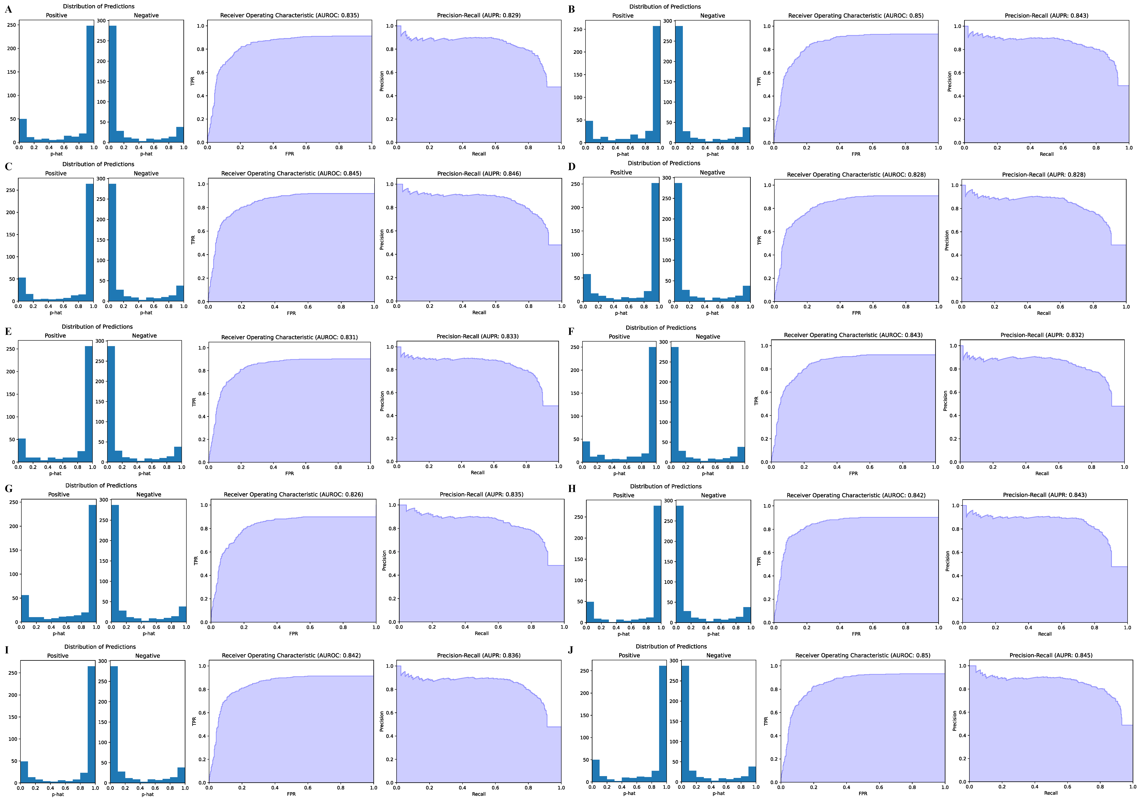
Figure S2. The distribution of predictions, the receiver operating characteristic, and precision-recall curves at transcript-level evaluation. TEC-miTarget is trained on the deepTargetPro training set and evaluated on the ten deepTargetPro test sets (A: test set 1, …, J: test set 10).

Table S1. TEC-miTarget’s average performance using different selection strategies
 | Accuracy | Sensitivity | Specificity | PPV | NPV | F1 score | AUC | AUPR
offset-9-mer-m7 | 79.39% | 73.24% | 85.13% | 82.13% | 77.33% | 77.42% | 0.8297 | 0.8083
13-mer-m9 | 79.97% | 78.56% | 81.29% | 79.67% | 80.25% | 79.11% | 0.8369 | 0.8393

