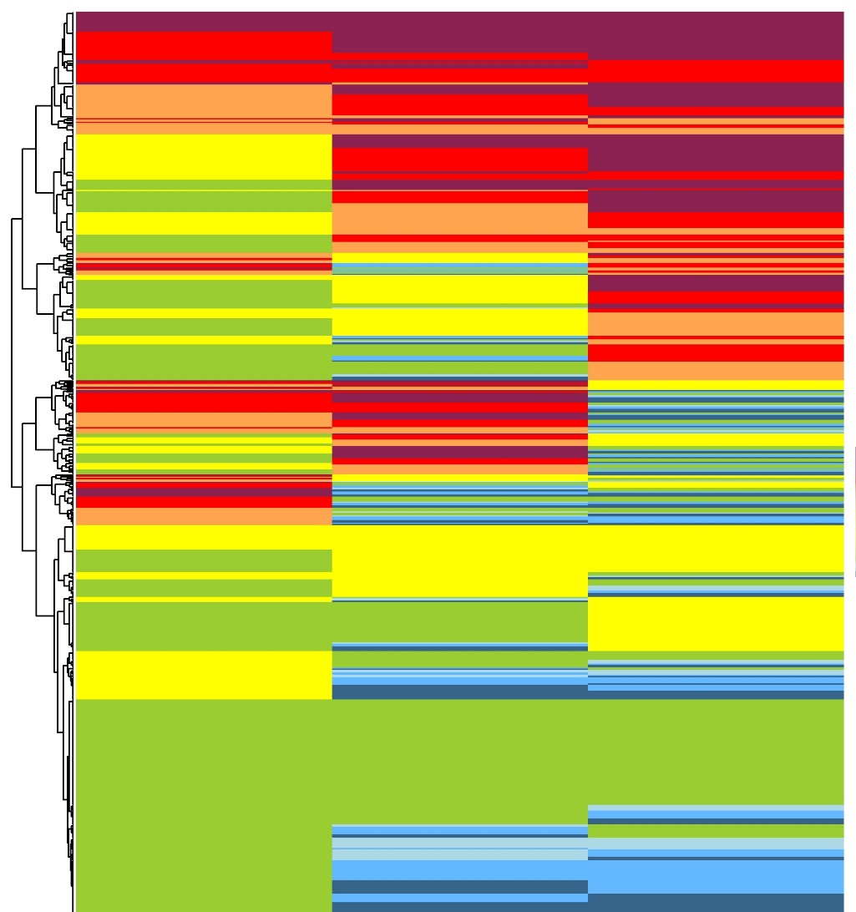
Supplementary Figure 1: Dendrogram of School Refusal trajectories
The analysis of back-to-school trajectories was analyzed in sequences, which were represented in the form of a dendrogram. A line from the dendrogram depicted a child. Blue is associated with a low absence from school and red with a high absence from school. We can see that some children never go back to school during the three years of follow-up. Others go to school between 1 month and 1 term and then never go back. Some children do not go to school and then go back completely. Others still have absences of between 2 and 1 month during the 3 years of follow-up. And finally, some children have returned to school completely after an absence of less than a month. These sequences, once grouped into clusters, develop the identification of the different back-to-school profiles.

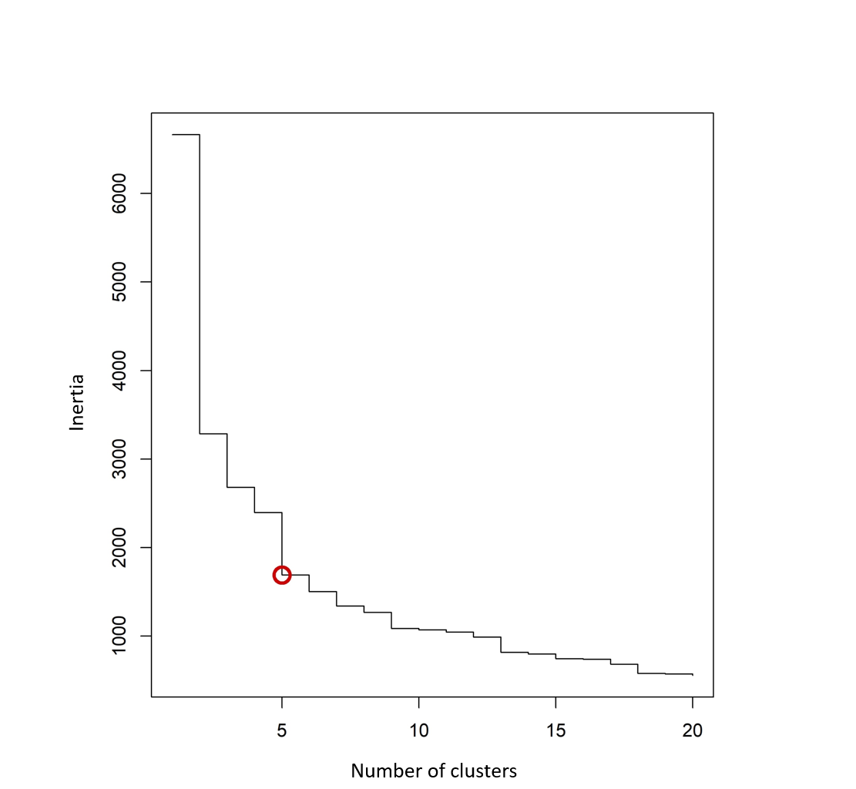
Supplementary Figure 2: Dissimilarities between sequences
We tested different methods for calculating the number of clusters such as the inertia block (the largest drop in inertia gives the group number) with the bestcutree function of the R JLutils library (version 1.16.0). Following a visual inspection of the clusters obtained during these tests and the cluster partitioning indices, we were able to confirm that the optimal number of clusters is 5.

