Supporting Information

Double-walled Al-based MOF with large microporous specific surface area for trace benzene adsorption

Laigang Hu ^{a,c,d}, Wenhao Wu ^{a,c,d}, Min Hu ^{a,c,d}, Ling Jiang ^{a,c,d},Daohui Lin ^{a,c,d},
Jian Wu ^{a,c,d}, Kun Yang ^{a,b,c,d*}

ª Department of Environmental Science, Zhejiang University, Hangzhou 310058, China;
^{b} ZJU-Hangzhou Global Scientific and Technological Innovation Center, Zhejiang University, Hangzhou 311215, China;
^{c} Key Laboratory of Environmental Pollution and Ecological Health of Ministry of Education, Hangzhou 310058, China;
^{d} Zhejiang Provincial Key Laboratory of Organic Pollution Process and Control, Hangzhou 310058, China;
∗ Corresponding author (Kun Yang): Tel.: 86-571-88982589; Fax: 86-571-88982590;
E-mail: kyang@zju.edu.cn

1. EXPERIMENTAL SECTION

1.1. Chemicals and Materials. All commercial chemicals were purchased without further extra purification. 4,6-Di(4-carboxyphenyl)pyrimidine (H₂DBP, 98 %) was supplied from Extension Technology Co., Ltd., China. Aluminium nitrate nonahydrate (Al(NO₃)₃·9H₂O, 99 %), formic acid (99 %), N,N-dimethylformamide (DMF, 99 %), acetone (98 %) and KBr (99 %) were purchased from Aladdin Reagent Co., Ltd., China. Benzene (> 98 %), toluene (>98 %), ethylbenzene (>98 %), ortho-xylene (>98 %), meta-xylene (>98 %) and para-xylene (>98 %) were all supplied from Shanghai Macklin Biochemical Co., Ltd., China.

1.2. Synthesis of ZJU-520(Al). H₂DBP (22.8 mg, 0.07 mmol), Al(NO₃)₃·9H₂O (30 mg, 0.08 mmol) and 0.02 mL formic acid were mixed and ultrasonically dissolved in 1.5 mL DMF. This mixture was heated at 130 ℃ for 72 h in the 50 mL Teflon vessel to yield rod-shaped crystalline products after cooling down to room temperature. The as-synthesized products were washed with DMF for three times. Then, the crystals were washed with acetone six times over the course of three days. Finally, the products were dried in the vacuum oven for 24 h at 80 ℃ (yield: ~ 10.21 mg).

1.3. N₂ adsorption-desorption measurements. N₂ adsorption-desorption isotherm on ZJU-520(Al) was measured by AUTOSORB AS–1 physisorption analyzer (Quantachrome, USA) at 77 K. Before the sorption measurement, the samples were heated at 378 K for 24 h under the vacuum environment. The specific surface area of ZJU-520(Al) was calculated by Brunauer-Emmett-Teller (BET) method in the range of 0.001 ~ 0.053 (P/P₀). The pore size distribution (PSD) of ZJU-520(Al) was calculated according to the nonlocal density functional theory (NLDFT) model using the geometry of slit ¹. The total pore volume of sample was obtained from N₂ adsorption-desorption isotherm at 77 K and relative pressure (P/P₀) of 0.99.

1.4. Thermal gravimetric analysis (TGA). Thermal stability examination of ZJU-520(Al) was performed on the SDT Q600 (Mettler Toledo, Switzerland) instruction. In detail, ZJU-520(Al) samples (4.91 mg) were put into the instruction and heated from room temperature to 1000 ℃ with the rate of 5 ℃/min under N₂ environment.

1.5. SEM image and EDS mapping. Scanning electron micrographs (SEM) images and energy dispersive spectroscope (EDS) mapping were taking using a Zeiss GIMINI 300 (Germany). Prior to measurement, samples were coated with Pt to ~ 9 nm thickness in MCIOOO ion sputter (HITACHI, Japan).

1.6. Fourier-transform infrared (FT-IR) spectra analysis. The functionalized groups of ZJU-520(Al) and H₂DBP were collected from 400 ~ 4000 cm⁻¹ on Bruker-vector-22 by Fourier-transform infrared spectra method. The samples of ZJU-520(Al) (1.00 mg) and H₂DBP (1.05 mg) were mixed with KBr using the agate mortar, then ground and compressed into circular flakes to FT-IR analysis ², respectively.

1.7. Static adsorption of BTEX and cyclohexane. The vapors adsorption isotherms of benzene, toluene, ethylbenzene, meta-xylene, ortho-xylene, para-xylene (BTEX) and cyclohexane were measured by JW-ZQ100 vapor adsorption instrument (Beijing JWGB Sci.& Tech. Co., Ltd). The vapors were generated by steam generation unit and heating unit. Before the measurement, adsorbate liquids were purified at 77 K in the liquid nitrogen, respectively. The heating unit of instrument was utilized to maintain the temperature of steam generation unit at 313 K, ensuring the consistent and continuous production of steam ³. The temperature of adsorbate samples was kept in the adsorption process, using the heating in water bath methods. Before the measurement, the samples were outgassed at 378 K for 24 h to remove the adsorbed water molecules in the pore structure of adsorbent.
To calculate the benzene/cyclohexane (Bz/Cy) separation of ZJU-520(Al), the Dual-site Langmuir-Freundlich (DSLF) model ⁴, Equation S1, was chosen to fit the single-component adsorption isotherms of benzene and cyclohexane at 298 K.
$$Q_{m}=Q_{m1}\frac{b_{1}p^{n}}{1+b_{1}p^{n}}+Q_{m2}\frac{b_{2}p^{m}}{1+b_{2}p^{m}}$$ | (S1)
Where Q_{m} is the adsorbed amount, mmol/g; Q_{mi (i=1,2)} is the saturation adsorption capacity, mmol/g; p is the equilibrium pressure of gas, kPa; b_{i(i=1,2)} is the affinity coefficient, 1/kPa; n and m are the deviations.
Adsorption selectivity for Bz/Cy gas mixture on ZJU-520(Al) at 298 K was calculated by ideal adsorbed solution theory (IAST) ⁵.
$$S= \frac{x_{1}/y_{1}}{x_{2}/y_{2}}$$ | (S2)
Where x_{i} and y_{i} are the molar fractions of components in the adsorbed and bulk phase.
In addition, the adsorption isotherms of benzene and cyclohexane are well fitted by Dual-site Langmuir-Freundlich (DSLF) model, listing in following Table.

Table. Fitting parameters of DSLF model for benzene and cyclohexane adsorption isotherms fitting on ZJU-520(Al) at 298 K.
Parameters | Benzene | Cyclohexane
Q_{m1} (mmol/g) | 5.01 | 16.58
b₁ (1/kPa) | 64691.33 | 0.060
n | 5.35 | 0.33
Q_{m2} (mmol/g) | 5.011 | 3.28
b₂ (1/kPa) | 64691.33 | 3257771.90
m | 5.35 | 5.69
R² | 0.96 | 0.99

1.8. Isosteric heat of adsorption. Isosteric heat of adsorption on ZJU-520(Al) was calculated from Clausius-Clapeyron equation ⁶ to predict the interaction between adsorbates and adsorbent, using the adsorption isotherms of adsorbates at 288, 298 and 308 K.
$$In P=-\frac{∆H}{R×T}+C$$ | (S3)
Where P is the pressure; R is the ideal gas constant, 8.314 kJ/mol; C is the constant; T is the temperature, K; ∆H is calculated from slopes of plots of In P versus 1/T of fixed loading.
1.9. Dynamic breakthrough experiment. The activated ZJU-520(Al) about 0.10 g was mixed with quartz wool uniformly and put into the fixed bed (6.00 mm outer diameter, 4.00 mm inner diameter, 130.00 mm lengthen) for dynamic breakthrough experiment of benzene/cyclohexane (Bz/Cy) at 298 K, using breakthrough curve analyzer (Beishide Instrument Technology (Beijing) Co., Ltd., China). The gas flow of high-purity N₂ gas was chosen to control the concentration of benzene vapor by bubbling the benzene liquid, using mass flow controller (MFC 1, Scheme 1). Another high-purity N₂ gas was used to bubble through cyclohexane liquid to control the concentration of cyclohexane vapor by MFC 2. The entire flow rate was 30 mL/min, controlled by MFC 3. The concentrations of mixture gases (Bz/Cy) were detected by gas chromatography (GC 9790Plus, FULI Instruments Co., Ltd., China) at the fixed inlet and outlet. Furthermore, the points of the breakthrough curve were obtained by continuously determining and recording the outlet concentrations at the time interval. In detail, dynamic breakthrough experiments of Bz/Cy (5/95) and Bz/Cy (1/99), with trace benzene concentration, are performed.
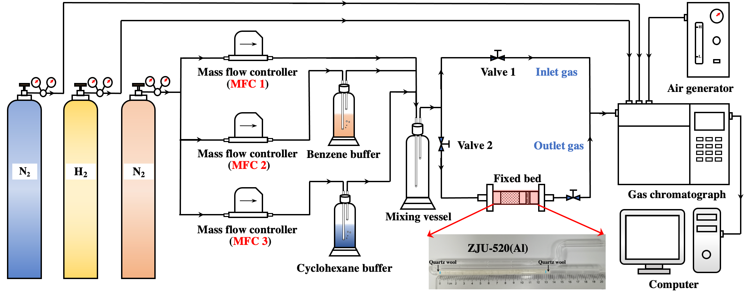
Scheme 1. Schematic illustration of dynamic breakthrough experiments of benzene/cyclohexane.

1.10. Powder X-ray diffraction (PXRD) analysis. PXRD patterns of ZJU-520(Al) were collected on the diffractometer (D8 ADVANCE, Bruker, Germany) equipped with Cu sealed tube (CuK𝜶1 radiation, 𝝀=1.5418 Å) at 40 kV and 40 mA to characterize crystallinity of synthesized materials. The intensity data of samples was collected from 2° to 50° with a scan step size of 0.02°. The refinement of ZJU-520(Al) structure was performed on the software of GASA II ⁷.

1.11. Single Crystal X-ray diffraction analysis. Single Crystal X-ray diffraction (SC-XRD) data of ZJU-520(Al) crystal, with 0.10 × 0.02 × 0.02 mm of dimensions (Fig. S1), was collected at 100.15 K using the Brucker D8 Venture diffractor equipped with the PHOTON II detector, Cryostream 80–400 K (Oxford Cryosystems, United Kingdom), and CuK𝜶 (𝝀=1.54178 Å) IμS microfocus X-ray source with MX Optics and a Kappa geometry goniometer. The rod-shaped crystal was obtained from mother solution, mounted on the MicroMesh (MiTeGen) with paratone oil. The space group of ZJU-520(Al) was belonged to I4₁md, solved by SIR2008 ^{8, 9}. Moreover, the structure of ZJU-520(Al) was determined by intrinsic phasing (SHELXT ¹⁰) and refined by full-matrix least-squares refinement on F² (SHELXL) using Olex2 software package ^{11, 12}. The solvent molecules were removed using PLATON SQUEEZE program ^{13, 14}. Refinement result and details of collected data on ZJU-520(Al) was summarized in Table S1. In addition, the selected bond length and angle were also summarized in Table S2-3. The SC-XRD data of ZJU-520(Al), containing the crystallographic data for this paper, was deposited in the Cambridge Crystallographic Data Centre (CCDC) database under deposition number CCDC 2288227.

1.12. Molecular simulations. Grand Canonical Monte Carlo (GCMC) simulations were carried out on the software of RASPA 2.0 ¹⁵ to investigate the vapor adsorption process on ZJU-520(Al). Before GCMC simulations, Helium (He) void fraction (HVF) of ZJU-520(Al) was calculated (ca. 0.64), using He as the probe according to Widom insertions method ^{15, 16}. Crystal structure of ZJU-520(Al), obtained from SC-XRD analysis, was without further geometry optimization for related simulations and kept rigid during the process of simulation. The theorical specific surface area and pore volume of ZJU-520(Al) were also obtained from GCMC simulations, using nitrogen (N₂) as probe (1.84 Å) at 77 K ¹⁷. Each point, in simulated adsorption isotherms, consisted of 10,000 initialization cycles and 10,000 production cycles. The adsorbate molecules could be translation, rotation, insertion and deletion in the framework of ZJU-520(Al). The interaction energies, such as van der Waals interaction, between adsorbate-framework were calculated through Lennard-Jones (LJ) potential ¹⁸, using the 12.5 Å cutoff to handle the nonbonding interactions ^{5, 19}. Furthermore, the density-derived electrostatic and chemical (DDEC) charges of ZJU-520(Al) with period framework were calculated through periodic density functional theory (DFT) methods, using Chargemol software ^{20, 21}. Restrained electrostatic potential (RESP) charges ^{22, 23} of adsorbates, such as benzene and cyclohexane, are calculated and summarized in Fig. 6a. Ewald & Group summation method was used to calculate the electrostatic interactions between adsorbate-framework. Universal force-field ²⁴ and Dreiding force-field ²⁵ were used to describe the LJ parameters of framework metal and nonmetal atoms, respectively. For adsorbate molecules, the LJ parameters were obtained from the TraPPE force-field ²⁶. The 4×4×4 supercells of ZJU-520(Al) were used to simulated adsorption at 298 K. The calculated excess adsorption of adsorbent compared with the experimental adsorption, obtained from Equation S4 ²⁷ ²⁸.
N_{exc}=N_{abs} -V_{p}×𝝆_{bulk} | (S4)
Where N_{abs} is the absolute adsorption, containing the amount of gas adsorbed in the pore volume in the presence of pore walls, mmol/g; N_{exc} is the excess adsorption capacity, mmol/g; V_{p} is the pore volume of adsorbent, cm³/g; 𝝆_{bulk} is the bulk density of adsorbate molecule, g/cm³.
Density functional theory (DFT) calculations were implemented for investigating the adsorption energy and electronic density of benzene molecule and ZJU-520(Al) with and without benzene, after optimization structure, using the software of CP2K ^{29, 30}. The input files of CP2K calculation tasks were generated by Multiwfn software ³¹. In detail, the theoretical method of Perdew, Burke and Ernzerhof (PBE) exchange-correlation function was applied with Generalized Gradient Approximation (GGA) ^{32, 33, 34}. The plane wave cutoff energy of this system was set to 400 Ry, with the relative cutoff of 50 Ry and progression factor of 3, according to the previous study ^{35, 36}. DFT-D3 scheme with semiempirical dispersion corrections ^{37, 38} was used to compensate the weak interaction, such as the long-range van der Waals dispersion interaction ³⁹ between adsorbate and the skeleton of ZJU-520(Al). The norm-conserving Goedecker−Teter−Hutter (GTH) pseudopotential ⁴⁰ and double-ζ valence polarized basis set (DZVP-MOLOPT-SR-GTH) ^{41, 42} were employed for DFT calculation. The binding energy of adsorbed benzene on ZJU-520(Al) was calculated, according to Equation (S5) ⁴³. The isosurfaces of charge density difference on ZJU-520(Al) with benzene molecules in site I, site II and center, was calculated by Equation (S6) ⁴⁴.
∆E_{ads} = E_{Benzene@ZJU-520(Al)} – (E_{Benzene} + E_{ZJU-520(Al)}) | (S5)
Where E_{Benzene@ZJU-520(Al)} is the total energy of ZJU-520(Al) with adsorbed benzene molecule in the equilibrium state, kJ/mol; E_{Benzene} is the energy of benzene, kJ/mol; E_{ZJU-520(Al)} is the energy of ZJU-520(Al) without adsorbed benzene molecules, kJ/mol; ∆E_{ads} is the binding energy of adsorbed benzene molecule on ZJU-520(Al).
∆ρ=ρ_{Benzene@ZJU-520(Al)} – (ρ_{Benzene} + ρ_{ZJU-520(Al)}) | (S6)
Where ρ_{Benzene@ZJU-520(Al)} is the charge density of ZJU-520(Al) with benzene, such as benzene molecule in site I, site II and center; ρ_{Benzene} is the charge density of benzene; ρ_{ZJU-520(Al)} is the charge density of ZJU-520(Al) without benzene; ∆ρ is the charge density difference of ZJU-520(Al) with benzene.

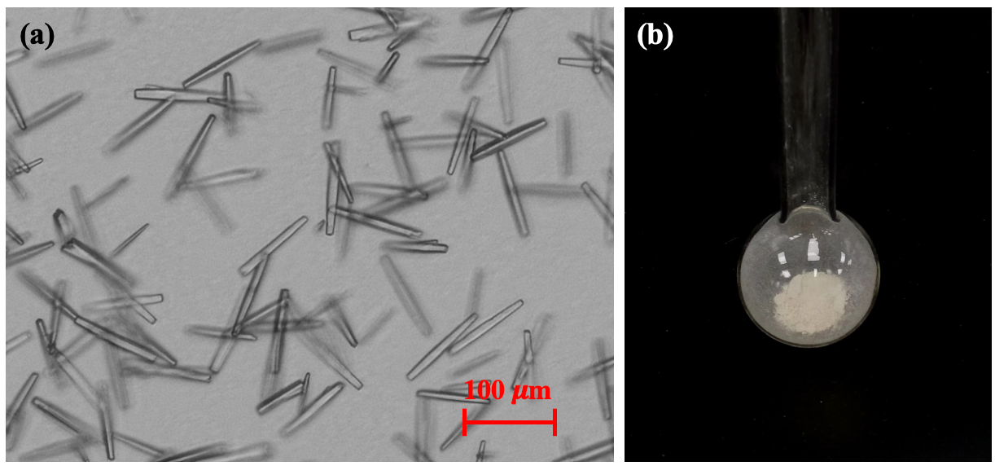
Fig. S1. Optical photo of ZJU-520(Al) crystal (a) and its white powder (b).

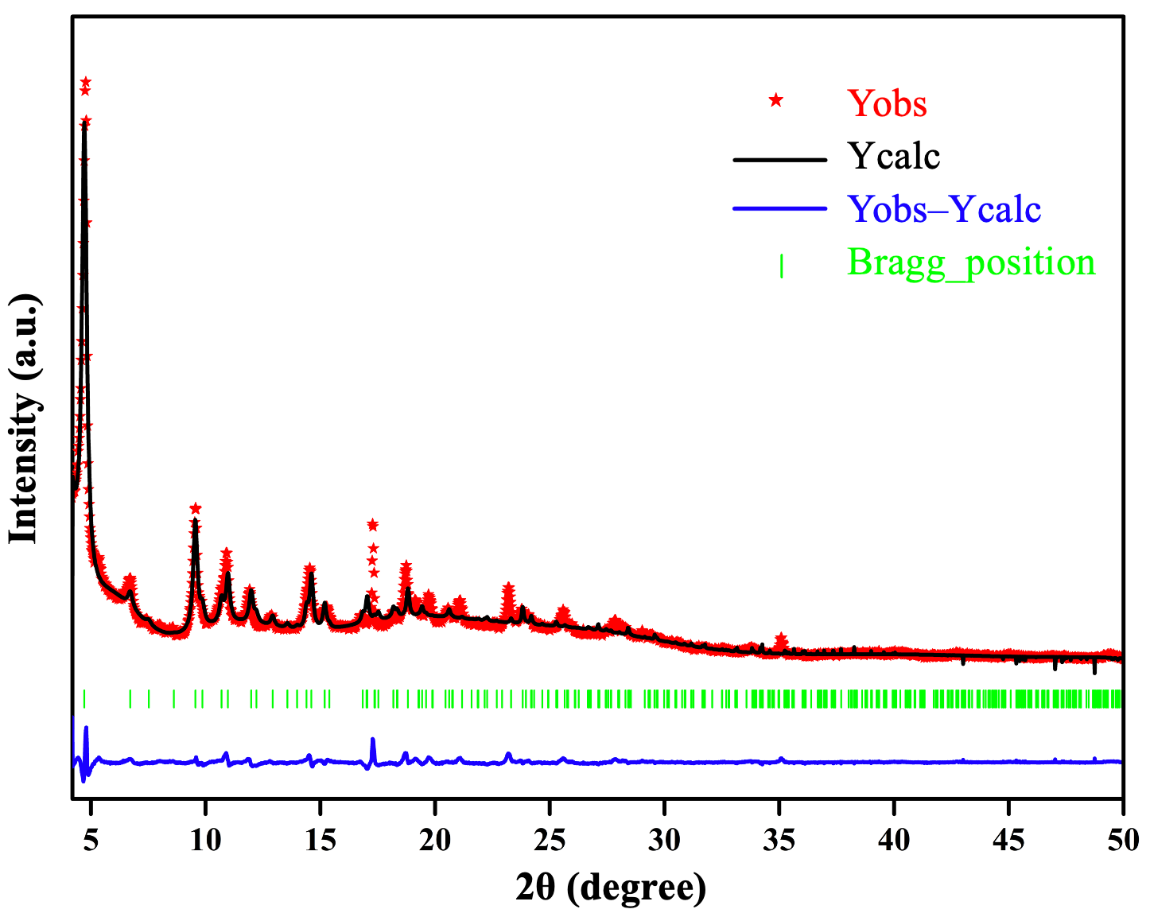
Fig. S2. Experimental PXRD patterns of as-synthesized ZJU-520(Al) compared with simulated ZJU-520(Al) diffraction pattern (𝝀 = 1.5418 Å). Observed (Y_{obs}, in red point) and calculated (Y_{calc}, in black line) PXRD patterns and different plot (in blue line) for the Rietveld refinement of ZJU-520(Al). The green vertical bars correspond to the position of Bragg peaks.

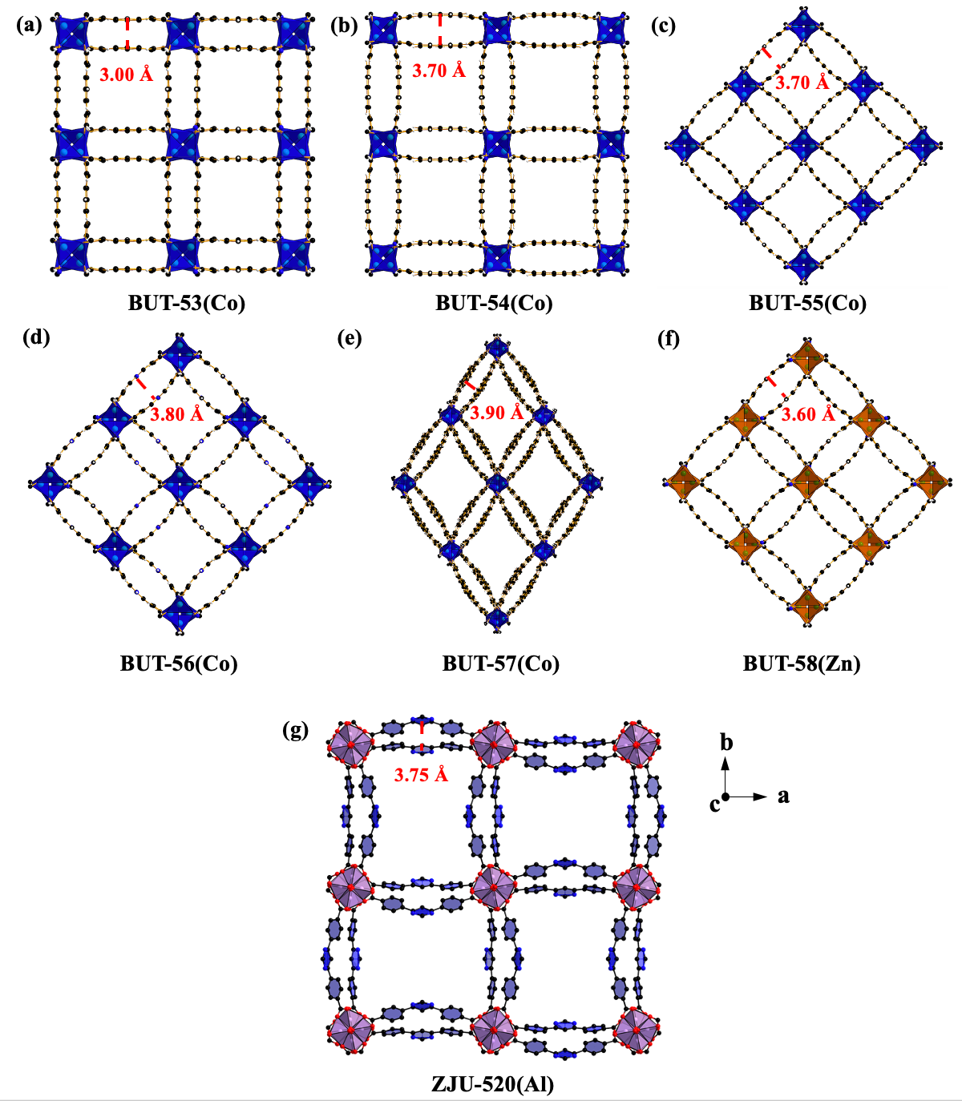

Fig. S3. The distance of double-wall on BUT-53 to BUT-58 and ZJU-520(Al), as viewed from c axis.

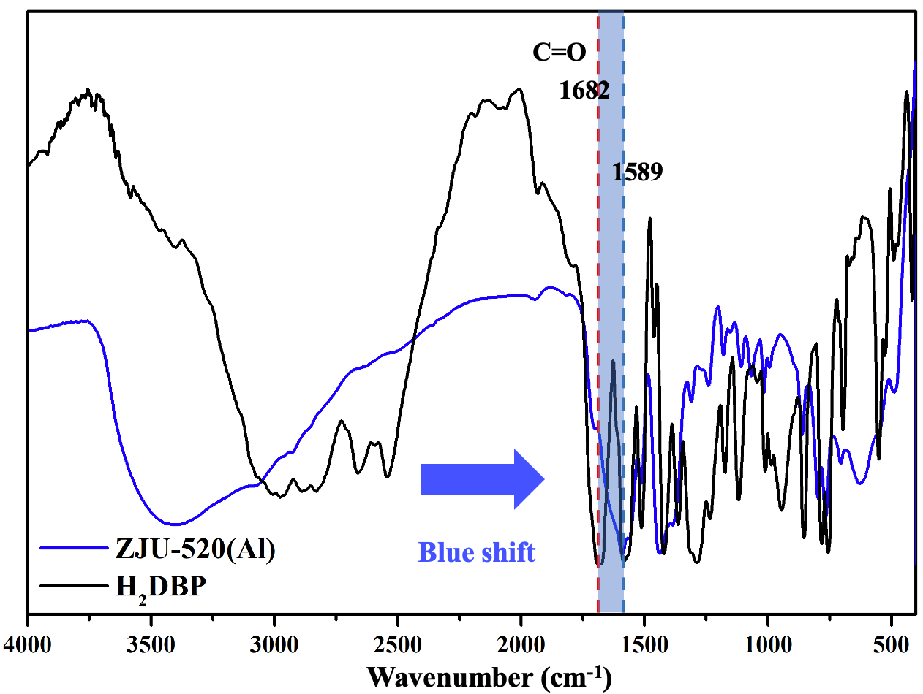

Fig. S4. FT-IR spectra of activated ZJU-520(Al) (in bule line) and H₂DBP ligand (in black line).
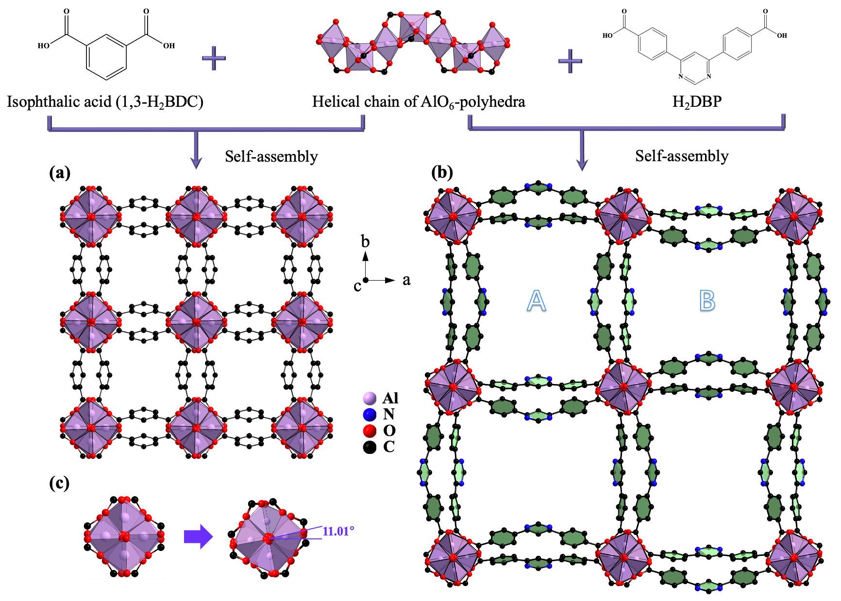
Fig. S5. Structure description of CAU-10(Al) (a) and ZJU-520(Al) (b). The AlO₆ cluster of ZJU-520(Al) with the rotation about 11.01 degree (c), compared with that of CAU-10(Al), as viewed from c axis.
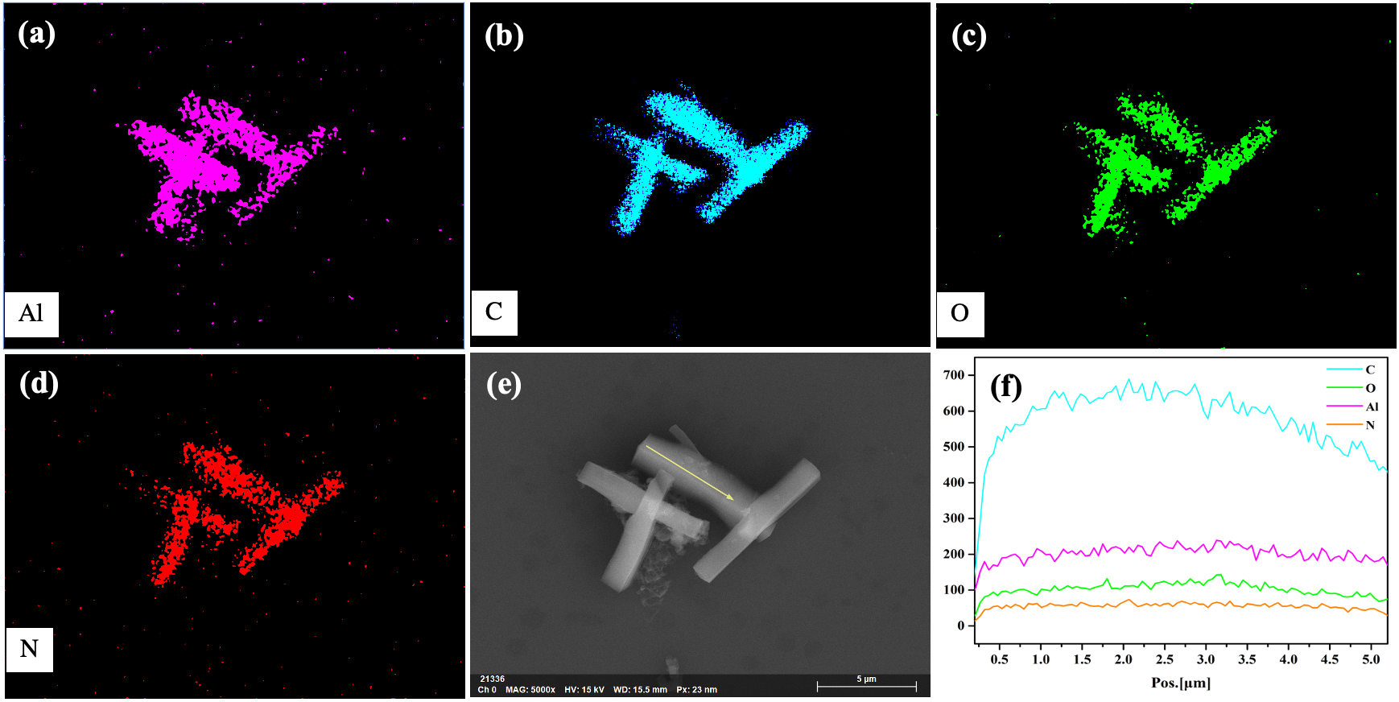
Fig. S6. Elemental energy dispersive spectroscope (EDS) spectral mapping, including Al (a), C (b), O (c) and N (d), SEM image (e), EDS linear scans (f) of ZJU-520(Al).

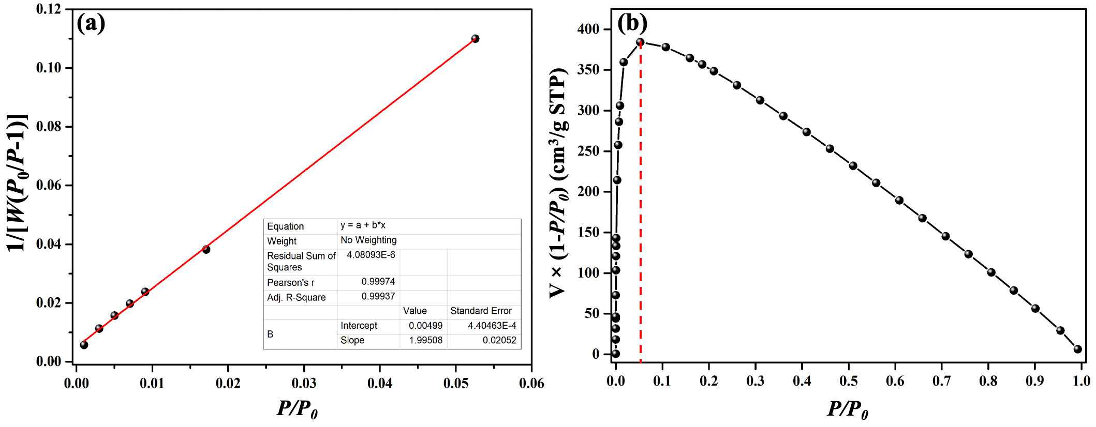
Fig. S7. Linear Brunauer-Emmett-Teller (BET) plot (a) and Rouquerol plot (b), i.e., V×(1-P/P₀) vs P/P₀, of ZJU-520(Al) from N₂ adsorption-desorption isotherm. The specific surface area of ZJU-520(Al) was calculated by BET method in the range of 0.001 – 0.053.
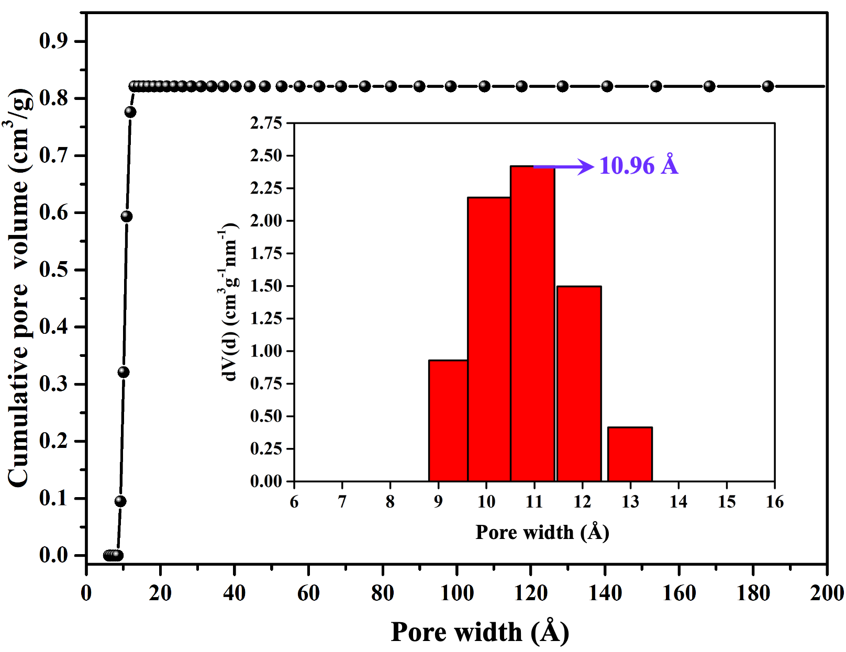
Fig. S8. Cumulative pore volume curve and inset PSD plot of ZJU-520(Al).

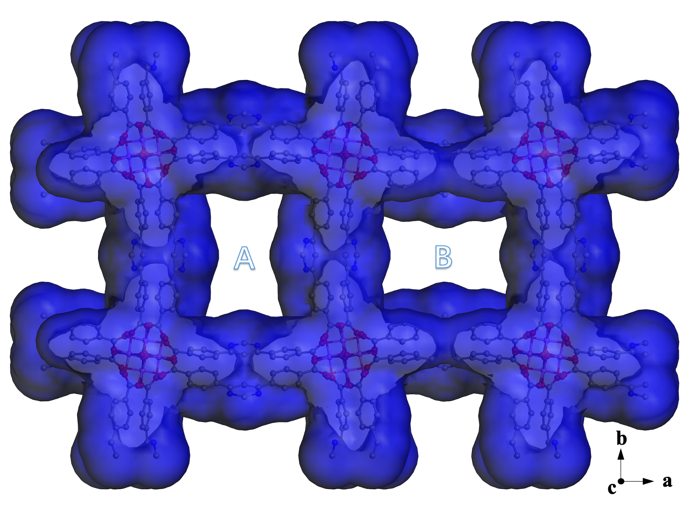
Fig. S9. Two types of microporous channels, named as A and B, using N₂ as probe, as viewed from c axis
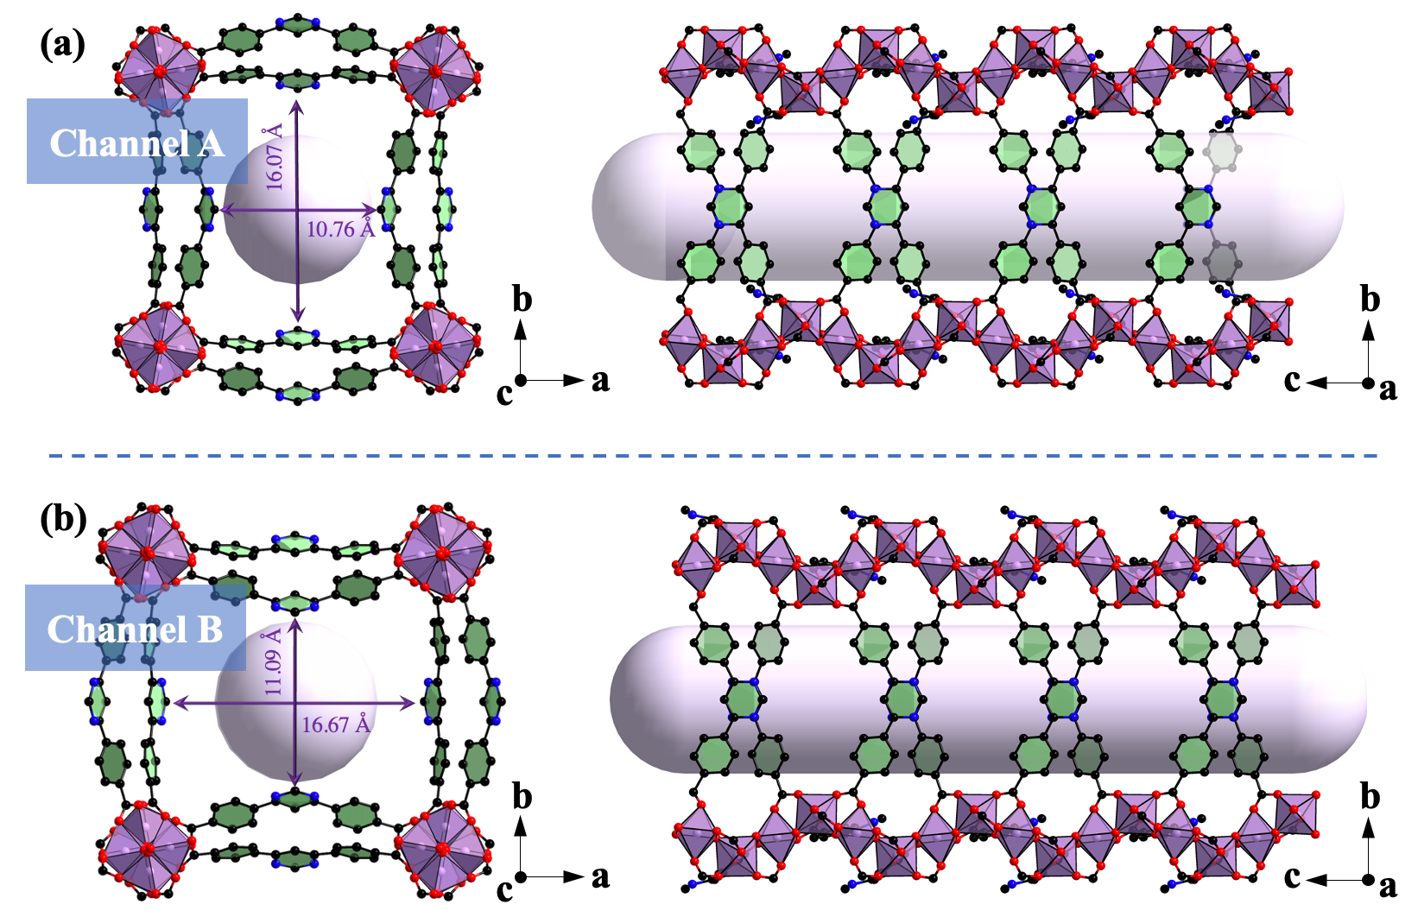
Fig. S10. Pore structures of ZJU-520(Al), including channel A (a) and B (b).

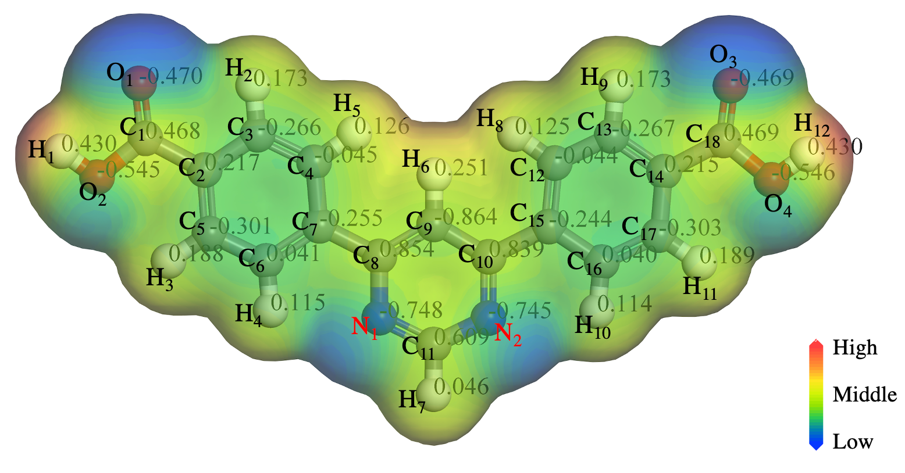
Fig. S11. Restrained electrostatic potential (RESP) charge distributions of H₂DBP ligand.
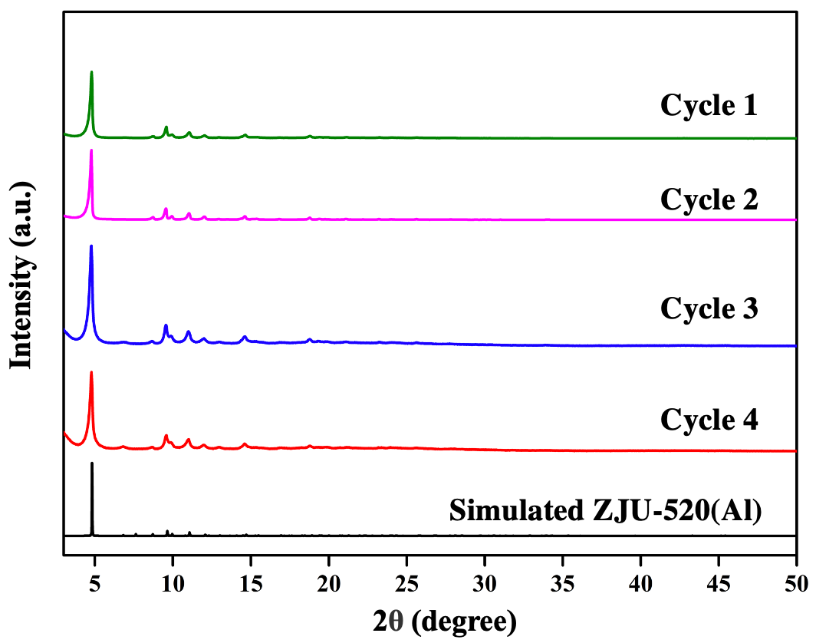
Fig. S12. PXRD patterns of ZJU-520(Al) after cyclical benzene adsorption experiments, in comparison with simulated PXRD patterns of ZJU-520(Al), using the same samples for benzene adsorption after degassed at 378 K for 4 hours.

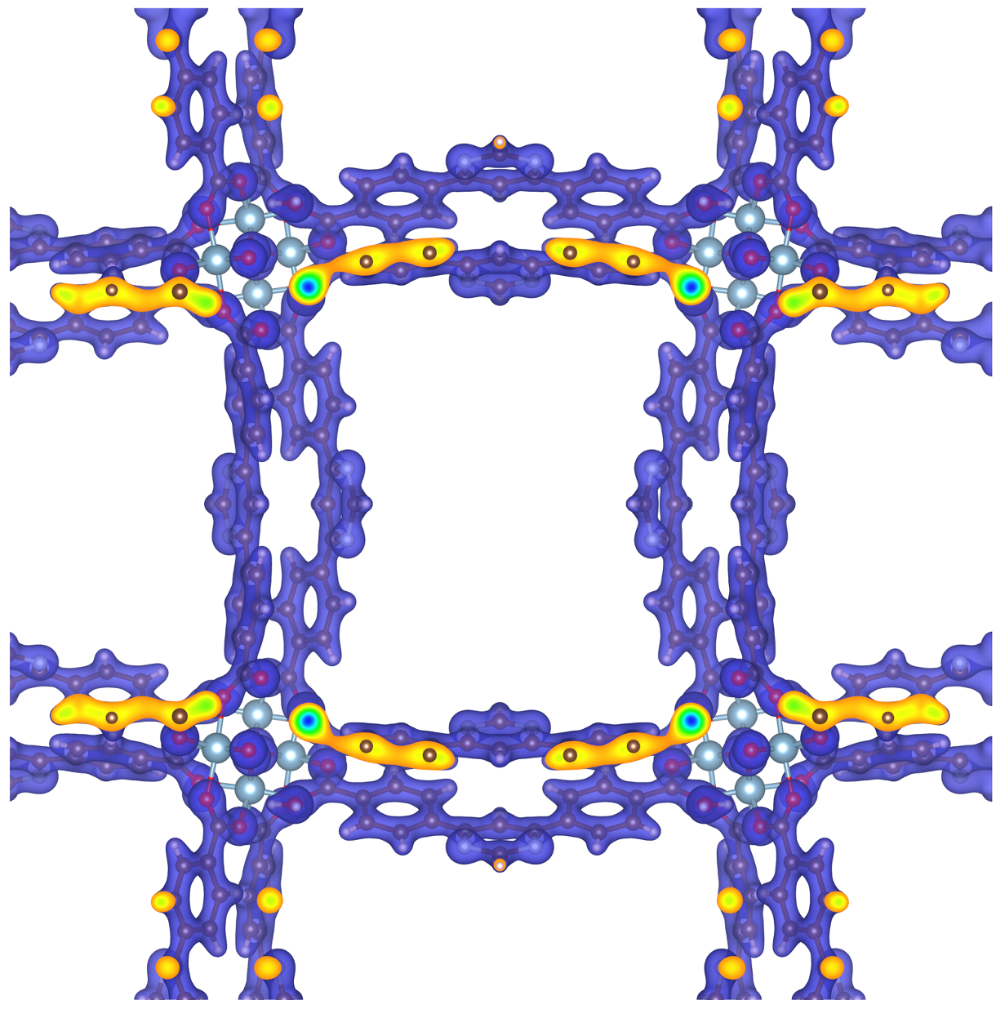
Fig. S13. Density-derived electrostatic and chemical (DDEC) charges of ZJU-520 (Al).
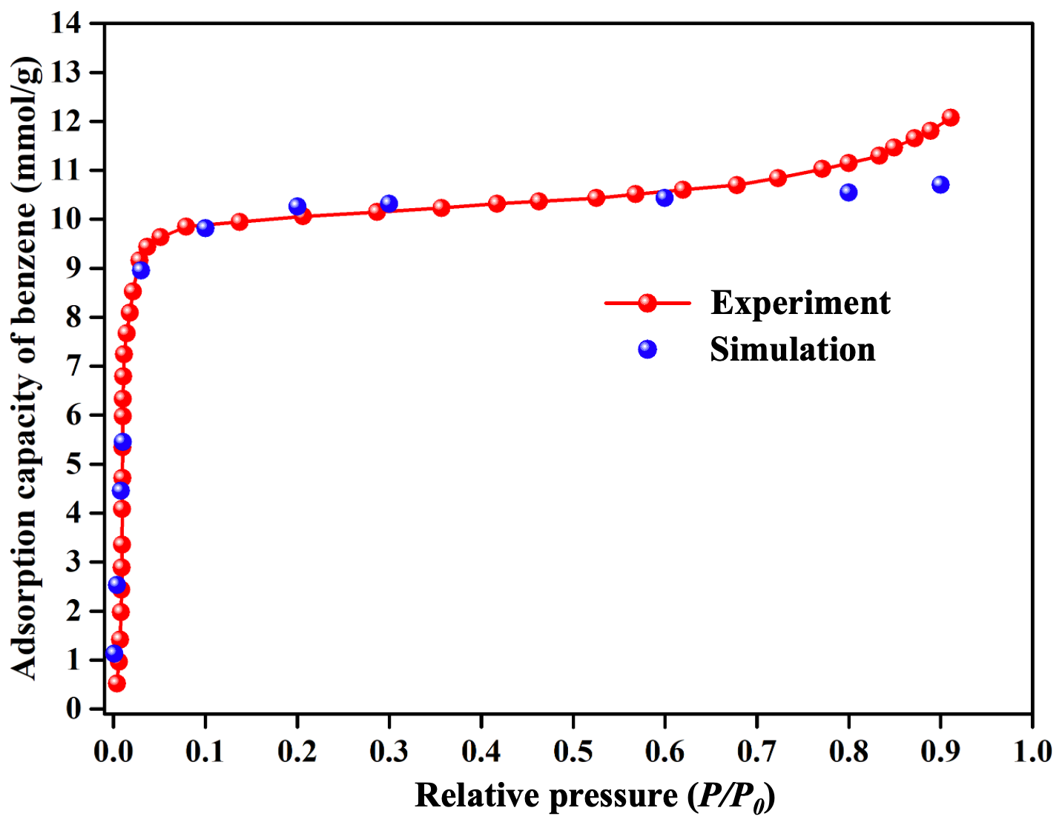
Fig. S14. Experimental benzene adsorption isotherm (in red line) and simulated benzene adsorption (in blue dots) on ZJU-520(Al) at 298 K.

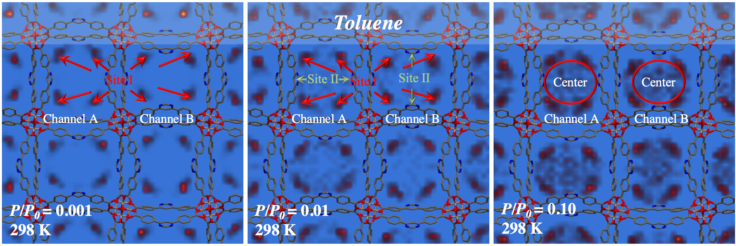
Fig. S15. Adsorption process of toluene by ZJU-520(Al) at 298 K using GCMC simulation, as viewed from c axis.
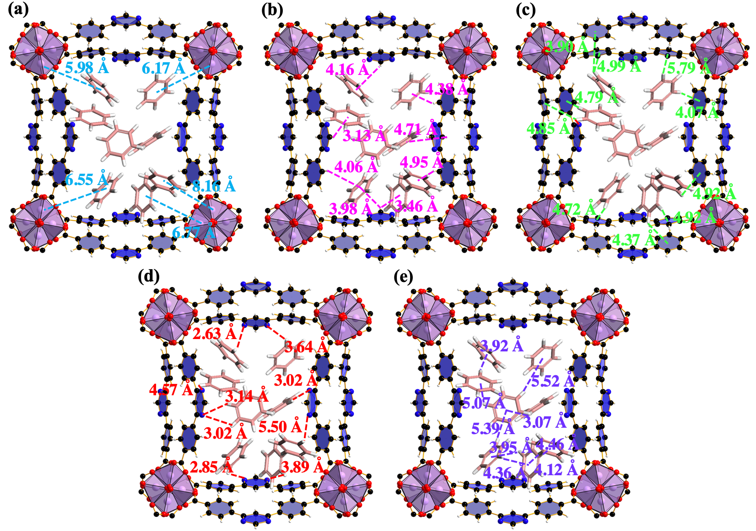
Fig. S16. Host – guest interactions, including Al – π interactions (a) (in blue lines), C – H(L) ⋯ π(Bz) interactions (b) (in pink lines), C – H(Bz) ⋯ π(L) interactions (c) (in green lines) and C – H(Bz) ⋯ N(L) interactions (d) (in red lines). Guest – guest interactions through C – H(Bz) ⋯ π(Bz) interactions (e) (in purple lines) at 298 K and P/P₀ = 0.01, as viewed from c axis.

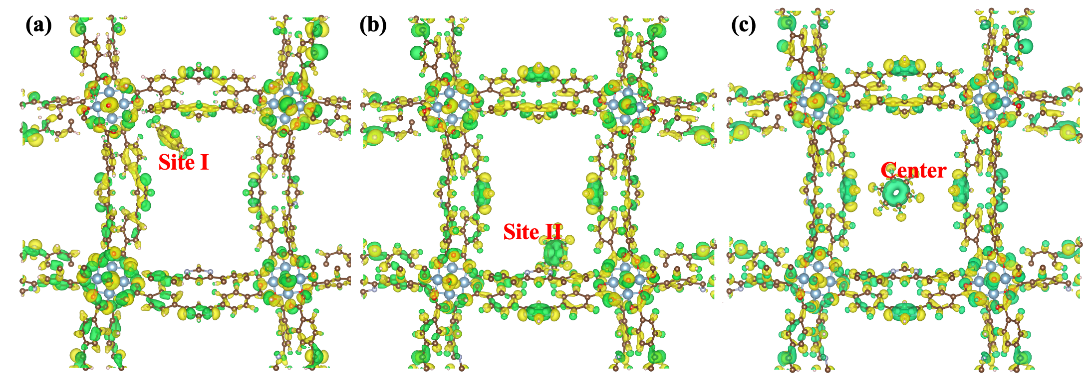
Fig. S17. Isosurfaces of charge density difference in ZJU-520(Al) with benzene molecule in site I (a), site II (b) and center (c). Yellow and green demonstrate electronic accumulation and depletion, respectively, as viewed from c axis.

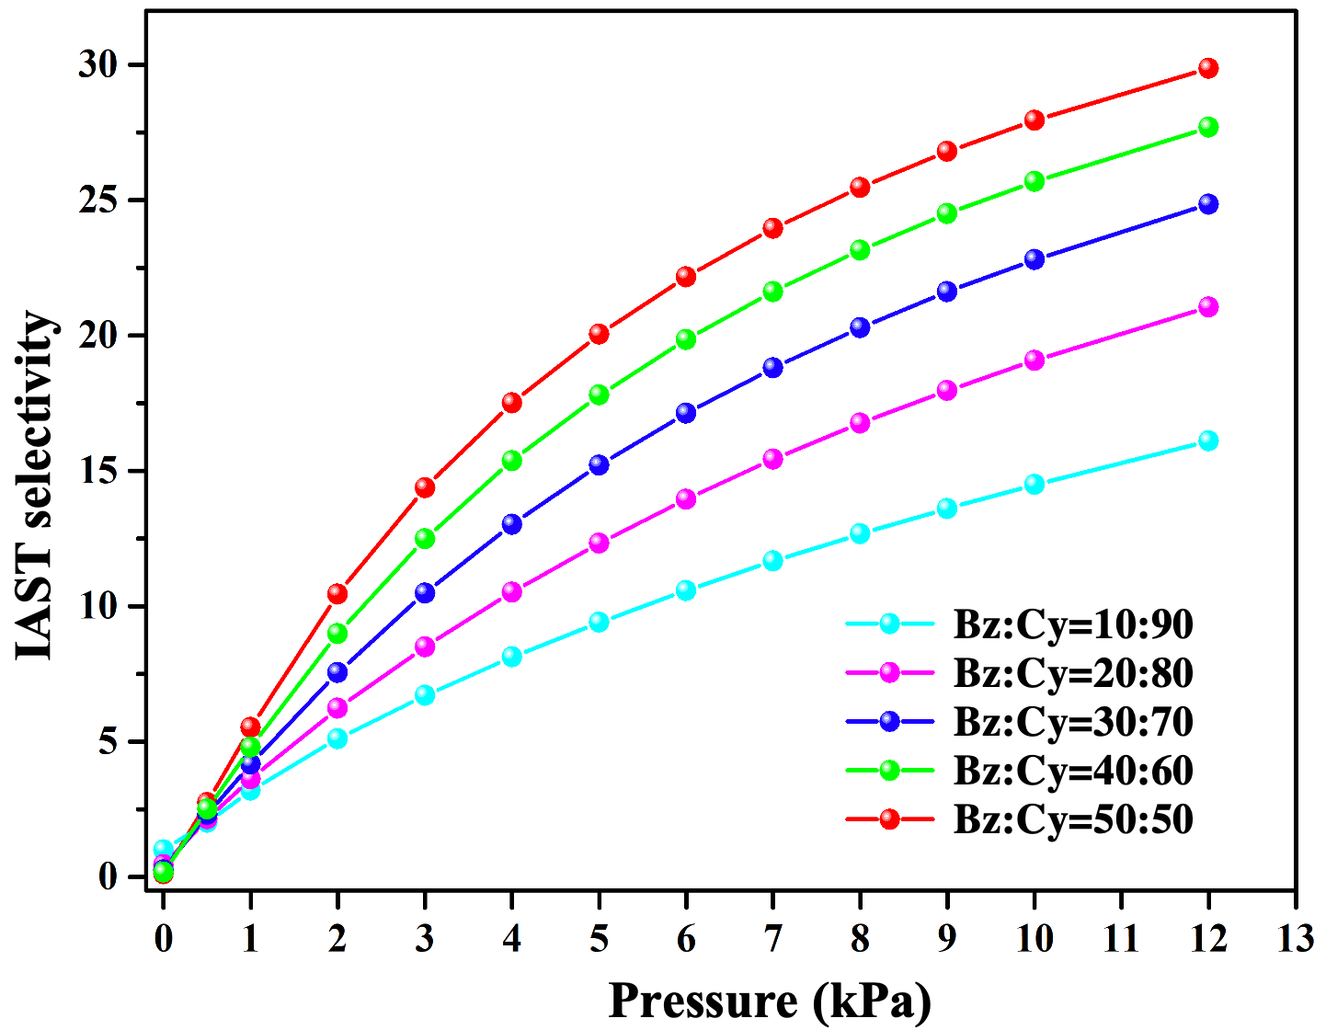
Fig. S18. Predicted ideal adsorption solution theory (IAST) selectivity curves of benzene/cyclohexane (Bz/Cy) with Bz:Cy = 10:90, 20:80, 30:70, 40:60, 50:50, respectively.

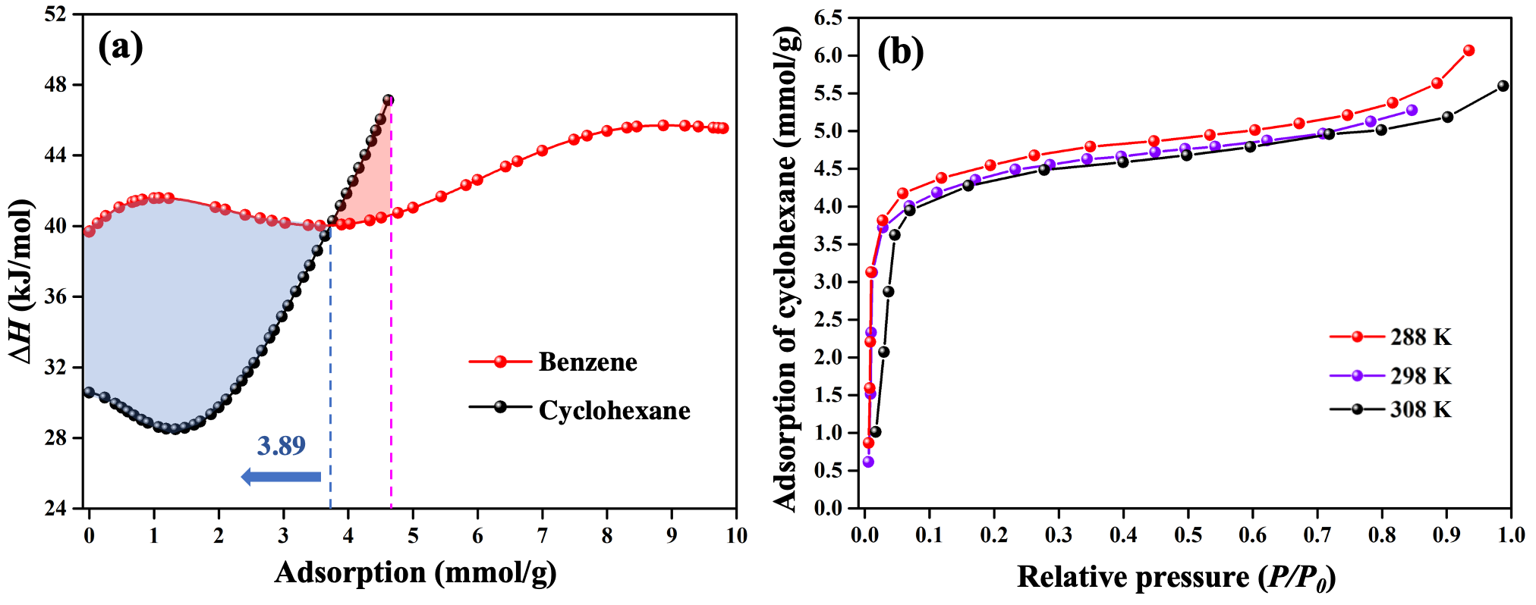
Fig. S19. Isosteric heat (∆H) of cyclohexane (in black line) and benzene (in red line) (a), and adsorption isotherms of cyclohexane at 288, 298 and 308 K (b) by ZJU-520(Al).
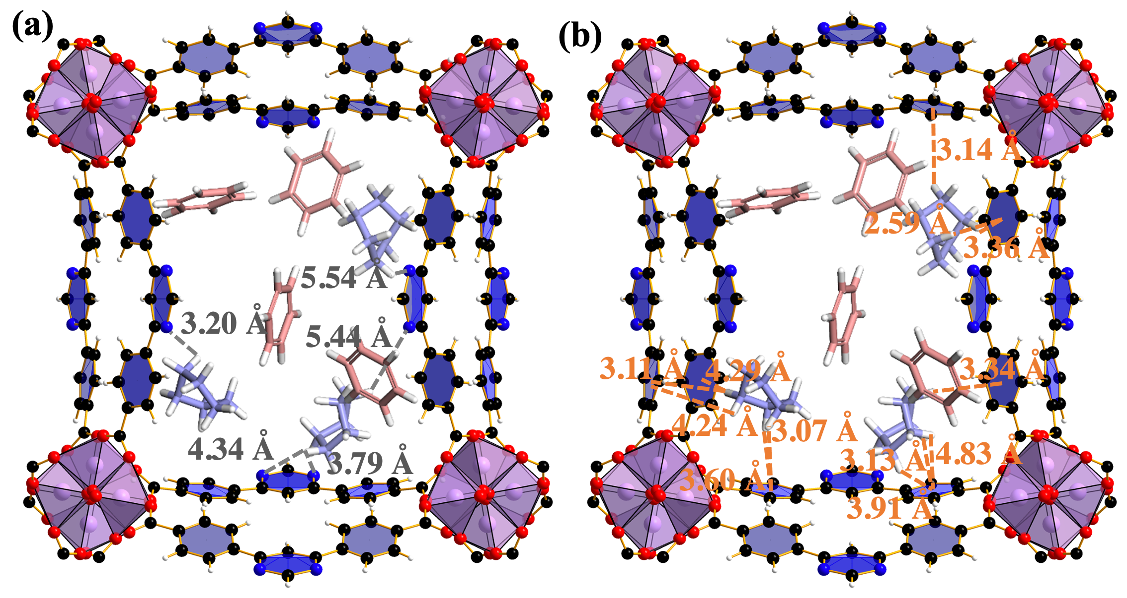
Fig. S20. Interactions between framework and cyclohexane, including C – H(Cy) ⋯ N(L) interactions (a) (in black lines) and C – H(Cy) ⋯ π(L) interactions (b) (in orange lines), as viewed from c axis.

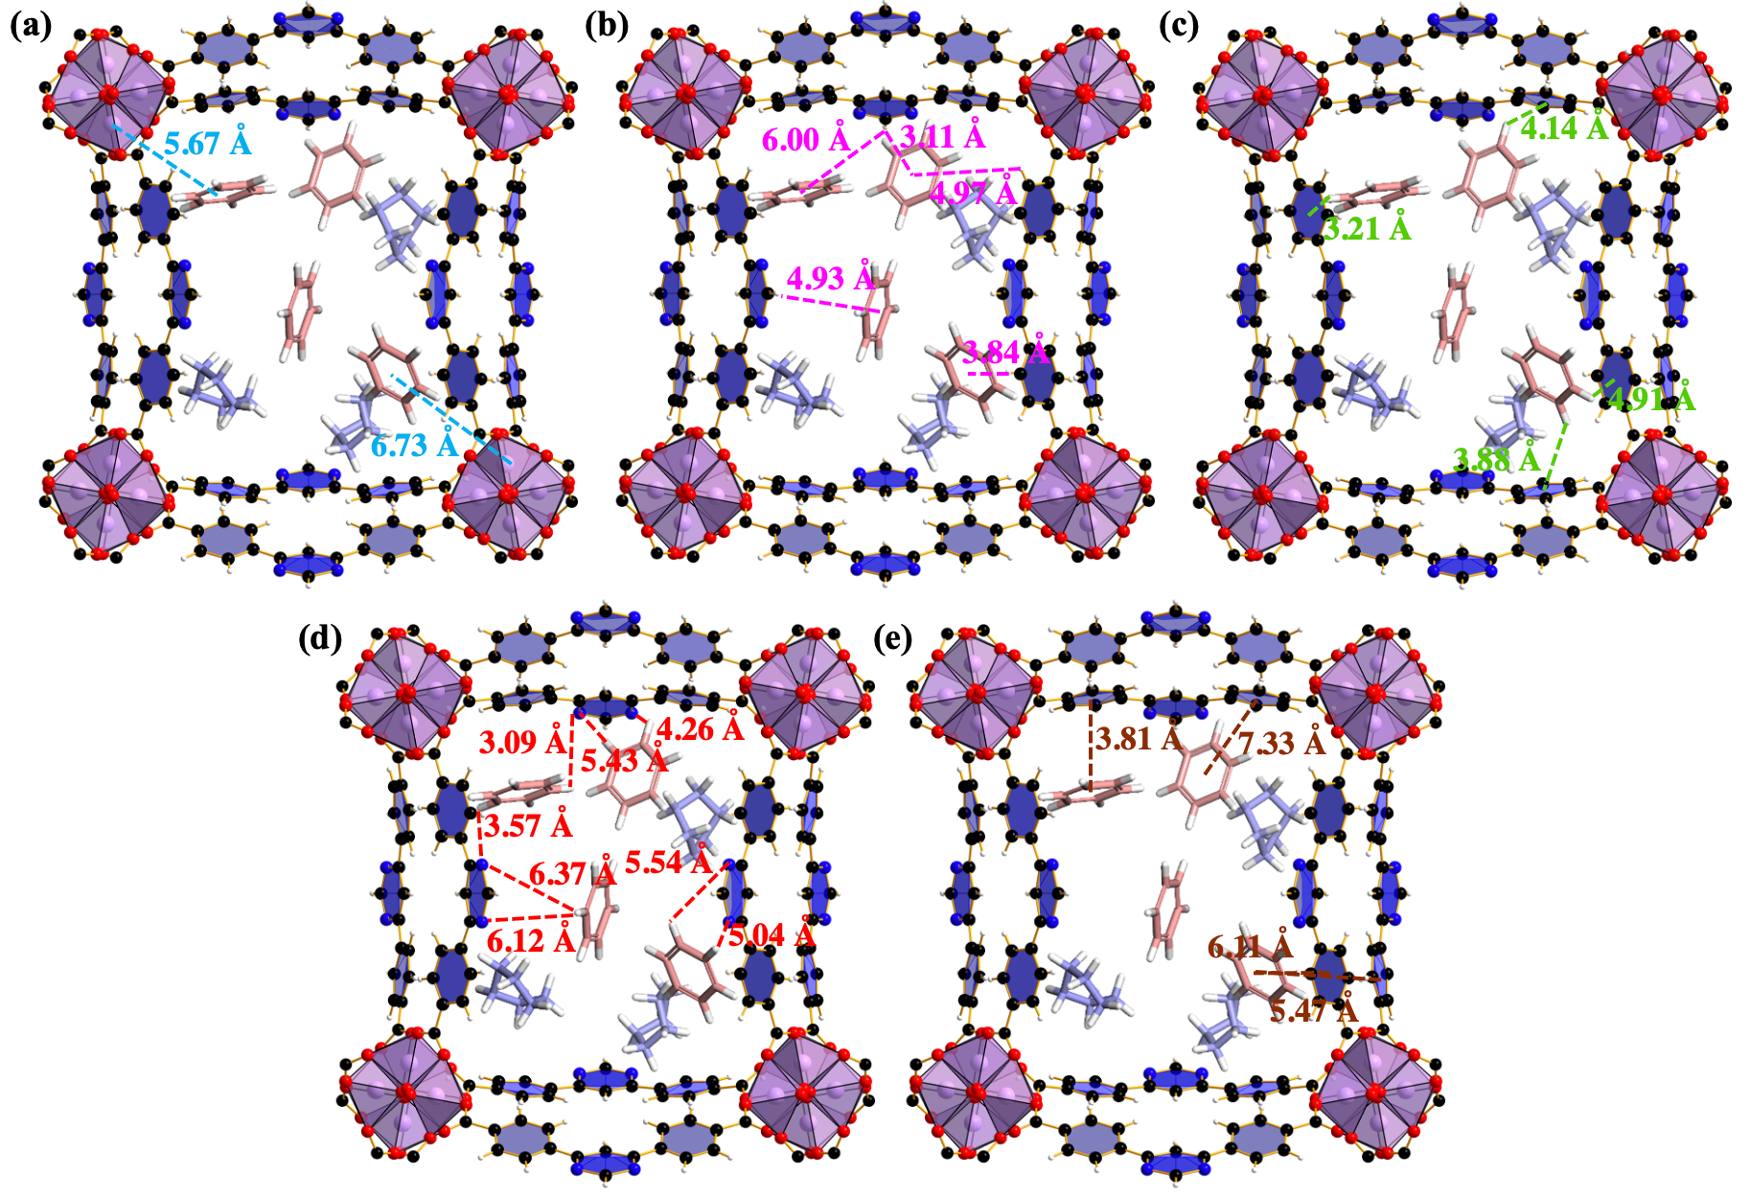
Fig. S21. Interactions between framework and benzene, including Al – π interaction (a) (in blue lines), C – H(L) ⋯ π(Bz) interactions (b) (in pink lines), C – H(Bz) ⋯ π(L) interactions (c) (in green lines), C – H(Bz) ⋯ N(L) (d) (in red lines) and π(Bz) ⋯ π(L) interactions (e) (in brown lines), as viewed from c axis.

Table S1. Crystal data and structure refinement for ZJU-520(Al).
Identification code | ZJU-520(Al)
Empirical formula | C₂₁H₁₉AlN₃O₇
Formula weight | 452.37
Temperature/K | 100.15
Crystal system | tetragonal
Space group | I4₁md
a/Å | 36.647(5)
b/Å | 36.647(5)
c/Å | 10.556(2)
α/° | 90
β/° | 90
γ/° | 90
Volume/Å³ | 14177(5)
Z | 16
ρ_{calc} g/cm³ | 0.848
μ/mm⁻¹ | 0.764
F(000) | 3760.0
Crystal size/mm³ | 0.10 × 0.02 × 0.02
Radiation | CuKα (λ = 1.54178)
2𝜽 range for data collection/° | 6.822 to 107.72
Index ranges | -33 ≤ h ≤ 38, -38 ≤ k ≤ 36, -11 ≤ l ≤ 9
Reflections collected | 34555
Independent reflections | 4161 [R_{int} = 0.2076, R_{sigma} = 0.1616]
Data/restraints/parameters | 4161/13/316
Goodness-of-fit on F² | 1.006
Final R indexes [I>=2σ (I)] | R₁ = 0.0980, wR₂ = 0.2524
Final R indexes [all data] | R₁ = 0.1204, wR₂ = 0.2831
Largest diff. peak/hole / e Å⁻³ | 0.47/-0.46
Flack parameter | 0.56(18)
ªR₁=∑(||F₀|-|F_{C}||)/∑|F₀|;
ª wR₂=[[∑w(|F₀|²-|F_{C}|²)²/∑w(F₀²)²]] ^{1/2}, [F₀>4𝝈(F₀)].

Table S2. Selected bond length (Å) of ZJU-520(Al).
Atom | Length (Å) | Atom | Length (Å) | Atom | Length (Å)
Al01-O002 | 1.828(8) | C00G-C00M | 1.433(18) | C1-C00Q | 1.378(18)
Al01-O0021 | 1.836(9) | C4-C00U | 1.384(18) | C00C-C2 | 1.405(17)
Al01-O003 | 1.877(8) | C4-C00U3 | 1.384(18) | C00C-C00K | 1.462(17)
Al01-O004 | 1.901(8) | C00H-C00I | 1.413(16) | C2-C00I | 1.365(16)
Al01-O005 | 1.935(8) | C00H-C00Q | 1.369(17) | C00E-C00H | 1.475(16)
Al01-O006 | 1.945(8) | C00J-C00N | 1.370(18) | C00G-C5 | 1.451(15)
N1-C00K | 1.424(17) | C00K-C00P | 1.384(16) | C00G-C00J | 1.418(17)
N1-C00O | 1.331(14) | C00M-C00T | 1.391(16) | C00U-N9 | 1.44(3)
O003-C00E | 1.282(14) | C00N-C00R | 1.401(19) | N9-C10 | 1.32(4)
O004-C5 | 1.307(13) | N9A-C10A | 1.33(3) | O009-C00L | 1.26(2)
O005-C51 | 1.209(13) | N9A-C00U | 1.50(3) | N8-C6 | 1.53(3)
O006-C00E2 | 1.266(14) | C00R-C00T | 1.394(17) | N8-C7 | 1.49(3)
C1-C00C | 1.389(19) | C00R-C00U | 1.500(19) | N8-C00L | 1.30(2)

Table S3. Selected bond angle (Å) of ZJU-520(Al).
Atom | Angle (˚) | Atom | Angle (˚) | Atom | Angle (˚)
O002-Al01-O0021 | 92.8(3) | C1-C00C-C2 | 117.5(11) | C00T-C00M-C00G | 119.7(11)
O0021-Al01-O003 | 93.4(4) | C1-C00C-C00K | 121.0(11) | C00J-C00N-C00R | 118.0(11)
O002-Al01-O003 | 173.8(4) | C2-C00C-C00K | 121.2(12) | C10A-N9A-C00U | 113(3)
O002-Al01-O004 | 89.3(4) | C00I-C2-C00C | 121.4(12) | N13-C00O-N1 | 127.1(19)
O0021-Al01-O004 | 177.2(4) | O003-C00E-C00H | 119.5(10) | N9A3-C10A-N9A | 130(4)
O002-Al01-O005 | 91.0(4) | O0061-C00E-O003 | 123.5(10) | C00K3-C00P-C00K | 120.7(17)
O0021-Al01-O005 | 91.6(3) | O0061-C00E-C00H | 117.0(11) | C00H-C00Q-C1 | 120.0(12)
O0021-Al01-O006 | 89.2(3) | C00J-C00G-C5 | 124.5(11) | C00N-C00R-C00U | 120.4(12)
O002-Al01-O006 | 93.6(3) | C00J-C00G-C00M | 116.1(10) | C00T-C00R-C00N | 120.3(11)
O003-Al01-O004 | 84.5(3) | C00M-C00G-C5 | 119.4(10) | C00T-C00R-C00U | 119.3(12)
O003-Al01-O005 | 89.6(3) | C00U-C4-C00U3 | 119.1(18) | C00M-C00T-C00R | 121.4(12)
O003-Al01-O006 | 85.7(3) | C00I-C00H-C00E | 119.2(10) | C4-C00U-N9A | 117.7(15)
O004-Al01-O005 | 90.3(3) | C00Q-C00H-C00E | 121.0(11) | C4-C00U-C00R | 123.1(14)
O004-Al01-O006 | 88.7(3) | C00Q-C00H-C00I | 119.6(11) | C4-C00U-N9 | 117.8(15)
O005-Al01-O006 | 175.2(4) | O004-C5-C00G | 113.5(10) | C00R-C00U-N9A | 112.4(15)
C00O-N1-C00K | 116.9(12) | O0052-C5-O004 | 124.6(9) | N9-C00U-C00R | 115.0(14)
Al01-O002-Al012 | 127.1(4) | O0052-C5-C00G | 121.7(10) | C10-N9-C00U | 110(3)
C00E-O003-Al01 | 131.3(7) | C2-C00I-C00H | 119.5(11) | N93-C10-N9 | 129(7)
C5-O004-Al01 | 130.0(6) | C00N-C00J-C00G | 124.4(12) | C7-N8-C6 | 116(2)
C51-O005-Al01 | 134.3(7) | N1-C00K-C00C | 116.5(10) | C00L-N8-C6 | 124(2)
C00E2-O006-Al01 | 133.4(7) | C00P-C00K-N1 | 119.2(12) | C00L-N8-C7 | 118(2)
C00Q-C1-C00C | 121.7(11) | C00P-C00K-C00C | 123.8(13) | O009-C00L-N8 | 122.3(16)

Table S4. Adsorption benzene by reported adsorbents at 298 K and P/P₀ = 0.01.
Adsorbates | Q_{0.01} (mmol/g) | S_{BET} (m²/g) | Reference
ZJU-520(Al) | 5.98 | 2235 | This work
Double-walled BUT-53(Co) | 2.49 | 811 | ³⁵
Double-walled BUT-54(Co) | 4.31 | 1128 | ³⁵
Double-walled BUT-55(Co) | 3.51 | 873 | ³⁵
Double-walled BUT-56(Co) | 3.42 | 897 | ³⁵
Double-walled BUT-57(Co) | 3.44 | 970 | ³⁵
Double-walled BUT-58(Zn) | 3.41 | 849 | ³⁵
ZJU-620(Al) | 3.80 | 1324 | ¹⁷
MIL-101(Cr) | 1.09 | 3980 | ⁴⁵
Carboxen 1000 | 2.81 | 1200 | ⁴⁵
ZIF-8(Zn) | 0.01 | 1345 | ⁴⁵
MCM-41 | 0.42 | 1046 | ⁴⁵
PAF-1 | 3.66 | 4201 | ⁴⁵
BUT-66(Zr) | 2.72 | 1096 | ⁴⁵
BUT-67(Zr) | 1.95 | 984 | ⁴⁵
MOF-177(Zn) | 1.60 | 2970 | ⁴⁶
HKUST-1 | 0.91 | 1707 | ⁴⁷
SBA-15 | 0.63 | 805 | ⁴⁸
HZSM-5 | 1.35 | 550 | ⁴⁸
Active carbon | 2.35 | 1600 | ⁴⁸
IISERP-COF2 | 0.13 | 584 | ⁴⁹
IISERP-COF4 | 0.063 | 337 | ⁴⁹
UiO-66-(Cu^{II}) | 3.92 | 1240 | ⁵⁰
MFM-300(Sc) | 3.02 | 1228 | ⁵⁰
MFM-300(VIII) | 2.28 | 1461 | ⁵⁰
MFM-300(Cr) | 2.71 | 1415 | ⁵⁰
MFM-300(Fe) | 2.63 | 1062 | ⁵⁰
MFM-300(Al) | 2.99 | 1370 | ⁵⁰
MFM-300(Ga) | 3.01 | 1242 | ⁵⁰
MFM-300(In) | 2.82 | 1084 | ⁵⁰
UiO-66-(Cu^{I}) | 2.74 | 1201 | ⁵⁰
UiO-66-defect | 2.55 | 1313 | ⁵⁰
UiO-66 | 1.78 | 996 | ⁵⁰

Table S5. Theorical interplanar spacing obtained from the crystal information file of ZJU-520(Al).
(h, k, l) | 2θ | Interplanar spacing (Å) | (h, k, l) | 2θ | Interplanar spacing (Å)
(2,2,0) | 6.82 | 12.96 | (1-5,0) | 12.31 | 7.19
(3,1,0) | 7.62 | 11.59 | (1,4,1) | 13.01 | 6.80
(1,0,1) | 8.71 | 10.14 | (4,1,1) | 13.01 | 6.80
(4,0,0) | 9.65 | 9.16 | (4,4,0) | 13.66 | 6.48
(2,1,1) | 9.96 | 8.87 | (3,5,0) | 14.08 | 6.28
(1,2,1) | 9.96 | 8.87 | (5,3,0) | 14.08 | 6.28
(4,2,0) | 10.79 | 8.19 | (0,6,0) | 14.49 | 6.11
(0,3,1) | 11.07 | 7.99 | (3,4,1) | 14.70 | 6.02
(3,0,1) | 11.07 | 7.99 | (6,2,0) | 15.28 | 5.79
(2,3,1) | 12.08 | 7.32 | (5,2,1) | 15.48 | 5.72
(3,2,1) | 12.08 | 7.32 | (6,1,1) | 16.93 | 5.23
(5,1,0) | 12.31 | 7.19 | (7,1,0) | 17.10 | 5.18

Table S6. Restrained electrostatic potential (RESP) charges of H₂DBP ligand.
Atom  Number | Charge (e) | Atom  Number | Charge (e) | Atom  Number | Charge (e)
C1 | 0.468 | C13 | -0.267 | H1 | 0.430
C2 | 0.217 | C14 | 0.215 | H2 | 0.173
C3 | -0.266 | C15 | -0.244 | H3 | 0.188
C4 | -0.045 | C16 | 0.040 | H4 | 0.115
C5 | -0.301 | C17 | -0.303 | H5 | 0.126
C6 | 0.041 | C18 | 0.469 | H6 | 0.251
C7 | -0.255 | O1 | -0.470 | H7 | 0.046
C8 | 0.854 | O2 | -0.545 | H8 | 0.125
C9 | -0.864 | O3 | -0.469 | H9 | 0.173
C10 | 0.839 | O4 | -0.546 | H10 | 0.114
C11 | 0.609 | N1 | -0.748 | H11 | 0.189
C12 | -0.044 | N2 | -0.745 | H12 | 0.430

Table S7. Density-derived electrostatic and chemical (DDEC) charges of ZJU-520(Al).
Atom | x | y | z | Partical charge | Atom | x | y | z | Partical charge | Atom | x | y | z | Partical charge | Atom | x | y | z | Partical charge
Al1 | 26.11 | 27.63 | 2.94 | 1.59 | C13 | 22.15 | 27.65 | 0.50 | -0.10 | C169 | 32.77 | 10.42 | 10.36 | -0.08 | H37 | 14.44 | 8.72 | 1.41 | 0.12
Al2 | 7.79 | 9.30 | 8.22 | 1.59 | C14 | 20.86 | 30.02 | 6.57 | 0.06 | C170 | 35.45 | 8.84 | 3.14 | 0.23 | H38 | 14.72 | 5.63 | 7.99 | 0.13
Al3 | 28.86 | 27.35 | 8.22 | 1.59 | C15 | 22.01 | 30.46 | 7.23 | -0.12 | C171 | 31.69 | 11.77 | 1.51 | -0.08 | H39 | 7.22 | 8.48 | 0.92 | 0.42
Al4 | 10.53 | 9.02 | 2.94 | 1.59 | C16 | 19.62 | 30.41 | 7.33 | 0.20 | C172 | 34.02 | 10.80 | 0.22 | -0.13 | H40 | 7.14 | 7.58 | 1.96 | 0.42
Al5 | 9.02 | 7.79 | 5.58 | 1.59 | C17 | 2.61 | 9.28 | 5.14 | -0.12 | C173 | 32.82 | 9.32 | 5.78 | -0.10 | H41 | 8.84 | 1.82 | 2.99 | 0.11
Al6 | 27.35 | 26.11 | 0.30 | 1.59 | C18 | 2.51 | 8.96 | 3.79 | 0.05 | C174 | 34.11 | 11.70 | 1.29 | 0.06 | H42 | 9.90 | 3.65 | 10.10 | 0.11
Al7 | 9.30 | 10.53 | 0.30 | 1.59 | C19 | 3.69 | 8.64 | 3.11 | -0.11 | C175 | 32.96 | 12.13 | 1.95 | -0.12 | H43 | 9.90 | 5.69 | 0.62 | 0.11
Al8 | 27.63 | 28.86 | 5.58 | 1.59 | C20 | 6.25 | 8.82 | 5.82 | 0.62 | C176 | 35.45 | 12.15 | 1.79 | 0.20 | H44 | 8.50 | 3.94 | 6.99 | 0.12
Al9 | 26.11 | 9.02 | 2.94 | 1.59 | C21 | 5.09 | 10.86 | 0.41 | -0.03 | C177 | 15.71 | 27.61 | 10.42 | -0.12 | H45 | 6.21 | 5.73 | 9.85 | 0.13
Al10 | 7.79 | 27.35 | 8.22 | 1.59 | C22 | 4.97 | 8.96 | 5.11 | -0.01 | C178 | 15.82 | 27.29 | 9.07 | 0.05 | H46 | 7.85 | 1.85 | 7.71 | 0.11
Al11 | 28.86 | 9.30 | 8.22 | 1.59 | C23 | 6.41 | 10.48 | 10.51 | 0.62 | C179 | 14.63 | 26.97 | 8.38 | -0.11 | H47 | 8.72 | 3.88 | 4.05 | 0.12
Al12 | 10.53 | 27.63 | 2.94 | 1.59 | C24 | 4.90 | 8.64 | 3.74 | -0.08 | C180 | 12.07 | 27.14 | 0.55 | 0.62 | H48 | 5.63 | 3.60 | 0.07 | 0.12
Al13 | 9.02 | 28.86 | 5.58 | 1.59 | C25 | 3.88 | 10.42 | 10.36 | -0.08 | C181 | 13.24 | 29.18 | 5.68 | -0.03 | H49 | 8.48 | 11.11 | 3.56 | 0.42
Al14 | 27.35 | 10.53 | 0.30 | 1.59 | C26 | 1.20 | 8.84 | 3.14 | 0.23 | C182 | 13.35 | 27.28 | 10.39 | -0.01 | H50 | 7.58 | 11.19 | 4.59 | 0.42
Al15 | 9.30 | 26.11 | 0.30 | 1.59 | C27 | 4.96 | 11.77 | 1.51 | -0.08 | C183 | 11.91 | 28.80 | 5.23 | 0.62 | H51 | 27.17 | 20.15 | 8.27 | 0.11
Al16 | 27.63 | 7.79 | 5.58 | 1.59 | C28 | 2.63 | 10.80 | 0.22 | -0.13 | C184 | 13.42 | 26.96 | 9.02 | -0.08 | H52 | 28.23 | 21.97 | 4.82 | 0.11
N1 | 19.52 | 26.60 | 7.11 | -0.34 | C29 | 3.83 | 9.32 | 5.78 | -0.10 | C185 | 14.44 | 28.75 | 5.09 | -0.08 | H53 | 28.23 | 24.02 | 5.90 | 0.11
N2 | 19.64 | 30.98 | 8.72 | -0.33 | C30 | 2.54 | 11.70 | 1.29 | 0.06 | C186 | 17.12 | 27.16 | 8.42 | 0.23 | H54 | 26.82 | 22.26 | 1.71 | 0.12
N3 | 1.19 | 8.28 | 1.84 | -0.34 | C31 | 3.69 | 12.13 | 1.95 | -0.12 | C187 | 13.37 | 30.09 | 6.78 | -0.08 | H55 | 24.53 | 24.05 | 4.57 | 0.13
N4 | 1.21 | 12.46 | 3.26 | -0.33 | C32 | 1.20 | 12.15 | 1.79 | 0.20 | C188 | 15.69 | 29.13 | 5.50 | -0.13 | H56 | 26.18 | 20.17 | 2.43 | 0.11
N5 | 35.46 | 28.37 | 1.84 | -0.34 | C33 | 34.03 | 27.36 | 5.14 | -0.12 | C189 | 14.49 | 27.65 | 0.50 | -0.10 | H57 | 27.05 | 22.20 | 9.33 | 0.12
N6 | 35.44 | 24.19 | 3.26 | -0.33 | C34 | 34.14 | 27.68 | 3.79 | 0.05 | C190 | 15.79 | 30.02 | 6.57 | 0.06 | H58 | 23.95 | 21.93 | 5.35 | 0.13
N7 | 17.13 | 10.05 | 7.11 | -0.34 | C35 | 32.96 | 28.01 | 3.11 | -0.11 | C191 | 14.64 | 30.46 | 7.23 | -0.12 | H59 | 26.80 | 29.43 | 8.84 | 0.42
N8 | 17.01 | 5.67 | 8.72 | -0.33 | C36 | 30.40 | 27.83 | 5.82 | 0.62 | C192 | 17.03 | 30.40 | 7.33 | 0.20 | H60 | 25.90 | 29.51 | 9.87 | 0.42
N9 | 10.05 | 1.19 | 9.75 | -0.34 | C37 | 31.56 | 25.79 | 0.41 | -0.03 | C193 | 9.04 | 34.03 | 2.50 | -0.12 | H61 | 9.48 | 16.50 | 8.27 | 0.11
N10 | 5.87 | 1.21 | 0.62 | -0.33 | C38 | 31.68 | 27.69 | 5.11 | -0.01 | C194 | 9.36 | 34.14 | 1.15 | 0.05 | H62 | 8.42 | 14.67 | 4.82 | 0.11
N11 | 28.37 | 19.52 | 4.48 | -0.34 | C39 | 30.23 | 26.17 | 10.51 | 0.62 | C195 | 9.68 | 32.96 | 0.47 | -0.11 | H63 | 8.42 | 12.63 | 5.90 | 0.11
N12 | 23.99 | 19.64 | 6.09 | -0.33 | C40 | 31.75 | 28.01 | 3.74 | -0.08 | C196 | 9.51 | 30.40 | 3.18 | 0.62 | H64 | 9.83 | 14.38 | 1.71 | 0.12
N13 | 8.28 | 17.13 | 4.48 | -0.34 | C41 | 32.77 | 26.23 | 10.36 | -0.08 | C197 | 7.47 | 31.56 | 8.32 | -0.03 | H65 | 12.12 | 12.60 | 4.57 | 0.13
N14 | 12.65 | 17.02 | 6.07 | -0.33 | C42 | 35.45 | 27.81 | 3.14 | 0.23 | C198 | 9.37 | 31.68 | 2.47 | -0.01 | H66 | 10.47 | 16.47 | 2.43 | 0.11
N15 | 26.60 | 35.46 | 9.75 | -0.34 | C43 | 31.69 | 24.88 | 1.51 | -0.08 | C199 | 7.85 | 30.23 | 7.87 | 0.62 | H67 | 9.60 | 14.44 | 9.33 | 0.12
N16 | 30.78 | 35.44 | 0.62 | -0.33 | C44 | 34.02 | 25.84 | 0.22 | -0.13 | C200 | 9.69 | 31.75 | 1.10 | -0.08 | H68 | 12.69 | 14.72 | 5.35 | 0.13
N17 | 19.52 | 10.05 | 7.11 | -0.34 | C45 | 32.82 | 27.32 | 5.78 | -0.10 | C201 | 7.90 | 32.77 | 7.72 | -0.08 | H69 | 9.84 | 7.22 | 8.84 | 0.42
N18 | 19.63 | 5.67 | 8.72 | -0.33 | C46 | 34.11 | 24.95 | 1.29 | 0.06 | C202 | 9.48 | 35.45 | 0.51 | 0.23 | H70 | 10.75 | 7.14 | 9.87 | 0.42
N19 | 1.19 | 28.37 | 1.84 | -0.34 | C47 | 32.96 | 24.51 | 1.95 | -0.12 | C203 | 6.56 | 31.69 | 9.42 | -0.08 | H71 | 27.81 | 34.82 | 2.99 | 0.11
N20 | 1.21 | 24.19 | 3.26 | -0.33 | C48 | 35.45 | 24.50 | 1.79 | 0.20 | C204 | 7.52 | 34.02 | 8.14 | -0.13 | H72 | 26.75 | 33.00 | 10.10 | 0.11
N21 | 35.46 | 8.28 | 1.84 | -0.34 | C49 | 15.71 | 9.04 | 10.42 | -0.12 | C205 | 9.00 | 32.82 | 3.14 | -0.10 | H73 | 26.74 | 30.96 | 0.62 | 0.11
N22 | 35.44 | 12.46 | 3.26 | -0.33 | C50 | 15.82 | 9.36 | 9.07 | 0.05 | C206 | 6.63 | 34.11 | 9.21 | 0.06 | H74 | 28.15 | 32.71 | 6.99 | 0.12
N23 | 17.13 | 26.60 | 7.11 | -0.34 | C51 | 14.63 | 9.68 | 8.38 | -0.11 | C207 | 6.19 | 32.96 | 9.87 | -0.12 | H75 | 30.44 | 30.92 | 9.85 | 0.13
N24 | 17.01 | 30.98 | 8.72 | -0.33 | C52 | 12.07 | 9.51 | 0.55 | 0.62 | C208 | 6.18 | 35.45 | 9.71 | 0.20 | H76 | 28.80 | 34.80 | 7.71 | 0.11
N25 | 10.05 | 35.46 | 9.75 | -0.34 | C53 | 13.24 | 7.47 | 5.68 | -0.03 | C209 | 27.36 | 15.71 | 7.78 | -0.12 | H77 | 27.92 | 32.77 | 4.05 | 0.12
N26 | 5.87 | 35.44 | 0.62 | -0.33 | C54 | 13.35 | 9.37 | 10.39 | -0.01 | C210 | 27.68 | 15.82 | 6.43 | 0.05 | H78 | 31.02 | 33.04 | 0.07 | 0.12
N27 | 28.37 | 17.13 | 4.48 | -0.34 | C55 | 11.91 | 7.85 | 5.23 | 0.62 | C211 | 28.01 | 14.63 | 5.75 | -0.11 | H79 | 28.17 | 25.54 | 3.56 | 0.42
N28 | 23.99 | 17.01 | 6.09 | -0.33 | C56 | 13.42 | 9.69 | 9.02 | -0.08 | C212 | 27.83 | 12.07 | 8.46 | 0.62 | H80 | 29.07 | 25.46 | 4.59 | 0.42
N29 | 8.28 | 19.52 | 4.48 | -0.34 | C57 | 14.44 | 7.90 | 5.09 | -0.08 | C213 | 25.79 | 13.24 | 3.05 | -0.03 | H81 | 20.15 | 8.84 | 0.35 | 0.11
N30 | 12.65 | 19.63 | 6.07 | -0.33 | C58 | 17.12 | 9.48 | 8.42 | 0.23 | C214 | 27.69 | 13.35 | 7.75 | -0.01 | H82 | 21.97 | 9.90 | 7.46 | 0.11
N31 | 26.60 | 1.19 | 9.75 | -0.34 | C59 | 13.37 | 6.56 | 6.78 | -0.08 | C215 | 26.17 | 11.91 | 2.59 | 0.62 | H83 | 24.02 | 9.90 | 8.54 | 0.11
N32 | 30.78 | 1.21 | 0.62 | -0.33 | C60 | 15.69 | 7.52 | 5.50 | -0.13 | C216 | 28.01 | 13.42 | 6.38 | -0.08 | H84 | 22.26 | 8.50 | 4.35 | 0.12
O1 | 27.30 | 27.55 | 4.33 | -0.77 | C61 | 14.49 | 9.00 | 0.50 | -0.10 | C217 | 26.23 | 14.44 | 2.45 | -0.08 | H85 | 24.05 | 6.21 | 7.21 | 0.13
O2 | 24.76 | 27.76 | 1.65 | -0.58 | C62 | 15.79 | 6.63 | 6.57 | 0.06 | C218 | 27.81 | 17.12 | 5.78 | 0.23 | H86 | 20.17 | 7.85 | 5.07 | 0.11
O3 | 24.73 | 28.03 | 4.18 | -0.58 | C63 | 14.64 | 6.19 | 7.23 | -0.12 | C219 | 24.88 | 13.37 | 4.15 | -0.08 | H87 | 22.20 | 8.72 | 1.41 | 0.12
O4 | 25.74 | 25.74 | 3.12 | -0.52 | C64 | 17.03 | 6.23 | 7.32 | 0.19 | C220 | 25.84 | 15.69 | 2.86 | -0.13 | H88 | 21.93 | 5.63 | 7.99 | 0.13
O5 | 26.37 | 29.53 | 2.67 | -0.56 | C65 | 9.04 | 2.61 | 2.50 | -0.12 | C221 | 27.32 | 14.49 | 8.42 | -0.10 | H89 | 29.43 | 8.48 | 0.92 | 0.42
O6 | 29.43 | 29.02 | 1.09 | -0.78 | C66 | 9.36 | 2.51 | 1.15 | 0.05 | C222 | 24.95 | 15.79 | 3.93 | 0.06 | H90 | 29.51 | 7.58 | 1.96 | 0.42
O7 | 8.98 | 9.23 | 9.61 | -0.77 | C67 | 9.68 | 3.69 | 0.47 | -0.11 | C223 | 24.51 | 14.64 | 4.59 | -0.12 | H91 | 1.82 | 27.17 | 5.63 | 0.11
O8 | 6.43 | 9.44 | 6.93 | -0.58 | C68 | 9.51 | 6.25 | 3.18 | 0.62 | C224 | 24.57 | 17.03 | 4.69 | 0.20 | H92 | 3.65 | 28.23 | 2.18 | 0.11
O9 | 6.40 | 9.70 | 9.46 | -0.58 | C69 | 7.47 | 5.09 | 8.32 | -0.03 | C225 | 9.28 | 20.94 | 7.78 | -0.12 | H93 | 5.69 | 28.23 | 3.26 | 0.11
O10 | 7.41 | 7.41 | 8.40 | -0.52 | C70 | 9.37 | 4.97 | 2.47 | -0.01 | C226 | 8.96 | 20.83 | 6.43 | 0.05 | H94 | 3.94 | 26.82 | 9.63 | 0.12
O11 | 8.04 | 11.21 | 7.95 | -0.56 | C71 | 7.85 | 6.41 | 7.87 | 0.62 | C227 | 8.64 | 22.01 | 5.75 | -0.11 | H95 | 5.73 | 24.53 | 1.93 | 0.13
O12 | 11.11 | 10.70 | 6.37 | -0.78 | C72 | 9.69 | 4.90 | 1.10 | -0.08 | C228 | 8.82 | 24.58 | 8.46 | 0.62 | H96 | 1.85 | 26.18 | 10.34 | 0.11
O13 | 27.67 | 27.42 | 9.61 | -0.77 | C73 | 7.90 | 3.88 | 7.72 | -0.08 | C229 | 10.86 | 23.41 | 3.05 | -0.03 | H97 | 3.88 | 27.05 | 6.69 | 0.12
O14 | 30.21 | 27.21 | 6.93 | -0.58 | C74 | 9.48 | 1.20 | 0.51 | 0.23 | C230 | 8.96 | 23.29 | 7.75 | -0.01 | H98 | 3.60 | 23.95 | 2.71 | 0.12
O15 | 30.24 | 26.94 | 9.46 | -0.58 | C75 | 6.56 | 4.96 | 9.42 | -0.08 | C231 | 10.48 | 24.74 | 2.59 | 0.62 | H99 | 11.11 | 26.80 | 6.20 | 0.42
O16 | 29.23 | 29.24 | 8.40 | -0.52 | C76 | 7.52 | 2.63 | 8.14 | -0.13 | C232 | 8.64 | 23.22 | 6.38 | -0.08 | H100 | 11.19 | 25.90 | 7.23 | 0.42
O17 | 28.61 | 25.44 | 7.95 | -0.56 | C77 | 9.00 | 3.83 | 3.14 | -0.10 | C233 | 10.42 | 22.20 | 2.45 | -0.08 | H101 | 34.82 | 9.48 | 5.63 | 0.11
O18 | 25.54 | 25.95 | 6.37 | -0.78 | C78 | 6.63 | 2.54 | 9.21 | 0.06 | C234 | 8.84 | 19.53 | 5.78 | 0.23 | H102 | 33.00 | 8.42 | 2.18 | 0.11
O19 | 9.35 | 9.10 | 4.33 | -0.77 | C79 | 6.19 | 3.69 | 9.87 | -0.12 | C235 | 11.77 | 23.28 | 4.15 | -0.08 | H103 | 30.96 | 8.42 | 3.26 | 0.11
O20 | 11.89 | 8.89 | 1.65 | -0.58 | C80 | 6.18 | 1.20 | 9.71 | 0.20 | C236 | 10.80 | 20.96 | 2.86 | -0.13 | H104 | 32.71 | 9.83 | 9.63 | 0.12
O21 | 11.92 | 8.62 | 4.18 | -0.58 | C81 | 27.36 | 20.94 | 7.78 | -0.12 | C237 | 9.32 | 22.15 | 8.42 | -0.10 | H105 | 30.92 | 12.12 | 1.93 | 0.13
O22 | 10.91 | 10.91 | 3.12 | -0.52 | C82 | 27.68 | 20.83 | 6.43 | 0.05 | C238 | 11.70 | 20.86 | 3.93 | 0.06 | H106 | 34.80 | 10.47 | 10.34 | 0.11
O23 | 10.28 | 7.11 | 2.67 | -0.56 | C83 | 28.01 | 22.01 | 5.75 | -0.11 | C239 | 12.13 | 22.01 | 4.59 | -0.12 | H107 | 32.77 | 9.60 | 6.69 | 0.12
O24 | 7.22 | 7.63 | 1.09 | -0.78 | C84 | 27.83 | 24.58 | 8.46 | 0.62 | C240 | 12.11 | 19.61 | 4.66 | 0.20 | H108 | 33.04 | 12.69 | 2.71 | 0.12
O25 | 9.10 | 8.98 | 6.97 | -0.77 | C85 | 25.79 | 23.41 | 3.05 | -0.03 | C241 | 27.61 | 2.61 | 2.50 | -0.12 | H109 | 25.54 | 9.84 | 6.20 | 0.42
O26 | 8.89 | 6.43 | 4.29 | -0.58 | C86 | 27.69 | 23.29 | 7.75 | -0.01 | C242 | 27.29 | 2.51 | 1.15 | 0.05 | H110 | 25.46 | 10.75 | 7.23 | 0.42
O27 | 8.62 | 6.40 | 6.82 | -0.58 | C87 | 26.17 | 24.74 | 2.59 | 0.62 | C243 | 26.97 | 3.69 | 0.47 | -0.11 | H111 | 16.50 | 27.81 | 0.35 | 0.11
O28 | 10.91 | 7.41 | 5.76 | -0.52 | C88 | 28.01 | 23.22 | 6.38 | -0.08 | C244 | 27.14 | 6.25 | 3.18 | 0.62 | H112 | 14.67 | 26.75 | 7.46 | 0.11
O29 | 7.11 | 8.04 | 5.31 | -0.56 | C89 | 26.23 | 22.20 | 2.45 | -0.08 | C245 | 29.18 | 5.09 | 8.32 | -0.03 | H113 | 12.63 | 26.74 | 8.54 | 0.11
O30 | 7.63 | 11.11 | 3.73 | -0.78 | C90 | 27.81 | 19.53 | 5.78 | 0.23 | C246 | 27.28 | 4.97 | 2.47 | -0.01 | H114 | 14.38 | 28.15 | 4.35 | 0.12
O31 | 27.42 | 27.30 | 1.69 | -0.77 | C91 | 24.88 | 23.28 | 4.15 | -0.08 | C247 | 28.80 | 6.41 | 7.87 | 0.62 | H115 | 12.60 | 30.44 | 7.21 | 0.13
O32 | 27.21 | 24.76 | 9.57 | -0.58 | C92 | 25.84 | 20.96 | 2.86 | -0.13 | C248 | 26.96 | 4.90 | 1.10 | -0.08 | H116 | 16.47 | 28.80 | 5.07 | 0.11
O33 | 26.94 | 24.73 | 1.54 | -0.58 | C93 | 27.32 | 22.15 | 8.42 | -0.10 | C249 | 28.75 | 3.88 | 7.72 | -0.08 | H117 | 14.44 | 27.92 | 1.41 | 0.12
O34 | 29.24 | 25.74 | 0.48 | -0.52 | C94 | 24.95 | 20.86 | 3.93 | 0.06 | C250 | 27.16 | 1.20 | 0.51 | 0.23 | H118 | 14.72 | 31.02 | 7.99 | 0.13
O35 | 25.44 | 26.37 | 0.03 | -0.56 | C95 | 24.51 | 22.01 | 4.59 | -0.12 | C251 | 30.09 | 4.96 | 9.42 | -0.08 | H119 | 7.22 | 28.17 | 0.92 | 0.42
O36 | 25.95 | 29.43 | 9.01 | -0.78 | C96 | 24.57 | 19.62 | 4.69 | 0.20 | C252 | 29.13 | 2.63 | 8.14 | -0.13 | H120 | 7.14 | 29.07 | 1.96 | 0.42
O37 | 9.23 | 9.35 | 1.69 | -0.77 | C97 | 9.28 | 15.71 | 7.78 | -0.12 | C253 | 27.65 | 3.83 | 3.14 | -0.10 | H121 | 8.84 | 34.82 | 2.99 | 0.11
O38 | 9.44 | 11.89 | 9.57 | -0.58 | C98 | 8.96 | 15.82 | 6.43 | 0.05 | C254 | 30.02 | 2.54 | 9.21 | 0.06 | H122 | 9.90 | 33.00 | 10.10 | 0.11
O39 | 9.70 | 11.92 | 1.54 | -0.58 | C99 | 8.64 | 14.63 | 5.75 | -0.11 | C255 | 30.46 | 3.69 | 9.87 | -0.12 | H123 | 9.90 | 30.96 | 0.62 | 0.11
O40 | 7.41 | 10.91 | 0.48 | -0.52 | C100 | 8.82 | 12.07 | 8.46 | 0.62 | C256 | 30.47 | 1.20 | 9.71 | 0.20 | H124 | 8.50 | 32.71 | 6.99 | 0.12
O41 | 11.21 | 10.28 | 0.03 | -0.56 | C101 | 10.86 | 13.24 | 3.05 | -0.03 | C257 | 18.32 | 30.15 | 6.61 | -0.25 | H125 | 6.21 | 30.92 | 9.85 | 0.13
O42 | 10.70 | 7.22 | 9.01 | -0.78 | C102 | 8.96 | 13.35 | 7.75 | -0.01 | C258 | 18.32 | 26.36 | 6.57 | 0.22 | H126 | 7.85 | 34.80 | 7.71 | 0.11
O43 | 27.55 | 27.67 | 6.97 | -0.77 | C103 | 10.48 | 11.91 | 2.59 | 0.62 | C259 | 18.32 | 31.27 | 9.42 | 0.15 | H127 | 8.72 | 32.77 | 4.05 | 0.12
O44 | 27.76 | 30.21 | 4.29 | -0.58 | C104 | 8.64 | 13.42 | 6.38 | -0.08 | C260 | 18.32 | 27.41 | 9.06 | -0.27 | H128 | 5.63 | 33.04 | 0.07 | 0.12
O45 | 28.03 | 30.24 | 6.82 | -0.58 | C105 | 10.42 | 14.44 | 2.45 | -0.08 | C261 | 0.00 | 24.93 | 1.24 | -0.25 | H129 | 8.48 | 25.54 | 3.56 | 0.42
O46 | 25.74 | 29.23 | 5.76 | -0.52 | C106 | 8.84 | 17.12 | 5.78 | 0.23 | C262 | 0.00 | 28.61 | 1.30 | 0.21 | H130 | 7.58 | 25.46 | 4.59 | 0.42
O47 | 29.53 | 28.61 | 5.31 | -0.56 | C107 | 11.77 | 13.37 | 4.15 | -0.08 | C263 | 0.00 | 23.87 | 3.73 | 0.21 | H131 | 27.17 | 16.50 | 8.27 | 0.11
O48 | 29.02 | 25.54 | 3.73 | -0.78 | C108 | 10.80 | 15.69 | 2.86 | -0.13 | C264 | 0.00 | 27.57 | 3.78 | -0.26 | H132 | 28.23 | 14.67 | 4.82 | 0.11
O49 | 27.30 | 9.10 | 4.33 | -0.77 | C109 | 9.32 | 14.49 | 8.42 | -0.10 | C265 | 6.60 | 0.00 | 9.15 | -0.25 | H133 | 28.23 | 12.63 | 5.90 | 0.11
O50 | 24.76 | 8.89 | 1.65 | -0.58 | C110 | 11.70 | 15.79 | 3.93 | 0.06 | C266 | 10.29 | 0.00 | 9.21 | 0.21 | H134 | 26.82 | 14.38 | 1.71 | 0.12
O51 | 24.73 | 8.62 | 4.18 | -0.58 | C111 | 12.13 | 14.64 | 4.59 | -0.12 | C267 | 5.55 | 0.00 | 1.09 | 0.21 | H135 | 24.53 | 12.60 | 4.57 | 0.13
O52 | 25.74 | 10.91 | 3.12 | -0.52 | C112 | 12.11 | 17.04 | 4.66 | 0.20 | C268 | 9.24 | 0.00 | 1.15 | -0.26 | H136 | 26.18 | 16.47 | 2.43 | 0.11
O53 | 26.37 | 7.11 | 2.67 | -0.56 | C113 | 27.61 | 34.03 | 2.50 | -0.12 | C269 | 24.82 | 18.32 | 3.97 | -0.25 | H137 | 27.05 | 14.44 | 9.33 | 0.12
O54 | 29.43 | 7.63 | 1.09 | -0.78 | C114 | 27.29 | 34.14 | 1.15 | 0.05 | C270 | 28.61 | 18.32 | 3.94 | 0.22 | H138 | 23.95 | 14.72 | 5.35 | 0.13
O55 | 8.98 | 27.42 | 9.61 | -0.77 | C115 | 26.97 | 32.96 | 0.47 | -0.11 | C271 | 23.70 | 18.32 | 6.78 | 0.15 | H139 | 26.80 | 7.22 | 8.84 | 0.42
O56 | 6.43 | 27.21 | 6.93 | -0.58 | C116 | 27.14 | 30.40 | 3.18 | 0.62 | C272 | 27.57 | 18.32 | 6.42 | -0.27 | H140 | 25.90 | 7.14 | 9.87 | 0.42
O57 | 6.40 | 26.94 | 9.46 | -0.58 | C117 | 29.18 | 31.56 | 8.32 | -0.03 | C273 | 11.91 | 18.32 | 3.92 | -0.25 | H141 | 9.48 | 20.15 | 8.27 | 0.11
O58 | 7.41 | 29.24 | 8.40 | -0.52 | C118 | 27.28 | 31.68 | 2.47 | -0.01 | C274 | 8.03 | 18.32 | 3.94 | 0.22 | H142 | 8.42 | 21.97 | 4.82 | 0.11
O59 | 8.04 | 25.44 | 7.95 | -0.56 | C119 | 28.80 | 30.23 | 7.87 | 0.62 | C275 | 12.93 | 18.33 | 6.77 | 0.15 | H143 | 8.42 | 24.02 | 5.90 | 0.11
O60 | 11.11 | 25.95 | 6.37 | -0.78 | C120 | 26.96 | 31.75 | 1.10 | -0.08 | C276 | 9.08 | 18.32 | 6.42 | -0.27 | H144 | 9.83 | 22.26 | 1.71 | 0.12
O61 | 27.67 | 9.23 | 9.61 | -0.77 | C121 | 28.75 | 32.77 | 7.72 | -0.08 | C277 | 30.04 | 0.00 | 9.15 | -0.25 | H145 | 12.12 | 24.05 | 4.57 | 0.13
O62 | 30.21 | 9.44 | 6.93 | -0.58 | C122 | 27.16 | 35.45 | 0.51 | 0.23 | C278 | 26.36 | 0.00 | 9.21 | 0.21 | H146 | 10.47 | 20.17 | 2.43 | 0.11
O63 | 30.24 | 9.70 | 9.46 | -0.58 | C123 | 30.09 | 31.69 | 9.42 | -0.08 | C279 | 31.10 | 0.00 | 1.09 | 0.21 | H147 | 9.60 | 22.20 | 9.33 | 0.12
O64 | 29.23 | 7.41 | 8.40 | -0.52 | C124 | 29.13 | 34.02 | 8.14 | -0.13 | C280 | 27.41 | 0.00 | 1.15 | -0.26 | H148 | 12.69 | 21.93 | 5.35 | 0.12
O65 | 28.61 | 11.21 | 7.95 | -0.56 | C125 | 27.65 | 32.82 | 3.14 | -0.10 | C281 | 18.32 | 6.47 | 6.59 | -0.25 | H149 | 9.84 | 29.43 | 8.84 | 0.42
O66 | 25.54 | 10.70 | 6.37 | -0.78 | C126 | 30.02 | 34.11 | 9.21 | 0.06 | C282 | 18.32 | 10.29 | 6.57 | 0.22 | H150 | 10.75 | 29.51 | 9.87 | 0.42
O67 | 9.35 | 27.55 | 4.33 | -0.77 | C127 | 30.46 | 32.96 | 9.87 | -0.12 | C283 | 18.32 | 5.38 | 9.42 | 0.15 | H151 | 27.81 | 1.82 | 2.99 | 0.11
O68 | 11.89 | 27.76 | 1.65 | -0.58 | C128 | 30.47 | 35.45 | 9.71 | 0.20 | C284 | 18.32 | 9.24 | 9.06 | -0.27 | H152 | 26.75 | 3.65 | 10.10 | 0.11
O69 | 11.92 | 28.03 | 4.18 | -0.58 | C129 | 20.94 | 9.04 | 10.42 | -0.12 | C285 | 0.00 | 11.72 | 1.24 | -0.25 | H153 | 26.74 | 5.69 | 0.62 | 0.11
O70 | 10.91 | 25.74 | 3.12 | -0.52 | C130 | 20.83 | 9.36 | 9.07 | 0.05 | C286 | 0.00 | 8.03 | 1.30 | 0.21 | H154 | 28.15 | 3.94 | 6.99 | 0.12
O71 | 10.28 | 29.53 | 2.67 | -0.56 | C131 | 22.01 | 9.68 | 8.38 | -0.11 | C287 | 0.00 | 12.78 | 3.73 | 0.21 | H155 | 30.44 | 5.73 | 9.85 | 0.13
O72 | 7.22 | 29.02 | 1.09 | -0.78 | C132 | 24.58 | 9.51 | 0.55 | 0.62 | C288 | 0.00 | 9.08 | 3.78 | -0.26 | H156 | 28.80 | 1.85 | 7.71 | 0.11
O73 | 9.10 | 27.67 | 6.97 | -0.77 | C133 | 23.41 | 7.47 | 5.68 | -0.03 | H1 | 20.15 | 27.81 | 0.35 | 0.11 | H157 | 27.92 | 3.88 | 4.05 | 0.12
O74 | 8.89 | 30.21 | 4.29 | -0.58 | C134 | 23.29 | 9.37 | 10.39 | -0.01 | H2 | 21.97 | 26.75 | 7.46 | 0.11 | H158 | 31.02 | 3.60 | 0.07 | 0.12
O75 | 8.62 | 30.24 | 6.82 | -0.58 | C135 | 24.74 | 7.85 | 5.23 | 0.62 | H3 | 24.02 | 26.74 | 8.54 | 0.11 | H159 | 28.17 | 11.11 | 3.56 | 0.42
O76 | 10.91 | 29.23 | 5.76 | -0.52 | C136 | 23.22 | 9.69 | 9.02 | -0.08 | H4 | 22.26 | 28.15 | 4.35 | 0.12 | H160 | 29.07 | 11.19 | 4.59 | 0.42
O77 | 7.11 | 28.61 | 5.31 | -0.56 | C137 | 22.20 | 7.90 | 5.09 | -0.08 | H5 | 24.05 | 30.44 | 7.21 | 0.13 | H161 | 18.32 | 29.73 | 5.55 | 0.14
O78 | 7.63 | 25.54 | 3.73 | -0.78 | C138 | 19.53 | 9.48 | 8.42 | 0.23 | H6 | 20.17 | 28.80 | 5.07 | 0.11 | H162 | 18.32 | 25.96 | 5.71 | 0.08
O79 | 27.42 | 9.35 | 1.69 | -0.77 | C139 | 23.28 | 6.56 | 6.78 | -0.08 | H7 | 22.20 | 27.92 | 1.41 | 0.12 | H163 | 18.32 | 31.71 | 10.48 | 0.14
O80 | 27.21 | 11.89 | 9.57 | -0.58 | C140 | 20.96 | 7.52 | 5.50 | -0.13 | H8 | 21.93 | 31.02 | 7.99 | 0.13 | H164 | 18.32 | 27.74 | 9.95 | 0.13
O81 | 26.94 | 11.92 | 1.54 | -0.58 | C141 | 22.15 | 9.00 | 0.50 | -0.10 | H9 | 29.43 | 28.17 | 0.92 | 0.42 | H165 | 0.00 | 25.51 | 0.48 | 0.14
O82 | 29.24 | 10.91 | 0.48 | -0.52 | C142 | 20.86 | 6.63 | 6.57 | 0.06 | H10 | 29.51 | 29.07 | 1.96 | 0.42 | H166 | 0.00 | 29.01 | 0.43 | 0.08
O83 | 25.44 | 10.28 | 0.03 | -0.56 | C143 | 22.01 | 6.19 | 7.23 | -0.12 | H11 | 1.82 | 9.48 | 5.63 | 0.11 | H167 | 0.00 | 23.33 | 4.52 | 0.08
O84 | 25.95 | 7.22 | 9.01 | -0.78 | C144 | 19.62 | 6.23 | 7.32 | 0.20 | H12 | 3.65 | 8.42 | 2.18 | 0.11 | H168 | 0.00 | 27.23 | 4.67 | 0.13
O85 | 9.23 | 27.30 | 1.69 | -0.77 | C145 | 2.61 | 27.36 | 5.14 | -0.12 | H13 | 5.69 | 8.42 | 3.26 | 0.11 | H169 | 7.18 | 0.00 | 8.40 | 0.14
O86 | 9.44 | 24.76 | 9.57 | -0.58 | C146 | 2.51 | 27.68 | 3.79 | 0.05 | H14 | 3.94 | 9.83 | 9.63 | 0.12 | H170 | 10.69 | 0.00 | 8.35 | 0.08
O87 | 9.70 | 24.73 | 1.54 | -0.58 | C147 | 3.69 | 28.01 | 3.11 | -0.11 | H15 | 5.73 | 12.12 | 1.93 | 0.13 | H171 | 5.01 | 0.00 | 1.88 | 0.08
O88 | 7.41 | 25.74 | 0.48 | -0.52 | C148 | 6.25 | 27.83 | 5.82 | 0.62 | H16 | 1.85 | 10.47 | 10.34 | 0.11 | H172 | 8.91 | 0.00 | 2.03 | 0.13
O89 | 11.21 | 26.37 | 0.03 | -0.56 | C149 | 5.09 | 25.79 | 0.41 | -0.03 | H17 | 3.88 | 9.60 | 6.69 | 0.12 | H173 | 25.24 | 18.32 | 2.91 | 0.14
O90 | 10.70 | 29.43 | 9.01 | -0.78 | C150 | 4.97 | 27.69 | 5.11 | -0.01 | H18 | 3.60 | 12.69 | 2.71 | 0.12 | H174 | 29.01 | 18.32 | 3.07 | 0.08
O91 | 27.55 | 8.98 | 6.97 | -0.77 | C151 | 6.41 | 26.17 | 10.51 | 0.62 | H19 | 11.11 | 9.84 | 6.20 | 0.42 | H175 | 23.26 | 18.32 | 7.84 | 0.14
O92 | 27.76 | 6.43 | 4.29 | -0.58 | C152 | 4.90 | 28.01 | 3.74 | -0.08 | H20 | 11.19 | 10.75 | 7.23 | 0.42 | H176 | 27.23 | 18.32 | 7.31 | 0.13
O93 | 28.03 | 6.40 | 6.82 | -0.58 | C153 | 3.88 | 26.23 | 10.36 | -0.08 | H21 | 34.82 | 27.17 | 5.63 | 0.11 | H177 | 11.55 | 18.32 | 2.84 | 0.14
O94 | 25.74 | 7.41 | 5.76 | -0.52 | C154 | 1.20 | 27.81 | 3.14 | 0.23 | H22 | 33.00 | 28.23 | 2.18 | 0.11 | H178 | 7.64 | 18.32 | 3.07 | 0.08
O95 | 29.53 | 8.04 | 5.31 | -0.56 | C155 | 4.96 | 24.88 | 1.51 | -0.08 | H23 | 30.96 | 28.23 | 3.26 | 0.11 | H179 | 13.35 | 18.33 | 7.84 | 0.14
O96 | 29.02 | 11.11 | 3.73 | -0.78 | C156 | 2.63 | 25.84 | 0.22 | -0.13 | H24 | 32.71 | 26.82 | 9.63 | 0.12 | H180 | 9.42 | 18.32 | 7.31 | 0.13
C1 | 20.94 | 27.61 | 10.42 | -0.12 | C157 | 3.83 | 27.32 | 5.78 | -0.10 | H25 | 30.92 | 24.53 | 1.93 | 0.13 | H181 | 29.47 | 0.00 | 8.40 | 0.14
C2 | 20.83 | 27.29 | 9.07 | 0.05 | C158 | 2.54 | 24.95 | 1.29 | 0.06 | H26 | 34.80 | 26.18 | 10.34 | 0.11 | H182 | 25.96 | 0.00 | 8.35 | 0.08
C3 | 22.01 | 26.97 | 8.38 | -0.11 | C159 | 3.69 | 24.51 | 1.95 | -0.12 | H27 | 32.77 | 27.05 | 6.69 | 0.12 | H183 | 31.64 | 0.00 | 1.88 | 0.08
C4 | 24.58 | 27.14 | 0.55 | 0.62 | C160 | 1.20 | 24.50 | 1.79 | 0.20 | H28 | 33.04 | 23.95 | 2.71 | 0.12 | H184 | 27.74 | 0.00 | 2.03 | 0.13
C5 | 23.41 | 29.18 | 5.68 | -0.03 | C161 | 34.03 | 9.28 | 5.14 | -0.12 | H29 | 25.54 | 26.80 | 6.20 | 0.42 | H185 | 18.32 | 6.86 | 5.53 | 0.13
C6 | 23.29 | 27.28 | 10.39 | -0.01 | C162 | 34.14 | 8.96 | 3.79 | 0.05 | H30 | 25.46 | 25.90 | 7.23 | 0.42 | H186 | 18.32 | 10.69 | 5.71 | 0.08
C7 | 24.74 | 28.80 | 5.23 | 0.62 | C163 | 32.96 | 8.64 | 3.11 | -0.11 | H31 | 16.50 | 8.84 | 0.35 | 0.11 | H187 | 18.32 | 4.95 | 10.48 | 0.14
C8 | 23.22 | 26.96 | 9.02 | -0.08 | C164 | 30.40 | 8.82 | 5.82 | 0.62 | H32 | 14.67 | 9.90 | 7.46 | 0.11 | H188 | 18.32 | 8.91 | 9.95 | 0.13
C9 | 22.20 | 28.75 | 5.09 | -0.08 | C165 | 31.56 | 10.86 | 0.41 | -0.03 | H33 | 12.63 | 9.90 | 8.54 | 0.11 | H189 | 0.00 | 11.14 | 0.48 | 0.14
C10 | 19.53 | 27.16 | 8.42 | 0.23 | C166 | 31.68 | 8.96 | 5.11 | -0.01 | H34 | 14.38 | 8.50 | 4.35 | 0.12 | H190 | 0.00 | 7.64 | 0.43 | 0.08
C11 | 23.28 | 30.09 | 6.78 | -0.08 | C167 | 30.23 | 10.48 | 10.51 | 0.62 | H35 | 12.60 | 6.21 | 7.21 | 0.13 | H191 | 0.00 | 13.31 | 4.52 | 0.08
C12 | 20.96 | 29.13 | 5.50 | -0.13 | C168 | 31.75 | 8.64 | 3.74 | -0.08 | H36 | 16.47 | 7.85 | 5.07 | 0.11 | H192 | 0.00 | 9.42 | 4.67 | 0.13

Reference
1. Maddox, M. W., Olivier, J. P. & Gubbins, K. E. Characterization of MCM-41 using molecular simulation: Heterogeneity effects. Langmuir 13, 1737 – 1745 (1997).
2. Gong, L., Wu, W., Lin, D. & Yang, K. A superhydrophobic and porous polymer adsorbent with large surface area. Journal of Materials Chemistry A 9, 254 – 258 (2021).
3. Yang, K., Sun, Q., FengXue & Lin, D. Adsorption of volatile organic compounds by metal-organic frameworks MIL-101: Influence of molecular size and shape. Journal of Hazardous Materials 195, 124 – 131 (2011).
4. Gao, J. et al. A microporous hydrogen-bonded organic framework for the efficient capture and purification of propylene. Angewandte Chemie International Edition 60, 20400 – 20406 (2021).
5. Gu, X. W. et al. Immobilization of lewis basic sites into a stable ethane-selective MOF enabling one-step separation of ethylene from a ternary mixture. Journal of the American Chemical Society 144, 2614 – 2623 (2022).
6. Serafin, J., Kiełbasa, K. & Michalkiewicz, B. The new tailored nanoporous carbons from the common polypody (Polypodium vulgare): The role of textural properties for enhanced CO₂ adsorption. Chemical Engineering Journal 429, 131751 – 131756 (2022).
7. Toby, B. H. & Von Dreele, R. B. GSAS-II: The genesis of a modern open-source all purpose crystallography software package. Journal of Applied Crystallography 46, 544 – 549 (2013).
8. Burla, M. C., Caliandro, R., Camalli, M., Carrozzini, B. & Spagna, R. SIR2004: An improved tool for crystal structure determination and refinement. Journal of Applied Crystallography 38, 381 – 388 (2010).
9. Gandara, F., Furukawa, H., Lee, S. & Yaghi, O. M. High methane storage capacity in aluminum metal-organic frameworks. Journal of the American Chemical Society 136, 5271 – 5280 (2014).
10. Sheldrick, G. M. Shelxt-integrated space-group and crystal-structure determination. Acta Crystallographica a-Foundation and Advances 71, 3 – 8 (2015).
11. Sheldrick, G. M. Crystal structure refinement with SHELXL. Acta Crystallographica Section C-Structural Chemistry 71, 3 – 8 (2015).
12. Dolomanov, O. V., Bourhis, L. J., Gildea, R. J., Howard, J. A. K. & Puschmann, H. Olex2: A complete structure solution, refinement and analysis program. Journal of Applied Crystallography 42, 339 – 341 (2009).
13. Chen, Z. et al. Reticular access to highly porous acs-MOFs with rigid trigonal prismatic linkers for water sorption. Journal of the American Chemical Society 141, 2900 – 2905 (2019).
14. Spek, A. L. Structure validation in chemical crystallography. Acta Crystallographica Section D-Structural Biology 65, 148 – 155 (2009).
15. Dubbeldam, D., Calero, S., Ellis, D. E. & Snurr, R. Q. RASPA: Molecular simulation software for adsorption and diffusion in flexible nanoporous materials. Molecular Simulation 42, 81 – 101 (2016).
16. Widom, B. Some topics in the theory of fluids. The Journal of Chemical Physics 39, 2808 – 2812 (1963).
17. Hu, L. et al. A novel aluminum-based metal-organic framework with uniform micropores for trace BTEX adsorption. Angewandte Chemie International Edition 62, e202215296 (2023).
18. Stöhr, M., Van Voorhis, T. & Tkatchenko, A. Theory and practice of modeling van der Waals interactions in electronic-structure calculations. Chemical Society Reviews 48, 4118 – 4154 (2019).
19. Grudinin, S. & Redon, S. Practical modeling of molecular systems with symmetries. Journal of Computational Chemistry 31, 1799 – 1814 (2010).
20. Manz, T. A. & Limas, N. G. Introducing DDEC6 atomic population analysis: Part 1. Charge partitioning theory and methodology. RSC Advances 6, 47771 – 47801 (2016).
21. Manz, T. A. & Sholl, D. S. Chemically meaningful atomic charges that reproduce the electrostatic potential in periodic and nonperiodic materials. Journal of Chemical Theory and Computation 6, 2455 – 2468 (2010).
22. Gong, W. et al. Wicking-polarization-induced water cluster size effect on triboelectric evaporation textiles. Advanced Materials 33, 2007352 – 2007363 (2021).
23. Zhang, C. et al. Enantiomeric MOF crystals using helical channels as palettes with bright white circularly polarized luminescence. Advanced Materials 32, 2002914 – 2002923 (2020).
24. Rappe, A. K., Casewit, C. J., Colwell, K. S., Goddard, W. A. & Skiff, W. M. UFF, a full periodic table force field for molecular mechanics and molecular dynamics simulations. Journal of the American Chemical Society 114, 10024 – 10035 (1992).
25. Sasaki, K. & Yamashita, T. Modification and validation of the Dreiding force field for molecular liquid simulations (Dreiding-UT). Journal of Chemical Information and Modeling 61, 1172 – 1179 (2021).
26. Casewit, C. J., Colwell, K. S. & Rappe, A. K. Application of a universal force field to organic molecules. Journal of the American Chemical Society 114, 10035 – 10046 (1992).
27. Pang, J. et al. A porous metal-organic framework with ultrahigh acetylene uptake capacity under ambient conditions. Nature Communications 6, 7575 – 7580 (2015).
28. Yu, X. et al. Determination of CH₄, C₂H₆ and CO₂ adsorption in shale kerogens coupling sorption-induced swelling. Chemical Engineering Journal 410, 127690 – 127702 (2021).
29. Kühne, T. D. et al. CP2K: An electronic structure and molecular dynamics software package-quickstep: Efficient and accurate electronic structure calculations. The Journal of Chemical Physics 152, 7534 – 7542 (2020).
30. VandeVondele, J. et al. Quickstep: Fast and accurate density functional calculations using a mixed Gaussian and plane waves approach. Computer Physics Communications 167, 103 – 128 (2005).
31. Lu, T. & Chen, F. Multiwfn: A multifunctional wavefunction analyzer. Journal of Computational Chemistry 33, 580 – 592 (2012).
32. Ernzerhof, M. & Scuseria, G. E. Assessment of the Perdew-Burke-Ernzerhof exchange-correlation functional. The Journal of Chemical Physics 110, 5029 – 5036 (1999).
33. Paier, J., Hirschl, R., Marsman, M. & Kresse, G. The Perdew-Burke-Ernzerhof exchange-correlation functional applied to the G2-1 test set using a plane-wave basis set. The Journal of Chemical Physics 122, 234102 – 234112 (2005).
34. Perdew, J. P., Burke, K. & Ernzerhof, M. Generalized gradient approximation made simple. Physical Review Letters 77, 3865 – 868 (1996).
35. He, T. et al. Trace removal of benzene vapour using double-walled metal-dipyrazolate frameworks. Nature Materials 21, 689 – 695 (2022).
36. Mo, Q. et al. Engineering single-atom sites into pore-confined nanospaces of porphyrinic metal-organic frameworks for the highly efficient photocatalytic hydrogen evolution reaction. Journal of the American Chemical Society 144, 22747 – 22758 (2022).
37. Mileo, P. G. M. et al. Achieving superprotonic conduction with a 2D fluorinated metal-organic framework. Journal of the American Chemical Society 140, 13156 – 13160 (2018).
38. Gan, L. et al. A highly water-stable meta-carborane-based copper metal-organic framework for efficient high-temperature butanol separation. Journal of the American Chemical Society 142, 8299 – 8311 (2020).
39. Stylianou, K. C. et al. Dimensionality transformation through paddlewheel reconfiguration in a flexible and porous Zn-based metal-organic framework. Journal of the American Chemical Society 134, 20466 – 20478 (2012).
40. Goedecker, S., Teter, M. & Hutter, J. Separable dual-space Gaussian pseudopotentials. Physical Review B 54, 1703 – 1710 (1996).
41. Pratik, S. M., Gagliardi, L. & Cramer, C. J. Engineering electrical conductivity in stable Zirconium-based PCN-222 MOFs with permanent mesoporosity. Chemistry of Materials 32, 6137 – 6149 (2020).
42. Perdew, J. P. et al. Restoring the density-gradient expansion for exchange in solids and surfaces. Physical Review Letters 100, 136406 – 136414 (2008).
43. Wang, Y. et al. Construction of fluorinated propane-trap in metal-organic frameworks for record polymer-grade propylene production under high humidity conditions. Advanced Materials 35, 2207955 – 2207963 (2023).
44. Meng, R., Deng, Q., Peng, C., Chen, B. & Yang, J. Two-dimensional organic-inorganic heterostructures of in situ-grown layered COF on Ti₃C₂ MXene nanosheets for lithium-sulfur batteries. Nano Today 35, 100991 – 100102 (2020).
45. Xie, L., Liu, X., He, T. & Li, J. Metal-organic frameworks for the capture of trace aromatic volatile organic compounds. Chem 4, 1911 – 1927 (2018).
46. Yang, K., Sun, Q., FengXue & Lin, D. Adsorption of volatile organic compounds by metal-organic frameworks MOF-177. Journal of Environmental Chemical Engineering 1, 713 – 718 (2013).
47. Zhao, Z. et al. Competitive adsorption and selectivity of benzene and water vapor on the microporous metal organic frameworks (HKUST-1). Chemical Engineering Journal 259, 79 – 89 (2015).
48. Jhung, S. H. et al. Microwave synthesis of chromium terephthalate MIL-101 and its benzene sorption ability. Advanced Materials 19, 121 – 124 (2007).
49. Mullangi, D., Shalini, S., Nandi, S., Choksi, B. & Vaidhyanathan, R. Super-hydrophobic covalent organic frameworks for chemical resistant coatings and hydrophobic paper and textile composites. Journal of Materials Chemistry A 5, 8376 – 8384 (2017).
50. Han, Y. et al. Control of the pore chemistry in metal-organic frameworks for efficient adsorption of benzene and separation of benzene/cyclohexane. Chem 9, 739 – 754 (2023).

