Supplementary Appendix
Single-cell immune landscape of measurable residual disease in AML after allogeneic hematopoietic stem cell transplantation
Contents
Supplementary Methods .........................................................................................................3
Transplant regimens 3
Measurement of PCR 3
Measurement of MFC 4
MRD monitoring and definition 4
Preemptive IFN-α treatment protocol 5
Definitions and assessments 5
Methods for scRNA 5
Methods for bulk RNAseq 7
Cell lines and culture conditions 9
Patient samples and culture conditions 9
Fluorescence activated cell sorting (FACS) 10
Magnetic bead sorting 10
Flow cytometry 10
Lactate dehydrogenase (LDH) assay 11
Supplementary Figures .........................................................................................................13
Supplementary Figure 1 The flowchart of our study. 13
Supplementary Figure 2 Feature plots for immune cell markers. 14
Supplementary Figure 3 CD8+ T cell clustering and subtype analysis. 15
Supplementary Figure 4 B cell clustering and subtype analysis. 16
Supplementary Figure 5 Monocyte clustering and subtype analysis. 18
Supplementary Figure 6 Erythrocyte clustering and subtype analysis. 20
Supplementary Figure 7 Heatmaps of differential outgoing interactions pathways between MRD-_CD8 and MRD+_CD8, H_B and MRD+_B, H_M and MRD+_M, and MRD-_ERY and MRD+_ERY. 22
Supplementary Figure 8 The predicted interactions mediated by MIF. Different line colors represent different cell groups. The thickness of the line represents the strength of the interaction. 23
Supplementary Figure 9 The interactions between The cellular communication between MRD-_CD8+ (or MRD+_CD8+) and other cell subtypes. (A), incoming interactions. (B), outgoing interactions; The cellular communication between H_B (or MRD+_B) and other cell subtypes. (C), incoming interactions. (D), outgoing interactions; (E) The outgoing cellular communication between H_M (or MRD+_M) and other cell subtypes; (F) The outgoing cellular communication between MRD-_ERY (or MRD+_ERY) and other cell subtypes. 24
Supplementary Figure 10 The ratio of MRD+_CD8 and MRD-_CD8 clusters before and after IFN-α treatment in IFN-R and IFN-NR group 25
Supplementary Figure 11 The ratio of MRD+_B and MRD-_B clusters before and after IFN-α treatment in IFN-R and IFN-NR group 26
Supplementary Figure 12 The ratio of MRD+_M and MRD-_M clusters before and after IFN-α treatment in IFN-R and IFN-NR group 27
Supplementary Figure 13 MRD related score and immune score of cell clusters identified from by scRNA-seq. 28
Supplementary Figure 14 Five immune models (IM): IM1 (C22_B cluster increase, i.e., C22B+), IM2 (C22_B cluster decrease and C24_M cluster decrease, i.e., C22B- and C24M-), IM3 (C35_CD8 cluster increase, without IM1 nor IM2, i.e, C35T+), IM4 (C35_CD8 cluster decrease and C23_M cluster increase, without IM1 nor IM2, i.e., C35T- and C23M+), and IM5 (other conditions). 29
Supplementary Figure 15 The relationships between immune modes (IMs) and MRD evolution after allo-HSCT using bulk RNA-seq. 30
Supplementary Figure 16 Purity validation for fluorescence activated cell sorting. 31
Supplementary Figure 17 Gating strategies for co-culture assays. 32
Supplementary Figure 18 The detection of cytotoxic functions of KLRG1+CD8+ and KLRG1-CD8+T cells from HD and MRD-negative patients via co-culture assays. 34
References 36

Supplementary methods

Transplant regimens
Preconditioning consisted of cytarabine (Ara-C), busulfan (3.2 mg·kg⁻¹·day⁻¹ administered intravenously on days −8 to −6) (day 0 being the first day of donor cell infusion), cyclophosphamide (CY, 1.8 g·m⁻²·day⁻¹, days −5 to −4), and semustine (250 mg.m⁻², day −3). Ara-C was administered at 4 g·m⁻²·day⁻¹ (days −10 to −9) to the human leukocyte antigen (HLA)-haploidentical donor (HID) group, at 2 g·m⁻²·day⁻¹ (days −10 to −9) to the HLA-unrelated donor (URD) group, and at 2 g·m⁻²·day⁻¹ (day −9) to the HLA-matched sibling donor (MSD) group. Rabbit antithymocyte globulin (thymoglobulin, 2.5 mg/kg, days −5 to −2; Sanofi, France) was administered to the haplo-RD and URD groups. Granulocyte colony-stimulating factor (G-CSF)-mobilized, fresh, and unmanipulated bone marrow (BM) and peripheral blood harvests were infused into the recipients on the day of collection. In addition, all the patients received cyclosporine A (CSA), mycophenolate mofetil (MMF), and short-term methotrexate (MTX) as graft versus host disease (GVHD) prophylaxis.

Measurement of PCR
Total RNA and genomic DNA were individually extracted from BM nucleated cells using Trizol and DNAzol Reagent (Invitrogen, Carlsbad, CA, USA). RNA was used to test RUNX1-RUNX1T1, CBFβ-MYH11, KMT2A rearrangements, KMT2A-PTD, TLS-ERG, DEK-NUP214, and BCR-ABL transcript levels by TaqMan-based real-time quantitative polymerase chain reaction (RQ-PCR), and DNA was used to amplify NPM1 mutations (A, B, and D type) by TaqMan-based RQ-PCR. A high capacity complementary DNA (cDNA) reverse transcription kit (Applied Biosystems, Foster City, CA, USA) was used to synthesize cDNA. The experiments were performed in duplicate. The primers and probes for the RUNX1–RUNX1T1, CBFβ–MYH11, KMT2A rearrangements, KMT2A-PTD, TLS-ERG, DEK–NUP214, BCR-ABL, and the internal control of ABL were based on a report from the Europe Against Cancer Program ¹⁻⁴. The primers and probes for NPM1 mutations A, B, and D and the internal control of Albumin (ALB) were synthesized as described previously ⁵. PCR was performed using the ABI PRISM_7500 FAST Sequence Detection System (Applied Biosystems). The reproducible sensitivity of RQ-PCR is five copies. All amplifications were performed in at least duplicate. The RUNX1–RUNX1T1, CBFβ–MYH11, KMT2A rearrangements, KMT2A-PTD, DEK–NUP214, BCR-ABL, TLS-ERG transcript levels were calculated as the percentage of target transcript copies/ABL copies. The NPM1 mutations A, B, and D transcript levels were calculated as the percentage of target transcript copies/ALB copies.
For RUNX1-RUNX1T1, MRD positivity was defined as a <4.5-log reduction in RUNX1-RUNX1T1 transcripts when compared with the pretreatment baseline level and/or the loss of a ≥4.5-log reduction after HSCT ⁶. For CBFB–MYH11, MRD positivity was defined as a <3-log reduction in CBFB–MYH11 transcripts when compared with the pretreatment baseline level and/or the loss of a ≥3-log reduction after HSCT ⁷. MLL-PTD/ABL ≥ 0.1% was defined as positive ⁸ while KMT2A rearrangements, BCR-ABL, DEK-NUP, TLS-ERG and other fusion or mutated genes (e.g., NPM1) transcript levels > 0.0% were defined as positive ^{8,9}.

Measurement of MFC
In brief, multiparameter flow cytometry (MFC) was performed in all patients as a routine clinical test on bone marrow aspirate samples. A panel of eight antibody combinations that recognize CD7, CD11b, CD13, CD14, CD16, CD19, CD33, CD34, CD36, CD38, CD41, CD45, CD56, CD61, CD64, CD71, CD117, CD123, and HLA-DR was used for AML-leukemia associated immunophenotype (LAIP) detection ⁴. The isotype control monoclonal antibodies were used, and 0.75-1 million events per tube were acquired on a FACS Cant II ¹⁰. For MFC, positive MRD was considered when a cluster of more than 20 cells with LAIP and SSC characteristics, identified in all plots of interest and carrying at least two LAIP markers identified at diagnosis, was observed. For those without LAIP markers at diagnosis, MRD was identified as a cell population showing deviation from the normal patterns of antigen expression seen on specific cell lineages at specific stages of maturation compared with either normal or regenerating marrow ¹¹.

MRD monitoring and definition
Routine MRD monitoring was performed at 1, 2, 3, 4.5, 6, 9, and 12 months post-transplantation and at 6-month intervals thereafter. A patient was considered to have an MRD-positive status when a single BM sample tested positive for MFC or one of the following molecular markers for MRD detection: RUNX1–RUNX1T1, CBFβ–MYH11, KMT2A, DEK–NUP214, BCR-ABL, TLS-ERG or NPM1 mutations A, B, and D.

Preemptive IFN-α treatment protocol
Recombinant human IFN-α-2b injections (Anferon; Tianjin Hualida Biotechnology Co., Ltd., Tianjin, China) were administered subcutaneously for 6 cycles (twice or thrice weekly in every 4 weeks’ cycle) at dosages of 3 million units for patients older than 16 years, and at 3 million units per square meter for those younger than 16 years (capped by 3 million units). Study medication with IFN-α was discontinued in any patient with active GVHD (grade II or higher aGVHD or cGVHD with moderate or higher severity), severe infection, grade ≥ 3 toxicity, salvage Chemo-DLI use, relapse, or non-relapse mortality ¹².

Definitions and assessments
Relapse was defined as recurrence of >5% BM blasts, reappearance of blasts in the peripheral blood, development of extramedullary disease, or the recurrence and sustained presence of pre-HSCT chromosomal abnormalities, and MRD status was not considered as relapse. Non-relapse mortality (NRM) was defined as death without evidence of disease recurrence. Leukemia-free survival (LFS) was defined as survival with continuous complete remission (CR). Overall survival (OS) events were defined as death from any cause.

Methods for scRNA
Single cell transcriptome library construction
The Chromium Single Cell 3ʹ Reagent Kits v3 (10x Genomics) was used to prepare Single-cell RNA-seq libraries, according to the reagent instructions. The 0.04% BSA DPBS was used to wash bone marrow mononuclear cells for three times then resuscitated to 700-1200 cells /ul, with the viability≥85%, which was used to determine through Countess® II Automated Cell Counter apparatus.
Gel Beads-in-emulsion (GEMs) were made from a combination of Barcoded Single Cell 3ʹ v3 Gel Beads, Partitioning Oil onto Chromium Chip B and a Master Mix containing cells. In order to achieve single cell resolution, we delivered cells at a limiting dilution. And the most generated GEMs (~90-99%) contain no cell, while the rest of the GEMs almost all contain a single cell.
After GEMs generation, we immediately dissolved the GEMs, releasing the primer, and lysis any co-partitioned cells. Primer including an Illumina TruSeq Read 1 (Read 1 sequencing primer) 12 nt unique molecular identifier (UMI), 16 nt 10x Barcode, and 30 nt poly(dT) sequence fused with the cell lysate and a Master Mix including reverse transcription (RT) reagents. The Barcoded and full-length cDNA was produced from poly-adenylated mRNA by incubation of the GEMs. After incubation, we broken GEMs and recovered the pooled fractions. We purified the first-strand cDNA from the post GEM-RT reaction mixture by the silane magnetic beads. To generate sufficient mass for constructing library, PCR was used to amplify barcoded, full-length cDNA.
We optimized the cDNA amplicon size by enzymatic fragmentation and size selection. During GEM incubation, we added TruSeq Read 1 (Read 1 primer sequence) to the molecules. Through End Repair, Adaptor Ligation, A-tailing, and PCR, the TruSeq Read 2 (Read 2 primer sequence), P5, P7, and a sample index were added. We used the final libraries including the P5 and P7 primers for Illumina bridge amplification. The final library mass of about 450bp was obtained by Agilent 2100 Bioanalyzer/Fragment Analyzer 5300.
Single cell transcriptome sequencing and analysis
According to the manufacturer’s instructions, we used the NovaSeq platform (Illumia) to sequence libraries and generate 150 bp paired-end Reads. The Illumina’s bcl2fastq converter was used to assemble Raw BCL files into fastq files. We firstly process the fastq files by the primary quality control. The downstream analyses of all the data were based on the high-quality clean data.
We demultiplexed the fastq files and mapped the fastq files to the hg19 reference genome by 10x Genomics Cell Ranger pipeline (https://support.10xgenomics.com/single-cell-geneexpression/software/pipelines/latest/what-is-cell-ranger) with default parameters. The Cell Ranger was used for all downstream single-cell analyses. For constructing digital expression matrices, we count unique molecule identifiers of every gene and every cell Barcode (filtered by Cell Ranger). For generating feature Barcode matrices, we applied Chromium cellular Barcodes through Cell Ranger by default parameter settings.
Single cell sequencing unsupervised clustering
The data’s batch effect was removed, and ﬁlter raw scRNA-seq data by Seurat v4.0.6.¹³ The filter criterion of reserved cells: 1) Cells with >100 genes but <30000 genes; 2) Cells with >1000 RNAs (UMIs) but <50000; 3) Cells with <10% UMIs from mitochondrial genes. The quality controls were listed in Table S3. Then all the scRNA-seq data were merged normalized and scaled by SCTransform. The top 3000 obvious variances (features) were selected in the scRNA-seq dataset. To determine which PCs could be reserved for further clustering and dimension reduction, we used principal component analysis (PCA) of RunPCA in Seurat. We use FindClusters in Seurat to unsupervised clustering. We visualized the clustering results by UMAP. To acquire specific cell marker between all the clusters, we used FindMarkers in Seurat.
We used 3 steps for cell type determination. 1) Automatic annotation using SingleR with built-in cell type specific reference genes (BlueprintEncodeData, DatabaseImmuneCellExpressionData, HumanPrimaryCellAtlasData, MonacoImmuneData, NovershternHematopoieticData) ¹⁴⁻¹⁶; 2) Manual annotation using AddModuleScore in Seurat with the cell type specific reference genes from bulk sequencing ¹⁷; 3) Manual annotation using AddModuleScore in Seurat with the cell type specific reference genes from single cell sequencing ¹⁸.
Single-cell trajectory analysis
We employed monocle2 for inferring trajectory of different cell types ¹⁹. We down sampled 5000 cells by random in each distinct cell type and used SCT assay of Seurat object as input expression matrix. Then, we extracted highly variable features from Seurat object as ordering genes and set “DDRTree” as dimension reduction method. To reduce the number of short branches, we set center=100 for B cells and monocytes. For erythrocytes, we just used 80 centers to build minimum spanning tree. As for T cells, we kept 4 dimensionality and used center value that monocle calculated by default.
Cell-cell communication analysis by CellChat
To explore the signature ligand-receptor pairs of MRD-related cell type, we used CellChat to calculate cell-cell communication ²⁰. We used expression matrix processed by Seurat SCTransform function. Then downsampled data set to 10000 cells by random. And we required the amount of each cell type must more than 10. When computing the average expression per cell type, we used truncated mean method to remove 25% from each end of the expression data which can keep more cell-cell interactions. Based on the results of CellChat, we compared the signal strength of signaling pathway between MRD-/H and MRD+ cell type, and kept the signaling pathway that fold change of signal strength greater than 1.5 or less than 0.5.

Methods for bulk RNAseq
RNA-seq library construction and sequencing
We qualified and quantified RNA from AML bone marrow mononuclear cells according to the following steps: (1) We examined RNA purity and concentration by NanoDrop 2000; (2) We measured RNA integrity and quantity by Agilent 2100/4200 system.
RNA-seq library was prepared according to the following steps: purification of mRNA from total RNA was carried out by polyT and then fragmented into fragments (300~350 bp), reverse-transcription of the first strand cDNA uses fragmented RNA and dNTPs. Then second strand cDNA was then synthesized. Through exonuclease/polymerase activities, the remaining overhangs of double-strand cDNA were transformed into blunt ends. After adenylation of DNA fragments 3’ ends, we ligated sequencing adaptors to the cDNA and purify the library fragments. To obtain the final library, the PCR was used to enrich the template and the PCR product was purified.
Illumina was used for sequencing the samples collected after the library was prepared and pooling of different samples. RNA-seq was sequenced by PE150 (paired-end 150nt).
RNA-seq data analysis
The in-house Perl scripts was used to process fastq raw data. In this stage, we remove following reads to obtain clean data: 1) reads with adapter; 2) reads >3N; 3) reads >20% nucleotides with Qphred <=5; Then Q20, Q30 and GC were calculated. We remove the rRNA by mapping the clean reads to the SILVA database. The downstream analyses of all the data were based on the clean data excluding rRNA. The Hisat2 was used to alien the paired-end clean reads to the hg19 reference genome ²¹. The numbers of reads mapped to each gene was counting by Featurecount ²². The quality controls were listed in Table S12.
Immune-cell type fractions estimation
To quantify the proportion of varied immune-cell types from bulk RNA-seq data of bone marrow mononuclear cells, CIBERSORTx (https://cibersortx.stanford.edu/) which can calculate the cell fractions of complex tissues based on gene expression profiles (GEPs) ^{23,24}. The reference immune-cell types and specific markers were generated from single cell transcriptome as previous described. Top 20 genes of each cell types defined as the reference markers for CIBERSORTx. We used the CIBERSORTx algorithm to analyze the normalized gene expression data, running 100 permutations with q < 0.01.
The definition of MRD related score
A comprehensive MRD related score was defined to evaluate if cell clusters are related to MRD. The MRD related score was calculated using the method in (1).
${MRD related score}_{j}= {(P1}_{j }-{ P2}_{j})×{ H}_{j}×100$ (1)
Where ${MRD related score}_{j}$ indicates the score of the jth cell cluster related to MRD.
${P1}_{j }$indicates the proportion of the jth cell cluster decrease of MRD deterioration patients compared with MRD improvement patients.
${P2}_{j }$indicates the proportion of the jth cell cluster increase of MRD deterioration patients compared with MRD improvement patients.
$H_{j }$When the jth cell cluster is related to MRD positive group, the value is -1. When the jth cell cluster is related to MRD negative group, the value is 1.
When ${MRD related score}_{j}$ > 0, the cell cluster is related to MRD.
When ${MRD related score}_{j}$ = 0, the cell cluster is not related to MRD.
When ${MRD related score}_{j}$ < 0, the ${MRD related score}_{j}$ is defined as 0, which is not related to MRD.
The definition of immune score
An immune score was defined to evaluate if immune change of each patient are related to MRD change. The immune score was calculated using the method in (2).
${Immune score}_{j}= {∑C1}_{j }-{ ∑C2}_{j}$ (2)
Where ${Immune score}_{j}$ indicates the score of the jth patients related to MRD change.
C22, C23, C24, C35 were used in the immune score calculation.
When the cell cluster decrease, it was defined as$C1=1$.
When the cell cluster increase, it was defined as $C2=1$.

Cell lines and culture conditions
The human acute myeloid leukemia (AML) cell lines U937 and THP-1 were purchased from the agent of American Type Culture Collection (ATCC). All the cell lines have passed the STR authentication and were regularly tested for mycoplasma. U937 and THP1 cells were cultured in RPMI 1640 medium (ThermoFisher Scientific, Cat#11875093, USA) containing 10% FBS (ThermoFisher Scientific, Cat#10091148, New Zealand) and 1% penicillin–streptomycin. (ThermoFisher Scientific, Cat#15240096, USA). Additional 0.05 mM 2-mercaptoethanol (Sigma-Aldrich, Cat#60-24-2, USA) was prepared for the culture of THP1. Cells were cultured at 37°C in a humidified atmosphere with 5% CO₂.

Patient samples and culture conditions
Bone marrow mononuclear cells (BMNCs) were isolated by Ficoll-Paque (TBD, Cat#SZLTS1077, China) density gradient centrifugation and cultured with IMDM (Thermo Fisher Scientific, Cat#12440053, USA) supplemented with 200 IU/ml interleukin 2 (IL2, Sigma-Aldrich, Cat#HIL2-RO, USA), 20% BIT 9500 (Stem Cell Technologies, Cat#099500, Canada) and 1% penicillin–streptomycin (ThermoFisher Scientific, Cat#15240096, USA). Cells were grown at 37°C in a humidified atmosphere with 5% CO₂.

Fluorescence activated cell sorting (FACS)
For the isolation of KLRG1⁺ CD8⁺ T and KLRG1⁻ CD8⁺ T cells, CD8⁺ T cells were first enriched through positive magnetic selection from BMNCs using human CD8 MicroBeads (Miltenyi Biotec, Cat# 130-045-201, Germany). Next, CD8⁺T cells were stained with CD3-AF700, 7AAD-PerCP, CD8-BV510, CD56-APC-Cy7, KLRG1-PE for 15 minutes at room temperature (Biolegend). KLRG1⁺CD8⁺ T and KLRG1⁻CD8⁺ T cells were sorted using a BD Symphony S6 flow cytometer. The sorted cells were activated by Dynabeads® Human T-Activator CD3/CD28 (Gibco, Cat#1132D, USA) overnight for sequent functional assays.

Magnetic bead sorting
PBMCs were isolated from 16 ml fresh peripheral blood samples by Ficoll-Paque (TBD, Cat#SZLTS1077, China) density gradient centrifugation. Then, CD8⁺ T cells were purified through negative magnetic selection from PBMCs using a human CD8⁺ T cell Isolation Kit (Miltenyi Biotec, Germany, Cat# 130-096-495). CD8⁺ T cells were incubated with PE-conjugated anti-KLRG1 antibody (Biolegend), followed by Anti-PE MultiSort MicroBeads (Miltenyi Biotec, Cat#130-048-801, Germany) according to the manufacturer’s instructions to separate KLRG1⁺ and KLRG1⁻ CD8 T cells. The purity for KLRG1 expression cells was over 95% (Figure S12A).

Flow cytometry
For ex vivo cytokine detection of unsorted BMNCs, cells were stimulated by phorbol myristate acetate (PMA, 50 ng/ml; Sigma-Aldrich, Cat#P1585), ionomycin (IOC, 1 μg/ml; Sigma-Aldrich, I3909) for 6 hours with Brefeldin A (BFA, 5 μg/ml, BD, Golgistop, Cat# 555029). A CD107a antibody was added simultaneously. Cells were first stained extracellularly with specific antibodies against human CD3, CD8, CD56, KLRG1, CD69, CD25, then were fixed and permeabilized with a transcription factor buffer set (BD Pharmigen, Cat# 562574, USA), and finally were stained intracellularly with regents including anti-interferon-γ (IFN-γ), anti-tumor necrosis factor-α (TNF-α), anti-IL-2, anti-Granzyme B (GZMB), anti-Granzyme K (GZMK), anti-Ki67 and anti-perforin (Biolegend).
For in vitro cytokine detection of sorted KLRG1⁺ CD8⁺ T and KLRG1⁻ CD8⁺ T cells after AML cell line stimulation, to distinguish the effector cells and the target cells, U937 and THP1 cell lines were first stained with 1um CellTrace CFSE™ (Invitrogen, Cat#C34554, USA). Stained cell lines were then cocultured with activated KLRG1⁺ CD8⁺ T cells and KLRG1⁻ CD8⁺ T cells in 96-well U bottom plate for 24 hours (5:1 effector to target ratio). Then the expression of GZMB, CD107a, CD69, Ki67, perforin and TNFα of T cells were detected according to protocols the same as ex vivo expreiments.
For apoptosis assay, U937 and THP1 cell lines were stained with 1um CellTrace™ Violet (Invitrogen, Cat#C34557, USA). Stained cell lines were then cocultured with activated KLRG1⁺CD8⁺ T cells and KLRG1⁻CD8⁺ T cells in 96-well U bottom plate for 12 hours (5:1 effector to target ratio). After collection, cells were then suspended with binding buffer (BD Biosciences, Cat#556454, USA) and stained with Annexin V- allophycocyanin (APC), 7AAD-PerCP for 15 min at 25°C in the dark for flow cytometry.
Data were acquired on a FACSCanto II flow cytometer and analyzed using Flowjo (v10.8.1). The fluorochrome-conjugated Abs used are summarized in Table S4.

Lactate dehydrogenase (LDH) assay
Activated KLRG1⁺ CD8⁺ T cells and KLRG1⁻ CD8⁺ T cells were incubated with target cell lines (U937, THP1) for 24 hours at three effector to target ratios (5:1, 2.5:1, 1.25:1). Target cell killing was detected by LDH cytotoxicity assay detection kit (Roche, Cat#11644793001, Germany) following the manufacturer’s instructions. The cytotoxicity (%) was calculated as: (effector-target cell mix- effector cell control- low control)/(high control- low control)×100%.

Supplementary Figures

Supplementary Figure 1 The flowchart of our study.
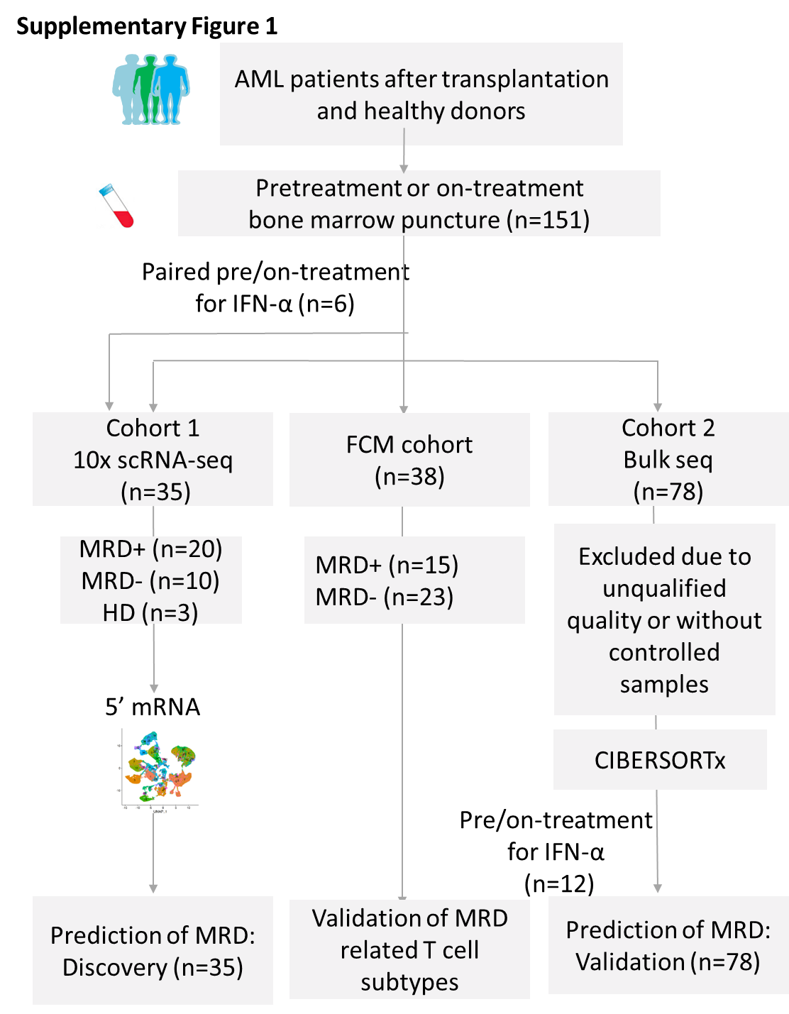

Supplementary Figure 2 Feature plots for immune cell markers.

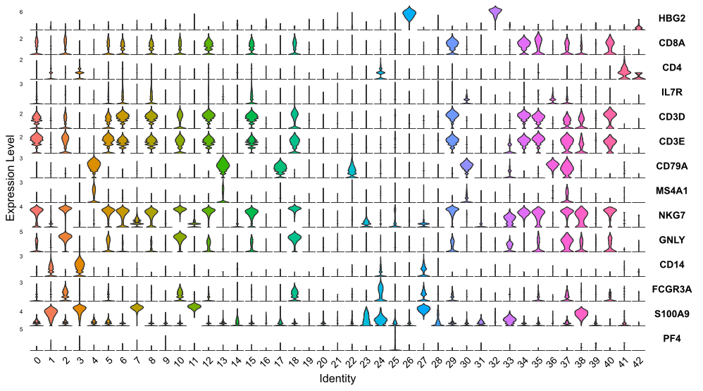

Supplementary Figure 3 CD8⁺ T cell clustering and subtype analysis.
A Heatmap displayed deferentially expressed genes between CD8⁺ T enriched in MRD-positive (MRD+_CD8) and negative (MRD-_CD8) patients; B, The gene expression profiles of antigen presentation, chemokines and their receptors, co-stimulatory, inhibitory receptor, and transcription factor, in MRD+_CD8 and MRD-_CD8 clusters; C-D Bubble plot showed differentially expressed genes of granzyme genes, KLR family genes, and IFITM family genes between MRD+_CD8 and MRD-_CD8 clusters; E Violin plots showed the score of exhaustion between MRD+_CD8 and MRD-_CD8 clusters.
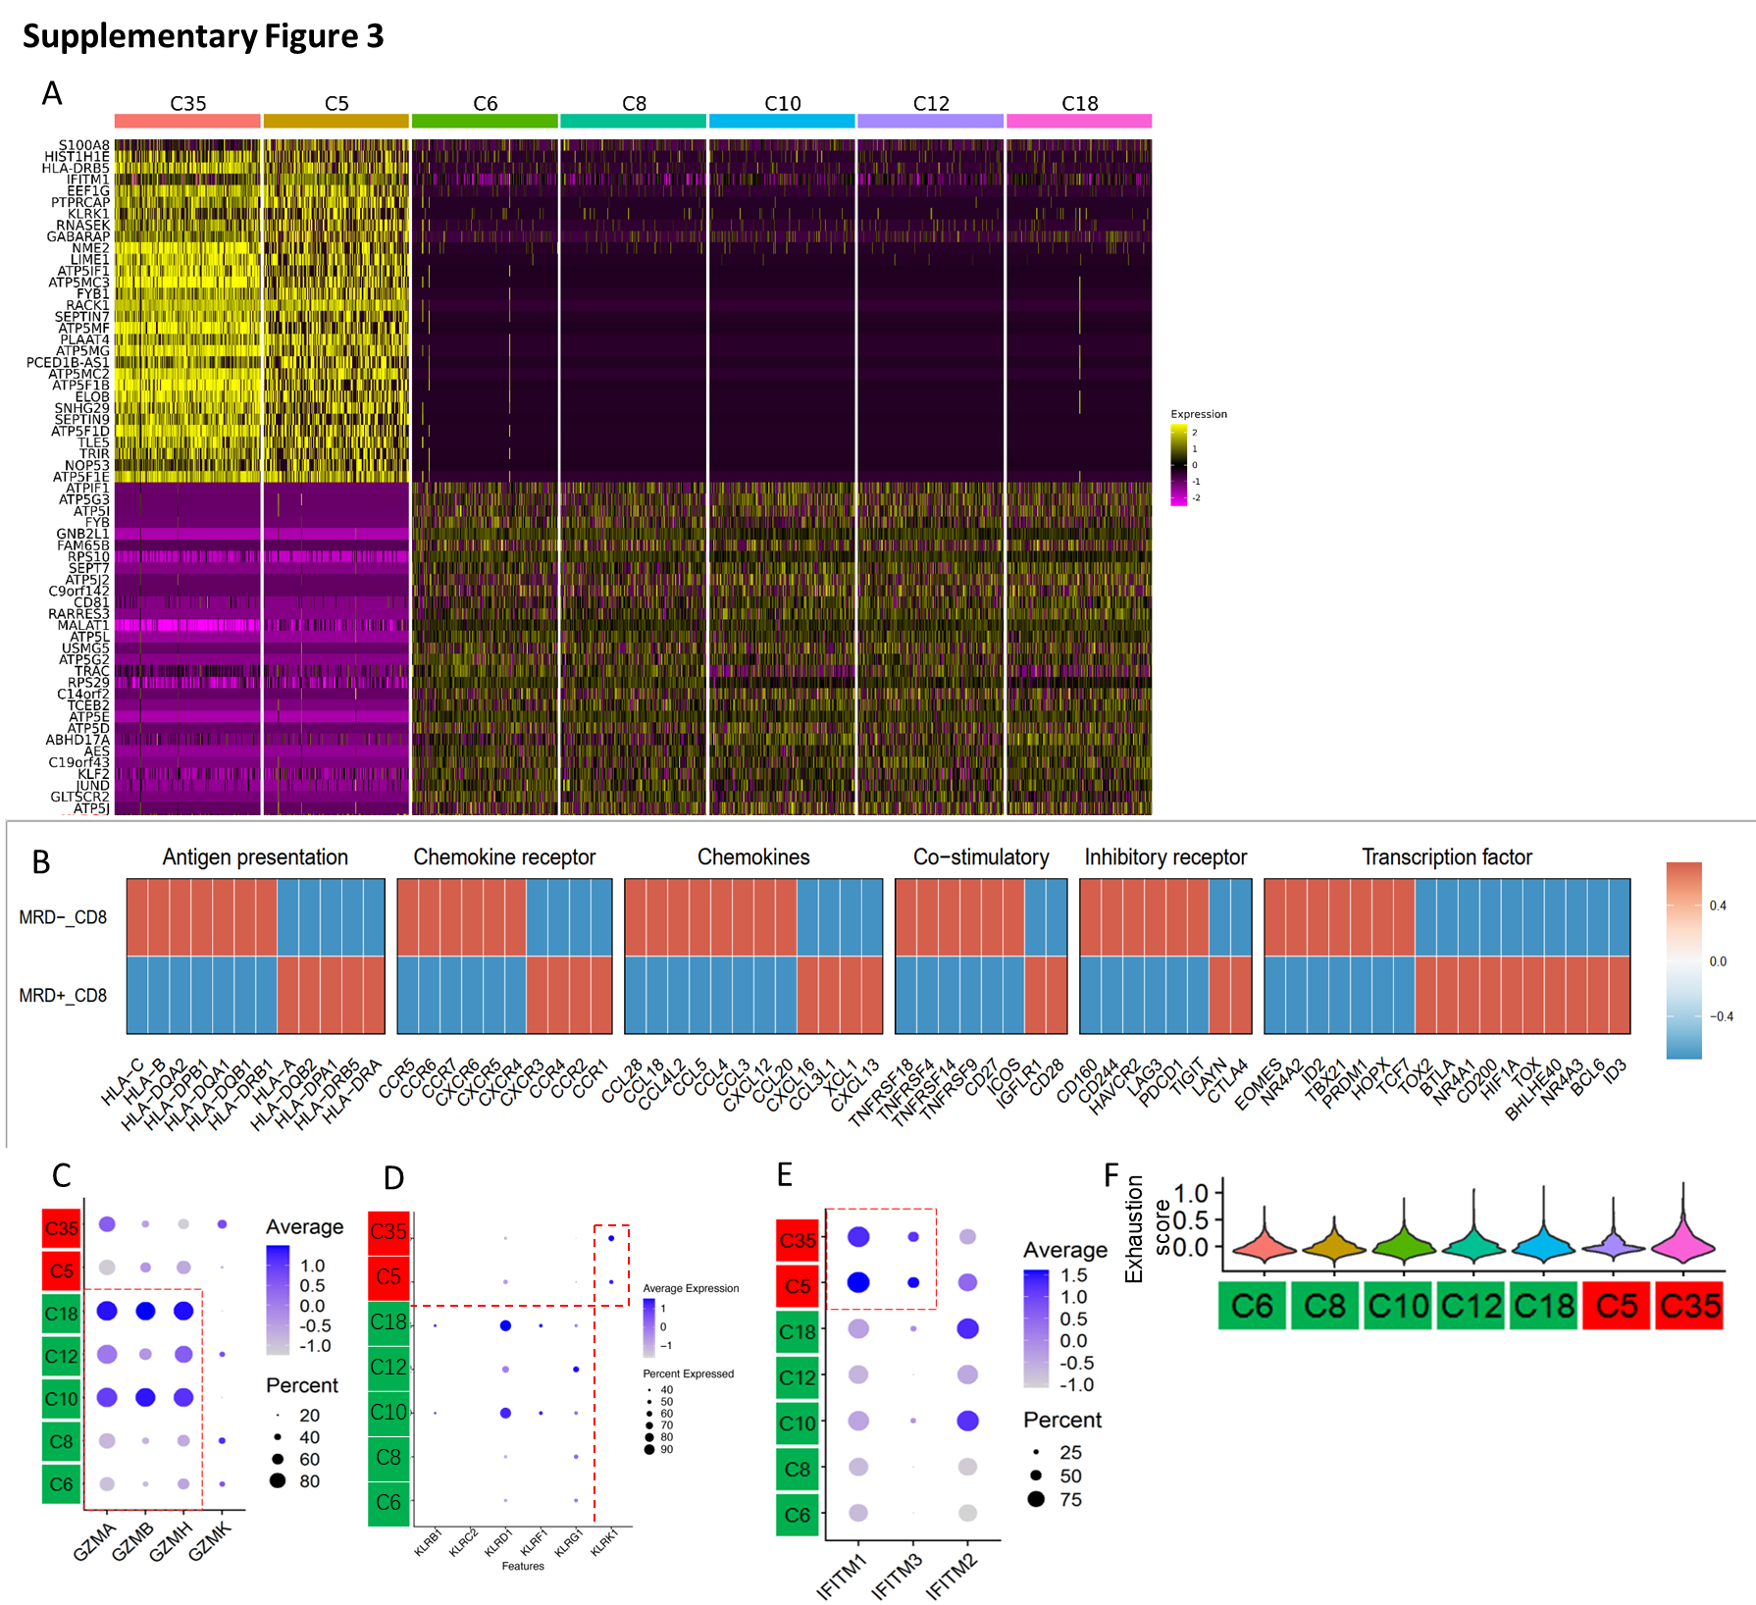

Supplementary Figure 4 B cell clustering and subtype analysis.
A Clustering of B cell enriched in MRD-positive patients (MRD+_B; C4, C22, and C30) and healthy donor (H_B; C13, C17, C33, C36) cell clusters.
B MZB1 gene was associated with a poorer survival of AML in The Cancer Genome Atlas (TCGA);
C Heatmap displayed deferentially expressed genes of MRD+_B and H_B cell clusters.
D The pseudotemporal trajectory of MRD+_B and H_B cell clusters.
E The pseudotemporal trajectory of B-cell clusters in healthy donor (H, red), MRD negative (N, green) and MRD positive (P, blue) was shown respectively.
F The pseudotemporal trajectory of differentially expressed gene MBZ1 between MRD+_B and H_B cell clusters in healthy donor (H), MRD negative (N) and MRD positive (P) were shown respectively.
G Pseudotime ordering of B cell clusters.
H The pseudotemporal trajectory of MBZ1+ B cells.
I Expression level of MBZ1 between H_B and MRD+_B.

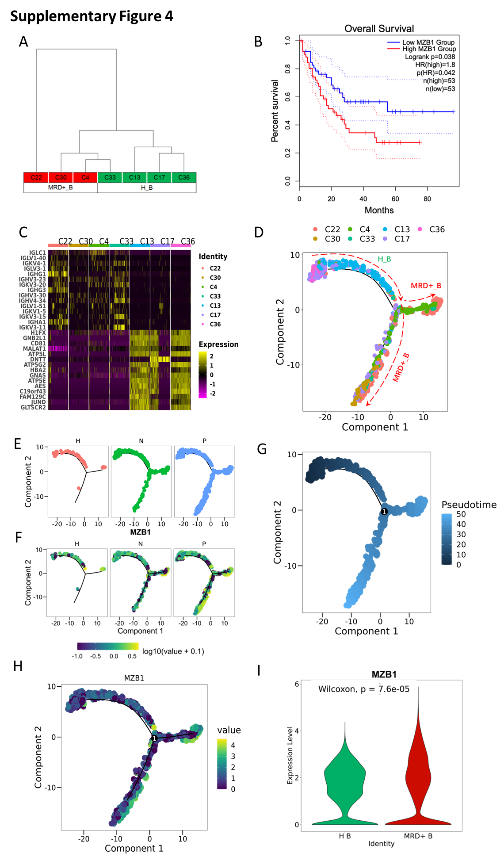

Supplementary Figure 5 Monocyte clustering and subtype analysis.
A Clustering of monocyte cell enricher in healthy donor (H_B; C3 and C27) and enricher in MRD-positive patients (MRD+_M; C1, C23 and C24).
B. ENO1 gene was associated with a poorer survival of AML in The Cancer Genome Atlas (TCGA);
C Heatmap displayed deferentially expressed genes of H_M and MRD+_M cell clusters.
D The pseudotemporal trajectory of H_M and MRD+_M cell clusters.
E The pseudotemporal trajectory of monocyte clusters in healthy donor (H, red), MRD negative (N, green) and MRD positive (P, blue) was shown respectively.
F The pseudotemporal trajectory of differentially expressed gene ENO1 between H_M and MRD+_M cell clusters in healthy donor (H), MRD negative (N) and MRD positive (P) were shown respectively.
G Pseudotime ordering of monocyte clusters.
H The pseudotemporal trajectory of ENO1+ monocytes.
I Expression level of ENO1 between H_M and MRD+_M.
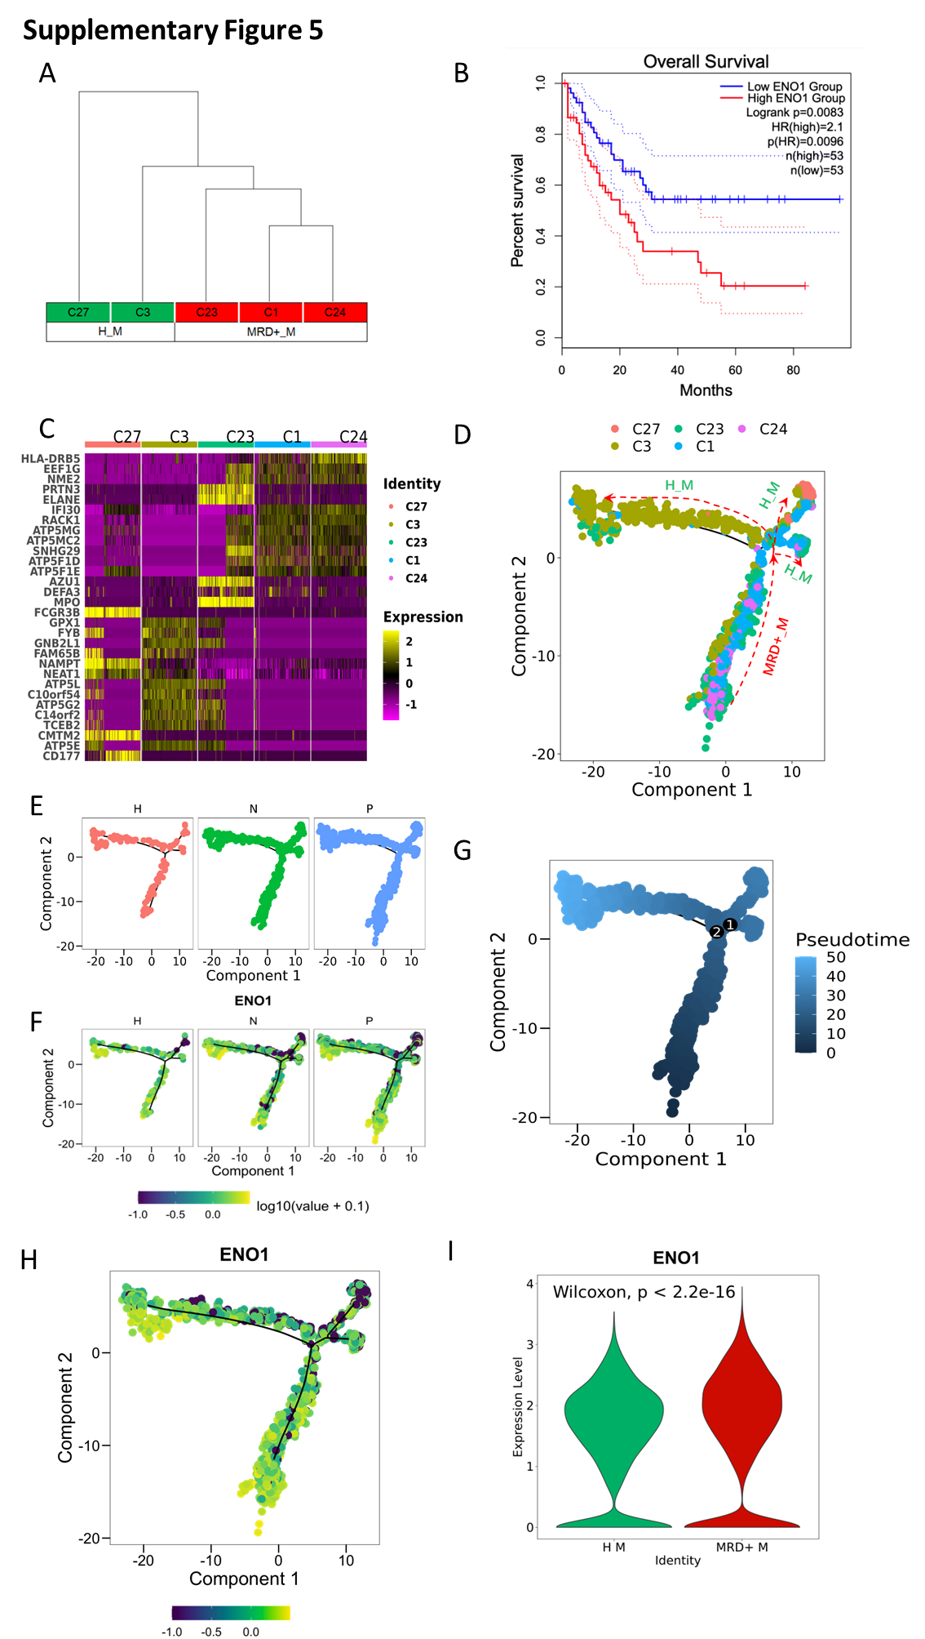

Supplementary Figure 6 Erythrocyte clustering and subtype analysis.
A Clustering of erythrocyte enriched in MRD-positive patients (MRD+_ERY; C14) and enriched in MRD-negative patients (MRD-_ERY; C16 and C21).
B SLC14A1 gene was associated with a better survival of AML in The Cancer Genome Atlas (TCGA);
C Heatmap displayed differentially expressed genes of MRD+ERY and MRD-_ERY cell clusters.
D The pseudotemporal trajectory of MRD+ERY and MRD-_ERY cell clusters.
E The pseudotemporal trajectory of erythrocyte clusters in healthy donor (H, red), MRD negative (N, green) and MRD positive (P, blue) were shown respectively.
F The pseudotemporal trajectory of differentially expressed gene SLC14A1 between MRD+_ERY and MRD-_ERY cell cluster in healthy donor (H), MRD negative (N), and MRD positive (P) was shown respectively.
G Pseudotime ordering of erythrocyte clusters.
H The pseudotemporal trajectory of SLC14A1+ erythrocytes.
I Expression level of SLC14A1 between MRD+_ERY and MRD-_ERY.
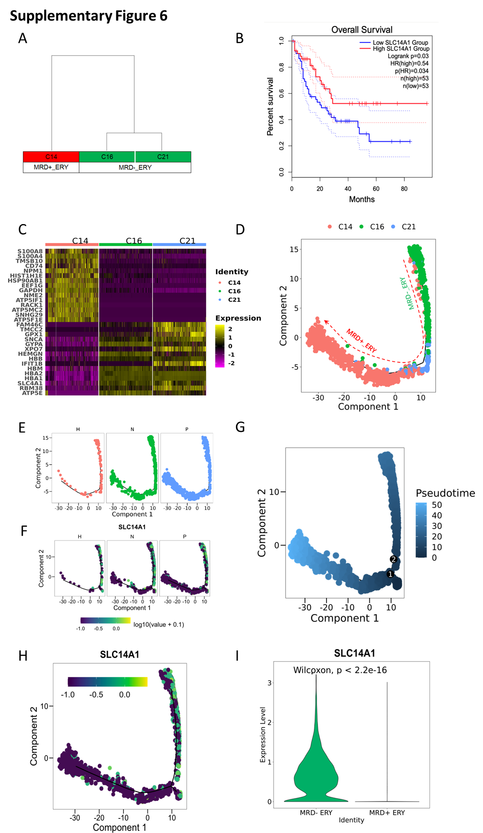

Supplementary Figure 7 Heatmaps of differential outgoing interactions pathways between MRD-_CD8 and MRD+_CD8, H_B and MRD+_B, H_M and MRD+_M, and MRD-_ERY and MRD+_ERY.

Supplementary Figure 8 The predicted interactions mediated by MIF. Different line colors represent different cell groups. The thickness of the line represents the strength of the interaction.

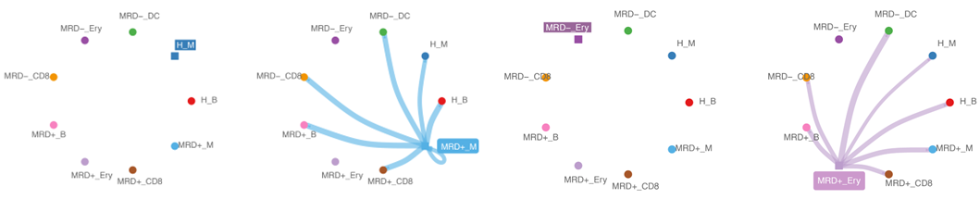

Supplementary Figure 9 The interactions between
The cellular communication between MRD-_CD8⁺ (or MRD+_CD8⁺) and other cell subtypes. (A), incoming interactions. (B), outgoing interactions;
The cellular communication between H_B (or MRD+_B) and other cell subtypes. (C), incoming interactions. (D), outgoing interactions;
(E) The outgoing cellular communication between H_M (or MRD+_M) and other cell subtypes;
(F) The outgoing cellular communication between MRD-_ERY (or MRD+_ERY) and other cell subtypes.
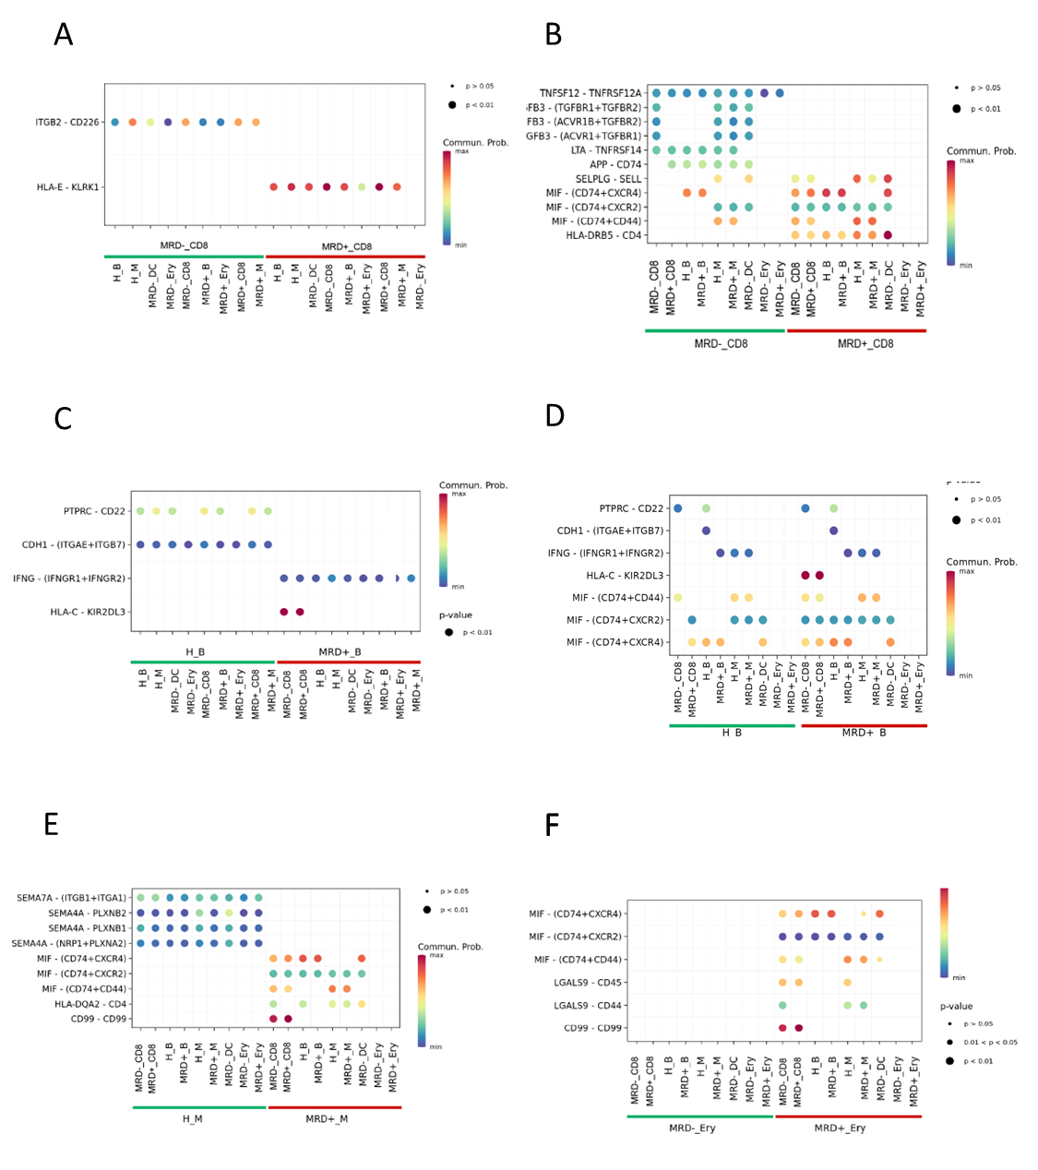

Supplementary Figure 10 The ratio of MRD+_CD8 and MRD-_CD8 clusters before and after IFN-α treatment in IFN-R and IFN-NR group
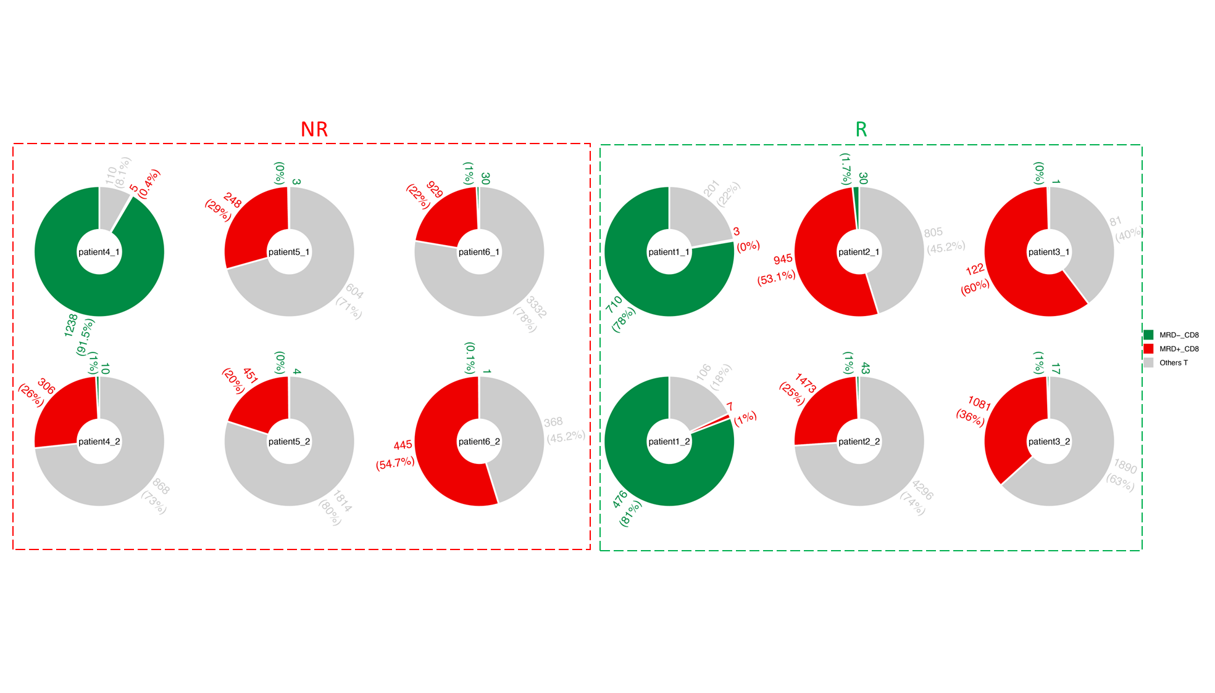

Supplementary Figure 11 The ratio of MRD+_B and MRD-_B clusters before and after IFN-α treatment in IFN-R and IFN-NR group

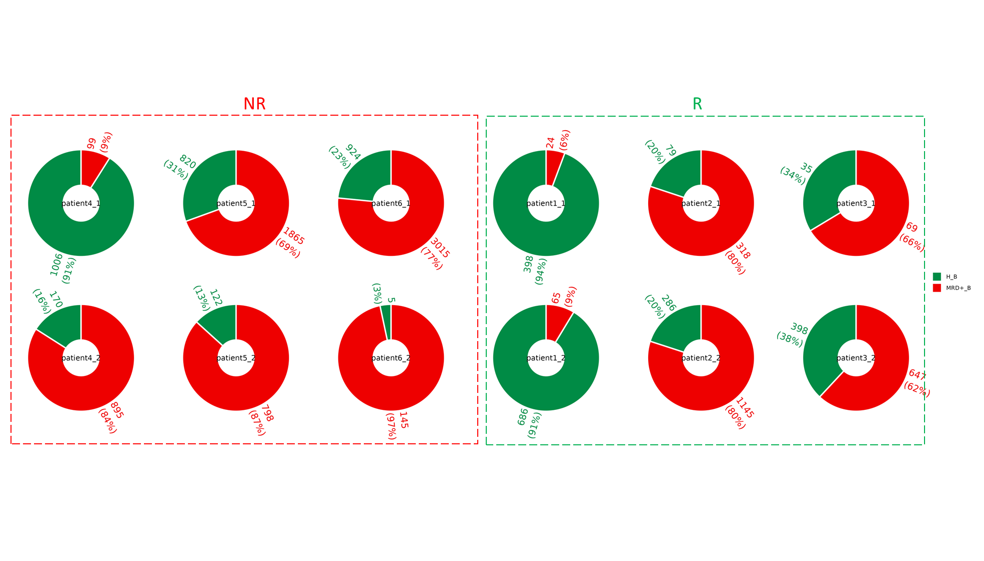

Supplementary Figure 12 The ratio of MRD+_M and MRD-_M clusters before and after IFN-α treatment in IFN-R and IFN-NR group

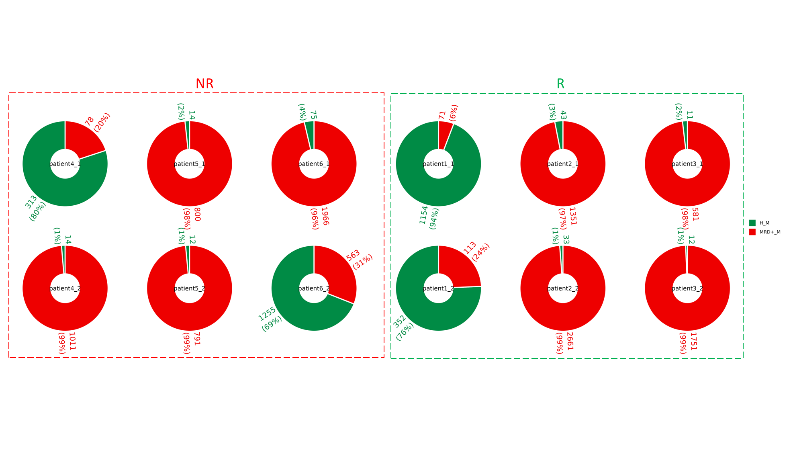

Supplementary Figure 13 MRD related score and immune score of cell clusters identified from by scRNA-seq.
A The MRD related score of 17 MRD related cell subtypes in 209 RNA-seq data of AML patients after allo-HSCT.
B The barplot showed the comparison of the immune score between MRD improvement, MRD stable and MRD deterioration. The parameter jitter was used in the ggboxplot function. ANOVA, *** and **** indicate P <= 0.001 and P <= 0.0001, respectively. Each group was compared to the MRD improvement group using unpaired t test, two sided.
C ROC curves showed the classification performance of immune score.
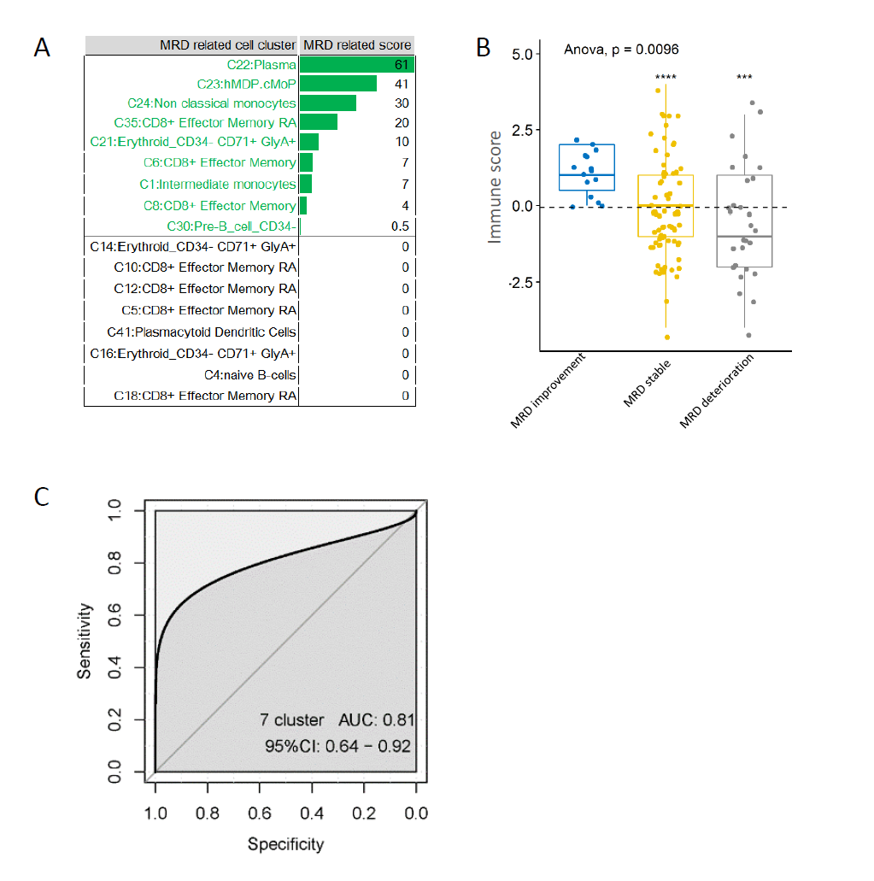

Supplementary Figure 14 Five immune models (IM): IM1 (C22_B cluster increase, i.e., C22B+), IM2 (C22_B cluster decrease and C24_M cluster decrease, i.e., C22B- and C24M-), IM3 (C35_CD8 cluster increase, without IM1 nor IM2, i.e, C35T+), IM4 (C35_CD8 cluster decrease and C23_M cluster increase, without IM1 nor IM2, i.e., C35T- and C23M+), and IM5 (other conditions).

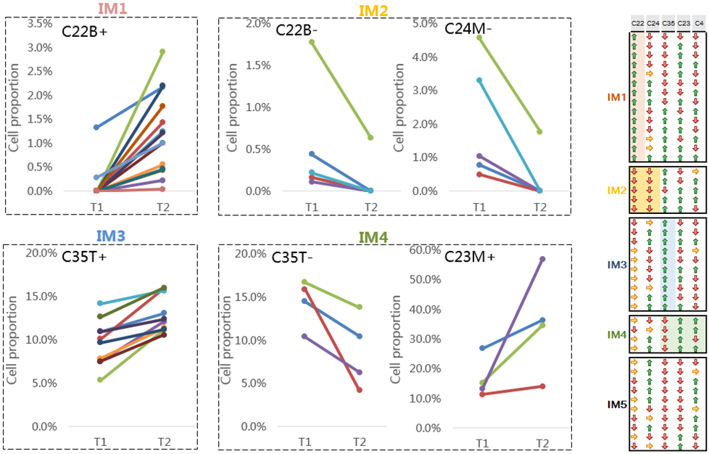

Supplementary Figure 15 The relationships between immune modes (IMs) and MRD evolution after allo-HSCT using bulk RNA-seq.
Immune cell abundance from 47 patients was used for building the IMs and the exploration their relationships with MRD evolution.
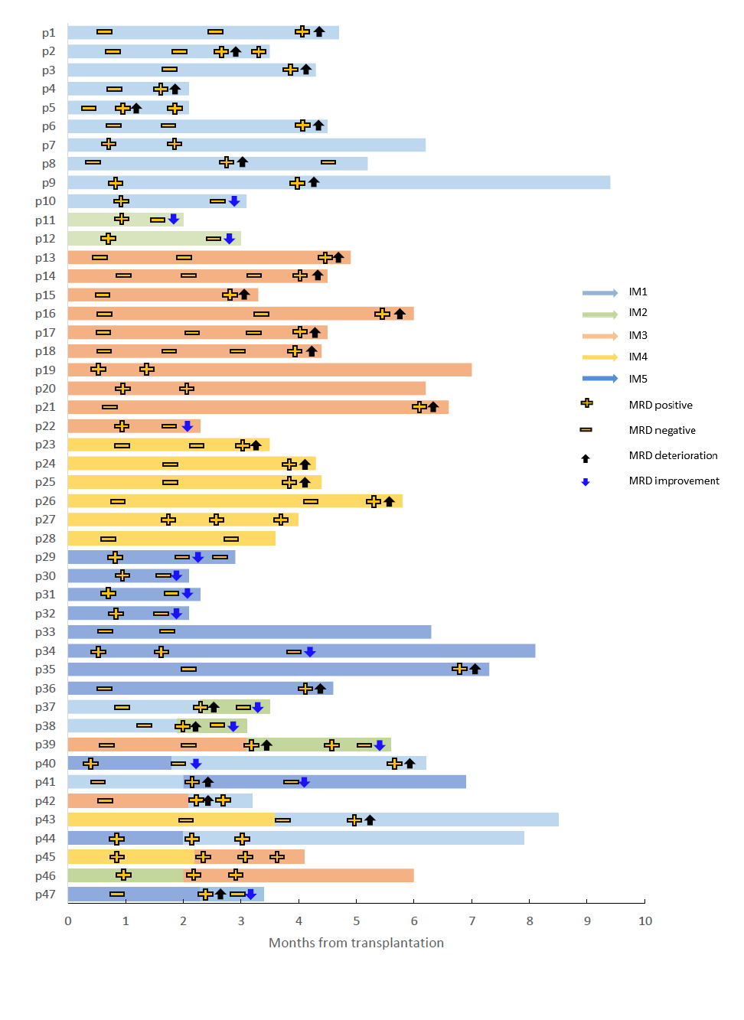

Supplementary Figure 16 Purity validation for fluorescence activated cell sorting.
A Gating strategies for cell sorting of KLRG1⁺ CD8⁺ T cells or KLRG1⁻ CD8⁺ T cells.
B The validation of the purity of fluorescence activated cell sorting.
C The expression of KLRG1 in KLRG1⁺ CD8⁺ T cells and KLRG1⁻ CD8⁺ T cells during the culture period.

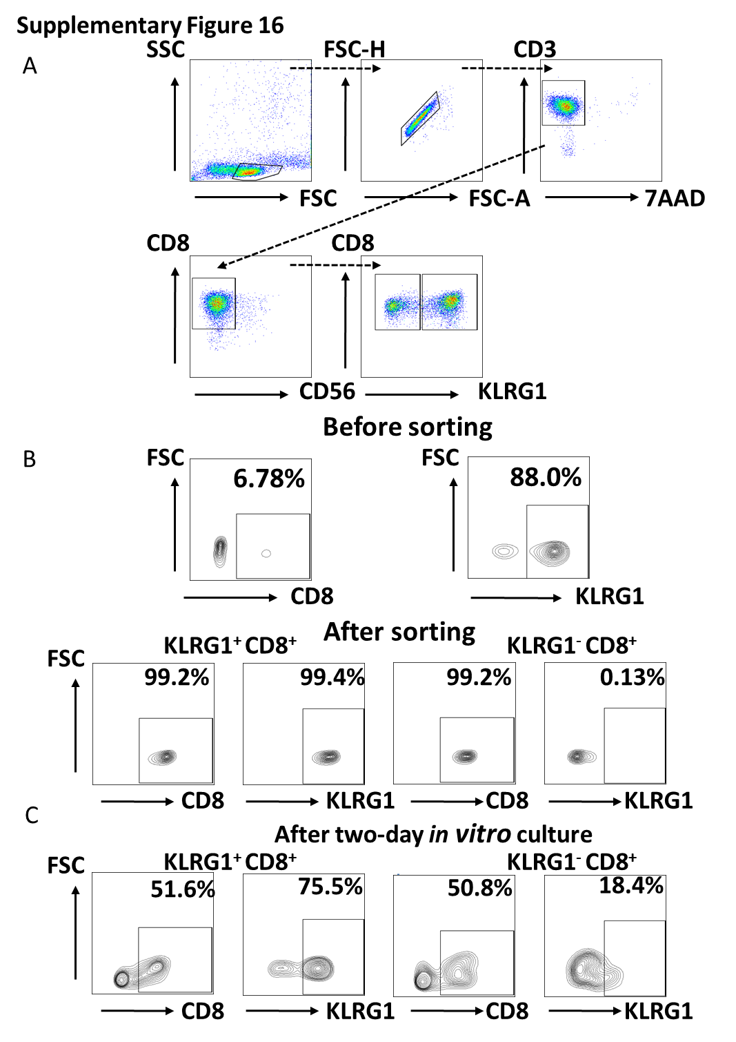

Supplementary Figure 17 Gating strategies for co-culture assays.
A Gating strategies for functional factors detection. Target cells were first stained with CellTrace™ CFSE. Then the sorted KLRG1⁺ CD8⁺ T cells or KLRG1⁻ CD8⁺ T cells were co-cultured with the labeled target cells. Next, we compared the expression of the functional molecules such as CD107a, GZMB, perforin, CD69, Ki67, TNFα in the CFSE negative T cell populations.
B Gating strategies for apoptosis experiments. Target cells were first stained with CellTrace™ Violet. Then the sorted KLRG1⁺ CD8⁺ T cells or KLRG1⁻ CD8⁺ T cells were co-cultured with the labeled target cells. Next, we compared the expression of Annexin V⁺ and 7AAD⁺ in the Violet positive tumor cell populations.

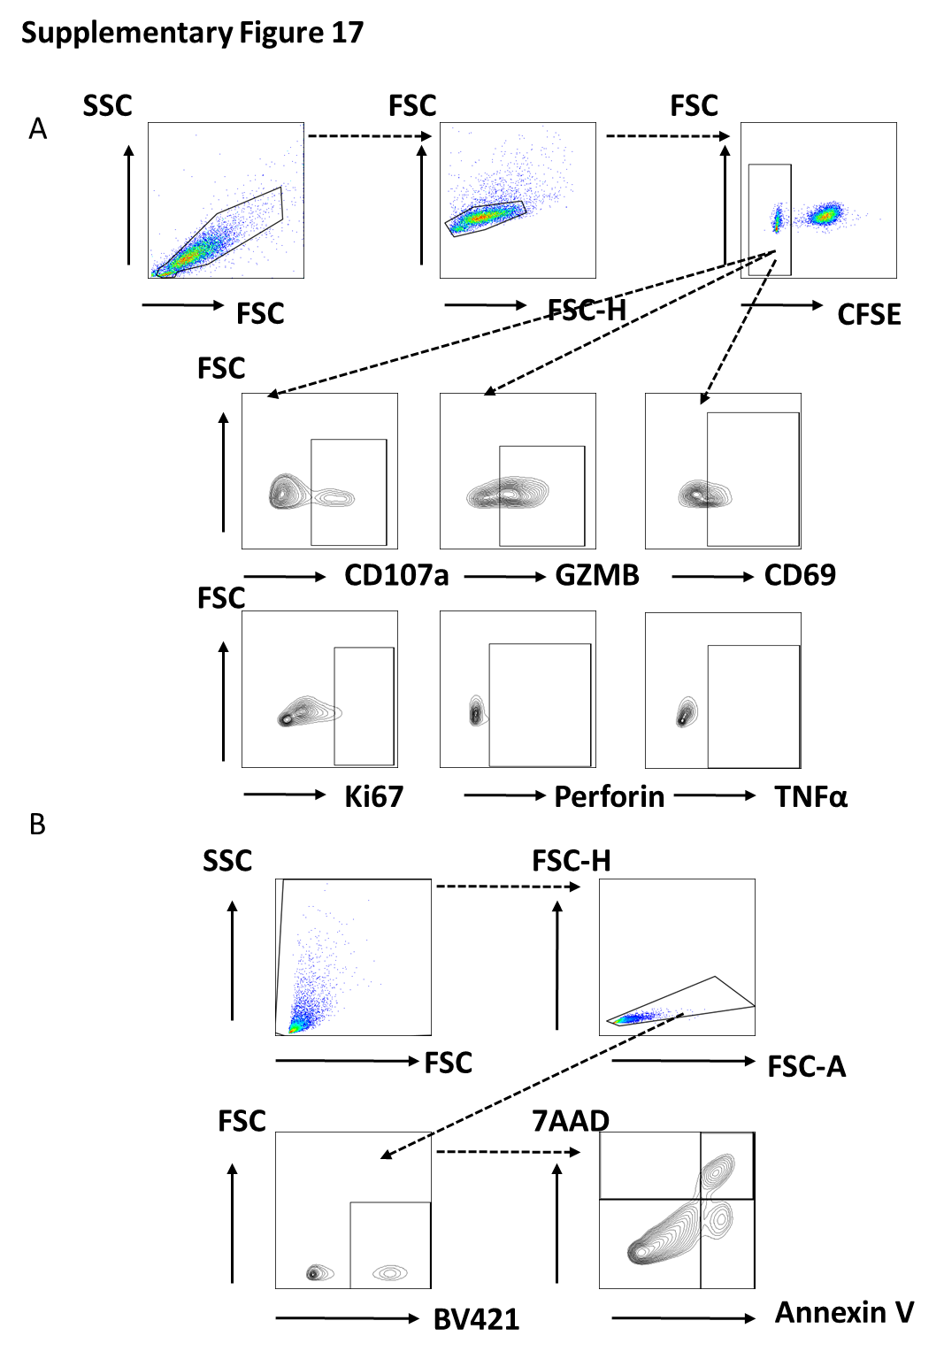

Supplementary Figure 18 The detection of cytotoxic functions of KLRG1+CD8+ and KLRG1-CD8+T cells from HD and MRD-negative patients via co-culture assays.
A Scatter plots displaying the number of CD8⁺ T cells from the BMNCs of MRD-negative and MRD-positive patients. Data are presented as mean ± s.e.m.. P values were calculated using a two-sided t test. *p < 0.05; ** p< 0.01, ****p < 0.001; ns, not significant.
B Scatter plots displaying the number of functional molecules in KLRG1⁺ CD8⁺ T cells from BMNCs of MRD-negative and MRD-positive patients. Data are presented as mean ± s.e.m.. P values were calculated using a two-sided t test.
C Scatter plots displaying the cytokine secretion by KLRG1⁺ CD8⁺ T cells and KLRG1⁻ CD8⁺ T cells from the BMNCs of healthy donors (left panel) and MRD-negative patients (right panels). Data are presented as mean ± s.e.m.. P values were calculated using a paired t test.
D Bar charts displaying the expression of functional molecules of KLRG1⁺ CD8⁺ T cells and KLRG1⁻ CD8⁺ T cells after co-culture with target cell lines from the BMNCs of healthy donors (upper panels) and MRD-negative patients (lower panels). Data are presented as mean ± s.e.m.. P values were calculated using a paired t test.
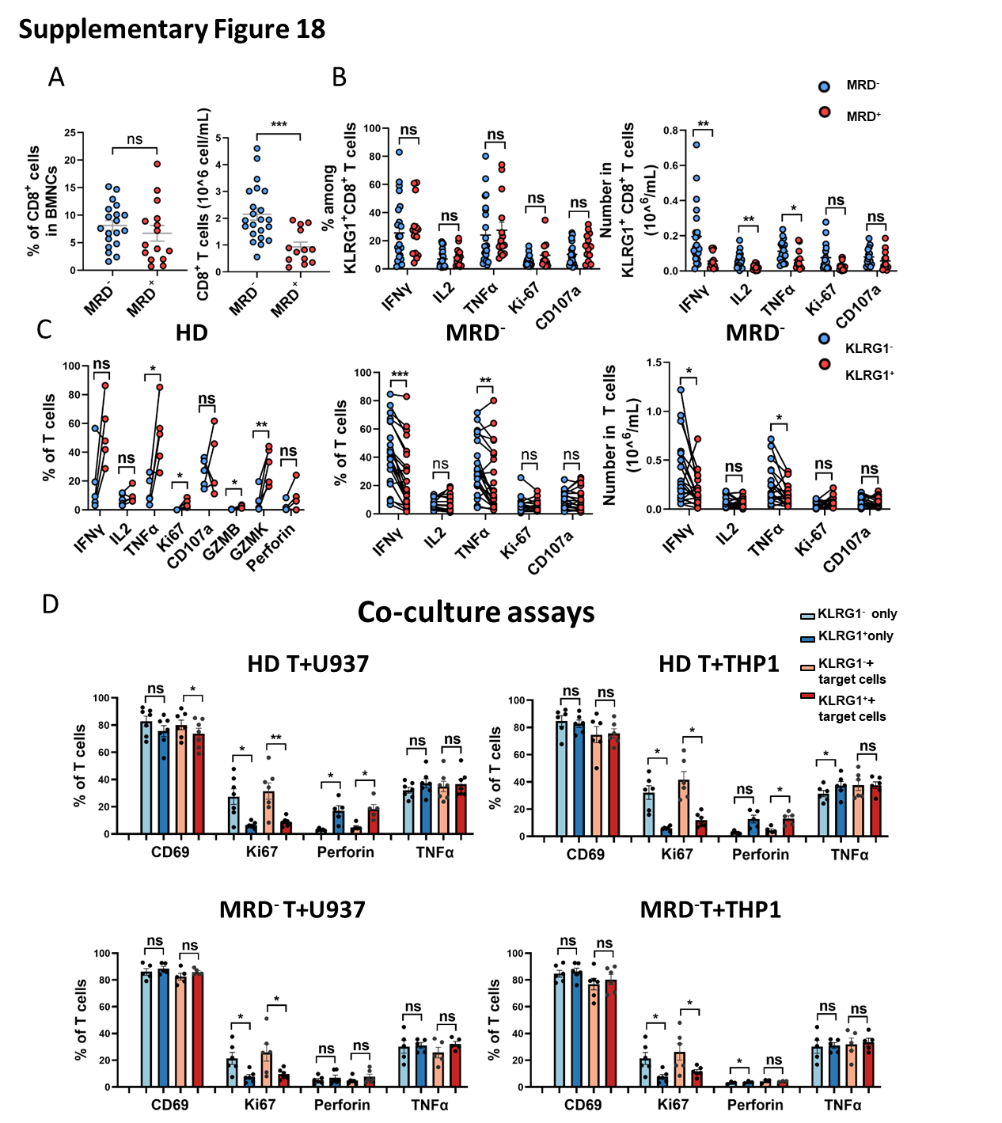

References
1. Gabert J, Beillard E, van der Velden VHJ, et al. Standardization and quality control studies of ‘real-time’ quantitative reverse transcriptase polymerase chain reaction of fusion gene transcripts for residual disease detection in leukemia – A Europe Against Cancer Program. Leukemia 2003;17:2318-57.
2. Beillard E, Pallisgaard N, van der Velden VHJ, et al. Evaluation of candidate control genes for diagnosis and residual disease detection in leukemic patients using ‘real-time’ quantitative reverse-transcriptase polymerase chain reaction (RQ-PCR) – a Europe against cancer program. Leukemia 2003;17:2474-86.
3. Meyer C, Burmeister T, Gröger D, et al. The MLL recombinome of acute leukemias in 2017. Leukemia 2018;32:273-84.
4. Liu J, Ma R, Liu Y-R, et al. The significance of peri-transplantation minimal residual disease assessed by multiparameter flow cytometry on outcomes for adult AML patients receiving haploidentical allografts. Bone Marrow Transplantation 2019;54:567-77.
5. Ruan G-R, Li J-L, Qin Y-Z, et al. Nucleophosmin mutations in Chinese adults with acute myelogenous leukemia. Annals of Hematology 2009;88:159-66.
6. Mo XD, Wang Y, Zhang XH, et al. Interferon-alpha Is Effective for Treatment of Minimal Residual Disease in Patients with t(8;21) Acute Myeloid Leukemia After Allogeneic Hematopoietic Stem Cell Transplantation: Results of a Prospective Registry Study. Oncologist 2018;23:1349-57.
7. Tang FF, Xu LP, Zhang XH, et al. Monitoring of post-transplant CBFB-MYH11 as minimal residual disease, rather than KIT mutations, can predict relapse after allogeneic haematopoietic cell transplantation in adults with inv(16) acute myeloid leukaemia. Br J Haematol 2018;180:448-51.
8. Wang XR, Chang Y, Yuan XY, et al. Overexpressed WT1 exhibits a specific immunophenotype in intermediate and poor cytogenetic risk acute myeloid leukemia. Ann Hematol 2020;99:215-21.
9. Liu J, Zhang XH, Xu LP, et al. Minimal residual disease monitoring and preemptive immunotherapies for frequent 11q23 rearranged acute leukemia after allogeneic hematopoietic stem cell transplantation. Ann Hematol 2021;100:1267-81.
10. Zhao XS, Yan CH, Liu DH, et al. Combined use of WT1 and flow cytometry monitoring can promote sensitivity of predicting relapse after allogeneic HSCT without affecting specificity. Ann Hematol 2013;92:1111-9.
11. Heuser M, Freeman SD, Ossenkoppele GJ, et al. 2021 Update on MRD in acute myeloid leukemia: a consensus document from the European LeukemiaNet MRD Working Party. Blood 2021;138:2753-67.
12. Shen MZ, Zhang XH, Xu LP, et al. Preemptive Interferon-α Therapy Could Protect Against Relapse and Improve Survival of Acute Myeloid Leukemia Patients After Allogeneic Hematopoietic Stem Cell Transplantation: Long-Term Results of Two Registry Studies. Frontiers in immunology 2022;13:757002.
13. Hao Y, Hao S, Andersen-Nissen E, et al. Integrated analysis of multimodal single-cell data. Cell 2021;184:3573-87.e29.
14. Aran D, Looney AP, Liu L, et al. Reference-based analysis of lung single-cell sequencing reveals a transitional profibrotic macrophage. Nature Immunology 2019;20:163-72.
15. Schmiedel BJ, Singh D, Madrigal A, et al. Impact of Genetic Polymorphisms on Human Immune Cell Gene Expression. Cell 2018;175:1701-15.e16.
16. Monaco G, Lee B, Xu W, et al. RNA-Seq Signatures Normalized by mRNA Abundance Allow Absolute Deconvolution of Human Immune Cell Types. Cell Rep 2019;26:1627-40.e7.
17. Novershtern N, Subramanian A, Lawton LN, et al. Densely interconnected transcriptional circuits control cell states in human hematopoiesis. Cell 2011;144:296-309.
18. Xie X, Liu M, Zhang Y, et al. Single-cell transcriptomic landscape of human blood cells. Natl Sci Rev 2021;8:nwaa180.
19. Trapnell C, Cacchiarelli D, Grimsby J, et al. The dynamics and regulators of cell fate decisions are revealed by pseudotemporal ordering of single cells. Nature Biotechnology 2014;32:381-6.
20. Jin S, Guerrero-Juarez CF, Zhang L, et al. Inference and analysis of cell-cell communication using CellChat. Nature Communications 2021;12:1088.
21. Kim D, Paggi JM, Park C, Bennett C, Salzberg SL. Graph-based genome alignment and genotyping with HISAT2 and HISAT-genotype. Nature Biotechnology 2019;37:907-15.
22. Liao Y, Smyth GK, Shi W. featureCounts: an efficient general purpose program for assigning sequence reads to genomic features. Bioinformatics 2013;30:923-30.
23. Newman AM, Liu CL, Green MR, et al. Robust enumeration of cell subsets from tissue expression profiles. Nat Methods 2015;12:453-7.
24. Yoshihara K, Shahmoradgoli M, Martínez E, et al. Inferring tumour purity and stromal and immune cell admixture from expression data. Nat Commun 2013;4:2612.

