Supplementary Information

Supplementary figures

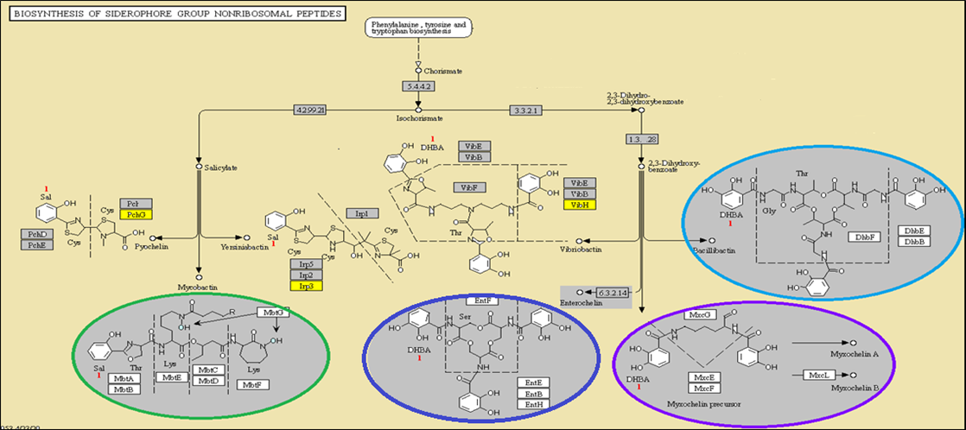

Figure S1 Pathway of biosynthesis of different types of Siderophores. The grey and yellow colored boxes in the siderophore pathway indicate the presence and absence of genes in the assembly, respectively.

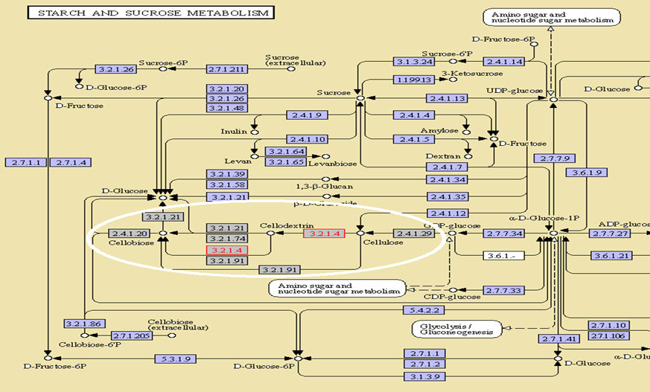
Figure S2 Cellulase production pathway. The grey boxes in Figure 5 indicate the genes (or enzymes) present in Amycolatopsis sp. BCA-696.

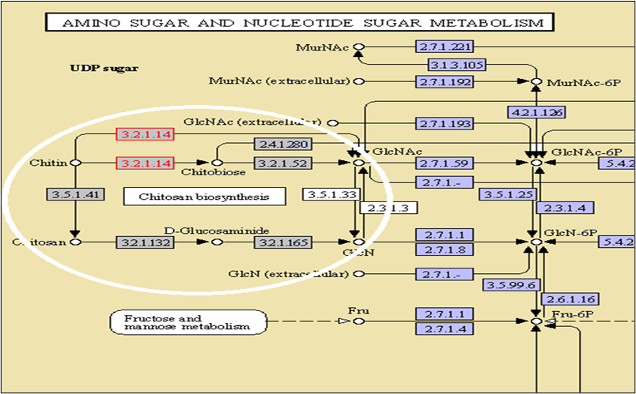
Figure S3. Chitinase activity pathway. The boxes highlighted in grey color indicate the enzymes present in the Amycolatopsis sp. BCA-696 assembly.

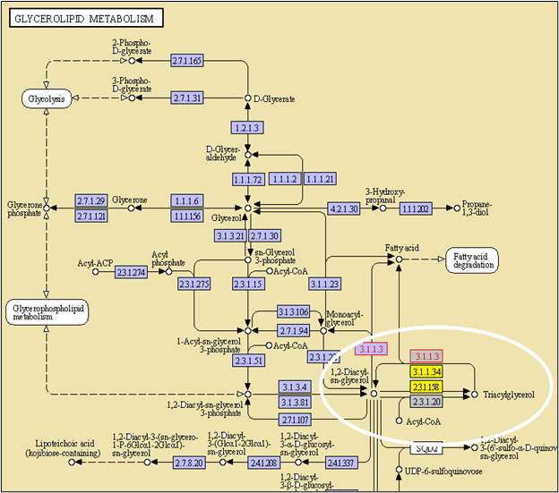
Figure S4. Lipase synthesis pathway. The enzymes present in A. BCA-696 were highlighted in grey color and absent ones in yellow color.

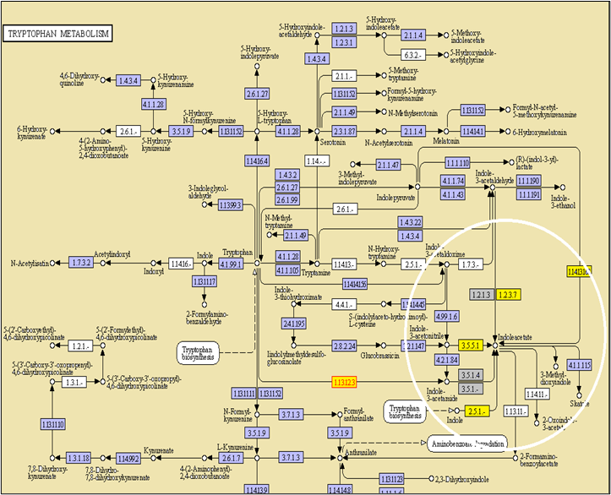

Figure S5. Indole-3-acetic acid biosynthesis Pathway. The IAA synthesis, here grey and yellow color highlighted boxes indicate the presence and absence of genes in the Amycolatopsis sp. assembly, respectively.

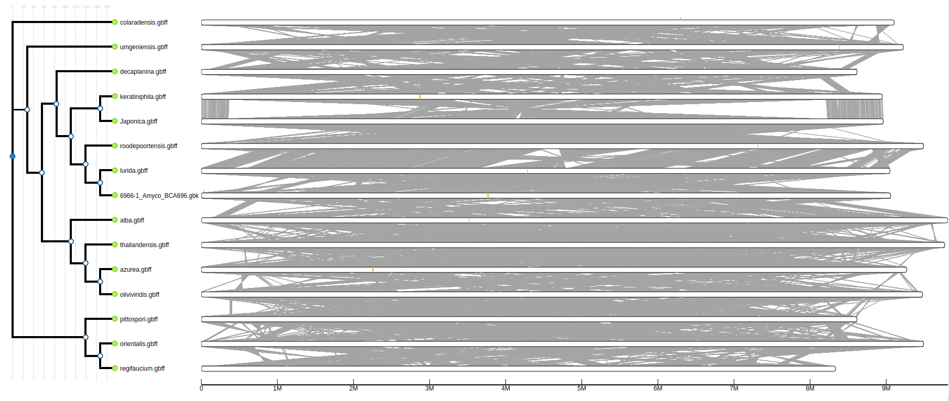
Figure S6: Amycolotapsis strains and genomic Island formed from BLAST is marked in orange:

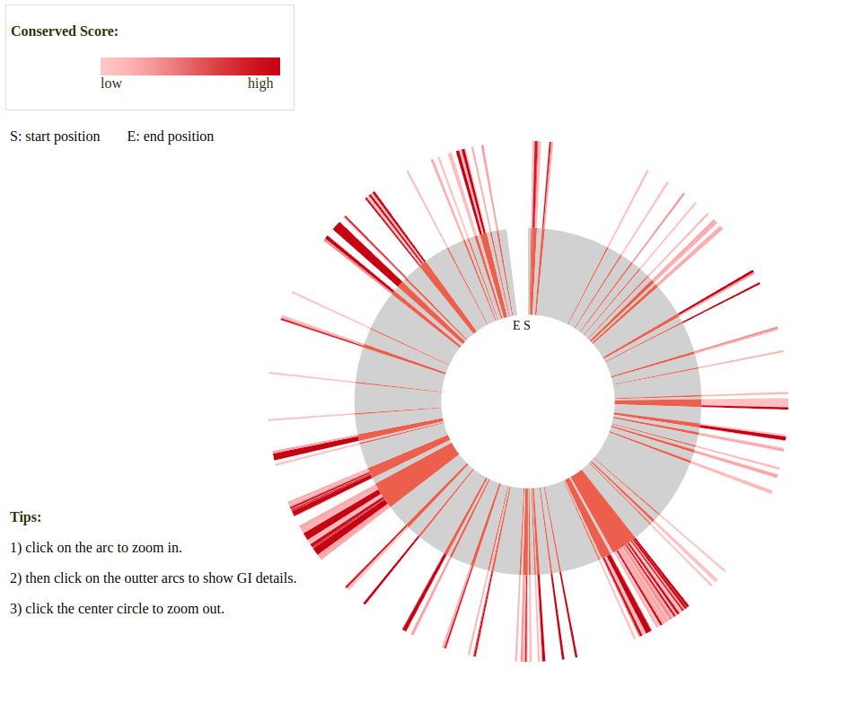
Figure S7: GIs based on MTGIpick from BCA-696

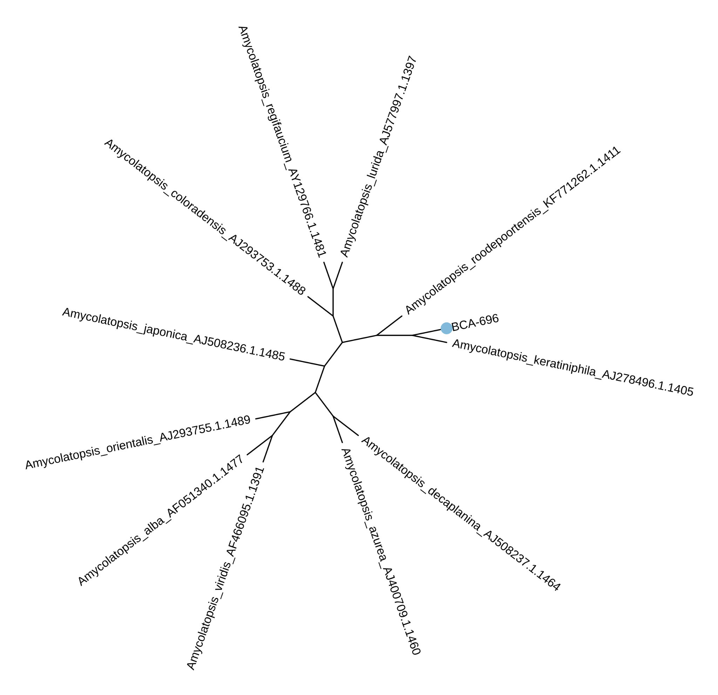
Figure S8: Tree constructed based on the complete 16s rRNA fragment from BCA-696 and related genomes from SILVA database.

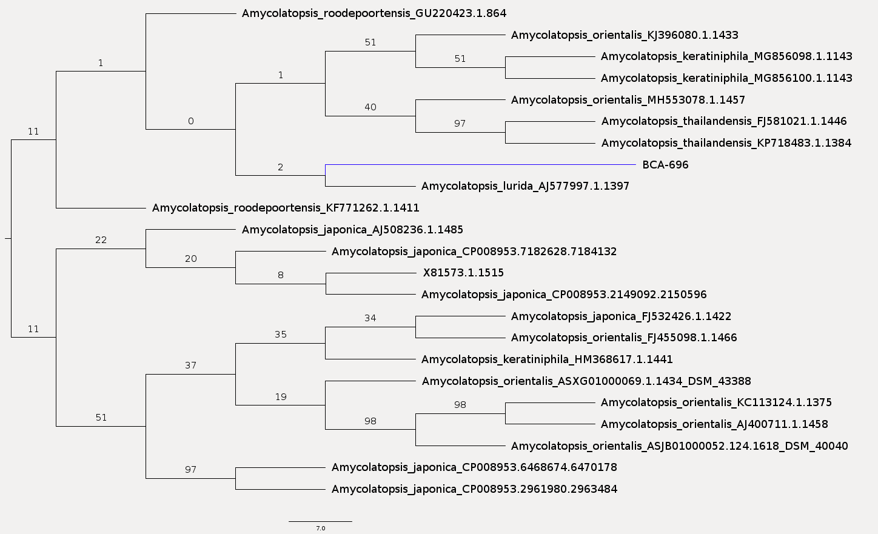
Figure S9: Tree constructed based on the complete 16s rRNA fragment from BCA-696 and strains of related genomes from SILVA database.

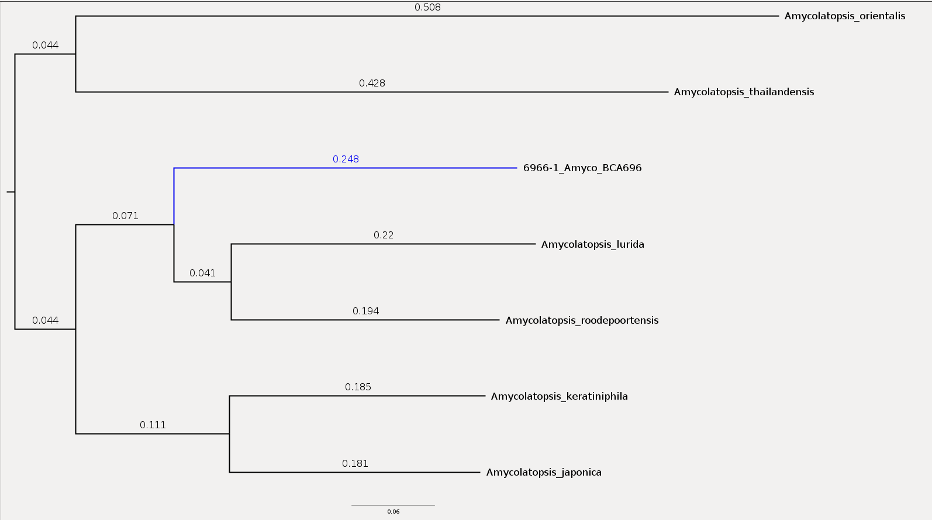
Figure S10: Results from Phylophlan 3.

Table S1: Summary of sequence data after pre-processing of reads. The same was subsequently used to generate genome assembly.

Library | Paired-end reads |  |  | Mate-pair reads
Library | Average sequence Length (bp) | Number of sequences (in millions) | Number of Bases (in millions) | Average sequence length | Number of sequences (in millions) | Number of Bases (in millions)
Forward-paired | 91 | 9.568 | 867.2 | 174 | 4.553 | 791.2
Reverse-paired | 90 | 9.568 | 859.1 | 167 | 4.553 | 761.9
Forward-unpaired | 87 | 0.241 | 21.1 | 192 | 0.980 | 188.4
Reverse-unpaired | 78 | 0.019 | 1.5 | 209 | 0.615 | 128.5

Table S2. Biosynthetic gene clusters predicted in Amycolatopsis sp. BCA-696 genome, and their annotation.
Cluster No | Start | End | Strand | BGC Domain | BGC Class
Cluster 1 | 28530 | 29427 | + | Glycopeptide Resistance: D-lactate dehydrogenase | Resistance
Cluster 1 | 29428 | 30469 | + | Glycopeptide: D-ala-D-lactate ligase | Resistance
Cluster 1 | 30465 | 31074 | + | Glycopeptide resistance: D-Ala-D-Ala dipeptidases | Resistance
Cluster 1 | 33381 | 34221 | + | Prephenate dehydrogenase | Aminocoumarin
Cluster 1 | 36435 | 42621 | + | Adenylation,Thiolation,Condensation,Epimerization | Thiotemplated
Cluster 1 | 42689 | 45773 | + | Adenylation | Thiotemplated
Cluster 1 | 46494 | 58494 | + | Adenylation | Thiotemplated
Cluster 1 | 58633 | 64195 | + | Adenylation | Thiotemplated
Cluster 1 | 64646 | 65822 | + | P450A | Tailoring
Cluster 1 | 65845 | 67003 | + | P450D | Tailoring
Cluster 1 | 66992 | 68189 | + | P450B | Tailoring
Cluster 1 | 68430 | 69672 | + | P450C | Tailoring
Cluster 1 | 69684 | 70842 | + | Glycosyltransferase | Tailoring
Cluster 1 | 70874 | 72092 | + | Glycosyltransferase | Tailoring
Cluster 1 | 72108 | 73323 | + | Glycosyltransferase | Tailoring
Cluster 1 | 74191 | 75319 | + | Glycosyltransferase | Tailoring
Cluster 1 | 76312 | 78109 | + | Glycosyltransferase | Tailoring
Cluster 1 | 80918 | 81743 | + | Thioesterase | Thiotemplated
Cluster 1 | 81739 | 83476 | + | Adenylation | Thiotemplated
Cluster 1 | 87272 | 88682 | + | 2,3-dehydratase | Deoxysugar
Cluster 1 | 88683 | 89649 | + | 4-ketoreductase | Deoxysugar
Cluster 1 | 89645 | 90755 | + | 3-aminotransferase | Deoxysugar
Cluster 1 | 90771 | 91389 | + | Epimerase | Deoxysugar
Cluster2 | 646201 | 646510 | - | Anthrone-type oxygenase | Type II polyketide
Cluster2 | 649559 | 650342 | + | Thioesterase | Thiotemplated
Cluster2 | 652326 | 653013 | + | Cyclodipeptide synthase | Cyclodipeptide
Cluster 3 | 823934 | 824480 | - | Linaridin precursor (legonaridin-type) | RiPP
Cluster 3 | 832999 | 833170 | + | Dehydratase | Thiotemplated
Cluster 3 | 833635 | 834862 | - | Glycosyltransferase | Tailoring
Cluster 3 | 837879 | 839619 | + | Acyl adenylating enzyme | Thiotemplated
Cluster 3 | 839615 | 843812 | + | Thiolation,Ketosynthase,Acyltransferase,Thiolation,Thioesterase | Thiotemplated
Cluster 4 | 877649 | 878780 | - | Glycosyltransferase | Tailoring
Cluster 4 | 878776 | 879553 | - | Thioesterase | Thiotemplated
Cluster 4 | 879566 | 879866 | - | Thiolation | Thiotemplated
Cluster 4 | 879882 | 883902 | - | Ketosynthase | Thiotemplated
Cluster 4 | 883898 | 890210 | - | Ketosynthase,Acyltransferase,Thiolation,Ketoreductase | Thiotemplated
Cluster 5 | 1952898 | 1953288 | + | Ectoine synthase | Ectoine
Cluster 6 | 2381161 | 2383714 | + | Lantipeptide kinase/cyclase (LanKC or LanL) | RiPP
Cluster 6 | 2383754 | 2383898 | + | Lantipeptide precursor (clade H1) | RiPP
Cluster 7 | 3195798 | 3197049 | - | Ketosynthase | Thiotemplated
Cluster 7 | 3197089 | 3197335 | - | Thiolation | Thiotemplated
Cluster 7 | 3198383 | 3199262 | - | Acyltransferase | Thiotemplated
Cluster 8 | 3382009 | 3387838 | + | Ketosynthase,Acyltransferase,Ketoreductase, Enediyne C-terminal phosphopantetheinyltransferase | Thiotemplated
Cluster 9 | 3686900 | 3689348 | - | Nitroreductase | Thiotemplated
Cluster 9 | 3696056 | 3701006 | - | Ketosynthase, Acyltransferase, Ketoreductase, Thiolation | Thiotemplated
Cluster 9 | 3701198 | 3702287 | - | Glycosyltransferase | Tailoring
Cluster 9 | 3702492 | 3703350 | + | Thioesterase | Thiotemplated
Cluster 10 | 3864919 | 3865738 | + | Tyrosine ortho-hydroxylase | Lincoside
Cluster 10 | 3870662 | 3871961 | + | Acyltransferase, Thiolation | Thiotemplated
Cluster 10 | 3871957 | 3877534 | + | Ketosynthase, Dehydratase | Thiotemplated
Cluster 11 | 3954845 | 3960062 | - | Ketosynthase,Acyltransferase,Ketoreductase,Thiolation | Thiotemplated
Cluster 11 | 3961583 | 3962879 | - | Ketosynthase | Thiotemplated
Cluster 11 | 3963018 | 3964992 | + | Amidotransferase | Type II polyketide
Cluster 11 | 3968606 | 3976322 | - | Acyl adenylating enzyme,Thiolation,Ketosynthase,Acyltransferase,Dehydratase,Ketoreductase,Thiolation,Thioesteras | Thiotemplated
Cluster 11 | 3976346 | 3977837 | - | Adenylation | Thiotemplated
Cluster 11 | 3979037 | 3980030 | + | Nitroreductase | Thiotemplated
Cluster 11 | 3987984 | 3988938 | + | Nitroreductase,Nitroreductase | Thiotemplated
Cluster 11 | 3991157 | 3993680 | + | Thiolation | Thiotemplated
Cluster 11 | 3993715 | 3996235 | + | Adenylation,Thiolation | Thiotemplated
Cluster 11 | 3997251 | 3998337 | + | 2,3-diaminopropionate biosynthesis protein SbnB | Beta-lactam
Cluster 11 | 3998375 | 3999362 | + | 2,3-diaminopropionate biosynthesis protein SbnA | Beta-lactam
Cluster 12 | 4512489 | 4513308 | - | Thioesterase | Thiotemplated
Cluster 12 | 4519960 | 4523389 | + | Adenylation,Thiolation,Ketosynthase | Thiotemplated
Cluster 12 | 4523385 | 4526844 | + | Adenylation,Thiolation,Condensation,Thiolation | Thiotemplated
Cluster 12 | 4526854 | 4532185 | + | Ketosynthase,Acyltransferase,Ketoreductase,Dehydratase,Thiolation | Thiotemplated
Cluster 12 | 4532509 | 4535536 | + | Condensation,Adenylation,Thiolation | Thiotemplated
Cluster 12 | 4535532 | 4540962 | + | Condensation,Adenylation,Thiolation,Thioesterase | Thiotemplated
Cluster 13 | 5086732 | 5086909 | - | Putative lantipeptide precursor | RiPP
Cluster 13 | 5090326 | 5093152 | - | Lantipeptide fused dehydratase/cyclase | RiPP
Cluster 13 | 5102686 | 5103151 | + | Thioesterase | Thiotemplated
Cluster 14 | 5340989 | 5342567 | - | Adenylation | Thiotemplated
Cluster 14 | 5342563 | 5343223 | - | Piperazic acid synthase | Rare monomer biosynthesis
Cluster 14 | 5347520 | 5348723 | + | P450C | Tailoring
Cluster 14 | 5348917 | 5352658 | - | Condensation,Adenylation,Thioesterase | Thiotemplated
Cluster 14 | 5352657 | 5354511 | - | Amidotransferase | Type II polyketide
Cluster 14 | 5354553 | 5356107 | - | Glutamine synthetase homologue - Acetylhydrazine transferase | Phosphonate
Cluster 14 | 5356116 | 5357535 | - | Acetylhydrazinearginine deacetylase | Phosphonate
Cluster 14 | 5359320 | 5359725 | - | Hydrazinosuccinate N-acetyltransferase | Phosphonate
Cluster 14 | 5359711 | 5361016 | - | Acetylhydrazinosuccinate lyase | Phosphonate
Cluster 14 | 5361036 | 5363085 | - | Condensation | Thiotemplated
Cluster 14 | 5363117 | 5363375 | - | Thiolation | Thiotemplated
Cluster 14 | 5368726 | 5369632 | - | Enoylreductase | Thiotemplated
Cluster 14 | 5374217 | 5374823 | - | Thioesterase | Thiotemplated
Cluster 15 | 5611746 | 5633991 | - | Condensation,Adenylation,Thiolation, | Thiotemplated
Cluster 15 | 5635515 | 5636463 | + | Formyltransferase | Tailoring
Cluster 15 | 5642604 | 5644242 | - | Hygromycin ABC transporter | Resistance
Cluster 16 | 5752830 | 5754237 | - | EmrB: drug resistance MFS transporter | Resistance
Cluster 16 | 5754233 | 5764190 | - | Condensation,Adenylation,Thiolation,E | Thiotemplated
Cluster 16 | 5768857 | 5769091 | - | Thiolation | Thiotemplated
Cluster 16 | 5769087 | 5769753 | - | Phenazine biosynthesis isochorismatase | Other
Cluster 16 | 5769755 | 5771378 | - | Acyl adenylating enzyme | Thiotemplated
Cluster 16 | 5776593 | 5777172 | + | D-Ala-D-Ala carboxypeptidase | Resistance
Cluster 16 | 5781676 | 5783092 | - | Adenylation | Thiotemplated
Cluster 17 | 5904000 | 5910423 | - | Thiolation,Ketosynthase,Acyltransferase,Dehydratase,Ketoreductase,Thiolation,Thioesterase | Thiotemplated
Cluster 17 | 5910419 | 5912180 | - | Acyl adenylating enzyme | Thiotemplated
Cluster 17 | 5917646 | 5918540 | + | Beta lactamase class A | Resistance
Cluster 17 | 5923836 | 5924625 | - | Thioesterase | Thiotemplated
Cluster 17 | 5925184 | 5926108 | - | Thioesterase | Thiotemplated
Cluster 18 | 6196743 | 6197046 | - | Anthrone-type oxygenase | Type II polyketide
Cluster 18 | 6197386 | 6198139 | - | C19 ketoreductase | Type II polyketide
Cluster 18 | 6198663 | 6199197 | - | Type II polyketide cyclase, clade 7 (tetracenomycins/pentangular polyphenols, 1st/2nd/3rd rings) | Type II polyketide
Cluster 18 | 6199198 | 6199486 | - | Thiolation | Thiotemplated
Cluster 18 | 6199482 | 6200733 | - | Chain length factor (KSβ) | Type II polyketide
Cluster 18 | 6204418 | 6204754 | + | Type II polyketide cyclase, clade 5a (pentangular polyphenols, 4th/5th rings) | Type II polyketide
Cluster 18 | 6204750 | 6205179 | + | Type II polyketide cyclase, clade 1 (tetracenomycins/pentangular polyphenols, | Type II polyketide
Cluster 18 | 6205175 | 6206429 | + | Ketosynthase α | Type II polyketide
Cluster 18 | 6207033 | 6209007 | + | Thiolation,Condensation,Thiolation | Thiotemplated
Cluster 18 | 6211766 | 6214205 | - | N-methyltransferase,C-methyltransferase | Deoxysugar
Cluster 18 | 6214201 | 6220513 | - | Ketosynthase,Acyltransferase,Ketoreductase,Ketoreductase,Thiolation,Condensation,Thioesterase | Thiotemplated
Cluster 18 | 6220509 | 6224319 | - | Thiolation,Condensation,Adenylation,Thiolation | Thiotemplated
Cluster 18 | 6228935 | 6230360 | + | Multidrug MFS transporter | Resistance
Cluster 18 | 6236266 | 6237553 | + | Thiolation | Thiotemplated
Cluster 19 | 6228935 | 6230360 | + | Multidrug MFS transporter | Resistance
Cluster 19 | 6236266 | 6237553 | + | Thiolation | Thiotemplated
Cluster 19 | 6237549 | 6240579 | + | Ketosynthase | Thiotemplated
Cluster 19 | 6248095 | 6248380 | - | Thiolation | Thiotemplated
Cluster 19 | 6248403 | 6250125 | - | Acyl adenylating enzyme | Thiotemplated
Cluster 19 | 6251392 | 6253081 | - | Carbamoyltransferase | Tailoring
Cluster 20 | 6583022 | 6583781 | - | Phosphopantetheinyltransferase | Thiotemplated
Cluster 20 | 6583777 | 6584524 | - | Thioesterase | Thiotemplated
Cluster 20 | 6585566 | 6586706 | - | Acyl-CoA dehydrogenase (methoxymalonate biosynthesis) | Rare monomer biosynthesis
Cluster 20 | 6586719 | 6586971 | - | Thiolation | Thiotemplated
Cluster 20 | 6587919 | 6590850 | - | Ketosynthase,Acyltransferase | Thiotemplated
Cluster 20 | 6590858 | 6599591 | - | Ketosynthase,Ketosynthase,Ketoreductase,Thiolation,Ketosynthase,Ketoreductase,Ketosynthase | Thiotemplated
Cluster 20 | 6599799 | 6610794 | - | Ketosynthase,Acyltransferase,Dehydratase, | Thiotemplated
Cluster 20 | 6610827 | 6632565 | - | Ketosynthase,Acyltransferase,Dehydratase, | Thiotemplated
Cluster 20 | 6632589 | 6636924 | - | Ketosynthase,Acyltransferase,Ketoreductase,Thiolation | Thiotemplated
Cluster 20 | 6636923 | 6644648 | - | Ketosynthase,Acyltransferase,Dehydratase,Ketoreductase,Thiolation,Thiolation,Acyltransferase | Thiotemplated
Cluster 20 | 6644887 | 6651343 | - | Thiolation,Ketosynthase,Acyltransferase,Dehydratase,Enoylreductase,Ketoreductase,Ketoreductase | Thiotemplated
Cluster 20 | 6651648 | 6653340 | + | Arginine monooxygenase | Tailoring
Cluster 20 | 6653359 | 6654772 | + | 4-guanidinylbutanoate:CoA ligase | Tailoring
Cluster 20 | 6654799 | 6655738 | + | 4-guanidinylbutanoyl-CoA:ACP acyltransferase | Tailoring
Cluster 20 | 6655734 | 6657279 | + | Multidrug MFS transporter | Resistance
Cluster 21 | 7604708 | 7604972 | + | Thiolation | Thiotemplated
Cluster 21 | 7607376 | 7609323 | + | Adenylation | Thiotemplated
Cluster 21 | 7609334 | 7614092 | + | Condensation,Condensation,Adenylation,Thiolation,Reductase | Thiotemplated
Cluster 21 | 7610988 | 7611054 | - | Dehydratase | Thiotemplated
Cluster 22 | 8006702 | 8007131 | - | Lasso peptide transglutaminase homolog | RiPP
Cluster 22 | 8007378 | 8009223 | - | Lasso peptide asparagine synthase homolog | RiPP
Cluster 22 | 8009244 | 8009373 | - | Lasso peptide precursor | RiPP
Cluster 23 | 8020295 | 8021375 | + | KasQ 2-epimerase | Aminoglycoside
Cluster 23 | 8026126 | 8027875 | + | Acyl adenylating enzyme | Thiotemplated
Cluster 23 | 8031408 | 8031657 | + | Thiolation | Thiotemplated
Cluster 23 | 8031653 | 8034602 | + | Ketosynthase,Acyltransferase,Thiolation | Thiotemplated
Cluster 23 | 8034615 | 8035641 | + | ACP-glycerate acyltransferase and ketosynthase | Tailoring
Cluster 23 | 8035637 | 8037572 | + | 1,3-Bisphospho-Glycerate S-acyltransferase and phosphatase | Tailoring
Cluster 23 | 8037568 | 8037796 | + | Thiolation | Thiotemplated
Cluster 23 | 8037792 | 8038563 | + | Two-component tetronate/tetramate Dieckmann cyclase/acetyltransferase | Tailoring
Cluster 23 | 8038562 | 8039615 | + | Two-component tetronate/tetramate Dieckmann cyclase/acetyltransferase | Tailoring

Table S3. Genes annotated to ‘siderophore’ sub-system in RAST annotation.

Feature ID | Type | Start | Stop | Strand | Function
fig|1813.56.peg.834 | CDS | 912638 | 913186 | + | Isochorismatase (EC 3.3.2.1)
fig|1813.56.peg.1461 | CDS | 1582984 | 1584015 | + | ABC-type Fe3+-siderophore transport system, permease component
fig|1813.56.peg.1462 | CDS | 1584012 | 1585016 | + | ABC-type Fe3+-siderophore transport system, permease 2 component
fig|1813.56.peg.2128 | CDS | 2235468 | 2236607 | + | Isochorismate synthase (EC 5.4.4.2) @ Isochorismate synthase (EC 5.4.4.2) of siderophore biosynthesis
fig|1813.56.peg.2476 | CDS | 2572150 | 2572914 | - | Thioesterase in siderophore biosynthesis gene cluster
fig|1813.56.peg.3737 | CDS | 3882650 | 3883909 | - | Salicylate synthetase (EC 5.4.4.2)(EC 4.2.99.21) @ Salicylate synthetase (EC 5.4.4.2)(EC 4.2.99.21) of siderophore biosynthesis
fig|1813.56.peg.3799 | CDS | 3997252 | 3998337 | + | 2,3-diaminopropionate for siderophore biosynthesis protein SbnB
fig|1813.56.peg.3800 | CDS | 3998376 | 3999362 | + | 2,3-diaminopropionate for siderophore biosynthesis protein SbnA
fig|1813.56.peg.5101 | CDS | 5343236 | 5344582 | - | Siderophore biosynthesis protein, monooxygenase
fig|1813.56.peg.5376 | CDS | 5603323 | 5604360 | - | ABC-type Fe3+-siderophore transport system, permease 2 component
fig|1813.56.peg.5377 | CDS | 5604384 | 5605427 | - | ABC-type Fe3+-siderophore transport system, permease component
fig|1813.56.peg.5383 | CDS | 5611747 | 5633991 | - | Siderophore biosynthesis non-ribosomal peptide synthetase modules
fig|1813.56.peg.5384 | CDS | 5634035 | 5635378 | - | Siderophore biosynthesis protein, monooxygenase
fig|1813.56.peg.5506 | CDS | 5764184 | 5764960 | - | ABC-type Fe3+-siderophore transport system, ATPase component
fig|1813.56.peg.5507 | CDS | 5764957 | 5765997 | - | ABC-type Fe3+-siderophore transport system, permease component
fig|1813.56.peg.5508 | CDS | 5765994 | 5766977 | - | putative siderophore transport system permease protein
fig|1813.56.peg.5510 | CDS | 5768007 | 5768861 | - | Iron-chelator utilization protein
fig|1813.56.peg.5511 | CDS | 5768858 | 5769091 | - | Isochorismatase of siderophore biosynthesis # fragment
fig|1813.56.peg.5512 | CDS | 5769088 | 5769753 | - | Isochorismatase (EC 3.3.2.1) of siderophore biosynthesis
fig|1813.56.peg.5513 | CDS | 5769756 | 5771378 | - | 2,3-dihydroxybenzoate-AMP ligase (EC 2.7.7.58) of siderophore biosynthesis
fig|1813.56.peg.5514 | CDS | 5771375 | 5772571 | - | Isochorismate synthase (EC 5.4.4.2) @ Isochorismate synthase (EC 5.4.4.2) of siderophore biosynthesis
fig|1813.56.peg.5515 | CDS | 5772721 | 5773470 | - | 2,3-dihydro-2,3-dihydroxybenzoate dehydrogenase (EC 1.3.1.28) of siderophore biosynthesis
fig|1813.56.peg.5948 | CDS | 6207034 | 6209007 | + | Siderophore biosynthesis non-ribosomal peptide synthetase modules
fig|1813.56.peg.5949 | CDS | 6209004 | 6210077 | + | Putative reductoisomerase in siderophore biosynthesis gene cluster
fig|1813.56.peg.6090 | CDS | 6359202 | 6359756 | - | Isochorismatase (EC 3.3.2.1)
fig|1813.56.peg.6317 | CDS | 6583778 | 6584524 | - | Thioesterase in siderophore biosynthesis gene cluster
fig|1813.56.peg.6746 | CDS | 7080190 | 7081017 | + | ABC-type Fe3+-siderophore transport system, ATPase component
fig|1813.56.peg.7225 | CDS | 7552770 | 7553330 | + | Isochorismatase (EC 3.3.2.1)
fig|1813.56.peg.7686 | CDS | 8011182 | 8011658 | - | Poly-gamma-glutamate synthase subunit PgsC/CapC (EC 6.3.2.-)
fig|1813.56.peg.7687 | CDS | 8011662 | 8012885 | - | Poly-gamma-glutamate synthase subunit PgsB/CapB (EC 6.3.2.-)
fig|1813.56.peg.7783 | CDS | 8122538 | 8123353 | + | Ferric hydroxamate ABC transporter (TC 3.A.1.14.3), ATP-binding protein FhuC
fig|1813.56.peg.7784 | CDS | 8123371 | 8124348 | + | Ferric hydroxamate ABC transporter (TC 3.A.1.14.3), periplasmic substrate binding protein FhuD
fig|1813.56.peg.7785 | CDS | 8124348 | 8126387 | + | Ferric hydroxamate ABC transporter (TC 3.A.1.14.3), permease component FhuB
fig|1813.56.peg.8334 | CDS | 8686544 | 8687890 | + | Salicylate synthetase (EC 5.4.4.2)(EC 4.2.99.21) @ Salicylate synthetase (EC 5.4.4.2)(EC 4.2.99.21) of siderophore biosynthesis
fig|1813.56.peg.8336 | CDS | 8688932 | 8690560 | + | 2,3-dihydroxybenzoate-AMP ligase (EC 2.7.7.58) of siderophore biosynthesis
fig|1813.56.peg.8404 | CDS | 8751903 | 8752697 | - | ABC-type Fe3+-siderophore transport system, ATPase component
fig|1813.56.peg.8405 | CDS | 8752694 | 8753752 | - | ABC-type Fe3+-siderophore transport system, permease 2 component
fig|1813.56.peg.8406 | CDS | 8753749 | 8754756 | - | ABC-type Fe3+-siderophore transport system, permease component

Table S4. Siderophore biosynthesis genes in Amycolatopsis sp. BCA-696 predicted using orthologous relationships.

S. no | Siderophore biosynthesis step | Enzyme name/description | Genes annotated by RAST | Genes predicted by orthology  (Reference gene name, ID, and species)
1 | Intermediate | Isochorismate synthase [EC:5.4.4.2] | fig|1813.56.peg.5514
2 | Intermediate | Isochorismatase [EC:3.3.2.1] | fig|1813.56.peg.5511, 5512
3 | Intermediate | 2,3-dihydro-2,3-dihydroxybenzoate dehydrogenase [EC:1.3.1.28] | fig|1813.56.peg.5515
4 | Enterobactin | Enterobactin synthetase component D (entD) [EC:6.3.2.14, EC:2.7.8.-] |  | No ortholog found  (entD; NP_415115; E. coli )
5 | Enterobactin | L-serine---[L-seryl-carrier protein] ligase (EntF) [EC:6.3.2.14, EC:6.2.1.72] |  | fig|1813.56.peg.37, 40, 4337, 4338, 5105, 56, 7283  (entF; NP_415118.1; E.coli)
6 | Enterobactin, Bacillibactin, Myxochelin, Vibriobactin | 2,3-dihydroxybenzoate---[aryl-carrier protein] ligase (entE, vibE, dhbE, mxcE) [EC:6.3.2.14, EC:6.2.1.71] |  | fig|1813.56.peg.5513, 8336  (entE; NP_415126; E.coli)
7 | Enterobactin, Bacillibactin, Myxochelin, Vibriobactin | bifunctional isochorismate lyase / aryl carrier protein (entB, dhbB, vibB, mxcF) [EC:6.3.2.14, EC:3.3.2.1] | fig|1813.56.peg.5512 | fig|1813.56.peg.5512  (entB; NP_415127; E.coli)
8 | Bacillibactin | glyine---[glycyl-carrier protein] ligase (dhbF) [EC:6.2.1.66] |  | No ortholog found  (dhbF; NP_391076; B. subtilis)
9 | Myxochelin | nonribosomal peptide synthetase (mxcG) |  | fig|1813.56.peg.2492, 36, 39, 40, 4335, 4337, 4338, 4977, 5105, 5505, 56, 7282, 7283  (mxcG; AYC38396/WP_120050897; S. griseorubiginosus)
10 | Vibriobactin | vibriobactin synthetase (vibH) |  | No ortholog found  (vibH; ABQ20274/WP_001880577; V. cholerae O395)
11 | Vibriobactin | nonribosomal peptide synthetase (VibF) |  | No ortholog found  (vibF; ABQ21224WP_000523394; V. cholerae O395)
12 | Intermediate | Salicylate biosynthesis protein (EC 4.2.99.21) | fig|1813.56.peg.3737, 8334
13 | Pyochelin | pyochelin biosynthesis protein PchG |  | No ortholog found  (pchG; NP_252914; P. aeruginosa PAO1)
14 | Pyochelin | L-cysteine---[L-cysteinyl-carrier protein] ligase (PchF) [EC:6.2.1.69] |  | fig|1813.56.peg.5954  (pchF; NP_252915; P. aeruginosa PAO1)
15 | Pyochelin | L-cysteine---[L-cysteinyl-carrier protein] ligase PchE [EC:6.2.1.69] |  | No ortholog found  (pchE; NP_252916; P. aeruginosa PAO1)
16 | Pyochelin | salicylate---[aryl-carrier protein] ligase (pchD) [EC:6.2.1.61] |  | fig|1813.56.peg.8336  (pchD; NP_252918; P. aeruginosa PAO1)
17 | Mycobactin | mycobactin salicyl-AMP ligase (mbtA) [EC:6.3.2.-] |  | fig|1813.56.peg.5513, 8336  (mtbA; NP_216900; M. tuberculosis H37Rv)
18 | Mycobactin | mycobactin phenyloxazoline synthetase (mbtB) |  | fig|1813.56.peg.36, 37, 3797, 39, 40, 4335, 4337, 4338, 5099, 5105, 5383, 5505, 56, 5954, 7282, 7283  (mtbB; NP_216899; M. tuberculosis H37Rv)
19 | Mycobactin | mycobactin peptide synthetase (MbtE) |  | No ortholog found  (mtbE; NP_216896; M. tuberculosis H37Rv)
20 | Mycobactin | mycobactin polyketide synthetase (MbtC) |  | fig|1813.56.peg.3772  (mtbC; NP_216898; M. tuberculosis H37Rv)
21 | Mycobactin | mycobactin polyketide synthetase MbtD |  | No ortholog found  (mtbD; NP_216897; M. tuberculosis H37Rv)
22 | Mycobactin | mycobactin peptide synthetase MbtF |  | fig|1813.56.peg.36, 37, 3797, 39, 40, 4335, 4337, 4338, 5099, 5105, 5383, 5505, 56, 5954, 7282, 7283  (mtbF; NP_216895; M. tuberculosis H37Rv)
23 | Mycobactin | mycobactin lysine-N-oxygenase |  | fig|1813.56.peg.5101, 5384, 6162  (mtbG; NP_216894; M.tuberculosis)
24 | Yersiniabactin | yersiniabactin salicyl-AMP ligase (irp5) [EC:6.3.2.-] |  | fig|1813.56.peg.8336  (irp5; CAL20546 / WP_001088826; Y. pestis CO92)
25 | Yersiniabactin | yersiniabactin nonribosomal peptide synthetase (irp2) |  | No ortholog found  (irp2; CAL20550; Y. pestis CO92)
26 | Yersiniabactin | yersiniabactin synthetase, thiazolinyl reductase component (irp3) |  | No ortholog found  (irp3; CAL20548/WP_000982866; Y. pestis CO92)
27 | Yersiniabactin | yersiniabactin nonribosomal peptide/polyketide synthase (irp1) |  | fig|1813.56.peg.4334, 4336, 5953, 6322, 6326, 7704, 778  (irp1; CAL20549/WP_002212777; Y. pestis CO92)

Table S5. Cellulase production genes in Amycolatopsis sp. BCA-696 identified using RAST and predicted using orthology relationship.
S. no | Cellulase related enzyme groups | Genes annotated by RAST | Genes predicted by orthology  (Reference gene ID and species)
1 | EC 3.2.1.4;  Beta-1,4-glucanase (cellulase) | fig|1813.56.peg.145 , fig|1813.56.peg.3493, 4919, fig|1813.56.peg.7366
2 | EC 3.2.1.91;  Cellulose-1,4-beta-cellobiosidase |  | fig|76021.10.peg.2347;  (WP_072961769.1, Vibrio gazogenes)
3 | EC 2.4.1.29;  cellulose synthase (GDP-forming) |  | fig|76021.10.peg.3843;  (WP_072962430.1, Vibrio gazogenes)
4 | EC 3.2.1.21; beta-glucosidase | Fig|1813.56.peg.1337, 2373, 3693, 4023, 4024, 4687, 4760, 5029, 5030
5 | EC 2.4.1.20;  cellobiose phosphorylase |  | fig|76021.10.peg.638;  (WP_072955605.1, Vibrio gazogenes)

Table S6. Chitinase genes in Amycolatopsis sp. BCA-696 identified using RAST and predicted using orthology relationship.

S. no | Chitinase related enzyme groups | Genes annotated by RAST | Genes predicted by orthology  (Reference gene ID and species)
1 | EC 3.2.1.14; chitinase | fig|1813.56.peg.183, 4745, 5397, 6354, 6635, 7110, 7111, 7113, 7128, fig|1813.56.peg.6537, fig|1813.56.peg.7366
2 | EC 3.2.1.52 - beta-N-acetylglucosaminidase | fig|1813.56.peg.3817,7805,
3 | EC 2.4.1.280;  N,N'-diacetylchitobiose phosphorylase;(chbP) |  | fig|76021.10.peg.2857  (WP_010985887.1, Streptomyces multispecies)
4 | EC 3.5.1.41;  chitin deacetylase; |  | fig|76021.10.peg.2847  (WP_010988692.1, Streptomyces multispecies)
5 | EC 3.2.1.132; chitosanase |  | fig|76021.10.peg.510  (WP_010984783.1, Streptomyces avermitilis)
6 | EC 3.2.1.165  exo-1,4-beta-D-glucosaminidase |  | fig|76021.10.peg.6601  (WP_010982661.1, Streptomyces avermitilis)

Table S7. Lipase genes in Amycolatopsis sp. BCA-696 identified using RAST and predicted using orthology relationship.

S. no | Lipase related enzyme groups | Genes annotated by RAST | Genes predicted by orthology  (Reference gene name, ID, and species)
1 | EC 3.1.1.3  lipase; triacylglycerol lipase | fig|1813.56.peg.663,789,1582,2080,3930,4056, fig|1813.56.peg.7644
2 | EC 3.1.1.34  diacylglycerol lipase;lipC |  | none |only found in Animals
3 | EC 2.3.1.158  phospholipid:diacylglycerol acyltransferase |  | none |only found in Plants, Fungi, Protista
4 | EC 2.3.1.20  Diacylglycerol O-acyltransferase | fig|1813.56.peg.247,  fig|1813.56.peg.2772, 3442

Table S8. Indole-3-acetic acid biosynthesis genes in Amycolatopsis sp. BCA-696 identified using RAST and predicted using orthology relationship

S. no | IAA biosynthesis pathway | Reactions | Enzymes | Genes annotated by RAST | Genes predicted by orthology  (Reference gene ID and species)
1 | Via Tryptamine | Tryptophan → Tryptamine | EC 4.1.1.28 (Trp decarboxylase) | Fig|1813.56.peg.2460, 3667  Aromatic-L-amino-acid decarboxylase (EC 4.1.1.28);
2 |  | Tryptamine → Indole 3-acetaldehyde | EC 1.4.3.22, 1.4.3.4 (Amine/Tyramine oxidase) | fig|1813.56.peg.5467 Monoamine oxidase (1.4.3.4)
3 |  | Indole 3-acetaldehyde→ Indole acetate | EC 1.2.1.3, 1.2.3.7 (Indole 3-acetaldehyde dehydrogenase) | fig|1813.56.peg.215,1351,1628, 2524, 3658, 5485, 5679, 5963, 8272, 8273, 8402 Aldehyde dehydrogenase
4 | Via Indole 3-pyruvate | Tryptophan → Indole 3-pyruvate | EC 2.6.1.99, 2.6.1.27, 1.4.3.2 (Aminotransferase)
5 |  | Indole 3-pyruvate → Indole 3-acetaldehyde | EC 4.1.1.43, 4.1.1.74 (Indole pyruvate decarboxylase)
6 |  | Indole 3-acetaldehyde→ Indole acetate | EC 1.2.1.3, 1.2.3.7 (Indole 3-acetaldehyde dehydrogenase) |  | fig|1813.56.peg.8272 Aldehyde dehydrogenase (EC 1.2.1.3) (NCBI-ProteinID: ANN20607, A. orientalis)
7 | Via Indole 3-acetamide | Tryptophan → Indole 3-acetamide | EC 1.13.12.3 (Tryptophan mono-oxygenase) | - | -
 |  | Indole 3-acetamide → Indole acetate | EC 3.5.1.4 (IAM hydrolase) | fig|1813.56.peg.3328, 4107,5108 Aliphatic amidase AmiE

Table S9. Genes present in the Unique region of Amycolatopsis sp. BCA-696 from IslandCompare

S. No | Feature ID | Type | Start | Stop | Strand | Function | Function Predicted from orthology  (RBB Ortholog gene ID, Expect-value)
1 | fig|1813.56.peg.3674 | CDS | 3759528 | 3760718 | - | pyridoxal-dependent decarboxylase family protein%2C putative (EC:4.1.1.- )
2 | fig|1813.56.peg.3675 | CDS | 3760963 | 3762150 | - |  | tryptophan 2,3-dioxygenase family protein [Amycolatopsis keratiniphila]  (WP_016335813.1, 0.0)
3 | fig|1813.56.peg.3676 | CDS | 3762216 | 3763397 | - |  | hydroxylase [Streptomyces sp. WAC 05977]  (RSN07990.1, 0.0)  acyl-CoA dehydrogenase family protein [Amycolatopsis keratiniphila]  (WP_043848261.1, 0.0)  acyl-CoA dehydrogenase family protein [Lentzea albida]  (WP_089919530.1, 0.0)
4 | fig|1813.56.peg.3677 | CDS | 3763481 | 3764695 | - |  | MFS transporter [Amycolatopsis keratiniphila]  (WP_016335811.1, 0.0)
5 | fig|1813.56.peg.3678 | CDS | 3764947 | 3765102 | - |  | No annotated ortholog found
6 | fig|1813.56.peg.3679 | CDS | 3765573 | 3766799 | - |  | 3-hydroxybenzoate transporter MhbT [Klebsiella oxytoca]  (Q5EXK5.1, 2E-40)
7 | fig|1813.56.peg.3680 | CDS | 3767317 | 3768096 | + |  | helix-turn-helix domain-containing protein|IclR family transcriptional regulator [Amycolatopsis keratiniphila]  (WP_016335809.1/AGM08069.1, 4E-179)
8 | fig|1813.56.peg.3681 | CDS | 3768185 | 3770983 | - | Transcriptional regulator, AfsR family
9 | fig|1813.56.peg.3682 | CDS | 3771337 | 3771600 | + |  | No annotated ortholog found
10 | fig|1813.56.peg.3683 | CDS | 3771777 | 3772538 | + | Orf21; putative lipoprotein | lipoprotein [Amycolatopsis keratiniphila]  (AGM08065.1, 2E-152)
11 | fig|1813.56.peg.3684 | CDS | 3772535 | 3772681 | + | Orf21; putative lipoprotein | lipoprotein [Amycolatopsis keratiniphila]  (AGM08065.1, 3E-20)
12 | fig|1813.56.peg.3685 | CDS | 3772781 | 3773443 | - |  | No annotated ortholog found
13 | fig|1813.56.peg.3686 | CDS | 3773999 | 3775069 | + | Alcohol dehydrogenase (EC 1.1.1.1)
14 | fig|1813.56.peg.3687 | CDS | 3775130 | 3775381 | - |  | No annotated ortholog found
15 | fig|1813.56.peg.3688 | CDS | 3775893 | 3776639 | + | Transcriptional regulator, AcrR family | GntR family transcriptional regulator|putative GntR family transcriptional regulator [Amycolatopsis keratiniphila]  (WP_016335801.1/AGM08061.1, 8E-166)

Table S10. Unique genes in Amycolatopsis sp. BCA-696, from orthofinder, having known or predicted functions
 |  |  | Annotation from RAST |  |  |  | Annotation from KEGG | Annotation from Reciprocal Best BLAST
Feature | Start | Stop | Role | Category | Subcategory | Subsystem | Process /pathway
fig|1813.56.peg.4269 | 4455825 | 4456508 | Alpha-1,2-mannosidase | Carbohydrates | Monosaccharides | Mannose Metabolism | Not Included in Pathway,typical type II membrane protein. | -
fig|1813.56.peg.3937 | 4119790 | 4120041 | Galactonate dehydratase (EC 4.2.1.6); Ontology_term | - | - | Muconate lactonizing enzyme family | ec00052 Galactose metabolism  ec01100 Metabolic pathways  ec01120 Microbial metabolism in diverse environments | -
fig|1813.56.peg.7338 | 7667892 | 7668284 | Cysteine desulfurase (EC 2.8.1.7); Ontology_term | - | Plant-Prokaryote DOE project | Iron-sulfur cluster assembly | map00730 Thiamine metabolism  map01100 Metabolic pathways  map01240 Biosynthesis of cofactors  map04122 Sulfur relay system | -
fig|1813.56.peg.7725 | 8057564 | 8058400 | Membrane alanine aminopeptidase N (EC 3.4.11.2); Ontology_term | Protein Metabolism | Protein degradation | Aminopeptidases (EC 3.4.11.-) | map00480 Glutathione metabolism  map01100 Metabolic pathways | -
fig|1813.56.peg.4200 | 4371834 | 4371974 | Quinone oxidoreductase (EC 1.6.5.5); Ontology_term | Respiration | - | Quinone oxidoreductase family | Not Included in Pathway or Brite | -
fig|1813.56.peg.7822 | 8163572 | 8164237 | diguanylate cyclase/phosphodiesterase (GGDEF & EAL domains) with PAS/PAC sensor(s) | Stress Response | - | Bacterial hemoglobins | Not Included in Pathway or Brite | -
fig|1813.56.peg.7746 | 8081570 | 8081698 | S-methyl-5-thioribose-1-phosphate isomerase (EC 5.3.1.23);Ontology_term | - | - | - | map00270 Cysteine and methionine metabolism  map01100 Metabolic pathways | -
fig|1813.56.peg.4812 | 5039270 | 5039431 | Carboxyvinyl-carboxyphosphonate phosphorylmutase (EC 2.7.8.23); Ontology_term | - | - | - | map00440 Phosphonate and phosphinate metabolism  map01110 Biosynthesis of secondary metabolites | -
fig|1813.56.peg.5988 | 6267796 | 6269049 | xylosidase/arabinosidase | - | - | - | map00520 Amino sugar and nucleotide sugar metabolism  map01100 Metabolic pathways | -
fig|1813.56.peg.129 | 169245 | 169391 | FIG00997878: hypothetical protein | - | - | - | - | -
fig|1813.56.peg.1420 | 1542101 | 1542613 | Cell division-associated ATP-dependent zinc metalloprotease FtsH | - | - | - | - | -
fig|1813.56.peg.2036 | 2146194 | 2146997 | Oxidoreductase short-chain dehydrogenase/reductase family | - | - | - | - | -
 |  |  | Orf21 putative lipoprotein | - | - | - | - | -
fig|1813.56.peg.3988 | 4162352 | 4162471 | probable ABC drug resistance transporter permease component | - | - | - | - | -
fig|1813.56.peg.4047 | 4215642 | 4216130 | Inner-membrane proton/drug antiporter (MSF type) of tripartite multidrug efflux system | - | - | - | - | -
fig|1813.56.peg.4450 | 4651710 | 4652408 | FIG022780: hypothetical protein | - | - | - | - | -
fig|1813.56.peg.5094 | 5336030 | 5336377 | Transcriptional regulator, MarR family | - | - | - | - | -
fig|1813.56.peg.5110 | 5359321 | 5359725 | Acetyltransferase, GNAT family | - | - | - | - | -
fig|1813.56.peg.5629 | 5899136 | 5899285 | Transcriptional regulator, GntR family | - | - | - | - | -
fig|1813.56.peg.5765 | 6027666 | 6027791 | CRISPR-associated protein Cas2 | - | - | - | - | -
fig|1813.56.peg.5767 | 6027920 | 6028741 | CRISPR-associated protein Cas1 | - | - | - | - | -
fig|1813.56.peg.5829 | 6093791 | 6095110 | KtrAB potassium uptake system, integral membrane component KtrB | - | - | - | - | -
fig|1813.56.peg.6018 | 6297868 | 6298518 | Putative protein-S-isoprenylcysteine methyltransferase | - | - | - | - | -
fig|1813.56.peg.6022 | 6300040 | 6301503 | ABC transporter, permease protein | - | - | - | - | -
fig|1813.56.peg.6987 | 7328269 | 7328379 | FIG01136066: hypothetical protein | - | - | - | - | -
fig|1813.56.peg.76 | 103674 | 105323 | periplasmic protein | - | - | - | - | -
fig|1813.56.peg.7758 | 8090795 | 8091028 | short-chain dehydrogenase/oxidoreductase | - | - | - | - | -
fig|1813.56.peg.8354 | 8701829 | 8702200 | Uncharacterized MFS-type transporter | - | - | - | - | -
fig|1813.56.peg.8470 | 8821199 | 8821327 | hypothetical glycine-rich protein | - | - | - | - | -
fig|1813.56.peg.1501 | 1617656 | 1618411 | hypothetical protein | - | - | - | - | WP_123099137.1 MAE_28990/MAE_18760 family HEPN-like nuclease [Streptomyces botrytidirepellens]
fig|1813.56.peg.2 | 447 | 692 | hypothetical protein | - | - | - | - | WP_233439918.1 sigma-70 family RNA polymerase sigma factor [Lentzea atacamensis]
fig|1813.56.peg.2418 | 2521102 | 2521335 | hypothetical protein | - | - | - | - | WP_089955919.1 STAS domain-containing protein [Lentzea xinjiangensis]
fig|1813.56.peg.2419 | 2521456 | 2521695 | hypothetical protein | - | - | - | - | WP_130477081.1 NaeI family type II restriction endonuclease, [Amycolatopsis suaedae],CCH32891.1 Putatibe restriction endonuclease [Saccharothrix  espanaensis DSM 44229]
fig|1813.56.peg.2423 | 2523624 | 2524280 | hypothetical protein | - | - | - | - | WP_139239184.1 HNH endonuclease [Actinopolymorpha cephalotaxi]
fig|1813.56.peg.2425 | 2529196 | 2530779 | hypothetical protein | - | - | - | - | MBP2323042.1 NAD(P)-dependent dehydrogenase (short-subunit alcohol dehydrogenase family) [Kibdelosporangium banguiense]
fig|1813.56.peg.2473 | 2569547 | 2570737 | hypothetical protein | - | - | - | - | AGO97172.1 transport protein [Streptomyces sp. CNT-179], BCW42699.1 sugar ABC transporter substrate-binding protein [Arthrobacter sp. StoSoilB3]
fig|1813.56.peg.3573 | 3661384 | 3661932 | hypothetical protein | - | - | - | - | WP_254752965.1 chloramphenicol phosphotransferase CPT family protein [Streptomyces sp. NEAU-Y11], WP_148589949.1 guanylate kinase [Streptomyces sp. WAC01526]
fig|1813.56.peg.3662 | 3747075 | 3747203 | hypothetical protein | - | - | - | - | SER99179.1 Transposase DDE domain-containing protein [Lentzea xinjiangensis]
fig|1813.56.peg.420 | 471423 | 471617 | hypothetical protein | - | - | - | - | WP_187280630.1 transposase, partial [Microbispora sp. CSR-4]
fig|1813.56.peg.4464 | 4667916 | 4668542 | hypothetical protein | - | - | - | - | WP_242382180.1 L-2-amino-thiazoline-4-carboxylic acid hydrolase [Actinomadura sp. ATCC 31491]
fig|1813.56.peg.4877 | 5107740 | 5108024 | hypothetical protein | - | - | - | - | WP_031510787.1 DUF1540 domain-containing protein [Streptomyces megasporus]
fig|1813.56.peg.5004 | 5245827 | 5246171 | hypothetical protein | - | - | - | - | WP_037273706.1 DUF2267 domain-containing protein [Kibdelosporangium aridum]
fig|1813.56.peg.5095 | 5336551 | 5336736 | hypothetical protein | - | - | - | - | EFL06535.1 transposase [Streptomyces sp. AA4]
fig|1813.56.peg.5118 | 5366846 | 5367985 | hypothetical protein | - | - | - | - | WP_206807638.1 DDE-type integrase/transposase/recombinase [Amycolatopsis sp. 195334CR], MBN1174856.1 Mu transposase C-terminal domain-containing protein [Micromonosporaceae bacterium]
fig|1813.56.peg.5717 | 5991134 | 5991952 | hypothetical protein | - | - | - | - | WP_209639684.1 recombinase family protein [Kibdelosporangium banguiense]
fig|1813.56.peg.5764 | 6027381 | 6027626 | hypothetical protein | - | - | - | - | WP_246459111.1 type I-E CRISPR-associated endoribonuclease Cas2e [Amycolatopsis jiangsuensis]
fig|1813.56.peg.5816 | 6082570 | 6082806 | hypothetical protein | - | - | - | - | WP_009151800.1 universal stress protein [Saccharomonospora marina]
fig|1813.56.peg.5880 | 6140644 | 6141483 | hypothetical protein | - | - | - | - | WP_121005597.1 nucleotidyltransferase domain-containing protein [Saccharothrix australiensis], QTR02959.1 DUF4111 domain-containing protein [Saccharothrix algeriensis]
fig|1813.56.peg.5887 | 6147801 | 6148976 | hypothetical protein | - | - | - | - | WP_025349737.1 sterol carrier protein domain-containing protein [Nocardia nova], WP_201843379.1 GNAT family N-acetyltransferase [Streptomyces actinomycinicus]
fig|1813.56.peg.5890 | 6150698 | 6152221 | hypothetical protein | - | - | - | - | WP_053701929.1 Gfo/Idh/MocA family oxidoreductase [Streptomyces sp. WM6368]
fig|1813.56.peg.5891 | 6152218 | 6153228 | hypothetical protein | - | - | - | - | WP_032755484.1 MULTISPECIES: phosphotransferase [Streptomyces microflavus subgroup]  streptomycin phosphotransferase (aphE) gene
fig|1813.56.peg.6959 | 7300000 | 7300188 | hypothetical protein | - | - | - | - | WP_204032210.1 ATP-binding protein [Micromonospora qiuiae]
fig|1813.56.peg.7377 | 7706325 | 7707278 | hypothetical protein | - | - | - | - | WP_165965202.1 GIY-YIG nuclease family protein [Actinomadura bangladeshensis],CNG13537.1 T5orf172 domain [Mycobacterium tuberculosis]

