SUPPLEMENTARY information
Methods & Results S1: Effect of developmental stage (i.e., age) and position on variation of stigma traits within plants
We observed intra-plant variation of stigma traits (Fig. 4, Table1). It is well known that developmental stage and position within inflorescences can affect the variation of floral traits [1, 2]. In Limonium, corolla, stigmas, and anthers wither within less than 24 hours after flower opening. For morphological analyses, we collected freshly opened flowers at the same day, if possible (see Table S3A). Therefore, all experimental flowers were at the same developmental stage when analyzed. Within spikes and spikelets, flowers bloom from the proximal to the distal part. Consequently, the later blooming flowers occur more distal within a spike or spikelet. If positional effects affected intra-plant variation of stigma traits, we would expect stigma traits to differ systematically in early vs. late blooming flowers. To test this prediction, we randomly sowed a second batch of seeds from each of the five island populations in July 2012, repotted six seedlings per population, and raised a total of 30 plants as described in the main section of the paper. One plant died. We thus harvested a total of 264 flowers from 29 individuals over a period of 13 to 84 days (details in Table S3B). Ten flowers had less than three intact stigmas and were therefore excluded from the analysis. From the remaining 254 flowers, we quantified the variability of stigma traits as described in the main section of the paper. Five out of 29 plants had invariable stigma traits (cob = 3 plants; pap = 2 plants), while 24 plants had variable stigma traits. In the latter group of plants, stigma traits did not produce consistent patterns of trait variation between early and late blooming flowers (Fig. S5), suggesting that positional effects should not have appreciably altered the results.

Methods & Results S2: Effects of timing of manual pollination and pollen type (one vs. two) on outcrossed seed-set
Effect of timing – Plants from populations I-1, I-4, I-5, M-1, M-2, and M-4 produced considerably more flowers than plants from populations I-2, I-3, M-3, and M-5. Therefore, the cross treatment (CROSS) could only be carried out on plants from the former set of populations (Fig. S4B). In addition, plants were cross-pollinated up to 19 days after they were manually selfed (islands: median = 16.5 days; mainland: median = 11.0 days; Table S4), which could affect the success of selfed vs. outcrossed seed formation [3, 4]. If this time lag negatively affected outcrossed seed-set, we would expect a negative and significant correlation between seed-set of cross-pollinated flowers and the time lag between the two manual pollination treatments (number of days between SELF_{GEITO} and CROSS) in both localities. To test this prediction, we calculated Spearmans rho between outcrossed seed-set and time lag for mainland and island plants. The correlation between seed set and time lag was not significant neither for island (Spearmans rho = -0.035, N = 28, P = 0.860) nor mainland plants (Spearmans rho = 0.017, N= 29, P = 0.930) indicating that the time lag between SELF_{GEITO} and CROSS should not have appreciably altered the results.
Effect of pollen type – If pollen and stigma trait combinations predicted SI, stigmas should be more compatible with one of the two dimorphic pollen types. In the manual pollination experiment, ten out of 57 cross-pollinated plants occurred in the pollen-dimorphic population I-1, while 47 plants occurred in pollen-monomorphic populations (I-4: 10 plants; I-3: 8 plants; M-1: 9 plants; M-2: 10 plants; and M-4: 10 plants; Figs 4D, S4). Since we did not record the pollen type of the pollen donors in the CROSS treatment, we might have pollinated flowers with either A pollen, or B pollen, or both in population I-1. If the two pollen types triggered incompatibility reactions of different strengths, we would expect outcrossed seed-set to vary more in pollen-dimorphic than pollen-monomorphic populations. To test this prediction, we estimated for each population the variance in outcrossed seeds-set and tested with a one-tailed one-sample Wilcoxon Signed Rank Test, whether outcrossed seed-set varied significantly more in pollen-dimorphic than pollen-monomorphic populations. Opposite to this expectation, thus non-significant (N = 5, Z = 2.032, P = 0.979), we discovered that outcrossed seed-set was less variable in the pollen-dimorphic (σ² = 0.005) than the pollen-monomorphic populations (M ± SE: 0.033 ± 0.014). This finding indicates that the presence of two vs. one pollen type in the populations should not have appreciably altered our results.

Supporting Figures
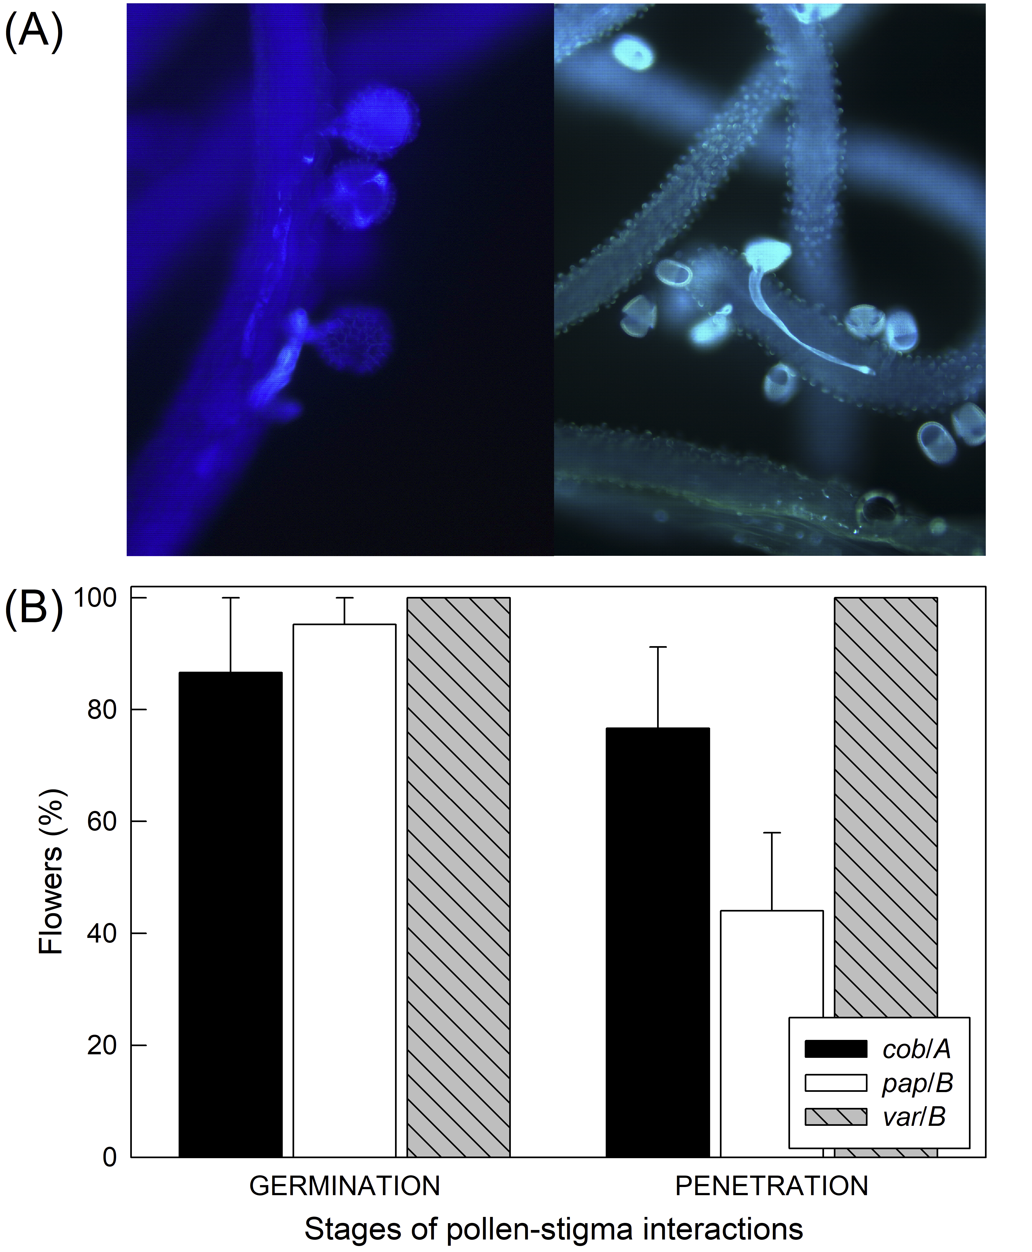
Figure S1. Pollen-stigma interactions within flowers of Limonium lobatum. Previous studies demonstrated that an incompatibility system prevents the germination of pollen grains or, if pollen grains germinate, the penetration of the stigmatic surfaces by the pollen tubes in plants with cob stigmas and A pollen (cob|A) and plants with pap stigmas and B pollen (pap|B; Fig. 1[5, 6]). (A) Pictures of A pollen on cob stigmas (left panel) and B pollen on pap stigmas (right panel). (B) Stages of pollen-stigma interactions: mean values and standard errors of relative number of self-pollinated flowers per plant with germinated pollen grains (GERMINATION) and pollen tubes that have penetrated the stigmatic surfaces (PENETRATION).
Figure S2. Comparison of seed set after self- and cross-pollinations among plants with previously undescribed (var|A and var|B) vs. typical stigma-pollen combinations subdivided into combinations previously described as SC (pap|A and cob|B) and SI (cob|A and pap|B). Abbreviations: SELF_{AUTO}, autonomous selfing; SELF_{GEITO}, geitonogamous selfing; and CROSS, cross-pollination. Significance levels: *P < 0.05, °P = 0.056 and ns P > 0.056. Sequential Bonferroni correction was used to account for multiple tests. Error bars denote standard errors, SE. For definitions of stigma and pollen traits, see Table 1.

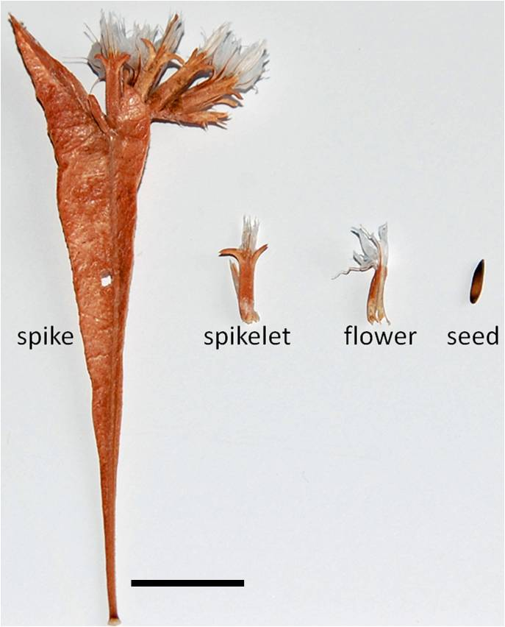
Figure S3. Inflorescence structure in Limonium lobatum. From left to right: a spike comprises 6-12 spikelets; a spikelet comprises two to three flowers; a flower comprises a single ovule and produces one seed. Scale bar = 1 cm (see also species description by Brullo & Erben [7]).
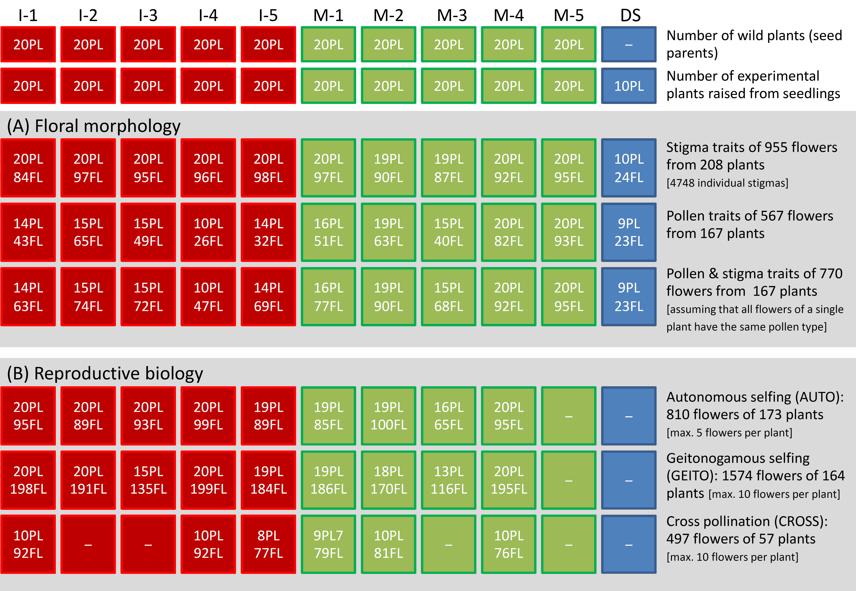
Figure S4. Sampling and experimental design used to study the (A) floral morphology and (B) reproductive biology of Limonium lobatum in five populations from the Canary Islands (I-1 to I-5), five populations from the Iberian mainland (M-1to M-5), and one population from the Dead Sea (DS). Abbreviations: PL, plant; FL, flower; −, no data available; and abbreviations of populations as reported in legend of Fig. 2.
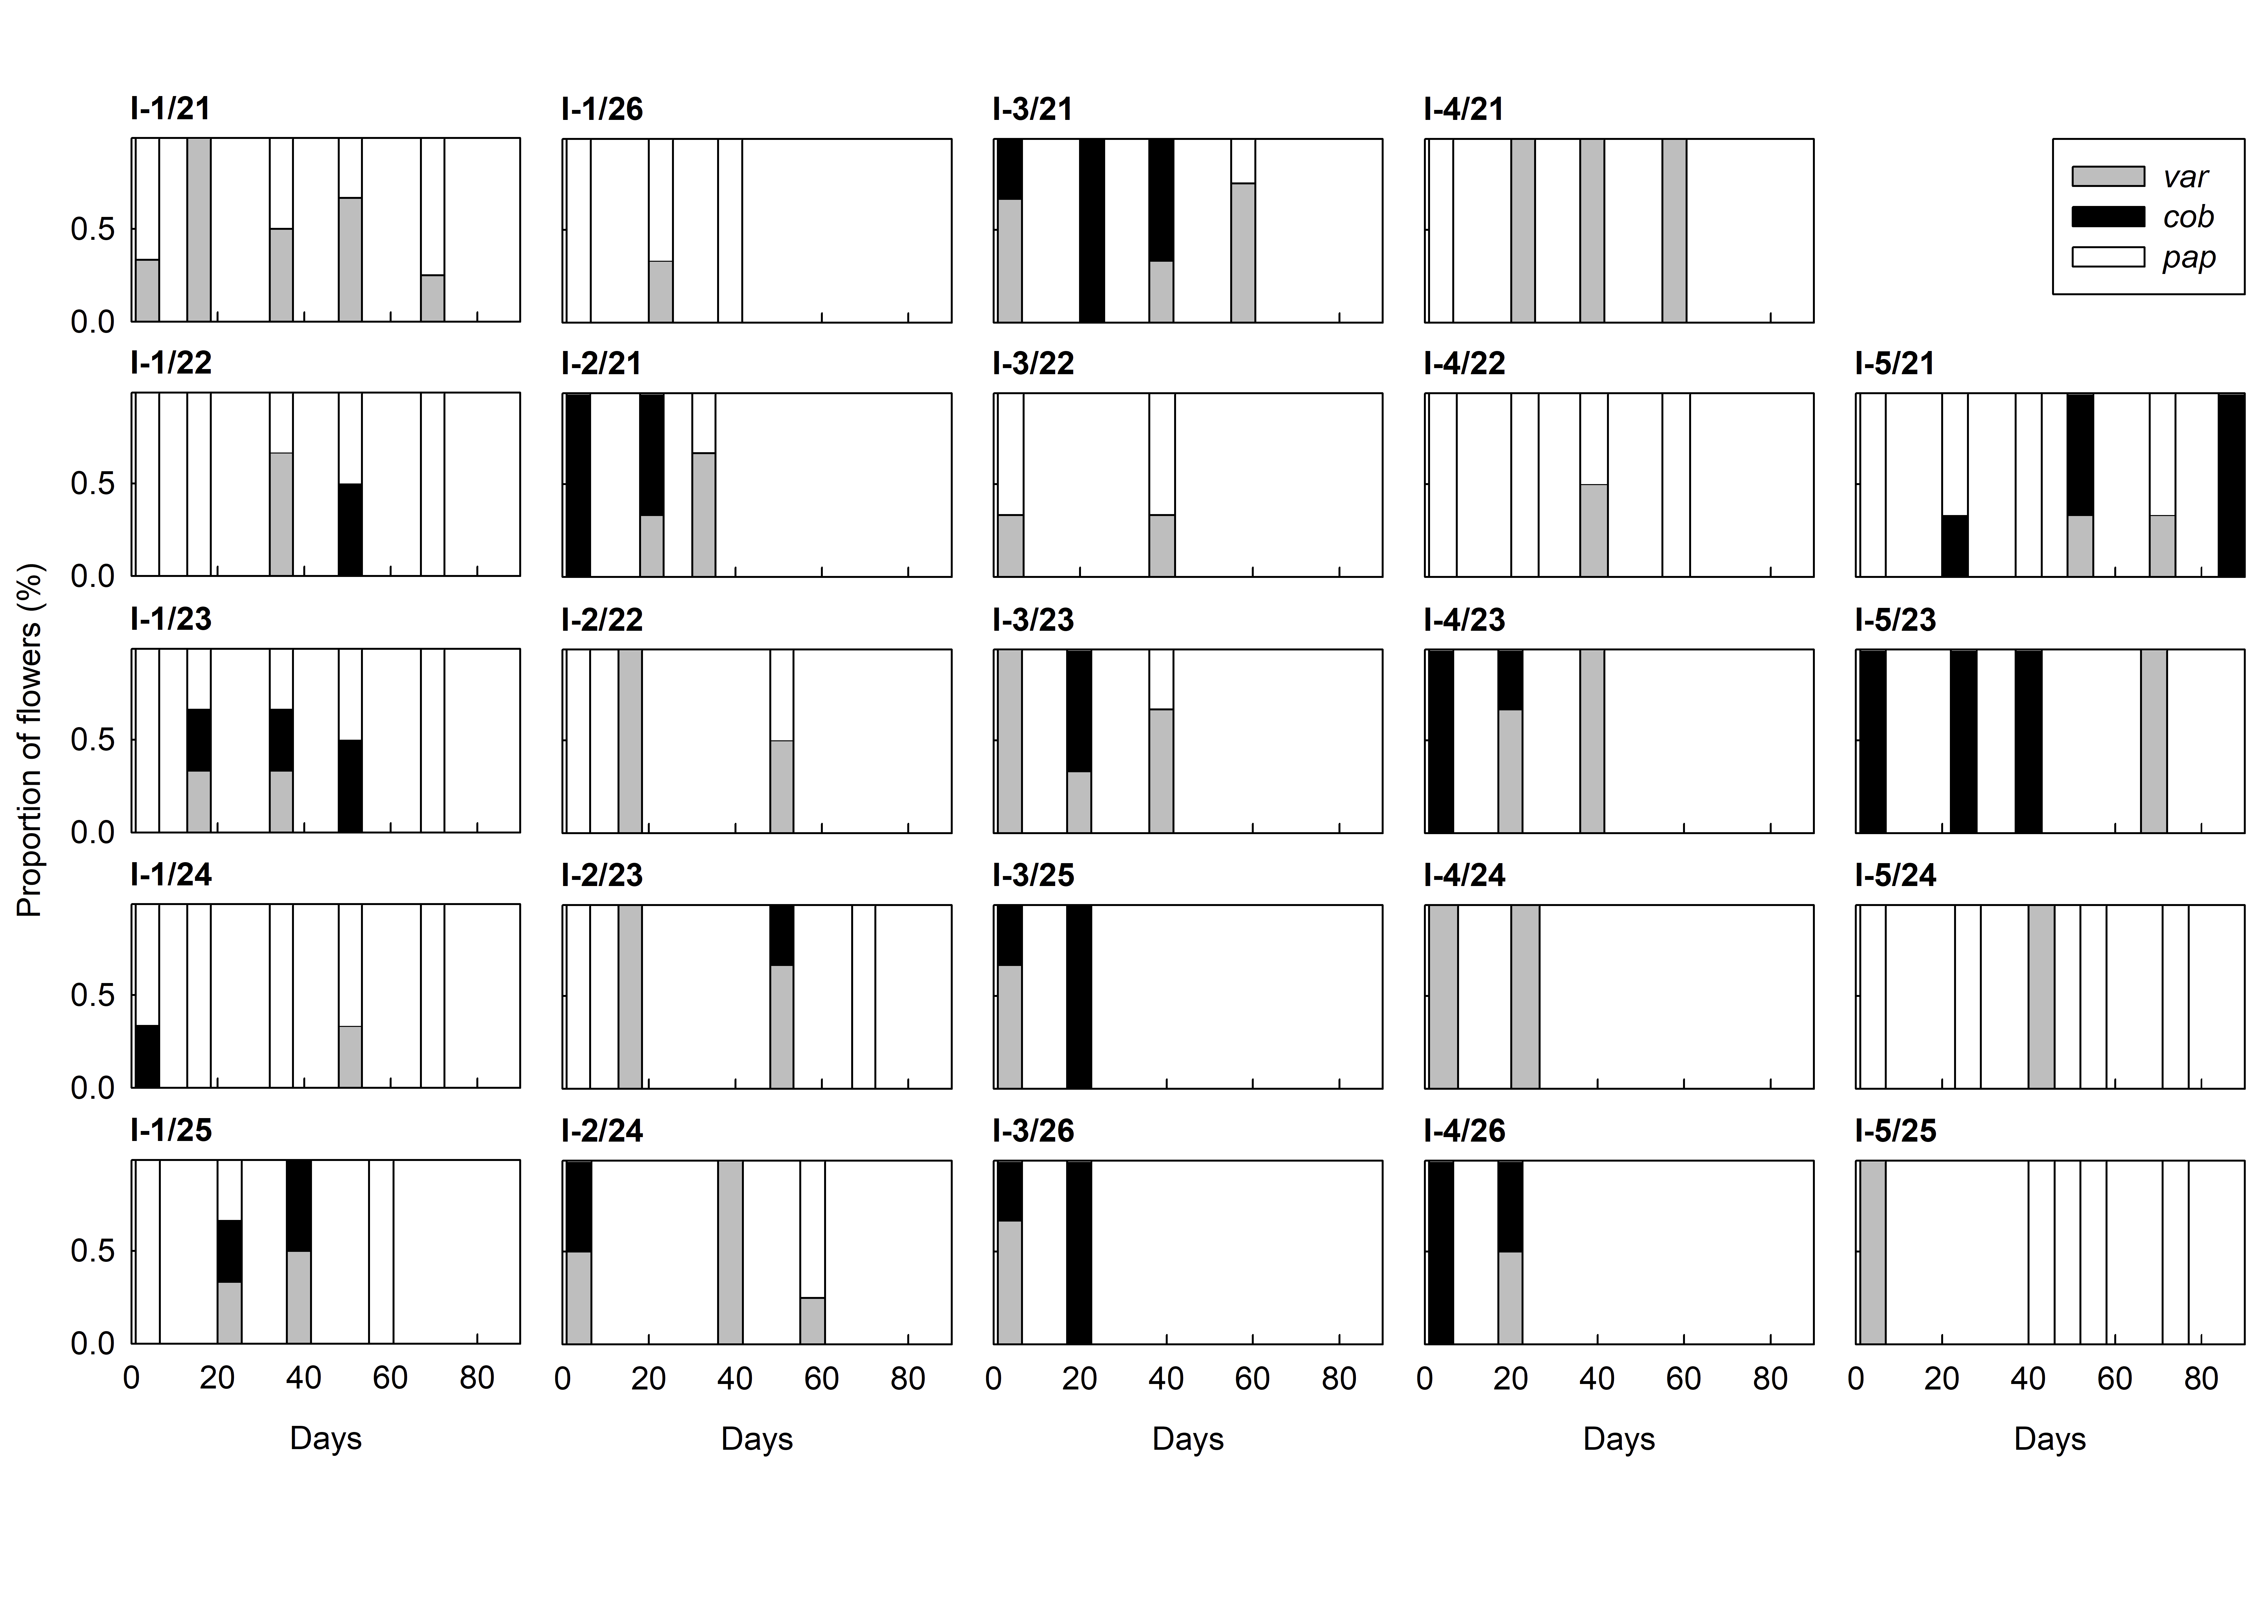
Figure S5. Temporal variation of stigma traits of individual island plants of Limonium lobatum. Abbreviations: pap = all stigmas of a flower with uniform protruding stigmatic papillae cells; cob = all stigmas of a flower with uniformly flat stigmatic papillae cells, var = either all stigmas of a flower with variable shapes of papillae cells or at least one stigma different from the others (see also Table 1). Abbreviations of populations as reported in legend of Fig. 2.

SUPPORTING TABLES
Table S1. Populations of Limonium lobatum from the Canary Islands (I) and the Iberian mainland (M) analysed in this study. Voucher specimens were deposited at the herbarium of Z, Zürich, Switzerland.
Population abbreviation | Location | Coordinates | Altitude  (m.a.s.l.) | Collectors | Collector number | Herbarium  voucher
I-1 | Antigua | 28° 22' 39.4'' N  13° 58' 46.2'' W | 171 | A. Jiménez,  A. Santos-Guerra | AJ 258 | Z-000227005
I-2 | Betancuria | 28° 24' 04.1'' N  14° 03' 45.4'' W | 320 | A. Jiménez,  A. Santos-Guerra | AJ 259 | Z-000227004
I-3 | Tarajalejo | 28° 14' 12.3'' N  14° 05' 14.9'' W | 71 | A. Jiménez,  A. Santos-Guerra | AJ 260 | Z-000227006
I-4 | Esquinzo | 28° 04' 47.2'' N  14° 17' 56.3'' W | 30 | A. Jiménez,  A. Santos-Guerra | AJ 261 | Z-000227018
I-5 | El Viso | 28° 10' 13.4'' N  16° 28' 59.8'' W | 425 | A. Jiménez | AJ 272 | Z-000227016
M-1 | Castillo de Macenas | 37º 04' 45.0'' N  01º 51' 03.8'' W | 8 | A. Jiménez | AJ 218 | Z-000227012
M-2 | Tabernas | 37º 1' 17.6'' N  02º 25' 51.5'' W | 323 | A. Jiménez | AJ 221 | Z-000227013
M-3 | Cala Blanca | 37º 29' 01.3'' N  01º 27' 47.7'' W | 4 | A. Jiménez | AJ 211 | Z-000227011
M-4 | Los Cocedores | 37º 22' 34.7'' N  01º 37' 43.3'' W | 9 | A. Jiménez | AJ 215 | Z-000227002
M-5 | Los Nietos | 37º 39' 28.2'' N  0º 48' 08.8'' W | 9 | A. Jiménez | AJ 209 | Z-000227015

Table S2. Results of generalized linear mixed effects models (GLMMs) and contrasts, testing whether seed-set differed among pollination treatments (autonomous selfing, geitonogamous selfing, and cross-pollination) and (A) plant types (PREV. UNDESCRIBED vs. TYPICAL, subdivided into stigma-pollen combinations previously described as self-incompatible (cob|A & pap|B) and self-compatible (cob|B & pap|A) and (B) location (island and mainland). (A) on 2646 flowers of 158 plants (70 PREV. UNDESCRIBED and 88 TYPICAL) and (B) based on 2881 flowers of 174 plants.

 | Source | F | d.f. | P | Contrasts | (test statistics, t; adjusted p-values)
(A) | Plant type (P) | 0.392 | 2, 181 | 0.676
 | Treatment (T) | 17.256 | 2, 2637 | <0.001
 | P × T | 7.171 | 4, 2637 | <0.001 |  | SELF_{AUTO} | SELF_{GEITO} | CROSS
 | TYPICAL, prev. described as SI vs. SC |  |  |  |  | -0.080; 1.000 | 0.370; 0.712 | 0.688; 0.492
 | PREV. UNDESCR. vs. TYPICAL, prev. described as SI |  |  |  |  | 0.714; 1.000 | 2.213; 0.056 | -2.571; 0.029
 | PREV. UNDESCR. vs. TYPICAL, prev. described as SC |  |  |  |  | 0.661; 1.000 | 2.701; 0.023 | -2.599; 0.029
(B) | Location (L) | 1.889 | 1, 208 | 0.171
 | Treatment (T) | 25.982 | 2, 2875 | <0.001
 | L × T | 22.822 | 2, 2875 | <0.001 |  | SELF_{AUTO} | SELF_{GEITO} | CROSS
 |  |  |  | island vs. mainland |  | 1.827; 0.068 | 2.601; 0.010 | -4.705; <0.001
SI, self-incompatible, SC, self-compatible, SELF_{AUTO}, autonomous selfing; SELF_{GEITO}, geitonogamous selfing; CROSS, cross pollination.

Table S3. Raw data of pollen and stigma traits - see Excel table.
Table S4. Raw data of pollination experiment: selfed vs. outcrossed seed-set- see Excel table.

References
1. Diggle PK: Modularity and intra-floral integration in metameric organisms: plants are more than the sum of their parts. Philosophical Transactions of the Royal Society B: Biological Sciences 2014, 369(1649).
2. Harder LD, Strelin MM, Clocher IC, Kulbaba MW, Aizen MA: The dynamic mosaic phenotypes of flowering plants. New Phytol 2019, 224(3):1021-1034.
3. Lloyd DG: Self- and Cross-Fertilization in Plants. II. The Selection of Self- Fertilization. Int J Plant Sci 1992, 153(3):370-380.
4. Kalisz S, Vogler DW, Hanley KM: Context-dependent autonomous self-fertilization yields reproductive assurance and mixed mating. Nature 2004, 430(7002):884-887.
5. Baker HG: Dimorphism and monomorphism in the Plumbaginaceae: II. pollen and stigmata in the genus Limonium. Ann Bot 1953, 17(67):433-445.
6. Erben M: Karyotype differentiation and its consequences in Mediterranean Limonium. Webbia 1979, 4(1):409-417.
7. Brullo S, Erben M: The genus Limonium (Plumbaginaceae) in Greece. Phytotaxa 2016, 240(1):1.

