Table 1 (next page). Definitions of typical and previously undescribed female and male reproductive structures in Limonium lobatum: (A) shape and arrangement of stigmatic papillae and structure of pollen exine within flowers; (B) stigma-pollen combinations in hierarchical levels ranging from intra-flower to inter-population with corresponding drawings. Absence of cross lines along stigmas indicates flat (cob) papillae; solid cross lines along stigmas indicate protruding (pap) papillae; dashed cross lines indicate intermediate or variable shapes of papillae cells (var); filled symbols for anthers represent A pollen; empty symbols for anthers represent B pollen.
(A) | Reproductive organ type | Stigma/pollen  traits | Typical  (previously described)* | Described in this study  (previously undescribed)
 | Gynoecium | Shape of individual papillae | - flat (cob papillae)  - protruding (pap papillae)  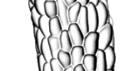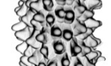  cob papillae pap papillae | - intermediate shapes between flat and protruding (int papillae)  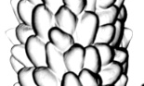  int papillae
 |  | Shapes of papillae along a single stigma | - all flat (cob stigma)  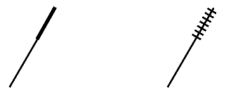  - all protruding (pap stigma)  cob pap var  stigma stigma stigma | - flat, protruding, and intermediate (var stigma)
 |  | Shapes of papillae among all stigmas of a flower | - all flat (cob gynoecium)  - all protruding (pap gynoecium)  cob pap  gynoecium gynoecium | - all stigmas of a gynoecium var or at least one stigma different from the others (var gynoecium)  var  gynoecium
 | Androecium | Exine structure of pollen grains | - coarse (A pollen)  - fine (B pollen)  A pollen B pollen | - none
(B) | Stigma-pollen combinations |  | Typical  (previously described)* | Described in this study  (previously undescribed)
 | Flower types |  | - cob|A, pap|B, cob|B, pap|A flowers  cob|A flower pap|A flower var|A flowers  cob|B flower pap|B flower var|B flowers | - var|A and var|B flowers
continued

Table 1. Continued
 | Stigma-pollen combinations |  | Typical  (previously described)* | Described in this study  (previously undescribed)
 | Plant types |  | - all flowers of a plant typical: cob|A, pap|B, cob|B, pap|A plants  cob|A pap|A var|A  plant plant plant  cob|B pap|B var|B  plant plant plant  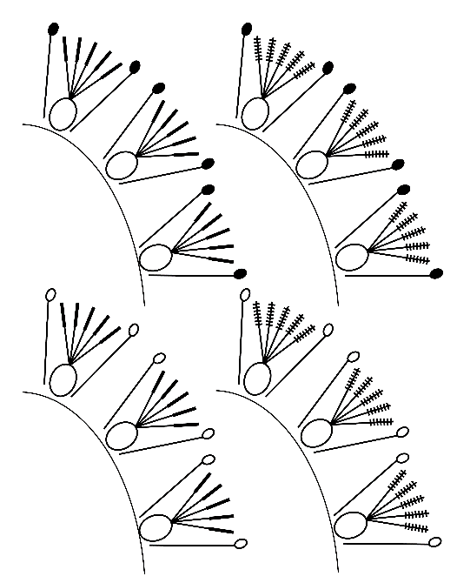 | - all flowers of a plant with var gynoecia or at least one flower different from the others: var|A and var|B plants
 | Population types |  | - Typical dimorphic populations with both cob|A and pap|B plants  - Typical monomorphic populations consisting entirely of either cob|A, pap|B, cob|B, or pap|A plants | - Previously undescribed di- or polymorphic populations with at least some var|A and/or var|B plants  - Previously undescribed type of monomorphic populations with all plants either var|A or var|B
 | Species |  | - Typical SI sexual species: all populations dimorphic with roughly equal ratios of cob|A and pap|B plants; pollen grains uniform  - Typical SC sexual species: all populations monomorphic with either pap|A or cob|B plants; pollen grains uniform  - Typical apomictic species: populations monomorphic with either cob|A, pap|B, pap|A or cob|B plants and/or dimorphic with cob|A and pap|B plants; pollen grains variable with misshaped forms and irregular sizes or absent. | - Previously undescribed type of species comprising mono-di- and polymorphic populations with previously undescribed and typical plant types; pollen grains uniform (Limonium lobatum)
SI, self-incompatible; SC, self-compatible; cob|A, pap|B, cob|B, and pap|A are also known as combination A, B, C, and D, respectively [35]; *, morphologies previously described in dimorphic SI sexual, monomorphic SC sexual, and (facultative) apomictic species of Limonioideae subfamily of Plumbaginaceae.

