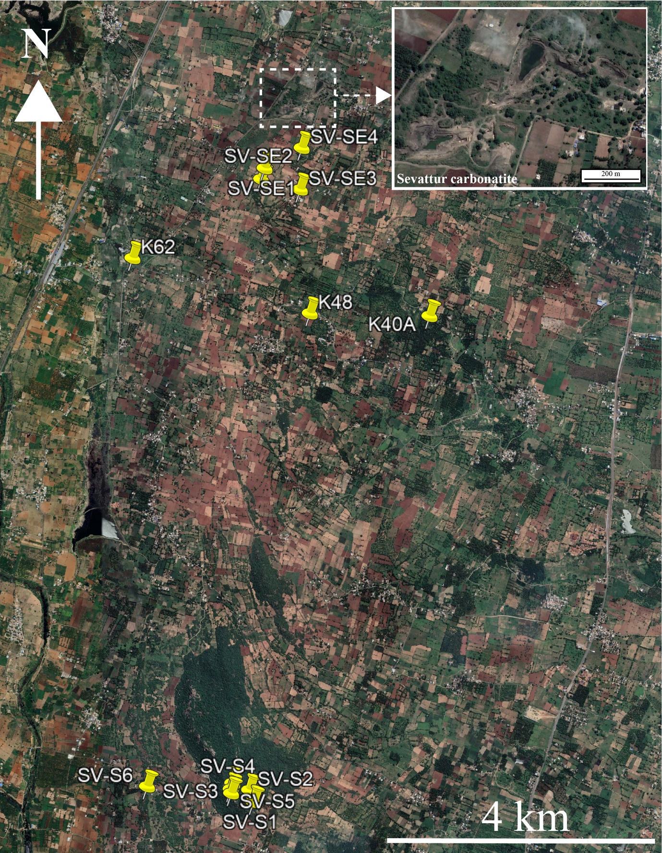

Supplementary Fig. Sample locations of silicate rocks within the Sevattur alkaline carbonatite complex are marked in the google earth image. Please refer to the inset google earth image of vermiculite mine located near Sevattur village, where the majority of carbonatites are exposed in the surroundings.

Supplementary Table: Sample locations of silicate rocks at Sevattur alkaline carbonatite complex.
Sr. No | Sample No | Rock type | Location
1 | SVS1 | Monzonite | 12°22'9.35''N; 78°31'23.23''E
2 | SVS2 | Monzonite | 12°22'12.44''N; 78°31'22.14''E
3 | SVS3 | Monzonite | 12°22'14.25''N; 78°31'17.64''E
4 | SVS4 | Monzonite | 12°22'12.68''N; 78°31'17.21"E
5 | SVS5 | Monzonite with ultramafic enclave | 12°22'14.09"N; 78°31'18.64"E
6 | SVS6 | Syenite | 12°22'14.18"N; 78°30'56.42"E
7 | SVSE1 | Syenite | 12°24'54.53"N; 78°31'26.35"E
8 | SVSE2 | Syenite | 12°24"51.70"N; 78°31"25.41"E
9 | SVSE3 | Monzonite | 12°24'59.00"N; 78°31'35.77"E
10 | SVSE4 | Monzodiorite | 12°24'59.86"N; 78°31'36.23"E
11 | K40A | Syenite | 12°24'16.15"N; 78°31"40.55"E
12 | K48 | Monzodiorite | 12°24'16.79"N; 78°31'38.39"E
13 | K64 | Albitite | 12°25'02.00"N; 78°31'26.17"E
14 | K62 | Granite | 12°24'31.22"N ;78°30'51.01"E

