Article title: Multiparametric MR characterization for human epithelial growth factor receptor 2 expression in bladder cancer: an exploratory study
Journal name: Journal of Cancer Research and Clinical Oncology
Author names: Lingmin Kong, Jian Ling, Wenxin Cao, Zhihua Wen, Yingyu Lin, Qian Cai, Yanling Chen, Yan Guo, Junxing Chen, Huanjun Wang
Affiliation: The First Affiliated Hospital, Sun Yat-Sen University, 58 Zhongshan Road 2, Guangzhou, Guangdong, PR China
E-mail address of the corresponding author: junxingchen@hotmail.com; wanghj45@mail.sysu.edu.cn
Supplementary table 1: Imaging Parameters of Major Sequences.
 | T1WI | T2WI | Synthetic MRI | DWI
Sequences | FSE | PROPELLER | MDME | SE-EPI
Orientation | Axial | Axial, coronal, sagittal | Axial | Axial
TR (ms) | 758 | 4817/4719/5845 | 4000 | 3904
TE (ms) | 12 | 125.7/112.9/119.1 | 15.9 | NA
Flip angle | 111 | 110/110/110 | NA | NA
FOV (mm) | 220 | 220/240/220 | 220 | 220
Matrix | 352×320 | 320/384/384 | 320×256 | 128×128
NEX | 2 | 3/2.5/2.5 | 1 | 1
Slice thickness | 4 | 4/4/3.5 | 4 | 4
Slice gap | 1 | 1/1/0.6 | 1 | 1
T1WI = T1 weighted imaging; T2WI = T2 weighted imaging; DWI = diffusion weighted imaging; TR = repetition time; TE = echo time; FOV = field of view; NEX = number of excitations; FSE = fast Spin echo; MDME = multidelay multiecho; SE-EPI = Single-shot echo-planar imaging.

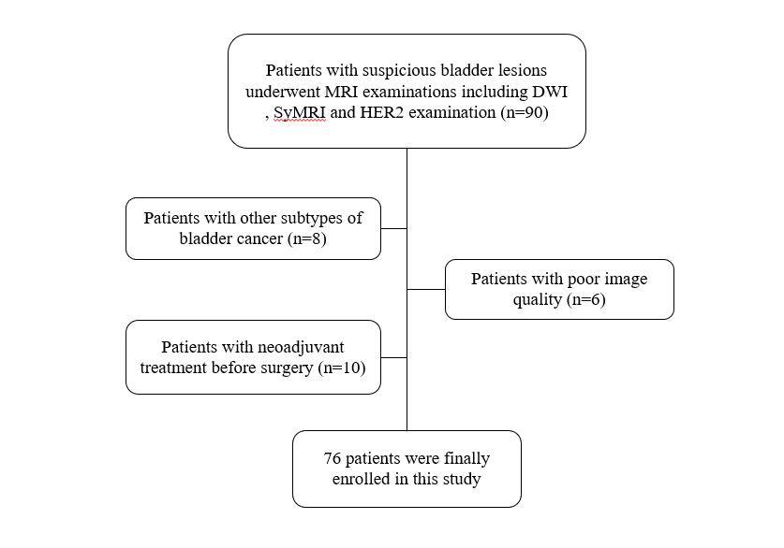
Supplementary figure 1: Flowchart showing the participant selection process in the present study.
DWI=diffusion weighted imaging; SyMRI=Synthetic MRI; HER2=Human epidermal growth factor receptor 2.

Supplementary figure 2: An example of ROI delineation. (a) The original synthetic T2-weighted image; (b) a ROI on the synthetic T2-weighted image (marked in red); (c) the obtained delineation; (d) the original ADC map; (e) a ROI on the ADC map (marked in red); (f) the obtained delineation.

