Supplementary Information for
Strain to shine: stretching-induced three-dimensional colloidal lattice transformations and optical transitions
Tong An¹, Xinyu Jiang¹, Feng Gao¹, Christian Schäfer², Junjun Qiu¹, Nan Shi¹, Xiaokun Song¹, Manyao Zhang¹, Chris E. Finlayson³, Xuezhi Zheng⁴, Xiuhong Li⁵, Feng Tian⁵, Bin Zhu⁶, Tan Sui⁶, Xianhong Han⁷, Jeremy J. Baumberg^{8*}, Tongxiang Fan^{1*}, Qibin Zhao^{1*}
- State Key Lab of Metal Matrix Composites, School of Materials Science and Engineering, Shanghai Jiao Tong University, Shanghai, 200240, China
- BASF SE, Dispersions & Resins, Carl-Bosch-Strasse 38, Ludwigshafen/Rhein, 67056, Germany
- Department of Physics, Prifysgol Aberystwyth University, Wales SY23 3BZ, UK
- Department of Electrical Engineering, KU Leuven, Leuven, B3001, Belgium
- Shanghai Synchrotron Radiation Facility, Shanghai, 201204, China
- School of Mechanical Engineering Sciences, University of Surrey, Guildford, GU2 7XH, UK
- Institute of Forming Technology and Equipment, School of Materials Science and Engineering, Shanghai Jiao Tong University, Shanghai, 200240, China
- Department of Physics, University of Cambridge, JJ Thomson Ave, Cambridge, CB3 0HE

*Qibin Zhao
Email: zhaoqibin@sjtu.edu.cn
*Tongxiang Fan
Email: txfan@sjtu.edu.cn
*Jeremy J. Baumberg
Email: jjb12@cam.ac.uk

This PDF file includes:

Supporting Figures S1 to S9

Supporting Discussions 1&2

Supporting Reference

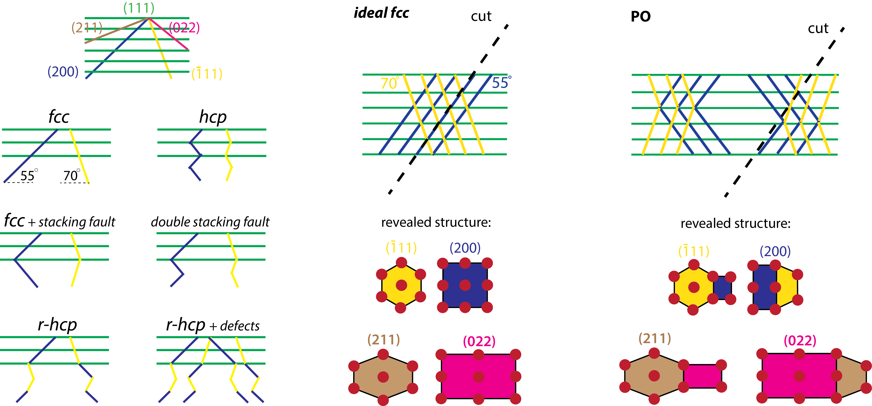
Figure S1. Illustrations depict the orientations of tilted planes across various close-packed structures, alongside structures revealed when POs are sectioned based on the specific tilting angles of these planes.
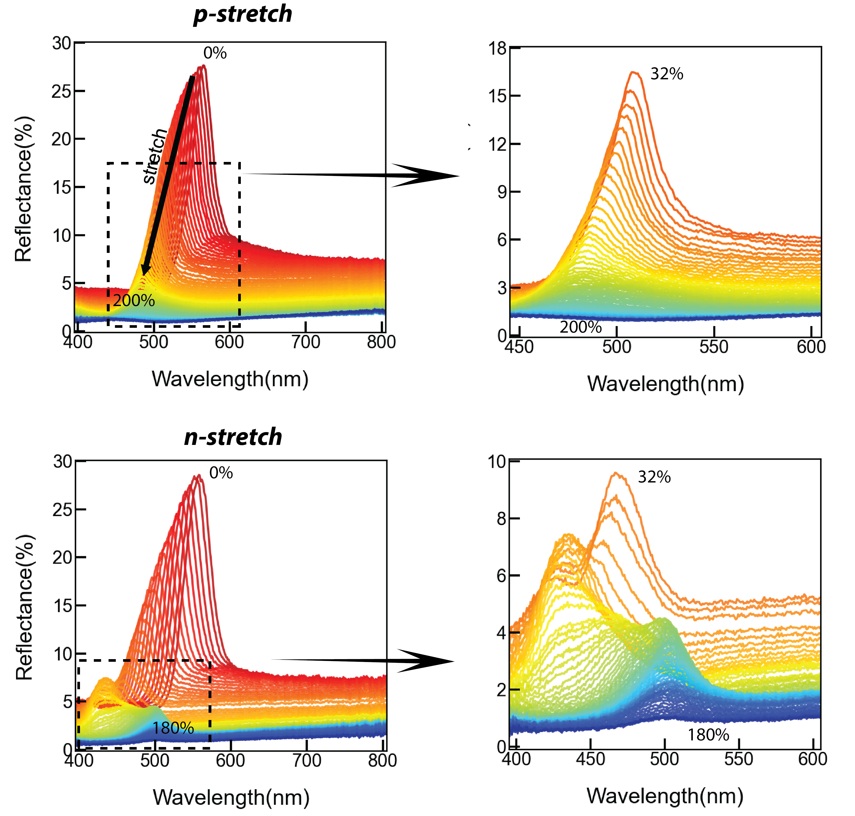
Figure S2. Brightfield reflectance spectra of p- and n-stretched POs at normal incidence.
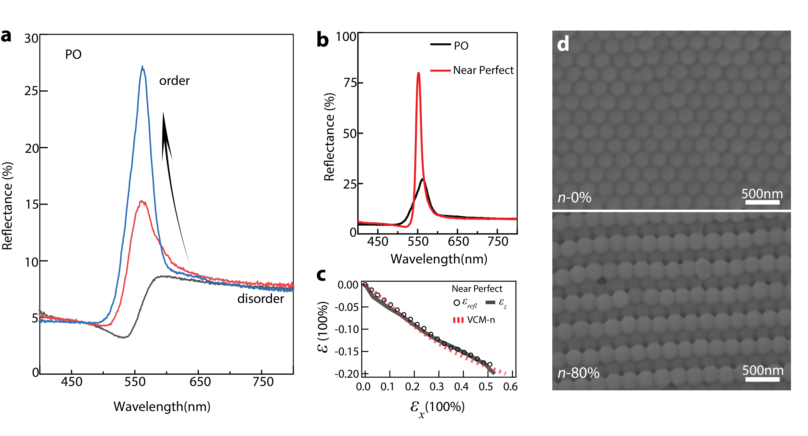
Figure S3. Influence of structural order on reflection peak wavelength and strain induced by stretching. a, Reflectance spectra of POs under normal incidence with increasing structural order, captured using a 5X objective in brightfield mode; a noticeable blueshift emerges as structural order improves. b, Reflectance spectra comparison between a well-ordered PO and a novel elastic opal that we developed recently with PS-polyacrylates; this new elastic opal displays exceptional optical characteristics due to its near-perfect structural order. c, Optical strain shifts $ε_{refl}$ and thickness strains $ε_{z}$ for the newly developed elastic opal under n-stretching conditions; results align remarkably with VCM model predictions. This eliminates observed discrepancies in POs, suggesting that these discrepancies mainly arise from structural disorder. d, SEM images of the new elastic opal pre- and post-n-stretching, illustrating a markedly superior structural order relative to POs.
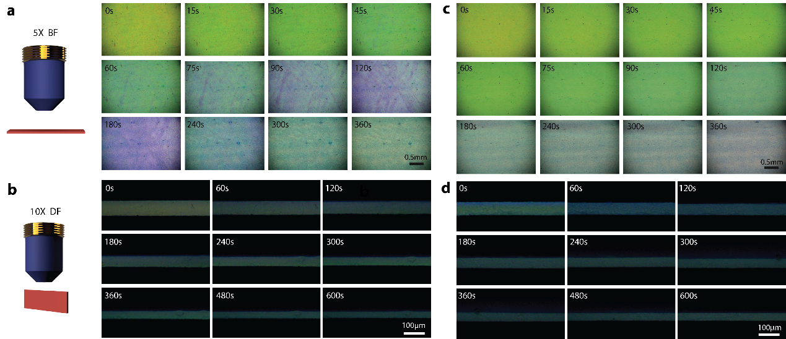
Figure S4. In-situ microscopic imaging of POs during stretching at a consistent rate of 0.1mm/s. a, Surface view of PO under normal incidence during n-stretching. b, Cross-sectional thickness view of PO during n-stretching. c, Surface view of PO under normal incidence during p-stretching. d, Cross-sectional thickness view of PO during p-stretching.
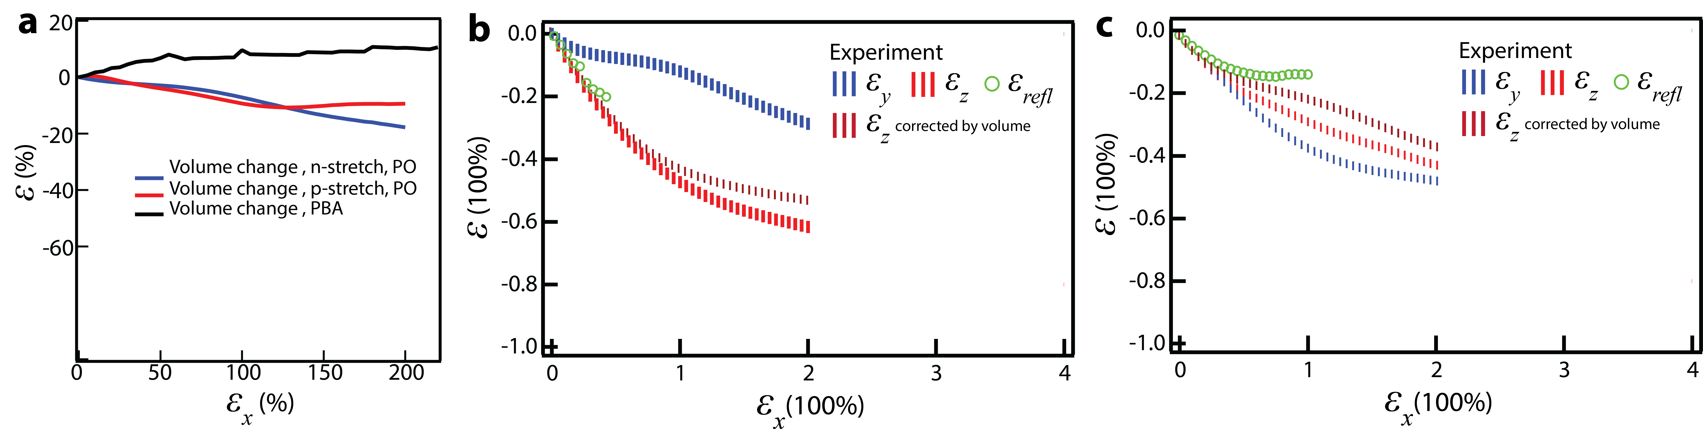
Figure S5. Analysis of experimental errors in strain measurements. a, Computed volume alterations in POs and PBA during n- and p-stretching using the measured values of $ε_{x}$, $ε_{y}$ and $ε_{z}$. b, Adjustment of thickness strain based on volume fluctuations in n-stretching. c, Adjustment of thickness strain considering volume fluctuations during p-stretching. It's pertinent to note that minor deviations in microscopic strain evaluations are inherent, especially given the extensive stretching strains employed. While the total material volume may exhibit slight variations during stretching due to numerous factors^{1,2}, for this analysis, we consider the most stringent scenario where these volume changes are entirely attributed to experimental inaccuracies. In practice, errors might be present in both width strain $ε_{y}$ and thickness strain $ε_{z}$, with $ε_{z}$ typically posing more challenges in accurate measurement. In a conservative assessment, we assume all discrepancies lie in $ε_{z}$, and subsequently adjust the measured $ε_{z}$ using the calculated volume changes. The results detailed in Fig S3b&c remain consistent with our primary conclusions.

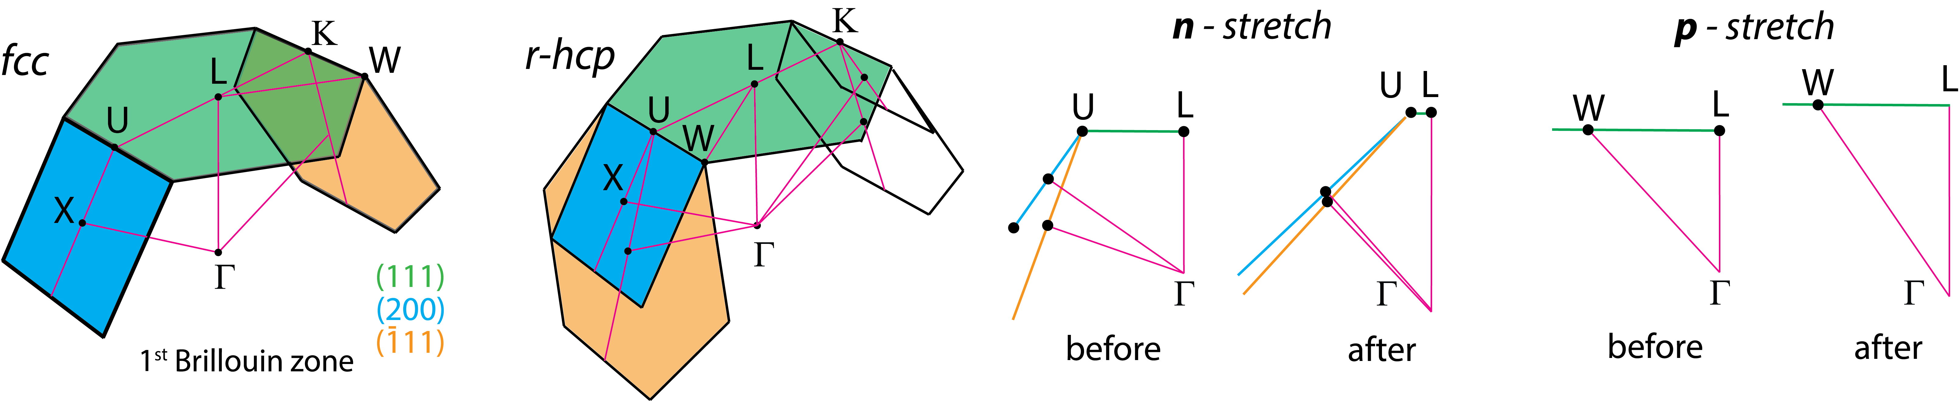
Figure S6. The 1st Brillouin zone of PO’s r-hcp lattice. The illustration depicts the 1st Brillouin zone of the r-hcp lattice of PO. Within the manuscript, references to light incidence along the n-direction at varied angles correspond to a trajectory spanning Γ-L-U-X. Similarly, incidences along the p-direction are associated with the Γ-L-K-W.

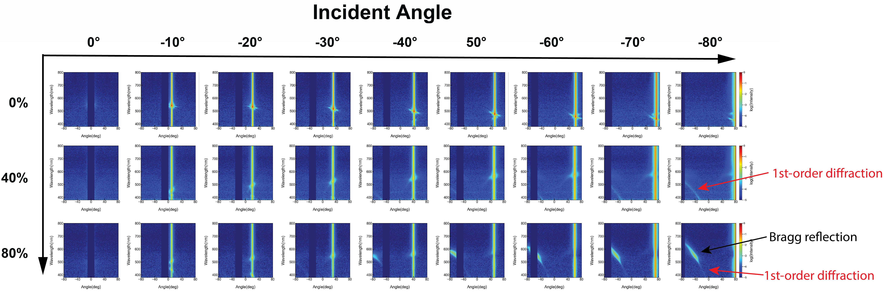
Figure S7. Angular scattering spectra of n-stretched elastic opals with near-perfect structural order. The spectra reveal a precise overlap between the 1st-order diffraction of the incident light and the retro-Bragg reflection emanating from tilted planes.
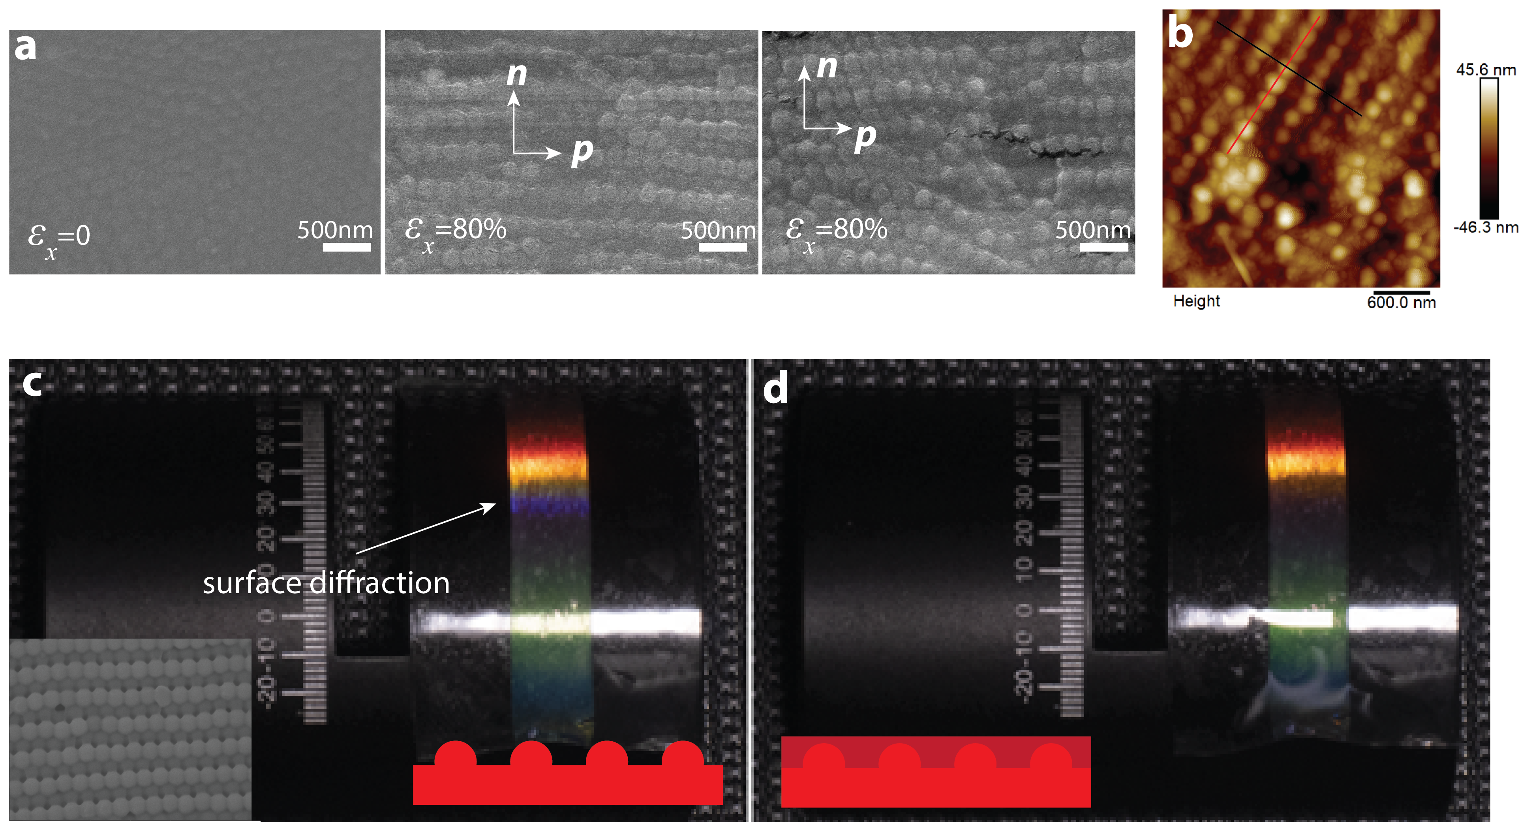
Figure S8. Removal of surface diffraction from retro-reflection colours. a, SEM images contrasting the surfaces of unstretched and n-stretched POs. Before stretching, the PS spheres are largely encapsulated in PEA, yielding a smooth surface. b, AFM depiction of a surface after 80% n-stretching in POs. This shows a sphere 'pop-up' phenomenon, with an average elevation of roughly 40nm. c, Left, our new elastic opal using PS-polyacrylates post 80% n-stretching. One side is bonded to a VHB substrate and positioned on a cylinder, with the opposing surface open to the atmosphere. The polyacrylate matrix marginally weakens the bond between the sphere and the matrix, leading to a significant increase in the 'pop-up' height of spheres, as illustrated in the inset SEM image. This alteration amplifies the surface diffraction effect, as indicated by its blue hue. The primary (111) Bragg reflection wavelength of the specimen is ~600nm before stretching. Following 80% n-stretching, it exhibits vibrant mixed retro-reflection hues resulting from both diffraction and Bragg reflection. d, A view of the sample's hue when its surface is submerged in dimethicone, which has a refractive index nearing 1.5—matching the sample's mean index of 1.53. While submersion in dimethicone largely negates surface diffraction, the retro-reflection is undisturbed.
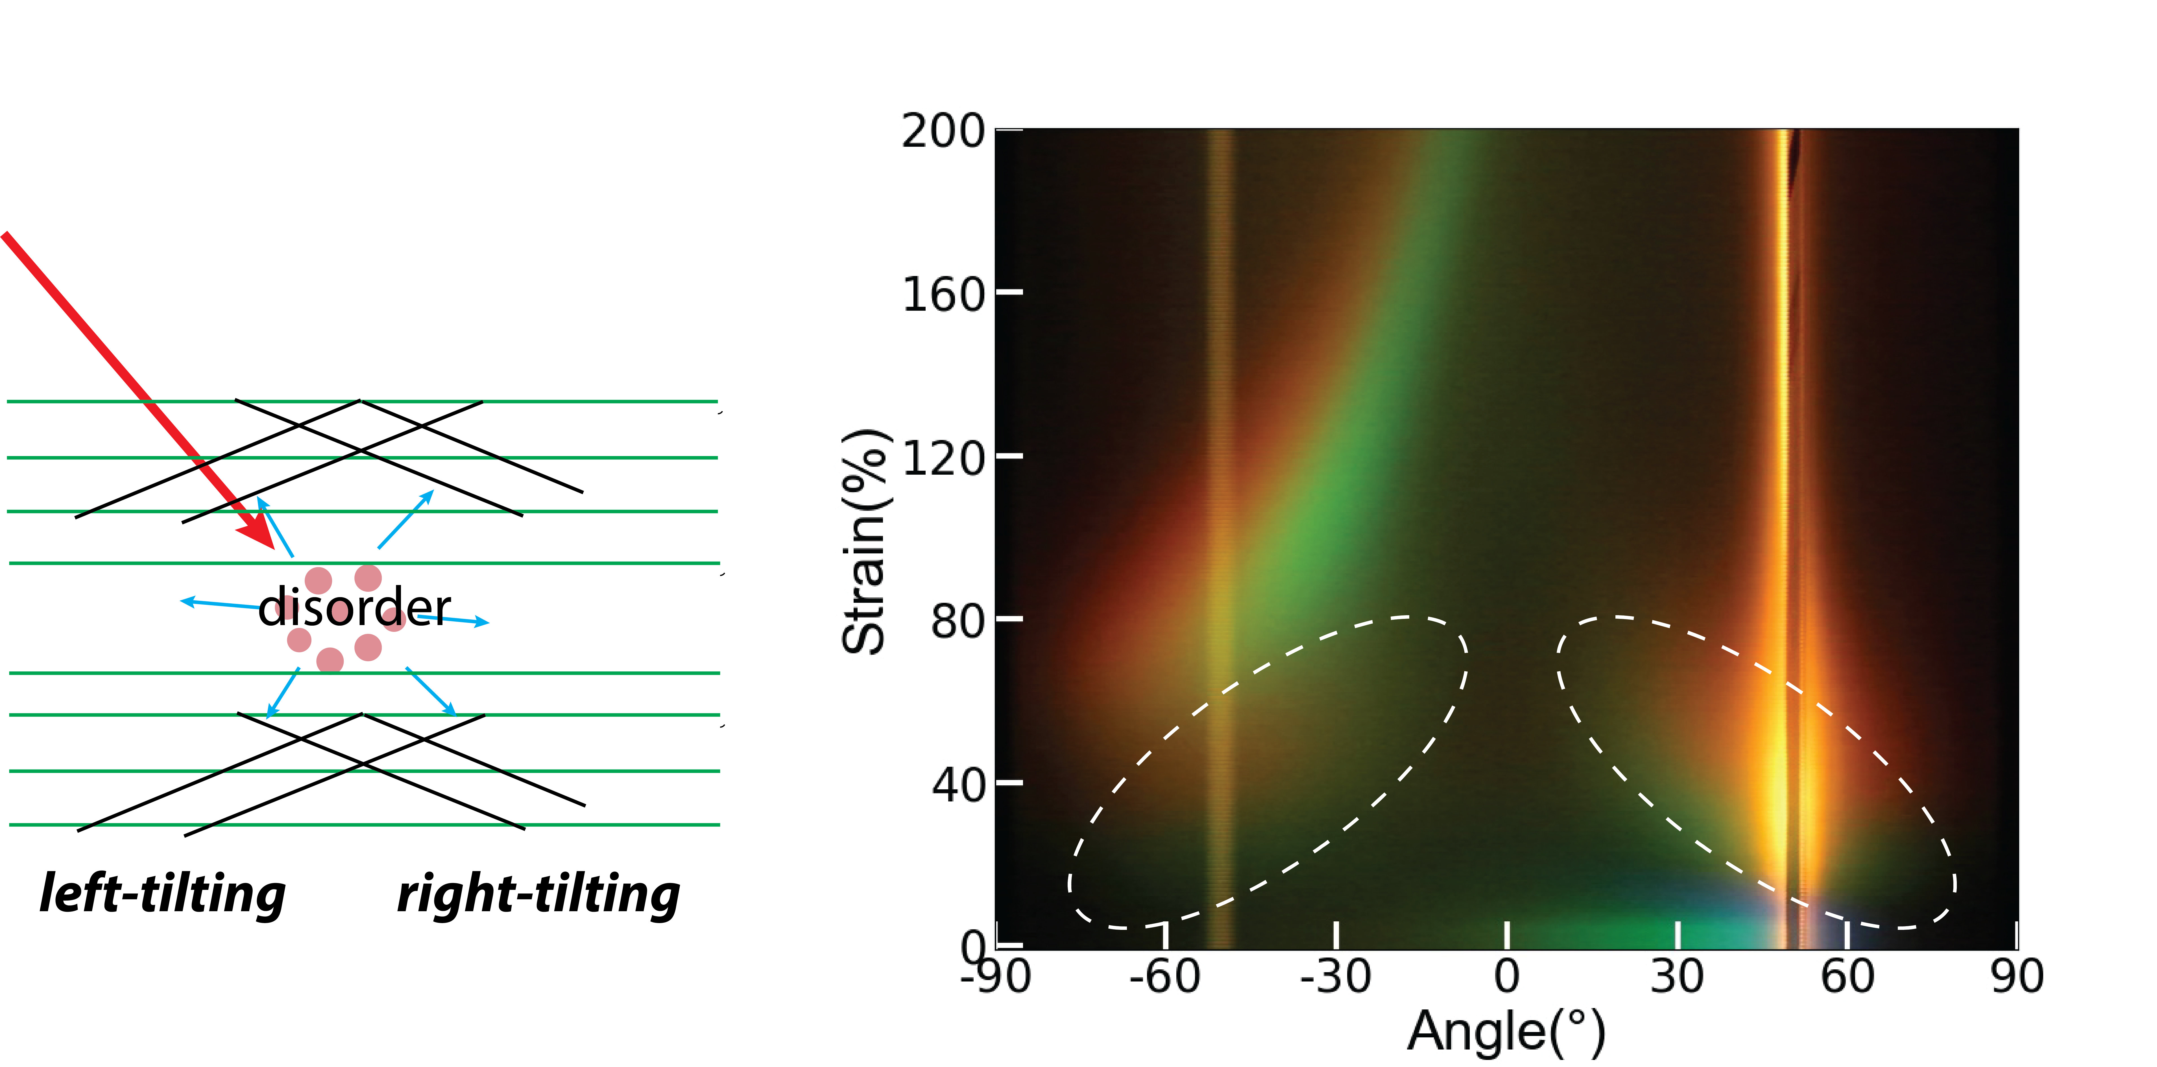
Figure S9. Structural disorder induced scattering colours in n-stretching. Structural disorder within POs, exacerbated by stretching, leads to the scattering of incident light in diverse directions. This effect can be likened to having an internal light source embedded within the POs, reminiscent of the generation of Kossel lines. As a result, POs exhibit colours in retro-reflection, mirroring those observed in specular reflection.

Supporting Discussion 1. Bragg reflection coupled diffraction model
The light path is illustrated in Figure 4b. Diffraction of (111) gratings is decided by:
$n_{1}\left(\sin{φ_{1}}+\sin{θ_{d}}\right)=m\frac{λ}{q}$
where $n_{1}$ is the refractive index of air, $φ_{1}$is the incident angle, $θ_{d}$ is the diffraction angle, $m$ is diffraction order, λ is wavelength, and $q$ is the period of the sphere lines.
Refraction of incident light is decided by the Snell’s law:
$φ_{2}=\sin^{-1}{\frac{n_{1}}{n_{2}}\sin{φ_{1}}}$
Bragg reflection wavelength of the left tiling plane is:
$λ=2n_{2}d_{hkl}\cos{(θ-φ_{2})}$
For right-tilting plane is:
$λ=2n_{2}d_{hkl}\cos{(θ+φ_{2})}$
with $θ$ being the tilt angle.
The Bragg-reflected light from tilted planes reflects back to the sample surfaces at angles:
$ψ_{1}=2θ-φ_{2}$ for left tiling, and
$ψ_{1}=2θ+φ_{2}$ for right tilting.
The critical angle for refraction determined by Snell’s law is:
$ψ_{c}=\sin^{-1}{\frac{n_{1}}{n_{2}}}$
The $ψ_{1}$ for right tilting plane is always larger than $ψ_{c}$, thus no refraction occurs. For left titling planes, when $ψ_{1}<ψ_{c}$, angle of refracted light is:
$ψ_{2}=\sin^{-1}{\frac{n_{1}}{n_{2}}\sin{ψ_{1}}}$
Using the calculated Bragg reflection wavelength of the tilting planes in the diffraction equation for 1st-order diffraction:
$\sin{θ_{d}}=\frac{n_{2}}{n_{1}}\left[2\sin{θ}\cos\left(θ-φ_{2}\right)-\sin{φ_{2}}\right]=\frac{n_{2}}{n_{1}}\sin\left(2θ{-φ}_{2}\right)$
From this, $θ_{d}=ψ_{2}$, proving that the retro-Bragg reflection of tilted planes coincides with the 1st-order diffraction of incident light. Regardless of whether refraction takes place, the 1st-order diffraction of Bragg reflection from a tilted plane always exits the surface. Similarly, its exit angle $ψ_{e}= -φ_{1}$, proving that it is always along the specular reflection direction of the incident light. Angular reflection spectra for n-stretched samples were derived by integrating this optical model with strains, lattice distances, and tilting angles computed via the VCM.

Supporting Discussion 2. Optical transitions in p-stretching
During p-stretching, POs mainly display a shift in the (111) Bragg reflection when light is incident in the n-direction, with no other distinctive optical features. Notably, when light is incident in the p-direction, intriguing optical patterns emerge.
For context, we revisit the optical shifts observed in n-stretching: at 40% strain, the retro-Bragg reflection emerges from the inclined (200) and $(\overline{1}11)$ planes. This reflection coincides with the 1st-order diffraction of incident light from the (111) gratings characterised by a period set by the spacing between sphere lines.
According to predictions made by our VCM model and corroborated by TEM characterizations, in p-stretching, planes begin to incline towards the p-direction at around 40% strain. By 80% strain, the tilt angle of these planes matches that of the (200) and $(\overline{1}11)$ planes in the pristine lattice. if we consider a specimen strained to 80% as our reference and further stretch it by 40%, the anticipated emergence of retro-reflection, as per the BCD model, should manifest around 160% strain.
In experiment, the angular scattering colour imaging reveals two distinct colour transition bands (Extended Data Fig. 7b). The initial band, albeit faint, starts appearing at lower strains, its manifestation resembling the retro-reflection observed in POs during n-stretching. The subsequent, brighter band commences around the 160% strain mark. These dual transitions are corroborated by both the measured angular scattering and transmission spectra (Extended Data Fig. 7a&c).
We hypothesize that the initial, fainter band arises from reflections on structural anomalies, specifically where smaller sphere domains are oriented differently due to line defects. As evidenced in the TEM image (Extended Data Fig. 7e), these line defects modify the orientation of sphere packing locally from the p to n-direction. While the predominant orientation of sphere packing remains consistent, as indicated by the SAXS patterns, such imperfections are an inescapable presence. However, their optical signatures remain subdued due to their minimal occurrence. The second band aligns well with our projections, but the intensities of the observed hues are somewhat diminished compared to their n-stretching counterparts, likely due to the structural degradation observed post the 160% strain threshold.

Supporting Reference
1. White, R. P. & Lipson, J. E. G. Why Volume and Dynamics Decouple in Nanocomposite Matrices: Space that Cannot Be Accessed is Not Free. Phys Rev Lett 131, 018101 (2023).
2. Gilormini, P., Toulemonde, P. A., Diani, J. & Gardere, A. Stress-strain response and volume change of a highly filled rubbery composite: Experimental measurements and numerical simulations. Mechanics of Materials 111, 57–65 (2017).

