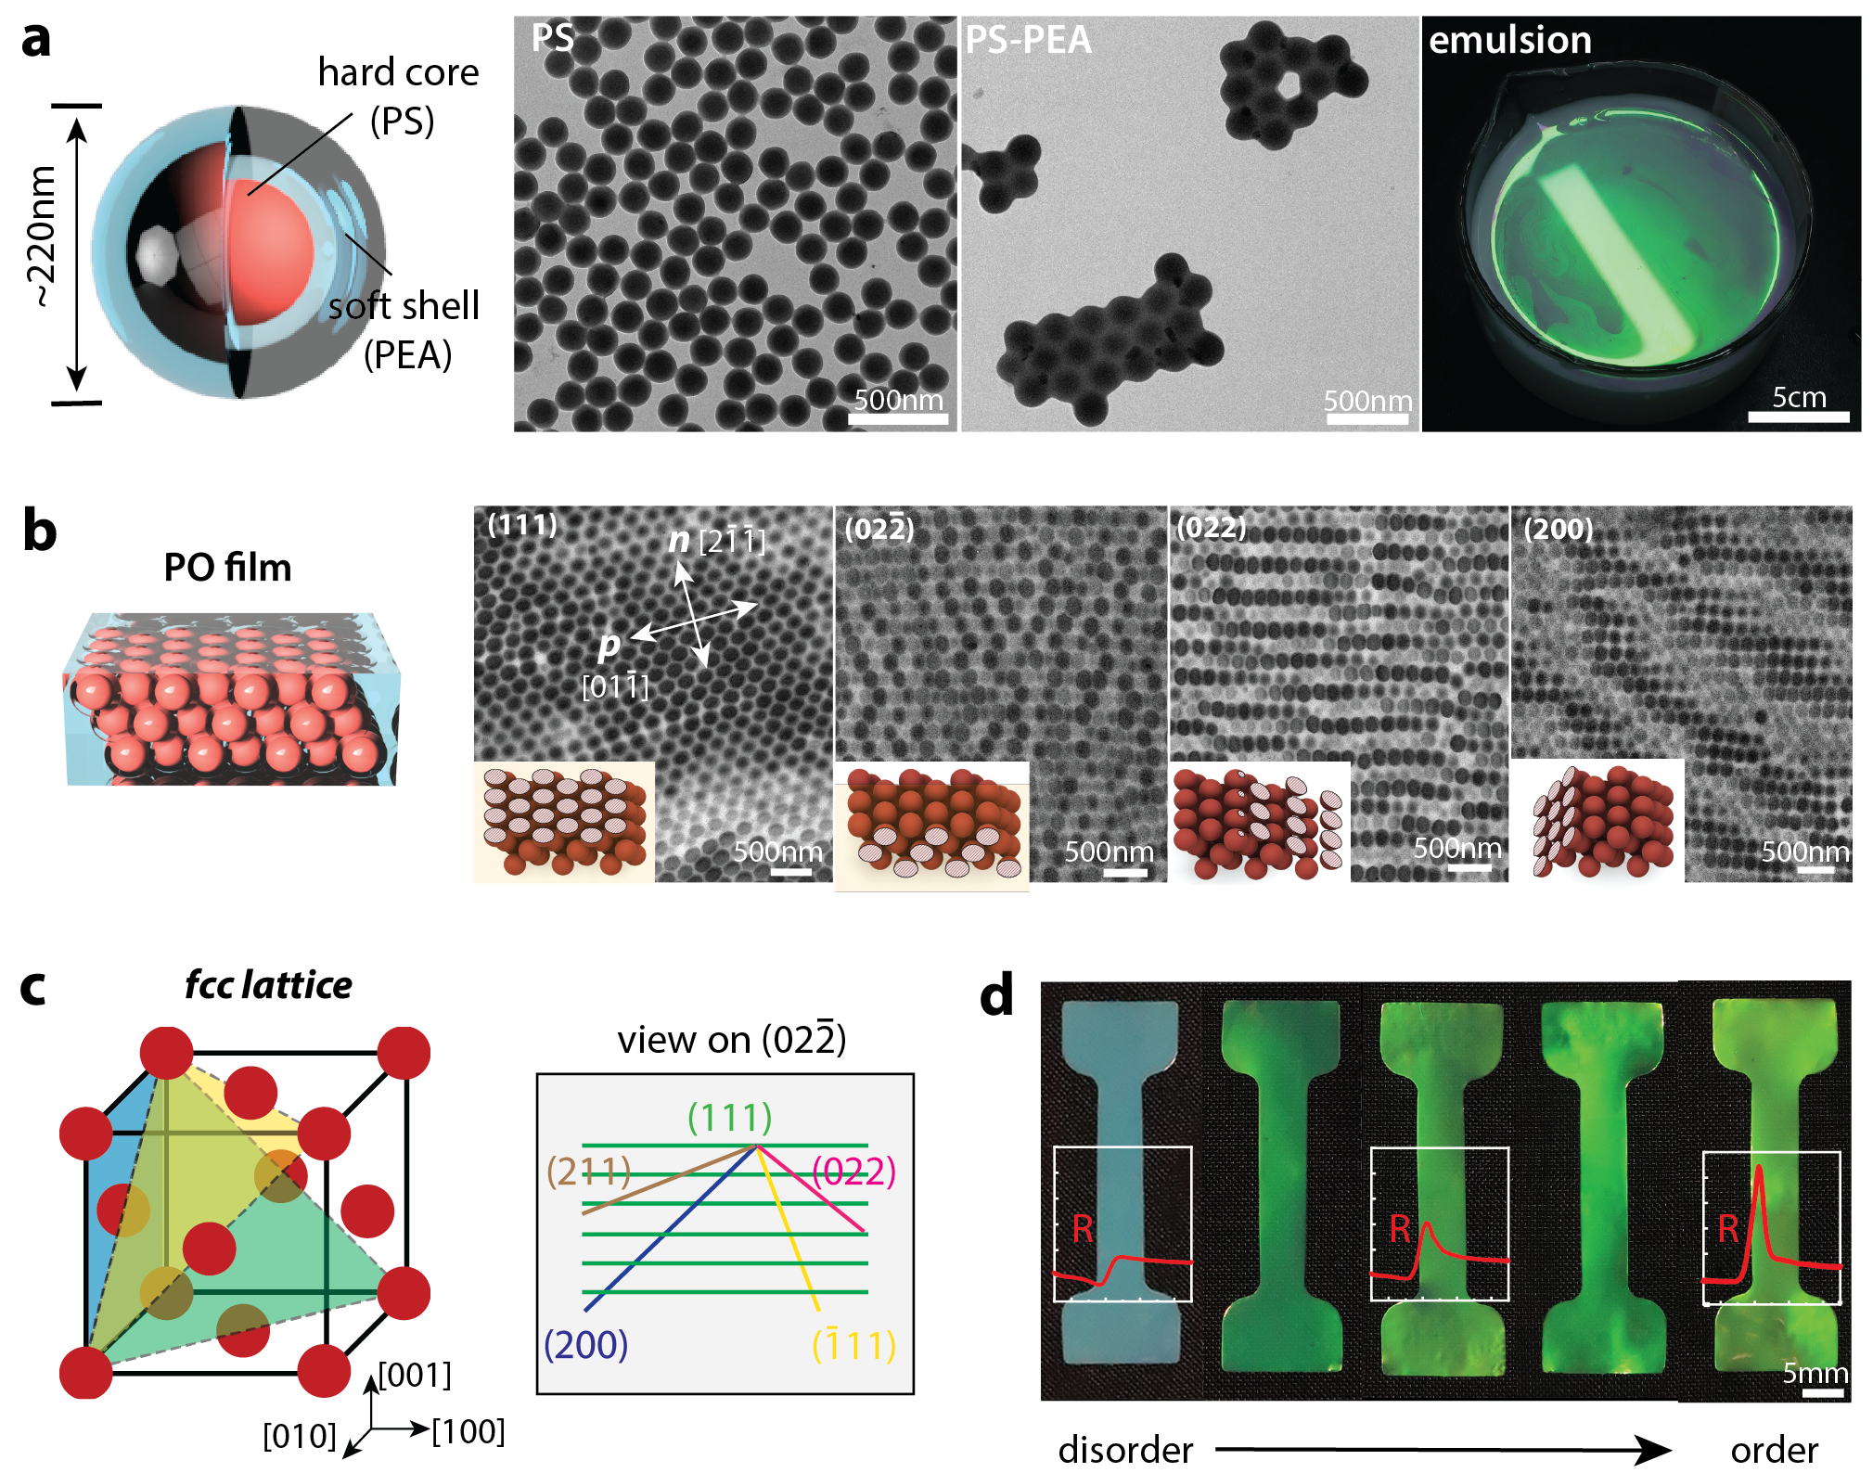
Extended Data Figure 1. Polymer opals (POs) structure characterization. a, From left to right: schematic representation of the PS-PEA core-shell sphere, TEM image of the PS core particle, TEM visualization post-PEA shell grafting, and the resultant core-shell sphere emulsion exhibiting the ‘milk skin’ effect indicative of high size monodispersity. b, TEM images detailing structures at specific tilt angles corresponding to certain planes. c, Coordinate system adopted for POs in accordance with the Miller indices for an fcc lattice. d, PO samples showcasing varied structural order, insets show the enhancing bright field reflection peak at normal incidence with improving order.

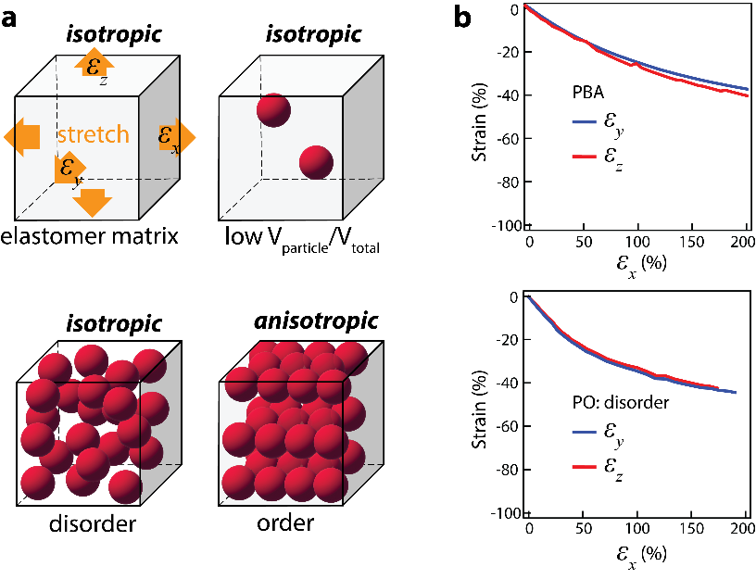
Extended Data Figure 2. a, Deformation properties of polymer composites incorporated with spheres of different packing structures. b, Thickness and width strains observed in poly (butyl acylate) (PBA) and disordered PO. PBA was employed to bypass the pungent smell of PEA. Although PBA is softer than PEA, both are anticipated to show similar deformation characteristics.

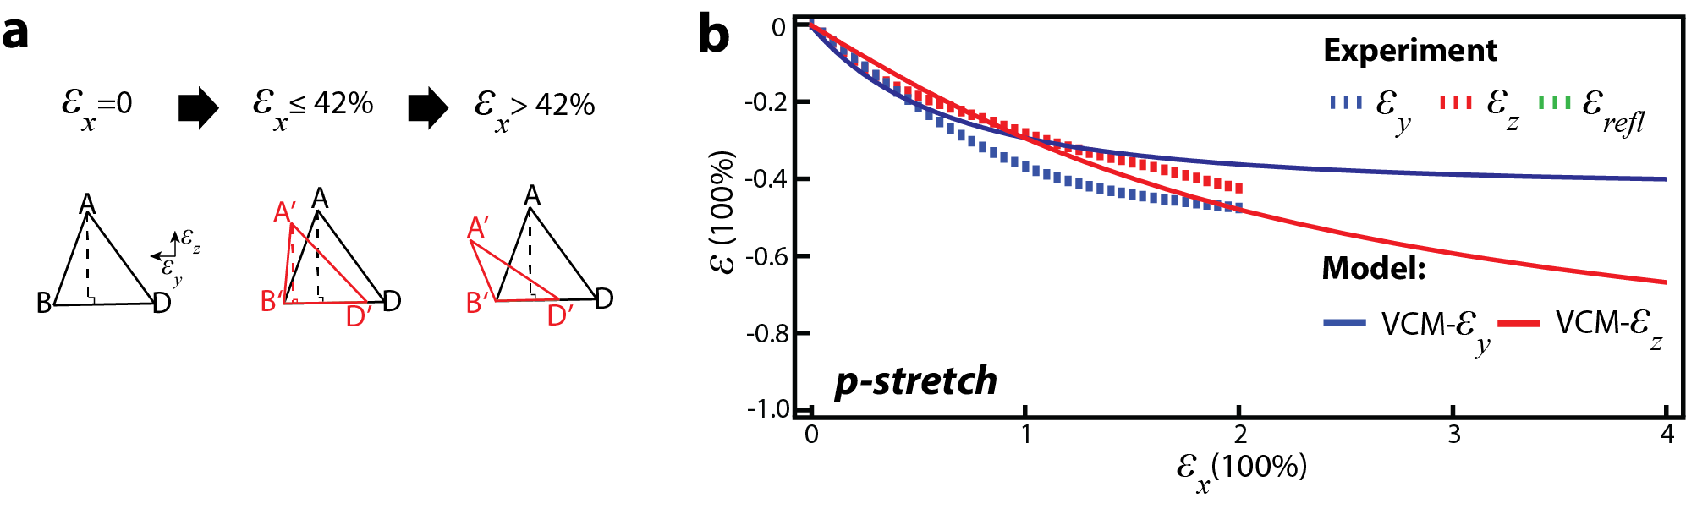
Extended Data Figure 3. Predicted effects of sustained protrusion of touching sphere pair during p-stretching. a. P-stretching deformation geometries: the initial phase deformation remains consistent with the original model. In the second phase, spheres A and D persistently move in the n-direction, causing AB and BD to deviate from being perpendicular beyond 42% strain. b. Model-derived strains indicate a deceleration effect on the width strain changes.

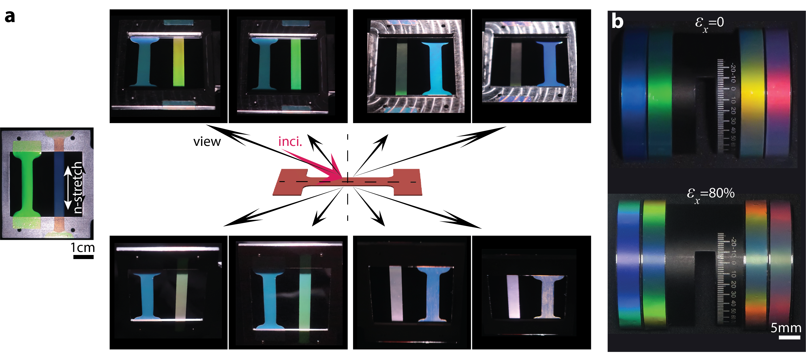
Extended Data Figure 4. Comparison of PO’s colour variations across different viewing angles pre and post n-stretching. a, Left, colours of the unstretched sample alongside a sample post 80% n-stretching at normal incidence, panels on the right reveal these samples’ hues when observed at varied angles under oblique white light LED illumination. b, Colour representations of POs, affixed to a cylinder, both before and after n-stretching, these samples were crafted using core-shell spheres of different sizes, each exhibiting a unique peak reflection wavelength.

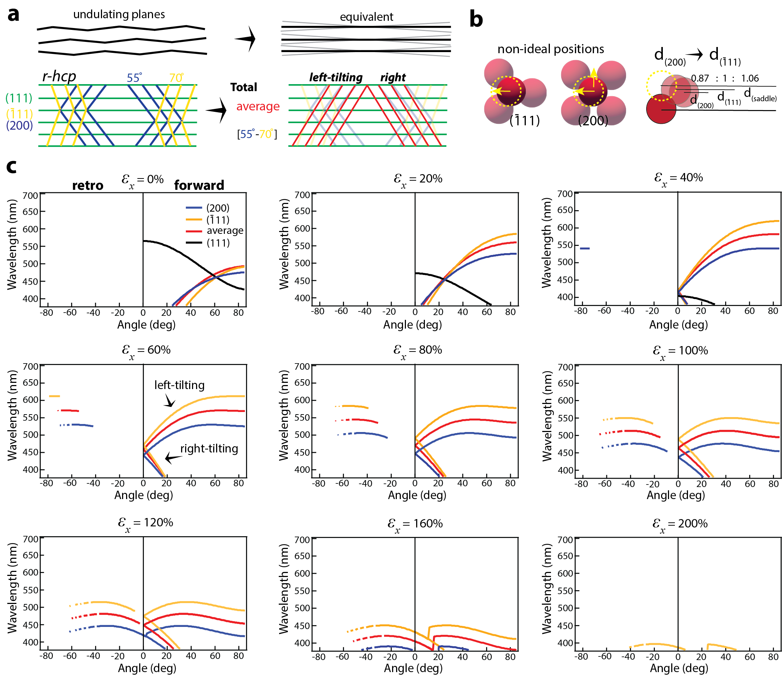
Extended Data Figure 5. BCD model predictions. a, Construction of the ‘average’ plane using the median plane distance and tilting angle of $(\overline{1}11)$ and (200). b, Illustration showing how spheres, when minutely shifted from their optimal positions within an imperfect lattice, lead to proximate plane distances for $(\overline{1}11)$ and (200) planes. c, Calculated reflection at varied incident angles for n-stretched PO.

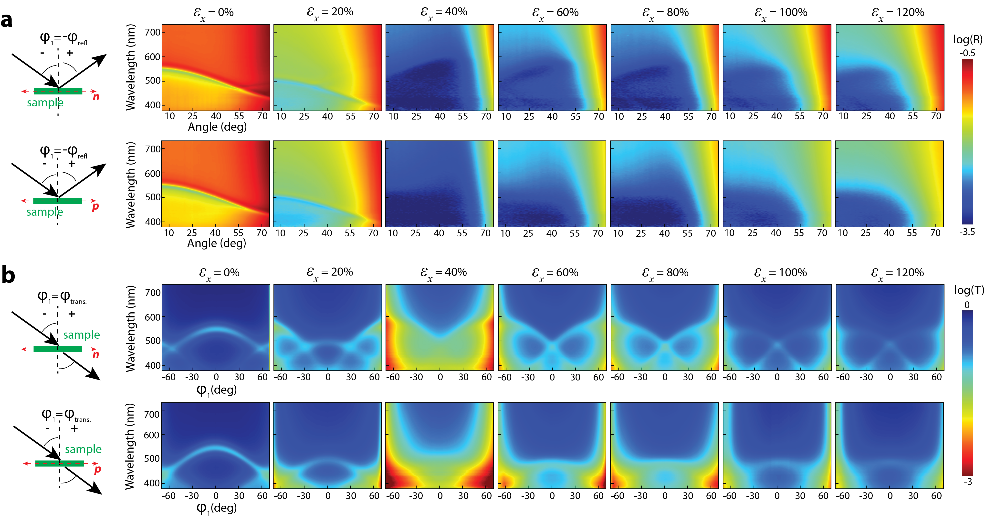
Extended Data Figure 6. Specular gonio-reflection and angular transmission spectra of n-stretched POs. a, Specular reflection with incident light along n and p directions of n-stretched samples. b, Transmission spectra with incident light along n and p direction of n-stretched samples.

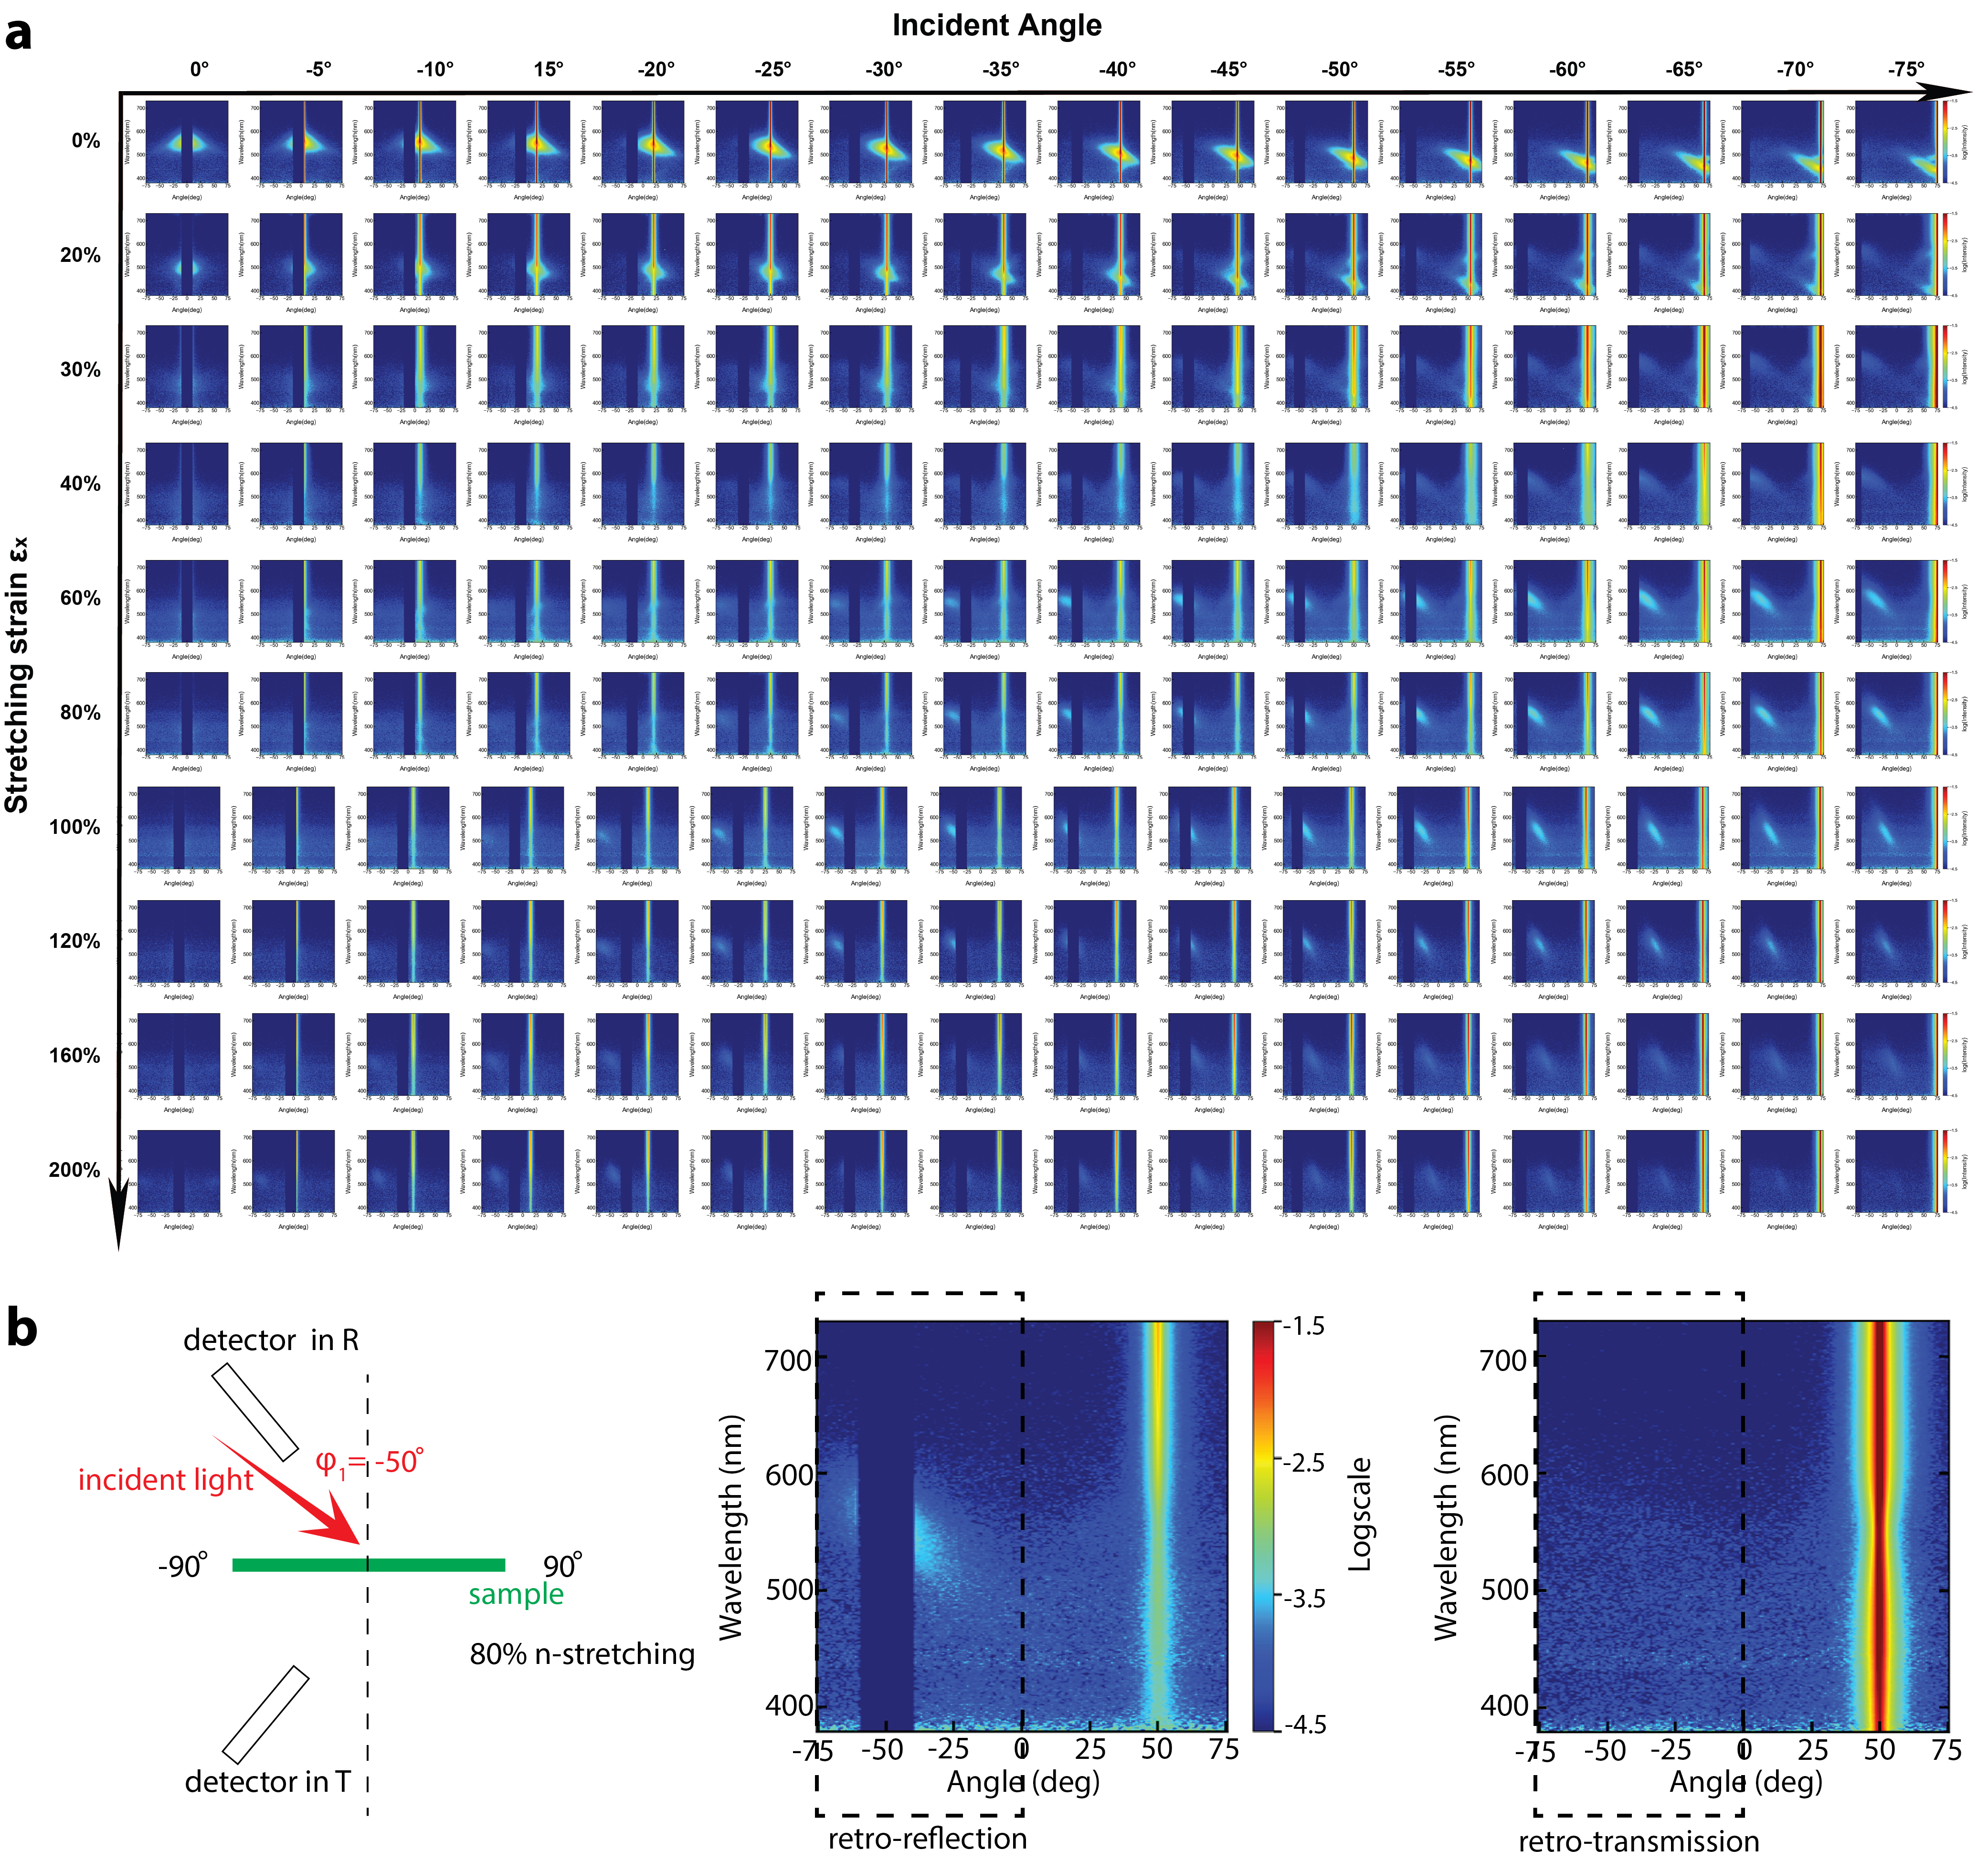
Extended Data Figure 7. Measured scattering spectra of n-stretched PO samples at varied incident angles along n-direction in both reflection and transmission. a, Measured scattering spectra in reflection showing a more complete map of optical property transition with obvious retro-Bragg reflection spots. b, Contrast between measured scattering spectra in retro-reflection and retro-transmission for 80% strain n-stretched PO at a fixed incident angle of -50˚.

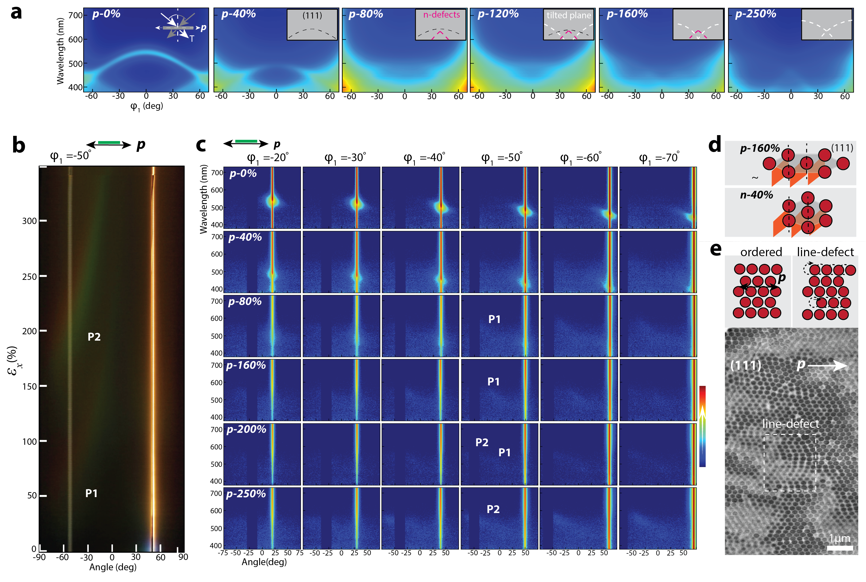
Extended Data Figure 8. Measured transition in angular optical properties of p-stretched POs. a, Angular transmission spectra with light incidence along the p-direction. Insets detail the hypothesized structural origins of spectral features: black signifies the (111) planes, red highlights features from defects in (111) oriented in the n-direction, and white marks features from tilting planes. b, Colours scattered at varied angles during p-stretching at a -50˚ incident angle along the p-direction. The P1 colour band emerges from defects within the (111) planes oriented in the n-direction, while P2 represents colours from tilted planes. c, Scattering spectra from p-stretched samples under changing incident angles along the p-direction. Signals correlating with the P1 and P2 colour bands are highlighted. d, An illustration indicating the tilt angle of planes post 160% p-stretching, which closely aligns with that of a sample stretched in the n-direction at 40% strain. e, Evidence illustrating the presence of defects oriented in the n-direction within the (111) planes, stemming from sphere misalignments.

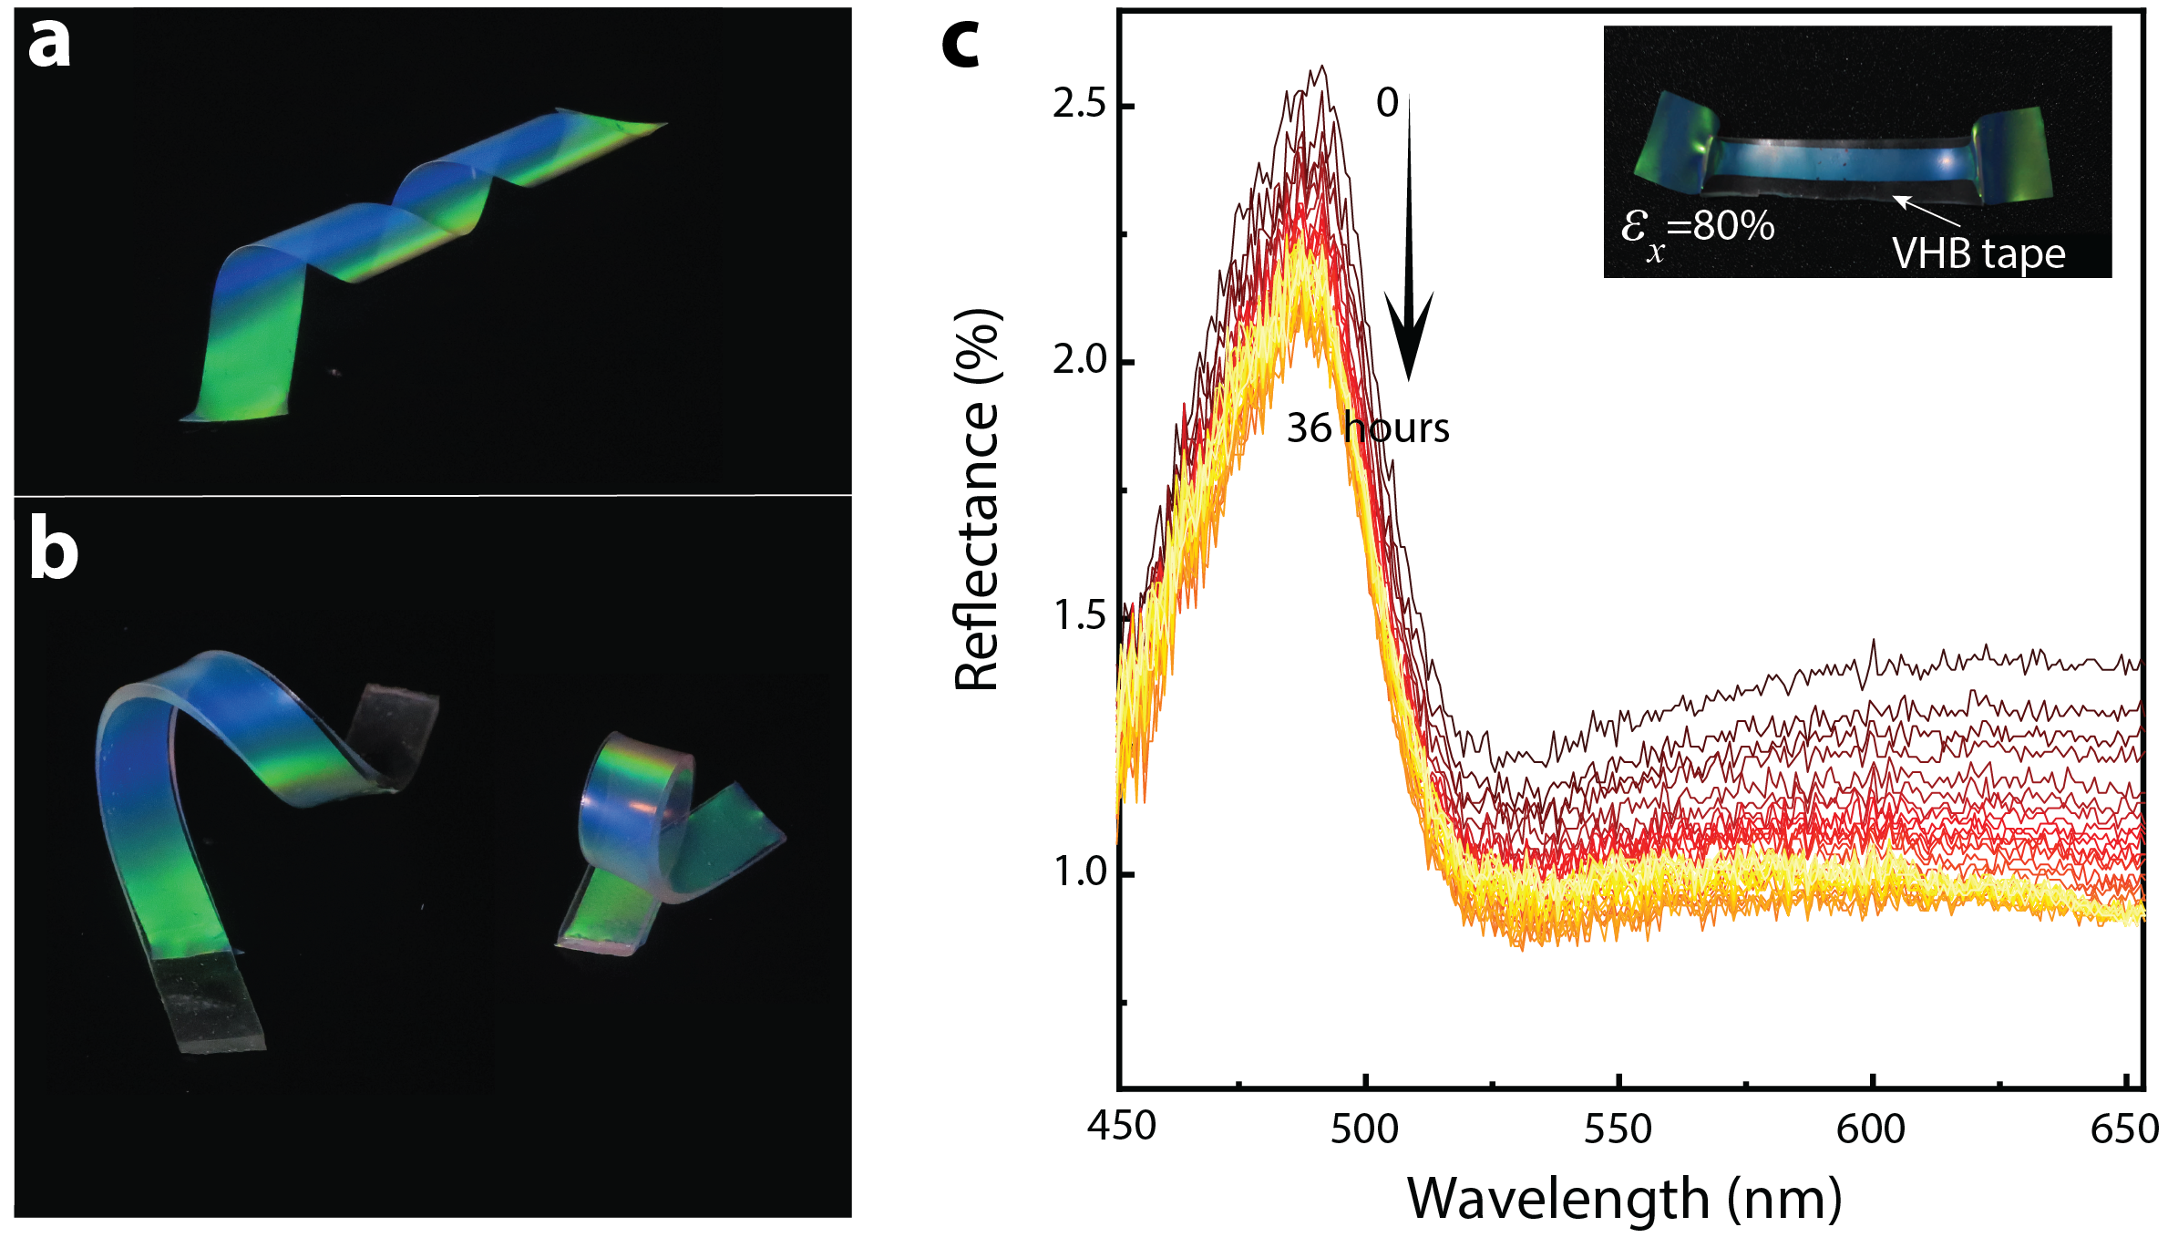
Extended Data Figure 9. N-stretched POs following different treatments. a, Freestanding n-stretched PO film. By maintaining the sample in its stretched state for several hours, its relaxation rate upon release was notably slower than if it were released immediately post-stretching. b, N-stretched samples fixed by VHB tapes. c, Spectra at normal incidence over time for an n-stretched PO secured by VHB tape. The peak wavelength remains consistent, suggesting negligible structural relaxation. The overall decrease in intensity likely results from the energy shift of the light source over extended periods.

