Supplementary Information for:
Localization-enhanced second harmonic generation in twisted WS₂ spirals

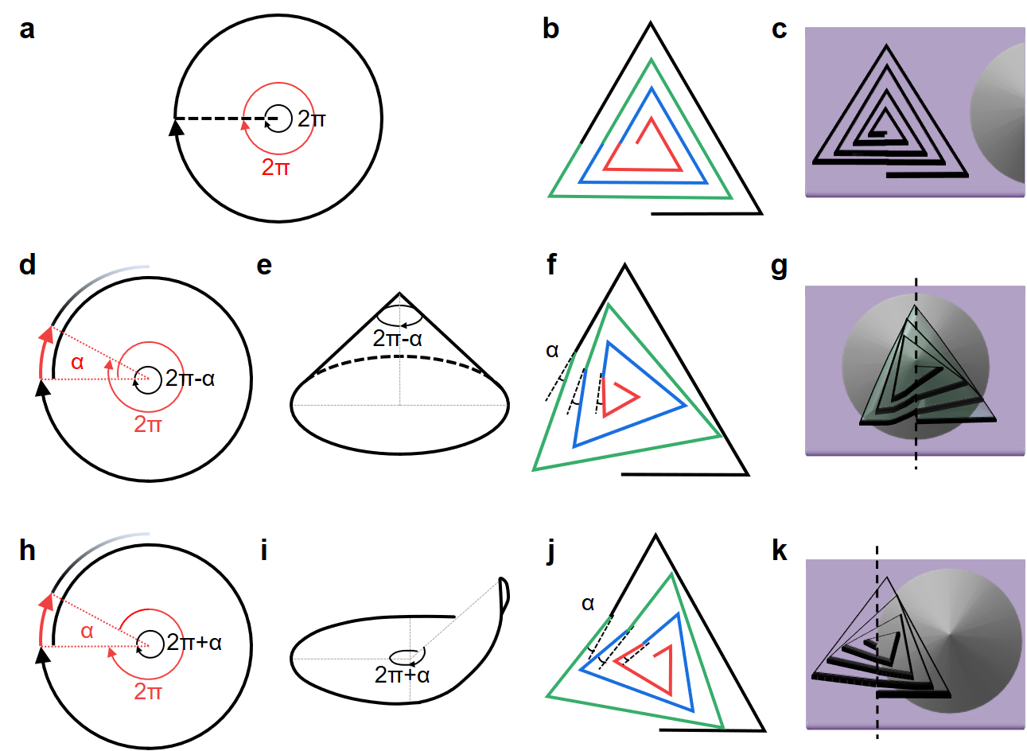
Figure S1. Formation mechanisms of twisted spiral MX₂ on different surfaces. a 2π angular period of lattice and substrate in a Euclidean surface. b, c Schematic crystal structure and growth model of twisted spiral MX₂ driven by screw dislocation, respectively. d, e 2π-α angular period on a non-Euclidean cone surface, the conical surface is firmed due to clipping α degree. f Schematic crystal structure of the left-hand supertwisted spiral MX₂, with the dislocation center at the apex of the cone (g). h, i 2π+α angular period on a non-Euclidean “hyperbolic cone” surface, the surface is firmed due to “borrowing” α degree from the next period. j Schematic crystal structure of the left-hand supertwisted spiral MX₂, with the dislocation center at the edge of the cone (k)
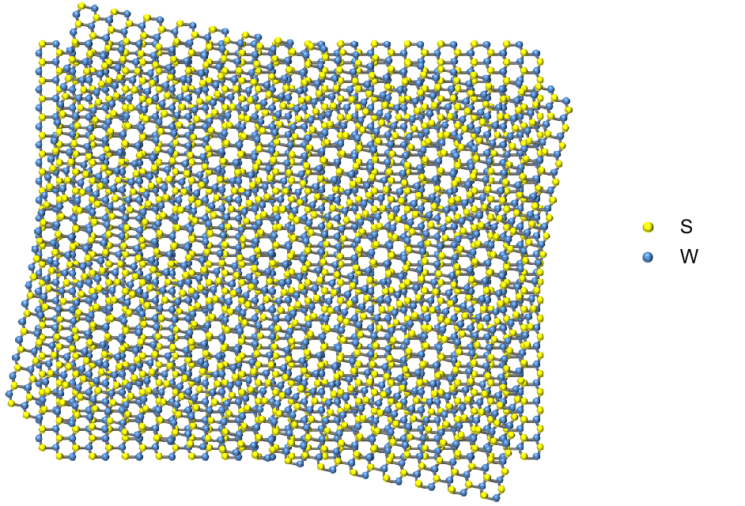
Figure S2. The schematic of a Moiré superlattice induced by the twisted neighboring two layers in a spiral WS₂ nanosheet in top view

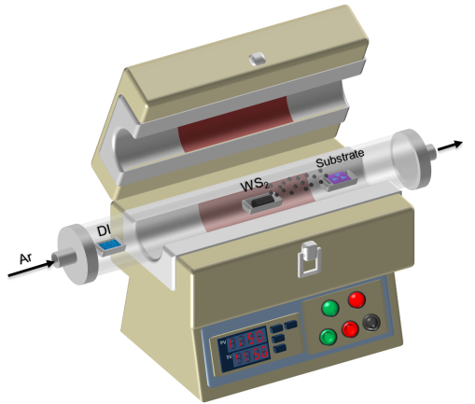
Figure S3. Schematic drawing of growth setup for twisted WS₂ spirals.
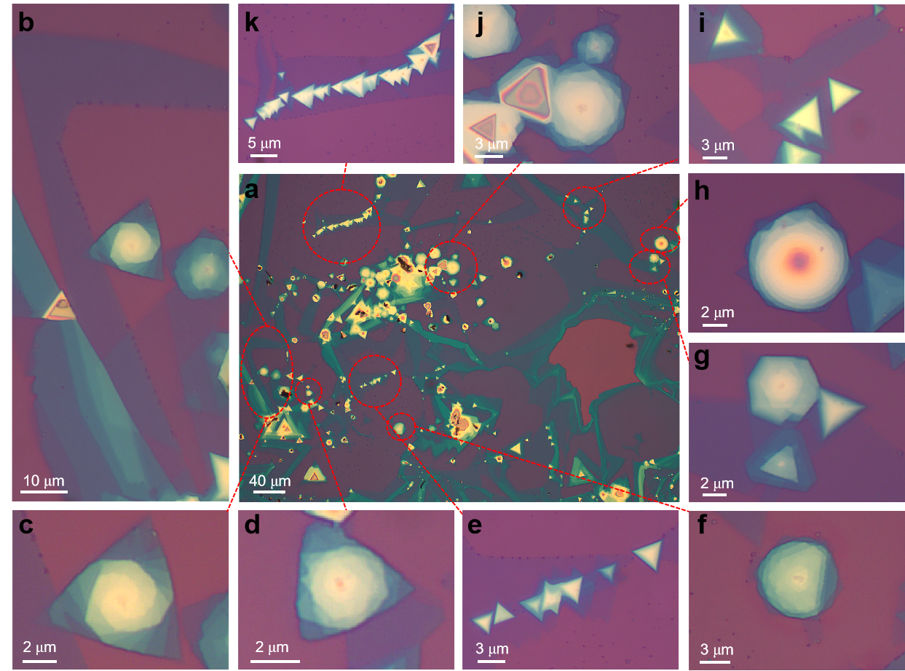
Figure S4. Optical images of as-grown ribbon structures.

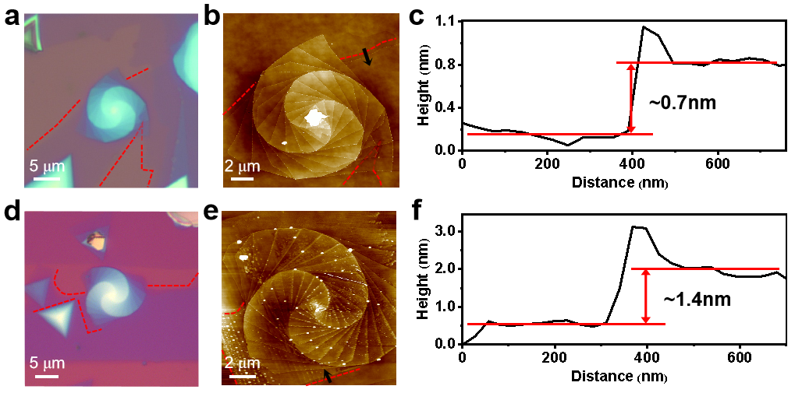
Figure S5. Optical (a, d) and AFM (b, e) images of left/right-handed supertwisted spiral WS₂. (c, f) Line profile marked with a black line in (b) and (e) showing that the height of the ribbon was about 0.7 nm and 1.4 nm, respectively. This suggested that supertwisted spiral WS₂ grows on the ribbon.

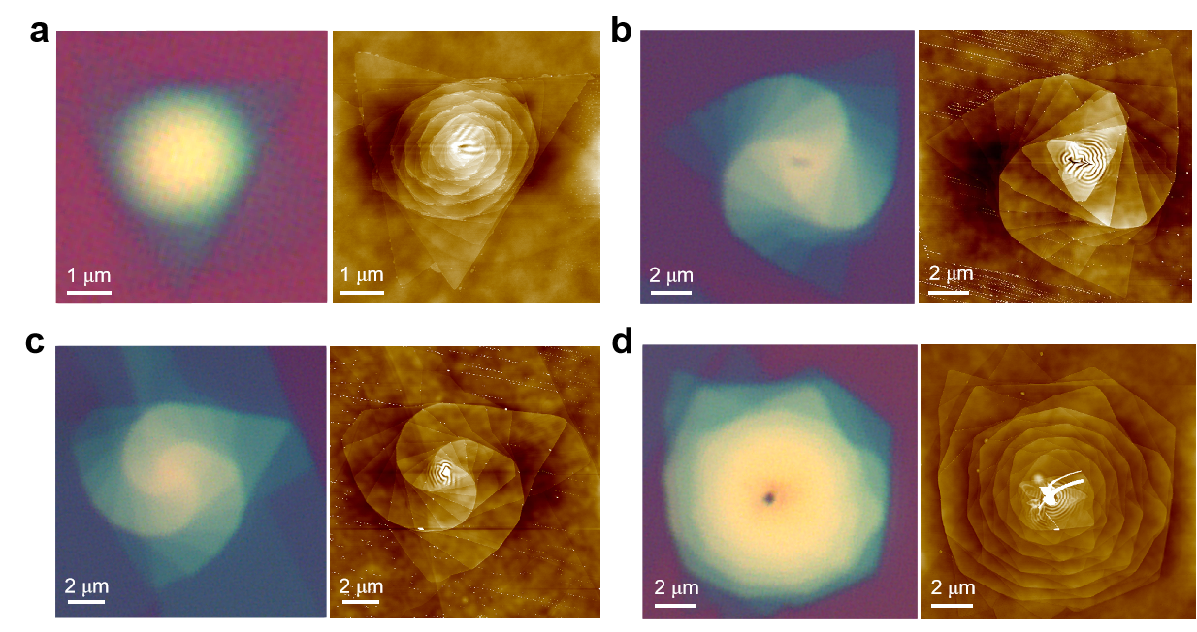
Figure S6. Optical and AFM images of other supertwisted WS₂ spirals.

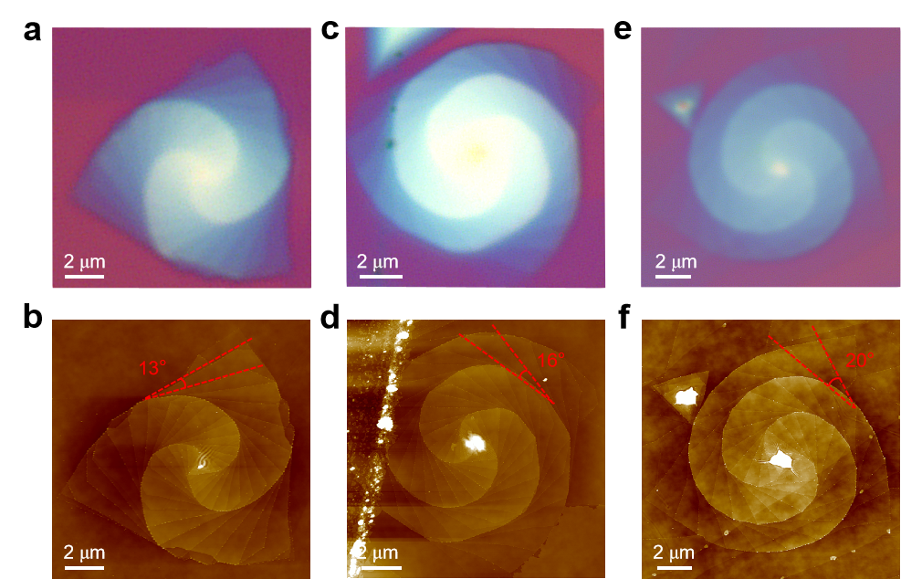
Figure S7. Optical images and AFM images of other supertwisted spiral WS₂ with α=13° (a, b), 16° (c, d), 20° (e, f) in Figure 3, respectively.
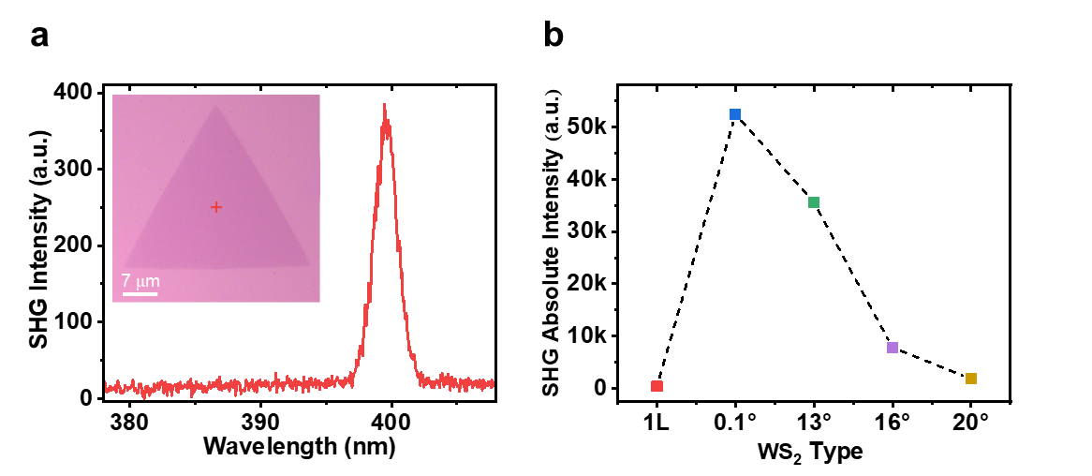
Figure S8. Optical image and SHG intensity. (a) Monolayer WS₂ optical image, the SHG intensity of monolayer tested the same parameters. (b) the SHG absolute intensity of monolayer WS₂ and supertwisted WS₂ spirals with twisted angle at ≈0°，13°，16° and 20°

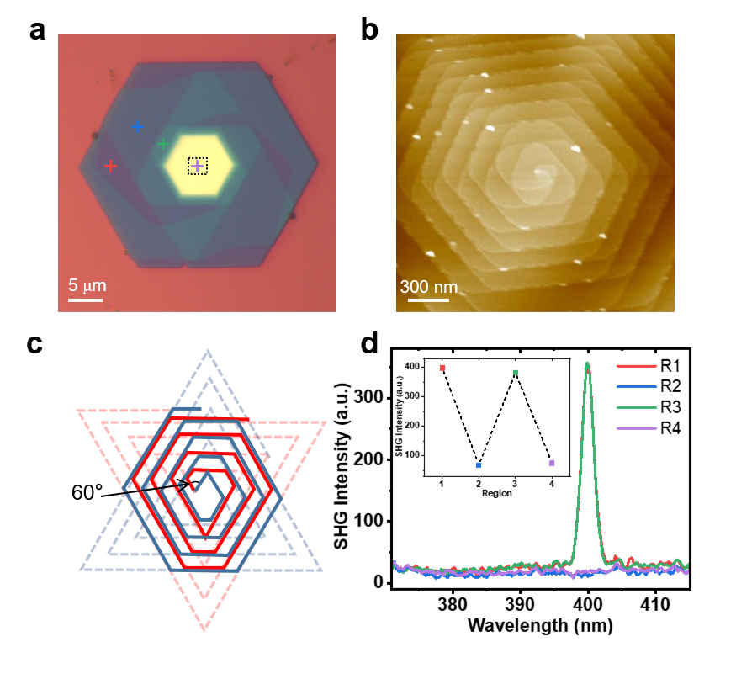
Figure S9 Spiral WS₂ of 2H phase. (a, b) Optical image and AFM image (zoomed-in of the black dashed lines) of the hexagonal double dislocation WS₂ with 2H phase, and its layer-dependent SHG (d). The SHG intensity shows a layer-dependent oscillatory relationship, the law of periodic fluctuation, and the SHG of odd layer is stronger, while that of even layer is almost zero. (c) The include angle of hexagonal double dislocation WS₂ is 60°.
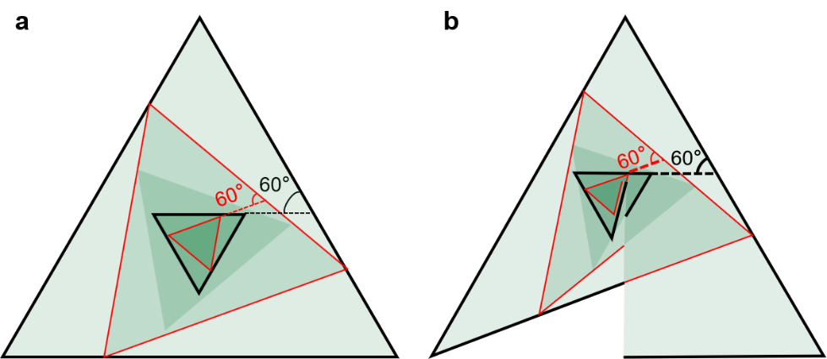
Figure S10. When WS₂ is stacked (a) or grown (b) by screw dislocation to the fifth layer, the included angle between 2,5 and 1,4 layer is 60°, which has inversion symmetry and no SHG signal.
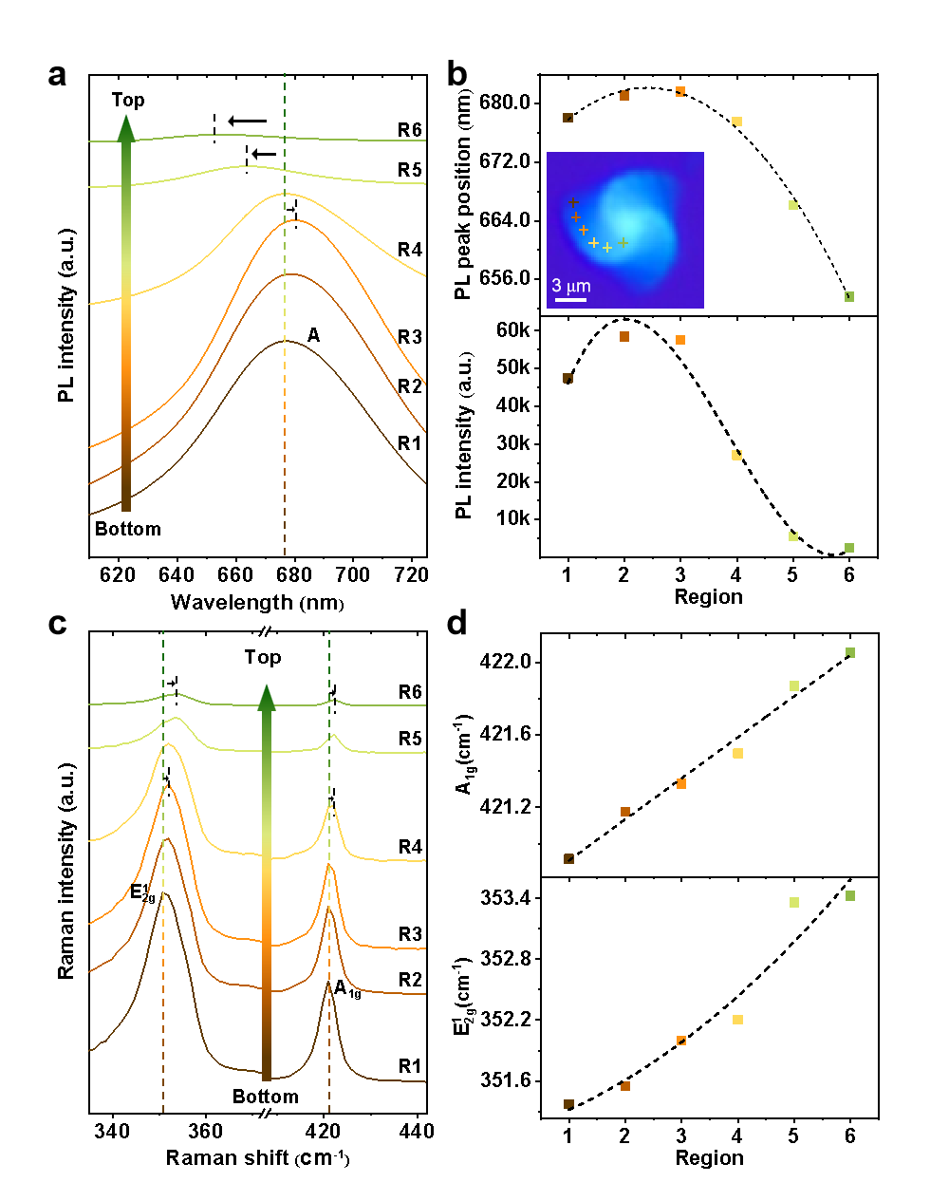
Figure S11. (a, b) PL spectra of a supertwisted spiral WS₂ with 16° from bottom to top. Optical image of sample was shown in the insets in panel (b). Peak position of A first redshift and then blueshift, PL intensity first increased and then decreased. (c, d) Raman spectra of the sample from bottom to top. Peak position of ${\text{E}}_{\text{2g}}^{\text{1}}$ and A_{1g} all blueshift.

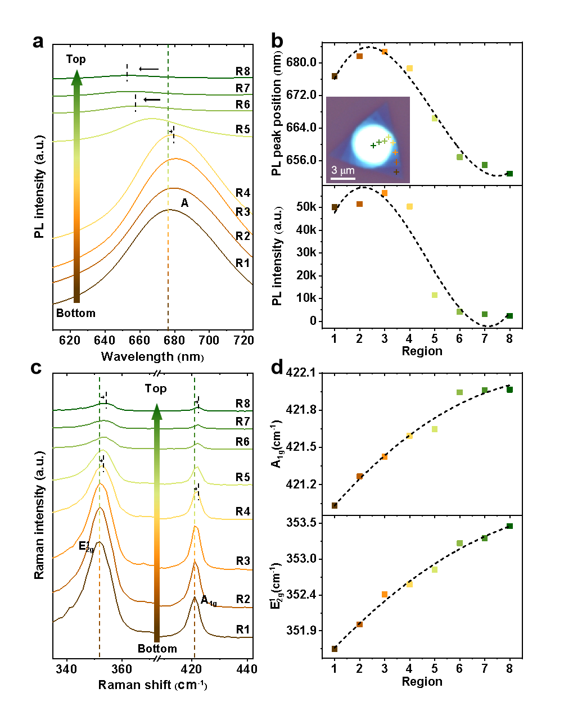
Figure S12. (a, b) PL spectra of a supertwisted spiral WS₂ with 19° (in the insets in panel (b)) from bottom to top. Peak position of A and PL intensity test results were the same as Figure 5 (a, b). (c, d) Raman spectra of the sample with 19° from bottom to top. Peak position of ${\text{E}}_{\text{2g}}^{\text{1}}$ and A_{1g} all blueshift, as with the results of Figure 5 (c, d).

