Supplementary figures.1. Body weight and blood glucose in db/db or db/m mice
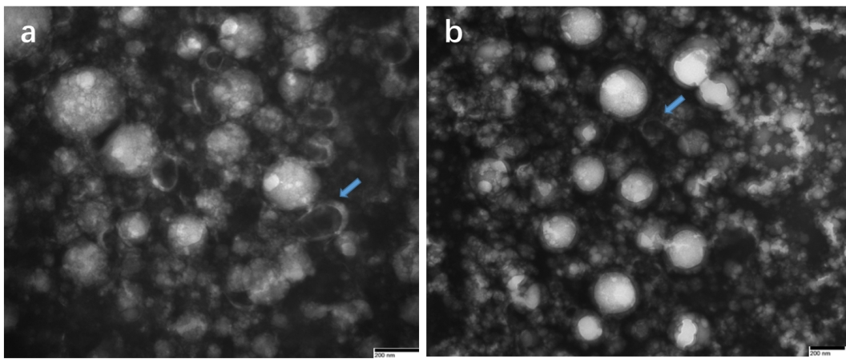
Supplementary figures.2. Exosomes obtained by qEV The direction of the blue arrow indicates exocytosis

