Supplementary Information

In situ formation of a melt-solid interface towards stable oxygen reduction for protonic ceramic fuel cells
Desheng Feng¹, Mengran Li*^{,2}, Vanessa K. Peterson*^{,3}, Rijia Lin¹, Anita D'Angelo⁴, Olexandra Marenych⁵, Anya Yago⁵, Dominique Appadoo⁴, Bin Zulkifli Muhammad Yazid¹, Shuai Gao^{1,6}, Yuming Wu¹, Xiaohe Tian², Xiaoyang Du², Zhonghua Zhu*^{,1}
1. School of Chemical Engineering, The University of Queensland, Brisbane, 4072, Australia
2. Department of Chemical Engineering, the University of Melbourne, Melbourne, 3010, Australia
3. Australian Centre for Neutron Scattering, Australian Nuclear Science and Technology Organisation, Sydney, New South Wales, Australia
4. Australian Synchrotron, Australian Nuclear Science and Technology Organization, 800 Blackburn Road, Clayton, Victoria, 3168 Australia
5. Centre for Microscopy and Microanalysis, The University of Queensland, St Lucia, 4072 Australia
6. Biomass Group, College of Engineering, Nanjing Agricultural University, 40 Dianjiangtai Road, Nanjing 210031, China
Corresponding authors:
M. Li: aaron.li1@unimelb.edu.au
V.K. Peterson: vanessa.peterson@ansto.gov.au
Z. Zhu: z.zhu@uq.edu.au

Supplementary Table 1 SXRPD refinement details for BCFZY and BCFZYLN
Atom | Site Multiplicity | x |  | y |  | z |  | Occupancy |  | U_{iso} (Å²)
BCFZY-1, a = 4.11758(5) Å, $Pm\overline{3}m$, phase fraction 51.5(3)%ª
Ba | 1 | 0.5 |  | 0.5 |  | 0.5 |  | 1 |  | 0.0292(5)
Zr/Y^{b} | 1 | 0 |  | 0 |  | 0 |  | 0.223^{c} |  | 0.0397(5)^{d}
Fe/Co^{e} | 1 | 0 |  | 0 |  | 0 |  | 0.777^{c} |  | 0.0397(5)^{d}
O | 3 | 0.5 |  | 0 |  | 0 |  | 0.8^{c} |  | 0.01^{f}
BCFZY-2, a = 4.12385(5) Å, $Pm\overline{3}m$, phase fraction 47.8(3)%ª
Ba | 1 | 0.5 |  | 0.5 |  | 0.5 |  | 1 |  | 0.0292(5)
Zr/Y^{b} | 1 | 0 |  | 0 |  | 0 |  | 0.223^{c} |  | 0.0397(5)^{d}
Fe/Co^{e} | 1 | 0 |  | 0 |  | 0 |  | 0.777^{c} |  | 0.0397(5)^{d}
O | 3 | 0.5 |  | 0 |  | 0 |  | 0.8^{c} |  | 0.01^{f}
BaCO₃, a = 6.456(5) Å, b = 5.306(3) Å, c = 8.936(7) Å, $Pmna$, phase fraction 0.68(3)%
Ba | 4 | 0.24046 | 0.25000 |  | 0.58492 |  | 1 |  | 0.01
C | 4 | 0.08518 | 0.25000 |  | 0.23789 |  | 1 |  | 0.01
O1 | 8 | 0.08726 | 0.02653 |  | 0.31935 |  | 1 |  | 0.01
O2 | 4 | 0.09557 | 0.25000 |  | 0.07776 |  | 1 |  | 0.01
Goodness of fit (GOF) = 3.55
Weighted profile R-factor (wR) = 5.96%
BCFZY-1 R-Bragg Factor (RF²) = 5.94%
BCFZY-2 RF² = 5.06%
BaCO₃ RF² = 57.1%
Atom | Site Multiplicity | x |  | y | z |  | Occupancy |  | U_{iso} (Å²)
BCFZYLN-1, a = 4.10999(4) Å, $Pm\overline{3}m$, phase fraction 19.3(1)%ª
Ba | 1 | 0.5 | 0.5 |  | 0.5 |  | 0.937^{g} |  | 0.0256(5)
Zr/Y^{b} | 1 | 0 | 0 |  | 0 |  | 0.257^{c} |  | 0.0426(5)^{d}
Fe/Co^{e} | 1 | 0 | 0 |  | 0 |  | 0.743^{c} |  | 0.0426(5)^{d}
O | 3 | 0.5 | 0 |  | 0 |  | 0.8^{c} |  | 0.01^{f}
BCFZYLN-2, a = 4.11833(3) Å, $Pm\overline{3}m$, phase fraction 80.7(1)%ª
Ba | 1 | 0.5 | 0.5 |  | 0.5 |  | 0.937^{g} |  | 0.0256(5)
Zr/Y^{b} | 1 | 0 | 0 |  | 0 |  | 0.257^{c} |  | 0.0426(5)^{d}
Fe/Co^{e} | 1 | 0 | 0 |  | 0 |  | 0.743^{c} |  | 0.0426(5)^{d}
O | 3 | 0.5 | 0 |  | 0 |  | 0.8 |  | 0.01^{f}
GOF = 5.49
wR = 5.74%
BCFZYLN-1 RF² = 7.18%
BCFZYLN-2 RF² = 4.99%
ª Data indicated a main phase of BCFZY or BCFZYLN with a distribution of lattice parameters that could not be fully resolved in the data and were modelled reasonably well using two $Pm\overline{3}m$ phases with all parameters of these phases constrained to be the same, except for the lattice constant.
^{b} Zr and Y are indistinguishable and combined.
^{c} Occupancies are fixed to those obtained from ICP-OES and that refined against NPD data for O.
^{d} Atomic displacement parameters constrained to be equal for atoms at the same site.
^{e} Co and Fe are indistinguishable and combined.
^{f} Atomic displacement fixed to the literature value.¹
^{g} Li and Na are excluded and cation occupancies are fixed to those obtained from ICP-OES.

Supplementary Table 2 NPD refinement details for BCFZY and BCFZYLN
Atom | Site Multiplicity | x |  | y | z | Occupancy | U_{iso} (Å²)
BCFZY-1, a = 4.11758 Å, $Pm\overline{3}m$, phase fraction 51.5%ª
Ba | 1 | 0.5 | 0.5 |  | 0.5 | 1 | 0.021(1)
Zr/Y^{b} | 1 | 0 | 0 |  | 0 | 0.223^{c} | 0.031(1)^{d}
Co | 1 | 0 | 0 |  | 0 | 0.3(2) | 0.031(1)^{d}
Fe | 1 | 0 | 0 |  | 0 | 0.40(5) | 0.031(1)^{d}
O | 3 | 0.5 | 0 |  | 0 | 0.80(1) | 0.032(1)
BCFZY-2, a = 4.12385 Å, $Pm\overline{3}m$, phase fraction 47.8%ª
Ba | 1 | 0.5 | 0.5 |  | 0.5 | 1 | 0.021(1)
Zr/Y^{b} | 1 | 0 | 0 |  | 0 | 0.223^{c} | 0.031(1)^{d}
Co | 1 | 0 | 0 |  | 0 | 0.3(2) | 0.031(1)^{d}
Fe | 1 | 0 | 0 |  | 0 | 0.40(5) | 0.031(1)^{d}
O | 3 | 0.5 | 0 |  | 0 | 0.80(1) | 0.032(1)
BaCO₃, a = 6.456 Å, b = 5.306 Å, c = 8.936 Å, $Pmna$, phase fraction 0.68%ª
Ba | 4 | 0.24046 | 0.25000 |  | 0.58492 | 1 | 0.01
C | 4 | 0.08518 | 0.25000 |  | 0.23789 | 1 | 0.01
O1 | 8 | 0.08726 | 0.02653 |  | 0.31935 | 1 | 0.01
O2 | 4 | 0.09557 | 0.25000 |  | 0.07776 | 1 | 0.01
Goodness of fit (GOF) = 1.32
Weighted profile R-factor (wR) = 3.61%
BCFZY-1 R-Bragg Factor (RF²) = 3.12%
BCFZY-2 RF² = 2.46%
BaCO₃ RF² = 50.58%
Atom | Site  Multiplicity | x |  | y | z | Occupancy | U_{iso} (Å²)
BCFZYLN-1, a = 4.10999 Å, $Pm\overline{3}m$, phase fraction 19.3%ª
Ba | 1 | 0.5 | 0.5 |  | 0.5 | 0.969(4) | 0.033(2)^{d}
Li | 1 | 0.5 | 0.5 |  | 0.5 | 0.02(1) | 0.033(2)^{d}
Na | 1 | 0.5 | 0.5 |  | 0.5 | 0.039(6) | 0.033(2)^{d}
Zr/Y^{b} | 1 | 0 | 0 |  | 0 | 0.257^{c} | 0.040(1)^{d}
Fe | 1 | 0 | 0 |  | 0 | 0.348(3) | 0.040(1)^{d}
Co | 1 | 0 | 0 |  | 0 | 0.32(1) | 0.040(1)^{d}
O | 3 | 0.5 | 0 |  | 0 | 0.759(4) | 0.038(1)
BCFZYLN-2, a = 4.11833 Å, $Pm\overline{3}m$, phase fraction 80.7%ª
Ba | 1 | 0.5 | 0.5 |  | 0.5 | 0.969(4) | 0.033(2)^{d}
Li | 1 | 0.5 | 0.5 |  | 0.5 | 0.02(1) | 0.033(2)^{d}
Na | 1 | 0.5 | 0.5 |  | 0.5 | 0.039(6) | 0.033(2)^{d}
Zr/Y^{b} | 1 | 0 | 0 |  | 0 | 0.257^{c} | 0.040(1)^{d}
Fe | 1 | 0 | 0 |  | 0 | 0.348(3) | 0.040(1)^{d}
Co | 1 | 0 | 0 |  | 0 | 0.32(1) | 0.040(1)^{d}
O | 3 | 0.5 | 0 |  | 0 | 0.759(4) | 0.038(1)
GOF = 1.21
wR = 3.30%
BCFZYLN-1 RF² = 6.37%
BCFZYLN-2 RF² = 6.1%
ª Two $Pm\overline{3}m$ phases were used to describe the data with all parameters of these phases fixed to those obtained from the refinement using the SXRD data, including the phase fractions.
^{b} Zr and Y are indistinguishable and combined.
^{c} Occupancies are fixed to those obtained from ICP-OES.
^{d} Atomic displacement parameters constrained to be equal for atoms at the same site.
Supplementary Table 3 CO₂ tolerance of Li/Na-doped BCFZY and reported PCFC cathodes.
Cathode | Temperature | ASR in the absence of CO₂ | Measurement duration | Degradation rate | Test conditions | Reference
Cathode | (° C) | (Ω cm²) | (h) | (Ω cm² min⁻¹) | Test conditions | Reference
BCFZY | 600 | 0.19 | 1 | 7.4(2) × 10⁻³ | Humid air 10% CO₂ | This work
BCFZYLN | 600 | 0.21 | 1 | 4.9(3) × 10⁻³ | Humid air 10% CO₂ | This work
BCFZYL | 600 | 0.23 | 1 | 1.00(4) × 10⁻² | Humid air 10% CO₂ | This work
BCFZYN | 600 | 0.23 | 1 | 8.10(2) × 10⁻³ | Humid air 10% CO₂ | This work
BCYF1 composite | 600 | 0.35 | 2 | 4.00 × 10⁻³ | 5% H₂O-air 1% CO₂ | ²
BCYF2 composite | 600 | 0.21 | 2 | 1.00 × 10⁻³ | 5% H₂O-air 1% CO₂ | ²
BCYF3 composite | 600 | 0.70 | 2 | 7.13 × 10⁻³ | 5% H₂O-air 1% CO₂ | ²
SSNCF | 600 | 0.39 | 2.5 | 2.15 × 10⁻³ | Humid air 1% CO₂ | ³
3 wt.% LWMN-  SSNCF | 600 | 0.32 | 2.5 | 1.33 × 10⁻³ | Humid air 1% CO₂ | ³
BCFCY64 | 600 | 0.67 | 6 | 1.55 × 10⁻³ | Humid air 10% CO₂ | ⁴
BCFCY73 | 600 | 0.67 | 6 | 1.55 × 10⁻³ | Humid air 10% CO₂ | ⁴
BCFCY82 | 600 | 0.67 | 6 | 1.55 × 10⁻³ | Humid air 10% CO₂ | ⁴
Note: BCYF = Ba(Ce_{0.8}Y_{0.2})_{x}Fe_{1−x}O_{3−δ}, SSNCF = Sr₂Sc_{0.1}Nb_{0.1}Co_{1.5}Fe_{0.3}O_{6-δ}, LWMN = La_{5.5}W_{0.45}Mo_{0.4}Nb_{0.15}O_{11.25-δ}, and BCFCY = Ba(Co_{0.7}Fe_{0.3})_{x}(Ce_{0.8}Y_{0.2})_{1-x}O3_{−δ}.

Supplementary Table 4 Laboratory XRD refinement details for BCFZYN
Atom | Site Multiplicity | x |  | y | z | Occupancy | U_{iso} (Å²)
BCFZYL, a = 4.0892(3) Å, $Pm\overline{3}m$, phase fraction 100%
Ba | 1 | 0.5 | 0.5 |  | 0.5 | 1.01(3) | 0. 024(3)
Zr/Yª | 1 | 0 | 0 |  | 0 | 0.24(5) | 0.036(3)^{c}
Fe/Co^{b} | 1 | 0 | 0 |  | 0 | 0.76(5) | 0.036(3)^{c}
O | 3 | 0.5 | 0 |  | 0 | 0.8^{d} | 0.01e
Goodness of fit (GOF) = 1.33
Weighted profile R-factor (wR) = 8.14%
BCFZYL R-Bragg Factor (RF²) = 4.78%
ª Zr and Y are indistinguishable and combined.
^{b} Co and Fe are indistinguishable and combined.
^{c} Atomic displacement parameters constrained to be equal for atoms at the same site.
^{d} Occupancy is fixed to that refined against NPD data for O for the BCFZY and BCFZYLN materials
^{e} Atomic displacement fixed to the literature value.¹

Supplementary Table 5 Laboratory XRD refinement details for BCFZYL
Atom | Site Multiplicity | x |  | y | z | Occupancy | U_{iso} (Å²)
BCFZYL, a = 4.0863(4) Å, $Pm\overline{3}m$, phase fraction 100%
Ba | 1 | 0.5 | 0.5 |  | 0.5 | 0.98(3) | 0. 023(3)
Zr/Yª | 1 | 0 | 0 |  | 0 | 0.19(5) | 0.036(3)^{c}
Fe/Co^{b} | 1 | 0 | 0 |  | 0 | 0.81(5) | 0.036(3)^{c}
O | 3 | 0.5 | 0 |  | 0 | 0.8^{d} | 0.01e
Goodness of fit (GOF) = 1.26
Weighted profile R-factor (wR) = 7.52%
BCFZYN R-Bragg Factor (RF²) = 4.34%
ª Zr and Y are indistinguishable and combined.
^{b} Co and Fe are indistinguishable and combined.
^{c} Atomic displacement parameters constrained to be equal for atoms at the same site.
^{d} Occupancy is fixed to that refined against NPD data for O for the BCFZY and BCFZYLN materials
^{e} Atomic displacement fixed to the literature value.¹

Supplementary Table 6 Laboratory XRD refinement details for CO₂-treated BCFZY
Atom | Site Multiplicity | x |  | y | z | Occupancy | U_{iso} (Å²)
Cubic perovskite, a = 4.126(8) Å, $Pm\overline{3}m$, phase fraction 8.2(7)%
Ba | 1 | 0.5 | 0.5 |  | 0.5 | 1 | 0.01^{c}
Zr/Yª | 1 | 0 | 0 |  | 0 | 0.2^{d} | 0.01^{c}
Fe/Co^{b} | 1 | 0 | 0 |  | 0 | 0.8^{d} | 0.01^{c}
O | 3 | 0.5 | 0 |  | 0 | 0.8^{d} | 0.01^{c}
(Co,Fe)₃O₄, a = 8.362(5) Å, $Fd\overline{3}m$, phase fraction 6.0(2)%
Co/Fe^{b} | 1 | 0.3750 | 0.3750 |  | 0.3750 | 1 | 0.01^{c}
Co/Fe^{b} | 1 | 0 | 0 |  | 0 | 1 | 0.01^{c}
O | 3 | 0.2445 |  | 0.2445 | 0.2445 | 1 | 0.01^{c}
BaCO₃, a = 6.455(3) Å, b = 5.300(2) Å, c = 8.887(4) Å, $Pmna$, phase fraction 85.8(6)%
Ba | 4 | 0.24046 | 0.25000 |  | 0.58492 | 1 | 0.01^{c}
C | 4 | 0.08518 | 0.25000 |  | 0.23789 | 1 | 0.01^{c}
O1 | 8 | 0.08726 | 0.02653 |  | 0.31935 | 1 | 0.01^{c}
O2 | 4 | 0.09557 | 0.25000 |  | 0.07776 | 1 | 0.01^{c}
Goodness of fit (GOF) = 1.27
Weighted profile R-factor (wR) = 9.17 %
Cubic perovskite R-Bragg Factor (RF²) = 7.55%
(Co,Fe)₃O₄ RF² = 5.55%
BaCO₃ RF² = 14.47%
ª Zr and Y are indistinguishable and combined.
^{b} Co and Fe are indistinguishable and combined.
^{c} Atomic displacement fixed to the literature value.¹
^{d} Occupancy is fixed to that refined against NPD data for the BCFZY and BCFZYLN materials

Supplementary Table 7 Laboratory XRD refinement details for CO₂-treated BCFZYLN
Atom | Site Multiplicity | x |  | y | z | Occupancy | U_{iso} (Å²)
BCFZYLN, a = 4.1110(3) Å, $Pm\overline{3}m$, phase fraction 95.3(1)%
Ba | 1 | 0.5 | 0.5 |  | 0.5 | 1 | 0.021(1)
Zr/Yª | 1 | 0 | 0 |  | 0 | 0.11(2) | 0.023(3)^{c}
Fe/Co^{b} | 1 | 0 | 0 |  | 0 | 0.89(2) | 0.023(3)^{c}
O | 3 | 0.5 | 0 |  | 0 | 0.8 | 0.01
BaCO₃, a = 6.466(2) Å, b = 5.307(1) Å, c = 8.903(2) Å, $Pmna$, phase fraction 4.7(1)%
Ba | 4 | 0.24046 | 0.25000 |  | 0.58492 | 1 | 0.01
C | 4 | 0.08518 | 0.25000 |  | 0.23789 | 1 | 0.01
O1 | 8 | 0.08726 | 0.02653 |  | 0.31935 | 1 | 0.01
O2 | 4 | 0.09557 | 0.25000 |  | 0.07776 | 1 | 0.01
Goodness of fit (GOF) = 1.44
Weighted profile R-factor (wR) = 9.74 %
BCFZYLN R-Bragg Factor (RF²) = 6.44%
BaCO₃ RF² = 22.94%
ª Zr and Y are indistinguishable and combined.
^{b} Co and Fe are indistinguishable and combined.
^{c} Atomic displacement parameters constrained to be equal for atoms at the same site.

Supplementary Table 8 Laboratory XRD refinement details for CO₂-treated BCFZYL
Atom | Site Multiplicity | x |  | y | z | Occupancy | U_{iso} (Å²)
BCFZYL-1, a = 4.083(1) Å, $Pm\overline{3}m$, phase fraction 28.7(9)%^{c}
Ba | 1 | 0.5 | 0.5 |  | 0.5 | 1 | 0.021(2)
Zr/Yª | 1 | 0 | 0 |  | 0 | 0.2 | 0.033(3)^{d}
Fe/Co^{b} | 1 | 0 | 0 |  | 0 | 0.8 | 0.033(3)^{d}
O | 3 | 0.5 | 0 |  | 0 | 0.8 | 0.01
BCFZYL-2, a = 4.0129(4) Å, $Pm\overline{3}m$, phase fraction 65.3(9)%^{c}
Ba | 1 | 0.5 | 0.5 |  | 0.5 | 1 | 0.021(2)
Zr/Yª | 1 | 0 | 0 |  | 0 | 0.2 | 0.033(3)^{d}
Fe/Co^{b} | 1 | 0 | 0 |  | 0 | 0.8 | 0.033(3)^{d}
O | 3 | 0.5 | 0 |  | 0 | 0.8 | 0.01
BaCO₃, a = 6.362(3) Å, b = 5.217(2) Å, c = 8.780(3) Å, $Pmna$, phase fraction 6.0(1)%
Ba | 4 | 0.24046 | 0.25000 |  | 0.58492 | 1 | 0.01
C | 4 | 0.08518 | 0.25000 |  | 0.23789 | 1 | 0.01
O1 | 8 | 0.08726 | 0.02653 |  | 0.31935 | 1 | 0.01
O2 | 4 | 0.09557 | 0.25000 |  | 0.07776 | 1 | 0.01
Goodness of fit (GOF) = 1.17
Weighted profile R-factor (wR) = 9.91%
BCFZYL-1 R-Bragg Factor (RF²) = 6.64%
BCFZYL-2 RF² = 15.02%
BaCO₃ RF² = 18.70%
ª Zr and Y are indistinguishable and combined.
^{b} Co and Fe are indistinguishable and combined.
^{c} Data indicated a main phase of BCFZYL with a distribution of lattice parameters that could not be fully resolved in the data and were modelled reasonably well using two $Pm\overline{3}m$ phases (termed BCFZYL-1 and BCFZYL-2) with all parameters of these phases constrained to be the same, except for the lattice constant.
^{d} Atomic displacement parameters constrained to be equal for atoms at the same site.

Supplementary Table 9 Laboratory XRD refinement details for CO₂-treated BCFZYN
Atom | Site Multiplicity | x |  | y | z | Occupancy | U_{iso} (Å²)
BCFZYN-1, a = 4.056(1) Å, $Pm\overline{3}m$, phase fraction 47(2)%^{c}
Ba | 1 | 0.5 | 0.5 |  | 0.5 | 1 | 0.039(3)
Zr/Yª | 1 | 0 | 0 |  | 0 | 0.2 | 0.030(4)^{d}
Fe/Co^{b} | 1 | 0 | 0 |  | 0 | 0.8 | 0.030(4)^{d}
O | 3 | 0.5 | 0 |  | 0 | 0.8 | 0.01
BCFZYN-2, a = 4.106(2) Å, $Pm\overline{3}m$, phase fraction 40(2)%^{c}
Ba | 1 | 0.5 | 0.5 |  | 0.5 | 1 | 0.039(3)
Zr/Yª | 1 | 0 | 0 |  | 0 | 0.2 | 0.030(4)^{d}
Fe/Co^{b} | 1 | 0 | 0 |  | 0 | 0.8 | 0.030(4)^{d}
O | 3 | 0.5 | 0 |  | 0 | 0.8 | 0.01
BaCO₃, a = 6.409(1) Å, b = 5.2713(8) Å, c = 8.865(1) Å, $Pmna$, phase fraction 13.2(2)%
Ba | 4 | 0.24046 | 0.25000 |  | 0.58492 | 1 | 0.01
C | 4 | 0.08518 | 0.25000 |  | 0.23789 | 1 | 0.01
O1 | 8 | 0.08726 | 0.02653 |  | 0.31935 | 1 | 0.01
O2 | 4 | 0.09557 | 0.25000 |  | 0.07776 | 1 | 0.01
Goodness of fit (GOF) = 1.12
Weighted profile R-factor (wR) = 9.51%
BCFZYN-1 R-Bragg Factor (RF²) = 5.36%
BCFZYN-2 RF² = 9.68%
BaCO₃ RF² = 7.54%
ª Zr and Y are indistinguishable and combined.
^{b} Co and Fe are indistinguishable and combined.
^{c} Data indicated a main phase of BCFZYN with a distribution of lattice parameters that could not be fully resolved in the data and were modelled reasonably well using two $Pm\overline{3}m$ phases (termed BCFZYN-1 and BCFZYN-2) with all parameters of these phases constrained to be the same, except for the lattice constant.
^{d} Atomic displacement parameters constrained to be equal for atoms at the same site.

Supplementary Table 10 SXRD refinement details for CO₂ treated BCFZYLN
Atom | Site Multiplicity | x |  | y | z | Occupancy | U_{iso} (Å²)
BCFZYLN, a = 4.12513(5) Å, $Pm\overline{3}m$, phase fraction 97.53(9)%
Ba | 1 | 0.5 | 0.5 |  | 0.5 | 0.998(7) | 0.0248(2)
Zr/Yª | 1 | 0 | 0 |  | 0 | 0.14(2) | 0.0341(6)^{b}
Fe/Co ^{c} | 1 | 0 | 0 |  | 0 | 0.85(2) | 0.0341(6)^{b}
O | 3 | 0.5 | 0 |  | 0 | 0.75 | 0.01
Second cubic, a = 4.2099(7) Å, $Pm\overline{3}m$, phase fraction 1.58(6)%
Ba | 1 | 0.5 | 0.5 |  | 0.5 | 1 | 0.01
Zr/Yª | 1 | 0 | 0 |  | 0 | 1 | 0.01
O | 3 | 0.5 | 0 |  | 0 | 0.8 | 0.01
BaCO₃, a = 6.512(3) Å, b = 5.338(2) Å, c = 8.960(4) Å, $Pmna$, phase fraction 0.90(5)%
Ba | 4 | 0.24046 | 0.25000 |  | 0.58492 | 1 | 0.01
C | 4 | 0.08518 | 0.25000 |  | 0.23789 | 1 | 0.01
O1 | 8 | 0.08726 | 0.02653 |  | 0.31935 | 1 | 0.01
O2 | 4 | 0.09557 | 0.25000 |  | 0.07776 | 1 | 0.01
Goodness of fit (GOF) = 4.24
Weighted profile R-factor (wR) = 6.99%
BCFZYLN R-Bragg Factor (RF²) = 4.79%
Second cubic R-Bragg Factor (RF²) = 20.65%
BaCO₃ R-Bragg Factor (RF²) = 27.35%
ª Zr and Y are considered equal in our SXRD refinement.
^{b} Thermal displacement parameters for all B-site cations are constrained to be equal.
^{c} Co and Fe are considered equal in our SXRD refinement

Supplementary Table 11 NPD refinement details for CO₂ treated BCFZYLN
Atom | Site Multiplicity | x |  | y | z | Occupancy | U_{iso} (Å²)
BCFZYLN, a = 4.12513 Å, $Pm\overline{3}m$, phase fraction 97.53%
Ba | 1 | 0.5 | 0.5 |  | 0.5 | 0.998 | 0.0221(8)^{b}
Na | 1 | 0.5 | 0.5 |  | 0.5 | 0.00(2) | 0.0221(8)^{b}
Li | 1 | 0.5 | 0.5 |  | 0.5 | 0.00(5) | 0.0221(8)^{b}
Zr/Yª | 1 | 0 | 0 |  | 0 | 0.143 | 0.0323(8)^{b}
Fe | 1 | 0 | 0 |  | 0 | 0.42(3) | 0.0323(8)^{b}
Co | 1 | 0 | 0 |  | 0 | 0.44(3) | 0.0323(8)^{b}
O | 3 | 0.5 | 0 |  | 0 | 0.76(3) | 0.0324(6)
Second cubic, a = 4.2099 Å, $Pm\overline{3}m$, phase fraction 1.58%
Ba | 1 | 0.5 | 0.5 |  | 0.5 | 1 | 0.01
Zr/Yª | 1 | 0 | 0 |  | 0 | 1 | 0.01
O | 3 | 0.5 | 0 |  | 0 | 1 | 0.01
BaCO₃, a = 6.512 Å, b = 5.338 Å, c = 8.960 Å, $Pmna$, phase fraction 0.90%
Ba | 4 | 0.24046 | 0.25000 |  | 0.58492 | 1 | 0.01
C | 4 | 0.08518 | 0.25000 |  | 0.23789 | 1 | 0.01
O1 | 8 | 0.08726 | 0.02653 |  | 0.31935 | 1 | 0.01
O2 | 4 | 0.09557 | 0.25000 |  | 0.07776 | 1 | 0.01
Goodness of fit (GOF) = 1.56
Weighted profile R-factor (wR) = 3.69 %
BCFZYLN R-Bragg Factor (RF²) = 3.12 %
Second cubic R-Bragg Factor (RF²) = 15.14 %
BaCO₃ R-Bragg Factor (RF²) = 29.16 %
ª Zr and Y are considered equal in our NPD refinement.
^{b} Atomic displacement parameters constrained to be equal for atoms at the same site.
^{c} Co and Fe are considered equal in our SXRD refinement

Supplementary Table 12 BET analysis results of BCFZY and BCFZYLN
BCFZY
BET surface area | 1.0931 ± 0.0048 m² g⁻¹
Slope | 3.9723 ± 0.0174 g cm⁻³ STP
Y-intercept | 0.0095 ± 0.0006g cm⁻³ STP
BCFZYLN
BET surface area | 0.2370 ± 0.0033 m² g⁻¹
Slope | 18.2842 ± 0.2520 g cm⁻³ STP
Y-intercept | 0.0775 ± 0.0087 g cm⁻³ STP

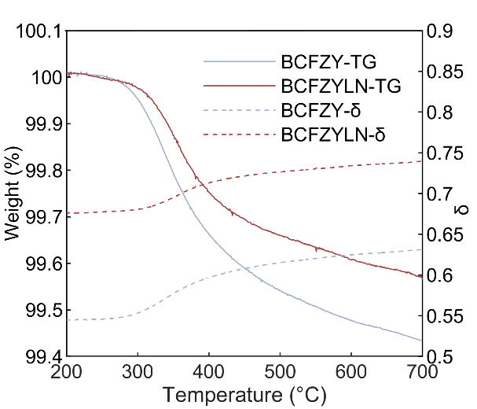
Supplementary Fig. 1 TGA (-TG) and oxygen non-stoichiometry (-δ) of BCFZY and BCFZYLN.

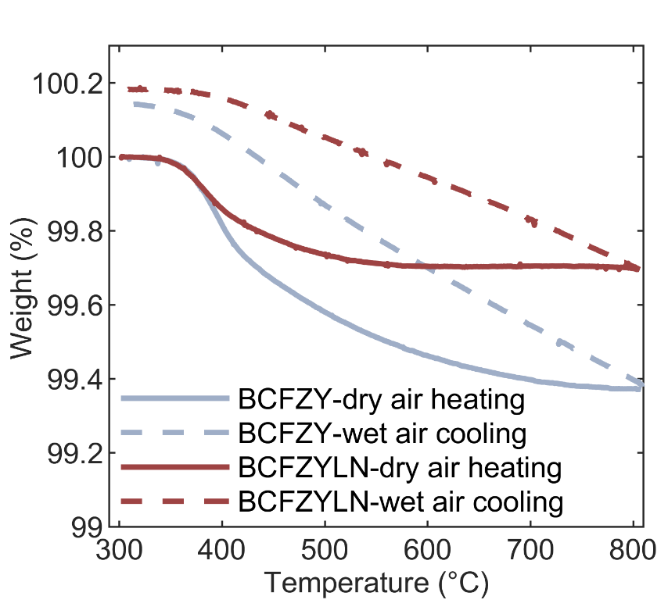
Supplementary Fig. 2 Thermogravimetric curves of BCFZY and BCFZYLN recorded during the heating stage under dry air (solid line) and cooling stage under humid air (dash line).

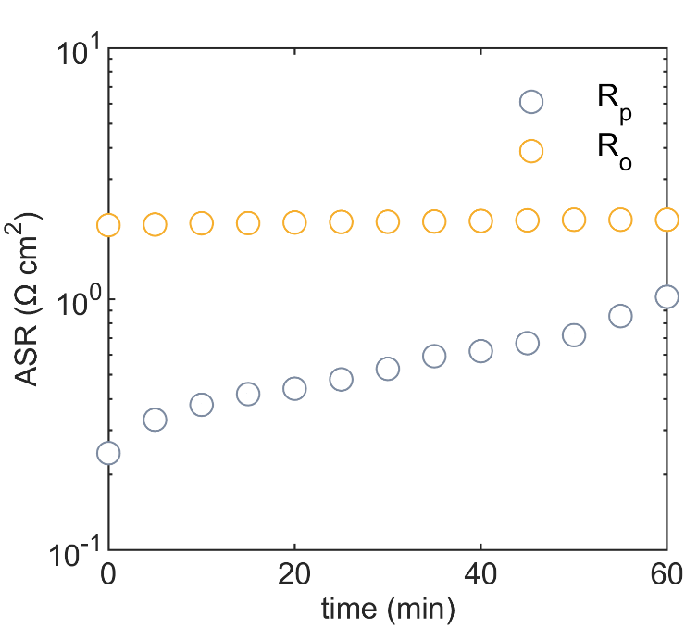
Supplementary Fig. 3 The real time ohmic and polarization resistance of a symmetric cell with a BCFZY cathode during CO₂ treatment.

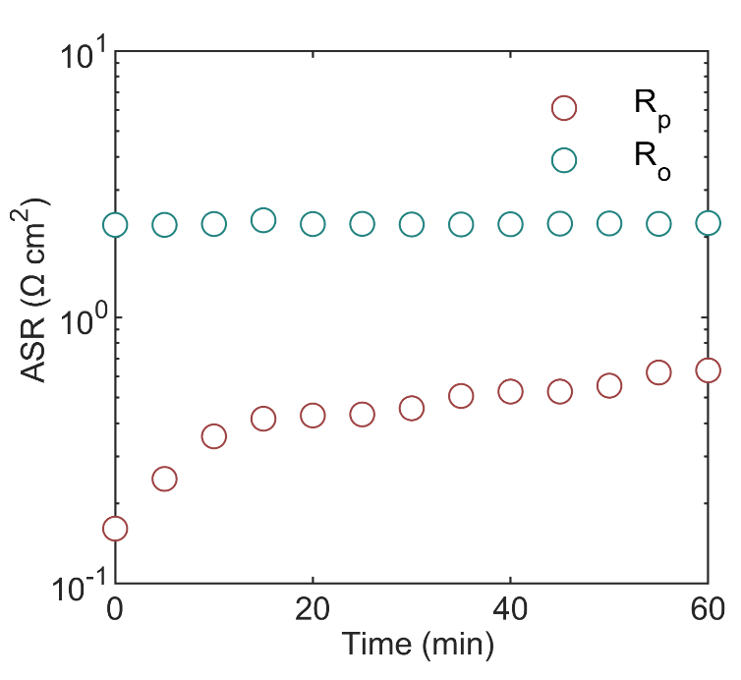
Supplementary Fig. 4 The real time ohmic and polarization resistance of a symmetric cell with a BCFZYLN cathode during CO₂ treatment.

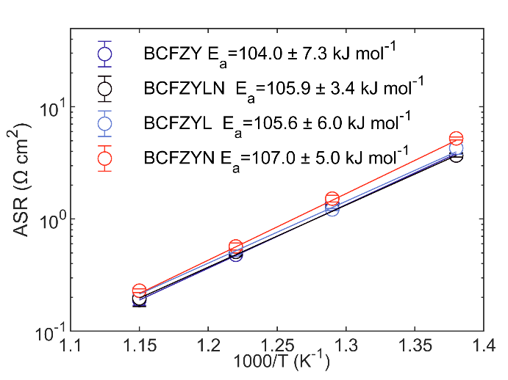
Supplementary Fig. 5 Arrhenius plots of ASRs of BCFZY, BCFZYL, BCFZYN and BCFZYLN cathodes in symmetric cell configuration using BZCYYb electrolyte. Lines through the points are linear fits where the slope is the activation energy (E_{a}), as detailed inset.

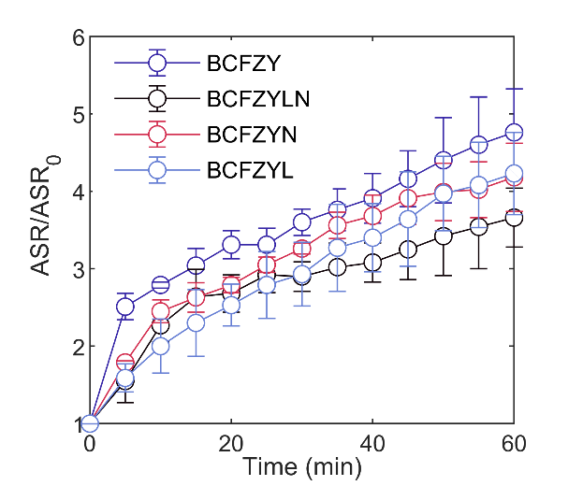
Supplementary Fig. 6 Ratio of the real time ASR to the initial ASR (ASR₀) for BCFZY, BCFZYLN, BCFZYL, and BCFZYN in 10% CO₂ at 600 °C

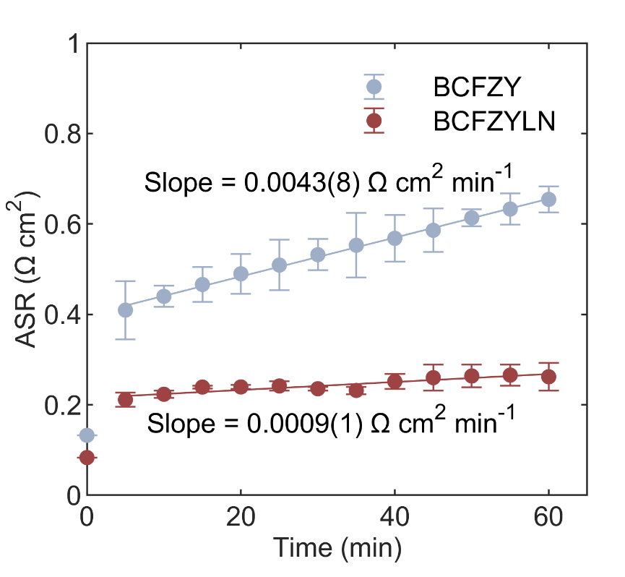
Supplementary Fig. 7 The ratio of real-time ASR to initial ASR (ASR₀) for BCFZY and BCFZYLN in a 10% CO₂ mixture at 700 °C. Lines through the points are linear fits where the slope is the degradation rate.

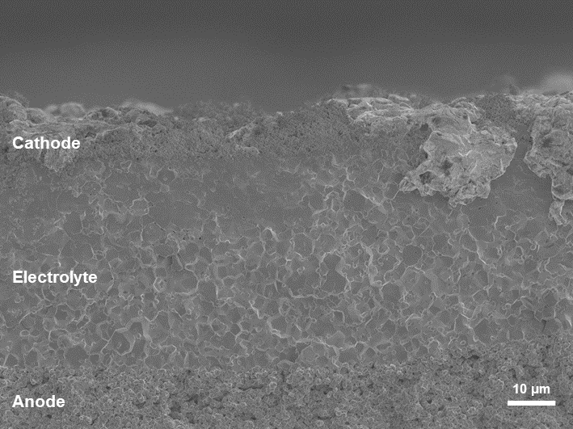
Supplementary Fig. 8 SEM image of a single cell with ~ 30 μm electrolyte, a BCFZYLN cathode and a Ni + BZCYYb anode.

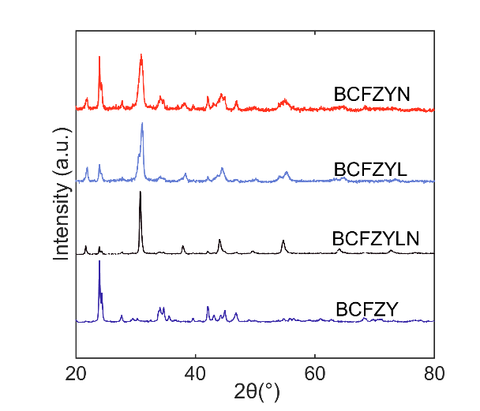
Supplementary Fig. 9 Laboratory XRD data of CO₂ treated BCFZY, BCFZYL, BCFZYN, and BCFZYLN. Data are offset in y for clarity.

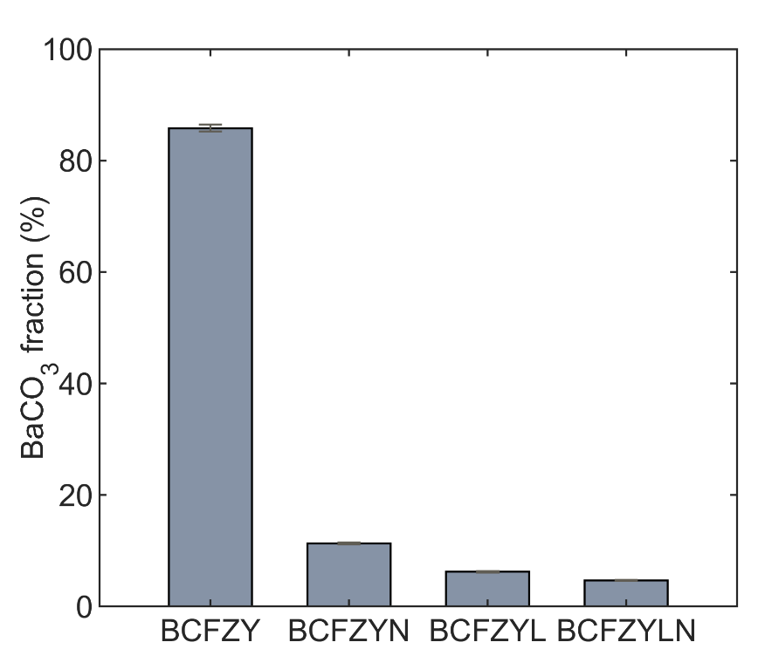
Supplementary Fig. 10 % BaCO₃ in treated samples obtained from XRD data: BCFZY, BCFZYN, BCFZYL, and BCFZYLN = 85.8(6), 11.3(1), 6.26(1), and 4.68(1), respectively.
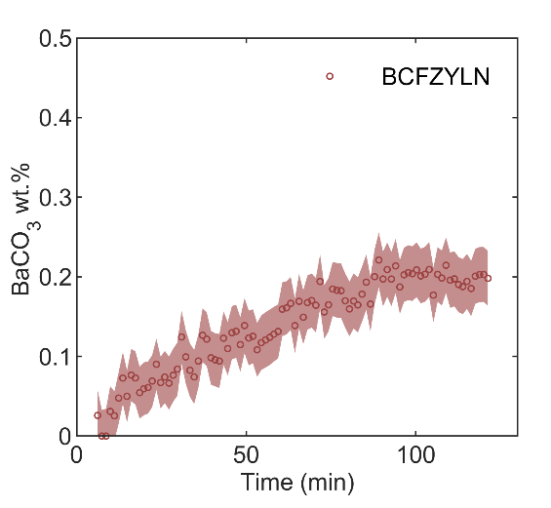
Supplementary Fig. 11 Wt.% BaCO₃ in BCFZYLN in a flow of pure CO₂ at 600 °C.

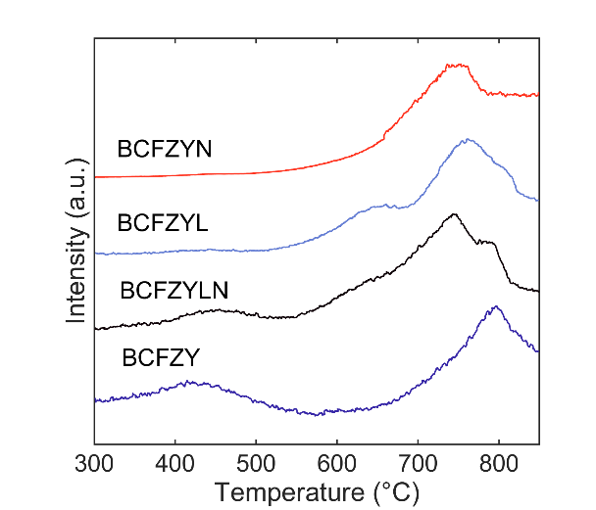
Supplementary Fig. 12 TPD data for BCFZY, BCFZYL, BCFZYN, and BCFZYLN. Data are offset in y for clarity.
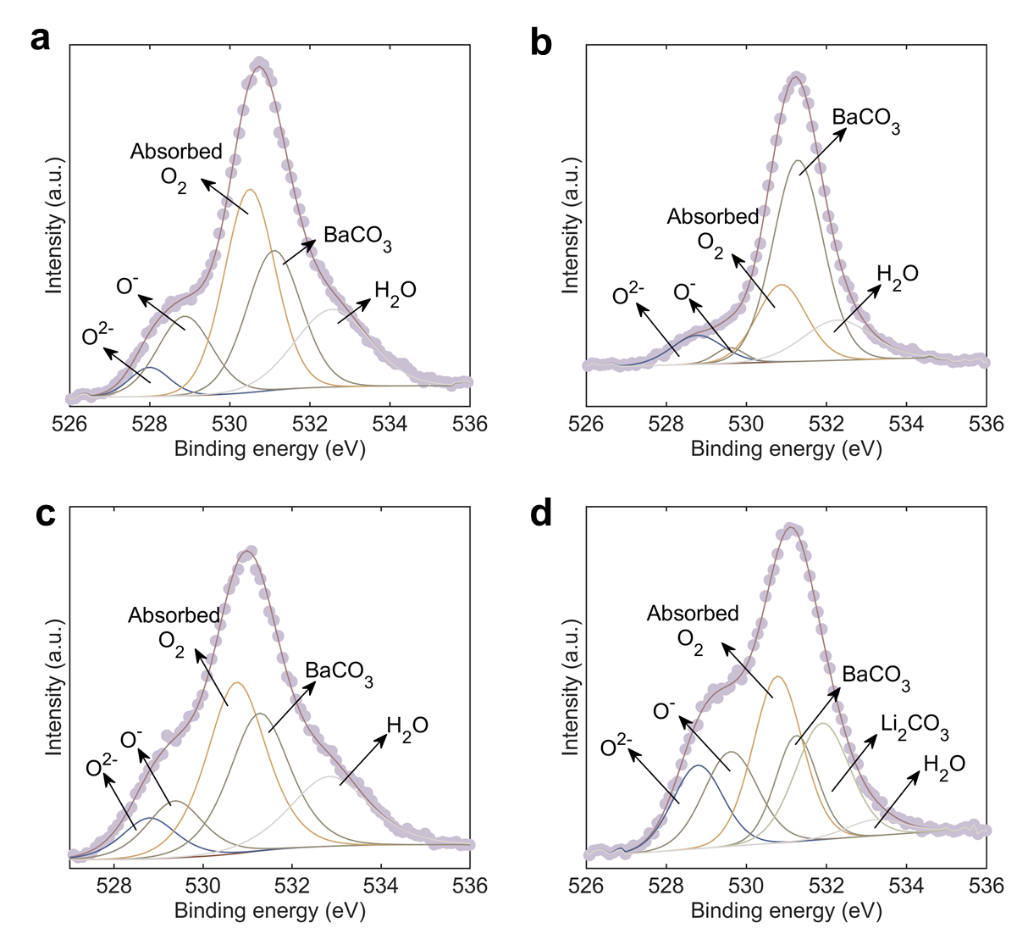
Supplementary Fig. 13 XPS spectra of O 1s for a) wet air treated BCFZY, b) wet CO₂ treated BCFZY, c)wet air treated BCFZYLN and d) wet CO₂ treated BCFZYLN
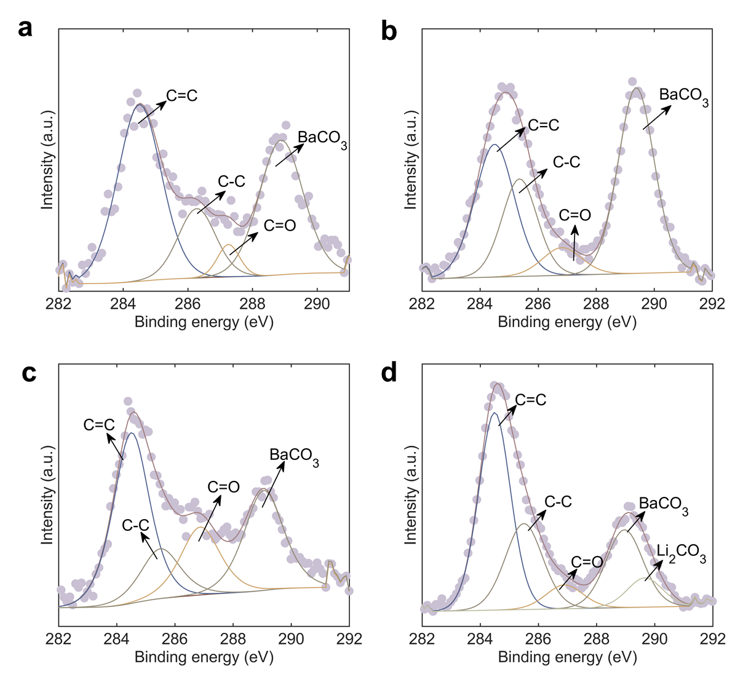
Supplementary Fig. 14 XPS spectra of C 1s for a) wet air treated BCFZY, b) wet CO₂ treated BCFZY, c)wet air treated BCFZYLN and d) wet CO₂ treated BCFZYLN.

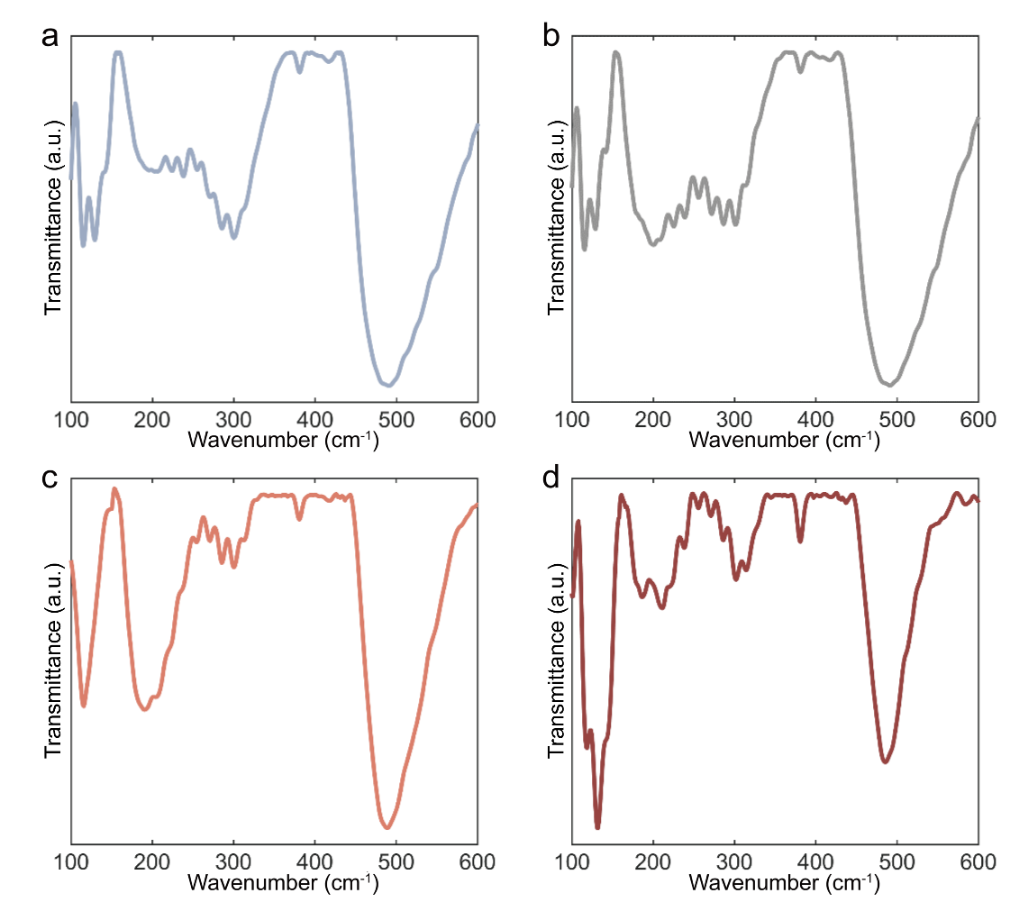
Supplementary Fig. 15- The terahertz spectrum of BCFZY treated in a air and b air with 10% CO₂ and BCFZYLN treated in c air and d air with 10% CO₂. The feature at ~ 435 cm⁻¹ for BCFZYLN in air and in air with 10% CO₂ can be attributed to alkali metal carbonates.
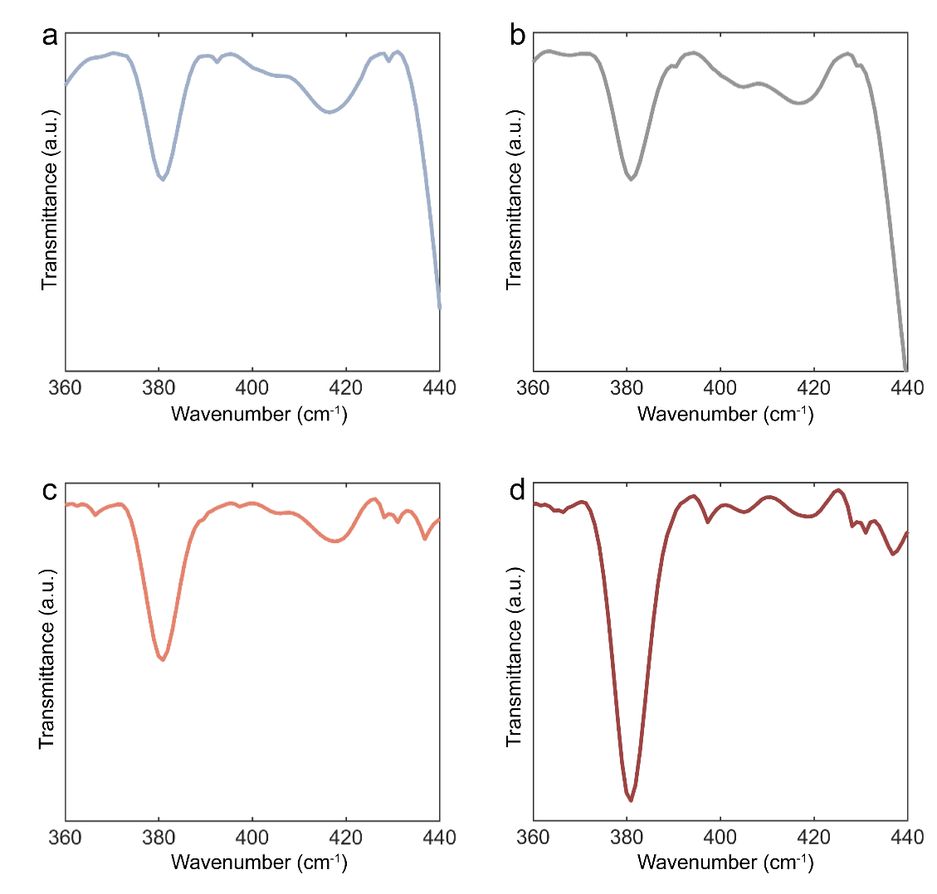
Supplementary Fig. 16- The terahertz spectrum between 360 cm⁻¹ and 440 cm⁻¹ of BCFZY treated in a air and b air with 10% CO₂ and BCFZYLN treated in c air and d air with 10% CO₂. The feature at ~ 435 cm⁻¹ in the spectrum for BCFZYLN in air and air with 10% CO₂ can be attributed to alkali metal carbonates.

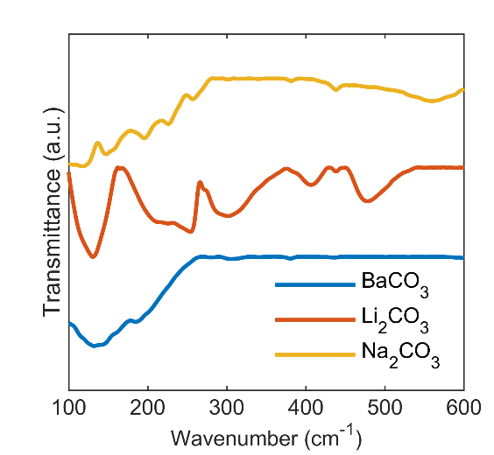
Supplementary Fig. 17- The terahertz spectrum of BaCO₃, Li₂CO_{3,} and Na₂CO₃. A feature at ~ 435 cm⁻¹ is observed in the spectrum of Li₂CO₃ or Na₂CO₃ but not BaCO₃. Data are offset in y for clarity.

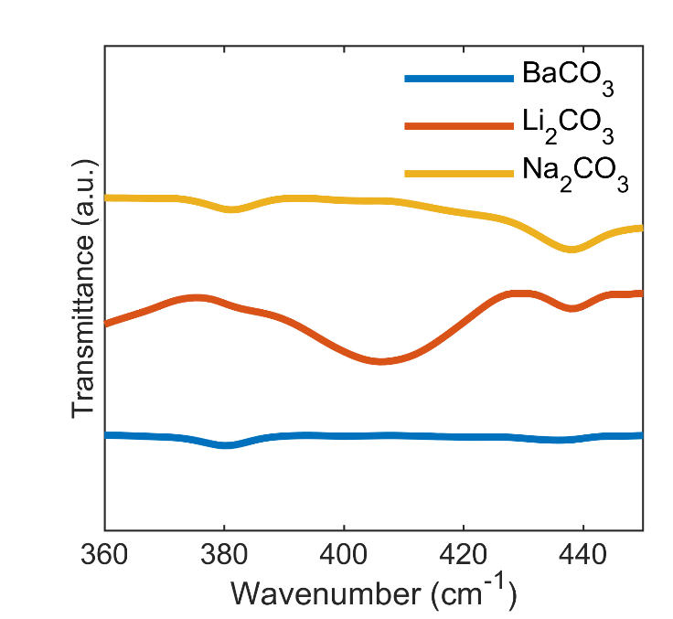
Supplementary Fig. 18- The terahertz spectrum of BaCO₃, Li₂CO_{3,} and Na₂CO₃ between 360 cm⁻¹ and 450 cm⁻¹. A feature at ~ 435 cm⁻¹ is observed in the spectrum of Li₂CO₃ or Na₂CO₃ but not BaCO₃. Data are offset in y for clarity.

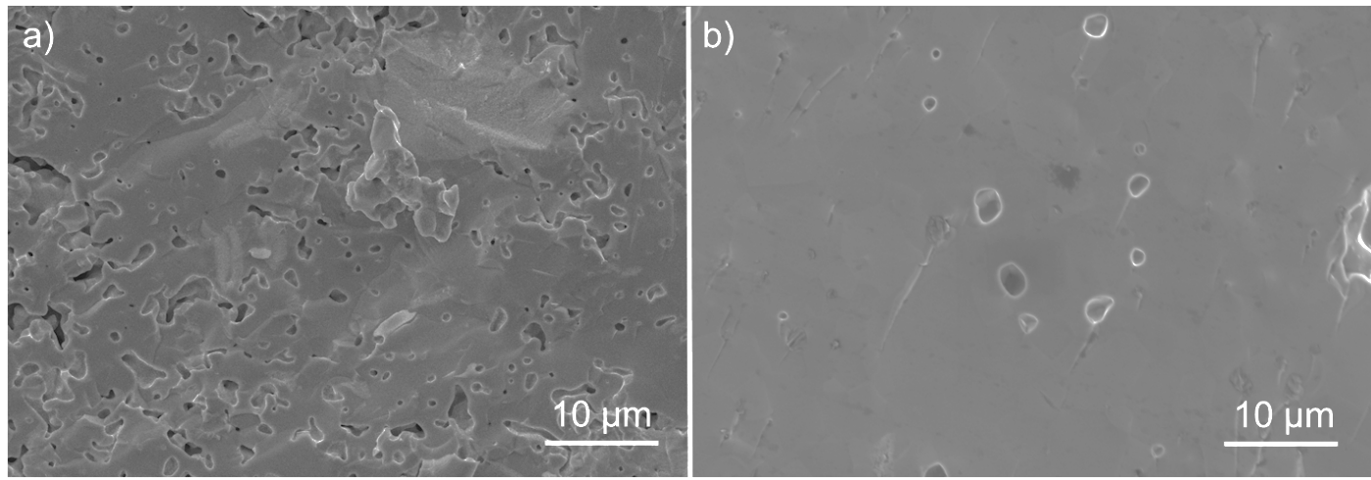
Supplementary Fig. 19 a Typical SEM image of untreated BCFZY. b Typical SEM image of untreated BCFZYLN

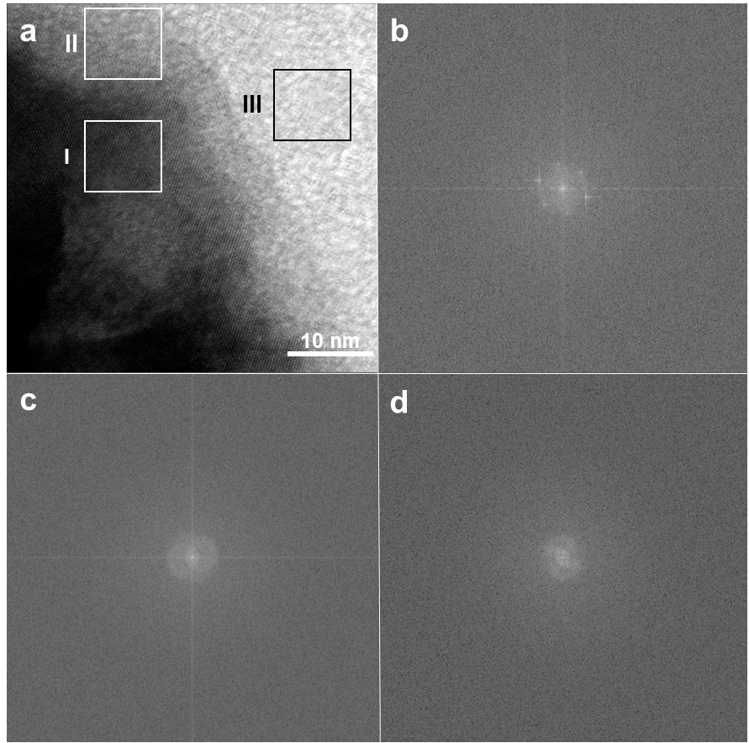
Supplementary Fig. 20 a TEM image of BCFZYLN after CO₂ treatment. b FFT of region I in a showing features consistent with the 100 reflection of the perovskite-type struictured oxide phase. c FFT of region II in a, without features consistent with a crystalline phase. d FFT of the sample background region III in a.

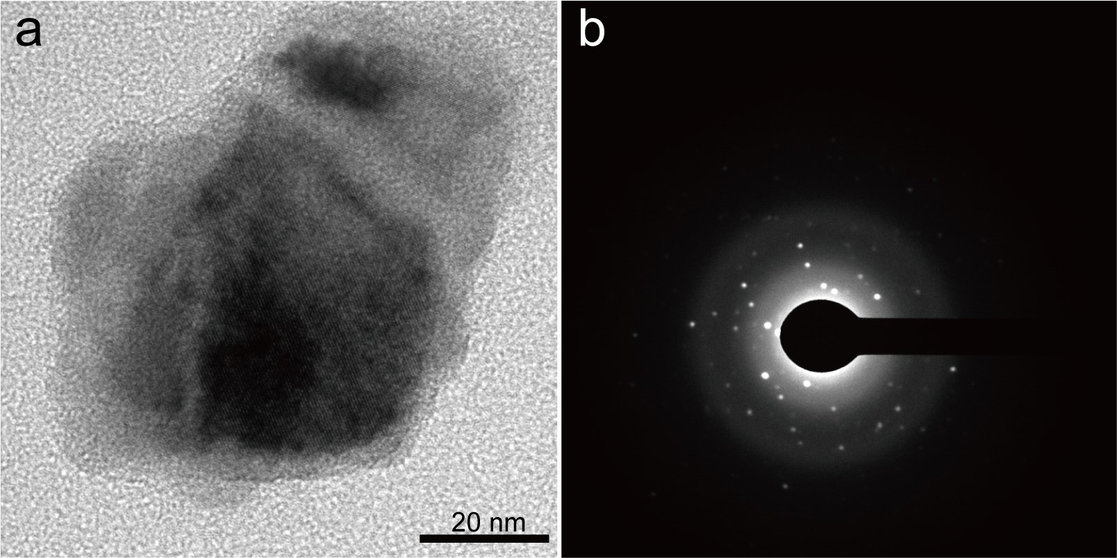
Supplementary Fig. 21 a TEM image of a BCFZYLN particle after CO₂ treatment. b SAED data from the overall region in a.

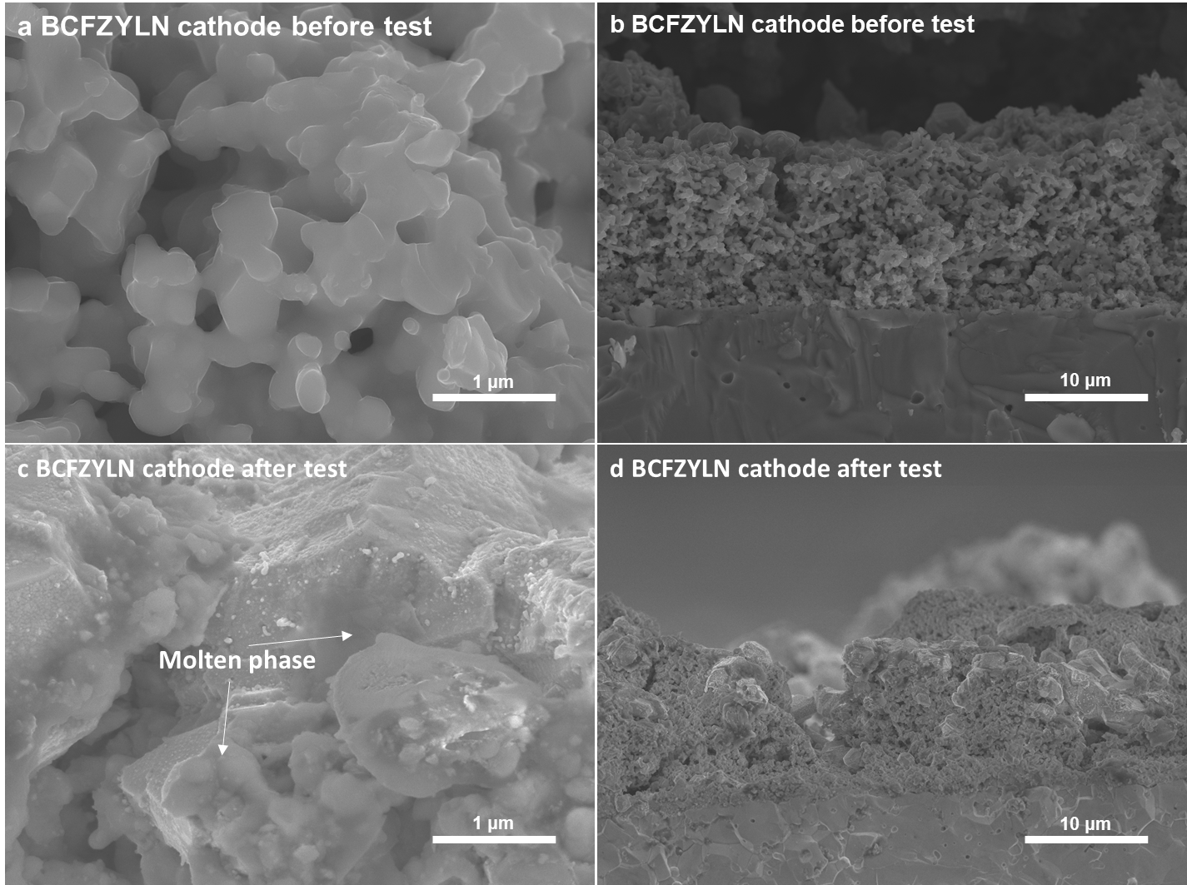
Supplementary Fig. 22 SEM image of the BCFZYLN cathode in a single cell showing microstructure before CO₂ treatment under a high and b low magnification and after CO₂ treatment under c high and d low magnification.

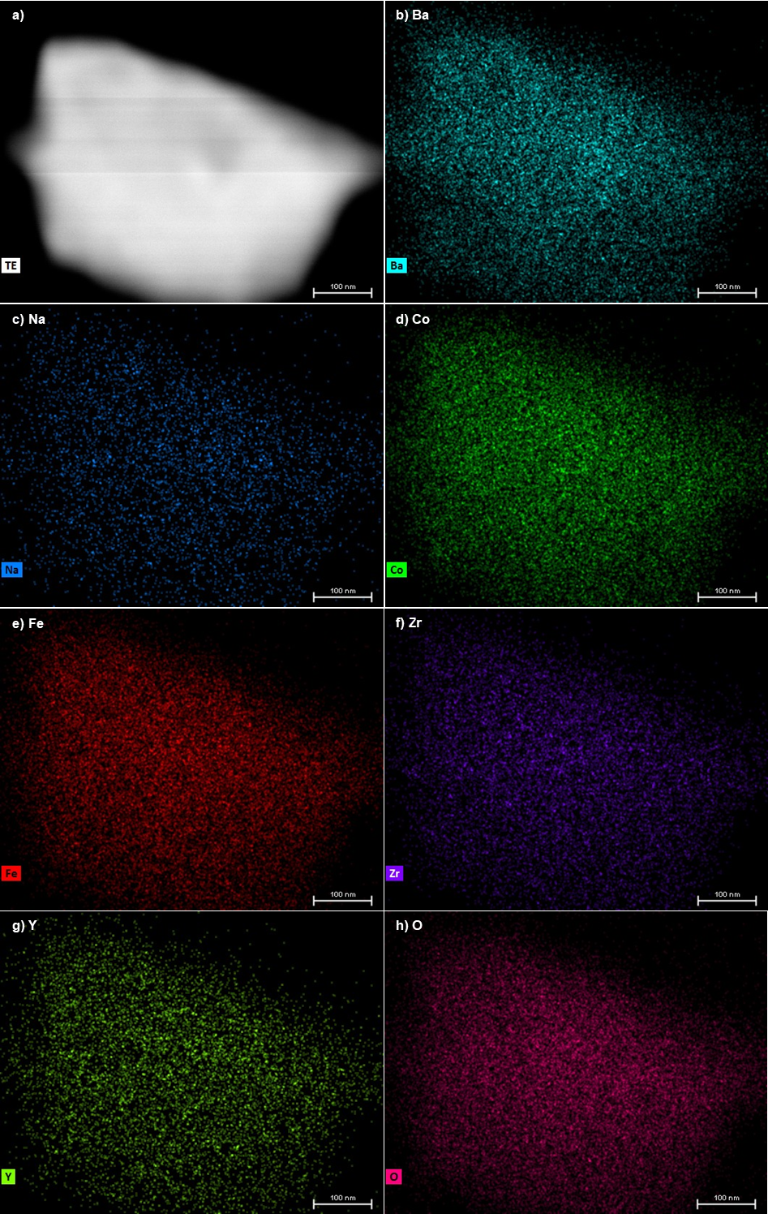
Supplementary Fig. 23 TEM image with elemental mapping obtained from EDS of CO₂-treated BCFZYLN.

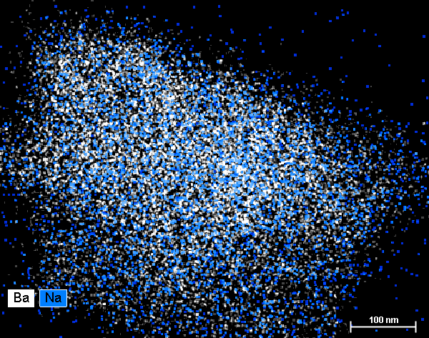
Supplementary Fig. 24 TEM image with Ba and Na mapping obtained from EDS of CO₂-treated BCFZYLN.

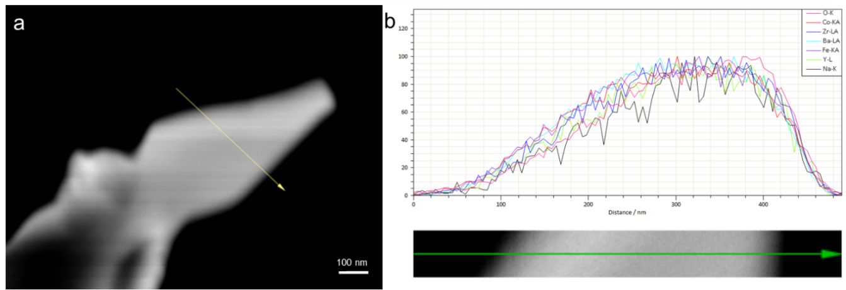
Supplementary Fig. 25 a Scanning TEM image of a BCFZYLN particle indicating the EDS scan direction. b Normalized corresponding elemental concentration obtained from the EDS scan.

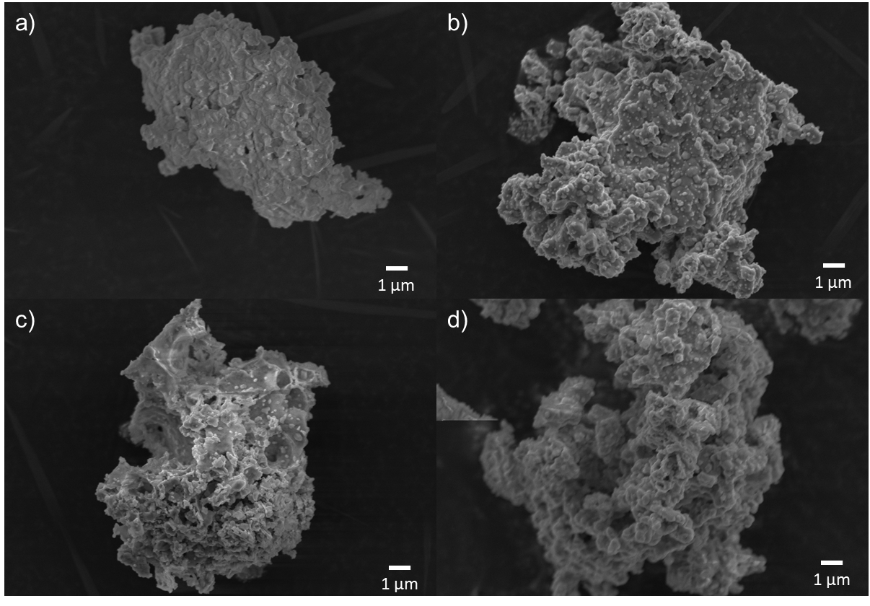
Supplementary Fig. 26 SEM image of the as-synthesized a) BCFZY, b) BCFZYLN, c) BCFZYN and d) BCFZYL.

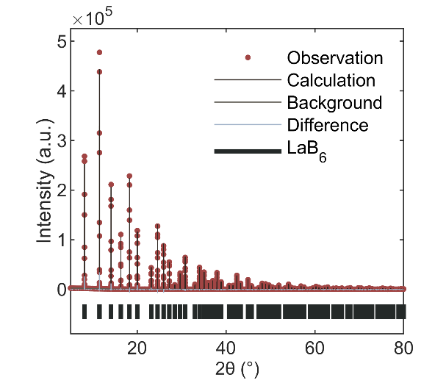
Supplementary Fig. 27 SXRD refinement profile for the NIST 660b LaB₆ standard reference material, the refined X-ray wavelength is 0.590313(7) Å.

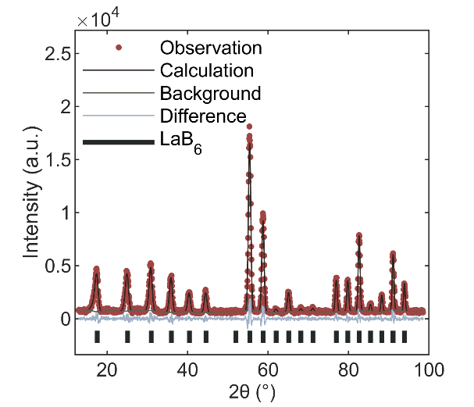
Supplementary Fig. 28 NPD refinement profile for the NIST 660b LaB₆ stanbdard reference material, the refined neutron wavelength is 1.2958(2) Å.

Reference
1 Kiryukhin, V. et al. Uncorrelated and correlated nanoscale lattice distortions in the paramagnetic phase of magnetoresistive manganites. Physical Review B 70, 214424, doi:10.1103/PhysRevB.70.214424 (2004).
2 Zou, D. et al. The BaCe0.16Y0.04Fe0.8O3−δ nanocomposite: a new high-performance cobalt-free triple-conducting cathode for protonic ceramic fuel cells operating at reduced temperatures. Journal of Materials Chemistry A 10, 5381-5390, doi:10.1039/D1TA10652J (2022).
3 Wang, X. et al. Enhanced proton conductivity and CO2-tolerance of intermediate-temperature protonic ceramic fuel cell with lanthanum tungstate-based composite cathode. Composites Part B: Engineering 253, 110565, doi:https://doi.org/10.1016/j.compositesb.2023.110565 (2023).
4 Xie, C. et al. Investigation of Self-Assembled Dual-Phase Cathodes with Triple Conductivity for Protonic Ceramic Fuel Cells. ACS Applied Energy Materials 6, 5979-5988, doi:10.1021/acsaem.3c00439 (2023).

