Supporting Information

Xiaohong Wenª, Zengcai Zhao^{b}, Yuchang Chen^{c}, Xinzhi Shanª, Xuefeng Zhao^{d*} Xiumin Gao^{a*}, Songlin Zhuangª

ª School of Optical-Electrical and Computer Engineering, University of Shanghai for Science and Technology, Shanghai 200093, China
^{b} School of Science, Hangzhou Dianzi University, Hangzhou, 310018, China
^{c} State Key Laboratory of ASIC and System, Shanghai Institute of Intelligent Electronics & Systems, School of Microelectronics, Fudan University, Shanghai 200433, China.
^{d} State Key Laboratory of High Performance Ceramics and Superfine Microstructure, Shanghai Institute of Ceramics, Chinese Academy of Sciences, Shanghai 200050, China.

∗ Corresponding authors
E-mail addresses: zhaoxuefeng@mail.sic.ac.cn; gxm@usst.edu.cn;

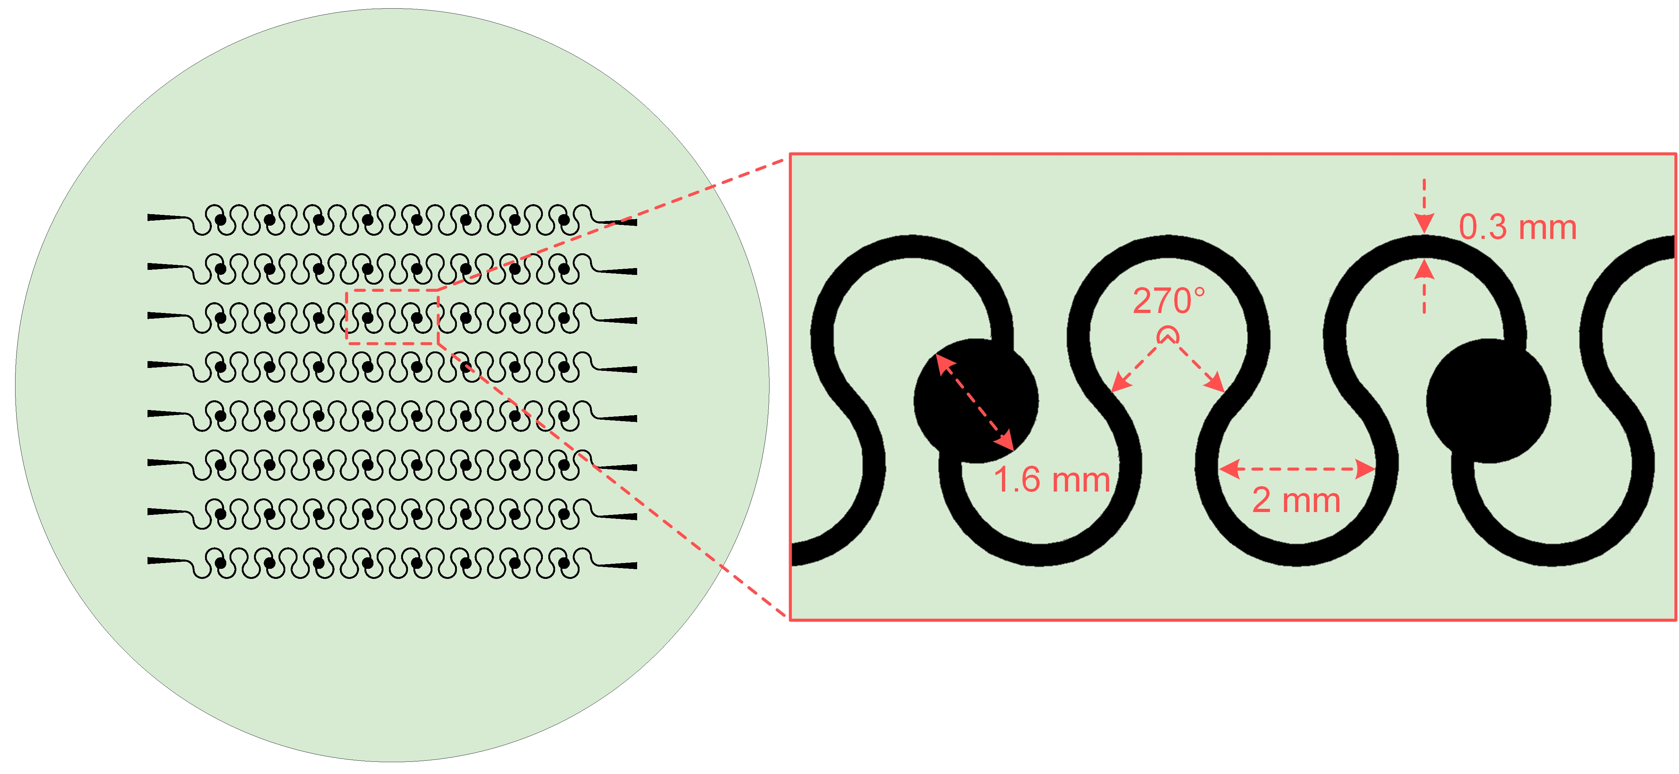
Fig. S1 Schematic diagram of the patterned template for the embedded stretchable electrodes and its key geometrical parameters.

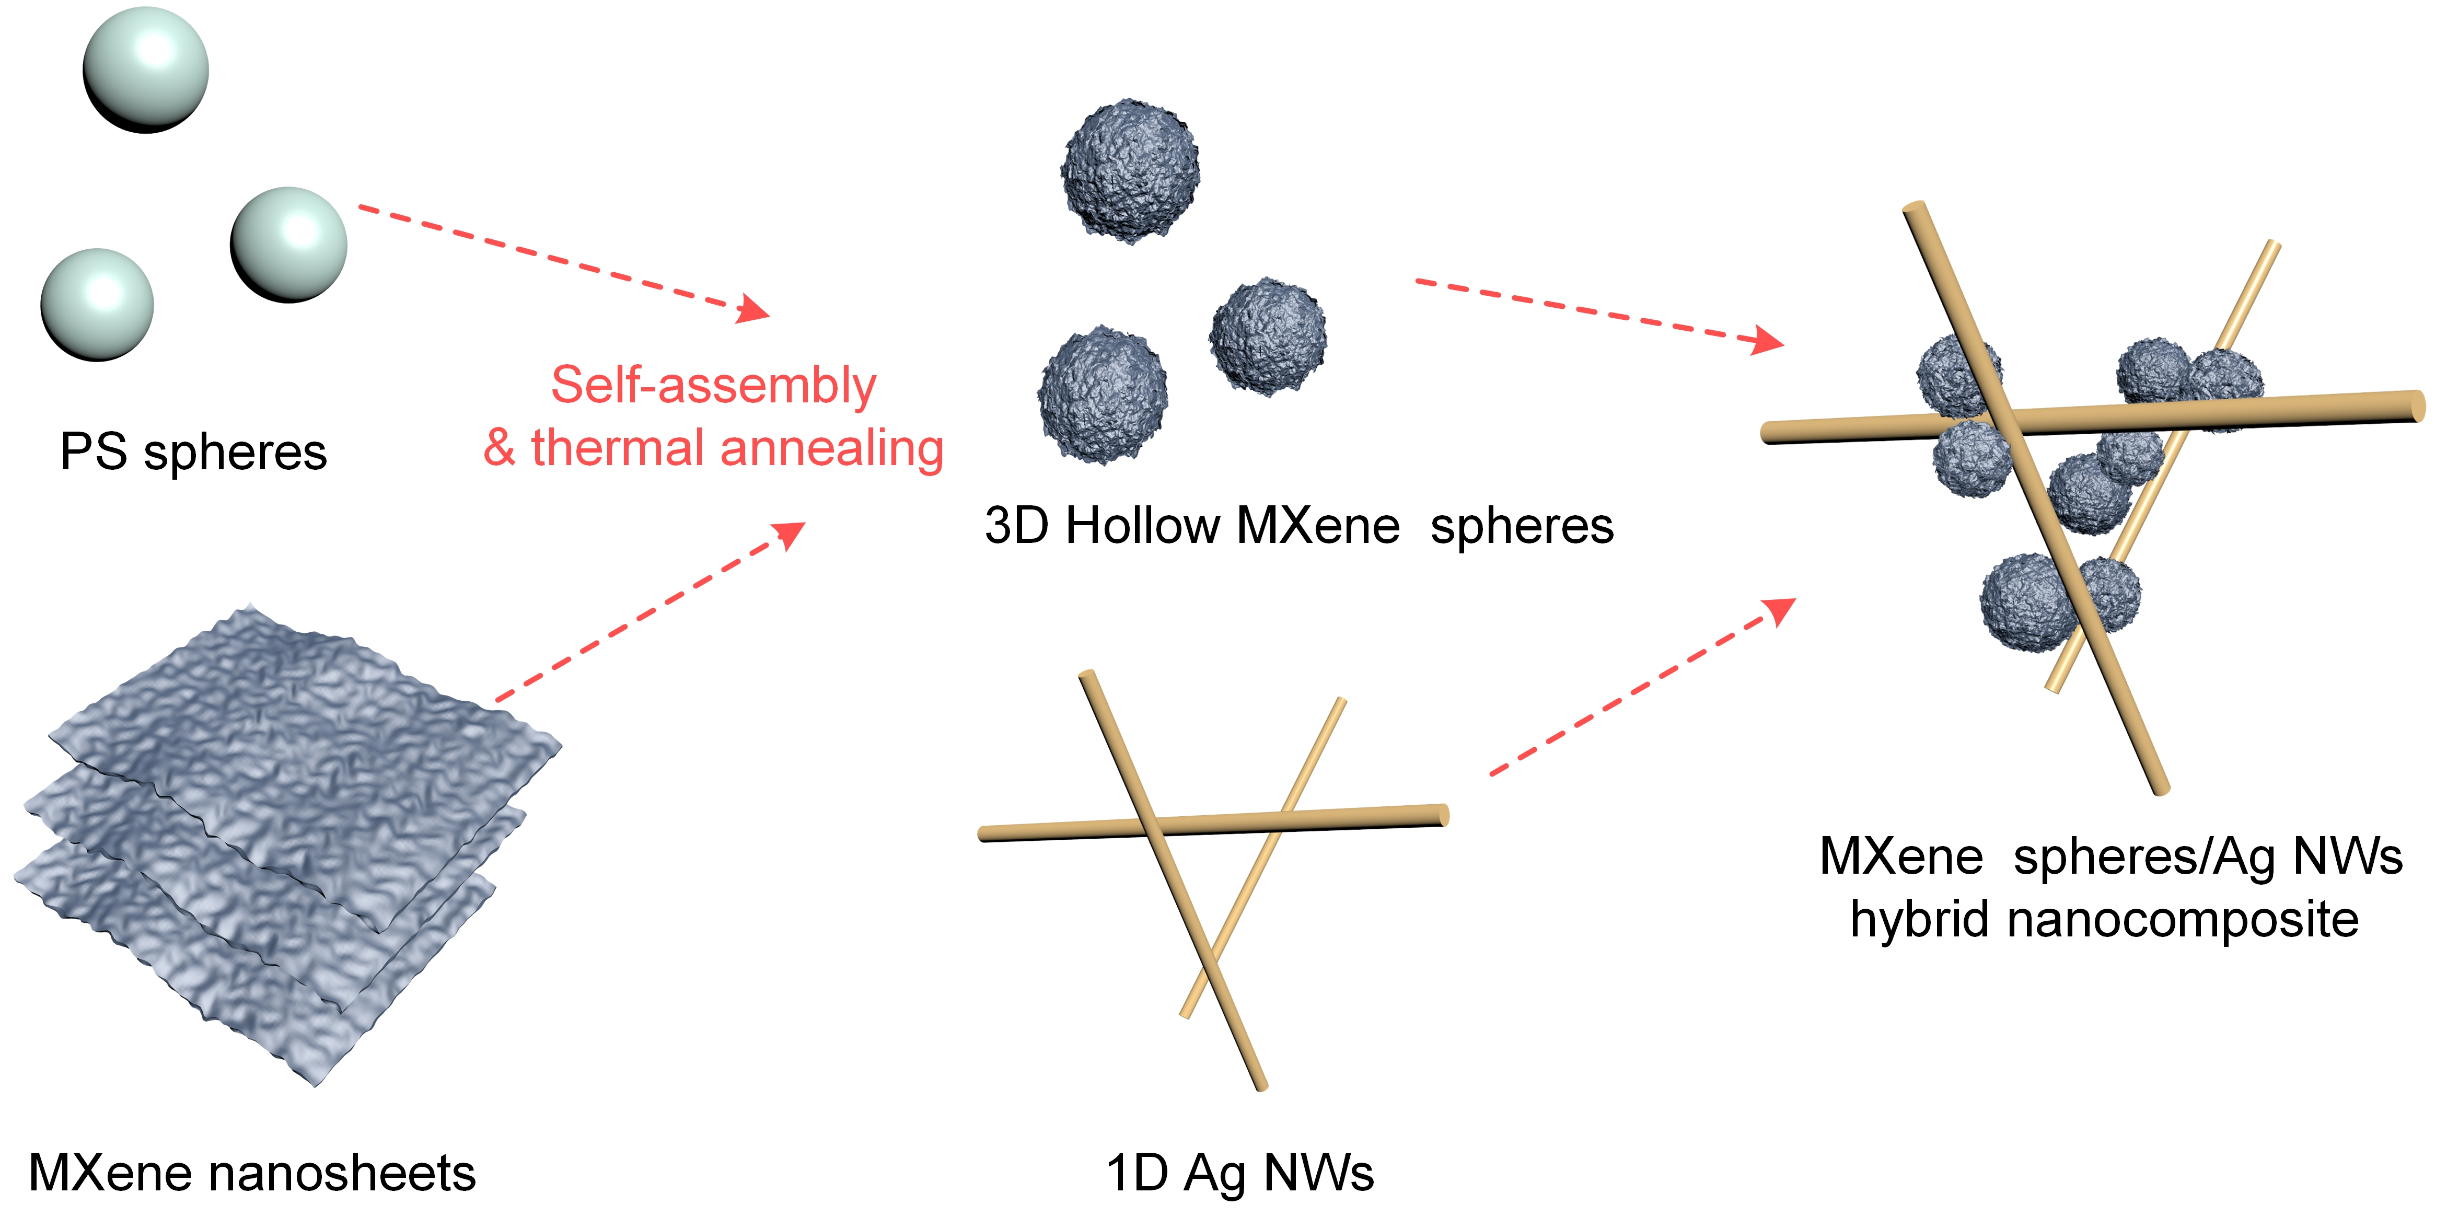
Fig.S2 Synthesis process of the 3D hollow MXene spheres/Ag NWs composite.

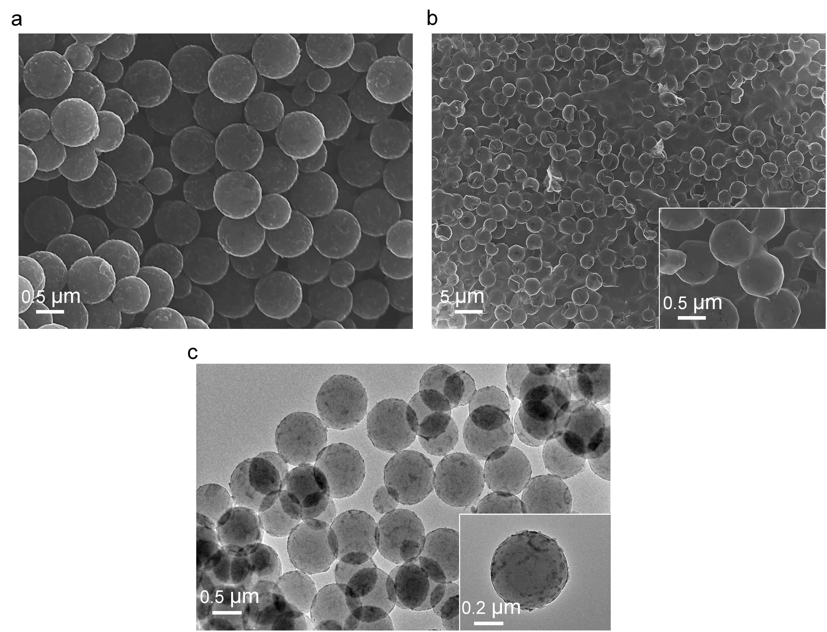
Fig.S3 SEM images of different preparation stages of embedded stretchable electrode: a PS @MXene spheres, b 3D hollow MXene spheres. c TEM images of PS @MXene spheres.

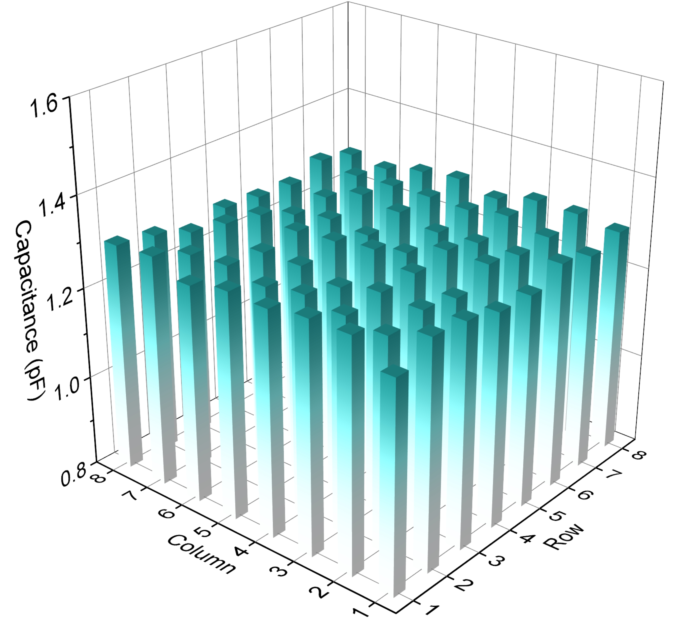
Fig. S4 The initial capacitance value of each capacitor in the e-skin.

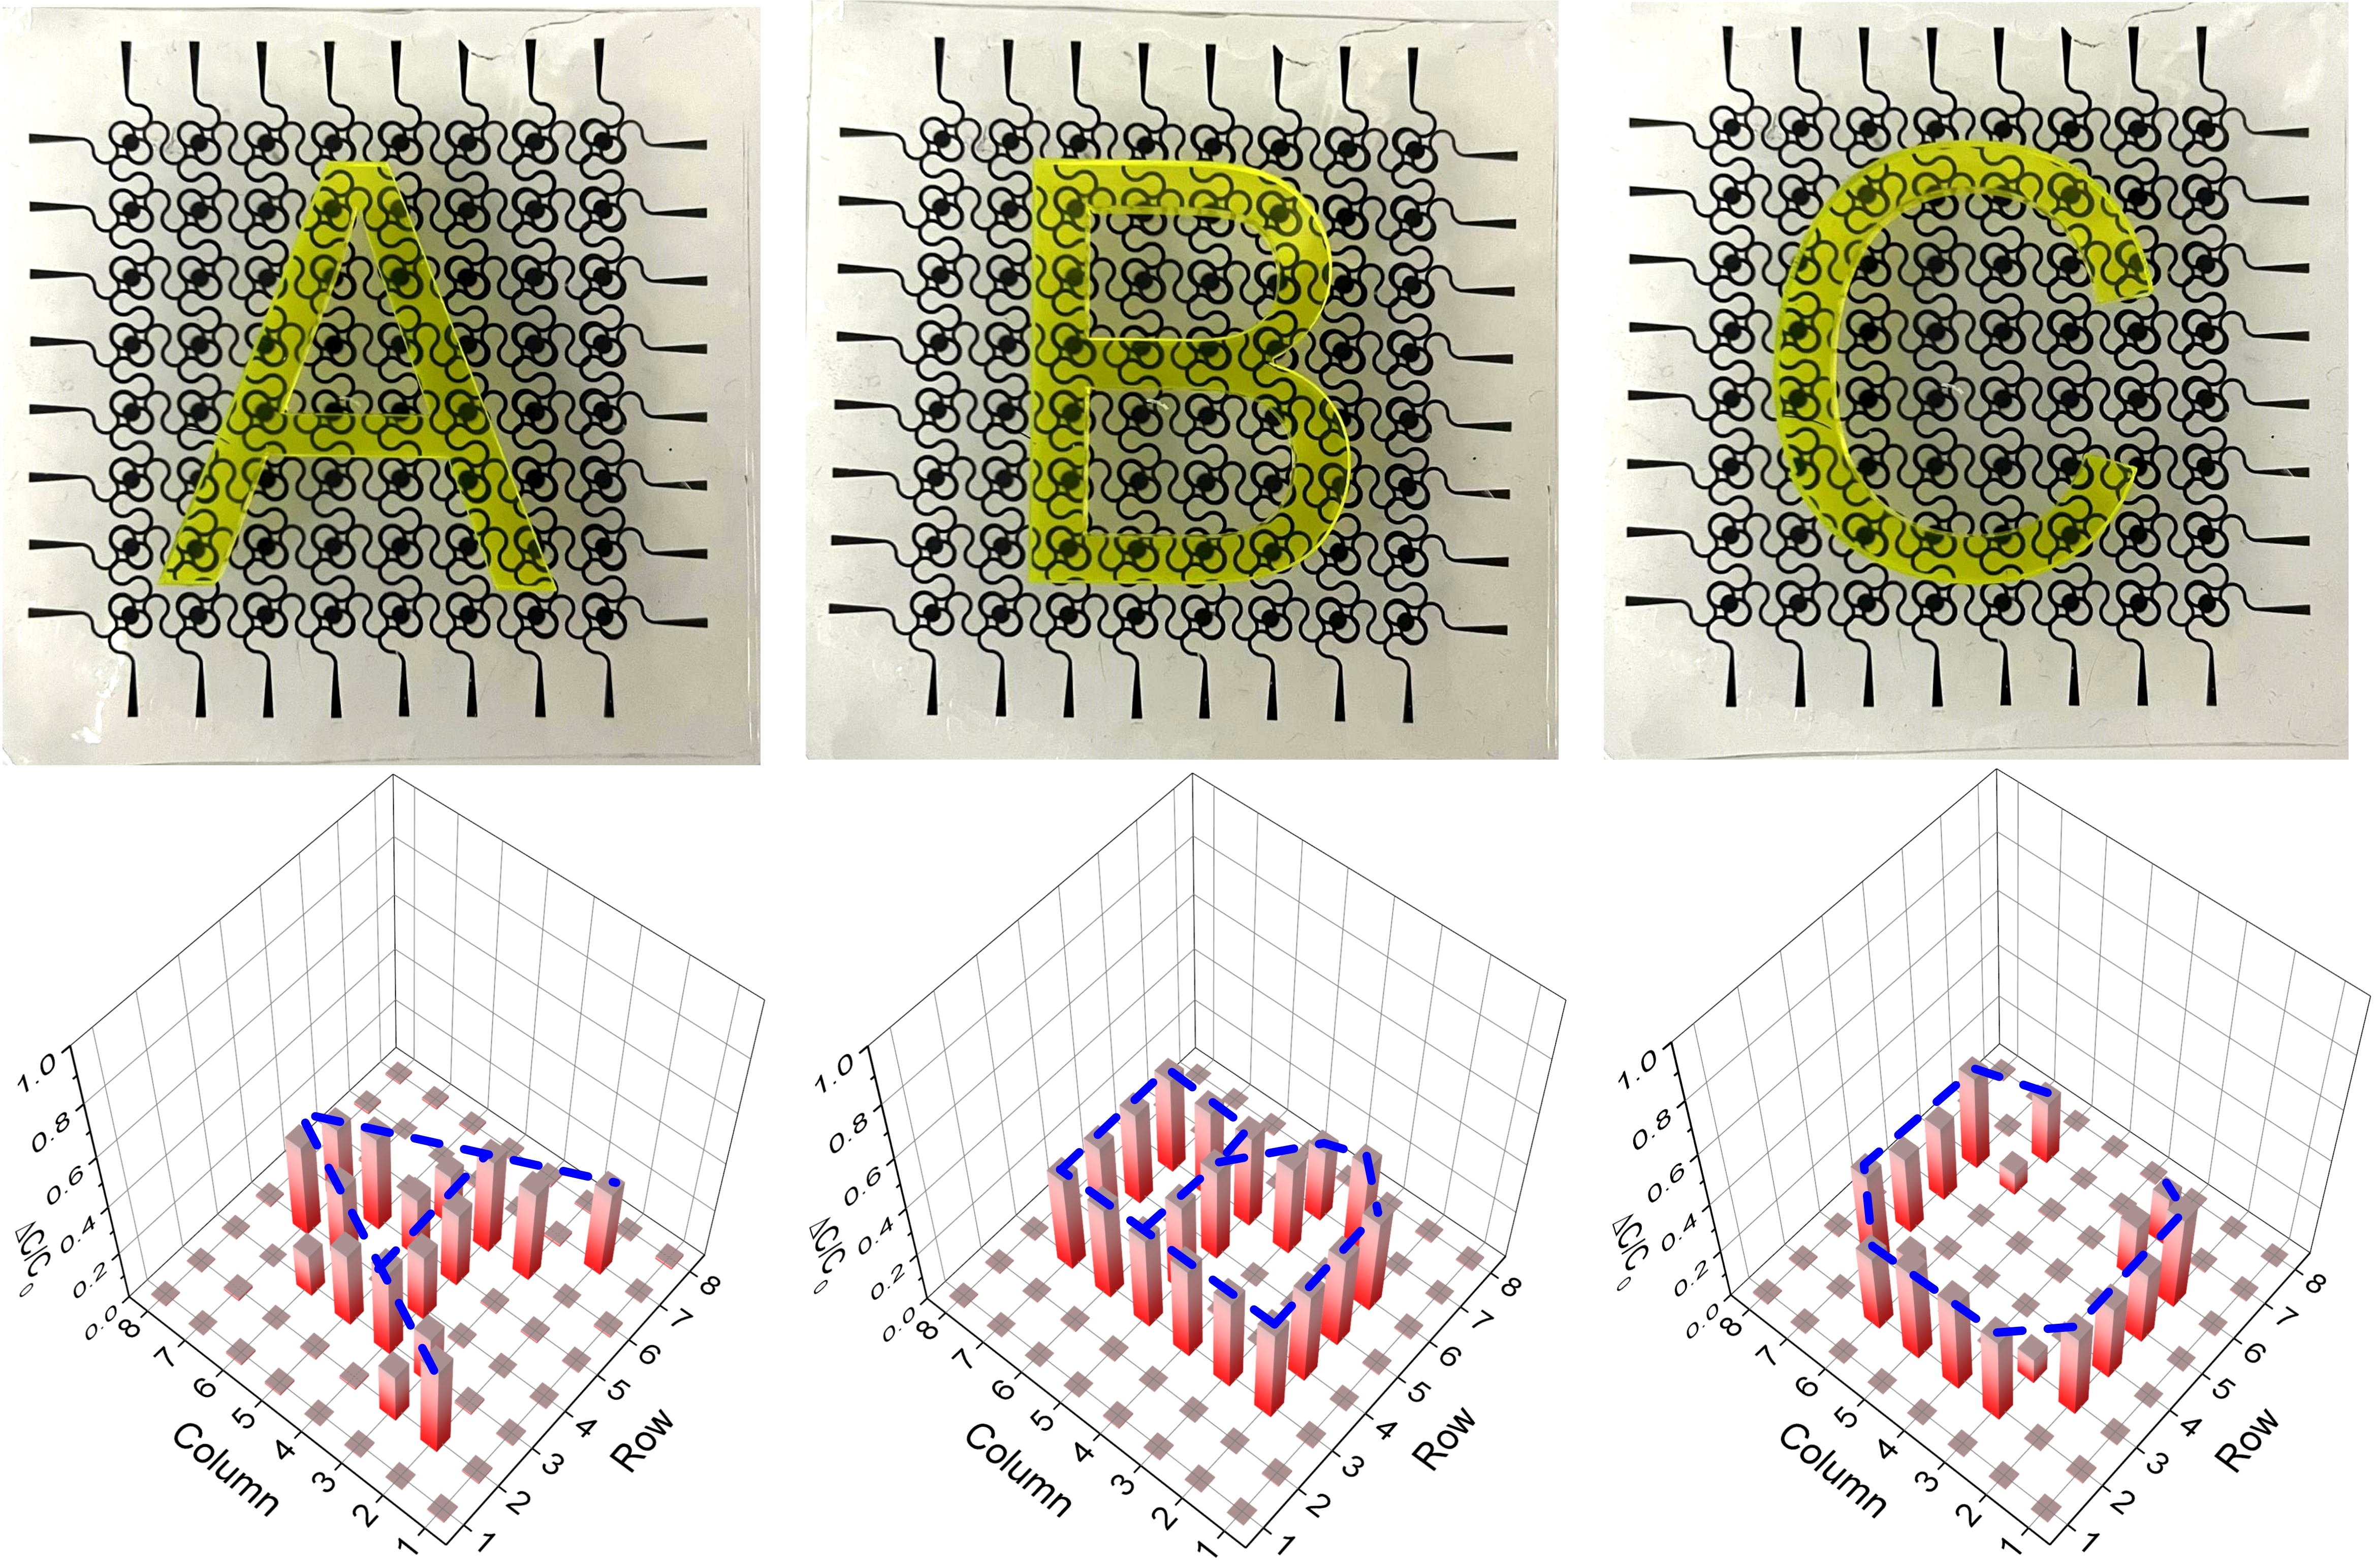
Fig.S5 “A”, “B” and “C” pressure graphics physical maps and letters recognition results.

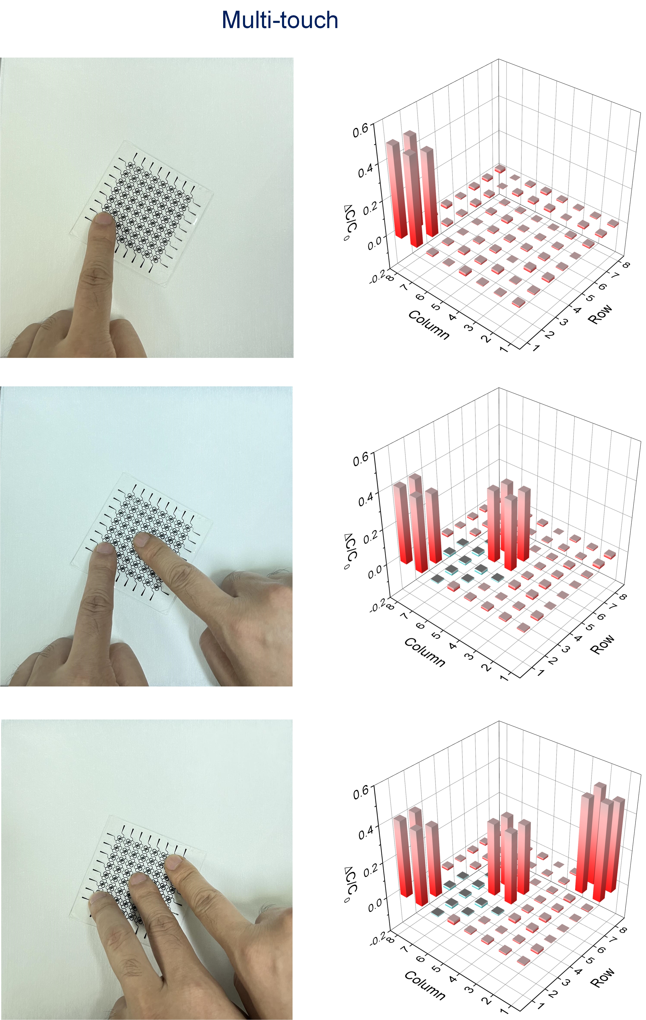
Fig.S6 Simultaneously detecting charts and results with different numbers of fingers, demonstrating multi-touch capabilities.

