Appendix 1: The Idealized Large-Eddy Simulations
Table 6 Characteristic values of each of the 148 idealized simulations
sim ID | $$U_{g}$$ | $$β$$ | $$〈H_{s}〉$$ | $$〈{λE}_{s}〉$$ | $$〈u_{*}/w_{*}〉$$ | $$z_{i}$$ | $$〈\overline{T_{s}}〉$$ | $$∆\overline{T}$$ | $$〈\overline{Q_{s}}〉$$ | $$H$$
1 | 0.5 | 0.185 | 115.7 | 616.5 | 0.188 | 671.2 | 289.4 | 0.136 | 0.0113 | 16.028
2 | 1.0 | 0.184 | 115.7 | 616.5 | 0.190 | 675.5 | 289.4 | 0.119 | 0.0113 | 3.464
3 | 2.0 | 0.184 | 115.7 | 616.5 | 0.182 | 673.6 | 289.4 | 0.100 | 0.0114 | 0.776
4 | 4.0 | 0.183 | 115.7 | 616.5 | 0.216 | 667.6 | 289.4 | 0.084 | 0.0115 | 0.179
5 | 9.0 | 0.184 | 115.7 | 616.5 | 0.347 | 672.6 | 289.5 | 0.081 | 0.0117 | 0.028
6 | 0.5 | 0.177 | 114.0 | 618.6 | 0.185 | 678.1 | 289.3 | 0.517 | 0.0114 | 47.100
7 | 1.0 | 0.179 | 114.0 | 618.6 | 0.188 | 670.9 | 289.3 | 0.486 | 0.0114 | 10.131
8 | 2.0 | 0.179 | 114.0 | 618.6 | 0.180 | 670.9 | 289.3 | 0.458 | 0.0114 | 2.230
9 | 4.0 | 0.180 | 114.0 | 618.6 | 0.217 | 657.8 | 289.4 | 0.425 | 0.0116 | 0.564
10 | 9.0 | 0.180 | 114.0 | 618.6 | 0.354 | 660.6 | 289.5 | 0.336 | 0.0117 | 0.088
11 | 0.5 | 0.187 | 119.9 | 611.3 | 0.184 | 661.3 | 289.4 | 0.613 | 0.0113 | 90.096
12 | 0.5 | 0.187 | 119.9 | 611.3 | 0.184 | 661.3 | 289.4 | 0.613 | 0.0113 | 90.096
13 | 1.0 | 0.191 | 119.9 | 611.3 | 0.181 | 686.9 | 289.4 | 0.544 | 0.0113 | 14.999
14 | 1.0 | 0.191 | 119.9 | 611.3 | 0.181 | 686.9 | 289.4 | 0.544 | 0.0113 | 14.999
15 | 2.0 | 0.191 | 119.9 | 611.3 | 0.180 | 680.6 | 289.4 | 0.507 | 0.0113 | 3.499
16 | 2.0 | 0.191 | 119.9 | 611.3 | 0.180 | 680.6 | 289.4 | 0.507 | 0.0113 | 3.499
17 | 4.0 | 0.192 | 119.9 | 611.3 | 0.211 | 671.6 | 289.5 | 0.492 | 0.0115 | 0.946
18 | 9.0 | 0.191 | 119.9 | 611.3 | 0.346 | 673.3 | 289.6 | 0.428 | 0.0116 | 0.155
19 | 0.5 | 0.177 | 113.2 | 619.6 | 0.183 | 647.1 | 289.3 | 0.556 | 0.0114 | 91.261
20 | 0.5 | 0.177 | 113.2 | 619.6 | 0.183 | 647.1 | 289.3 | 0.556 | 0.0114 | 91.261
21 | 1.0 | 0.175 | 113.2 | 619.6 | 0.185 | 651.8 | 289.3 | 0.547 | 0.0115 | 22.314
22 | 1.0 | 0.175 | 113.2 | 619.6 | 0.185 | 651.8 | 289.3 | 0.547 | 0.0115 | 22.314
23 | 2.0 | 0.178 | 113.2 | 619.6 | 0.181 | 661.9 | 289.3 | 0.497 | 0.0115 | 4.464
24 | 2.0 | 0.178 | 113.2 | 619.6 | 0.181 | 661.9 | 289.3 | 0.497 | 0.0115 | 4.464
25 | 4.0 | 0.179 | 113.2 | 619.6 | 0.220 | 653.6 | 289.3 | 0.493 | 0.0117 | 1.216
26 | 9.0 | 0.178 | 113.2 | 619.6 | 0.355 | 649.2 | 289.4 | 0.459 | 0.0118 | 0.221
27 | 0.5 | 0.487 | 232.6 | 473.4 | 0.163 | 870.8 | 291.5 | 0.215 | 0.0095 | 28.519
28 | 1.0 | 0.485 | 232.6 | 473.4 | 0.163 | 868.9 | 291.5 | 0.198 | 0.0095 | 5.867
29 | 2.0 | 0.484 | 232.6 | 473.4 | 0.162 | 868.2 | 291.6 | 0.163 | 0.0095 | 0.949
30 | 4.0 | 0.484 | 232.6 | 473.4 | 0.172 | 864.6 | 291.6 | 0.141 | 0.0096 | 0.237
31 | 9.0 | 0.482 | 232.6 | 473.4 | 0.272 | 866.8 | 291.8 | 0.132 | 0.0097 | 0.052
32 | 0.5 | 0.479 | 231.8 | 474.4 | 0.161 | 873.0 | 291.5 | 0.437 | 0.0095 | 45.086
33 | 1.0 | 0.480 | 231.8 | 474.4 | 0.164 | 862.2 | 291.5 | 0.398 | 0.0095 | 9.300
34 | 2.0 | 0.480 | 231.8 | 474.4 | 0.162 | 867.7 | 291.5 | 0.389 | 0.0095 | 2.262
35 | 4.0 | 0.480 | 231.8 | 474.4 | 0.173 | 863.2 | 291.6 | 0.367 | 0.0096 | 0.600
36 | 9.0 | 0.480 | 231.8 | 474.4 | 0.271 | 865.5 | 291.8 | 0.304 | 0.0097 | 0.092
37 | 0.5 | 0.471 | 229.6 | 477.1 | 0.159 | 867.8 | 291.5 | 0.499 | 0.0095 | 68.753
38 | 0.5 | 0.471 | 229.6 | 477.1 | 0.159 | 867.8 | 291.5 | 0.499 | 0.0095 | 68.753
39 | 1.0 | 0.473 | 229.6 | 477.1 | 0.162 | 869.5 | 291.5 | 0.467 | 0.0095 | 13.356
40 | 1.0 | 0.473 | 229.6 | 477.1 | 0.162 | 869.5 | 291.5 | 0.467 | 0.0095 | 13.356
41 | 2.0 | 0.473 | 229.6 | 477.1 | 0.158 | 862.7 | 291.5 | 0.451 | 0.0095 | 3.817
42 | 2.0 | 0.473 | 229.6 | 477.1 | 0.158 | 862.7 | 291.5 | 0.451 | 0.0095 | 3.817
43 | 4.0 | 0.473 | 229.6 | 477.1 | 0.173 | 853.9 | 291.6 | 0.444 | 0.0096 | 0.881
44 | 9.0 | 0.472 | 229.6 | 477.1 | 0.277 | 854.6 | 291.7 | 0.395 | 0.0098 | 0.155
45 | 0.5 | 0.489 | 236.5 | 468.7 | 0.154 | 888.4 | 291.6 | 0.559 | 0.0094 | 106.074
46 | 0.5 | 0.489 | 236.5 | 468.7 | 0.154 | 888.4 | 291.6 | 0.559 | 0.0094 | 106.074
47 | 1.0 | 0.495 | 236.5 | 468.7 | 0.158 | 887.1 | 291.6 | 0.521 | 0.0094 | 24.269
48 | 1.0 | 0.495 | 236.5 | 468.7 | 0.158 | 887.1 | 291.6 | 0.521 | 0.0094 | 24.269
49 | 2.0 | 0.495 | 236.5 | 468.7 | 0.158 | 875.3 | 291.6 | 0.468 | 0.0095 | 4.959
50 | 2.0 | 0.495 | 236.5 | 468.7 | 0.158 | 875.3 | 291.6 | 0.468 | 0.0095 | 4.959
51 | 4.0 | 0.496 | 236.5 | 468.7 | 0.173 | 865.2 | 291.7 | 0.480 | 0.0096 | 1.336
52 | 9.0 | 0.496 | 236.5 | 468.7 | 0.268 | 868.3 | 291.8 | 0.509 | 0.0097 | 0.289
53 | 0.5 | 0.116 | 79.3 | 661.1 | 0.231 | 443.4 | 288.5 | 0.112 | 0.0121 | 15.021
54 | 1.0 | 0.117 | 79.3 | 661.1 | 0.225 | 446.9 | 288.5 | 0.095 | 0.0122 | 2.706
55 | 2.0 | 0.117 | 79.3 | 661.1 | 0.212 | 464.0 | 288.5 | 0.077 | 0.0122 | 0.660
56 | 4.0 | 0.117 | 79.3 | 661.1 | 0.258 | 499.5 | 288.6 | 0.070 | 0.0124 | 0.163
57 | 9.0 | 0.117 | 79.3 | 661.1 | 0.426 | 498.5 | 288.6 | 0.064 | 0.0126 | 0.023
58 | 0.5 | 0.115 | 79.8 | 660.4 | 0.228 | 444.2 | 288.5 | 0.598 | 0.0122 | 72.087
59 | 1.0 | 0.116 | 79.8 | 660.4 | 0.224 | 454.9 | 288.5 | 0.551 | 0.0122 | 15.560
60 | 2.0 | 0.116 | 79.8 | 660.4 | 0.215 | 483.6 | 288.5 | 0.508 | 0.0123 | 3.899
61 | 4.0 | 0.117 | 79.8 | 660.4 | 0.254 | 524.2 | 288.6 | 0.452 | 0.0125 | 0.760
62 | 9.0 | 0.118 | 79.8 | 660.4 | 0.423 | 502.8 | 288.7 | 0.342 | 0.0125 | 0.111
63 | 0.5 | 0.101 | 73.1 | 668.7 | 0.226 | 403.8 | 288.3 | 0.864 | 0.0126 | 122.025
64 | 1.0 | 0.105 | 73.1 | 668.7 | 0.229 | 416.4 | 288.3 | 0.741 | 0.0125 | 22.001
65 | 2.0 | 0.105 | 73.1 | 668.7 | 0.223 | 450.7 | 288.3 | 0.602 | 0.0125 | 4.434
66 | 4.0 | 0.106 | 73.1 | 668.7 | 0.276 | 458.1 | 288.4 | 0.540 | 0.0127 | 0.942
67 | 9.0 | 0.106 | 73.1 | 668.7 | 0.443 | 467.1 | 288.5 | 0.425 | 0.0128 | 0.171
68 | 0.5 | 0.123 | 84.9 | 654.2 | 0.212 | 457.9 | 288.6 | 0.534 | 0.0121 | 100.453
69 | 1.0 | 0.124 | 84.9 | 654.2 | 0.205 | 511.7 | 288.6 | 0.543 | 0.0122 | 25.607
70 | 2.0 | 0.125 | 84.9 | 654.2 | 0.200 | 564.1 | 288.6 | 0.543 | 0.0122 | 6.572
71 | 4.0 | 0.126 | 84.9 | 654.2 | 0.249 | 542.4 | 288.7 | 0.506 | 0.0124 | 1.377
72 | 9.0 | 0.126 | 84.9 | 654.2 | 0.418 | 502.3 | 288.8 | 0.469 | 0.0124 | 0.276
73 | 0.5 | 0.329 | 179.2 | 538.7 | 0.169 | 784.9 | 290.6 | 0.181 | 0.0102 | 17.725
74 | 1.0 | 0.328 | 179.2 | 538.7 | 0.174 | 784.9 | 290.6 | 0.160 | 0.0102 | 3.707
75 | 2.0 | 0.327 | 179.2 | 538.7 | 0.169 | 776.7 | 290.6 | 0.133 | 0.0102 | 0.849
76 | 4.0 | 0.326 | 179.2 | 538.7 | 0.184 | 780.6 | 290.7 | 0.116 | 0.0103 | 0.183
77 | 9.0 | 0.326 | 179.2 | 538.7 | 0.298 | 778.1 | 290.8 | 0.109 | 0.0105 | 0.040
78 | 0.5 | 0.323 | 179.0 | 539.1 | 0.171 | 788.7 | 290.6 | 0.480 | 0.0102 | 53.100
79 | 1.0 | 0.325 | 179.0 | 539.1 | 0.174 | 782.5 | 290.6 | 0.439 | 0.0102 | 10.971
80 | 2.0 | 0.324 | 179.0 | 539.1 | 0.168 | 778.9 | 290.6 | 0.420 | 0.0102 | 2.251
81 | 4.0 | 0.325 | 179.0 | 539.1 | 0.185 | 776.8 | 290.7 | 0.392 | 0.0104 | 0.575
82 | 9.0 | 0.326 | 179.0 | 539.1 | 0.298 | 783.1 | 290.8 | 0.320 | 0.0105 | 0.138
83 | 0.5 | 0.323 | 179.4 | 538.5 | 0.166 | 789.1 | 290.6 | 0.495 | 0.0102 | 64.815
84 | 1.0 | 0.327 | 179.4 | 538.5 | 0.172 | 789.3 | 290.6 | 0.454 | 0.0102 | 13.765
85 | 2.0 | 0.326 | 179.4 | 538.5 | 0.169 | 781.0 | 290.6 | 0.443 | 0.0102 | 3.640
86 | 4.0 | 0.326 | 179.4 | 538.5 | 0.186 | 775.8 | 290.7 | 0.436 | 0.0104 | 0.781
87 | 9.0 | 0.325 | 179.4 | 538.5 | 0.300 | 779.9 | 290.8 | 0.397 | 0.0105 | 0.151
88 | 0.5 | 0.323 | 179.4 | 538.6 | 0.165 | 789.3 | 290.6 | 0.521 | 0.0102 | 84.199
89 | 1.0 | 0.327 | 179.4 | 538.6 | 0.168 | 787.1 | 290.6 | 0.475 | 0.0102 | 22.673
90 | 2.0 | 0.328 | 179.4 | 538.6 | 0.168 | 778.5 | 290.6 | 0.468 | 0.0103 | 5.139
91 | 4.0 | 0.327 | 179.4 | 538.6 | 0.185 | 771.9 | 290.7 | 0.472 | 0.0104 | 1.309
92 | 9.0 | 0.327 | 179.4 | 538.6 | 0.299 | 782.7 | 290.8 | 0.435 | 0.0105 | 0.228
93 | 0.5 | 0.833 | 314.6 | 373.0 | 0.148 | 1005.4 | 292.8 | 0.262 | 0.0086 | 27.786
94 | 1.0 | 0.834 | 314.6 | 373.0 | 0.155 | 999.4 | 292.8 | 0.236 | 0.0086 | 6.943
95 | 2.0 | 0.832 | 314.6 | 373.0 | 0.151 | 995.4 | 292.8 | 0.203 | 0.0086 | 1.499
96 | 4.0 | 0.832 | 314.6 | 373.0 | 0.159 | 988.1 | 292.9 | 0.182 | 0.0086 | 0.435
97 | 9.0 | 0.830 | 314.6 | 373.0 | 0.242 | 994.4 | 293.1 | 0.154 | 0.0087 | 0.066
98 | 0.5 | 0.820 | 312.4 | 375.7 | 0.151 | 993.2 | 292.8 | 0.443 | 0.0086 | 46.124
99 | 1.0 | 0.823 | 312.4 | 375.7 | 0.153 | 997.2 | 292.8 | 0.412 | 0.0086 | 9.446
100 | 2.0 | 0.818 | 312.4 | 375.7 | 0.152 | 991.9 | 292.8 | 0.389 | 0.0086 | 2.445
101 | 4.0 | 0.816 | 312.4 | 375.7 | 0.157 | 982.6 | 292.9 | 0.370 | 0.0087 | 0.728
102 | 9.0 | 0.818 | 312.4 | 375.7 | 0.245 | 992.2 | 293.1 | 0.315 | 0.0088 | 0.106
103 | 0.5 | 0.807 | 310.0 | 378.6 | 0.149 | 996.5 | 292.7 | 0.461 | 0.0086 | 68.539
104 | 0.5 | 0.807 | 310.0 | 378.6 | 0.149 | 996.5 | 292.7 | 0.461 | 0.0086 | 68.539
105 | 1.0 | 0.808 | 310.0 | 378.6 | 0.153 | 995.8 | 292.7 | 0.425 | 0.0086 | 12.896
106 | 1.0 | 0.808 | 310.0 | 378.6 | 0.153 | 995.8 | 292.7 | 0.425 | 0.0086 | 12.896
107 | 2.0 | 0.804 | 310.0 | 378.6 | 0.155 | 988.3 | 292.7 | 0.415 | 0.0086 | 2.919
108 | 2.0 | 0.804 | 310.0 | 378.6 | 0.155 | 988.3 | 292.7 | 0.415 | 0.0086 | 2.919
109 | 4.0 | 0.807 | 310.0 | 378.6 | 0.160 | 978.5 | 292.8 | 0.388 | 0.0087 | 0.672
110 | 9.0 | 0.807 | 310.0 | 378.6 | 0.246 | 977.8 | 293.0 | 0.378 | 0.0088 | 0.153
111 | 0.5 | 0.870 | 321.3 | 364.8 | 0.148 | 1018.7 | 292.9 | 0.443 | 0.0085 | 68.882
112 | 0.5 | 0.870 | 321.3 | 364.8 | 0.148 | 1018.7 | 292.9 | 0.443 | 0.0085 | 68.882
113 | 1.0 | 0.867 | 321.3 | 364.8 | 0.152 | 1009.3 | 292.9 | 0.435 | 0.0085 | 16.297
114 | 1.0 | 0.867 | 321.3 | 364.8 | 0.152 | 1009.3 | 292.9 | 0.435 | 0.0085 | 16.297
115 | 2.0 | 0.870 | 321.3 | 364.8 | 0.153 | 995.9 | 292.9 | 0.393 | 0.0085 | 4.114
116 | 2.0 | 0.870 | 321.3 | 364.8 | 0.153 | 995.9 | 292.9 | 0.393 | 0.0085 | 4.114
117 | 4.0 | 0.865 | 321.3 | 364.8 | 0.157 | 1006.9 | 293.0 | 0.395 | 0.0086 | 0.946
118 | 9.0 | 0.867 | 321.3 | 364.8 | 0.242 | 1000.0 | 293.2 | 0.397 | 0.0087 | 0.176
119 | 0.5 | 0.301 | 118.7 | 375.9 | 0.174 | 672.0 | 289.3 | 0.627 | 0.0098 | 96.847
120 | 1.0 | 0.307 | 118.7 | 375.9 | 0.177 | 661.3 | 289.3 | 0.566 | 0.0098 | 17.707
121 | 2.0 | 0.306 | 118.7 | 375.9 | 0.175 | 654.2 | 289.3 | 0.545 | 0.0098 | 3.693
122 | 0.5 | 0.236 | 101.4 | 397.1 | 0.173 | 632.9 | 288.9 | 0.665 | 0.0102 | 111.370
123 | 1.0 | 0.245 | 101.4 | 397.1 | 0.179 | 627.8 | 288.9 | 0.582 | 0.0101 | 25.164
124 | 2.0 | 0.246 | 101.4 | 397.1 | 0.182 | 621.6 | 288.9 | 0.538 | 0.0102 | 5.395
125 | 0.5 | 0.578 | 115.3 | 190.5 | 0.168 | 643.8 | 289.2 | 0.533 | 0.0084 | 69.781
126 | 1.0 | 0.576 | 115.3 | 190.5 | 0.170 | 634.8 | 289.2 | 0.510 | 0.0084 | 15.802
127 | 2.0 | 0.580 | 115.3 | 190.5 | 0.170 | 631.6 | 289.2 | 0.495 | 0.0085 | 3.626
128 | 0.5 | 0.618 | 121.7 | 182.7 | 0.160 | 656.9 | 289.3 | 0.898 | 0.0085 | 168.688
129 | 1.0 | 0.630 | 121.7 | 182.7 | 0.162 | 655.0 | 289.3 | 0.842 | 0.0085 | 42.160
130 | 2.0 | 0.638 | 121.7 | 182.7 | 0.167 | 644.8 | 289.3 | 0.669 | 0.0084 | 7.558
131 | 0.5 | 0.573 | 78.8 | 121.5 | 0.160 | 571.6 | 288.3 | 0.937 | 0.0083 | 162.036
132 | 1.0 | 0.606 | 78.8 | 121.5 | 0.171 | 561.4 | 288.3 | 0.799 | 0.0082 | 33.584
133 | 2.0 | 0.616 | 78.8 | 121.5 | 0.177 | 550.6 | 288.3 | 0.671 | 0.0082 | 6.379
134 | 0.5 | 0.742 | 90.3 | 107.5 | 0.160 | 591.0 | 288.4 | 1.446 | 0.0083 | 257.571
135 | 1.0 | 0.776 | 90.3 | 107.5 | 0.163 | 586.3 | 288.5 | 1.261 | 0.0082 | 54.134
136 | 2.0 | 0.790 | 90.3 | 107.5 | 0.171 | 578.8 | 288.6 | 0.957 | 0.0081 | 9.803
137 | 0.5 | 0.303 | 78.1 | 236.1 | 0.171 | 574.8 | 288.2 | 1.233 | 0.0094 | 174.427
138 | 1.0 | 0.311 | 78.1 | 236.1 | 0.179 | 568.5 | 288.2 | 1.045 | 0.0093 | 38.336
139 | 2.0 | 0.312 | 78.1 | 236.1 | 0.182 | 562.6 | 288.3 | 0.841 | 0.0093 | 7.335
140 | 0.5 | 0.347 | 86.6 | 225.7 | 0.165 | 598.3 | 288.4 | 1.323 | 0.0093 | 230.985
141 | 1.0 | 0.364 | 86.6 | 225.7 | 0.172 | 584.5 | 288.4 | 1.209 | 0.0093 | 52.784
142 | 2.0 | 0.366 | 86.6 | 225.7 | 0.178 | 582.0 | 288.5 | 0.833 | 0.0091 | 8.293
143 | 0.5 | 1.255 | 237.8 | 182.7 | 0.154 | 860.4 | 291.6 | 0.488 | 0.0078 | 59.748
144 | 1.0 | 1.276 | 237.8 | 182.7 | 0.157 | 850.9 | 291.6 | 0.441 | 0.0078 | 13.092
145 | 2.0 | 1.278 | 237.8 | 182.7 | 0.157 | 847.1 | 291.6 | 0.420 | 0.0078 | 3.059
146 | 0.5 | 1.210 | 233.3 | 188.2 | 0.155 | 852.9 | 291.5 | 0.483 | 0.0079 | 82.348
147 | 1.0 | 1.214 | 233.3 | 188.2 | 0.158 | 847.7 | 291.5 | 0.433 | 0.0079 | 18.663
148 | 2.0 | 1.214 | 233.3 | 188.2 | 0.155 | 839.9 | 291.5 | 0.397 | 0.0079 | 4.192

Figure 11 shows that even with horizontally homogeneous surface fluxes, a weak pattern of cells (low $U_{g}$) or stripes (high $U_{g}$) develops. This pattern is superimposed over the much stronger pattern resulting from the heterogeneous surface fluxes. However, the surface temperature still exhibits a pattern of accurate squares with a low $U_{g}$, whereas the surface temperature pattern becomes more blurred when $U_{g}$ is high.
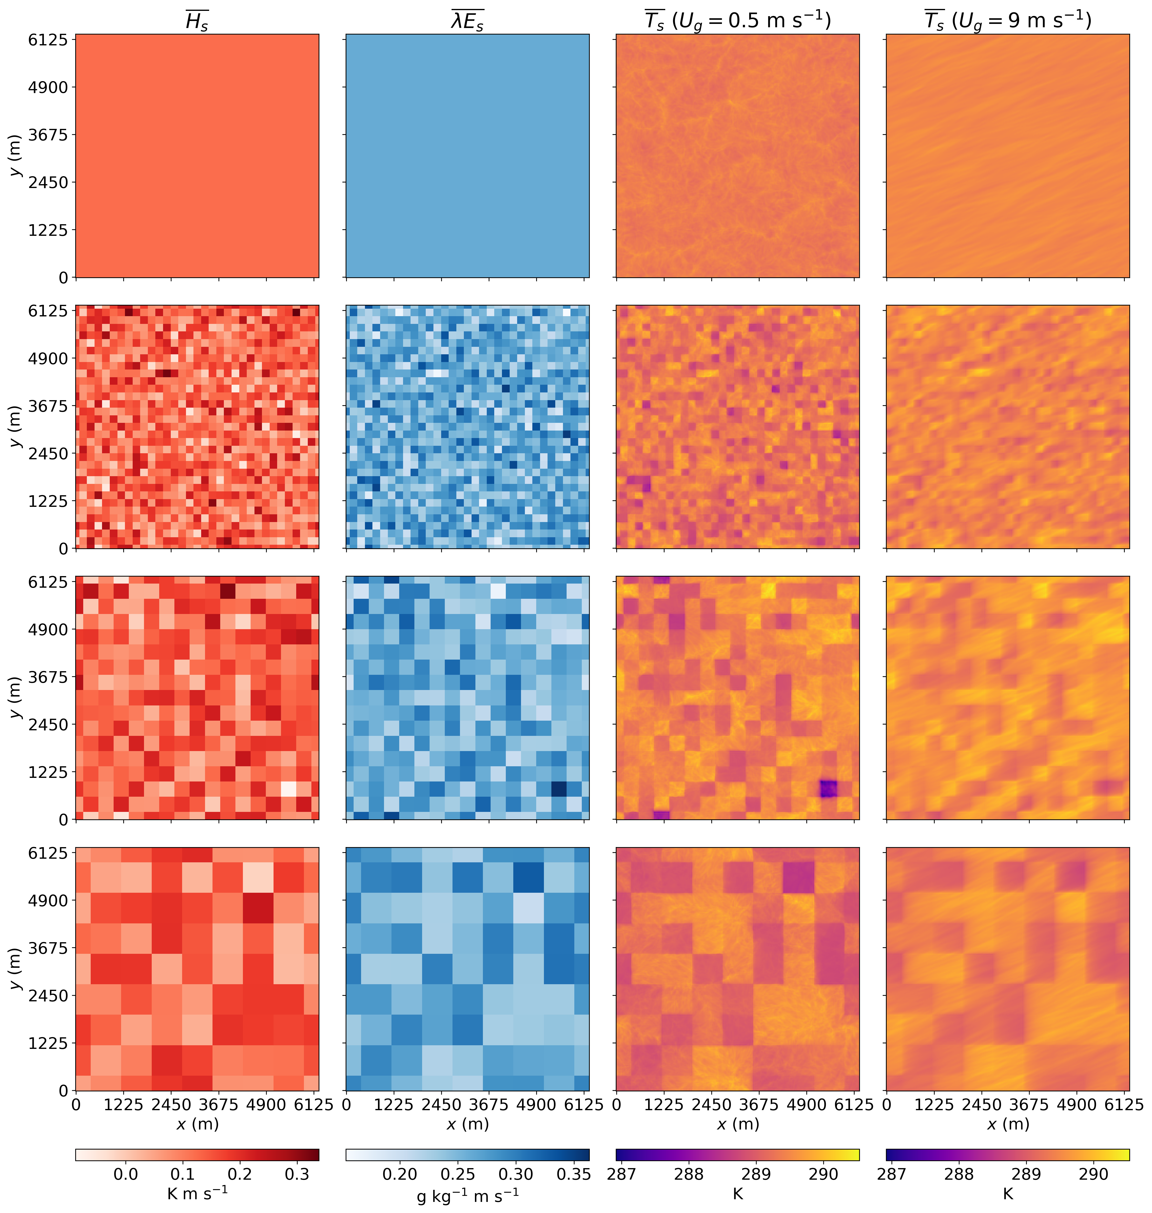
Fig. 11 The left two columns show prescribed surface fluxes ($\overline{H_{s}}$, $\overline{{λE}_{s}}$) from exemplary simulations with the same Bowen ratio ($β$). The right two columns show the resulting surface temperatures ($\overline{T_{s}}$) for simulations with the lowest ($U_{g}$ = 0.5 m s⁻¹) and highest ($U_{g}$ = 9 m s⁻¹) geostrophic wind speed. The top row shows simulations with homogeneous surface fluxes. The rows below show simulations with heterogeneous surface fluxes with increasing patch size (200 m, 400 m, 800 m).
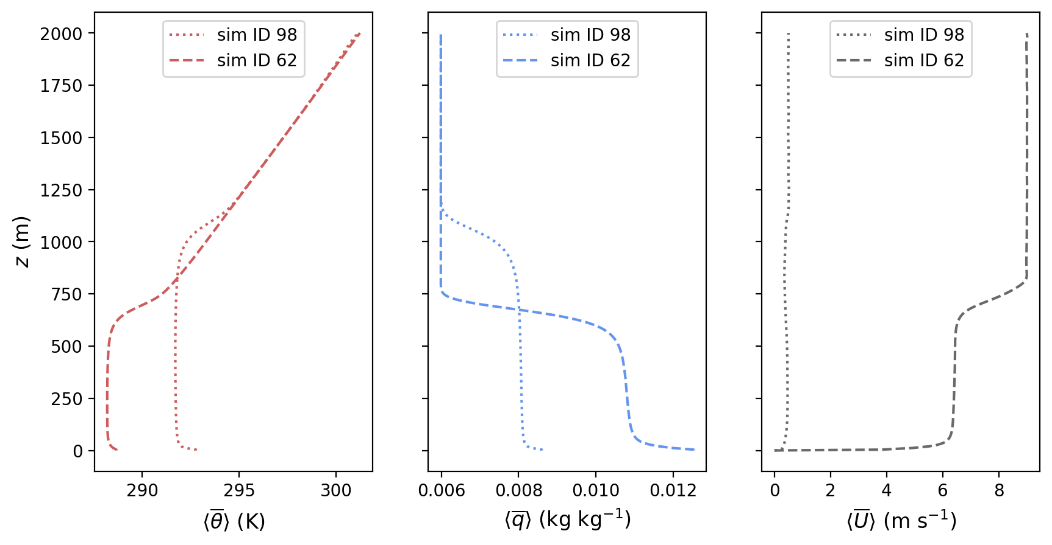
Fig. 12 Profiles of 30-min and domain-averaged potential temperature (θ), mixing ratio (q), and horizontal wind speed (U) for two example simulations. The simulation with ID 98 has very low horizontal wind speed and high sensible surface heat flux, and the simulation with ID 62 has very high horizontal wind speed and low sensible surface heat flux.

Appendix 2: The More Realistic CHEESEHEAD LES
Fig. 13 shows the time series of horizontally domain-averaged surface, turbulent and dispersive heat fluxes with $〈H_{s}〉$ > W m⁻². Only grid levels above the average canopy height $z_{c}$ are considered.
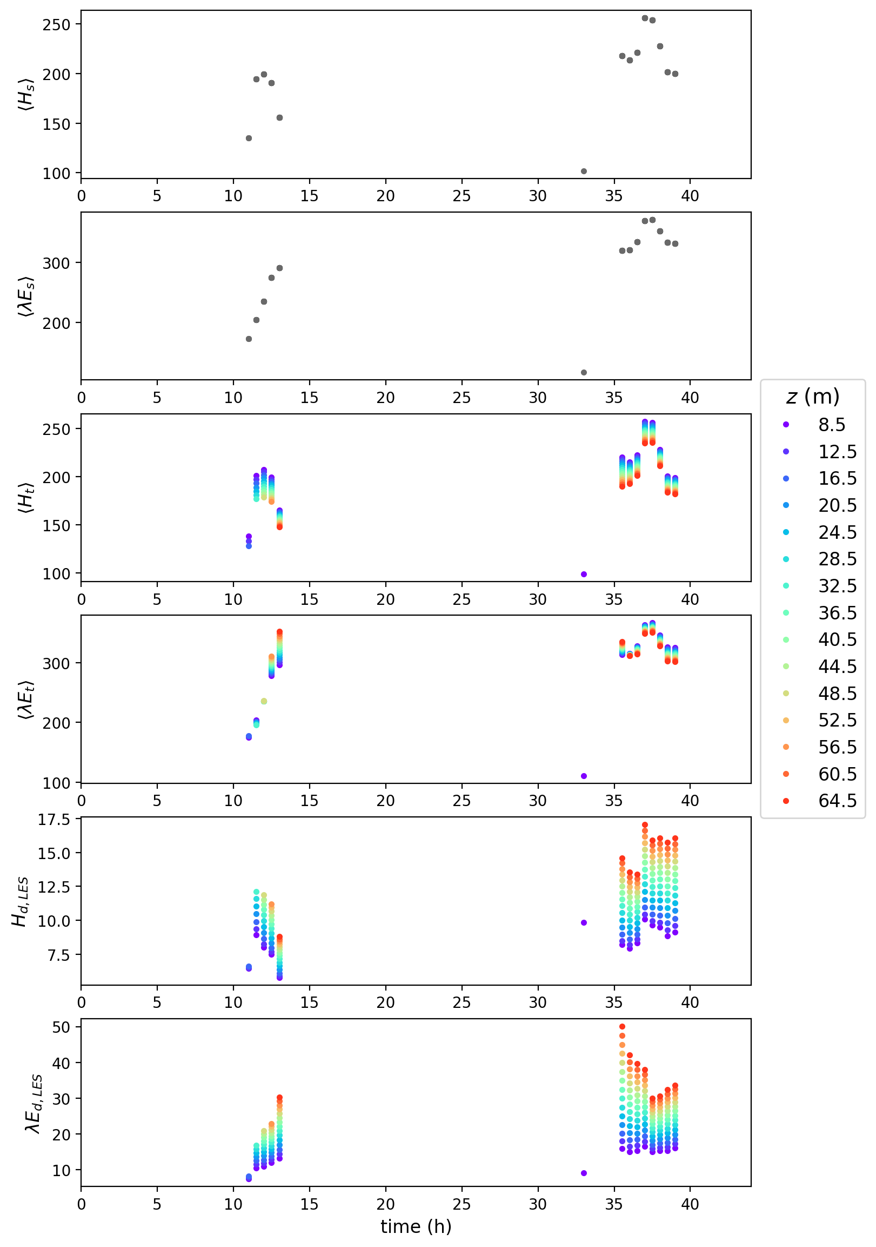
Fig. 13 Time series of the surface fluxes ($〈H_{s}〉$ and $〈{λE}_{s}〉$), turbulent flux contributions ($〈H_{t}〉$ and $〈{λE}_{t}〉$) and dispersive flux contributions ($H_{d,LES}$ and ${λE}_{d,LES}$) that were encountered in the CHEESEHEAD simulations.
Appendix 3: The ERA5 Reanalysis Data
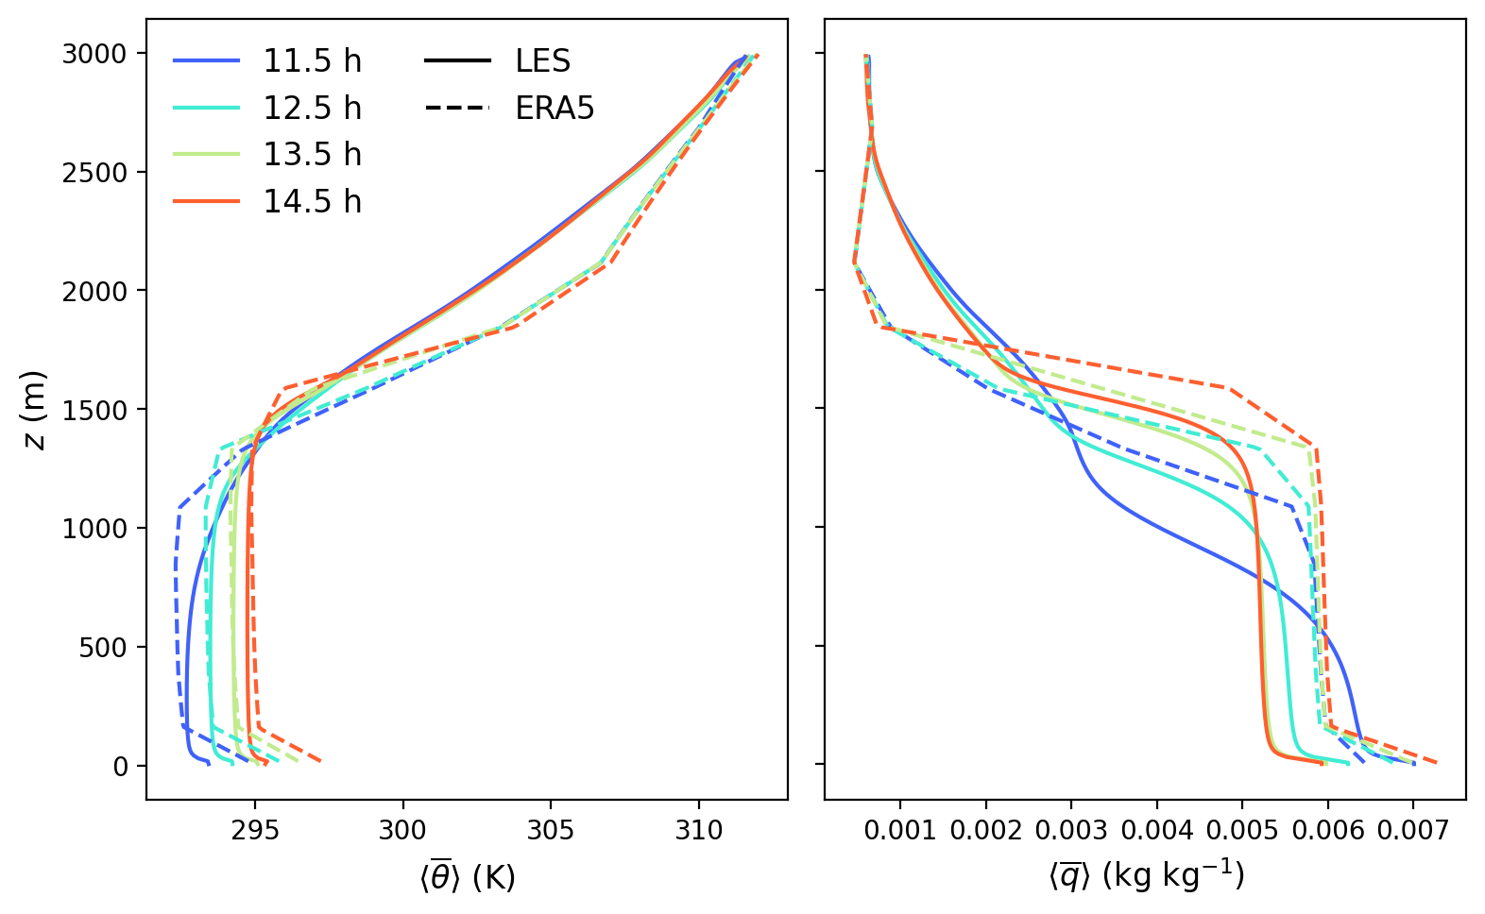
Fig. 14 Comparison of hourly averaged vertical profiles of potential temperature ($〈\overline{θ}〉$) and mixing ratio ($〈\overline{q}〉$) between the CHEESEHEAD LES and ERA5 reanalysis data for August 23, 2019.

