Figure 1: Mesenteric nodules culture showed the specific characteristics of T. marneffei

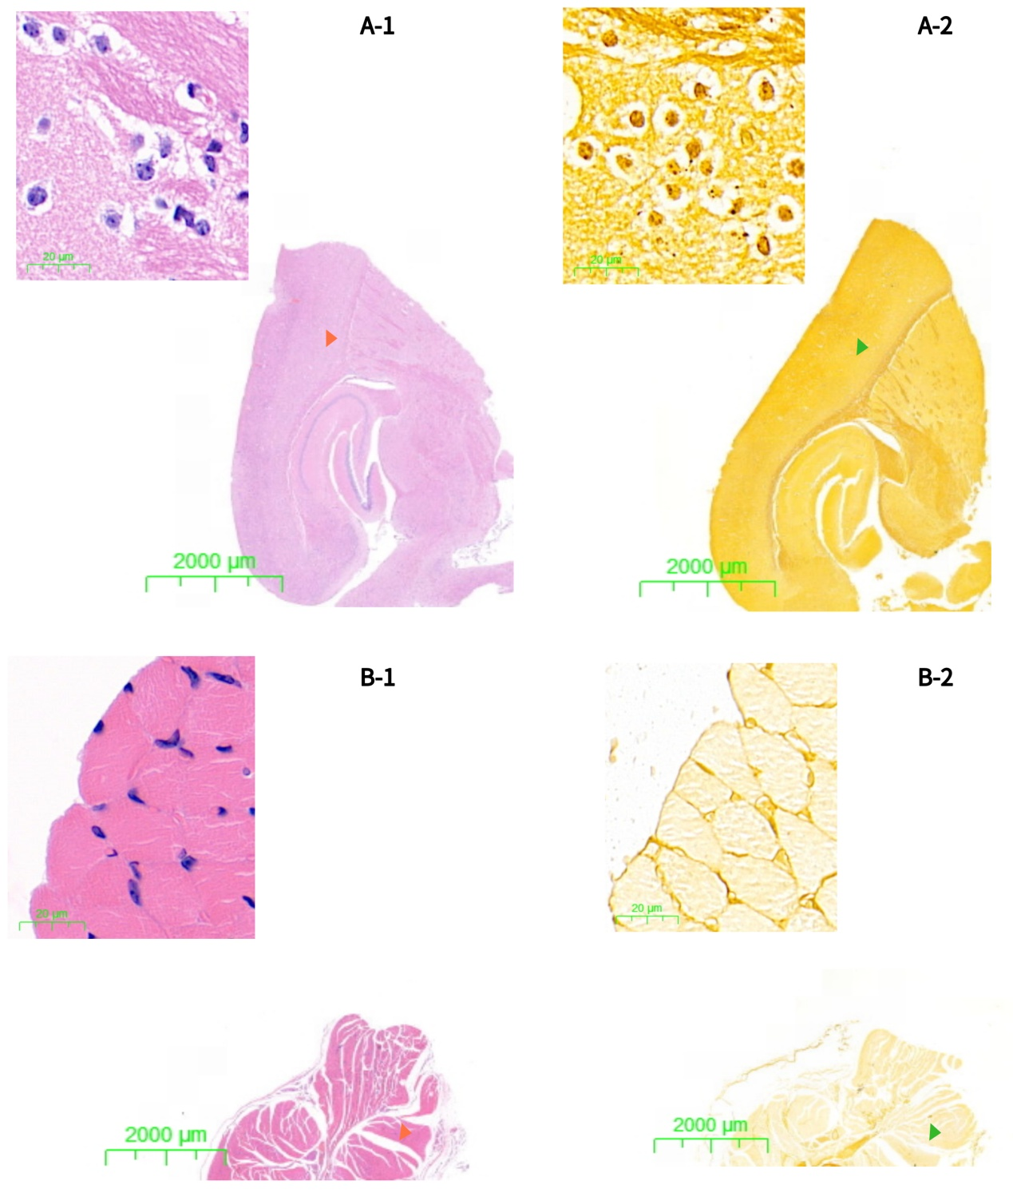Figure 2: HE (n-1) and PASM (n-2) analyses of BALB/c nude mice infected with T. marneffei.
No fungal yeasts were observed in the brain (A) and skeletal muscle (B) tissues of the infected mice. Magnification: The lower right corner ×4, scale bars: 2000μm. The top left corner × 400, scale bars: 20μm.

