Supplementary
Appendix 1: Search strategy
Pubmed:
("Colorectal Neoplasms"[Mesh] OR "Colonic Neoplasms"[Mesh] OR "Rectal Neoplasms"[Mesh]) AND (tumor*[tw] OR carcinom*[tw] OR sarcom*[tw] OR adeno*[tw]) AND ("Occult Blood"[Mesh] OR fecal*[tw] OR feces[tw] OR gFOBT[tw] OR FOBT[tw] OR FOB[tw] OR FIT[tw] OR hemoccult*[tw] OR “hema screen*”[tw] OR hemofec*[tw] OR fecatest[tw] OR coloscreen[tw] OR seracult[tw] OR guaiac*[tw] OR “occult bleed*”[tw]) AND ("Mass Screening"[Mesh] OR "Population Surveillance"[Mesh])

COCHRANE:
(Colorectal Neoplasms) AND (Occult Blood OR gFOBT OR FOBT OR occult bleeding) AND (Mass Screening OR Population Surveillance)

SCOPUS:
(Colorectal Neoplasms OR Colonic Neoplasms OR Rectal Neoplasms) AND ("Occult Blood OR feces OR gFOBT OR FOBT OR hemoccult OR guaiac OR occult bleeding) AND (Mass Screening OR Population Surveillance)

Clinical trials.gov
Colorectal Neoplasms AND FOBT OR occult bleeding AND Mass Screening OR Population Surveillance

GOOGLE SCHOLAR:
(Colorectal Neoplasms) AND (Occult Blood OR gFOBT OR FOBT OR occult bleeding) AND (Mass Screening OR Population Surveillance)

Appendix 2: Quality Assessment Table
Unique ID | 1A | Study ID | Grobbe | Assessor | Affan
Ref or Label | Grobbe | Aim | assignment to intervention (the 'intention-to-treat' effect)
Experimental | Colonoscopy | Comparator | Flexible sigmoidoscopy, FIT | Source | Journal article(s)
Outcome | Incidence of CRC | Results |  | Weight | 1
Domain | Signalling question |  |  | Response | Comments
Bias arising from the randomization process | 1.1 Was the allocation sequence random? |  |  | PY | There is absence of specific information about methodology of randomisation.  There is a lack of details in the article about sealing or concealment of mailed letters and kits.
Bias arising from the randomization process | 1.2 Was the allocation sequence concealed until participants were enrolled and assigned to interventions? |  |  | PY
Bias arising from the randomization process | 1.3 Did baseline differences between intervention groups suggest a problem with the randomization process? |  |  | N
Bias arising from the randomization process | Risk of bias judgement |  |  | Low | The allocation sequence would probably have been random; only that the article does not explain the methodology of randomization in detail.  The allocation sequence would have been probably concealed until enrolling of participants; only that the article does not mention it fully.
Bias due to deviations from intended interventions | 2.1.Were participants aware of their assigned intervention during the trial? |  |  | Y | It was not possible to blind the participants and the people delivering interventions, as the three interventions can be differentiated on method of delivery. Only the people performing colonoscopy could be unaware of the assigned intervention.
Bias due to deviations from intended interventions | 2.2.Were carers and people delivering the interventions aware of participants' assigned intervention during the trial? |  |  | PY
Bias due to deviations from intended interventions | 2.3. If Y/PY/NI to 2.1 or 2.2: Were there deviations from the intended intervention that arose because of the experimental context? |  |  | N | The non-adherence to intervention is inconsistent with the trial protocol.
Bias due to deviations from intended interventions | 2.4 If Y/PY to 2.3: Were these deviations likely to have affected the outcome? |  |  | NA
Bias due to deviations from intended interventions | 2.5. If Y/PY/NI to 2.4: Were these deviations from intended intervention balanced between groups? |  |  | NA
Bias due to deviations from intended interventions | 2.6 Was an appropriate analysis used to estimate the effect of assignment to intervention? |  |  | Y | An appropriate analysis was used, highlighted in the article.
Bias due to deviations from intended interventions | 2.7 If N/PN/NI to 2.6: Was there potential for a substantial impact (on the result) of the failure to analyse participants in the group to which they were randomized? |  |  | NA
Bias due to deviations from intended interventions | Risk of bias judgement |  |  | Low
Bias due to missing outcome data | 3.1 Were data for this outcome available for all, or nearly all, participants randomized? |  |  | N | The participation rate was 73% for FIT, 31% for sigmoidoscopy and 24% for colonoscopy. Also, 175 and 3 participants having positive FIT and sigmoidoscopy results respectively, did not undergo eventual colonoscopy.
Bias due to missing outcome data | 3.2 If N/PN/NI to 3.1: Is there evidence that result was not biased by missing outcome data? |  |  | N
Bias due to missing outcome data | 3.3 If N/PN to 3.2: Could missingness in the outcome depend on its true value? |  |  | PN | Missing outcome data occured for reasons unrelated to the outcome itself.
Bias due to missing outcome data | 3.4 If Y/PY/NI to 3.3: Is it likely that missingness in the outcome depended on its true value? |  |  | NA
Bias due to missing outcome data | Risk of bias judgement |  |  | Low
Bias in measurement of the outcome | 4.1 Was the method of measuring the outcome inappropriate? |  |  | N | The methods are clearly outlined in the article.
Bias in measurement of the outcome | 4.2 Could measurement or ascertainment of the outcome have differed between intervention groups? |  |  | PY | Total of 4 rounds of FIT are compared to once-only sigmoidoscopy and once-only colonoscopy. 4 rounds of intervention would lead to increased probability of a positive result and thus, incidence of CRC.
Bias in measurement of the outcome | 4.3 Were outcome assessors aware of the intervention received by study participants? |  |  | NA
Bias in measurement of the outcome | 4.4 If Y/PY/NI to 4.3: Could assessment of the outcome have been influenced by knowledge of intervention received? |  |  | NA
Bias in measurement of the outcome | 4.5 If Y/PY/NI to 4.4: Is it likely that assessment of the outcome was influenced by knowledge of intervention received? |  |  | NA
Bias in measurement of the outcome | Risk of bias judgement |  |  | High | The repeated interventions of FIT over the screening period significantly increases the likelihood of a positive detection episode than a once-only intervention (sigmoidoscopy or colonoscopy)
Bias in selection of the reported result | 5.1 Were the data that produced this result analysed in accordance with a pre-specified analysis plan that was finalized before unblinded outcome data were available for analysis? |  |  | Y | The analysis was done in accordance with pre-specified plan, as highlighted in the article.
Bias in selection of the reported result | 5.2 ... multiple eligible outcome measurements (e.g. scales, definitions, time points) within the outcome domain? |  |  | N
Bias in selection of the reported result | 5.3 ... multiple eligible analyses of the data? |  |  | N
Bias in selection of the reported result | Risk of bias judgement |  |  | Low
Overall bias | Risk of bias judgement |  |  | High
Unique ID | 2A | Study ID | Hardcastle | Assessor | Affan
Ref or Label | Hardcastle | Aim | assignment to intervention (the 'intention-to-treat' effect)
Experimental | FOB | Comparator | No screening | Source | Journal article(s)
Outcome | Incidence of CRC | Results |  | Weight | 1
Domain | Signalling question |  |  | Response | Comments
Bias arising from the randomization process | 1.1 Was the allocation sequence random? |  |  | PY | There is absence of specific information about methodology of randomisation.  There is a lack of details in the article about sealing or concealment of letters and test kits.
Bias arising from the randomization process | 1.2 Was the allocation sequence concealed until participants were enrolled and assigned to interventions? |  |  | PY
Bias arising from the randomization process | 1.3 Did baseline differences between intervention groups suggest a problem with the randomization process? |  |  | N
Bias arising from the randomization process | Risk of bias judgement |  |  | Low | The allocation sequence would probably have been random; only that the article does not explain the methodology of randomization in detail.  The allocation sequence would have been probably concealed until enrolling of participants; only that the article does not mention it fully.
Bias due to deviations from intended interventions | 2.1.Were participants aware of their assigned intervention during the trial? |  |  | Y | It was not possible to blind the participants and the people delivering interventions, as FOB and absence of screening (control) can easily be differentiated on method of delivery.
Bias due to deviations from intended interventions | 2.2.Were carers and people delivering the interventions aware of participants' assigned intervention during the trial? |  |  | Y
Bias due to deviations from intended interventions | 2.3. If Y/PY/NI to 2.1 or 2.2: Were there deviations from the intended intervention that arose because of the experimental context? |  |  | N | The non-adherence to intervention is inconsistent with the trial protocol.
Bias due to deviations from intended interventions | 2.4 If Y/PY to 2.3: Were these deviations likely to have affected the outcome? |  |  | NA
Bias due to deviations from intended interventions | 2.5. If Y/PY/NI to 2.4: Were these deviations from intended intervention balanced between groups? |  |  | NA
Bias due to deviations from intended interventions | 2.6 Was an appropriate analysis used to estimate the effect of assignment to intervention? |  |  | Y | An appropriate analysis was used, highlighted in the article.
Bias due to deviations from intended interventions | 2.7 If N/PN/NI to 2.6: Was there potential for a substantial impact (on the result) of the failure to analyse participants in the group to which they were randomized? |  |  | NA
Bias due to deviations from intended interventions | Risk of bias judgement |  |  | Low
Bias due to missing outcome data | 3.1 Were data for this outcome available for all, or nearly all, participants randomized? |  |  | N | 1.7% of the randomized individuals could not be traced by the Office of Population Censuses and Surveys or had emigrated. In the screening group, acceptance of testing ranged from 29% to 74% according to the general practice screened. The acceptance of first FOB test for each age and sex subgroup was less than 60%.
Bias due to missing outcome data | 3.2 If N/PN/NI to 3.1: Is there evidence that result was not biased by missing outcome data? |  |  | N
Bias due to missing outcome data | 3.3 If N/PN to 3.2: Could missingness in the outcome depend on its true value? |  |  | PN | Missing outcome data occured for reasons unrelated to the outcome itself.
Bias due to missing outcome data | 3.4 If Y/PY/NI to 3.3: Is it likely that missingness in the outcome depended on its true value? |  |  | NA
Bias due to missing outcome data | Risk of bias judgement |  |  | Low
Bias in measurement of the outcome | 4.1 Was the method of measuring the outcome inappropriate? |  |  | N | The methods are clearly outlined in the article.
Bias in measurement of the outcome | 4.2 Could measurement or ascertainment of the outcome have differed between intervention groups? |  |  | N
Bias in measurement of the outcome | 4.3 Were outcome assessors aware of the intervention received by study participants? |  |  | PN | The assessment of stage of CRC and classification of adenomas was done by pathologists unaware of the participant’s study group.  Investigators reviewing registry databases and case notes were unaware of the screening status of study participants throughout the assessment of CRC mortality.
Bias in measurement of the outcome | 4.4 If Y/PY/NI to 4.3: Could assessment of the outcome have been influenced by knowledge of intervention received? |  |  | NA
Bias in measurement of the outcome | 4.5 If Y/PY/NI to 4.4: Is it likely that assessment of the outcome was influenced by knowledge of intervention received? |  |  | NA
Bias in measurement of the outcome | Risk of bias judgement |  |  | Low
Bias in selection of the reported result | 5.1 Were the data that produced this result analysed in accordance with a pre-specified analysis plan that was finalized before unblinded outcome data were available for analysis? |  |  | Y | The analysis was done in accordance with pre-specified plan, as highlighted in the article.
Bias in selection of the reported result | 5.2 ... multiple eligible outcome measurements (e.g. scales, definitions, time points) within the outcome domain? |  |  | N
Bias in selection of the reported result | 5.3 ... multiple eligible analyses of the data? |  |  | N
Bias in selection of the reported result | Risk of bias judgement |  |  | Low
Overall bias | Risk of bias judgement |  |  | Low
Unique ID | 3A | Study ID | Kronborg | Assessor | Affan
Ref or Label | Kronborg | Aim | assignment to intervention (the 'intention-to-treat' effect)
Experimental | FOB | Comparator | No screening | Source | Journal article(s)
Outcome | Incidence of CRC | Results |  | Weight | 1
Domain | Signalling question |  |  | Response | Comments
Bias arising from the randomization process | 1.1 Was the allocation sequence random? |  |  | Y | A central randomisation procedure was used based on the population register of the county. 137 485 inhabitants of Funen were listed according to social security number, but married women were placed after their husbands. Balanced randomisation was done in groups of 14 (three to screening, three to the control group, and eight not enrolled).  There is a lack of details in the article about sealing or concealment of letters and test kits.
Bias arising from the randomization process | 1.2 Was the allocation sequence concealed until participants were enrolled and assigned to interventions? |  |  | PY
Bias arising from the randomization process | 1.3 Did baseline differences between intervention groups suggest a problem with the randomization process? |  |  | N
Bias arising from the randomization process | Risk of bias judgement |  |  | Low | The allocation sequence would have been probably concealed until enrolling of participants; only that the article does not mention it fully.
Bias due to deviations from intended interventions | 2.1.Were participants aware of their assigned intervention during the trial? |  |  | Y | It was not possible to blind the participants and the people delivering interventions, as FOB and absence of screening (control) can easily be differentiated on method of delivery.
Bias due to deviations from intended interventions | 2.2.Were carers and people delivering the interventions aware of participants' assigned intervention during the trial? |  |  | Y
Bias due to deviations from intended interventions | 2.3. If Y/PY/NI to 2.1 or 2.2: Were there deviations from the intended intervention that arose because of the experimental context? |  |  | N | The non-adherence to intervention is inconsistent with the trial protocol.
Bias due to deviations from intended interventions | 2.4 If Y/PY to 2.3: Were these deviations likely to have affected the outcome? |  |  | NA
Bias due to deviations from intended interventions | 2.5. If Y/PY/NI to 2.4: Were these deviations from intended intervention balanced between groups? |  |  | NA
Bias due to deviations from intended interventions | 2.6 Was an appropriate analysis used to estimate the effect of assignment to intervention? |  |  | Y | An appropriate analysis was used, highlighted in the article.
Bias due to deviations from intended interventions | 2.7 If N/PN/NI to 2.6: Was there potential for a substantial impact (on the result) of the failure to analyse participants in the group to which they were randomized? |  |  | NA
Bias due to deviations from intended interventions | Risk of bias judgement |  |  | Low
Bias due to missing outcome data | 3.1 Were data for this outcome available for all, or nearly all, participants randomized? |  |  | N | 205 people died between randomisation and planned invitation for screening, while 1145 had moved away from Funen and six from Denmark. 67% of invited individuals for FOB completed first screening round. More than 85%, and not 100%, of those with positive tests underwent eventual colonoscopy.
Bias due to missing outcome data | 3.2 If N/PN/NI to 3.1: Is there evidence that result was not biased by missing outcome data? |  |  | N
Bias due to missing outcome data | 3.3 If N/PN to 3.2: Could missingness in the outcome depend on its true value? |  |  | PN | Missing outcome data occured for reasons unrelated to the outcome itself.
Bias due to missing outcome data | 3.4 If Y/PY/NI to 3.3: Is it likely that missingness in the outcome depended on its true value? |  |  | NA
Bias due to missing outcome data | Risk of bias judgement |  |  | Low
Bias in measurement of the outcome | 4.1 Was the method of measuring the outcome inappropriate? |  |  | N | The methods are clearly outlined in the article.
Bias in measurement of the outcome | 4.2 Could measurement or ascertainment of the outcome have differed between intervention groups? |  |  | N
Bias in measurement of the outcome | 4.3 Were outcome assessors aware of the intervention received by study participants? |  |  | PN | Investigators obtaining information from Funen patient database, Danish National Registry of Patients and Danish Cancer Society were unaware of the participants’ screening status during the assessment of diagnosed cases and death certificates.  Dukes’ staging of tumors and classification of adenomas were done by one investigator under masked conditions.
Bias in measurement of the outcome | 4.4 If Y/PY/NI to 4.3: Could assessment of the outcome have been influenced by knowledge of intervention received? |  |  | NA
Bias in measurement of the outcome | 4.5 If Y/PY/NI to 4.4: Is it likely that assessment of the outcome was influenced by knowledge of intervention received? |  |  | NA
Bias in measurement of the outcome | Risk of bias judgement |  |  | Low
Bias in selection of the reported result | 5.1 Were the data that produced this result analysed in accordance with a pre-specified analysis plan that was finalized before unblinded outcome data were available for analysis? |  |  | Y | The analysis was done in accordance with pre-specified plan, as highlighted in the article.
Bias in selection of the reported result | 5.2 ... multiple eligible outcome measurements (e.g. scales, definitions, time points) within the outcome domain? |  |  | N
Bias in selection of the reported result | 5.3 ... multiple eligible analyses of the data? |  |  | N
Bias in selection of the reported result | Risk of bias judgement |  |  | Low
Overall bias | Risk of bias judgement |  |  | Low
Unique ID | 4A | Study ID | Mandel | Assessor | Affan
Ref or Label | Mandel | Aim | assignment to intervention (the 'intention-to-treat' effect)
Experimental | FOB | Comparator | No screening | Source | Journal article(s); Trial protocol
Outcome | Incidence of CRC | Results |  | Weight | 1
Domain | Signalling question |  |  | Response | Comments
Bias arising from the randomization process | 1.1 Was the allocation sequence random? |  |  | Y | After stratification according to age, sex, and place of residence, the participants were randomly permuted and assigned to screening once a year, to screening once every two years (biennially), or to a control group.  There is a lack of details in the article about sealing or concealment of letters and test kits.
Bias arising from the randomization process | 1.2 Was the allocation sequence concealed until participants were enrolled and assigned to interventions? |  |  | PY
Bias arising from the randomization process | 1.3 Did baseline differences between intervention groups suggest a problem with the randomization process? |  |  | N
Bias arising from the randomization process | Risk of bias judgement |  |  | Low | The allocation sequence would have been probably concealed until enrolling of participants; only that the article does not mention it fully.
Bias due to deviations from intended interventions | 2.1.Were participants aware of their assigned intervention during the trial? |  |  | Y | It was not possible to blind the participants and the people delivering interventions, as FOB and absence of screening (control) can easily be differentiated on method of delivery.
Bias due to deviations from intended interventions | 2.2.Were carers and people delivering the interventions aware of participants' assigned intervention during the trial? |  |  | Y
Bias due to deviations from intended interventions | 2.3. If Y/PY/NI to 2.1 or 2.2: Were there deviations from the intended intervention that arose because of the experimental context? |  |  | N | The non-adherence to intervention is inconsistent with the trial protocol.
Bias due to deviations from intended interventions | 2.4 If Y/PY to 2.3: Were these deviations likely to have affected the outcome? |  |  | NA
Bias due to deviations from intended interventions | 2.5. If Y/PY/NI to 2.4: Were these deviations from intended intervention balanced between groups? |  |  | NA
Bias due to deviations from intended interventions | 2.6 Was an appropriate analysis used to estimate the effect of assignment to intervention? |  |  | Y | An appropriate analysis was used, highlighted in the article.
Bias due to deviations from intended interventions | 2.7 If N/PN/NI to 2.6: Was there potential for a substantial impact (on the result) of the failure to analyse participants in the group to which they were randomized? |  |  | NA
Bias due to deviations from intended interventions | Risk of bias judgement |  |  | Low
Bias due to missing outcome data | 3.1 Were data for this outcome available for all, or nearly all, participants randomized? |  |  | N | The annually screened group completed 75.2% of the screening offered, and the biennially screened group completed 78.4%. Over 96% of those examined at the university underwent colonoscopy.
Bias due to missing outcome data | 3.2 If N/PN/NI to 3.1: Is there evidence that result was not biased by missing outcome data? |  |  | N
Bias due to missing outcome data | 3.3 If N/PN to 3.2: Could missingness in the outcome depend on its true value? |  |  | N | The missingness in the outcome data is unrelated to the outcome itself.
Bias due to missing outcome data | 3.4 If Y/PY/NI to 3.3: Is it likely that missingness in the outcome depended on its true value? |  |  | NA
Bias due to missing outcome data | Risk of bias judgement |  |  | Low
Bias in measurement of the outcome | 4.1 Was the method of measuring the outcome inappropriate? |  |  | PY | Most participants who were examined other than at university (at sites and physicians of their own choice), were examined with different diagnostic tools with different sensitivities. The assessment of outcome would have varied from examiner to examiner too at different institutions.
Bias in measurement of the outcome | 4.2 Could measurement or ascertainment of the outcome have differed between intervention groups? |  |  | N
Bias in measurement of the outcome | 4.3 Were outcome assessors aware of the intervention received by study participants? |  |  | NA
Bias in measurement of the outcome | 4.4 If Y/PY/NI to 4.3: Could assessment of the outcome have been influenced by knowledge of intervention received? |  |  | NA
Bias in measurement of the outcome | 4.5 If Y/PY/NI to 4.4: Is it likely that assessment of the outcome was influenced by knowledge of intervention received? |  |  | NA
Bias in measurement of the outcome | Risk of bias judgement |  |  | High | Lack of a uniform method of measuring the outcome is likely, leading to high risk of bias.
Bias in selection of the reported result | 5.1 Were the data that produced this result analysed in accordance with a pre-specified analysis plan that was finalized before unblinded outcome data were available for analysis? |  |  | Y | The analysis was done in accordance with pre-specified plan, as highlighted in the article.
Bias in selection of the reported result | 5.2 ... multiple eligible outcome measurements (e.g. scales, definitions, time points) within the outcome domain? |  |  | N
Bias in selection of the reported result | 5.3 ... multiple eligible analyses of the data? |  |  | N
Bias in selection of the reported result | Risk of bias judgement |  |  | Low
Overall bias | Risk of bias judgement |  |  | High
Unique ID | 5A | Study ID | Pitkaneimi | Assessor | Affan
Ref or Label | Pitkaneimi | Aim | assignment to intervention (the 'intention-to-treat' effect)
Experimental | FOB | Comparator | No screening | Source | Journal article(s); Trial protocol
Outcome | Incidence of CRC | Results |  | Weight | 1
Domain | Signalling question |  |  | Response | Comments
Bias arising from the randomization process | 1.1 Was the allocation sequence random? |  |  | PY | There is absence of specific information about methodology of randomisation.  There is a lack of details in the article about sealing or concealment of mailed letters and kits.
Bias arising from the randomization process | 1.2 Was the allocation sequence concealed until participants were enrolled and assigned to interventions? |  |  | PY
Bias arising from the randomization process | 1.3 Did baseline differences between intervention groups suggest a problem with the randomization process? |  |  | N
Bias arising from the randomization process | Risk of bias judgement |  |  | Low | The allocation sequence would probably have been random; only that the article does not explain the methodology of randomization in detail.  The allocation sequence would have been probably concealed until enrolling of participants; only that the article does not mention it fully.
Bias due to deviations from intended interventions | 2.1.Were participants aware of their assigned intervention during the trial? |  |  | Y | It was not possible to blind the participants and the people delivering interventions, as FOB and absence of screening (control) can easily be differentiated on method of delivery.
Bias due to deviations from intended interventions | 2.2.Were carers and people delivering the interventions aware of participants' assigned intervention during the trial? |  |  | Y
Bias due to deviations from intended interventions | 2.3. If Y/PY/NI to 2.1 or 2.2: Were there deviations from the intended intervention that arose because of the experimental context? |  |  | N | The non-adherence to intervention is inconsistent with the trial protocol.
Bias due to deviations from intended interventions | 2.4 If Y/PY to 2.3: Were these deviations likely to have affected the outcome? |  |  | NA
Bias due to deviations from intended interventions | 2.5. If Y/PY/NI to 2.4: Were these deviations from intended intervention balanced between groups? |  |  | NA
Bias due to deviations from intended interventions | 2.6 Was an appropriate analysis used to estimate the effect of assignment to intervention? |  |  | Y | An appropriate analysis was used, highlighted in the article.
Bias due to deviations from intended interventions | 2.7 If N/PN/NI to 2.6: Was there potential for a substantial impact (on the result) of the failure to analyse participants in the group to which they were randomized? |  |  | NA
Bias due to deviations from intended interventions | Risk of bias judgement |  |  | Low
Bias due to missing outcome data | 3.1 Were data for this outcome available for all, or nearly all, participants randomized? |  |  | N | 68.8% of the invited participants complied with the screening. Colonoscopy was performed in 84% of screen positives.
Bias due to missing outcome data | 3.2 If N/PN/NI to 3.1: Is there evidence that result was not biased by missing outcome data? |  |  | N
Bias due to missing outcome data | 3.3 If N/PN to 3.2: Could missingness in the outcome depend on its true value? |  |  | N | The missingness in the outcome data is unrelated to the outcome itself.
Bias due to missing outcome data | 3.4 If Y/PY/NI to 3.3: Is it likely that missingness in the outcome depended on its true value? |  |  | NA
Bias due to missing outcome data | Risk of bias judgement |  |  | Low
Bias in measurement of the outcome | 4.1 Was the method of measuring the outcome inappropriate? |  |  | N | The methods are clearly outlined in the article.
Bias in measurement of the outcome | 4.2 Could measurement or ascertainment of the outcome have differed between intervention groups? |  |  | N
Bias in measurement of the outcome | 4.3 Were outcome assessors aware of the intervention received by study participants? |  |  | PN | The eventual colonoscopies of screening and control participants were performed by the same colonoscopy providers.
Bias in measurement of the outcome | 4.4 If Y/PY/NI to 4.3: Could assessment of the outcome have been influenced by knowledge of intervention received? |  |  | NA
Bias in measurement of the outcome | 4.5 If Y/PY/NI to 4.4: Is it likely that assessment of the outcome was influenced by knowledge of intervention received? |  |  | NA
Bias in measurement of the outcome | Risk of bias judgement |  |  | Low
Bias in selection of the reported result | 5.1 Were the data that produced this result analysed in accordance with a pre-specified analysis plan that was finalized before unblinded outcome data were available for analysis? |  |  | Y | The analysis was done in accordance with pre-specified plan, as highlighted in the article.
Bias in selection of the reported result | 5.2 ... multiple eligible outcome measurements (e.g. scales, definitions, time points) within the outcome domain? |  |  | N
Bias in selection of the reported result | 5.3 ... multiple eligible analyses of the data? |  |  | N
Bias in selection of the reported result | Risk of bias judgement |  |  | Low
Overall bias | Risk of bias judgement |  |  | Low
Unique ID | 6A | Study ID | Quintero | Assessor | Affan
Ref or Label | Quintero | Aim | assignment to intervention (the 'intention-to-treat' effect)
Experimental | Colonoscopy | Comparator | FIT | Source | Journal article(s); Trial protocol
Outcome | Incidence of CRC | Results |  | Weight | 1
Domain | Signalling question |  |  | Response | Comments
Bias arising from the randomization process | 1.1 Was the allocation sequence random? |  |  | Y | Subjects were identified through each Community Health Registry, sorted according to household, and stratified according to age (in 5-year age groups) and sex. Households were randomly assigned in a 1:1 ratio to undergo either one-time colonoscopy or biennial FIT. Randomization was performed with the use of a computer-generated allocation algorithm on the basis of a randomized-blocks method.  There is a lack of details in the article about sealing or concealment of mailed letters and FIT kits.
Bias arising from the randomization process | 1.2 Was the allocation sequence concealed until participants were enrolled and assigned to interventions? |  |  | PY
Bias arising from the randomization process | 1.3 Did baseline differences between intervention groups suggest a problem with the randomization process? |  |  | N
Bias arising from the randomization process | Risk of bias judgement |  |  | Low | The allocation sequence would have been probably concealed until enrolling of participants; only that the article does not mention it fully.
Bias due to deviations from intended interventions | 2.1.Were participants aware of their assigned intervention during the trial? |  |  | Y | It was not possible to blind the participants and the people delivering interventions, as the two interventions can easily be differentiated on method of delivery. Only the people performing colonoscopy could be unaware of the assigned intervention.
Bias due to deviations from intended interventions | 2.2.Were carers and people delivering the interventions aware of participants' assigned intervention during the trial? |  |  | PY
Bias due to deviations from intended interventions | 2.3. If Y/PY/NI to 2.1 or 2.2: Were there deviations from the intended intervention that arose because of the experimental context? |  |  | PY | Major deviation was from colonoscopy arm to FIT arm (likely due to colonoscopy being a more uncomfortable procedure).
Bias due to deviations from intended interventions | 2.4 If Y/PY to 2.3: Were these deviations likely to have affected the outcome? |  |  | PN | Only the total number of participants in the two arms change with the deviation, with no likely effect on the outcome.
Bias due to deviations from intended interventions | 2.5. If Y/PY/NI to 2.4: Were these deviations from intended intervention balanced between groups? |  |  | NA
Bias due to deviations from intended interventions | 2.6 Was an appropriate analysis used to estimate the effect of assignment to intervention? |  |  | Y | An appropriate analysis was used, highlighted in the article.
Bias due to deviations from intended interventions | 2.7 If N/PN/NI to 2.6: Was there potential for a substantial impact (on the result) of the failure to analyse participants in the group to which they were randomized? |  |  | NA
Bias due to deviations from intended interventions | Risk of bias judgement |  |  | Some concerns | The deviation of participants from colonoscopy arm to FIT arm lead to some concerns over risk of bias.
Bias due to missing outcome data | 3.1 Were data for this outcome available for all, or nearly all, participants randomized? |  |  | N | Only 7368 out of 26703 eligible for colonoscopy and 9512 out of 26599 eligible for FIT attended the screening office. 4953 completed colonoscopy out of the colonoscopy group and 8983 completed FIT out of the FIT group. Not all participants having positive FIT results undergo subsequent colonoscopy.
Bias due to missing outcome data | 3.2 If N/PN/NI to 3.1: Is there evidence that result was not biased by missing outcome data? |  |  | N
Bias due to missing outcome data | 3.3 If N/PN to 3.2: Could missingness in the outcome depend on its true value? |  |  | PN | Missing outcome data occured for reasons unrelated to the outcome itself.
Bias due to missing outcome data | 3.4 If Y/PY/NI to 3.3: Is it likely that missingness in the outcome depended on its true value? |  |  | NA
Bias due to missing outcome data | Risk of bias judgement |  |  | Low
Bias in measurement of the outcome | 4.1 Was the method of measuring the outcome inappropriate? |  |  | N | The methods are clearly outlined in the article.
Bias in measurement of the outcome | 4.2 Could measurement or ascertainment of the outcome have differed between intervention groups? |  |  | PY | Total of 5 rounds of FIT are compared to once-only colonoscopy over a period of 10 years. 5 rounds of intervention would lead to increased probability of a positive result and thus, incidence of CRC.
Bias in measurement of the outcome | 4.3 Were outcome assessors aware of the intervention received by study participants? |  |  | NA
Bias in measurement of the outcome | 4.4 If Y/PY/NI to 4.3: Could assessment of the outcome have been influenced by knowledge of intervention received? |  |  | NA
Bias in measurement of the outcome | 4.5 If Y/PY/NI to 4.4: Is it likely that assessment of the outcome was influenced by knowledge of intervention received? |  |  | NA
Bias in measurement of the outcome | Risk of bias judgement |  |  | High | The repeated interventions of FIT over the screening period significantly increases the likelihood of a positive detection episode than a once-only intervention (colonoscopy).
Bias in selection of the reported result | 5.1 Were the data that produced this result analysed in accordance with a pre-specified analysis plan that was finalized before unblinded outcome data were available for analysis? |  |  | Y | The analysis was done in accordance with pre-specified plan, as highlighted in the article.
Bias in selection of the reported result | 5.2 ... multiple eligible outcome measurements (e.g. scales, definitions, time points) within the outcome domain? |  |  | N
Bias in selection of the reported result | 5.3 ... multiple eligible analyses of the data? |  |  | N
Bias in selection of the reported result | Risk of bias judgement |  |  | Low
Overall bias | Risk of bias judgement |  |  | High
Unique ID | 7A | Study ID | Forsberg | Assessor | Affan
Ref or Label | Forsberg | Aim | assignment to intervention (the 'intention-to-treat' effect)
Experimental | Colonoscopy | Comparator | FIT | Source | Journal article(s); Non-commercial trial registry record (e.g. ClinicalTrials.gov record)
Outcome | Incidence of CRC | Results |  | Weight | 1
Domain | Signalling question |  |  | Response | Comments
Bias arising from the randomization process | 1.1 Was the allocation sequence random? |  |  | Y | Randomisation was performed separately for each birth year, by country and by sex. List of eligible individuals was randomly permuted, and were then assigned proportionally to study groups.  There is a lack of details in the article about sealing or concealment of mailed letters.
Bias arising from the randomization process | 1.2 Was the allocation sequence concealed until participants were enrolled and assigned to interventions? |  |  | PY
Bias arising from the randomization process | 1.3 Did baseline differences between intervention groups suggest a problem with the randomization process? |  |  | NI
Bias arising from the randomization process | Risk of bias judgement |  |  | Low | The allocation sequence would have been probably concealed until enrolling of participants; only that the article does not mention it fully.
Bias due to deviations from intended interventions | 2.1.Were participants aware of their assigned intervention during the trial? |  |  | Y | It was not possible to blind the participants and the people delivering interventions, as the two interventions can easily be differentiated.
Bias due to deviations from intended interventions | 2.2.Were carers and people delivering the interventions aware of participants' assigned intervention during the trial? |  |  | Y
Bias due to deviations from intended interventions | 2.3. If Y/PY/NI to 2.1 or 2.2: Were there deviations from the intended intervention that arose because of the experimental context? |  |  | N | The non-adherence to intervention is inconsistent with the trial protocol.
Bias due to deviations from intended interventions | 2.4 If Y/PY to 2.3: Were these deviations likely to have affected the outcome? |  |  | NA
Bias due to deviations from intended interventions | 2.5. If Y/PY/NI to 2.4: Were these deviations from intended intervention balanced between groups? |  |  | NA
Bias due to deviations from intended interventions | 2.6 Was an appropriate analysis used to estimate the effect of assignment to intervention? |  |  | Y | An appropriate analysis was used, highlighted in the article.
Bias due to deviations from intended interventions | 2.7 If N/PN/NI to 2.6: Was there potential for a substantial impact (on the result) of the failure to analyse participants in the group to which they were randomized? |  |  | NA
Bias due to deviations from intended interventions | Risk of bias judgement |  |  | Low
Bias due to missing outcome data | 3.1 Were data for this outcome available for all, or nearly all, participants randomized? |  |  | N | Some people could  not be invited because they had died, emigrated, or could  not be located at a valid address. Participation rates were 35.1% and 55.5% for colonoscopy and FIT group respectively. Also, 90.8% participants having positive FIT underwent a subsequent colonoscopy.
Bias due to missing outcome data | 3.2 If N/PN/NI to 3.1: Is there evidence that result was not biased by missing outcome data? |  |  | N
Bias due to missing outcome data | 3.3 If N/PN to 3.2: Could missingness in the outcome depend on its true value? |  |  | N | The missingness in the outcome data is unrelated to the outcome itself.
Bias due to missing outcome data | 3.4 If Y/PY/NI to 3.3: Is it likely that missingness in the outcome depended on its true value? |  |  | NA
Bias due to missing outcome data | Risk of bias judgement |  |  | Low
Bias in measurement of the outcome | 4.1 Was the method of measuring the outcome inappropriate? |  |  | N | The methods are clearly outlined in the article.
Bias in measurement of the outcome | 4.2 Could measurement or ascertainment of the outcome have differed between intervention groups? |  |  | PN | 2 rounds of FIT are compared to once-only colonoscopy.
Bias in measurement of the outcome | 4.3 Were outcome assessors aware of the intervention received by study participants? |  |  | PY | Most of the outcome assessors, but the investigators performing colonoscopies, could be aware of the intervention.
Bias in measurement of the outcome | 4.4 If Y/PY/NI to 4.3: Could assessment of the outcome have been influenced by knowledge of intervention received? |  |  | N | The observer-reported outcomes are unlikely to be influenced by knowledge of intervention.
Bias in measurement of the outcome | 4.5 If Y/PY/NI to 4.4: Is it likely that assessment of the outcome was influenced by knowledge of intervention received? |  |  | NA
Bias in measurement of the outcome | Risk of bias judgement |  |  | Low
Bias in selection of the reported result | 5.1 Were the data that produced this result analysed in accordance with a pre-specified analysis plan that was finalized before unblinded outcome data were available for analysis? |  |  | Y | The analysis was done in accordance with pre-specified plan, as highlighted in the article.
Bias in selection of the reported result | 5.2 ... multiple eligible outcome measurements (e.g. scales, definitions, time points) within the outcome domain? |  |  | N
Bias in selection of the reported result | 5.3 ... multiple eligible analyses of the data? |  |  | N
Bias in selection of the reported result | Risk of bias judgement |  |  | Low
Overall bias | Risk of bias judgement |  |  | Low
Unique ID | 8A | Study ID | Bretthauer | Assessor | Affan
Ref or Label | Bretthauer | Aim | assignment to intervention (the 'intention-to-treat' effect)
Experimental | Colonoscopy | Comparator | No screening | Source | Journal article(s); Trial protocol
Outcome | Incidence of CRC | Results |  | Weight | 1
Domain | Signalling question |  |  | Response | Comments
Bias arising from the randomization process | 1.1 Was the allocation sequence random? |  |  | Y | Randomization is stratified by sex, birth year and preferably also by household (individuals living together are assigned to the same randomization group). Each subject randomized to the screening group is matched to two subjects from the control group with the same sex and birth year. The randomization process is performed separately by independent bodies in each participating country. Subjects were randomly assigned to either colonoscopy screening or control group in a one-to-two ratio.  There is a lack of details in the article about sealing or concealment of mailed letters.
Bias arising from the randomization process | 1.2 Was the allocation sequence concealed until participants were enrolled and assigned to interventions? |  |  | PY
Bias arising from the randomization process | 1.3 Did baseline differences between intervention groups suggest a problem with the randomization process? |  |  | N
Bias arising from the randomization process | Risk of bias judgement |  |  | Low | The allocation sequence would have been probably concealed until enrolling of participants; only that the article does not mention it fully.
Bias due to deviations from intended interventions | 2.1.Were participants aware of their assigned intervention during the trial? |  |  | Y | It was not possible to blind the participants, as colonoscopy and absence of screening (control) can easily be differentiated on method of delivery.
Bias due to deviations from intended interventions | 2.2.Were carers and people delivering the interventions aware of participants' assigned intervention during the trial? |  |  | N
Bias due to deviations from intended interventions | 2.3. If Y/PY/NI to 2.1 or 2.2: Were there deviations from the intended intervention that arose because of the experimental context? |  |  | N | The non-adherence to intervention is inconsistent with the trial protocol.
Bias due to deviations from intended interventions | 2.4 If Y/PY to 2.3: Were these deviations likely to have affected the outcome? |  |  | NA
Bias due to deviations from intended interventions | 2.5. If Y/PY/NI to 2.4: Were these deviations from intended intervention balanced between groups? |  |  | NA
Bias due to deviations from intended interventions | 2.6 Was an appropriate analysis used to estimate the effect of assignment to intervention? |  |  | Y | An appropriate analysis was used, highlighted in the article.
Bias due to deviations from intended interventions | 2.7 If N/PN/NI to 2.6: Was there potential for a substantial impact (on the result) of the failure to analyse participants in the group to which they were randomized? |  |  | NA
Bias due to deviations from intended interventions | Risk of bias judgement |  |  | Low
Bias due to missing outcome data | 3.1 Were data for this outcome available for all, or nearly all, participants randomized? |  |  | N | 169 individuals from screening group and 369 individuals from control group were excluded because they were dead or diagnosed with colorectal cancer before study entry. Only 40.0% of individuals assigned to colonoscopy underwent the procedure.
Bias due to missing outcome data | 3.2 If N/PN/NI to 3.1: Is there evidence that result was not biased by missing outcome data? |  |  | N
Bias due to missing outcome data | 3.3 If N/PN to 3.2: Could missingness in the outcome depend on its true value? |  |  | N | The missingness in the outcome data is unrelated to the outcome itself.
Bias due to missing outcome data | 3.4 If Y/PY/NI to 3.3: Is it likely that missingness in the outcome depended on its true value? |  |  | NA
Bias due to missing outcome data | Risk of bias judgement |  |  | Low
Bias in measurement of the outcome | 4.1 Was the method of measuring the outcome inappropriate? |  |  | N | The methods are clearly outlined in the article.
Bias in measurement of the outcome | 4.2 Could measurement or ascertainment of the outcome have differed between intervention groups? |  |  | N
Bias in measurement of the outcome | 4.3 Were outcome assessors aware of the intervention received by study participants? |  |  | N | According to the protocol, the endpoints of the trial were evaluated by matching of study subjects to cause of death and cancer registries in the participating countries. Committee members were blinded as to the allocation to screening or control arm and all information that could identify whether a cancer was screen-detected was withheld from them.
Bias in measurement of the outcome | 4.4 If Y/PY/NI to 4.3: Could assessment of the outcome have been influenced by knowledge of intervention received? |  |  | NA
Bias in measurement of the outcome | 4.5 If Y/PY/NI to 4.4: Is it likely that assessment of the outcome was influenced by knowledge of intervention received? |  |  | NA
Bias in measurement of the outcome | Risk of bias judgement |  |  | Low
Bias in selection of the reported result | 5.1 Were the data that produced this result analysed in accordance with a pre-specified analysis plan that was finalized before unblinded outcome data were available for analysis? |  |  | Y | The analysis was done in accordance with pre-specified plan, as highlighted in the article.
Bias in selection of the reported result | 5.2 ... multiple eligible outcome measurements (e.g. scales, definitions, time points) within the outcome domain? |  |  | N
Bias in selection of the reported result | 5.3 ... multiple eligible analyses of the data? |  |  | N
Bias in selection of the reported result | Risk of bias judgement |  |  | Low
Overall bias | Risk of bias judgement |  |  | Low
Unique ID | 9A | Study ID | Randel | Assessor | Affan
Ref or Label | Randel | Aim | assignment to intervention (the 'intention-to-treat' effect)
Experimental | FIT | Comparator | Sigmoidoscopy | Source | Journal article(s); Non-commercial trial registry record (e.g. ClinicalTrials.gov record)
Outcome | Incidence of CRC | Results |  | Weight | 1
Domain | Signalling question |  |  | Response | Comments
Bias arising from the randomization process | 1.1 Was the allocation sequence random? |  |  | Y | Individuals were identified through the population registry and randomly assigned in a 1:1 ratio. Randomization was performed by the Cancer Registry of Norway, using a computer-based algorithm and stratified by screening center, sex, and year of birth.  There is a lack of details in the article about sealing or concealment of mailed letters and FIT kits.
Bias arising from the randomization process | 1.2 Was the allocation sequence concealed until participants were enrolled and assigned to interventions? |  |  | PY
Bias arising from the randomization process | 1.3 Did baseline differences between intervention groups suggest a problem with the randomization process? |  |  | N
Bias arising from the randomization process | Risk of bias judgement |  |  | Low | The allocation sequence would have been probably concealed until enrolling of participants; only that the article does not mention it fully.
Bias due to deviations from intended interventions | 2.1.Were participants aware of their assigned intervention during the trial? |  |  | Y | It was not possible to blind the participants and the people delivering interventions, as the two interventions can easily be differentiated on method of delivery.
Bias due to deviations from intended interventions | 2.2.Were carers and people delivering the interventions aware of participants' assigned intervention during the trial? |  |  | Y
Bias due to deviations from intended interventions | 2.3. If Y/PY/NI to 2.1 or 2.2: Were there deviations from the intended intervention that arose because of the experimental context? |  |  | N | The non-adherence to intervention is inconsistent with the trial protocol.
Bias due to deviations from intended interventions | 2.4 If Y/PY to 2.3: Were these deviations likely to have affected the outcome? |  |  | NA
Bias due to deviations from intended interventions | 2.5. If Y/PY/NI to 2.4: Were these deviations from intended intervention balanced between groups? |  |  | NA
Bias due to deviations from intended interventions | 2.6 Was an appropriate analysis used to estimate the effect of assignment to intervention? |  |  | Y | An appropriate analysis was used, highlighted in the article.
Bias due to deviations from intended interventions | 2.7 If N/PN/NI to 2.6: Was there potential for a substantial impact (on the result) of the failure to analyse participants in the group to which they were randomized? |  |  | NA
Bias due to deviations from intended interventions | Risk of bias judgement |  |  | Low
Bias due to missing outcome data | 3.1 Were data for this outcome available for all, or nearly all, participants randomized? |  |  | N | 10% of randomized individuals were excluded before the first invitation. The participation rate for sigmoidoscopy screening was 52.1%, compared to 58.4% in the first FIT round and 68.4% after 3 cumulative FIT rounds (participation at least once). 97.6% of participants, who were referred for colonoscopy from the sigmoidoscopy study group, underwent colonoscopy. While colonoscopy compliance was approximately 93% among the FIT positive individuals.
Bias due to missing outcome data | 3.2 If N/PN/NI to 3.1: Is there evidence that result was not biased by missing outcome data? |  |  | N
Bias due to missing outcome data | 3.3 If N/PN to 3.2: Could missingness in the outcome depend on its true value? |  |  | PN | Missing outcome data occured for reasons unrelated to the outcome itself.
Bias due to missing outcome data | 3.4 If Y/PY/NI to 3.3: Is it likely that missingness in the outcome depended on its true value? |  |  | NA
Bias due to missing outcome data | Risk of bias judgement |  |  | Low
Bias in measurement of the outcome | 4.1 Was the method of measuring the outcome inappropriate? |  |  | N | The methods are clearly outlined in the article.
Bias in measurement of the outcome | 4.2 Could measurement or ascertainment of the outcome have differed between intervention groups? |  |  | PY | Total of 4 rounds of FIT are compared to once-only sigmoidoscopy. 4 rounds of intervention would lead to increased probability of a positive result and thus, incidence of CRC.
Bias in measurement of the outcome | 4.3 Were outcome assessors aware of the intervention received by study participants? |  |  | NA
Bias in measurement of the outcome | 4.4 If Y/PY/NI to 4.3: Could assessment of the outcome have been influenced by knowledge of intervention received? |  |  | NA
Bias in measurement of the outcome | 4.5 If Y/PY/NI to 4.4: Is it likely that assessment of the outcome was influenced by knowledge of intervention received? |  |  | NA
Bias in measurement of the outcome | Risk of bias judgement |  |  | High | The repeated interventions of FIT over the screening period significantly increases the likelihood of a positive detection episode than a once-only intervention (sigmoidoscopy).
Bias in selection of the reported result | 5.1 Were the data that produced this result analysed in accordance with a pre-specified analysis plan that was finalized before unblinded outcome data were available for analysis? |  |  | Y | The analysis was done in accordance with pre-specified plan, as highlighted in the article.
Bias in selection of the reported result | 5.2 ... multiple eligible outcome measurements (e.g. scales, definitions, time points) within the outcome domain? |  |  | N
Bias in selection of the reported result | 5.3 ... multiple eligible analyses of the data? |  |  | N
Bias in selection of the reported result | Risk of bias judgement |  |  | Low
Overall bias | Risk of bias judgement |  |  | High
Unique ID | 10A | Study ID | Steele | Assessor | Affan
Ref or Label | Steele | Aim | assignment to intervention (the 'intention-to-treat' effect)
Experimental | FOB | Comparator | Sigmoidoscopy | Source | Journal article(s)
Outcome | Incidence of CRC | Results |  | Weight | 1
Domain | Signalling question |  |  | Response | Comments
Bias arising from the randomization process | 1.1 Was the allocation sequence random? |  |  | Y | Individuals, which were identified by their unique community health index as eligible for FOB screening, were randomly assigned to study and control groups. Random allocation to the study group was carried out with a modification to the existing Bowel Screening Scotland IT System.  There is a lack of details in the article about sealing or concealment of invitation letters.
Bias arising from the randomization process | 1.2 Was the allocation sequence concealed until participants were enrolled and assigned to interventions? |  |  | PY
Bias arising from the randomization process | 1.3 Did baseline differences between intervention groups suggest a problem with the randomization process? |  |  | NI
Bias arising from the randomization process | Risk of bias judgement |  |  | Low | The allocation sequence would have been probably concealed until enrolling of participants; only that the article does not mention it fully.
Bias due to deviations from intended interventions | 2.1.Were participants aware of their assigned intervention during the trial? |  |  | Y | It was not possible to blind the participants and the people delivering interventions, as the two interventions can easily be differentiated on method of delivery.
Bias due to deviations from intended interventions | 2.2.Were carers and people delivering the interventions aware of participants' assigned intervention during the trial? |  |  | Y
Bias due to deviations from intended interventions | 2.3. If Y/PY/NI to 2.1 or 2.2: Were there deviations from the intended intervention that arose because of the experimental context? |  |  | PY | The deprivation gradient for uptake of FS was significantly different from that for uptake of FOB (overall uptake for sigmoidoscopy was considerably less than for FOB), likely due to sigmoidoscopy being a more uncomfortable procedure.
Bias due to deviations from intended interventions | 2.4 If Y/PY to 2.3: Were these deviations likely to have affected the outcome? |  |  | PN | Only the total number of participants in the two arms change with the deviation, with no likely effect on the outcome.
Bias due to deviations from intended interventions | 2.5. If Y/PY/NI to 2.4: Were these deviations from intended intervention balanced between groups? |  |  | NA
Bias due to deviations from intended interventions | 2.6 Was an appropriate analysis used to estimate the effect of assignment to intervention? |  |  | Y | An appropriate analysis was used, highlighted in the article.
Bias due to deviations from intended interventions | 2.7 If N/PN/NI to 2.6: Was there potential for a substantial impact (on the result) of the failure to analyse participants in the group to which they were randomized? |  |  | NA
Bias due to deviations from intended interventions | Risk of bias judgement |  |  | Some concerns | The overall uptake for sigmoidoscopy was considerably less than for FOB, which leads to some concerns over risk of bias.
Bias due to missing outcome data | 3.1 Were data for this outcome available for all, or nearly all, participants randomized? |  |  | N | Only 17.8% of individuals invited for flexible sigmoidoscopy and 59.3% invited for FOB actually underwent the investigation.
Bias due to missing outcome data | 3.2 If N/PN/NI to 3.1: Is there evidence that result was not biased by missing outcome data? |  |  | N
Bias due to missing outcome data | 3.3 If N/PN to 3.2: Could missingness in the outcome depend on its true value? |  |  | PN | Missing outcome data occured for reasons unrelated to the outcome itself.
Bias due to missing outcome data | 3.4 If Y/PY/NI to 3.3: Is it likely that missingness in the outcome depended on its true value? |  |  | NA
Bias due to missing outcome data | Risk of bias judgement |  |  | Low
Bias in measurement of the outcome | 4.1 Was the method of measuring the outcome inappropriate? |  |  | N | The methods are clearly outlined in the article.
Bias in measurement of the outcome | 4.2 Could measurement or ascertainment of the outcome have differed between intervention groups? |  |  | N
Bias in measurement of the outcome | 4.3 Were outcome assessors aware of the intervention received by study participants? |  |  | PY | Most of the outcome assessors, but the investigators performing colonoscopies, could be aware of the intervention.
Bias in measurement of the outcome | 4.4 If Y/PY/NI to 4.3: Could assessment of the outcome have been influenced by knowledge of intervention received? |  |  | N | The observer-reported outcomes are unlikely to be influenced by knowledge of intervention.
Bias in measurement of the outcome | 4.5 If Y/PY/NI to 4.4: Is it likely that assessment of the outcome was influenced by knowledge of intervention received? |  |  | NA
Bias in measurement of the outcome | Risk of bias judgement |  |  | Low
Bias in selection of the reported result | 5.1 Were the data that produced this result analysed in accordance with a pre-specified analysis plan that was finalized before unblinded outcome data were available for analysis? |  |  | NI
Bias in selection of the reported result | 5.2 ... multiple eligible outcome measurements (e.g. scales, definitions, time points) within the outcome domain? |  |  | N
Bias in selection of the reported result | 5.3 ... multiple eligible analyses of the data? |  |  | N
Bias in selection of the reported result | Risk of bias judgement |  |  | Some concerns | No information in the article about any pre-specified analysis plan leads to some concerns over risk of bias.
Overall bias | Risk of bias judgement |  |  | Some concerns
Unique ID | 11A | Study ID | Atkin | Assessor | Affan
Ref or Label | Atkin | Aim | assignment to intervention (the 'intention-to-treat' effect)
Experimental | Sigmoidoscopy | Comparator | No screening | Source | Journal article(s); Trial protocol
Outcome | Incidence of CRC | Results |  | Weight | 1
Domain | Signalling question |  |  | Response | Comments
Bias arising from the randomization process | 1.1 Was the allocation sequence random? |  |  | Y | Eligible, interested respondents were randomly allocated to the screening or control groups of the trial in the ratio one to two. The unit of randomisation was the household, stratified by general practice and household type—single male, single female, couple, other. Randomisation was carried out remotely in blocks of six (four control groups, two screening groups).  There is a lack of details in the article about sealing or concealment of mailed letters.
Bias arising from the randomization process | 1.2 Was the allocation sequence concealed until participants were enrolled and assigned to interventions? |  |  | PY
Bias arising from the randomization process | 1.3 Did baseline differences between intervention groups suggest a problem with the randomization process? |  |  | PN | Details on baseline characteristics are not mentioned.
Bias arising from the randomization process | Risk of bias judgement |  |  | Low | The allocation sequence would have been probably concealed until enrolling of participants; only that the article does not mention it fully.  It is unlikely that the baseline differences are significant enough to suggest some randomization fault.
Bias due to deviations from intended interventions | 2.1.Were participants aware of their assigned intervention during the trial? |  |  | Y | It was not possible to blind the participants and the people delivering interventions, as sigmoidoscopy and absence of screening (control) can easily be differentiated on method of delivery.
Bias due to deviations from intended interventions | 2.2.Were carers and people delivering the interventions aware of participants' assigned intervention during the trial? |  |  | Y
Bias due to deviations from intended interventions | 2.3. If Y/PY/NI to 2.1 or 2.2: Were there deviations from the intended intervention that arose because of the experimental context? |  |  | N | The non-adherence to intervention is inconsistent with the trial protocol.
Bias due to deviations from intended interventions | 2.4 If Y/PY to 2.3: Were these deviations likely to have affected the outcome? |  |  | NA
Bias due to deviations from intended interventions | 2.5. If Y/PY/NI to 2.4: Were these deviations from intended intervention balanced between groups? |  |  | NA
Bias due to deviations from intended interventions | 2.6 Was an appropriate analysis used to estimate the effect of assignment to intervention? |  |  | Y | An appropriate analysis was used, highlighted in the article.
Bias due to deviations from intended interventions | 2.7 If N/PN/NI to 2.6: Was there potential for a substantial impact (on the result) of the failure to analyse participants in the group to which they were randomized? |  |  | NA
Bias due to deviations from intended interventions | Risk of bias judgement |  |  | Low
Bias due to missing outcome data | 3.1 Were data for this outcome available for all, or nearly all, participants randomized? |  |  | N | 71% of the people invited attended their screening appointment. 80 people out of 2131 referred for subsequent colonoscopy did not undergo the procedure.
Bias due to missing outcome data | 3.2 If N/PN/NI to 3.1: Is there evidence that result was not biased by missing outcome data? |  |  | N
Bias due to missing outcome data | 3.3 If N/PN to 3.2: Could missingness in the outcome depend on its true value? |  |  | N | The missingness in the outcome data is unrelated to the outcome itself.
Bias due to missing outcome data | 3.4 If Y/PY/NI to 3.3: Is it likely that missingness in the outcome depended on its true value? |  |  | NA
Bias due to missing outcome data | Risk of bias judgement |  |  | Low
Bias in measurement of the outcome | 4.1 Was the method of measuring the outcome inappropriate? |  |  | N | The methods are clearly outlined in the article.
Bias in measurement of the outcome | 4.2 Could measurement or ascertainment of the outcome have differed between intervention groups? |  |  | N
Bias in measurement of the outcome | 4.3 Were outcome assessors aware of the intervention received by study participants? |  |  | Y | The removal of polyps and further assessment, including staging the adenomas or cancers and assessing the adverse physical and psychological effects of the screening procedure, was entirely done on participants in the screening group.
Bias in measurement of the outcome | 4.4 If Y/PY/NI to 4.3: Could assessment of the outcome have been influenced by knowledge of intervention received? |  |  | N | The observer-reported outcomes are unlikely to be influenced by knowledge of intervention.
Bias in measurement of the outcome | 4.5 If Y/PY/NI to 4.4: Is it likely that assessment of the outcome was influenced by knowledge of intervention received? |  |  | NA
Bias in measurement of the outcome | Risk of bias judgement |  |  | Low
Bias in selection of the reported result | 5.1 Were the data that produced this result analysed in accordance with a pre-specified analysis plan that was finalized before unblinded outcome data were available for analysis? |  |  | Y | The analysis was done in accordance with pre-specified plan, as highlighted in the article.
Bias in selection of the reported result | 5.2 ... multiple eligible outcome measurements (e.g. scales, definitions, time points) within the outcome domain? |  |  | N
Bias in selection of the reported result | 5.3 ... multiple eligible analyses of the data? |  |  | N
Bias in selection of the reported result | Risk of bias judgement |  |  | Low
Overall bias | Risk of bias judgement |  |  | Low

Figure 1: Radial SUCRA values for CRC screening modalities
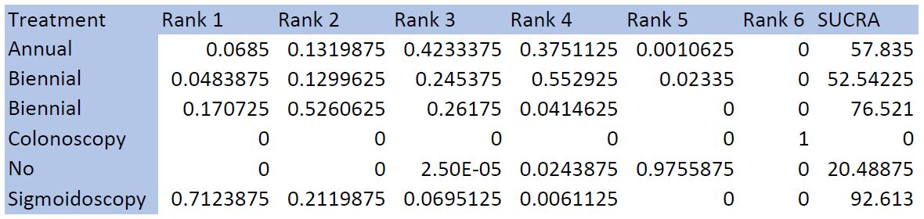

Figure 2: UME model plot for CRC
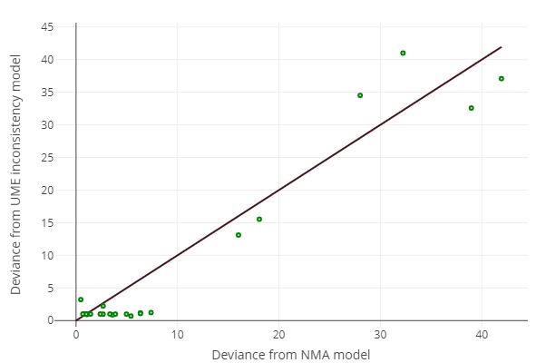

Figure 3: Nodesplit comparison of screening modalities for high-risk adenoma
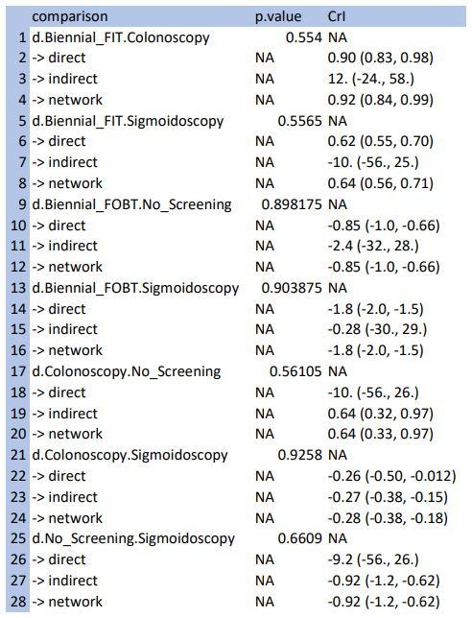

Figure 4: Radial SUCRA plot for high-risk adenomas
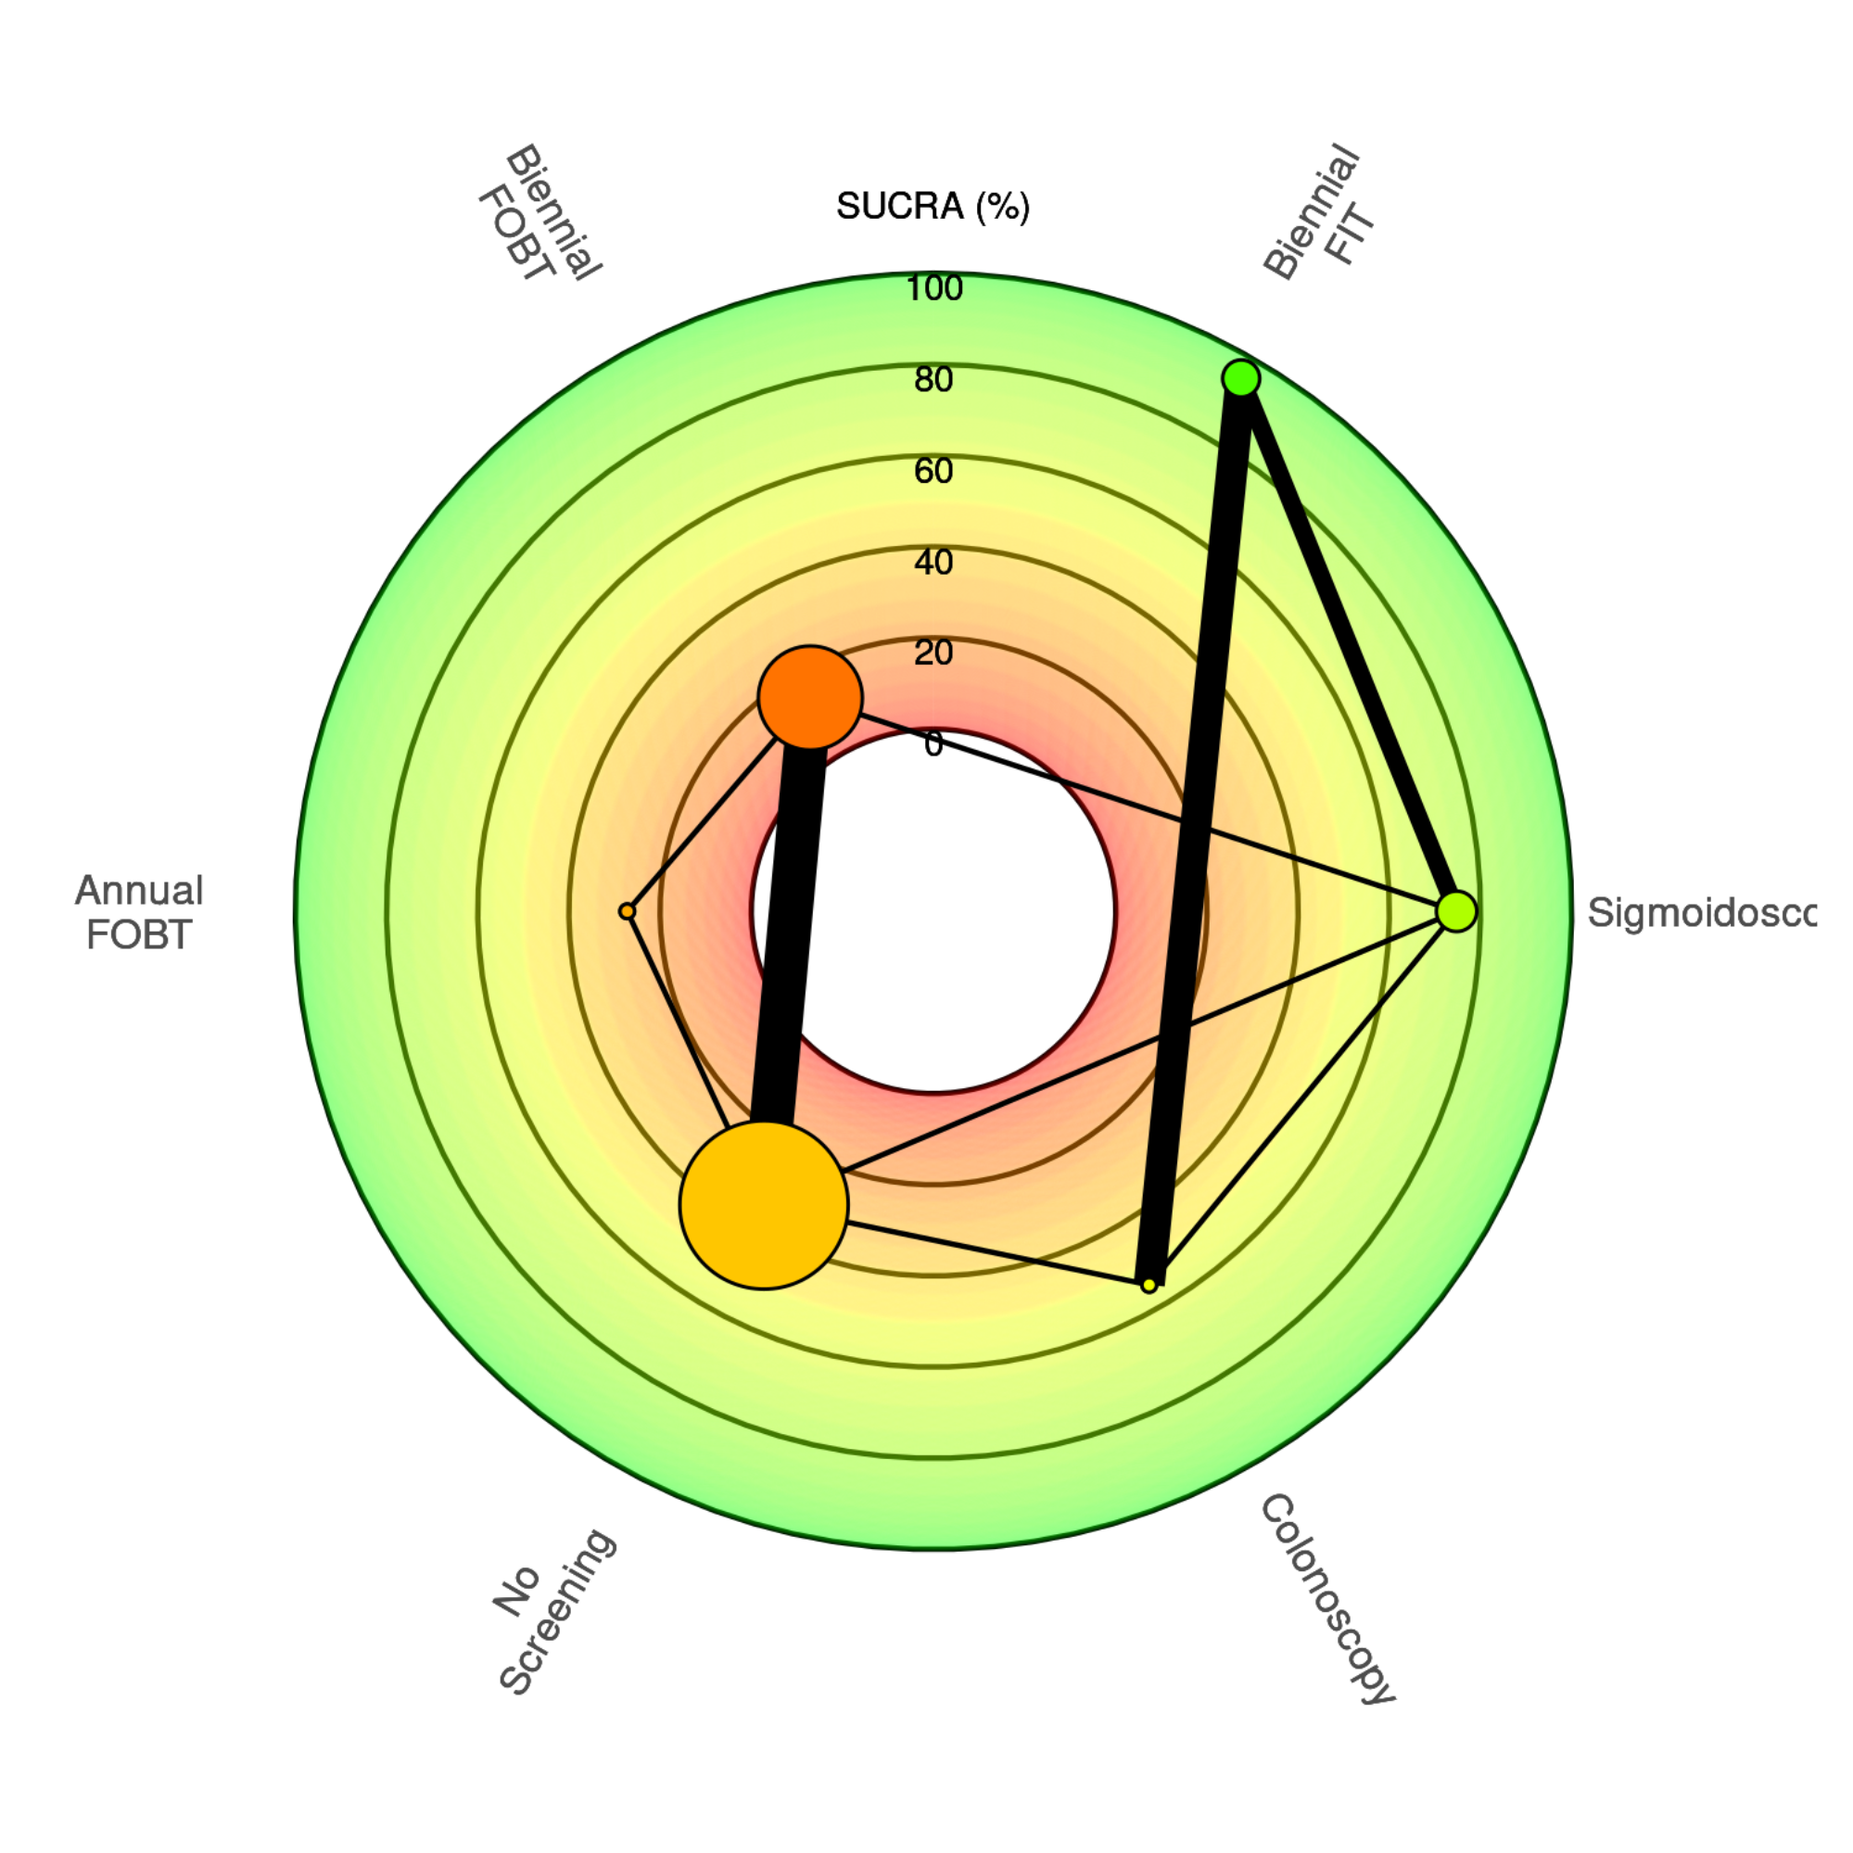

Figure 5: Radial SUCRA values for high-risk adenoma
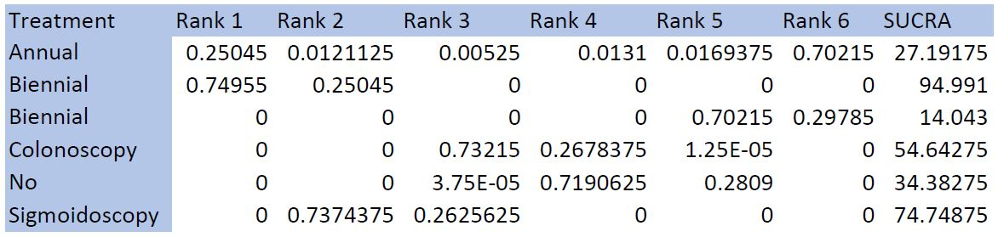

Figure 6: UME model plot for high-risk adenomas
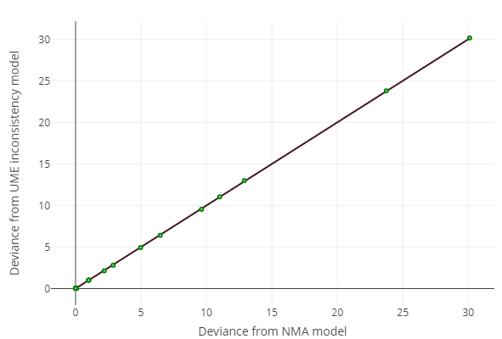

Figure 7: Nodesplit comparison of screening modalities for CRC mortality
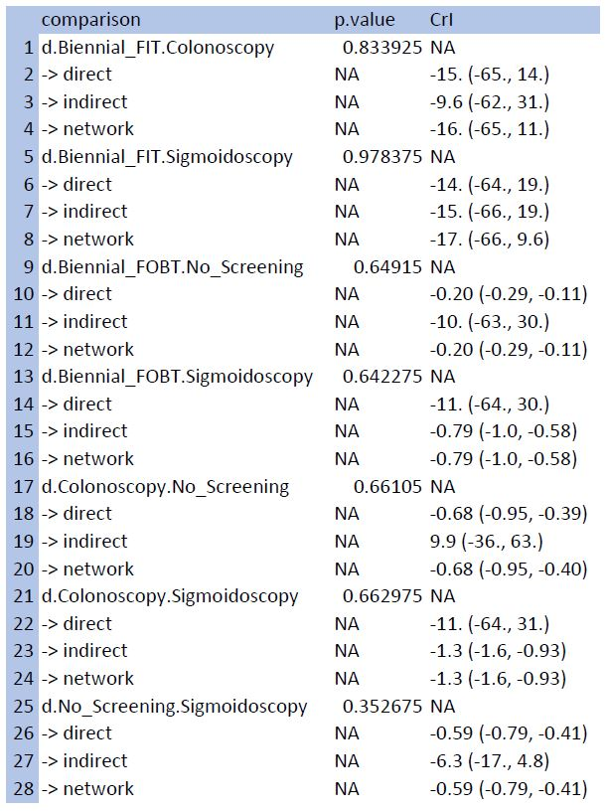

Figure 8: Radial SUCRA plot for CRC mortality
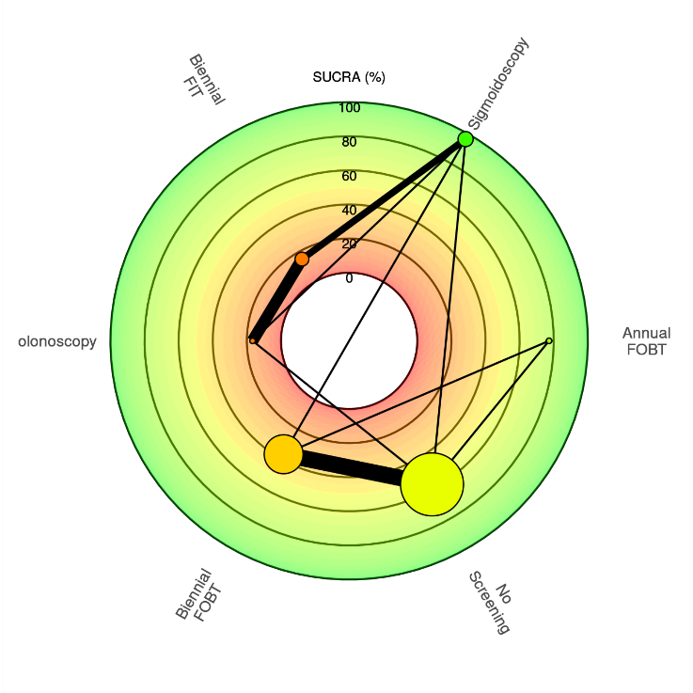

Figure 9: Radial SUCRA values for CRC mortality
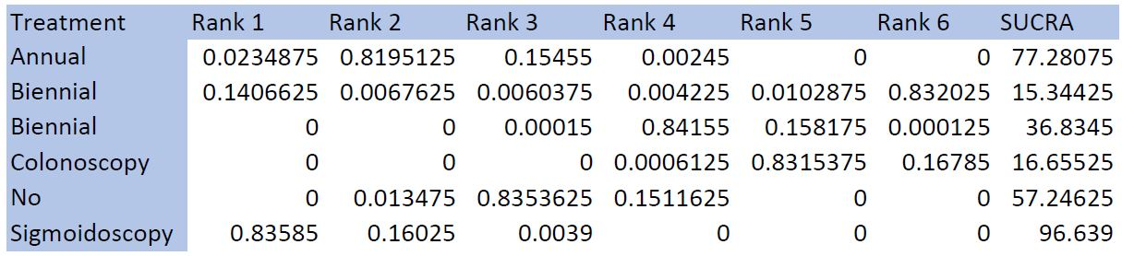

Figure 10: UME model plot for CRC mortality
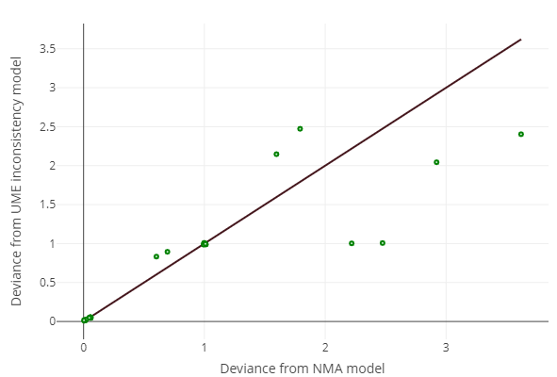

Figure 11: Nodesplit diagram for all-cause mortality
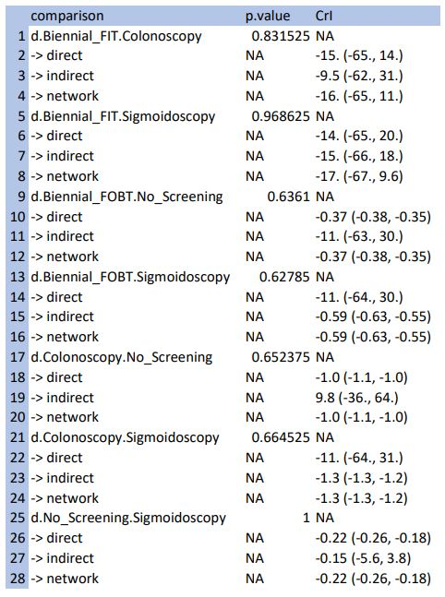

Figure 12: Radial SUCRA plot for all-cause mortality
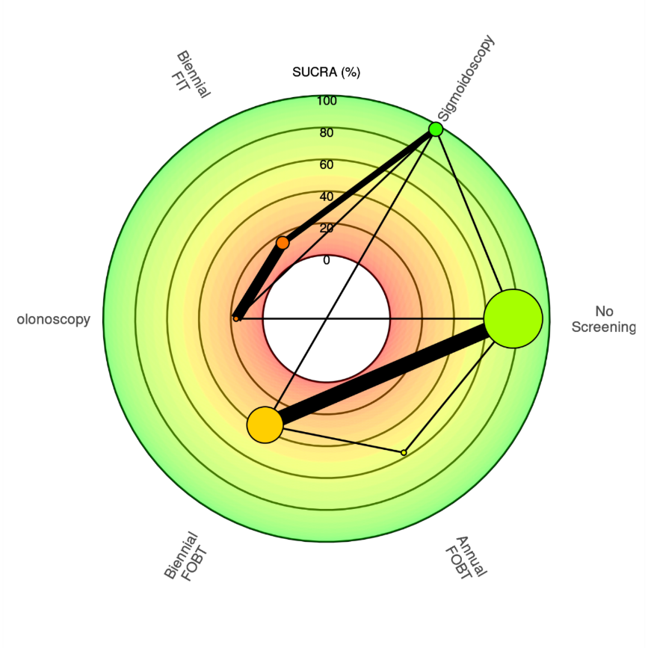

Figure 13: Radial SUCRA values for all-cause mortality
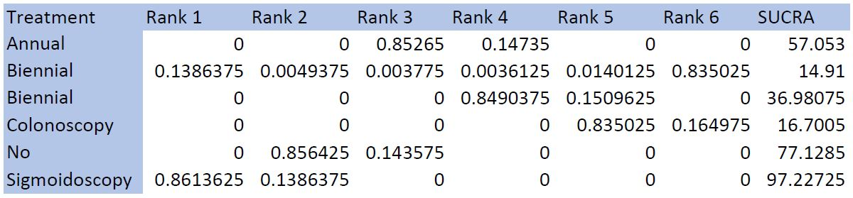
Figure 14: UME model plot for all-cause mortality
