Supplementary materials
Journal name: World Journal of Surgical Oncology

This file includes:
Supplementary Figure:
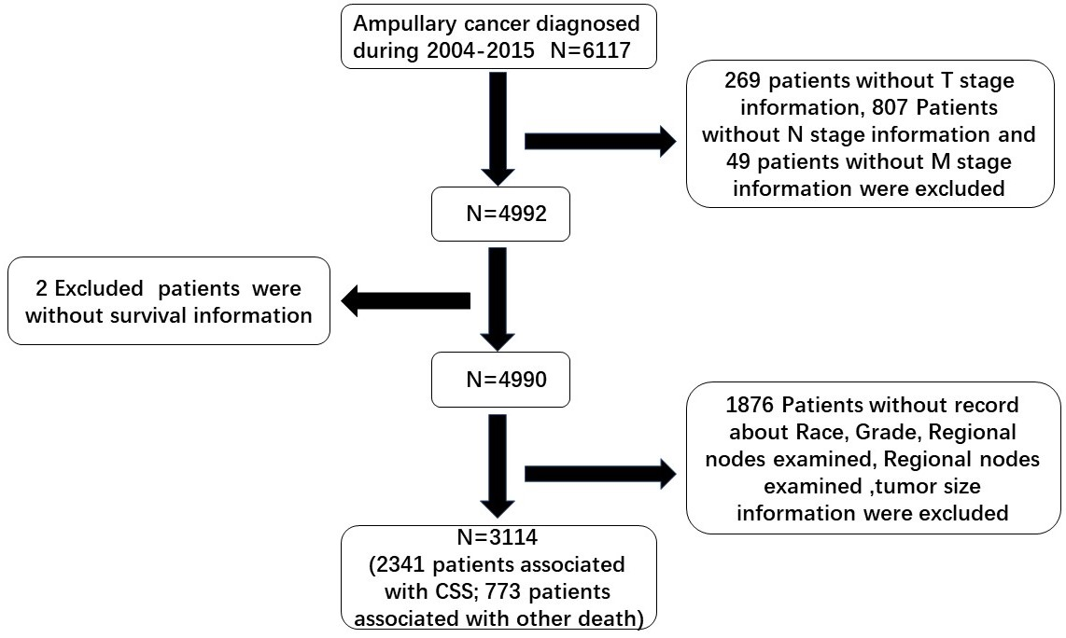
Supplementary Figure 1: The flow chart of extracting patients’ information in our study.

