Supplementary information - The overall decomposition of the spring-detached litter is faster than the autumn-detached litter in a steppe ecosystem
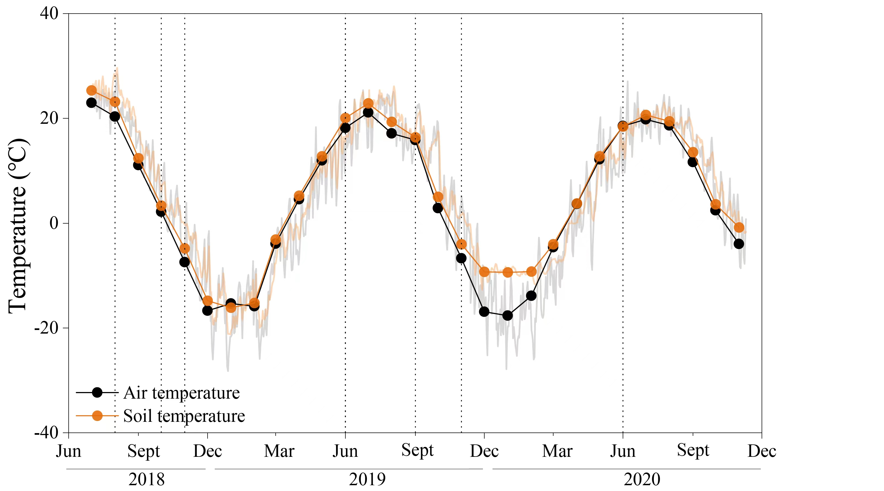
Figure S1. Monthly mean air temperature and soil temperature

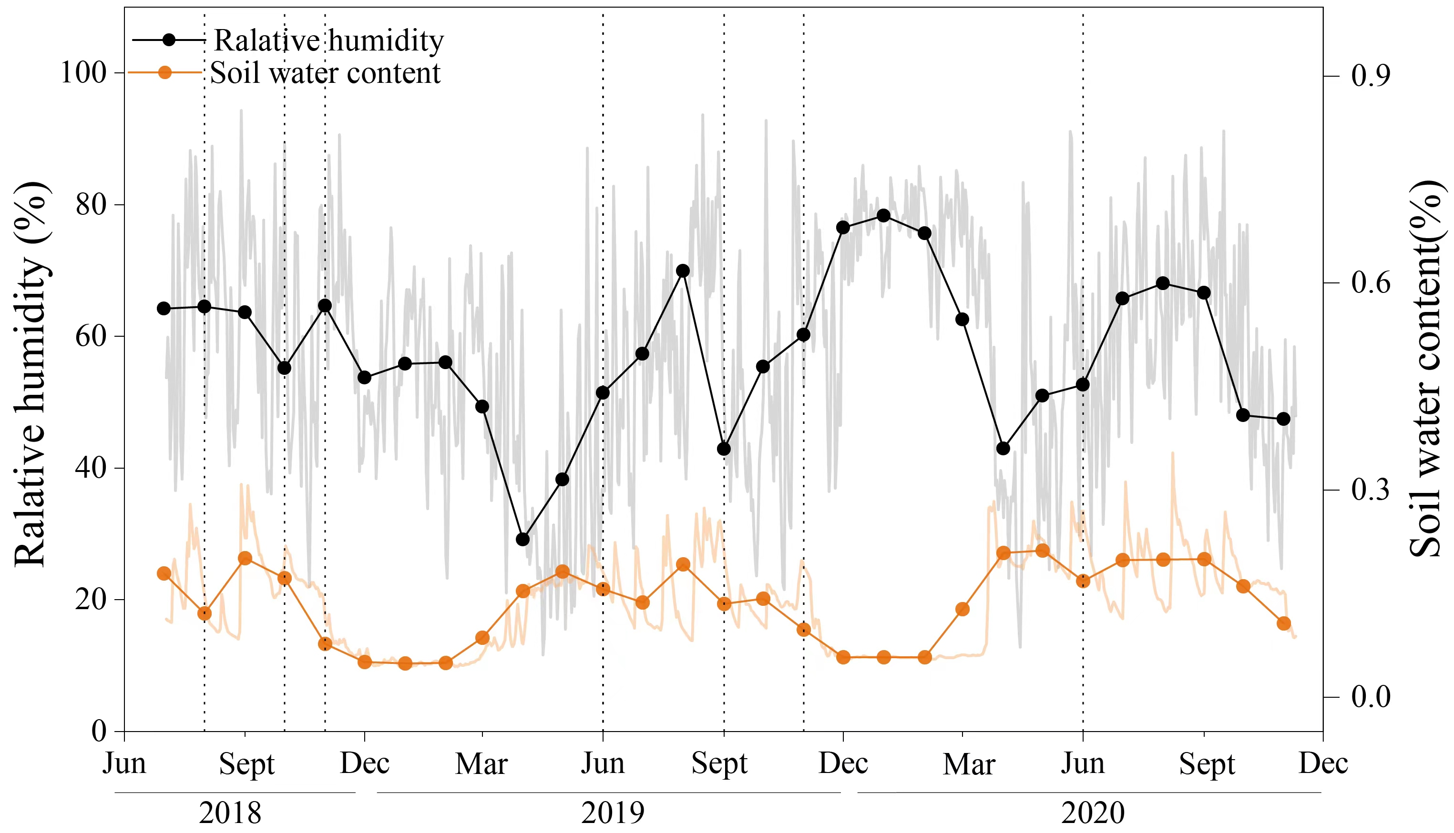
Figure S2. Monthly mean relative humidity and soil water content

