Appendix A: Multi-temporal VIs

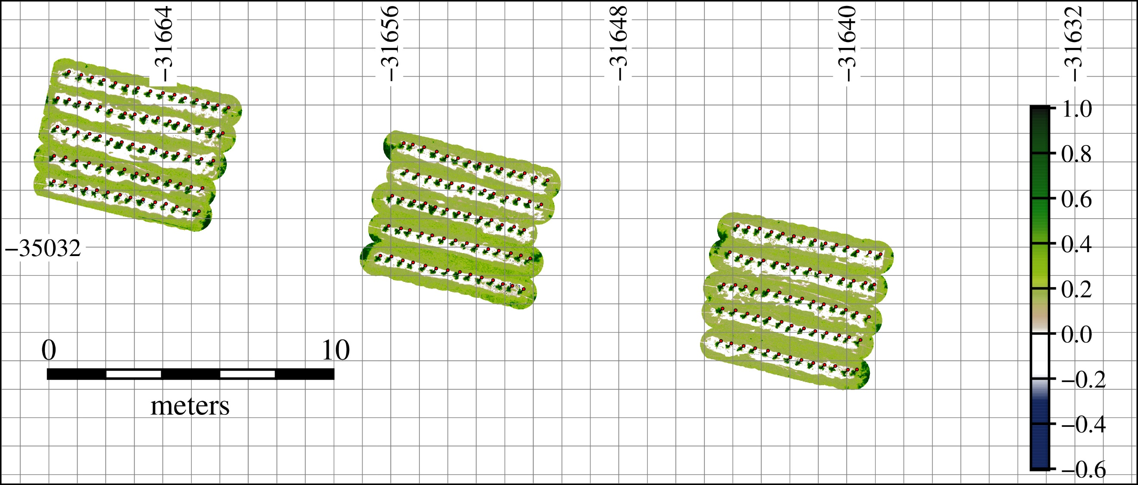  (a) | 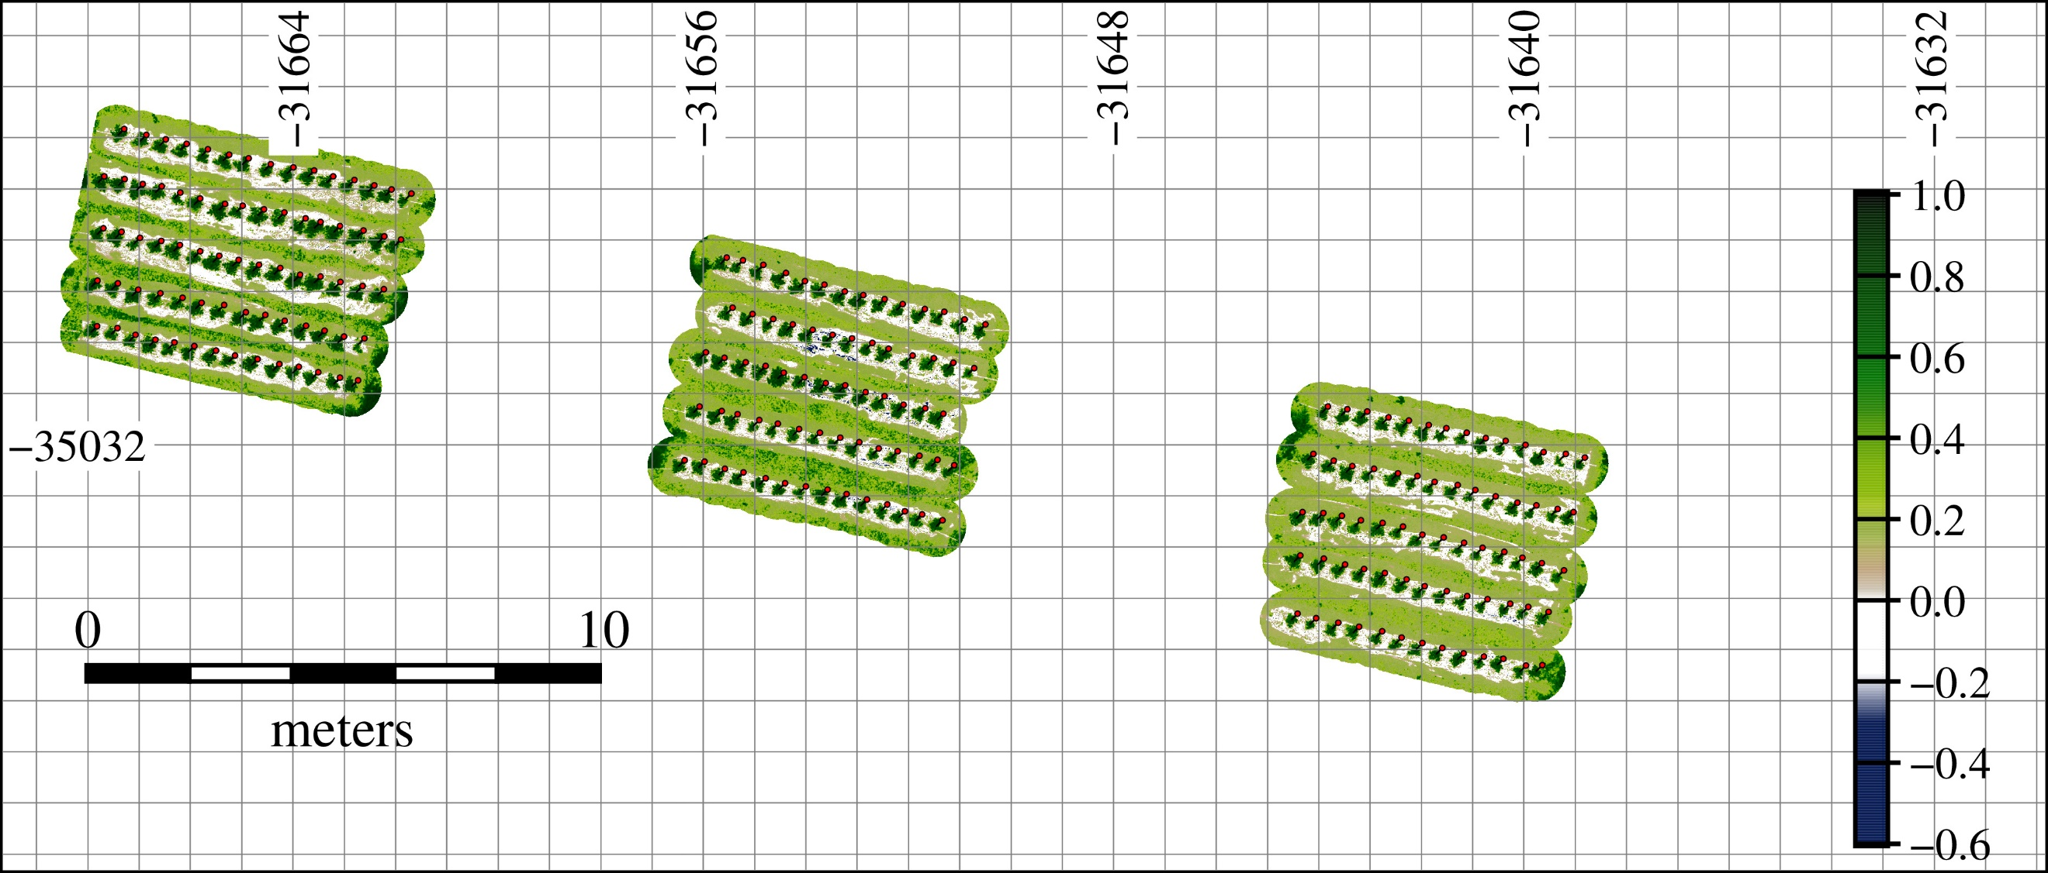  (b)
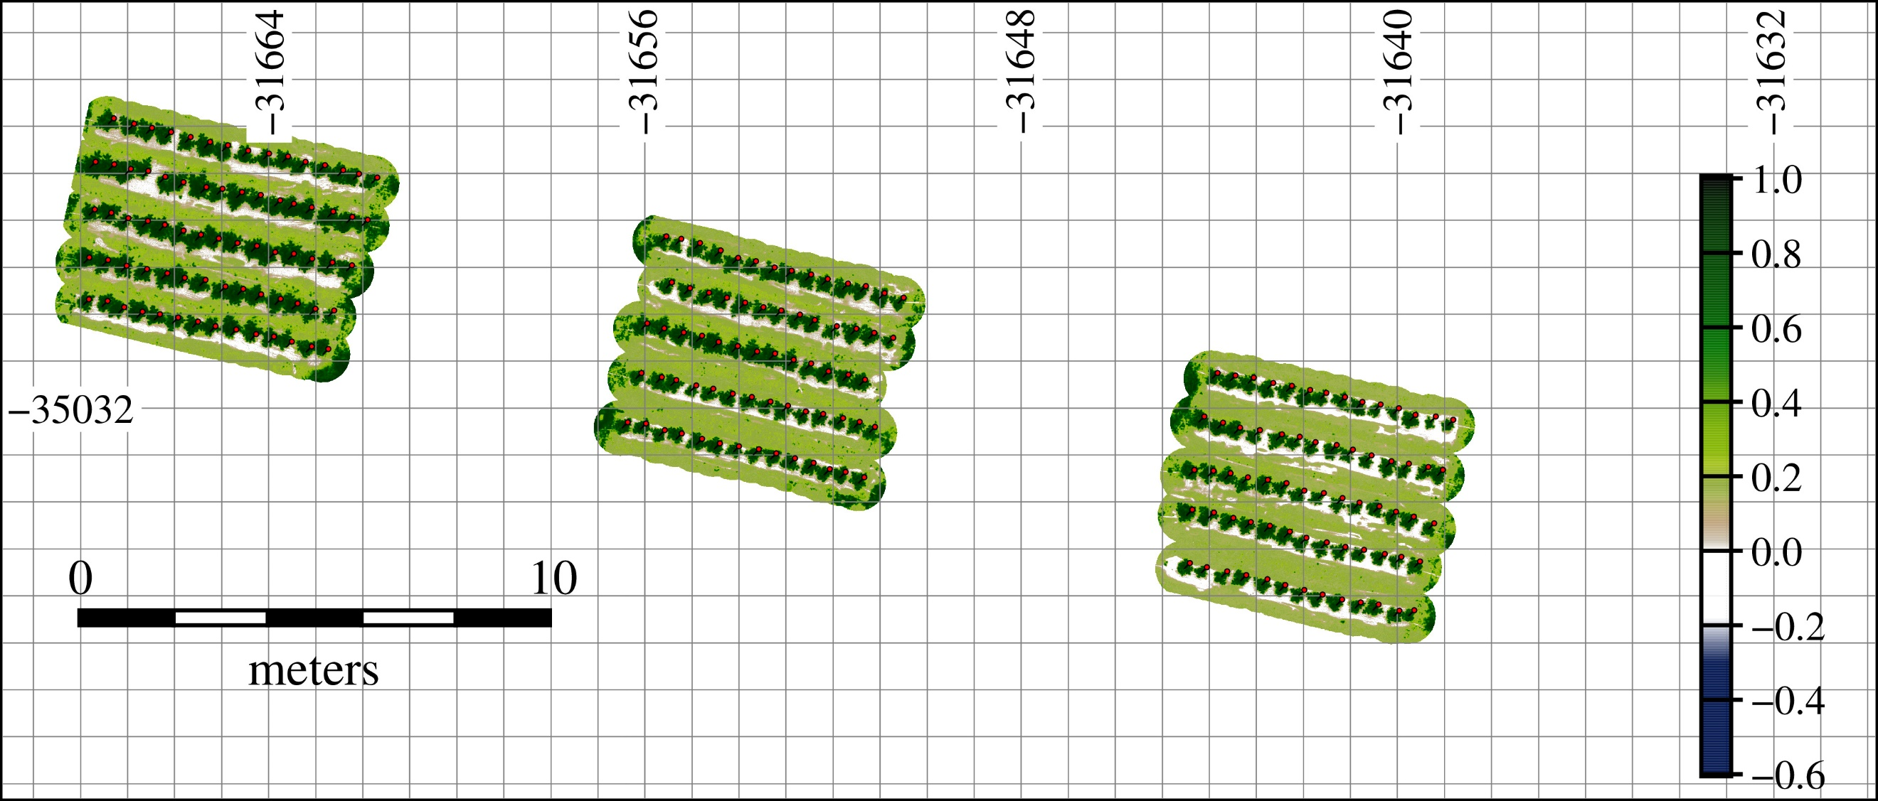  (c) | 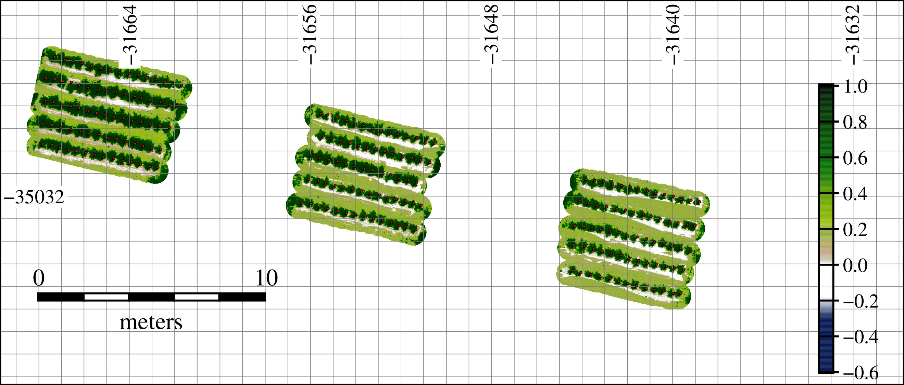  (d)
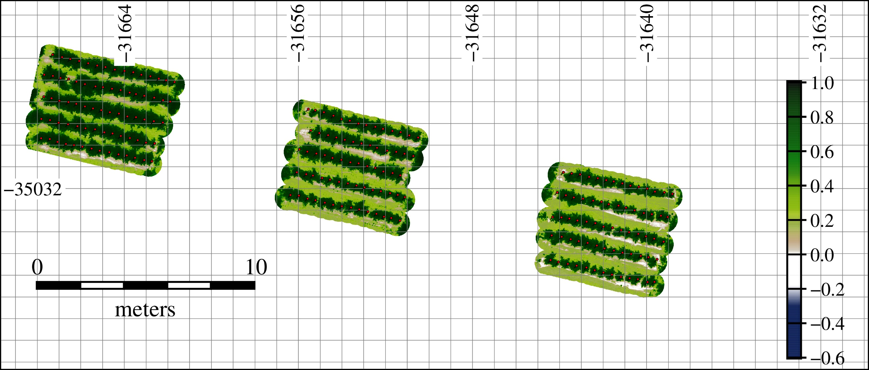  (e) | 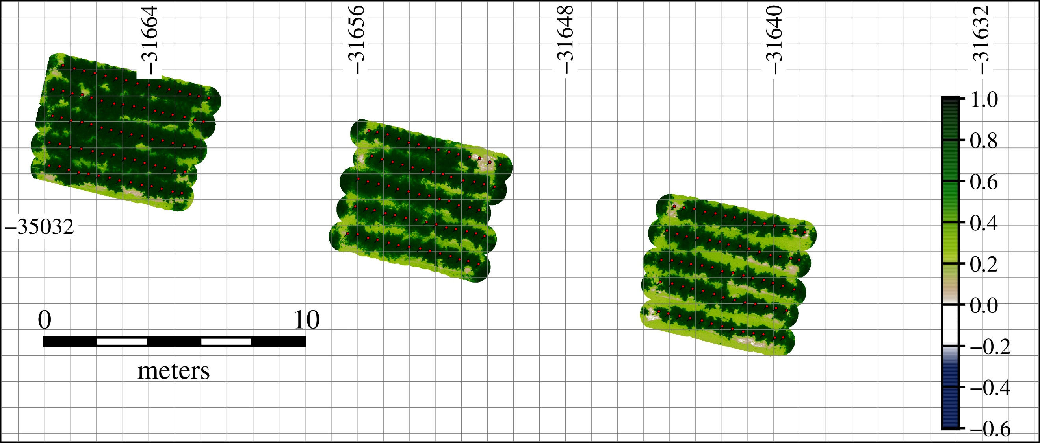  (f)
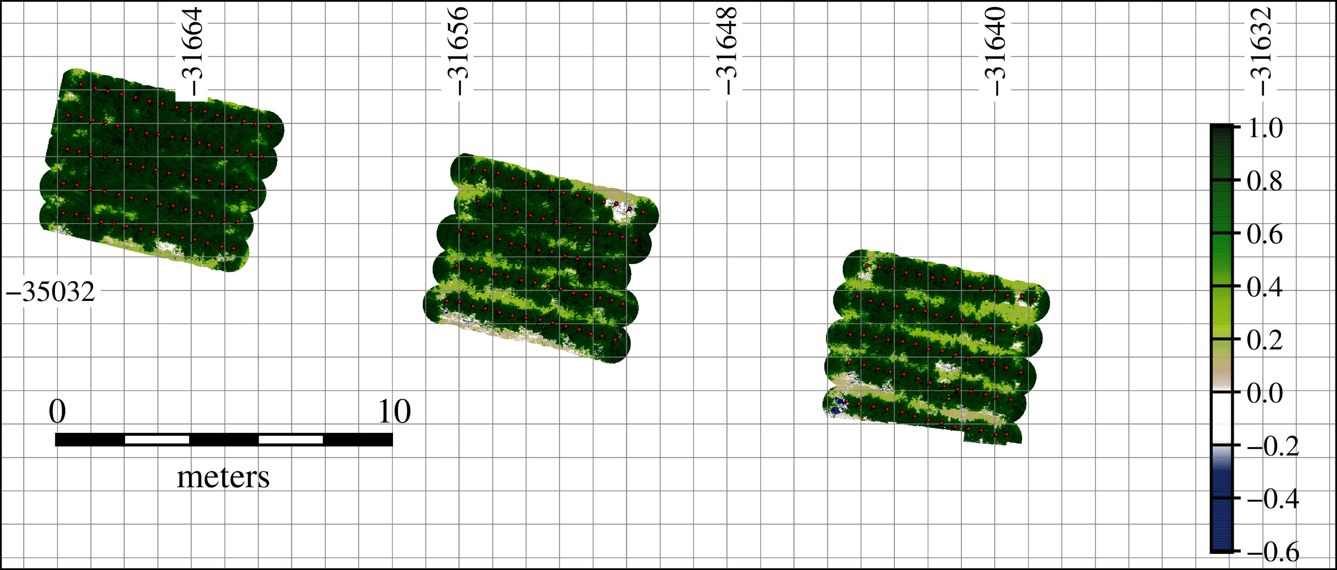  (g) | 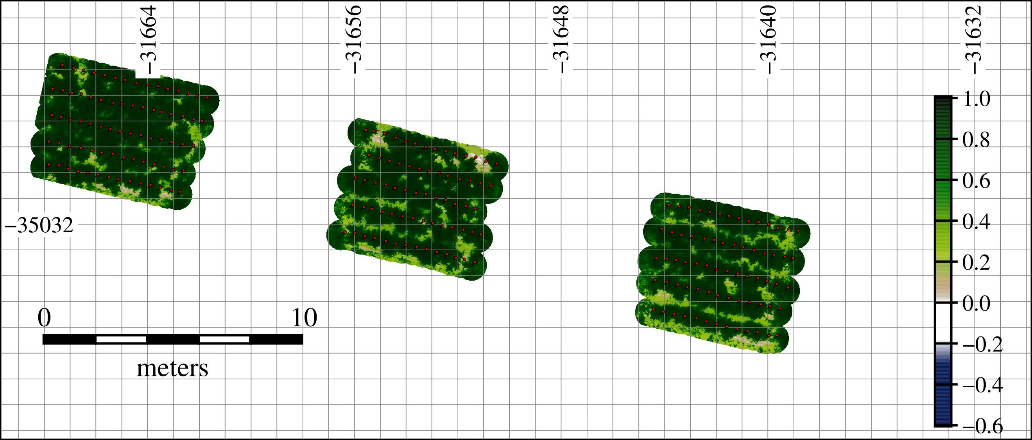  (h)
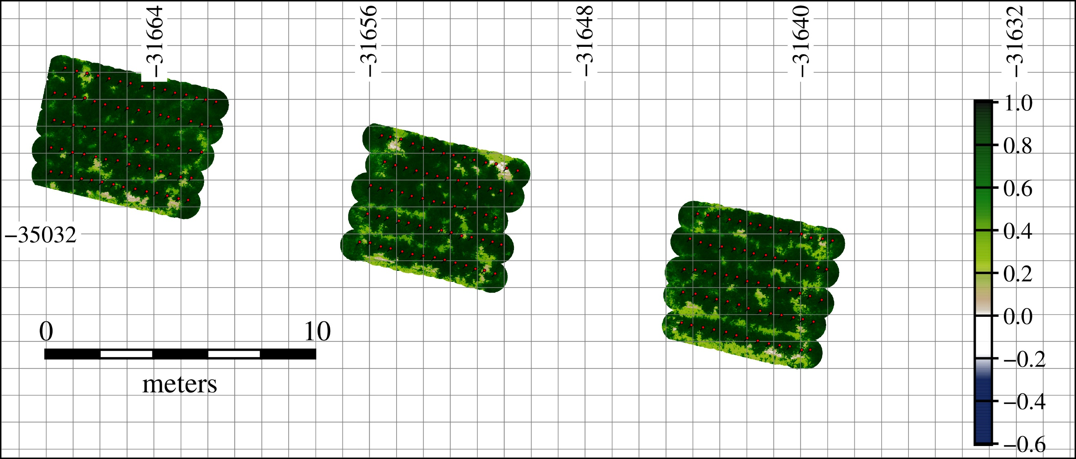  (i) | 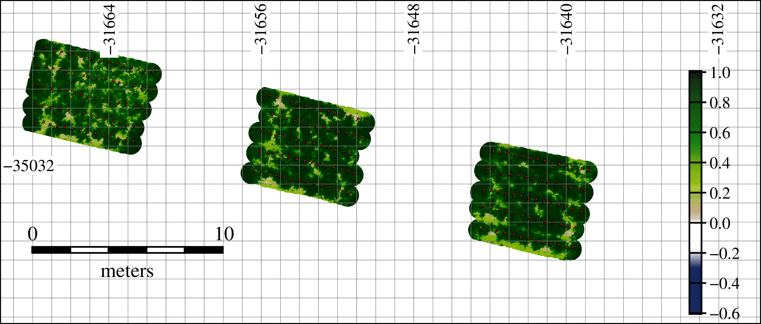  (j)

Additional file 1

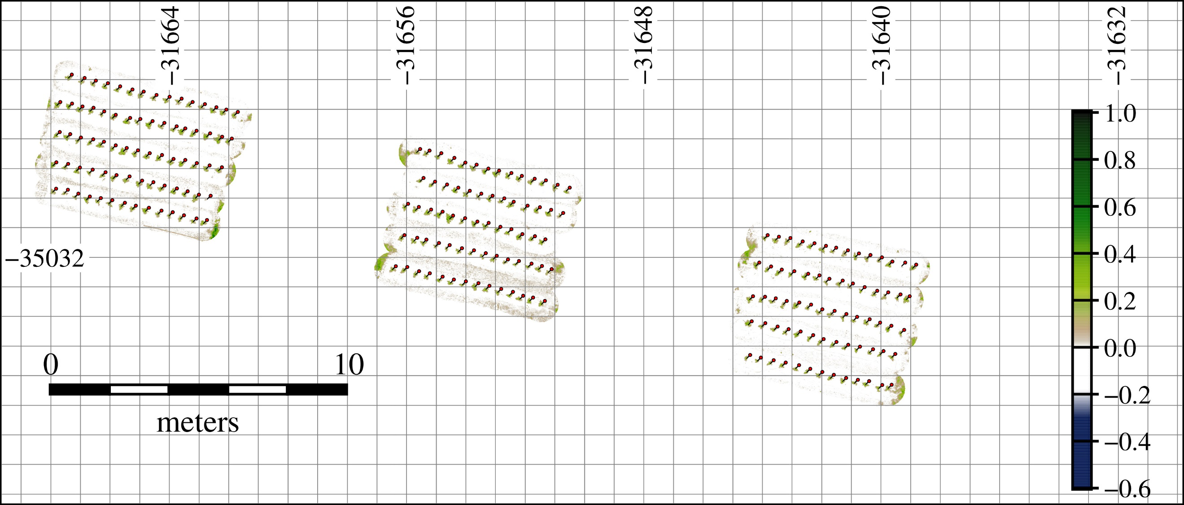  (a) | 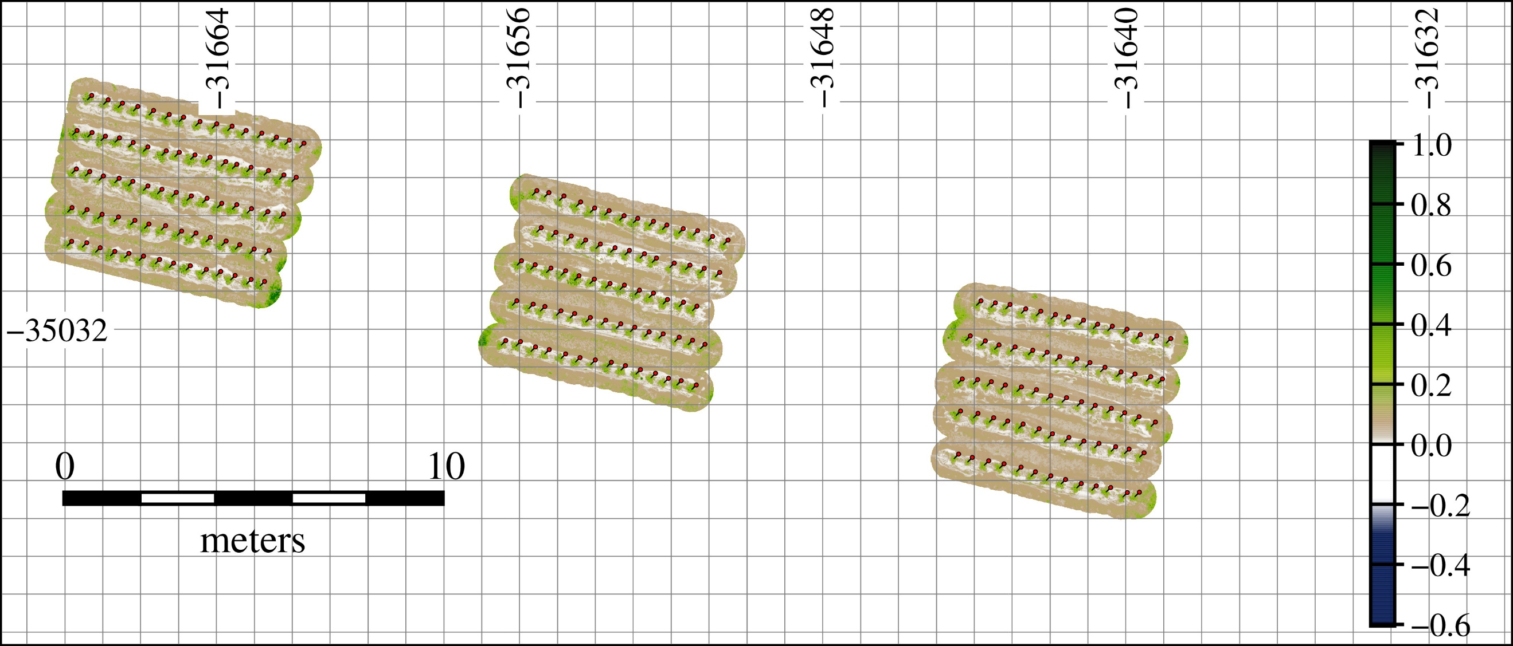  (b)
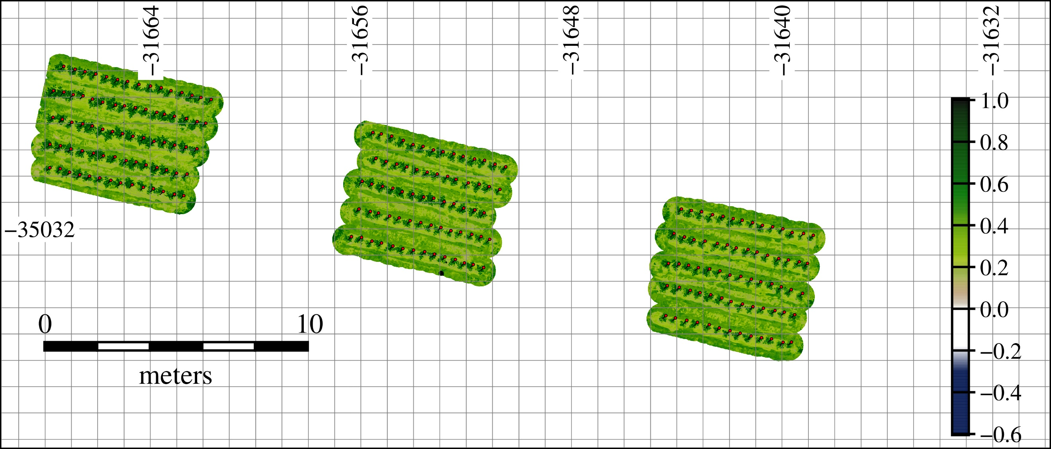  (c) | 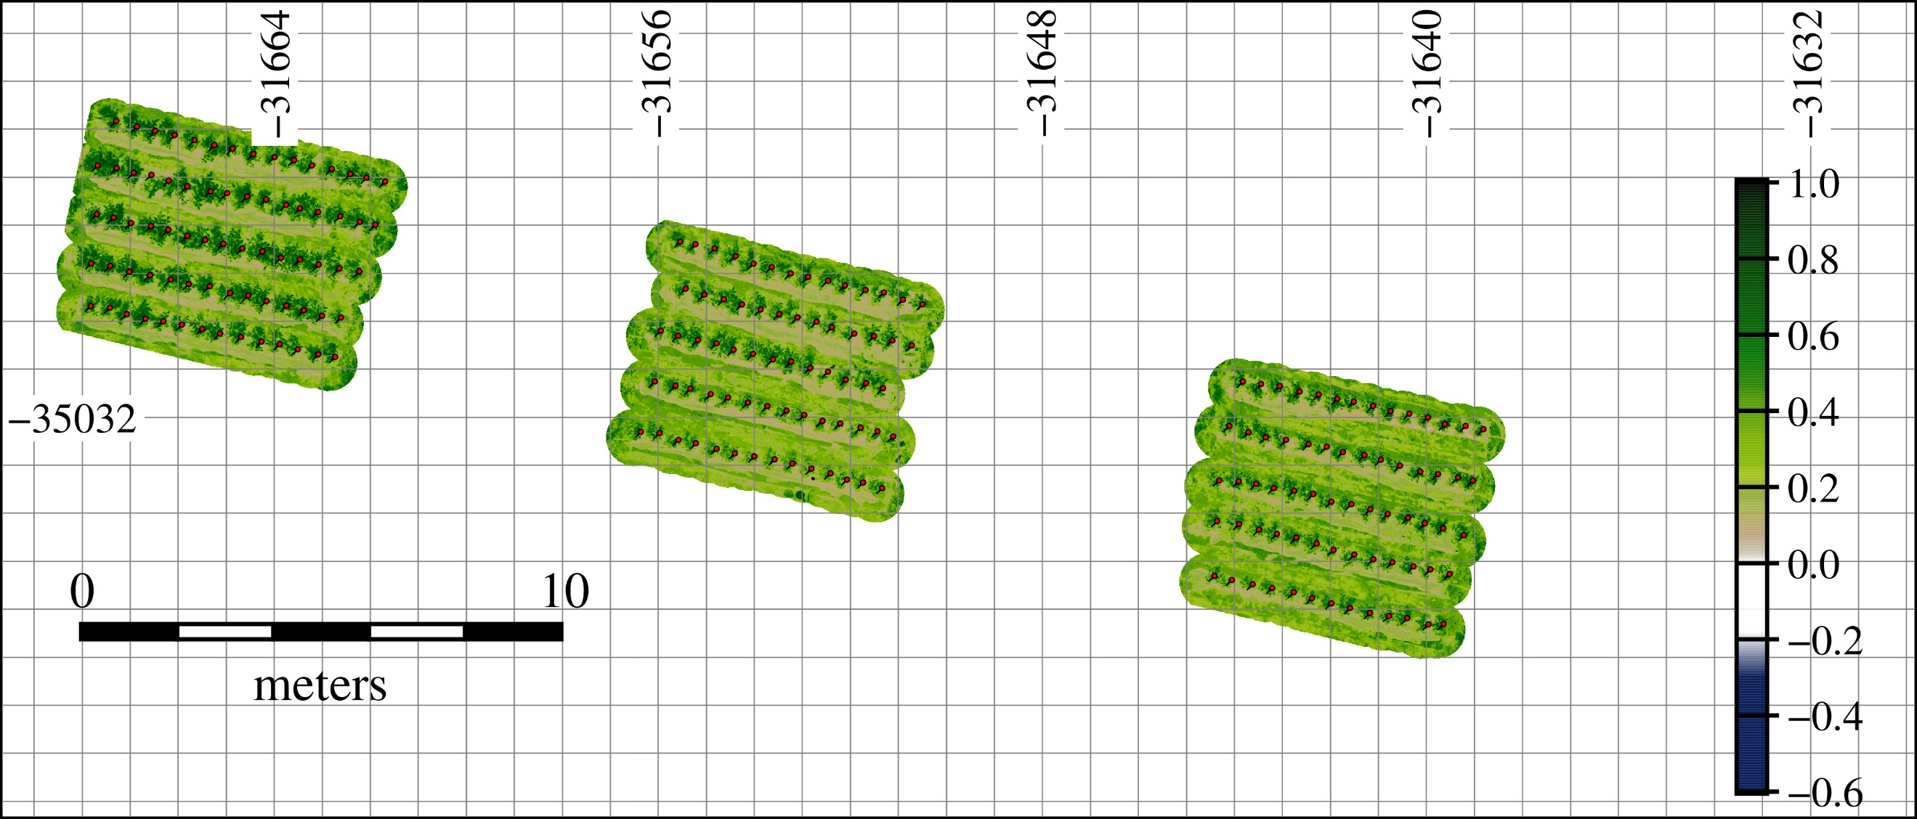  (d)
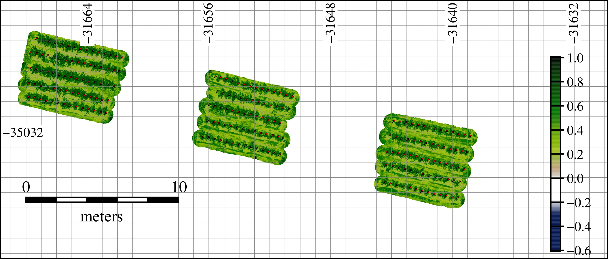  (e) | 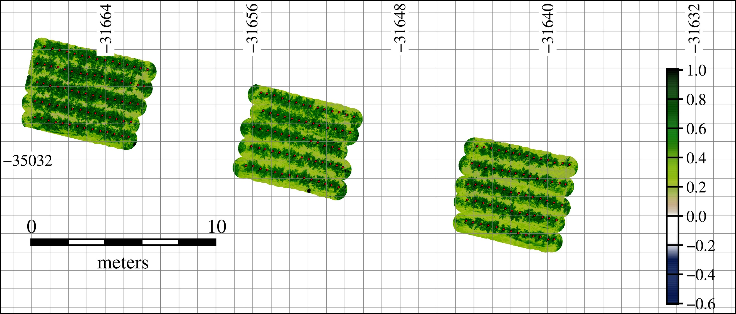  (f)
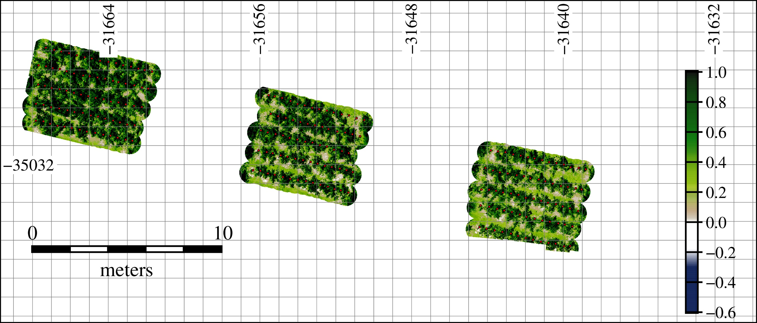  (g) | 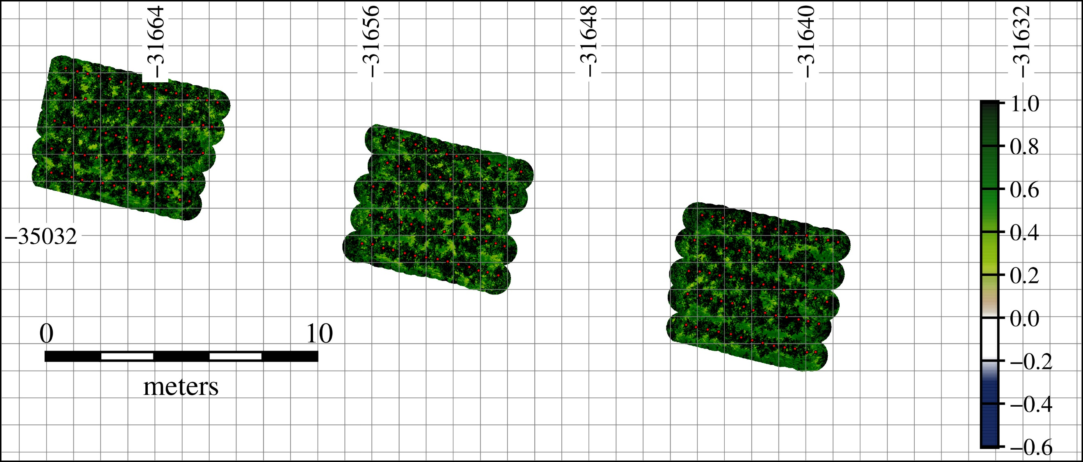  (h)
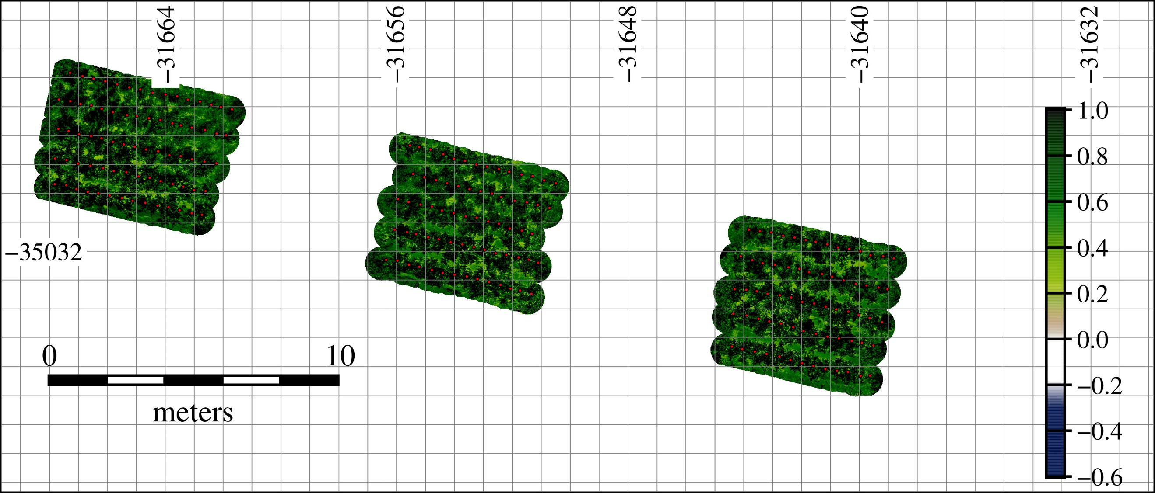  (i) | 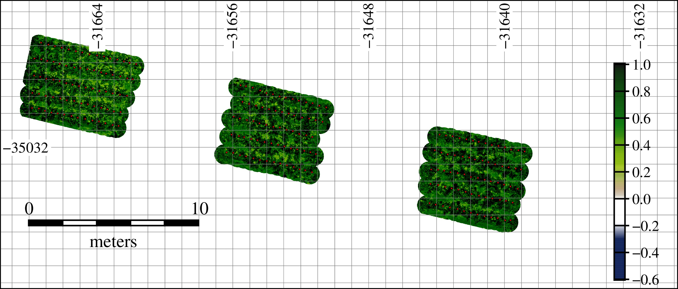  (j)

Additional file 2

Appendix B: Auxiliary formula for calculation of gray-level co-occurrence matrix (GLCM) features
(1)
(2)
(3)
(4)
(5)
(6)
(7)
(8)
(9)
(10)
(11)
$${\text{P}}_{\text{x}}\text{(}\text{i}\text{)} \text{=}\sum_{\text{j}\text{=0}}^{\text{N}\text{–}\text{1}}{{\text{P}}_{\text{d}}\text{(}\text{i}\text{,} \text{j}\text{)}}$$
$${\text{P}}_{\text{y}}\text{(}\text{j}\text{)} \text{=}\sum_{\text{i}\text{=0}}^{\text{N}\text{–}\text{1}}{{\text{P}}_{\text{d}}\text{(}\text{i}\text{,} \text{j}\text{) }}$$
$${\text{P}}_{\text{x}\text{+}\text{y}}\left(\text{k}\right) \text{=}\sum_{\text{i}\text{=0}}^{\text{N}\text{–}\text{1}}{\sum_{\text{j}\text{=0}}^{\text{N}\text{–}\text{1}}{{\text{P}}_{\text{d}}\text{(}\text{i}\text{,} \text{j}\text{)}}}\text{, }\text{k}\text{=}\text{i}\text{+}\text{j}\text{=0,1} \text{,…,} \text{2(N}\text{–}\text{1)}$$
$${\text{P}}_{\text{x}\text{–}\text{y}}\left(\text{k}\right) \text{=}\sum_{\text{i}\text{=0}}^{\text{N}\text{–}\text{1}}{\sum_{\text{j}\text{=0}}^{\text{N}\text{–}\text{1}}{{\text{P}}_{\text{d}}\text{(}\text{i}\text{,} \text{j}\text{)}}}\text{, }\text{k}\text{=}\text{i}\text{–}\text{j}\text{=0,1} \text{,…,} \text{N}\text{–}\text{1}$$
$$\text{HX} \text{= }\text{–}\sum_{\text{i=0}}^{\text{N}\text{–}\text{1}}{{\text{P}}_{\text{x}}\left(\text{i}\right)}\text{log}{\text{(}}{\text{P}}_{\text{x}}\text{(}\text{i}\text{))}$$
$$\text{HY} \text{= }\text{–}\sum_{\text{j}\text{=0}}^{\text{N}\text{–}\text{1}}{{\text{P}}_{\text{y}}\left(\text{j}\right)}\text{log}{\text{(}}{\text{P}}_{\text{y}}\text{(}\text{j}\text{))}$$
$$\text{HXY} \text{=} \text{–} \sum_{\text{i=0}}^{\text{N}\text{–}\text{1}}{\sum_{\text{j=0}}^{\text{N}\text{–}\text{1}}{{\text{P}}_{\text{d}}\left(\text{i}\text{,} \text{j}\right)\text{log(}{\text{P}}_{\text{d}}\left(\text{i}\text{,} \text{j}\right)\text{)}}}$$
$$\text{HXY}\text{1=} \text{–} \sum_{\text{i}\text{=0}}^{\text{N}\text{–}\text{1}}{\sum_{\text{j}\text{=0}}^{\text{N}\text{–}\text{1}}{{\text{P}}_{\text{d}}\left(\text{i}\text{,} \text{j}\right)\text{log(}{\text{P}}_{\text{x}}\left(\text{i}\right){ \text{P}}_{\text{y}}\left(\text{j}\right)\text{)}}}$$
$$\text{HXY}\text{2} \text{=} \text{–} \sum_{\text{i}\text{=0}}^{\text{N}\text{–}\text{1}}{\sum_{\text{j}\text{=0}}^{\text{N}\text{–}\text{1}}{{\text{P}}_{\text{x}}\left(\text{i}\right){ \text{P}}_{\text{y}}\left(\text{j}\right)\text{log(}{\text{P}}_{\text{x}}\left(\text{i}\right){ \text{P}}_{\text{y}}\left(\text{j}\right)\text{)}}}$$
$${ \text{μ}}_{\text{x}}= \sum_{\text{i}\text{=0}}^{\text{N}\text{–}\text{1}}{\sum_{\text{j}\text{=0}}^{\text{N}\text{–}\text{1}}{{\text{i} \text{P}}_{\text{d}}\text{(}\text{i}\text{,} \text{j}\text{)}}}$$
$${ \text{μ}}_{\text{y}}= \sum_{\text{i}\text{=0}}^{\text{N}\text{–}\text{1}}{\sum_{\text{j}\text{=0}}^{\text{N}\text{–}\text{1}}{{\text{i} \text{P}}_{\text{d}}\text{(}\text{i}\text{,} \text{j}\text{)}}}$$
$${\text{σ}}_{\text{x}}= \sqrt{\sum_{\text{i}\text{=0}}^{\text{N}\text{–}\text{1}}{\sum_{\text{j}\text{=0}}^{\text{N}\text{–}\text{1}}{\text{(}\text{i} \text{–} \text{μ}{\text{)}}^{\text{2}}{\text{P}}_{\text{d}}\text{(}\text{i}\text{,} \text{j}\text{)}}}}$$
$${\text{σ}}_{\text{y}}= \sqrt{\sum_{\text{i}\text{=0}}^{\text{N}\text{–}\text{1}}{\sum_{\text{j}\text{=0}}^{\text{N}\text{–}\text{1}}{\text{(}\text{j} \text{–} \text{μ}{\text{)}}^{\text{2}}{\text{P}}_{\text{d}}\text{(}\text{i}\text{,} \text{j}\text{)}}}}$$
(12)
(13)

