Supporting Information
Determination on the Thickness of Superficially Weathered Layer of Stone Cultural Relics
Xuemei Wang^{1,2}, Hongjie Luo ^{1,2}, Haidong Yu^{3,4*}, Can Xiong^{3,4*}, Xiao Huang ^{2*}
¹School of Materials Science and Engineering, Shanghai University, Shanghai 200444, China
²Institute for the Conservation of Cultural Heritage, Shanghai University, Shanghai 200444, China
³Chongqing Key Laboratory of Paleontology and Paleoenvironment Co-evolution, Chongqing, 400700, China
⁴208 Hydrogeological and Engineering Geological Team, Chongqing Bureau of Geological and Mineral Resource Exploration and Development, Chongqing, 400700, China
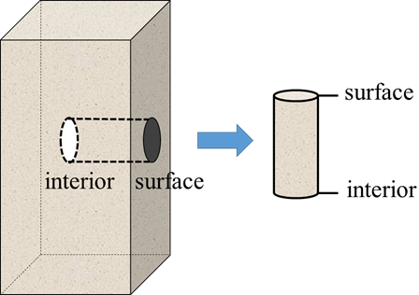
Figure S1. Schematic diagram of sandstone sampling

Table S1 The classification standard of ultrasonic velocity ratio and weathering grade [47]
Ultrasonic Velocity ratio | Grade | Weathering extent
0-0.2 | 6 | Residual soil
0.2-0.4 | 5 | Fully weathered
0.4-0.6 | 4 | Highly weathered
0.6-0.8 | 3 | Moderately weathered
0.8-0.9 | 2 | Weakly weathered
0.9-1 | 1 | Unweathered

Reference
[47] Chen X., Qi, X., Xu, Z. Determination of weathered degree and mechanical properties of stone relics with ultrasonic CT: a case study of an ancient stone bridge in China. Journal of Cultural Heritage. 2020, 42:131-138.

