Supplementary material 1: the user was provided with a short clinical vignette and ECG with a standardised template for online analysis

1A: the web application required a systematic approach to ECG analysis, starting with a rhythm overview

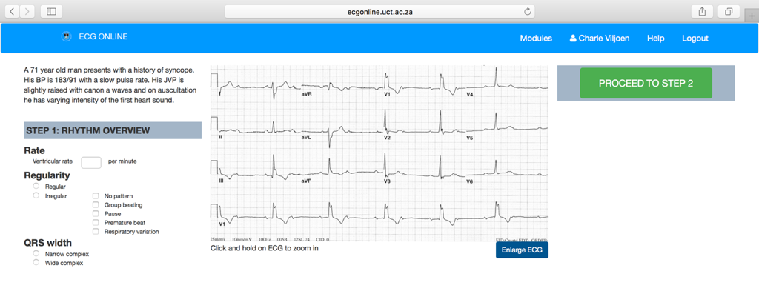

1B: the user could not proceed to the next step of their analysis without completing all the necessary fields

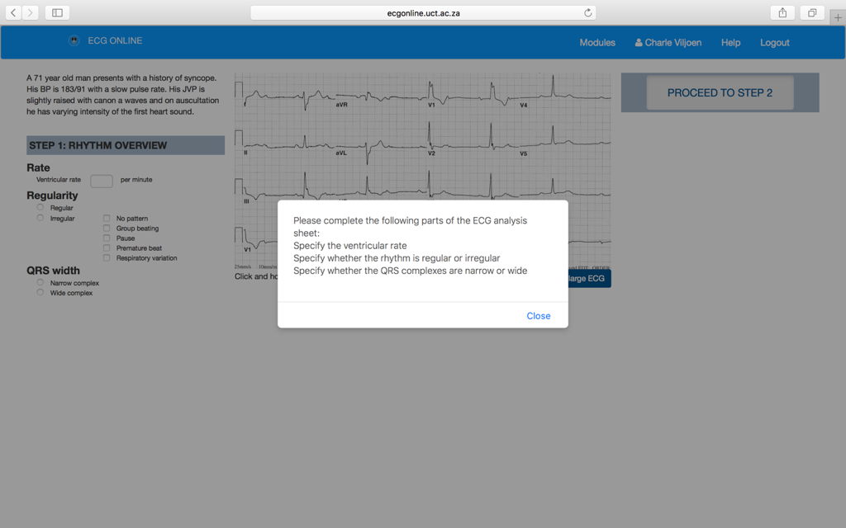

1C: once the user completed the ECG analysis and interpretation (i.e. provided a diagnosis), they could submit their answer.

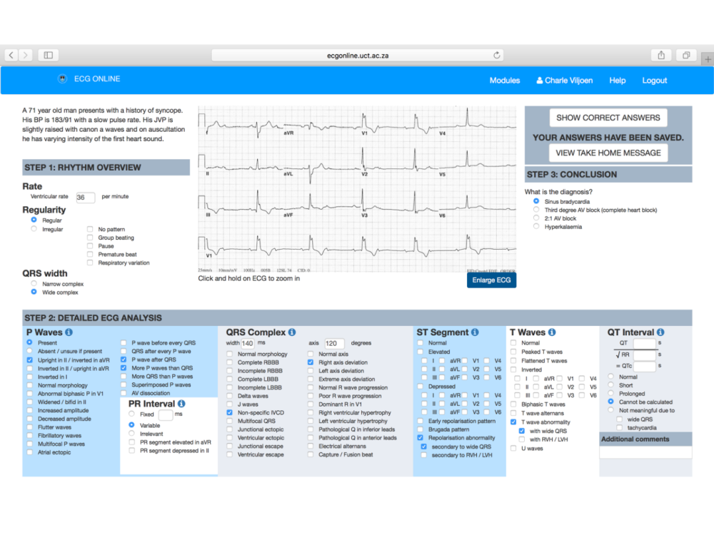

1D: the correct answers were displayed in red alongside the user’s own ECG analysis and interpretation.

