Supporting Information for

Benzocaine-N-acylindoline Conjugates: Synthesis and Antiviral Activity Against Coxsackievirus B3

Alexandrina S. Volobueva ^{1,2}, Anton A. Shetnev ^{2, 3*}, Mikhail G. Mikhalski ¹, Valeria A. Panova ²,
Darina D. Barkhatova ⁴, Ekaterina D. Korshunova ², Sergey A. Ivanovskiy ², Vladimir V. Zarubaev ¹ and Sergey V. Baykov ⁴
¹ Saint Petersburg Pasteur Institute, 14 Mira Street, 197101 Saint Petersburg, Russia; sasha-khrupina@mail.ru (A.S.V.); misha.pogorany@gmail.com (M.G.M); zarubaev@gmail.com (V.V.Z.)
² Pharmaceutical Technology Transfer Center, Yaroslavl State Pedagogical University named after K.D. Ushinsky, 108 Respublikanskaya St., 150000 Yaroslavl, Russia; v.panova@yspu.org (V.A.P), s.ivanovskiy@yspu.org (S.A.I.), katyakor0@yandex.ru (E.D.K.)
³ Moscow Institute of Physics and Technology, 1“А” Kerchenskaya st., 117303 Moscow, Russia (A.A.S.)
⁴ Institute of Chemistry, Saint Petersburg State University, 7/9 Universitetskaya Nab., 199034 Saint Petersburg, Russia

* Correspondence: a.shetnev@list.ru (A.A.S.)

*Corresponding author.
E-mail address a.shetnev@list.ru

Contents:
Copies of ¹H and ¹³C NMR spectra for compounds 3a-d, 4a-d, 5a-d, 6a-d, 7

1-(indolin-1-yl)ethan-1-one (3a)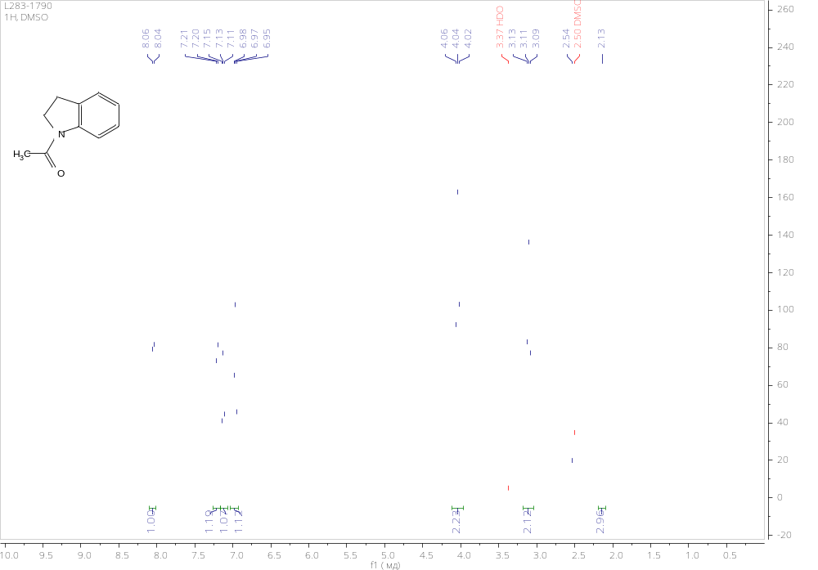
1-(indolin-1-yl)propan-1-one (3b)
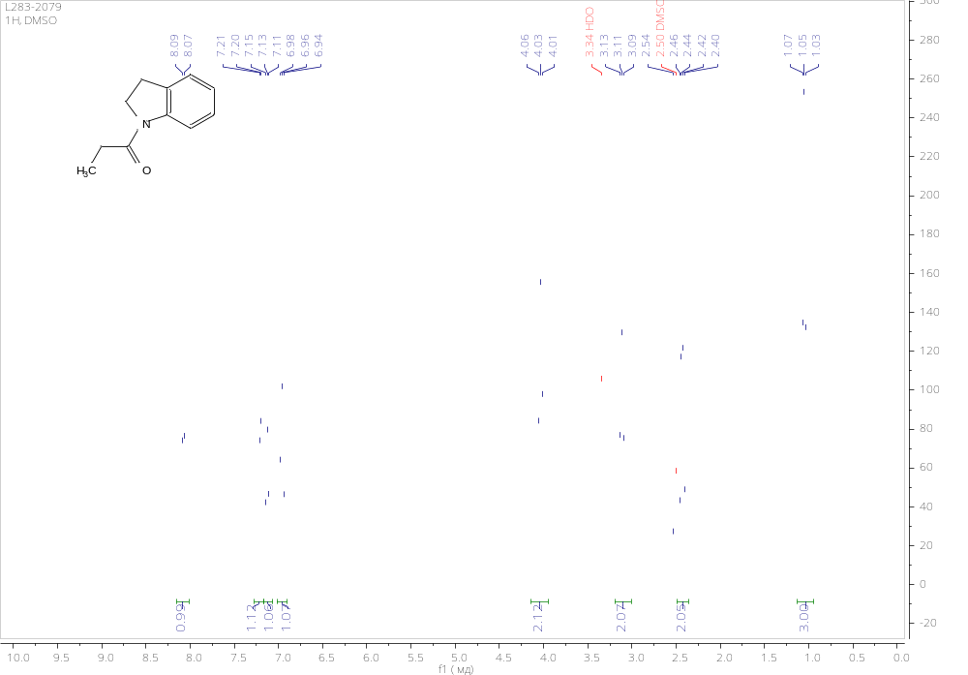
Cyclobutyl(indolin-1-yl)methanone (3c)
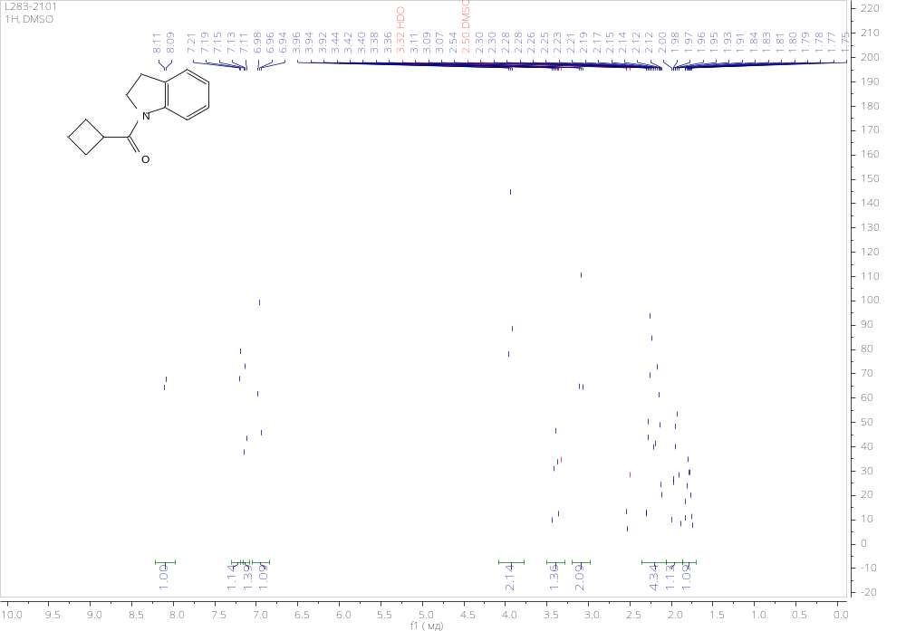
indolin-1-yl(phenyl)methanone (3d)
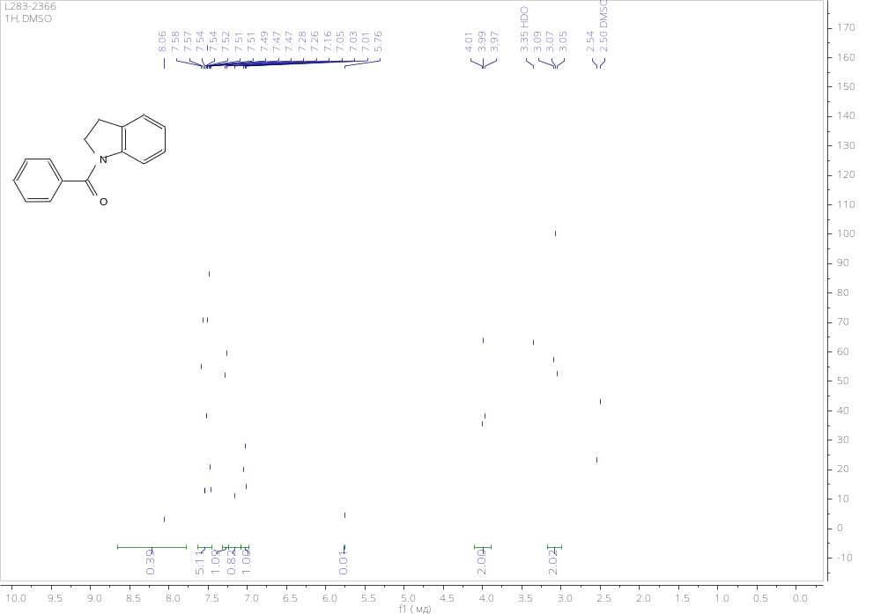
1-acetylindoline-5-sulfonyl chloride (4a)
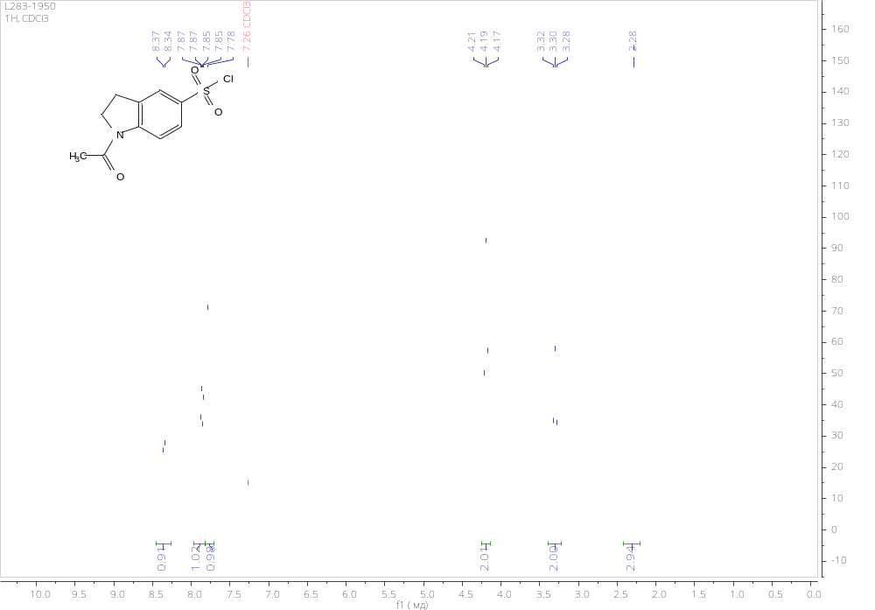1-propionylindoline-5-sulfonyl chloride (4b)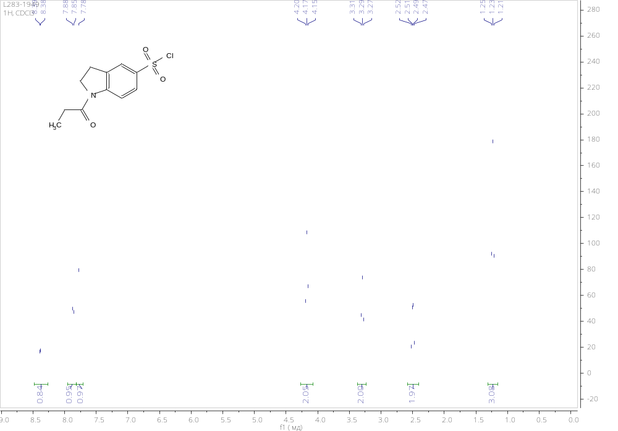

1-(cyclobutanecarbonyl)indoline-5-sulfonyl chloride (4c)
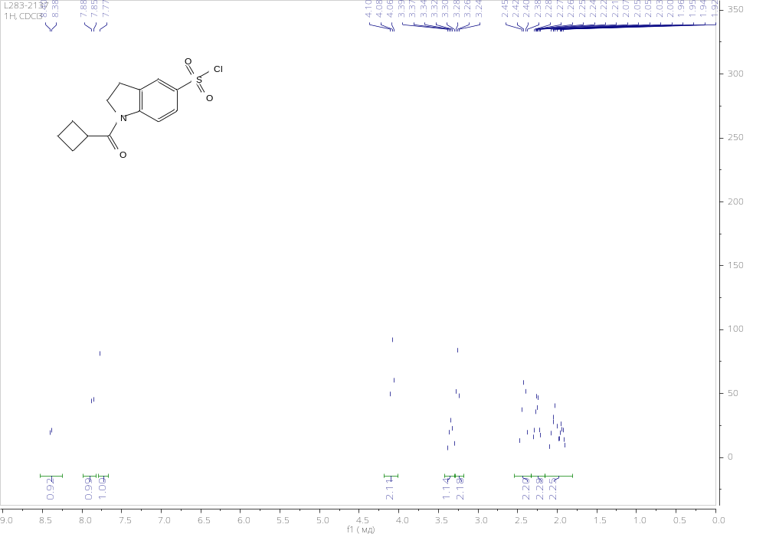
1-benzoylindoline-5-sulfonyl chloride (4d)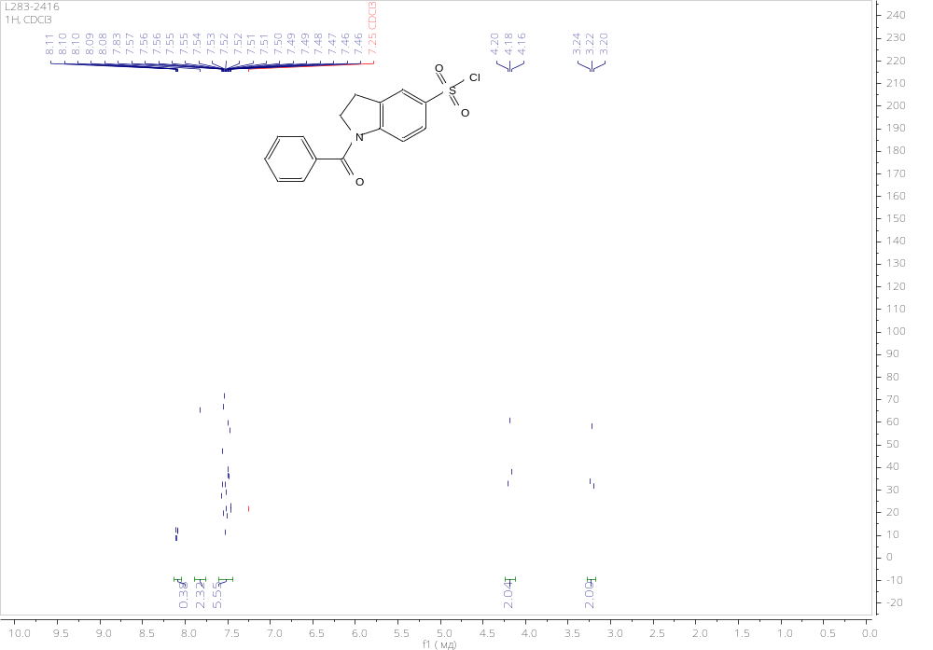

Ethyl 4-((1-acetylindoline)-5-sulfonamido)benzoate (5a)
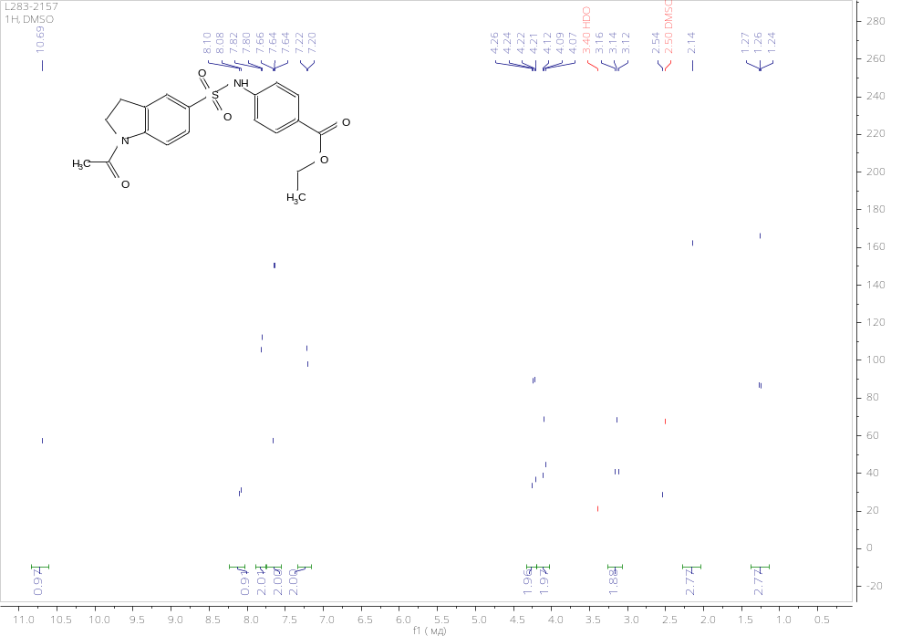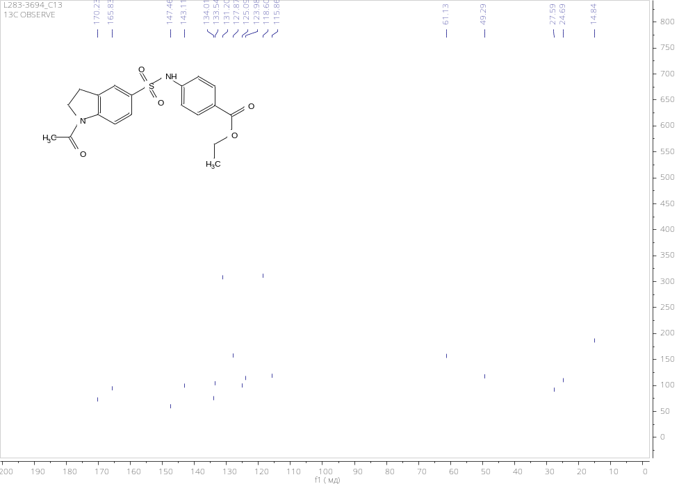

Ethyl 4-((1-propionylindoline)-5-sulfonamido)benzoate (5b)
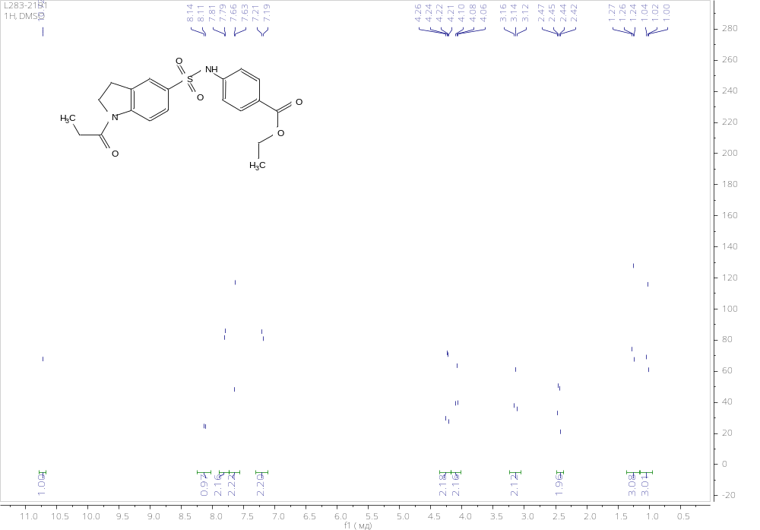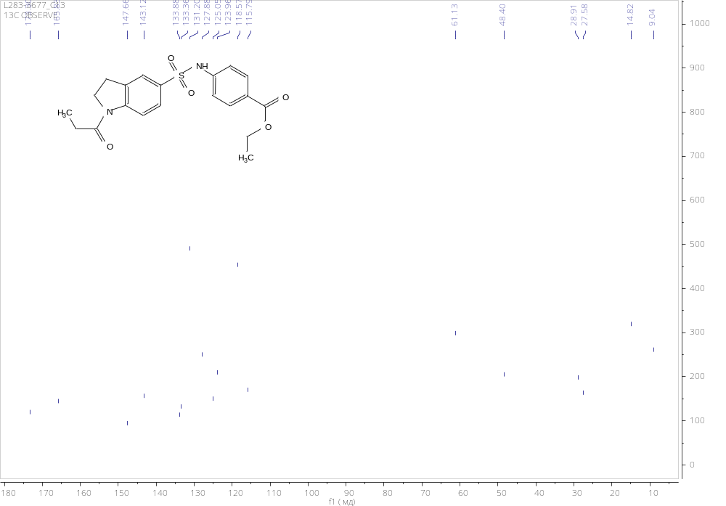

Ethyl 4-((1-(cyclobutanecarbonyl)indoline)-5-sulfonamido)benzoate (5c)
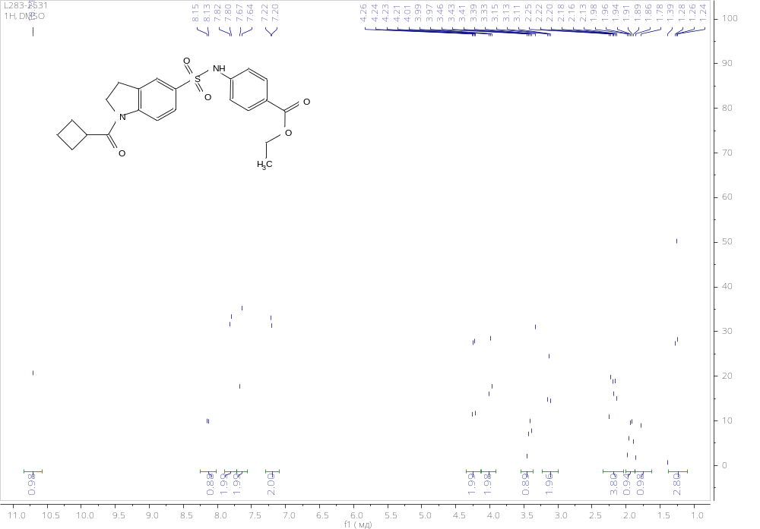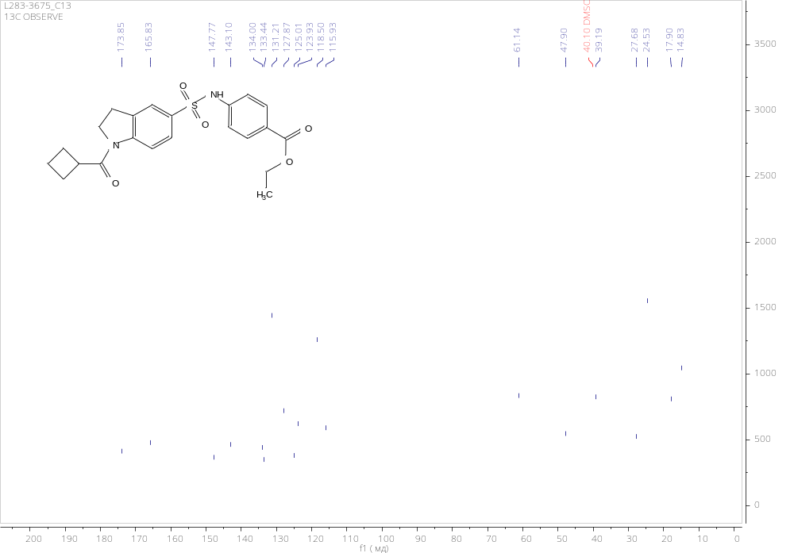

Ethyl 4-((1-benzoylindoline)-5-sulfonamido)benzoate (5d)
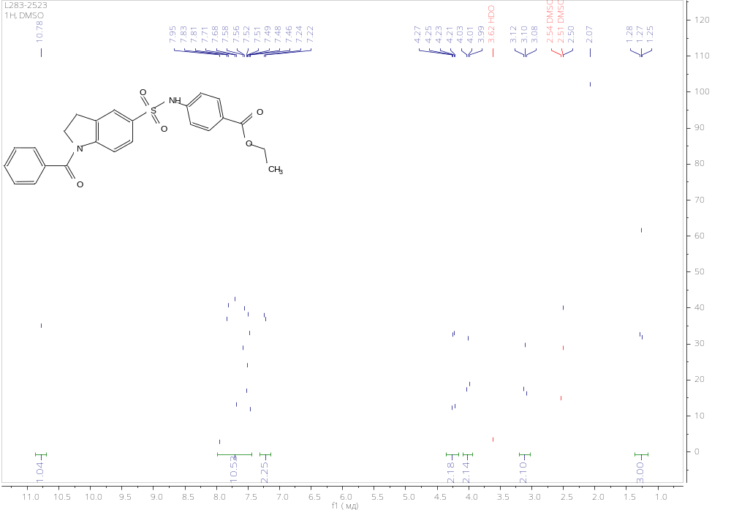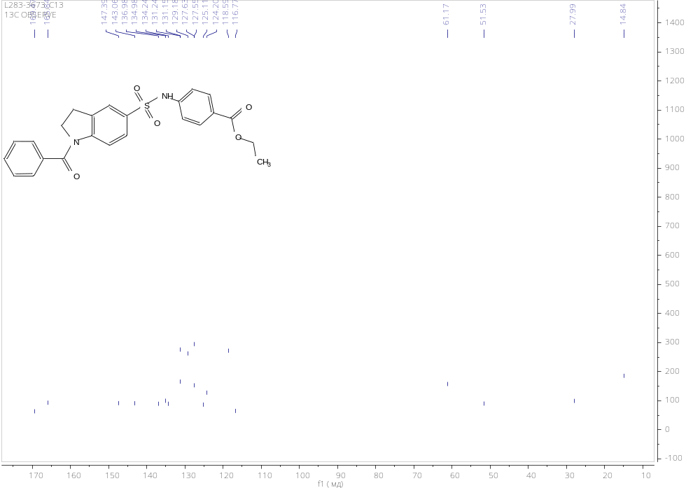

4-((1-Acetylindoline)-5-sulfonamido)benzoic acid (6a)
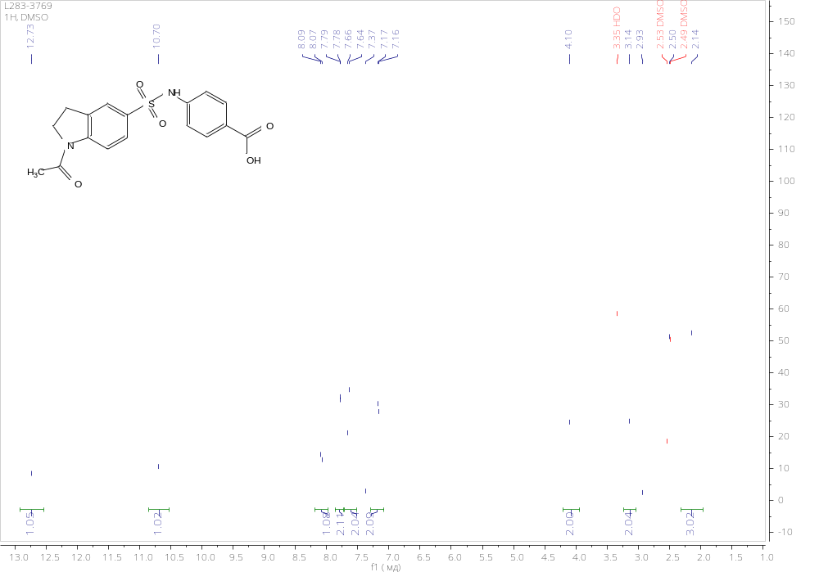
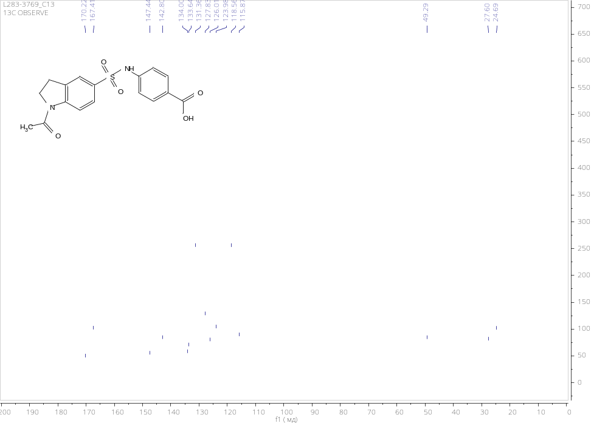

4-((1-Propionylindoline)-5-sulfonamido)benzoic acid (6b)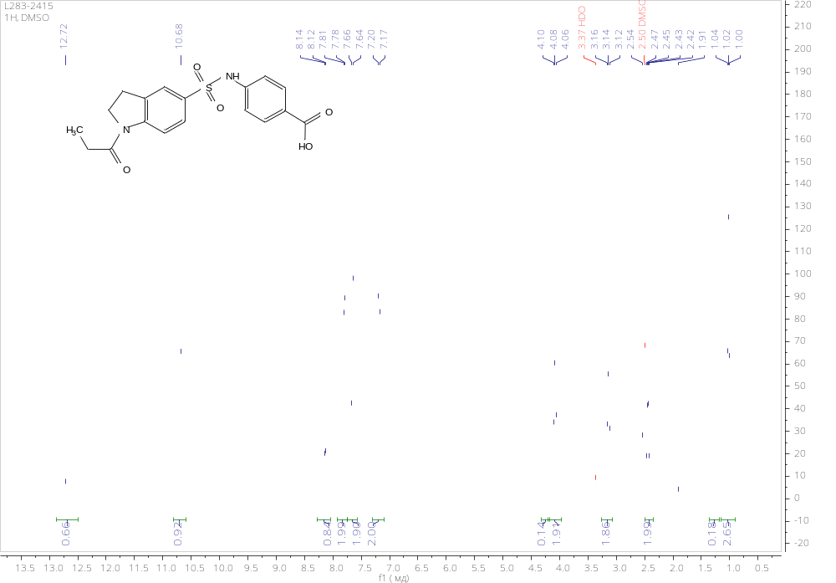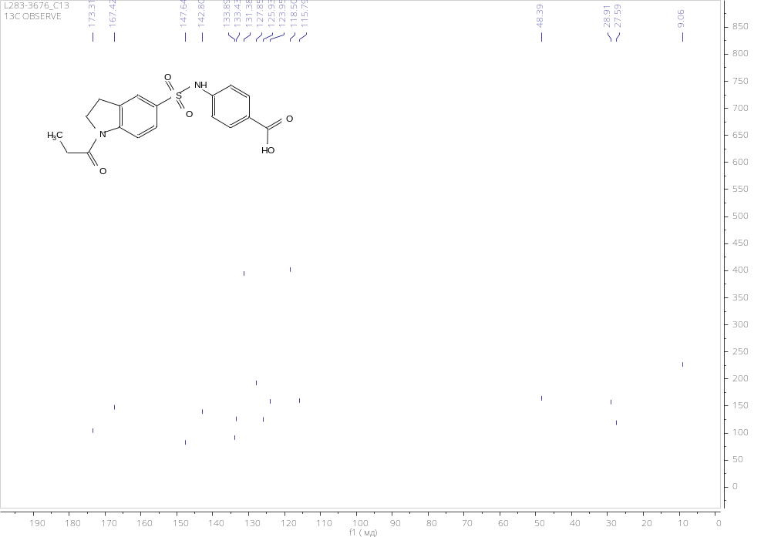

4-((1-(Cyclobutanecarbonyl)indoline)-5-sulfonamido)benzoic acid (6c)
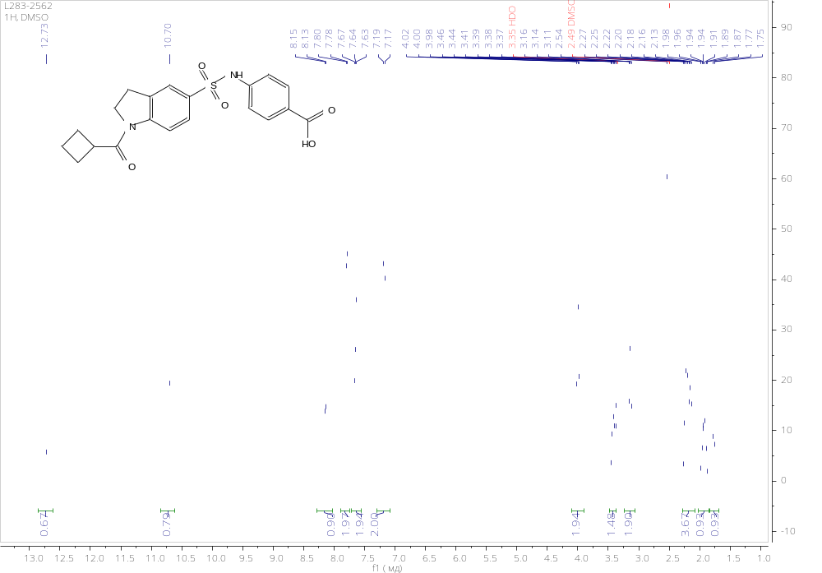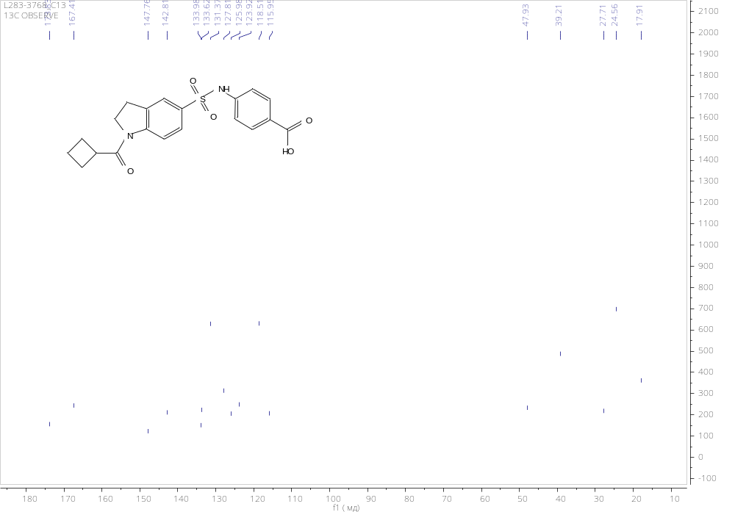

4-((1-benzoylindoline)-5-sulfonamido)benzoic acid (6d)
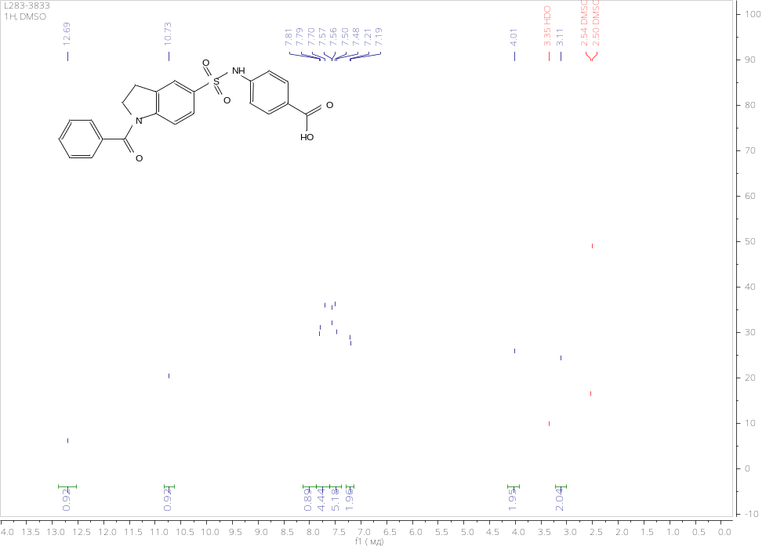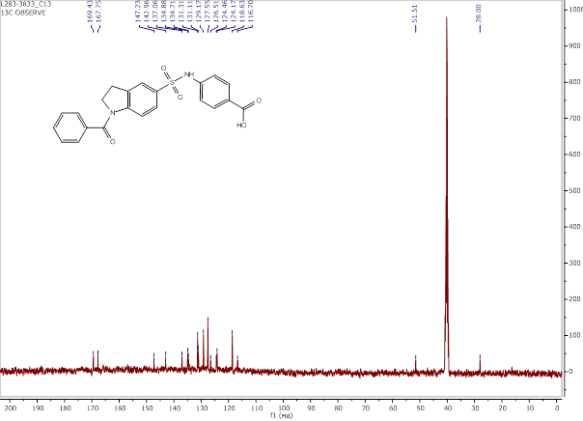

4-(indoline-5-sulfonamido)benzoic acid (7)
