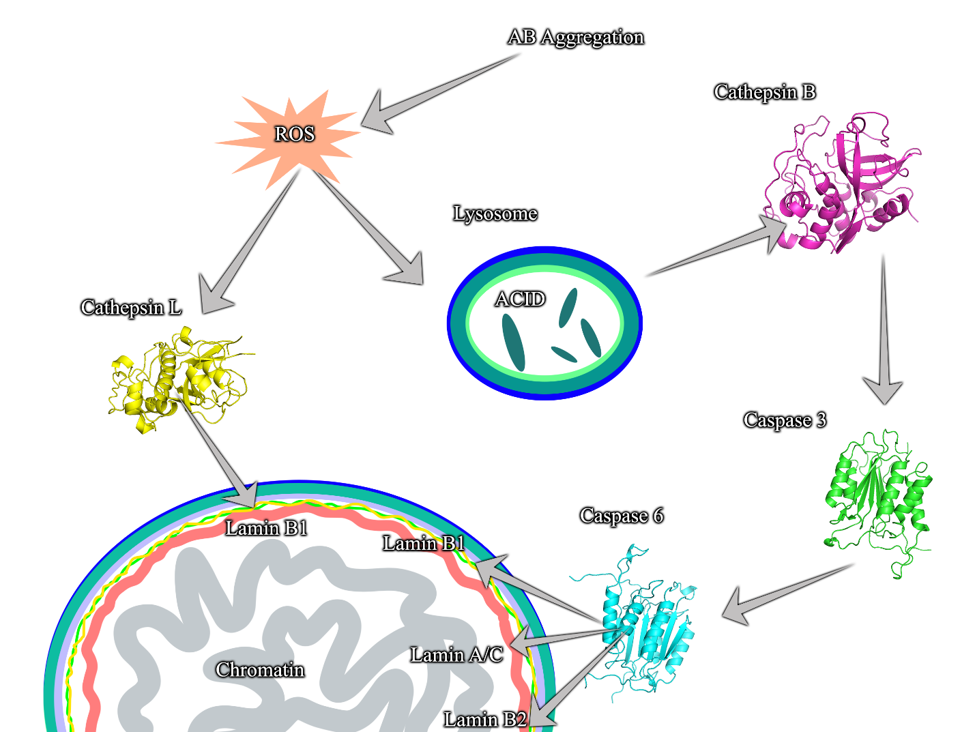
The graphical abstract of the participation of the cathepsin L and B, as well as caspase 3 and 6 in lamin degradation.

