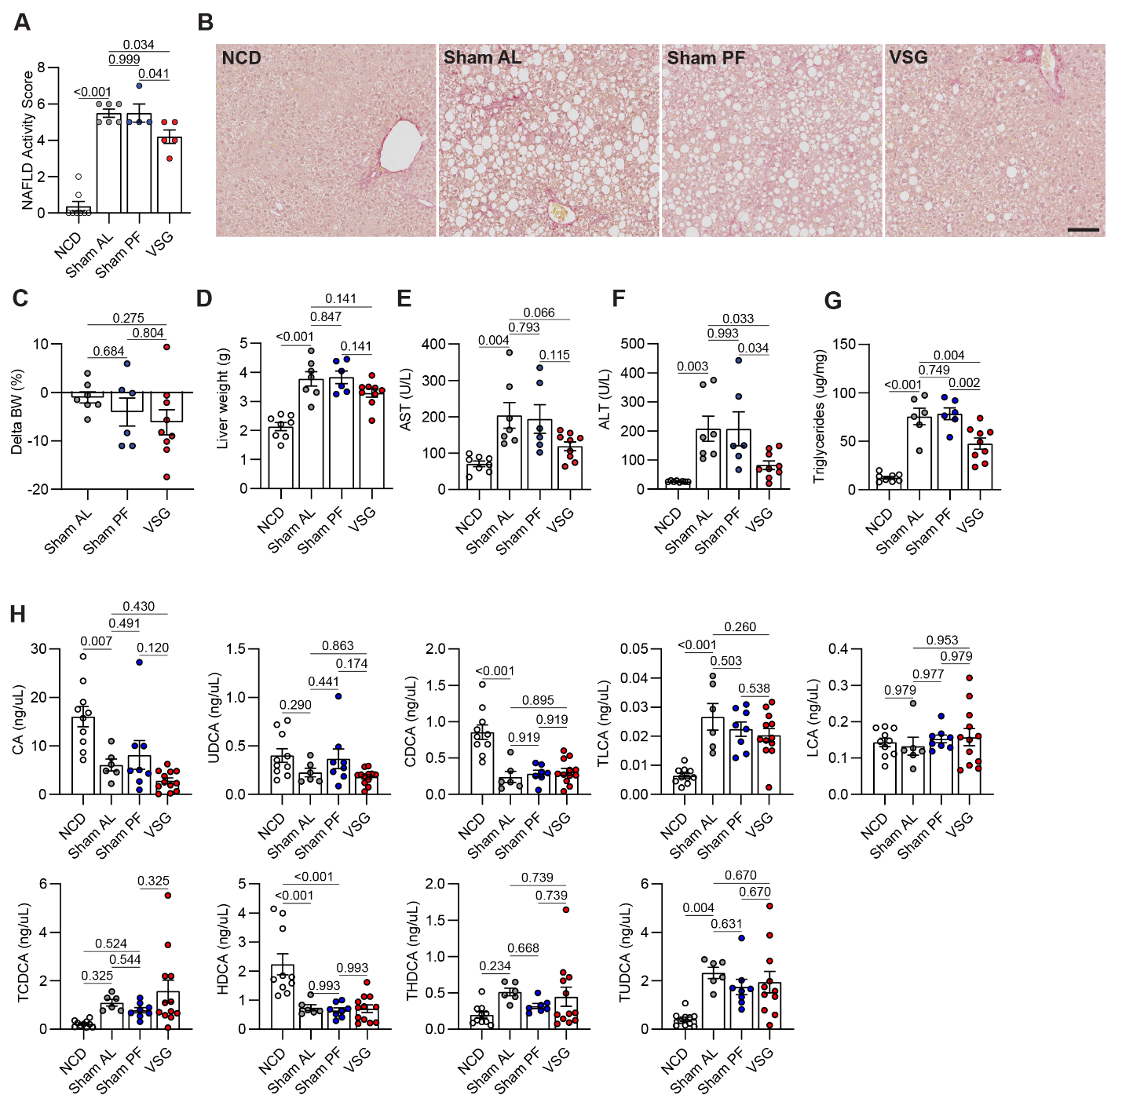
Extended Data Figure 1 (related to Figure 1). (A) NAFLD activity score; NCD (n = 8), Sham AL (n = 6), Sham PF (n = 4), VSG (n = 5), and (B) Representative Picro Sirius red-stained liver sections 5 weeks post surgeries. (C) Percentage change in body weight, (D) Liver weight, (E) Serum AST, (F) Serum ALT, and (G) Hepatic triglyceride content in C57BL6/J (WT) mice fed either an NCD (n = 8) for 22 weeks or an HFHC diet for 12 weeks, assigned to Sham AL (n = 6-7), Sham PF (n = 6), or VSG (n = 9) surgeries, and maintained on the HFHC diet for 10 weeks post-surgery. (H) Concentration of portal vein bile acids 5 weeks post-surgery: cholic acid (CA), ursodeoxycholic acid (UDCA), chenodeoxycholic acid (CDCA), taurolithocholic acid (TLCA), lithocholic acid (LCA), taurochenodeoxycholic acid (TCDCA), hyodeoxycholic acid (HDCA), taurohyodeoxycholic acid (THDCA), tauroursodeoxycholic acid (TUDCA); NCD (n = 10), Sham AL (n = 6), Sham PF (n = 8), VSG (n = 12). Data were analyzed by one-way ANOVA with Holm-Šídák multiple comparison test. Data are biological experimental units presented as mean ± SEM.

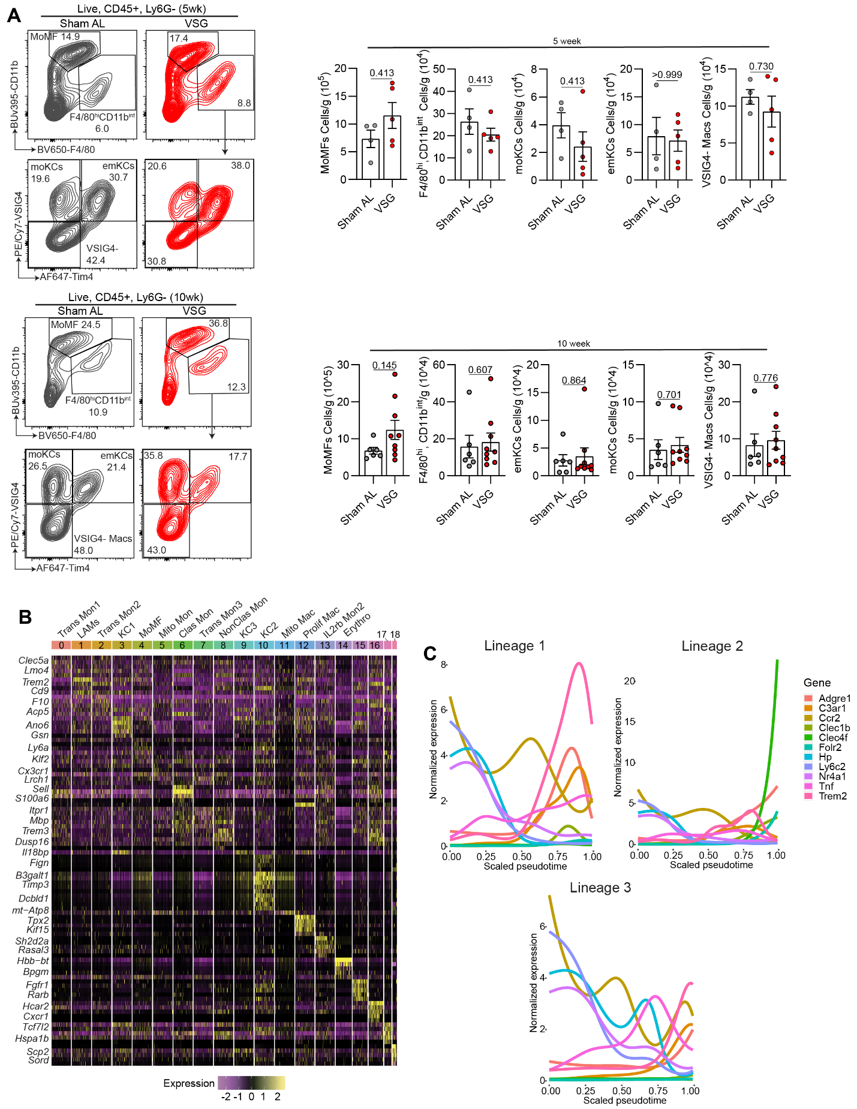
Extended Data Figure 2 (related to Figure 2). (A) Representative flow plots (left) and quantification of hepatic macrophage subsets per gram of liver (right) at 5 weeks (top) and 10 weeks post-surgery (bottom); 5 week Sham AL (n = 4), 5 week VSG (n = 5), 10 week Sham AL (n = 6) and 10 week VSG (n = 9). (B) Heat map of top genes for each cluster. (C) Gene expression over pseudotime for trajectories 1 (top left), 2 (top right) and 3 (bottom). Data were analyzed by Mann Whitney tests. Data are biological experimental units presented as mean ± SEM.

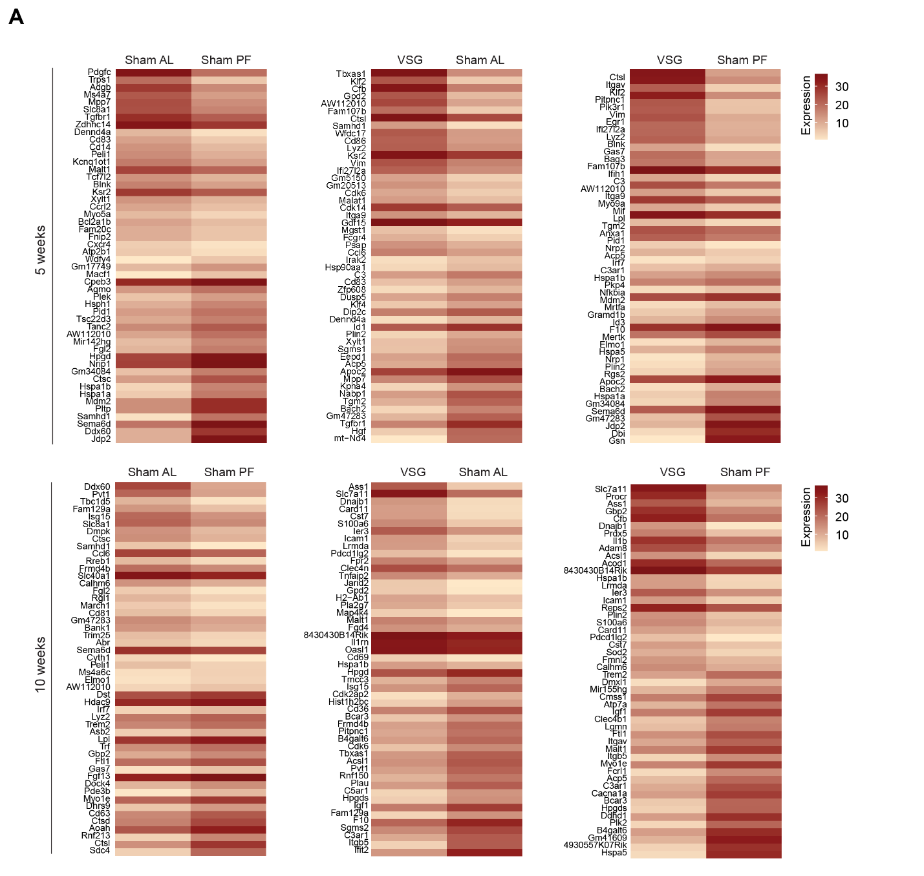
Extended Data Figure 3 (related to Figure 3). (A) Heat maps of top DEGs between all groups at both time points for total macrophages. All data presented in this figure (n = 4).

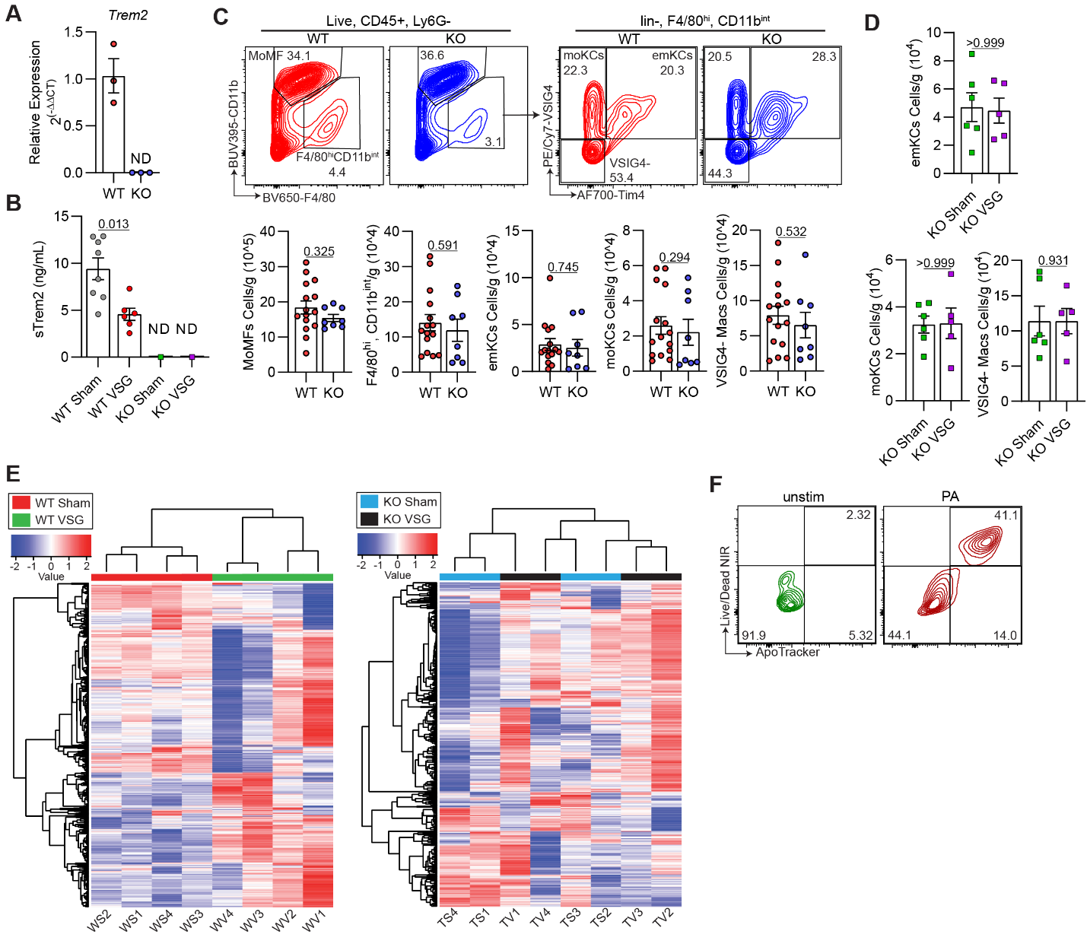
Extended Data Figure 4 (related to Figure 4). (A) Relative expression Trem2 in WT and TREM2 KO BMDMs; WT (n = 3) and KO (n = 3). (B) Concentration of sTREM2 in the serum 5 weeks post-VSG; WT Sham (n = 8), WT VSG (n = 6), KO Sham (n = 8), and KO VSG (n = 8). (C) Representative flow plots (top) and quantification of hepatic macrophage subsets per gram of liver (bottom) after 12 weeks of HFHC feeding; WT (n = 15) and KO (n = 8). (D) Quantification of hepatic macrophage subsets per gram of liver 5 weeks post-VSG; WT (n = 5) and KO (n = 5). (E) Heat map of the top 500 most variable genes between WT Sham and WT VSG macrophages (left) and KO Sham and KO VSG macrophages (right). (F) Representative flow plots of AML12 cells that were either unstimulated or stimulated with PA. Data were analyzed by Mann Whitney tests. Data are biological experimental units presented as mean ± SEM.

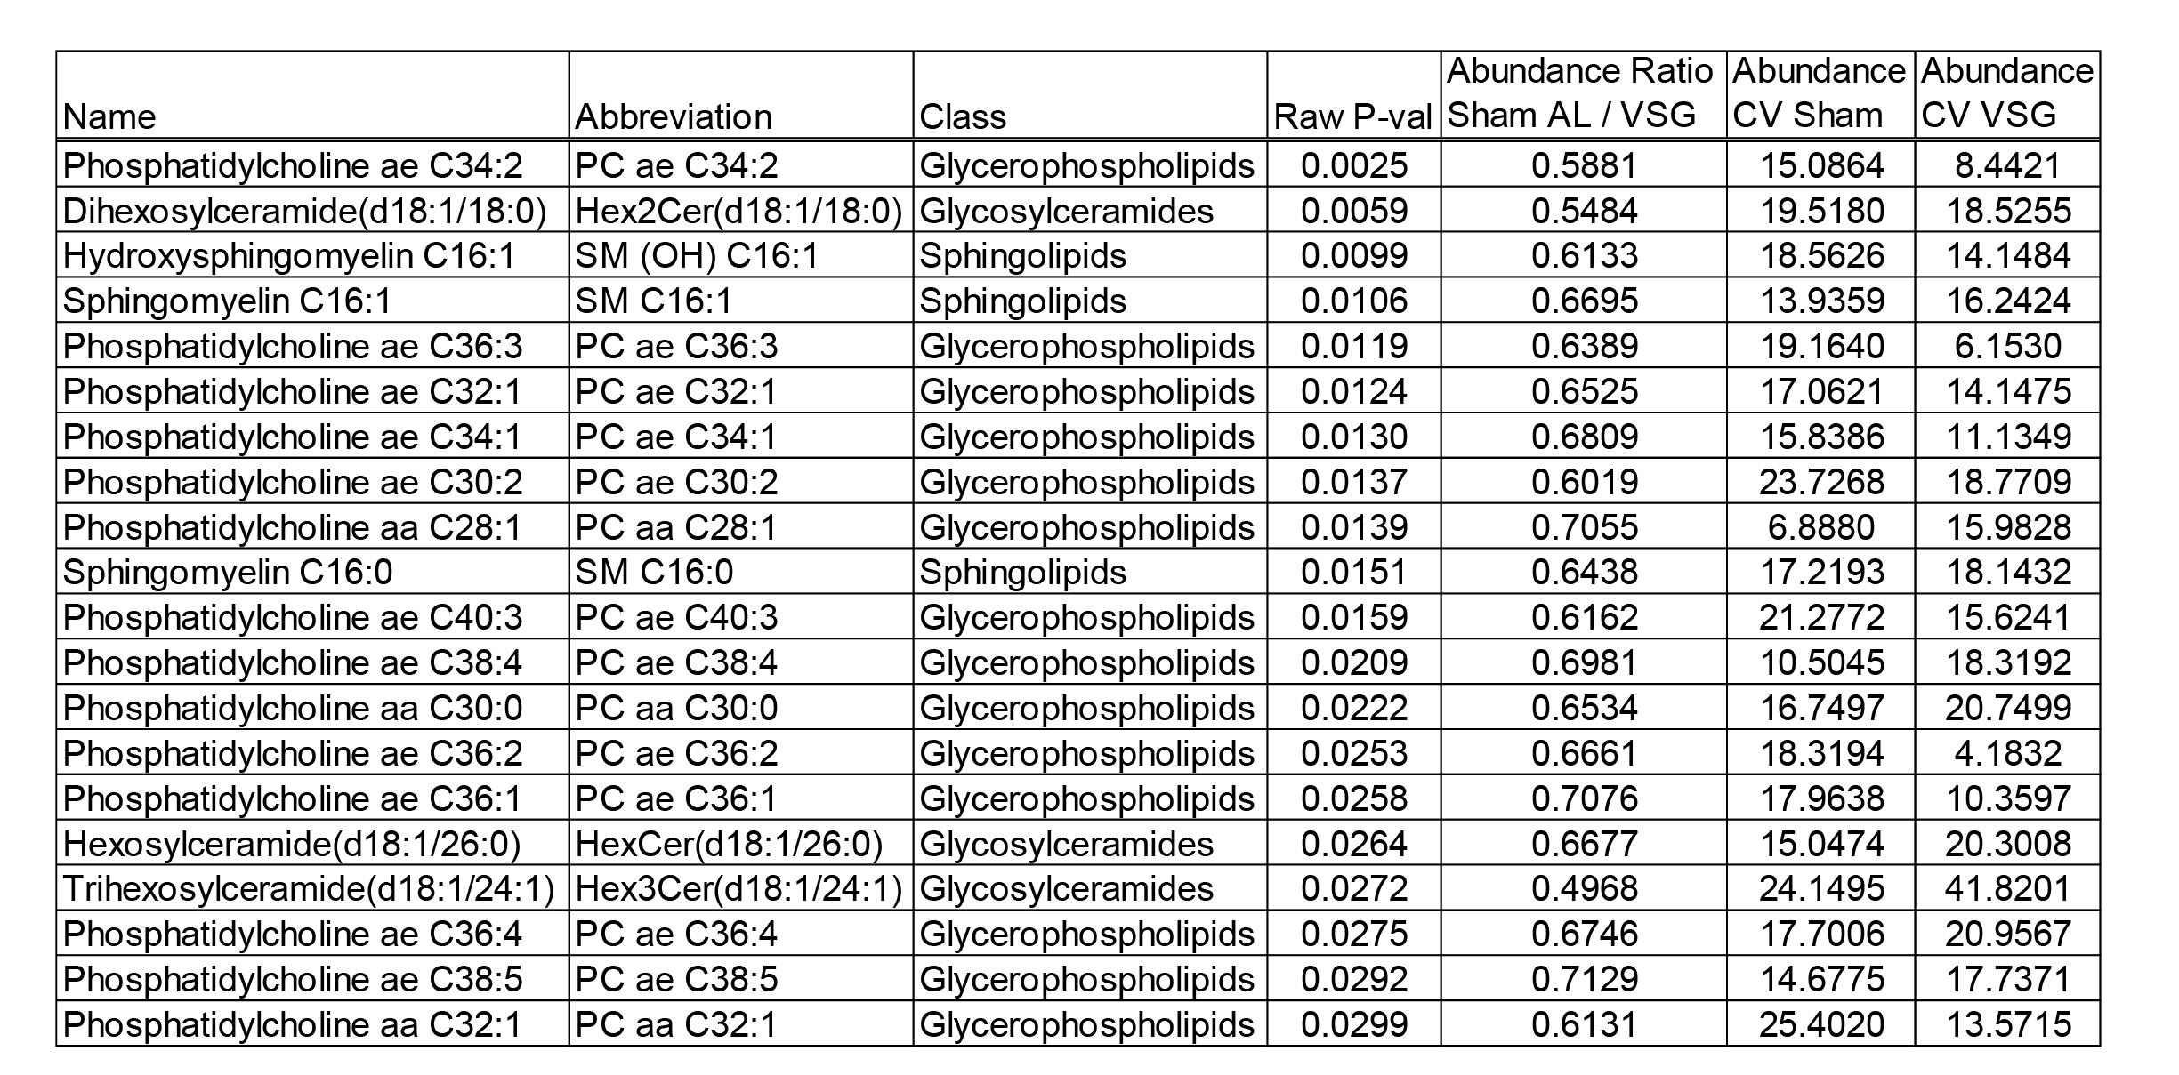
Extended Data Figure 5 (related to Figure 5). Table of top metabolites in hepatic macrophages 5 weeks post-VSG.

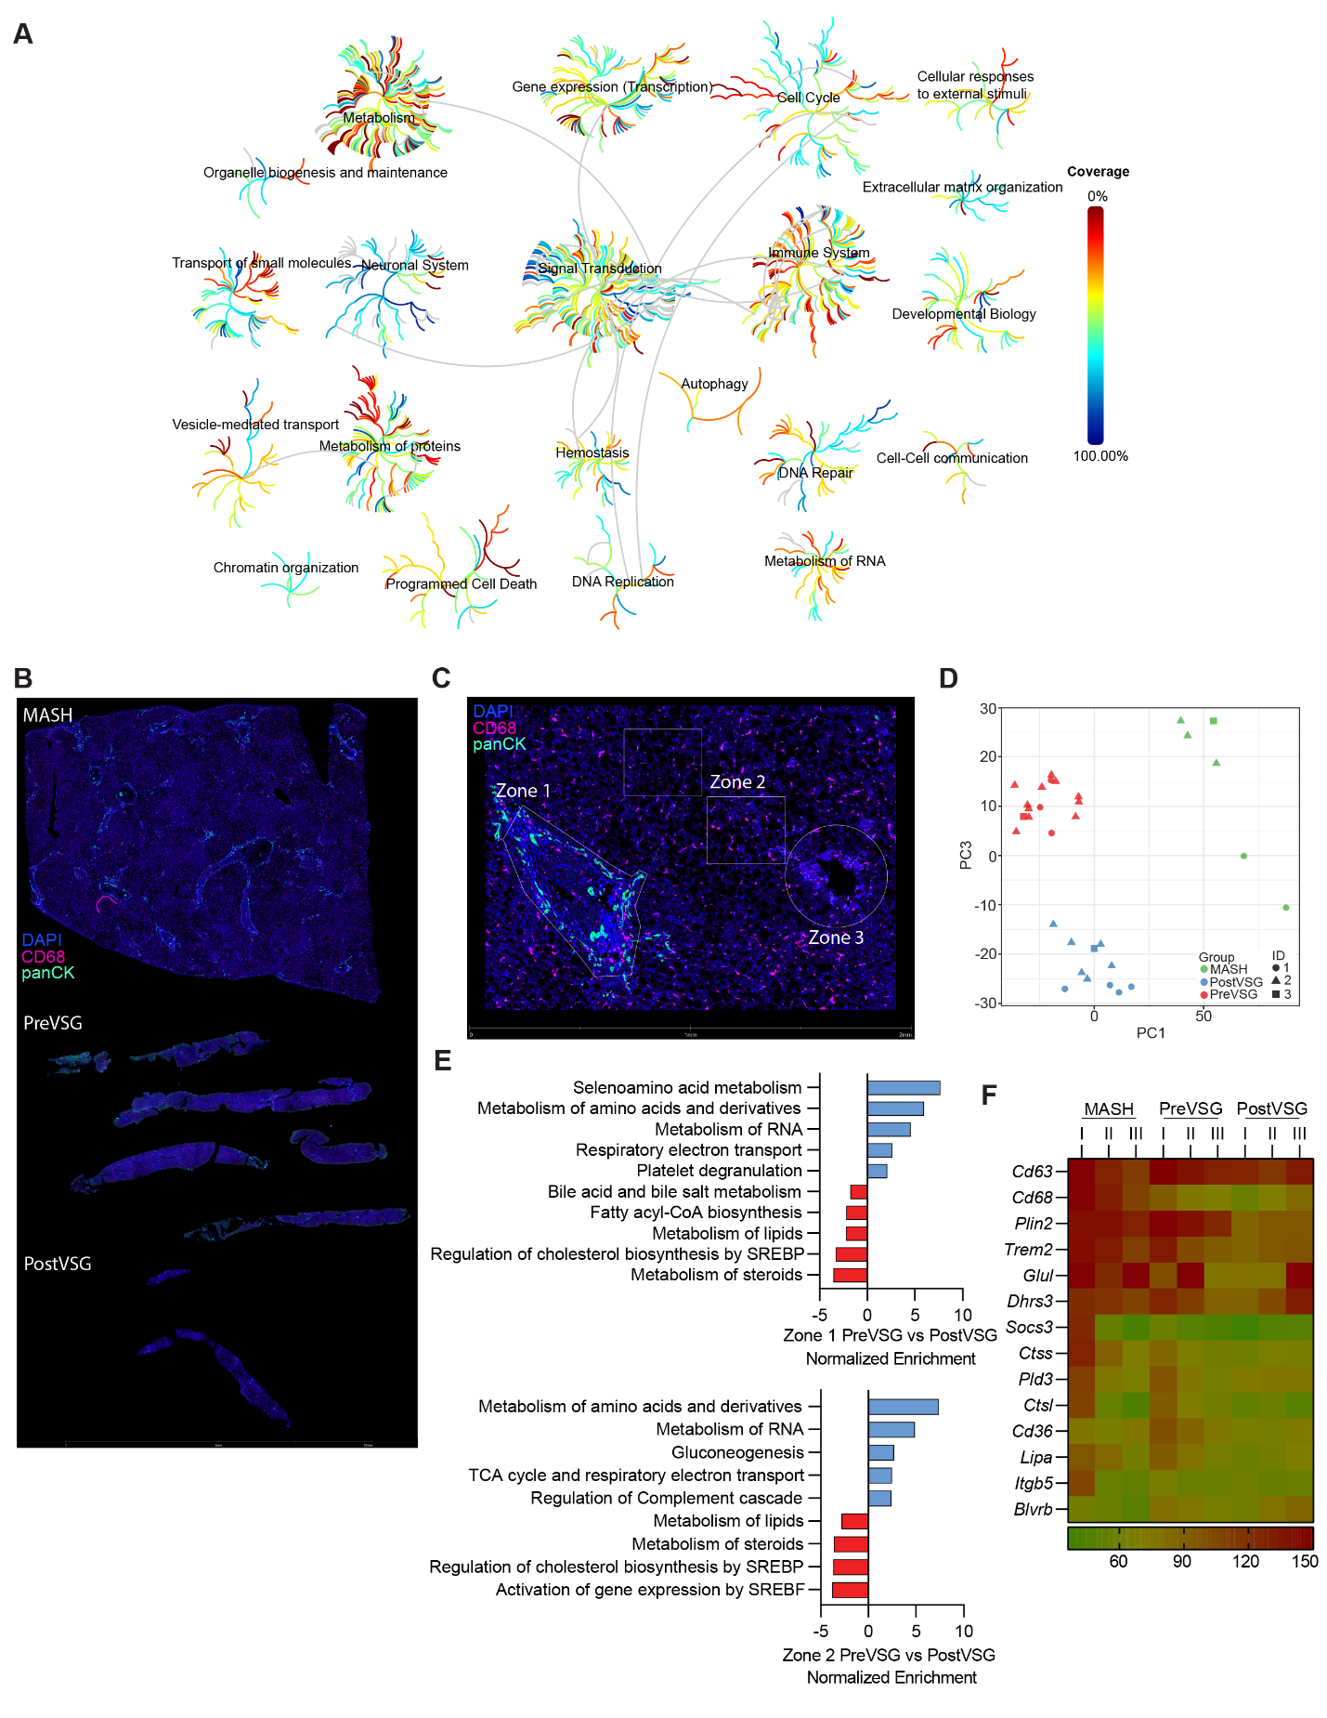

Extended Data Figure 6 (related to Figure 6). (B-F) Spatial sequencing of human liver samples pre-VSG and post-VSG. (A) Pathway coverage for mouse VSG GeoMx analysis. (B) Representative human liver sections used for GeoMx. (C) Representative human liver section used for GeoMx with liver zones indicated. (D) Unsupervised PCA of all human liver ROIs (n = 1). (E) Pathway analysis for Zone 1 PreVSG vs. Zone 1 PostVSG (top) and Zone 2 PreVSG vs. Zone 2 PostVSG (bottom). (F) Heatmap of LAM genes.

