Title: Self-reactive germline-like TCR alpha chains shared between blood and pancreas

Supplemental Tables
Table S1. Characteristics of study participants.
Table S2. Compiled and filtered TCR sequences used in this study.
Table S3. Peptide contacts with IAR TCR sequence features.
Table S4. Flow cytometry antibodies.

Supplemental Figures
Figure S1. Lack of sequence matching between PIT and IAR T cell V genes is independent of HLA genotype. PIT matches with different TRA junction segments in IAR T cell TRA chains from Cohort 1 were as in Figure 1D but displayed by PIT HLA-DRB1 genotype. Numbers of TCRs compared were 784, 153, 303, and 138for HLA-DRB1*03:01, *04:01, *07:01, and other HLA-DRB1 alleles, respectively.
Figure S2. Fractions of PIT-matched and non-matched TRA junctions vary by disease group and TCR expansion. We tabulated frequencies of PIT-matched and non-matched TRA junction numbers by group after down sampling to equivalent junction numbers as in Figure 1F but analyzed at the donor level. Differences between groups did not differ significantly after multiple testing correction.
Figure S3. Most PIT-matches map to the TRA junction region. The distribution of amino acid sequence positions of single PIT mismatches between IAR and PIT TRA junctions. The starting C residues (N terminus) all junctions were assigned position = 0. The distribution of observed mismatches (mismatch)was more centrally distributed than of the C-terminal ends of V genes (vEnd) and the N-terminal ends of J genes (jStart), as delineated by IMGT/HighV-QUEST ¹. Vertical lines, median position of PIT mismatches.
Figure S4. Length differences between PIT-matched and non-matched TRA junctions map to peptide-contacting regions. Shown are distributions of sequence lengths (in nt) for sequence features from PIT-matched and non-matched TRA junctions, as delineated by IMGT/HighV-QUEST ¹. A) CDR1; B) CDR2; C) CDR3; D) N region (Nregion); E) 3’ end of V gene (threeVRegion); F) 5’end of the J region (fiveJRegion). The significance of differences in values from PIT-matched and non-matched chains was assessed using Kolmogorov-Smirnov tests. ****, pAdj <1e-4; NS, not significant. Solid vertical line, median value from PIT-matched junctions; dashed vertical line, median value from PIT-non-matched junctions.
Figure S5. TRA V genes enriched in PIT- matched versus mismatched TCRs. We enumerated numbers of PIT-matches and -non-matches for each TRA V gene found in IAR T cells using IMGT/HighV-QUEST ¹ (N = 68 TRA V genes). Shown is a bar plot of the negative log10 of pAdj values for differences between abundance for each V gene in PIT-matched and non-matched TCR chains, determined by Fisher’s exact test. Dotted line, pAdj = 0.05.

Figure S6. Distribution of peptide contact regions in PIT-matched and PIT-non-matched TCR sequence features. We identified predicted peptide contact residues from molecular models of PIT-matched and PIT-non-matched TCRs and mapped these to various sequence features. Plotted are numbers of contact residues in each TCR chain sequence by subject feature plotted versus TRA junction length. ***, pAdj <1e-3 that the slope was zero, calculated using linear modeling. Other comparisons did not show significant differences.
Figure S7. Molecular modeling of a cross-reactive PIT-matched TCR with two different peptides. We built molecular models of Clone 81 TCR with GAD65 377-396 and MP74 97-116 MHC class II DRA*0101/DRB1*0401 complexes. A-B). Predicted overall topological similarity of tripartite models of Clone 81 TCRs with GAD65 377-396 and MP74 97-116 MHC class II complexes. The viewing plane is from the interface with the MHC molecules, which have been removed from the representation for clarity. C) Green font, peptide contact residues; bars, CDR 1, CDR2 and CDR3 regions, from left to right. There were no predicted contact residues in the TRA CDR2 region. D-E) Alignment of predicted structures for the Clone 81 TRA (D) and TRB (E) chains. Green, sequences for MP54 peptide models; orange, GAD65 peptide models. Labels indicate the CDR loops of the respective chains. CDR3 regions, which are labeled because they show the greatest divergence between the two models. Outside the CDR loops, the structures were mostly superimposed and may not be separately visible.
Figure S8. TRB junctions from cross-reactive TCRs in the VDJdb database were not shorter and did not encode more hydrophobic peptide sequences than junctions from single specificity TCRs. A) Density of TRB chains from TCRs with one versus multiple specificities in VDJdb. There were N = 19,508 unique TRB chains from TCRs with single specificity and N = 1,292 with multiple specificities. B) Distribution of TRB CDR3 nt lengths from TCRs with one versus multiple specificities; C) Distribution of TRB N region nt lengths. D) Distribution of TRB junction AA hydrophobicity. Solid vertical lines, median values from TCRs with multiple specificities; Dashed vertical lines, median values in TRB regions from TCRs with single reported specificities. Significance of differences in distributions were assessed using Kolmogorov-Smirnov tests. NS, not significant.
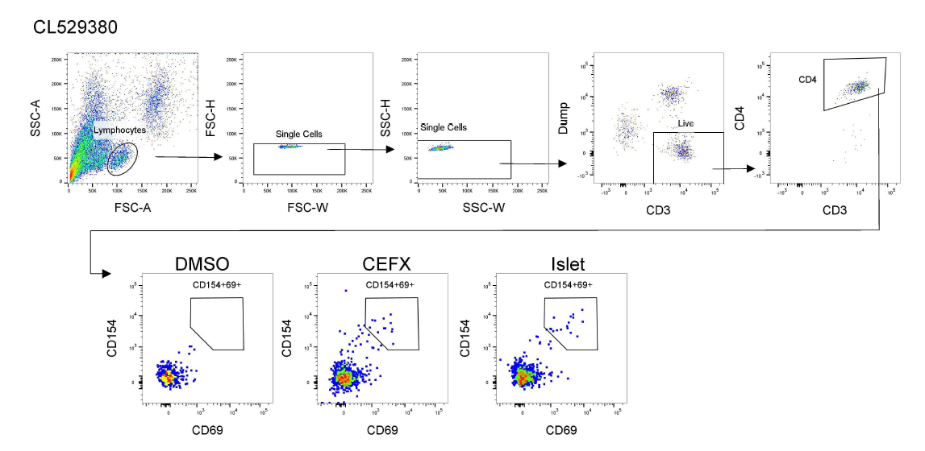
Figure S9. Gating strategy for flow cytometry identification of IAR CD4 T cells for singly cell sorting from sample CL529380. PBMC were stimulated with DMSO (vehicle), foreign antigen (CEFX, positive control), or a pool of class II optimized peptides from islet proteins after overnight culture. Activated cells were identified as CD154+CD69+.

